5.14 Create course

5.14.1 Fully Dressed Use Case

|  |  |  |
| --- | --- | --- |
| Use Case ID: | UC14 | |
| Use Case Name: | Create Course | |
| Created By: | Claudia Della Serra | Last Updated By: |
| Date Created: | Marc 26th, 2016 | Last Revision Date: |
| Actor(s): | Primary Actor(s): Administrator | |
| Goal/Actor Goals: | Administrator wishes to add a course to the database of courses | |
| Description/Summary: | The Administrator wishes to add a course to the system’s database of courses by entering its course code, the course description, and the amount of credits awarded by the course. A course may be a section, a tutorial, or a lab. | |
| Preconditions: | * The administrator has logged in. * The administrator has viewed the list of courses in the database. | |
| Post-conditions: | The course is added to the database of courses | |
| Minimum Guarantee: | The database of courses will remain unaltered. | |
| Basic Flow: | 1. Administrator requests to create a course 2. The system presents a page asking for the course id, the course description, and the amount of credits awarded by the course. 3. The Administrator enters the course information and presses submit 4. The system presents the course information, with the options to manage the course or view all courses in the database | |
| Risk assessment: | 3/5 | |
| Importance assessment: | 5/5 | |

5.14.2 System Sequence Diagram

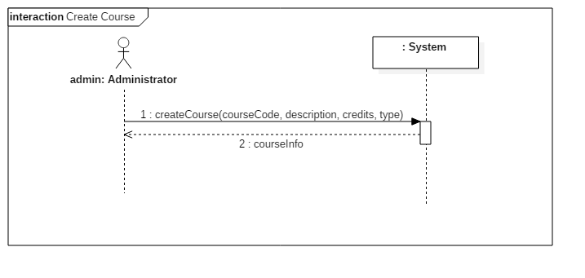

5.14.3 Contract Diagrams

|  |  |  |
| --- | --- | --- |
| Contract 14.1 | createCourse | |
| Created By: | Claudia Della Serra | Last Updated By: Claudia Della Serra |
| Date Created: | March 2, 2016 | Last Revision Date: March 2, 2016 |
| Operation: | createCourse(courseCode: String, description: String, credits: int, type: String) : Course | |
| Cross-reference: | UC14 | |
| Preconditions: | * User is logged into the system as an Administrator. * User has requested to create a course | |
| Post-conditions: | * A new Course is created (instance creation) * The new Course is displayed to the Administrator (association formed) | |

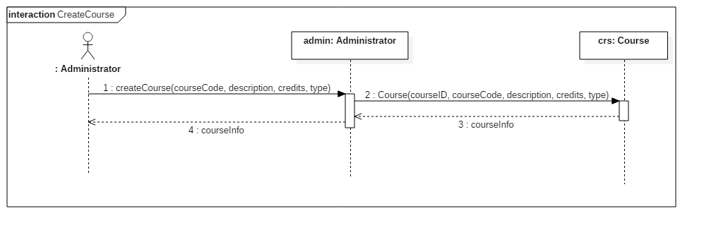

5.15 Browse Courses (Administrator)

5.15.1 Fully Dressed Use Case

|  |  |  |
| --- | --- | --- |
| Use Case ID: | UC15 | |
| Use Case Name: | Browse Courses | |
| Created By: | Claudia Della Serra | Last Updated By: |
| Date Created: | Marc 26th, 2016 | Last Revision Date: |
| Actor(s): | Primary Actor(s): Administrator | |
| Goal/Actor Goals: | Administrator wishes to view the database of courses | |
| Description/Summary: | The Administrator wishes to add view the system’s database of courses. From here, the administrator may choose to add a course or manage courses. | |
| Preconditions: | * The administrator has logged in. | |
| Post-conditions: | The course database will be presented | |
| Minimum Guarantee: | The administrator will remain on the home page. | |
| Basic Flow: | * + - 1. Administrator requests to view the course database       2. The system presents a page listing all the courses in the database | |
| Risk assessment: | 2/5 | |
| Importance assessment: | 4/5 | |

15.2 System Sequence Diagram

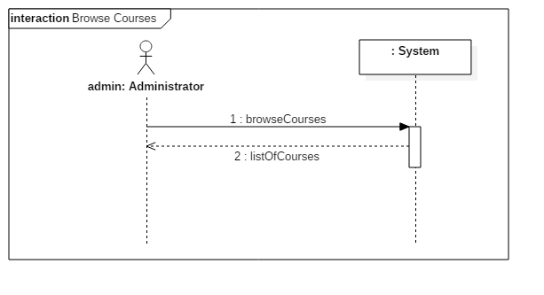

15.3 Contract Diagrams

|  |  |  |
| --- | --- | --- |
| Contract 15.1 | browseCourses | |
| Created By: | Claudia Della Serra | Last Updated By: Claudia Della Serra |
| Date Created: | March 2, 2016 | Last Revision Date: March 2, 2016 |
| Operation: | browseCourses() : list<Course> | |
| Cross-reference: | UC14 | |
| Preconditions: | * User is logged into the system as an Administrator. | |
| Post-conditions: | * A new list of Courses is created (instance creation) * The new list of Courses is displayed to the Administrator (association formed) | |

