**ELEC 477**

Kevin Yu: 20203451

Raatik Sharma: 20120770

Ainsley Taylor: 20210012

2024-02-05

# Test 1: Testing Integrated DNS System

***“For testing the integrated system, you should test two different kv servers running as different service names, and that theclients correctly find them by service name.”***

The test results for Test 1 are shown in the “Test1.txt” file in the repository. In this file it showcases the system logs of the DNS program. In main.cpp file the test case illustrates a DNS server being configured with the following setttings:

Lastly, two clients were instantiated to talk to one of these two servers by utilizing the directory service name stub which would talk to the DNS server and DNS stub:A computer screen shot of a program code

From the system logs in “Test.txt” we can see that the servers registered their services with the DNS server:

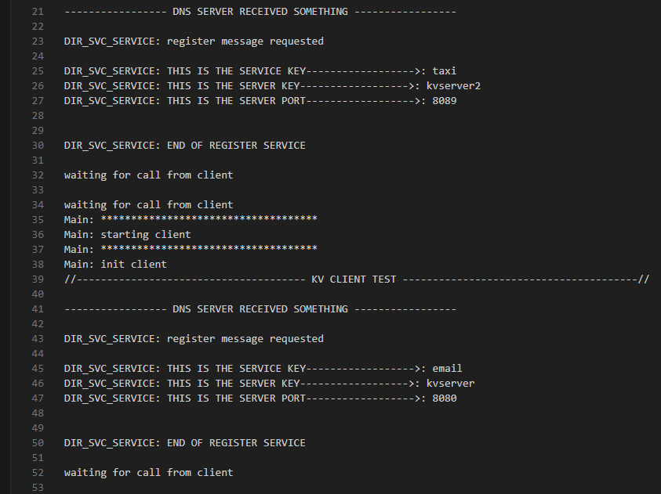

After the servers registered their services, the clients can then use the DNS service to lookup the server address information based on the corresponding choosen service name:A screenshot of a computer program

# Test 2: Deleting Service from Service Server

***“You should check that when a kv server exits, that the name of the service is no longer in the service server.”***

Using the same test results shown in “Test.txt” and the same main.cpp class we can see what happens when a service is shutdown and deleted from the service server. In the system logs every time we shutdown/delete a service we iterate through the remaining services left in the server: A screenshot of a computer

Line 127 showcases the remaining services stored on the service server. Once the last service is deleted the following is shown:

We can see that our system logs show that there are no more services registered in the DNS server. Therefore when a kv server exits, the name of the service is no longer in the service server.