- Configure Raspberry Pi to enable I2C interface
- Go to menu: Preferences -> Control Centre, and open Control Centre GUI.
- Find Interfaces tab and enable I2C interface
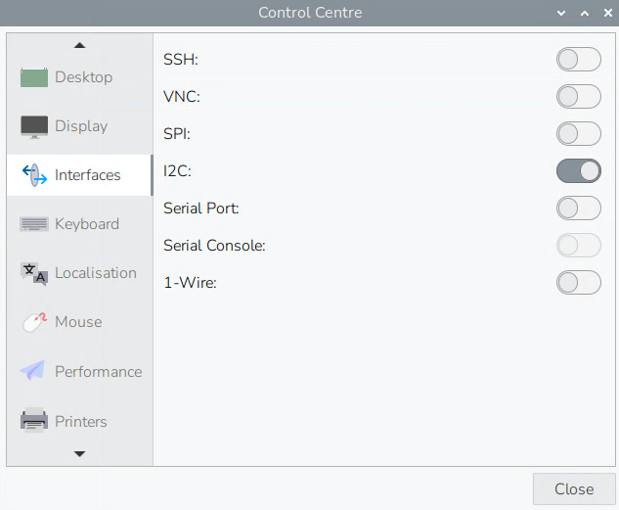
- Detect I2C devices
- Run command and check i2c devices at address 0x20 and 0x68
i2cdetect -y 1
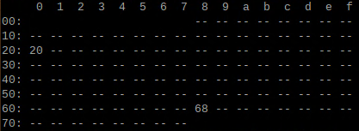
- The address 0x20 is the controller board with buttons and lights
- The address 0x68 is RTC board
- Install WiringPi library
- Clone WiringPi library
git clone https://github.com/WiringPi/WiringPi.git
- Go to WiringPi folder, build library and install
./build
- Clone i2c demo, make and run
git clone https://github.com/KevinZ-FI/adk-button-and-led-light-demo.git
make
./adk-button-led-light-demo

