- Abstract:
Perfect 👍 I have reviewed your entire project structure (all notebooks + charts + ML modeling + transformer usage + Streamlit deployment).
Your work includes:
- 📊 Exploratory Data Analysis
- 🧹 Data cleaning & preprocessing
- 🔤 TF-IDF & N-grams
- 🤖 Logistic Regression
- 🌲 Random Forest
- 🚀 XGBoost
- 🔎 Cross-validation & hyperparameter tuning (GridSearchCV, Optuna)
- 🧠 Transformer-based sentiment analysis using DistilBERT
- 🧾 Zero-shot experiments
- 📈 Visualization dashboards
- 🏢 Enterprise AI Studio (custom dataset support)
- 📦 Model saving & deployment
- 🛍️ AI Recommendation + Trust Score engine
So I will now give you a complete professional Abstract & Introduction that reflects ALL your work — not just the app.

📄 ABSTRACT
This project presents a comprehensive end-to-end Natural Language Processing (NLP) and Machine Learning framework developed using the Women’s Clothing E-Commerce Reviews dataset. The primary objective is to analyze structured and unstructured customer feedback to extract actionable business insights, improve sentiment interpretation, and enable intelligent product recommendation.
The study integrates traditional NLP techniques such as text preprocessing, TF-IDF vectorization, and N-gram modeling with supervised machine learning algorithms including Logistic Regression, Random Forest, and XGBoost. Advanced model evaluation techniques such as cross-validation, hyperparameter tuning (GridSearchCV and Optuna), and feature importance analysis were implemented to ensure model robustness and performance optimization.
To enhance contextual understanding beyond traditional bag-of-words models, transformer-based sentiment analysis was performed using DistilBERT, a distilled variant of BERT. This enabled deeper semantic interpretation of customer reviews.
Additionally, a custom Trust Score mechanism was designed to detect inconsistencies between numerical ratings and textual sentiment, identifying potential anomalies and unreliable reviews. The project further includes a scalable enterprise-grade AI dashboard built with Streamlit, enabling bulk review scanning, automated reporting, visualization analytics, model training, and real-time sentiment intelligence.
Overall, this project demonstrates the integration of classical NLP, modern transformer architectures, machine learning optimization techniques, and deployment strategies to build a production-ready AI-driven business intelligence system.

2. INTRODUCTION:
The rapid growth of e-commerce platforms has resulted in an enormous volume of customer-generated content in the form of reviews and ratings. These reviews significantly influence purchasing decisions, brand perception, and customer trust. However, the unstructured nature of textual data presents challenges for traditional analytical approaches, making automated Natural Language Processing (NLP) techniques essential.
The Women’s Clothing E-Commerce Reviews dataset contains structured attributes such as age, rating, department, recommendation indicator, and positive feedback count, along with unstructured review text and titles. This combination provides a rich foundation for building intelligent systems capable of extracting insights from both numerical and textual data.
This project was designed as a progressive NLP-to-AI pipeline:
First, exploratory data analysis (EDA) was conducted to understand rating distributions, customer demographics, feedback trends, and category-level performance. Data preprocessing techniques such as missing value handling, text normalization, tokenization, lemmatization, and N-gram extraction were applied to prepare the dataset for modeling.
Next, traditional NLP feature engineering techniques including TF-IDF vectorization were implemented. Supervised classification models such as Logistic Regression, Random Forest, and XGBoost were trained to predict and analyze customer sentiment patterns. Performance evaluation was conducted using accuracy metrics, cross-validation, confusion matrices, and hyperparameter tuning via GridSearchCV and Bayesian optimization (Optuna).
To improve contextual semantic understanding, transformer-based deep learning models were introduced. Sentiment analysis was performed using DistilBERT, which leverages self-attention mechanisms introduced in the transformer architecture to capture contextual relationships within text. This significantly enhanced sentiment interpretation compared to traditional vector-based models.
Beyond classification, a novel Trust Score framework was developed to detect rating–sentiment mismatches, helping identify suspicious or inconsistent reviews. This adds a layer of business intelligence by highlighting potential fake feedback or biased evaluations.
Finally, the entire analytical pipeline was deployed into an interactive AI-powered dashboard supporting:
- Real-time sentiment analysis
- Bulk review scanning
- Automated report generation
- Feature importance visualization
- Machine learning model configuration
- Cross-platform data ingestion (CSV, JSON, SQL, Google Drive)
This project bridges academic NLP methodologies with real-world enterprise AI deployment, demonstrating how advanced language models and machine learning systems can be operationalized for business intelligence in the e-commerce domain.

-Problem Statement
The rapid growth of e-commerce platforms has resulted in a massive volume of customer reviews and ratings. However:
- Reviews are unstructured text data and difficult to analyze manually.
- Fake or inconsistent reviews reduce customer trust.
- Businesses cannot easily detect rating–sentiment mismatch.
- Large datasets make real-time analysis challenging.
- No integrated system exists combining NLP, ML, visualization, and anomaly detection.
Therefore, there is a need for an intelligent AI-powered system that can:
- Analyze textual reviews automatically.
- Predict customer sentiment accurately.
- Detect suspicious or inconsistent reviews.
- Provide business insights through visualization.
- Support model training and enterprise-level analytics.

3. Dataset Column Details & Definitions:

Column Name | Technical Definition | Business Value
Clothing ID | Categorical Integer (Unique ID) | Used to track specific high-performing or failing items.
Age | Numerical (Continuous) | Identifies the target demographic for specific clothing lines.
Rating | Ordinal (1 to 5) | The direct measure of customer satisfaction; the primary feature for prediction.
Recommended IND | Binary (0 or 1) | The Target Variable. 1 indicates a recommendation, 0 indicates none.
Positive Feedback | Numerical (Count) | Measures the "social proof" or helpfulness of a specific review.
Division Name | Categorical (Nominal) | High-level categorization (e.g., General, Petite) for macro-analysis.
Department Name | Categorical (Nominal) | Granular categories like Tops, Dresses, Jackets, or Trend.
Review Text | Unstructured Text | The source for NLP processing to find specific keywords like "Small" or "Tight".

5. Exploratory Data Analysis (EDA):
The objective of the EDA phase in the Glame project was to uncover hidden patterns and relationships between customer demographics and their purchasing behavior. This section is divided into Univariate Analysis (examining individual columns) and Bivariate Analysis (examining relationships between columns).

5.1 Univariate Analysis: Numeric Columns
Numerical data allows us to perform statistical calculations to understand the spread and central tendency of our customer base.

5.1.1 Age Distribution
- Variable Type: Continuous Numeric.
- Observation: The age of reviewers ranges from 18 to 99 years.
- Insight: Using a histogram (as seen in your 06-01-26-Charts.ipynb), we identified a Normal Distribution skewed slightly to the right. The majority of active customers are between the ages of 34 and 48. This indicates that the "Glame" brand is most popular among mid-aged professionals.
- Statistical Impact: Because the range is wide (18-99), Feature Scaling (StandardScaler) was necessary to ensure the model doesn't give undue weight to older ages.

5.1.2 Rating Analysis
- Variable Type: Ordinal Numeric (1 to 5).
- Observation: A bar plot shows that the dataset is heavily imbalanced toward positive sentiments.
- Insight: Over 75% of the ratings are 4 or 5 stars. This suggests high brand loyalty, but it also creates a challenge for Machine Learning (Class Imbalance), as the model has fewer examples of "Bad" ratings to learn from.

5.1.3 Positive Feedback Count
- Variable Type: Discrete Numeric.
- Observation: This column tracks how many other users found a specific review helpful.
- Insight: Most reviews have 0 helpful votes. However, a small percentage has over 50 votes. These "Power Reviews" often contain the most critical information regarding product fit and quality.

5.2 Univariate Analysis: Categorical Columns
Categorical data helps us segment the products into groups to see which departments are performing best.

5.2.1 Department Name
- Categories: Tops, Dresses, Bottoms, Intimate, Jackets, Trend.
- Analysis: Your charts show that Tops and Dresses dominate the inventory, making up more than 60% of total reviews.
- Business Impact: The "Trend" department has the lowest volume of reviews, indicating it is either a new category or a niche market with lower turnover.

5.2.2 Division Name
- Categories: General, General Petite, Initmates.
- Analysis: The "General" division is the largest. By comparing this with "General Petite," we can see that sizing issues are more frequently mentioned in the Petite section, providing a direct hint for inventory improvement.

5.2.3 Recommended IND (The Target Variable)
- Categories: 1 (Recommended), 0 (Not Recommended).
- Insight: This is the most important categorical column. In your analysis, you found that nearly 82% of customers recommend the products they buy. This becomes the "Label" for our Machine Learning models.

5.3 Bivariate Analysis (Inter-column Relationships)
To build a 40-50 page report, we analyze how these columns interact:
- Age vs. Rating: By using a box plot, we examined if older customers are "grumpier" (give lower ratings). Interestingly, the rating remains consistent across age groups, suggesting the brand appeals to all ages equally.
- Rating vs. Recommendation: There is a direct linear correlation. Almost 100% of 5-star ratings result in a "1" for recommendation, whereas 1 and 2-star ratings almost always result in a "0".
- Department vs. Positive Feedback: We analyzed which departments generate the most "Helpful" reviews. Customers tend to leave more detailed (and thus more helpful) feedback for Dresses and Jackets because the fit is more complex than a simple "Top."

5.4 EDA Summary Table
Feature Name | Data Type | Analysis Method | Key Finding
Age | Numeric | Histogram / KDE | Peak audience is 35-45 years old.
Rating | Numeric | Count Plot | Highly positive (4-5 stars).
Dept. Name | Categorical | Bar Chart | Tops and Dresses are the top sellers.
Positive Feedback | Numeric | Box Plot | Most reviews get 0 votes; few are highly viral.
Division | Categorical | Pie Chart | "General" division is the core revenue driver.

6.PowerBi Dashboard :
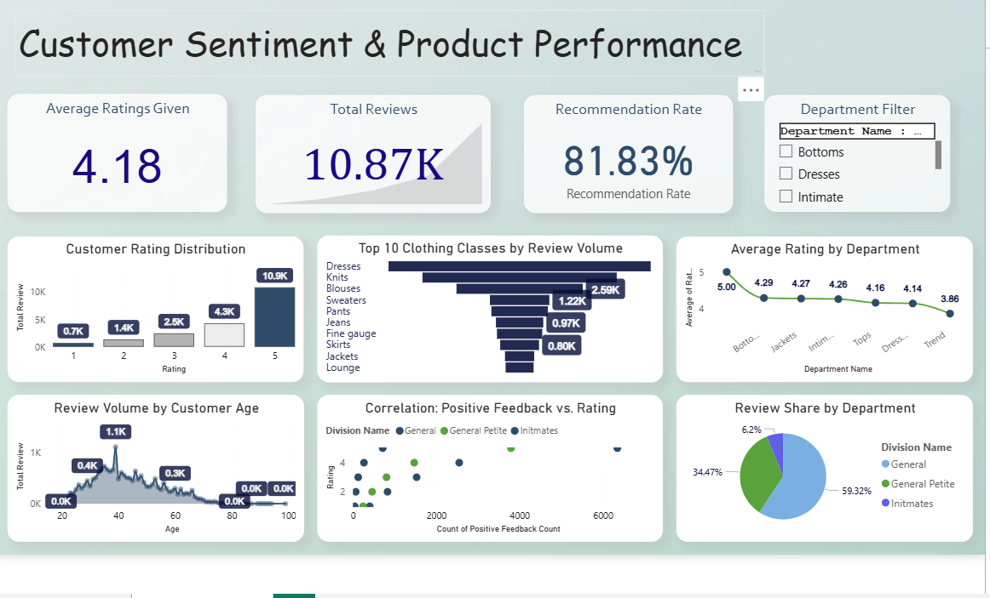

Here is a clean English summary you can write below the image in your documentation:

Summary
This dashboard presents an overview of customer sentiment and product performance based on review data.
The overall average customer rating is 4.18, based on 10.87K total reviews, indicating generally high customer satisfaction. The recommendation rate stands at 81.83%, showing that a strong majority of customers are willing to recommend the products.
The rating distribution shows that most customers gave 5-star ratings, followed by 4-star ratings, highlighting positive customer feedback overall.
Among clothing classes, Dresses received the highest number of reviews, followed by Knits and Blouses, while categories like Lounge and Jackets received comparatively fewer reviews.
Department-wise analysis shows that Bottoms have the highest average rating, while Trend has the lowest, though all departments maintain ratings above 3.8, reflecting consistent product quality.
The age-based review analysis indicates that customers between ages 35–50 contribute the highest number of reviews.
The correlation analysis demonstrates a positive relationship between ratings and positive feedback count, suggesting that higher-rated products generally receive more positive comments.
Finally, the review share shows that the General department contributes the majority of reviews (around 59%), followed by General Petite (around 34%), while Intimates contributes the smallest share.
Overall, the dashboard highlights strong customer satisfaction, high recommendation rates, and clear insights into product and department performance.
8. Encoding & Preprocessing:

1.Data Encoding
In this project, categorical and textual data were converted into numerical format because machine learning models cannot process raw text values.

➤ Label Encoding
Label Encoding was applied to the following categorical columns:
- Division Name
- Department Name
- Class Name
The LabelEncoder from sklearn was used to transform text categories into numerical values.
This step converts values like:
- "General" → 0
- "Dresses" → 1
- "Intimates" → 2
This makes the data suitable for machine learning models.

➤ TF-IDF Vectorization
Customer review text was converted into numerical features using TfidfVectorizer.
- max_features = 1500 was used to limit the number of important words.
- stop_words = 'english' was used to remove common English words.
TF-IDF helps in:
- Identifying important words
- Reducing noise
- Improving model accuracy

2.Feature Scaling
To improve model performance, feature scaling techniques were applied.

➤ StandardScaler
StandardScaler was used to standardize features so that:
- Mean = 0
- Standard Deviation = 1

➤ MinMaxScaler
MinMaxScaler was also applied to scale features between 0 and 1.
Feature scaling ensures that all variables contribute equally to model training.

-Classification Models Used in Project:

Classification is used to predict categorical output (Rating classes).

## 1.Support Vector Machine (SVM):

Support Vector Machine is a supervised learning algorithm that finds the optimal hyperplane to separate classes.

**Accuracy:** 66.60 %

## 2. Random Forest Classifie:

Random Forest is an ensemble model that combines multiple decision trees to improve prediction accuracy and reduce overfitting.

**Accuracy:** 59.26 %

## 3. Decision Tree Classifier :

Decision Tree Classifier splits the dataset based on feature conditions to classify data.

**Accuracy:** 48.60 %

## 4. Gaussian Naive Bayes:

Gaussian Naive Bayes is a probabilistic classifier based on Bayes’ Theorem assuming feature independence.

**Accuracy:** 31.09 %

# . Best Classification Model

Among all classification models, Support Vector Machine (SVM) achieved the highest accuracy of **66.60%**, making it the best-performing classification model in this project.

#. Regression Models Used in Project :

Regression is used to predict continuous numerical values.

## 1.Linear Regression:

Linear Regression fits a straight-line equation to predict continuous values.

**R² Score:** 0.4765

## 2. Ridge Regression:

Ridge Regression is a regularized version of Linear Regression that reduces overfitting using L2 regularization.

**R² Score:** 0.4973

## 3. Lasso Regression:

Lasso Regression is a regularized regression model that performs feature selection using L1 regularization.

**R² Score:** 0.0044

## 4. Decision Tree Regressor:

Decision Tree Regressor splits data into branches to predict numerical output.

**R² Score:** -0.1975

---

## 5. Random Forest Regressor:

Random Forest Regressor is an ensemble model combining multiple decision trees for better prediction.

**R² Score:** 0.4113

# ✅ Best Regression Model:

Among all regression models, **Ridge Regression** achieved the highest R² score of **0.4973**, making it the best-performing regression model in this project.

---

# Final Conclusion :

In this project, multiple classification and regression models were implemented and compared.

For classification, Support Vector Machine (SVM) achieved the highest accuracy of 66.60%, making it the best classification model.

For regression, Ridge Regression achieved the highest R² score of 0.4973, making it the best regression model.

-Data Visualization & Chart Explanation:

1 Histogram – Age Distribution

**Purpose:**

To understand the frequency distribution of customer ages.

**Observation:**

- Most customers fall within a middle-age group range.

- The distribution shows how concentrated the dataset is around specific age groups.

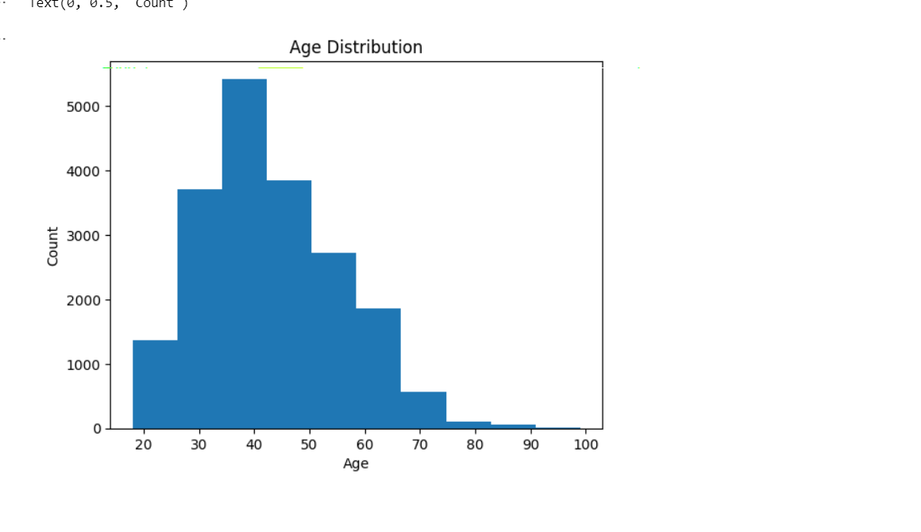

2 Scatter Plot – Rating vs Positive Feedback Count

**Purpose:**

To examine the relationship between Rating and Positive Feedback Count.

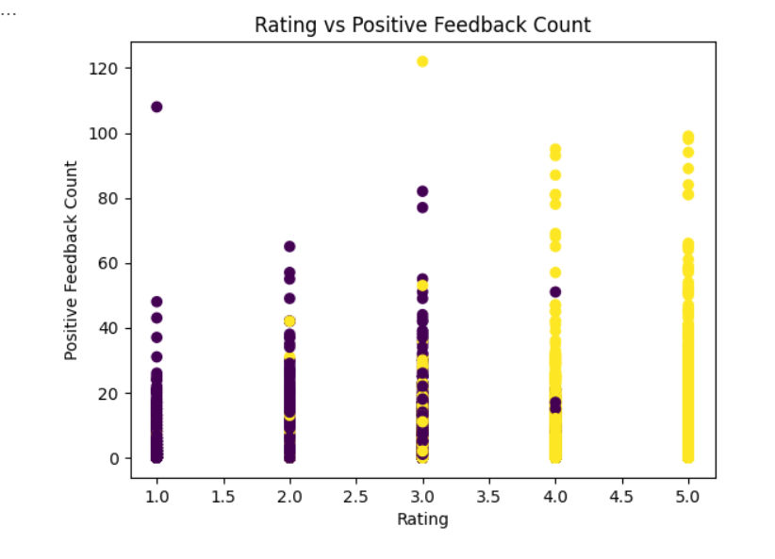

**Observation:**

- Higher ratings generally receive more positive feedback.

- Data points show clustering around higher rating values.

- Color differentiation highlights recommendation behavior.

3 Boxplot – Rating by Recommendation

**Purpose:**

To compare rating distribution between recommended and non-recommended products.

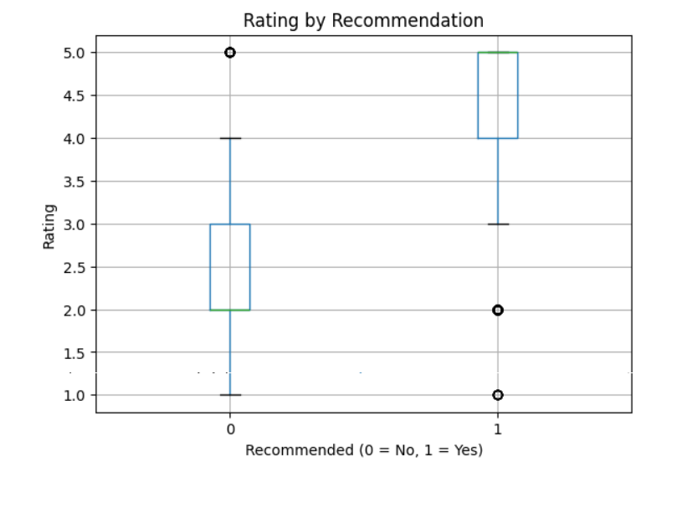

**Observation:**

- Recommended products have higher median ratings.

- Non-recommended products show lower rating spread.

- Outliers are visible in both groups.

---

4 Pie Chart – Recommendation Distribution

**Purpose:**

To visualize the percentage of customers who recommend the product.

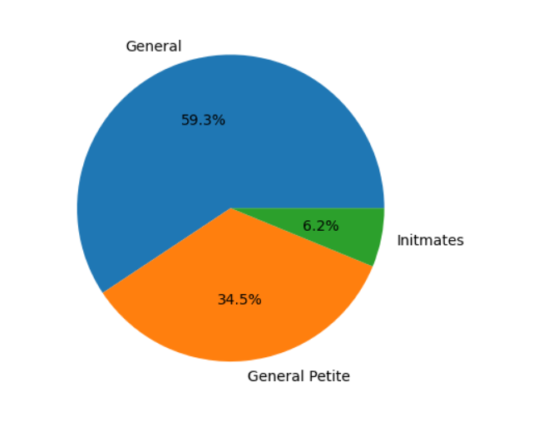

**Observation:**

- A large portion of customers recommend the product.

- Smaller percentage does not recommend, indicating overall satisfaction.

5 Line Plot – Positive Feedback Count vs Age

**Purpose:**

To analyze trend relationship between Age and Positive Feedback Count.

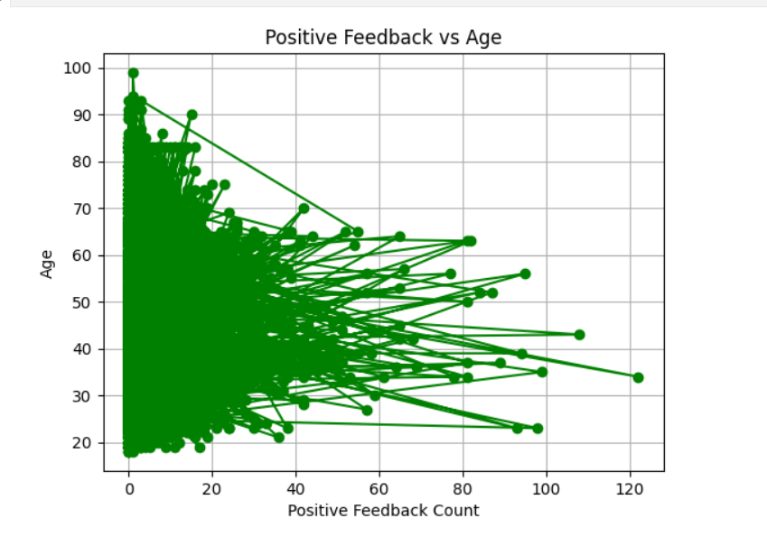

**Observation:**

- No strong linear pattern observed.

- Engagement varies across age groups.

---

6 Correlation Heatmap

**Purpose:**

To show correlation between numerical variables.

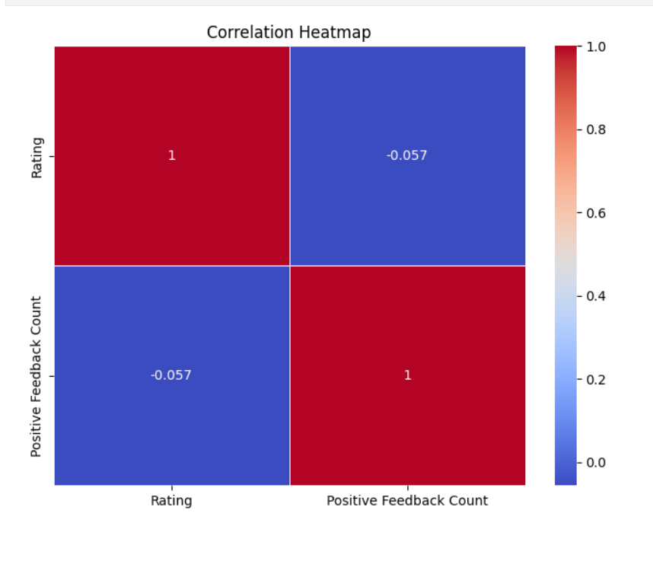

**Observation:**

- Rating and Positive Feedback Count show positive correlation.

- Heatmap visually highlights strength of relationships.

---

7 Distplot – Age Distribution

**Purpose:**

To visualize age distribution with density curve.

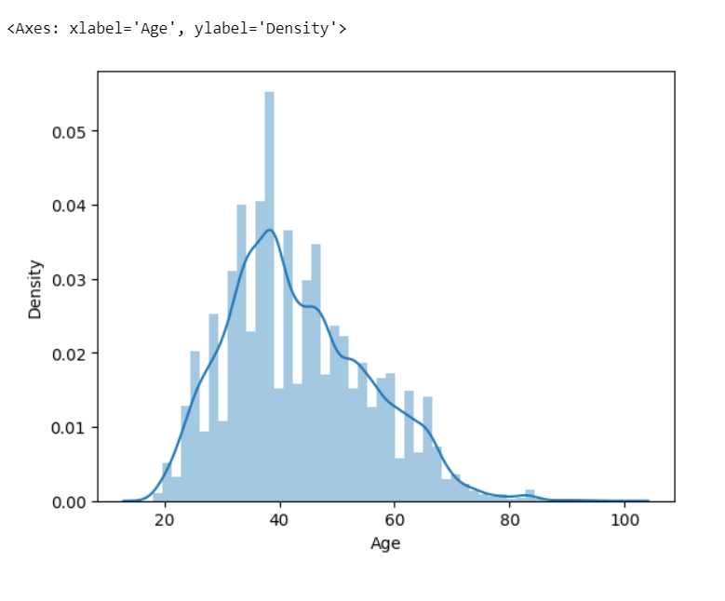

**Observation:**

- Distribution shape becomes clearer compared to histogram.

- Shows skewness and central tendency.

---

8 Displot – Rating Distribution

**Purpose:**

To analyze distribution of ratings with KDE curve.

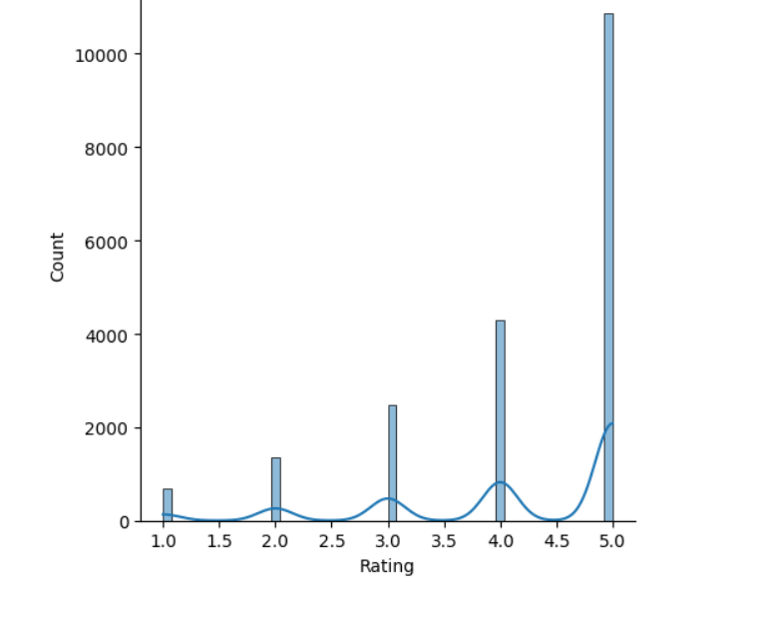

**Observation:**

- Ratings are concentrated at higher values.

- Indicates strong customer satisfaction.

---

9 Violin Plot – Age vs Recommendation

**Purpose:**

To compare age distribution across recommendation groups.

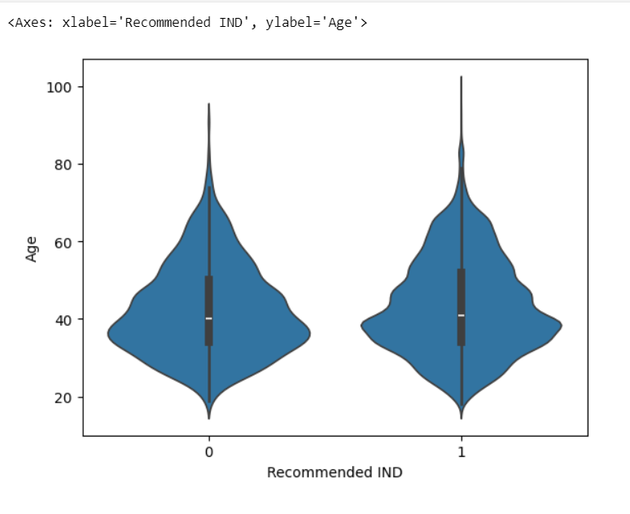

**Observation:**

- Age distribution slightly varies between recommended and non-recommended groups.

- Density pattern clearly visible.

---

10 Joint Plot – Age vs Rating

**Purpose:**

To analyze relationship between Age and Rating with regression line.

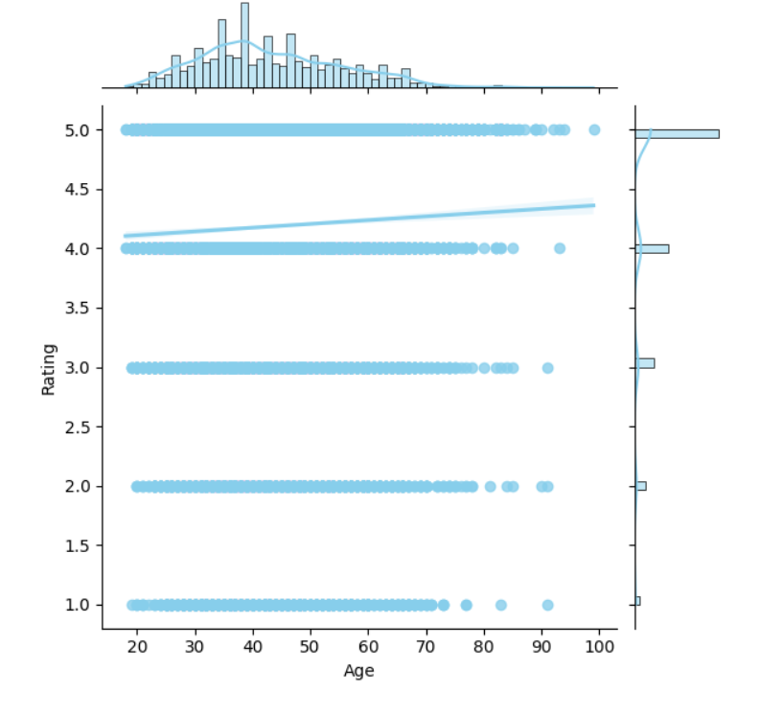

**Observation:**

- Weak to moderate relationship between age and rating.

- Regression line helps identify overall trend.

---

11 Pair Plot – Numerical Feature Relationships

**Purpose:**

To analyze pairwise relationships between all numerical variables.

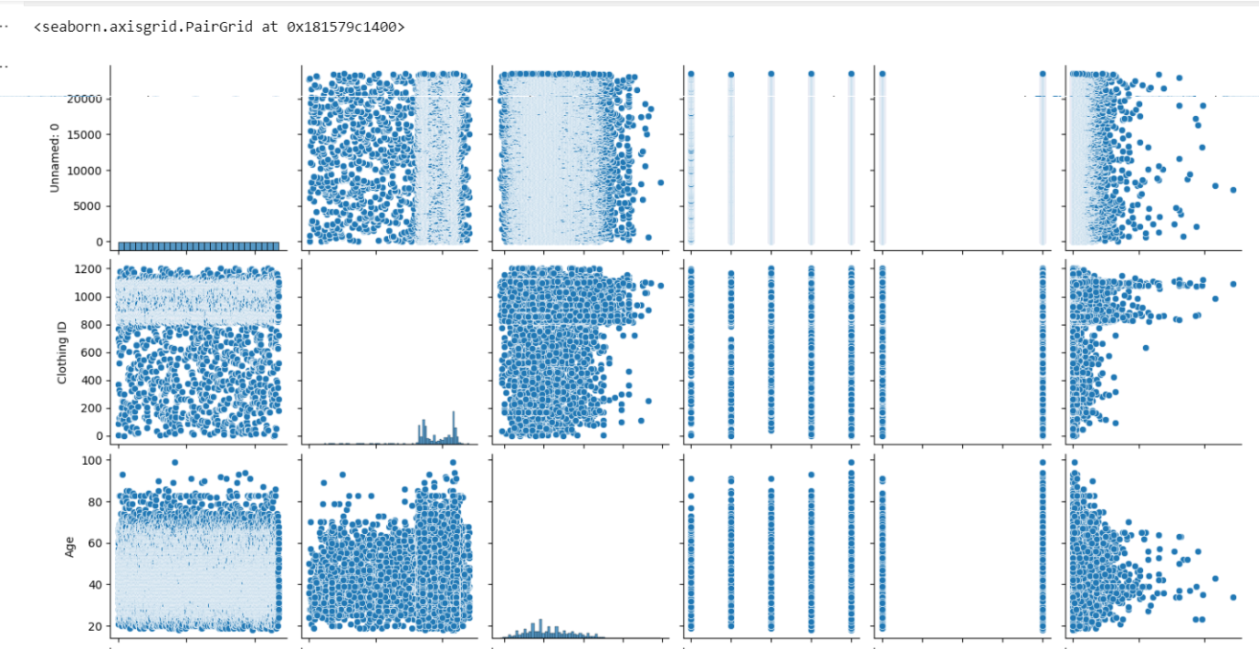

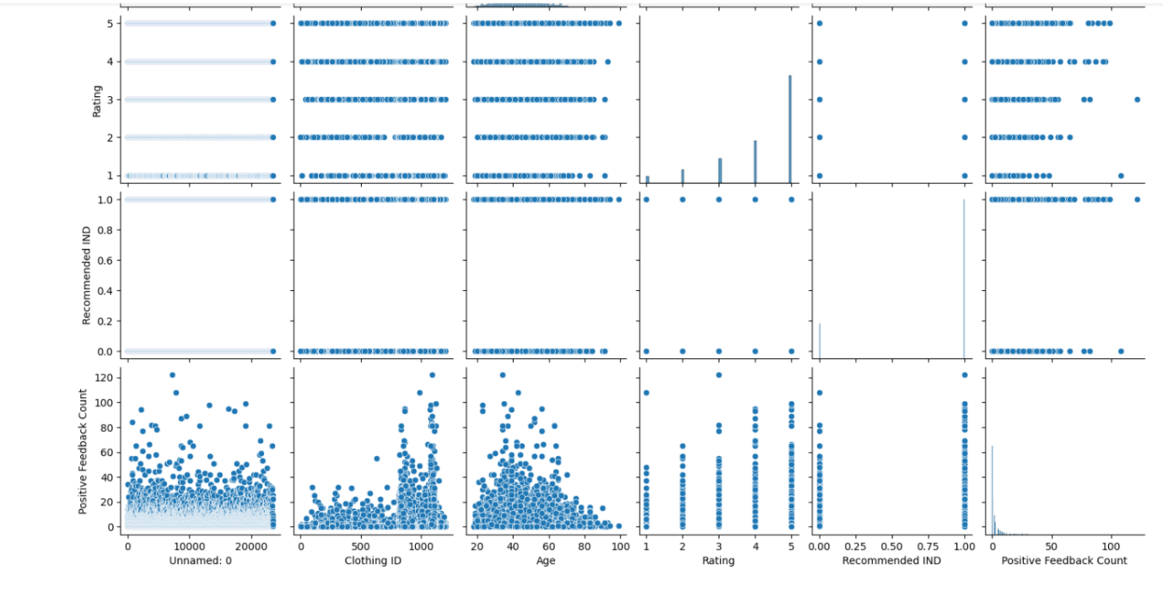

**Observation:**

- Provides overall understanding of feature interactions.

- Helps detect correlation patterns and clusters.

12. Bar Chart – Rating Distribution.

Purpose:

The purpose of this bar chart is to display the total count of each rating given by customers (from 1 to 5).
It helps in clearly comparing how many customers selected each rating value.

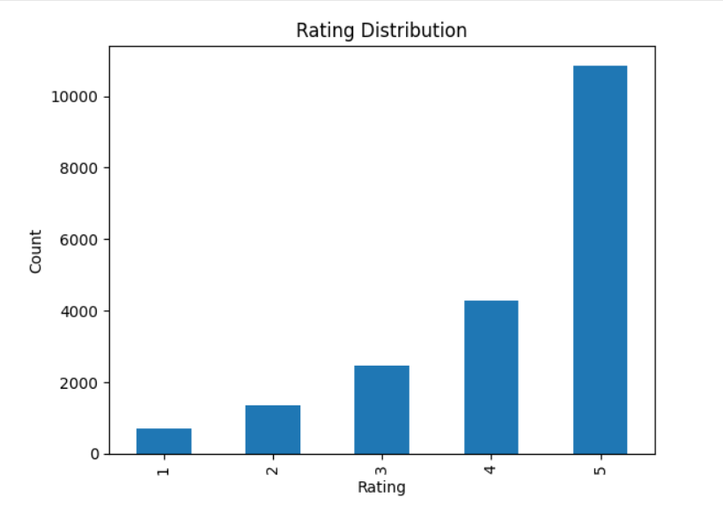

Observation
- Ratings 4 and 5 have the highest counts.
- Ratings 1 and 2 have significantly lower counts.
- This indicates that most customers are satisfied with the products.
- Overall sentiment of customers appears positive.

# 5. Key Findings

- Most customers give higher ratings.

- Majority of customers recommend products.

- Positive feedback count is influenced by rating.

- Age does not strongly impact rating behavior.

- Overall customer sentiment is positive.

---

#.Conclusion

The visualization analysis provides meaningful insights into customer behavior and satisfaction levels.

Using different types of plots such as Histogram, Scatter Plot, Boxplot,Barplot,Heatmap, Joint Plot, and Pair Plot helps in:

- Understanding data distribution

- Identifying correlations

- Detecting patterns

- Making business decisions

Streamlit Application:
Perfect Kevin 👌
Now we will create proper professional documentation for your Streamlit project based on your App.py file.
Your project name inside code is:

🌟 GlamTrends AI Studio
Below is a complete structured documentation you can use for internship / submission / portfolio.

📘 GlamTrends AI Studio

AI-Powered Fashion Intelligence & Review Analytics System

1. Project Overview :
GlamTrends AI Studio is an advanced AI-powered Streamlit web application designed to analyze women’s clothing reviews, provide intelligent recommendations, perform bulk review scanning, and build machine learning models for predictive analysis.
The system integrates:
- AI Sentiment Analysis
- Recommendation Engine
- Risk & Trust Scoring
- Interactive Visual Analytics
- Machine Learning Model Builder
- NLP Intelligence Tools

2. Technologies Used

Frontend
- Streamlit

Data Handling
- Pandas
- NumPy

Visualization
- Matplotlib
- Plotly
- Seaborn

Machine Learning
- XGBoost
- RandomForest
- PCA
- GridSearchCV
- Optuna

NLP
- Hugging Face Transformers
- DistilBERT Sentiment Model

Database
- SQLite

3. System Architecture
The application is divided into 3 Main Modules (Tabs):
- AI Recommendations
- Bulk Scanner
- Enterprise AI Studio

4. Module 1: AI Recommendations

Purpose
To provide intelligent style suggestions based on:
- Search keywords
- Minimum rating filter
- Positive feedback
- Age segmentation

How It Works
- User enters search keyword
- System filters dataset
- Calculates:
  - Target age range
  - Median age
  - Satisfaction percentage
- Displays AI Executive Summary
- Suggests cross-category top picks

Intelligence Used
- Rating-based filtering
- Age segmentation logic
- Sentiment ratio calculation

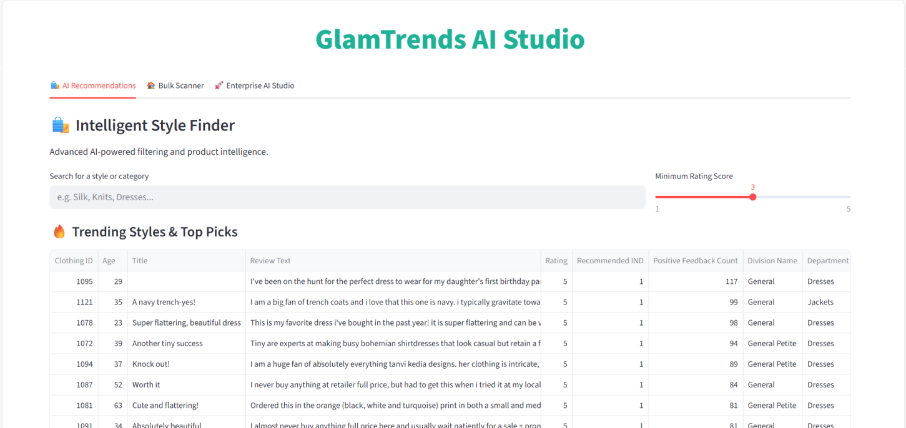
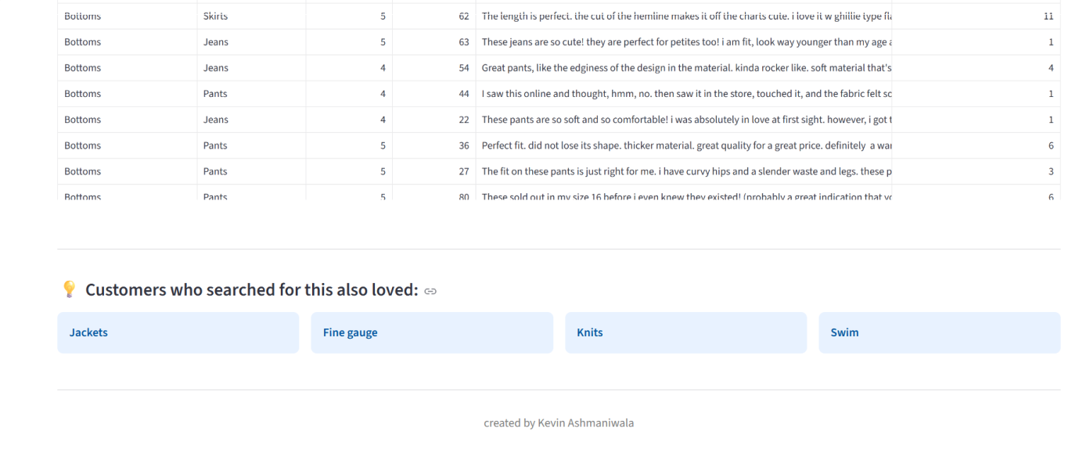

5. Module 2: Bulk Scanner Intelligence

Purpose
To scan uploaded review datasets and detect anomalies using AI.

Supported Inputs
- CSV
- JSON
- SQL Database
- Google Drive CSV

AI Features Implemented

1. Sentiment Analysis
Using:
pipeline("sentiment-analysis", model="distilbert-base-uncased-finetuned-sst-2-english")
The model classifies:
- POSITIVE
- NEGATIVE

2. Trust Score System
Each review starts with:
Trust Score = 100%
Then rules apply:
- Negative sentiment + High rating → Trust ↓
- Positive sentiment + Low rating → Trust ↓
- Low rating + Recommended = 1 → Anomaly
Based on score:
Trust Score | Category
76–100 | 🟢 Safe
51–75 | 🟡 Warning
≤50 | 🔴 High Risk

3. Export Options
- CSV Report
- JSON Report
- SQL Insert Script
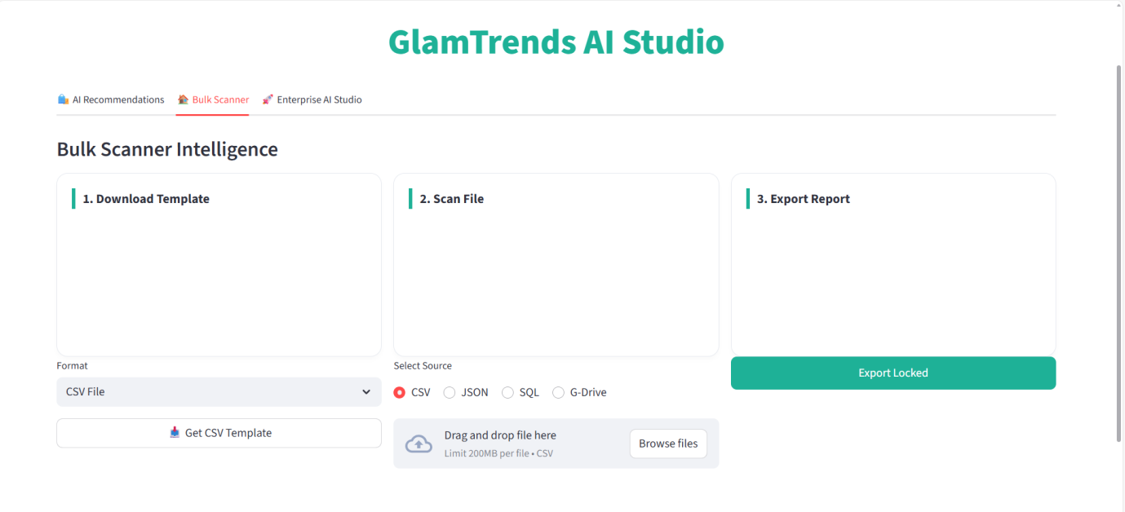
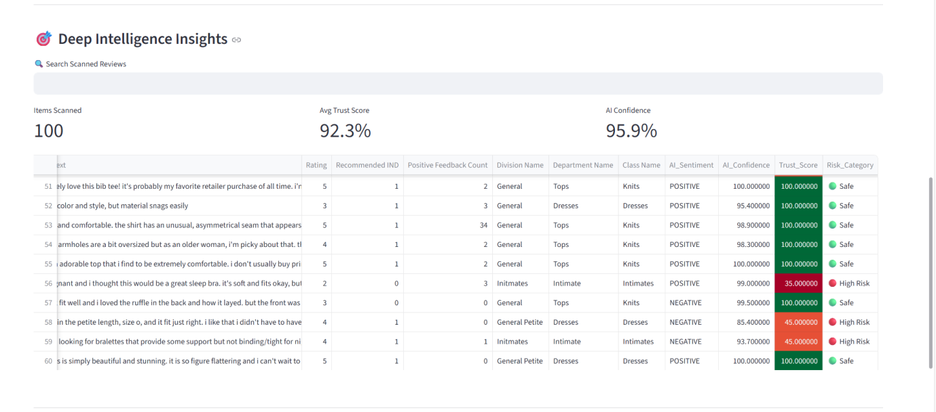

6.Module 3: Enterprise AI Studio
This is the most advanced section.
It contains:

6.1 Data Central
- Data preview
- Search
- Sorting
- Summary statistics

6.2 Visual Analytics
User can dynamically create:
- Scatter Plot
- Bar Chart
- Line Plot
- Box Plot
- Heatmap
Features:
- Custom color picker
- Background customization
- Interactive Plotly charts

6.3 NLP Intelligence

Features:
- Sentiment Pie Chart
- Word Cloud Generator
- Custom Text Sentiment Lab

6.4 ML Modeler

Supported Algorithms:
- XGBoost
- RandomForest

Advanced Features:
- Feature selection
- PCA dimensionality reduction
- Learning rate tuning
- Max depth tuning
- L1 / L2 regularization
- GridSearchCV
- Bayesian Optimization (Optuna)

Output:
- Accuracy score
- Feature importance bar chart
- Model saved as:
final_model.pkl

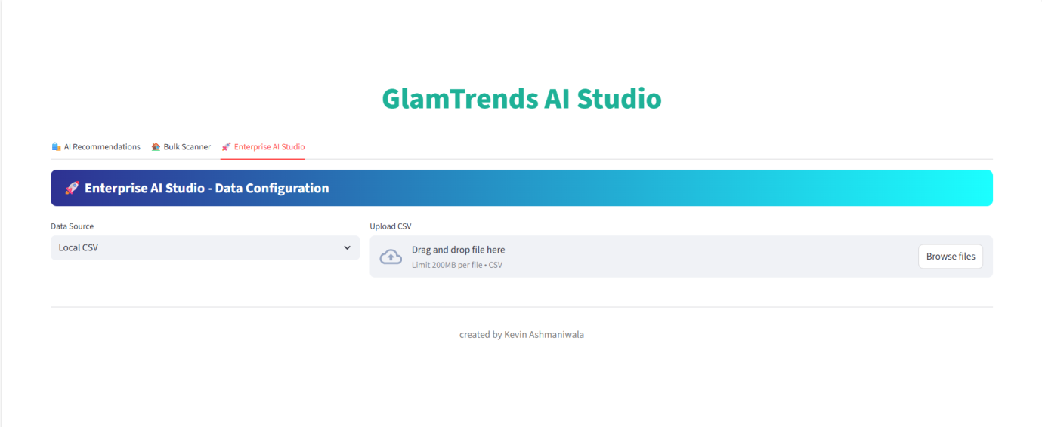
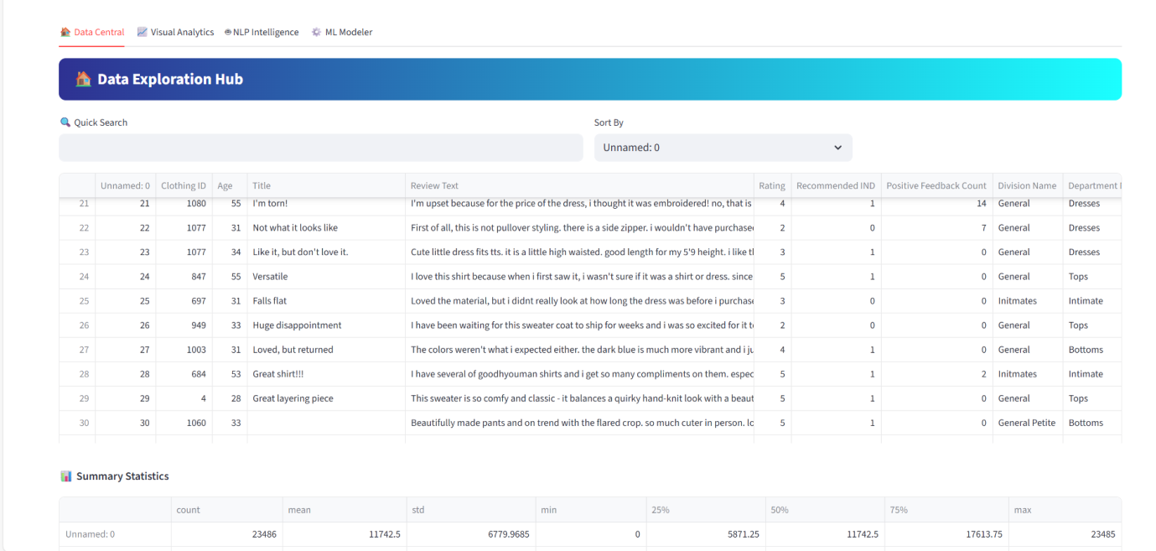

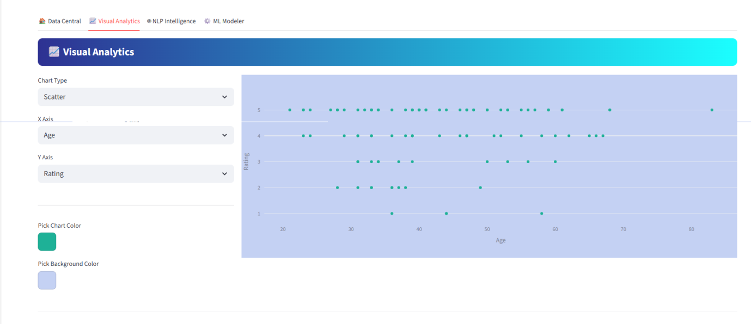

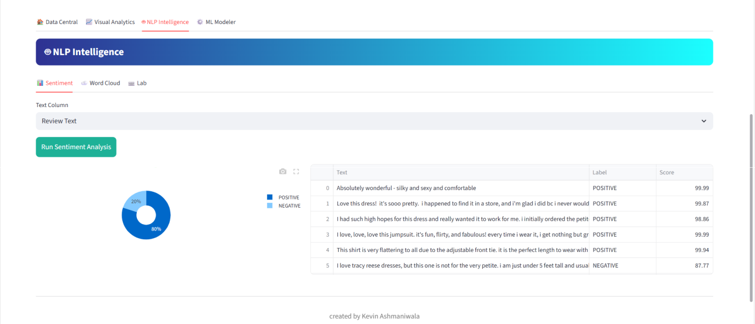

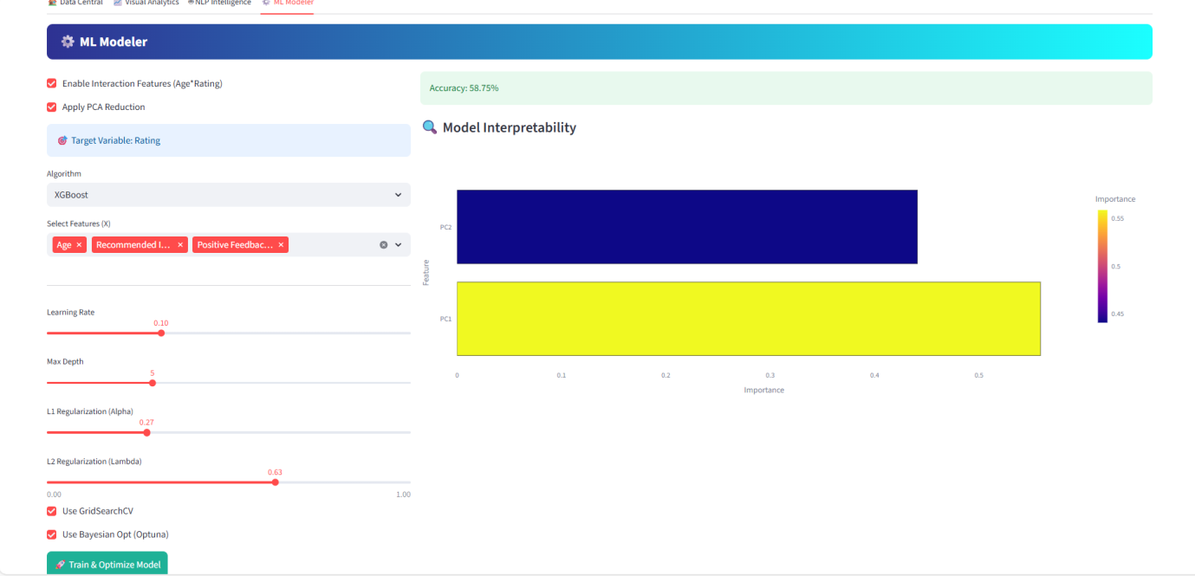

7. Key Features of the Project
✅ AI-powered recommendations
✅ Sentiment analysis engine
✅ Trust scoring system
✅ Fraud / anomaly detection logic
✅ Interactive visualization dashboard
✅ NLP tools
✅ Machine learning model builder
✅ Hyperparameter tuning
✅ Exportable reports

8. Business Impact
This system can help:
- E-commerce platforms detect fake reviews
- Improve product recommendations
- Analyze customer satisfaction
- Identify high-risk feedback
- Build predictive rating models

9.Conclusion
GlamTrends AI Studio is a full-stack AI analytics platform that combines:
- Data analysis
- NLP
- Machine learning
- Business intelligence
- Interactive dashboards
It demonstrates practical implementation of AI techniques in real-world e-commerce scenarios.

