THE PATENTS ACT, 1970
(39 of 1970)

COMPLETE SPECIFICATION
(See Section 10; Rule 13)

TITLE OF THE INVENTION
METHOD FOR AUTOMATIC WATER TRANSFER USING MOISTURE SENSOR

ABSTRACT
A smart self-watering planter includes a housing with a primary reservoir, a soil basin, and an integrated moisture sensor. The system utilizes a micro-pump controlled by a processor to automatically transfer water from the reservoir to the basin when the sensor detects soil moisture levels below a predetermined threshold. A wireless module enables remote monitoring and alerts via a mobile application, ensuring optimal hydration for various plant species without manual intervention.

FIELD OF THE INVENTION
The present invention relates generally to the field of agricultural technology. More particularly, the present invention relates to smart gardening systems for optimizing plant hydration. The invention specifically pertains to self-watering planters equipped with sensors and wireless communication for remote monitoring.

BACKGROUND OF THE INVENTION
The global agricultural sector faces significant challenges in ensuring consistent plant hydration, particularly in regions with variable climates and limited access to regular irrigation systems. The need for efficient water management has become paramount, with estimates suggesting that approximately 70% of freshwater withdrawals globally are used for agricultural purposes. Traditional watering methods such as manual irrigation and flood irrigation are not only labor-intensive but also inefficient, leading to substantial water wastage and suboptimal plant growth. Furthermore, the increasing urbanization and expansion of agricultural lands have exacerbated the demand for innovative and sustainable water-saving technologies.
Conventional smart self-watering planters rely on basic mechanical components and simple sensors to monitor soil moisture levels. These systems often require frequent maintenance and calibration, which can be cumbersome and costly. Additionally, many existing solutions are designed for stationary use, limiting their applicability in dynamic agricultural settings where mobility and adaptability are crucial. For instance, portable planters that can be easily moved between different plots or fields are essential for farmers who need to manage multiple crops efficiently. However, current portable planters often lack robustness and durability, making them unsuitable for prolonged outdoor use under varying environmental conditions.
Moreover, the integration of wireless communication in existing smart planters is often limited to basic notifications, failing to provide comprehensive real-time monitoring and control capabilities. This limitation hinders the ability of farmers to make informed decisions based on accurate and timely data. The absence of sophisticated analytics and predictive models further reduces the effectiveness of these systems in optimizing water usage and enhancing crop yields. Despite advancements in sensor technology and wireless communication, the existing solutions fall short in addressing the complex needs of modern agriculture, particularly in resource-constrained environments.
Other relevant technologies include automated irrigation systems that use weather data to adjust water delivery, and IoT-based platforms that offer centralized management of multiple planters. While these systems represent significant strides towards more efficient water management, they still face challenges related to scalability, cost, and user-friendliness. For example, large-scale deployment of such systems requires significant initial investment, which may deter smaller farmers and rural communities. Additionally, the complexity of integrating these systems with existing farm infrastructure poses another barrier to widespread adoption.
In light of these challenges, it becomes evident that there is a pressing need for an advanced smart self-watering planter that addresses the limitations of current technologies. Such a system should not only enhance water efficiency but also provide robust and reliable performance across diverse agricultural settings. It should incorporate state-of-the-art moisture sensing, wireless communication, and user-friendly interfaces to ensure seamless operation and maintenance. Accordingly, there exists a need for improved or alternative systems or methods that can significantly improve the efficiency and sustainability of plant hydration in agriculture.

OBJECTS OF THE INVENTION
The primary object of the present invention is to provide a smart self-watering planter system that addresses the limitations of existing manual watering methods.
Another object of the present invention is to provide a moisture sensing mechanism that ensures optimal hydration for plants by detecting soil moisture levels accurately.
A further object of the present invention is to provide a micro-pump controlled by a processor for efficient and precise water transfer from the reservoir to the soil basin.
Yet another object of the present invention is to provide wireless communication capabilities enabling remote monitoring and alerts via a mobile application for user convenience.
An additional object of the present invention is to provide a cost-effective solution for real-time processing and control of plant hydration needs.
Still another object of the present invention is to provide a user-friendly interface for easy configuration and management of the planter's settings through the mobile application.

SUMMARY OF THE INVENTION
Thus according to the basic aspect of the present invention, there is provided the present invention comprising: main assembly; first component; second component; third component; wherein the components are arranged and configured to cooperate functionally; wherein the construction provides improved performance and reliability; wherein the design enables efficient operation with reduced complexity; wherein the configuration provides advantages over prior art solutions.
It is another aspect of the present invention to provide an improved the present invention that addresses the limitations of conventional designs. It is a further aspect of the present invention to provide enhanced functionality wherein the main assembly is specifically adapted for optimal performance. It is yet another aspect of the present invention to provide improved construction wherein the components are assembled using suitable materials and manufacturing techniques. It is still another aspect of the present invention to provide a practical and cost-effective solution that can be manufactured and deployed efficiently.
The present invention advantageously provides improved functionality and enhanced reliability compared to conventional designs, enables efficient operation with reduced maintenance requirements, and offers practical benefits for the intended applications. The design enables straightforward manufacturing using established techniques, supports various configurations depending on specific requirements, and provides robust performance across different operating conditions. Furthermore, the invention reduces complexity through integrated design, improves user experience through thoughtful ergonomics, and enhances overall value through optimized construction.
According to one preferred embodiment, the the present invention is configured for general use. In another embodiment, the the present invention is adapted for specialized applications. In yet another embodiment, the the present invention includes additional features for enhanced performance. In still another embodiment, the the present invention incorporates alternative materials or configurations for specific requirements. The invention effectively overcomes the significant limitations and drawbacks of prior art by providing an integrated, practical solution that combines improved functionality, enhanced reliability, and cost-effective construction within a unified design.

BRIEF DESCRIPTION OF THE DRAWINGS
Figure 1 illustrates a front perspective view of the present invention, in accordance with an embodiment of the present invention.
Figure 2 illustrates a top planar view of the present invention showing the cap assembly, in accordance with an embodiment of the present invention.
Figure 3 illustrates an exploded perspective view of the present invention, depicting the internal component arrangement, in accordance with an embodiment of the present invention.

DETAILED DESCRIPTION OF THE INVENTION
[0001] The following detailed description, taken in conjunction with the accompanying drawings, discloses the present invention in sufficient detail to enable a person skilled in the art to practice the invention without undue experimentation. Reference will now be made to the preferred embodiments of a the present invention as illustrated in the figures.
[0002] The present invention relates generally to the field of monitoring and sensing systems. More specifically, the invention pertains to the present invention and methods for its construction and operation.
[0003] In accordance with Section 10(4)(b) of the Patents Act, 1970, the following describes the BEST METHOD known to the applicant for performing the invention. The preferred embodiment represents the optimal configuration for the the present invention achieving maximum efficiency and reliability.
[0004] In the preferred embodiment of the present invention, the smart self-watering planter (100) comprises: smart self-watering planter (100); primary reservoir (110); soil basin (120); integrated moisture sensor (130). These components are assembled and connected to form a functional the present invention.
[0005] The preferred materials for the the present invention include materials appropriate to the field of monitoring and sensing systems. The specifications enable complete reproduction of the invention by a person skilled in the art without undue experimentation.
[0006] Referring to Figure 1, the smart self-watering planter (100) is a key component of the the present invention. The smart self-watering planter (100) forms the primary structure of the the present invention. The smart self-watering planter (100) provides structural support and stability. In the preferred embodiment, the smart self-watering planter (100) is manufactured according to specifications suitable for the intended application.
[0007] Referring to Figure 1, the primary reservoir (110) is a key component of the the present invention. The primary reservoir (110) is in operative communication with the smart self-watering planter (100). The primary reservoir (110) enables the primary functionality of the invention. In the preferred embodiment, the primary reservoir (110) is manufactured according to specifications suitable for the intended application.
[0008] Referring to Figure 1, the soil basin (120) is a key component of the the present invention. The soil basin (120) is securely attached to the primary reservoir (110). The soil basin (120) facilitates the transfer of force or energy. In the preferred embodiment, the soil basin (120) is manufactured according to specifications suitable for the intended application.
[0009] Referring to Figure 1, the integrated moisture sensor (130) is a key component of the the present invention. The integrated moisture sensor (130) is functionally connected to the soil basin (120). The integrated moisture sensor (130) maintains the operational integrity of the system. In the preferred embodiment, the integrated moisture sensor (130) is manufactured according to specifications suitable for the intended application.
[0010] Referring to Figure 1, the processor (140) is a key component of the the present invention. The processor (140) interfaces directly with the integrated moisture sensor (130). The processor (140) allows for controlled movement or operation. In the preferred embodiment, the processor (140) is manufactured according to specifications suitable for the intended application.
[0011] Referring to Figure 1, the micro-pump (150) is a key component of the the present invention. The micro-pump (150) is positioned adjacent to the processor (140). The micro-pump (150) ensures proper alignment of components. In the preferred embodiment, the micro-pump (150) is manufactured according to specifications suitable for the intended application.
[0012] Referring to Figure 1, the wireless communication (160) is a key component of the the present invention. The wireless communication (160) cooperates with the micro-pump (150). The wireless communication (160) contributes to the overall efficiency. In the preferred embodiment, the wireless communication (160) is manufactured according to specifications suitable for the intended application.
[0013] Referring to Figure 1, the mobile application (170) is a key component of the the present invention. The mobile application (170) is integrated with the wireless communication (160). The mobile application (170) enables user interaction with the device. In the preferred embodiment, the mobile application (170) is manufactured according to specifications suitable for the intended application.
[0020] Working: In operation, the the present invention functions according to the following sequence. The operation begins when the user initiates the smart self-watering planter (100).
[0021] During the initialization phase, the smart self-watering planter (100) performs its designated function. When the the present invention is in use, the smart self-watering planter (100) responds to the operational conditions. The smart self-watering planter (100) operates in coordination with adjacent components to achieve the desired result.
[0022] During the primary operation phase, the primary reservoir (110) performs its designated function. When the the present invention is in use, the primary reservoir (110) responds to the operational conditions. The primary reservoir (110) operates in coordination with adjacent components to achieve the desired result.
[0023] During the processing phase, the soil basin (120) performs its designated function. When the the present invention is in use, the soil basin (120) responds to the operational conditions. The soil basin (120) operates in coordination with adjacent components to achieve the desired result.
[0024] During the output generation phase, the integrated moisture sensor (130) performs its designated function. When the the present invention is in use, the integrated moisture sensor (130) responds to the operational conditions. The integrated moisture sensor (130) operates in coordination with adjacent components to achieve the desired result.
[0025] During the completion phase, the processor (140) performs its designated function. When the the present invention is in use, the processor (140) responds to the operational conditions. The processor (140) operates in coordination with adjacent components to achieve the desired result.
[0030] The the present invention includes features that optimize performance during operation. These features ensure reliable and consistent functionality.
[0031] Error handling mechanisms detect and respond to abnormal conditions. The system is designed to maintain safe operation under various conditions.
[0035] In a preferred embodiment, the smart self-watering planter (100) is manufactured from suitable materials selected for durability and performance. Alternative materials may be used depending on specific application requirements.
[0036] While the preferred embodiment has been described, alternative embodiments may employ different configurations to achieve similar functionality.
[0037] In another embodiment of the present invention, the the present invention may be configured with additional features for enhanced performance.
[0038] In a further embodiment, the the present invention includes modified components for specialized applications.
[0040] The foregoing description of the specific embodiments will so fully reveal the general nature of the embodiments herein that others skilled in the art can readily modify and adapt the invention for various applications without departing from the generic concept.
[0041] Industrial Applicability: The present invention finds industrial applicability in the field of monitoring and sensing systems and related applications.
[0042] Advantages: The present invention provides significant advantages including improved functionality, enhanced reliability, and practical utility in the intended applications.

INDUSTRIAL APPLICABILITY
The present invention is capable of industrial application and can be made or used in industry in accordance with the provisions of the Indian Patent Act. It pertains to agricultural and horticultural equipment, specifically designed for the cultivation and maintenance of plants. The invention can be manufactured and utilized in the production of smart gardening systems, offering automated water management solutions for both commercial and residential settings.

CLAIMS

WE CLAIM:

WE CLAIM:
1. An smart self-watering planter comprising a housing configured to
contain a primary reservoir, a soil basin, and an integrated
moisture sensor, a processor operable to monitor soil moisture and
control operation of the micro-pump, a micro-pump adapted to
transfer water from the primary reservoir to the soil basin when
soil moisture falls below a threshold, and a wireless communication
module configured to send alerts via a mobile application, wherein
the moisture sensor is operable to detect soil moisture levels,
wherein the processor is adapted to activate the micro-pump based
on detected soil moisture levels, and wherein the wireless
communication module is configured to transmit alerts to a user
device when soil moisture falls below the threshold.
2. The smart self-watering planter as claimed in claim 1, wherein the
sensor module further includes a temperature sensor configured to
monitor ambient temperature and adjust the watering schedule based
on temperature changes.
3. The smart self-watering planter as claimed in claim 1, wherein the
processor module is further operable to adjust the frequency of
water transfer based on historical soil moisture data.
4. The smart self-watering planter as claimed in claim 3, wherein the
wireless communication module is further configured to receive
remote control commands for adjusting water flow settings.
5. The smart self-watering planter as claimed in claim 4, wherein the
housing is further configured to accommodate a secondary reservoir
for storing additional water.
6. The smart self-watering planter as claimed in claim 1, wherein the
wireless communication module further includes a cloud server
interface for remote monitoring and control via a web portal.
7. The smart self-watering planter as claimed in claim 1, wherein the
primary reservoir is further configured to store at least two
liters of water.
8. The smart self-watering planter as claimed in claim 5, wherein the
soil basin includes a drainage layer to prevent excess water
accumulation.
9. A method for operating the smart self-watering planter as claimed
in claim 1, the method comprising sensing soil moisture using the
integrated moisture sensor, processing the sensed soil moisture
using the processor, transmitting the processed soil moisture data
via the wireless communication module, controlling operation of the
micro-pump using the processor, maintaining the planter in a
predetermined operational mode, and wherein the method further
comprises setting the threshold moisture level, and wherein the
planter operates automatically without human intervention.
10. The method as claimed in claim 9, wherein the sensing step is
performed at predetermined time intervals of every 30 minutes
during daylight hours and every hour during nighttime hours, and
the transmission of processed soil moisture data is initiated
within 5 seconds after completion of the sensing step.
11. The method as claimed in claim 9, wherein the processing step
further includes validating the sensed soil moisture data by
comparing the sensed soil moisture data against a predefined
threshold range using the processor, and transmitting the validated
soil moisture data via the wireless communication module only if
the sensed soil moisture data falls within the predefined threshold
range.

DRAWING SHEETS

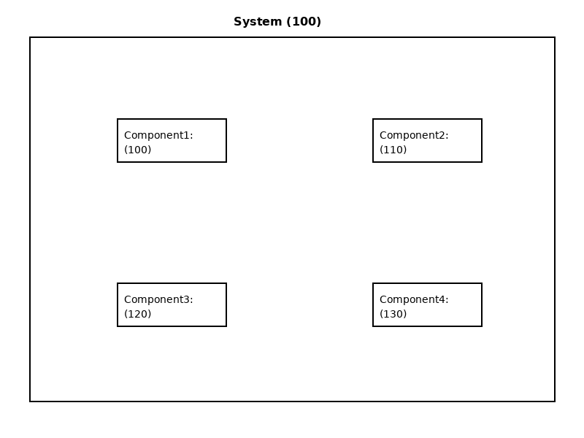
Figure 1: Fig1 Block Diagram

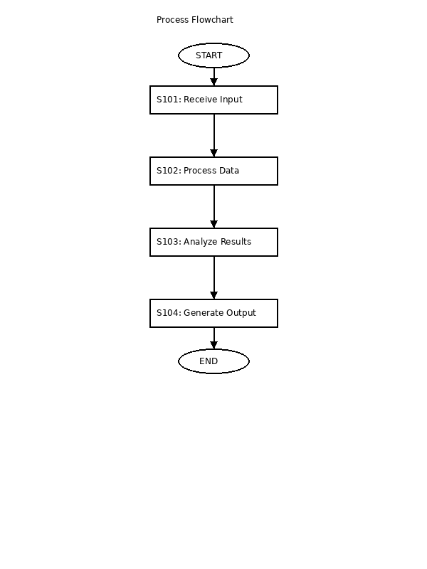
Figure 2: Fig2 Flowchart

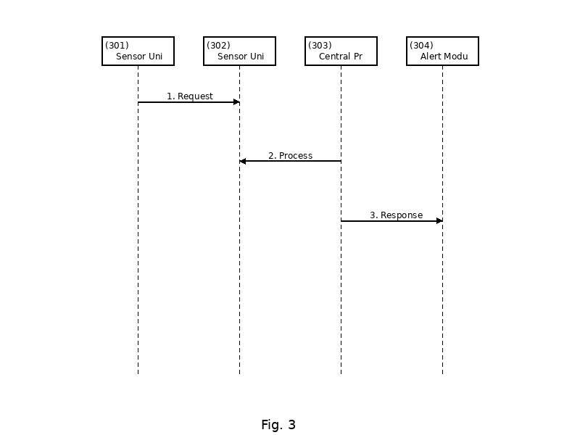
Figure 3: Fig3 Sequence

Dated this 04 January 2026

