THE PATENTS ACT, 1970
(39 of 1970)

COMPLETE SPECIFICATION
(See Section 10; Rule 13)

TITLE OF THE INVENTION
A SMART INDUSTRIAL MONITORING SYSTEM
Applicant: Test Applicant
Inventor: Test Inventor

ABSTRACT
The present invention relates to a smart monitoring system for industrial environments comprising sensor units (101), a central processing hub (102), and an alert module (103) for real-time anomaly detection and notification.

FIELD OF THE INVENTION
The present invention relates to the field of industrial automation and monitoring systems, more particularly to an intelligent system for real-time monitoring and anomaly detection in industrial environments.

BACKGROUND OF THE INVENTION
Conventional industrial monitoring systems rely on manual inspection and basic sensor readings. These systems lack intelligent analysis capabilities and fail to provide real-time anomaly detection. There exists a need for an automated, intelligent monitoring solution that can process sensor data in real-time and generate immediate alerts.

OBJECTS OF THE INVENTION
The primary object of the present invention is to provide an intelligent industrial monitoring system.
Another object is to provide real-time anomaly detection capabilities.
Yet another object is to minimize industrial accidents through predictive maintenance.

SUMMARY OF THE INVENTION
According to one aspect of the invention, there is provided a smart industrial monitoring system comprising: a plurality of sensor units (101) configured to collect environmental data; a central processing hub (102) connected to said sensor units; and an alert module (103) for generating notifications.

BRIEF DESCRIPTION OF THE DRAWINGS
Figure 1 shows a block diagram of the smart monitoring system (100) according to the present invention.
Figure 2 shows a flowchart illustrating the method of operation.
Figure 3 shows a sequence diagram of component interactions.

DETAILED DESCRIPTION OF THE INVENTION
Referring now to Figure 1, the smart industrial monitoring system (100) comprises a sensor unit (101), a processing hub (102), and an alert module (103). The sensor unit (101) includes temperature sensors, pressure sensors, and vibration sensors. The processing hub (102) receives data from the sensor unit (101) and performs intelligent analysis. The alert module (103) generates notifications when anomalies are detected.

INDUSTRIAL APPLICABILITY
The present invention finds application in various industries including manufacturing, oil and gas, chemical processing, and power generation. The system enables predictive maintenance and reduces downtime.

CLAIMS

WE CLAIM:

1. A smart industrial monitoring system comprising:
a plurality of sensor units (101);
a central processing hub (102) connected to said sensor units; and
an alert module (103).
2. The system as claimed in claim 1, wherein the sensor units include temperature, pressure, and vibration sensors.
3. The system as claimed in claim 1, wherein the processing hub performs real-time anomaly detection.
4. A method for industrial monitoring comprising:
collecting sensor data;
analyzing said data; and
generating alerts.

DRAWING SHEETS

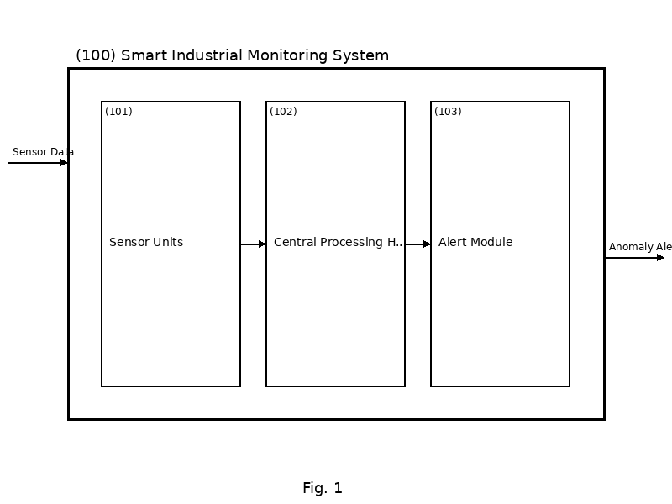
Figure 1: Fig1 Block Diagram

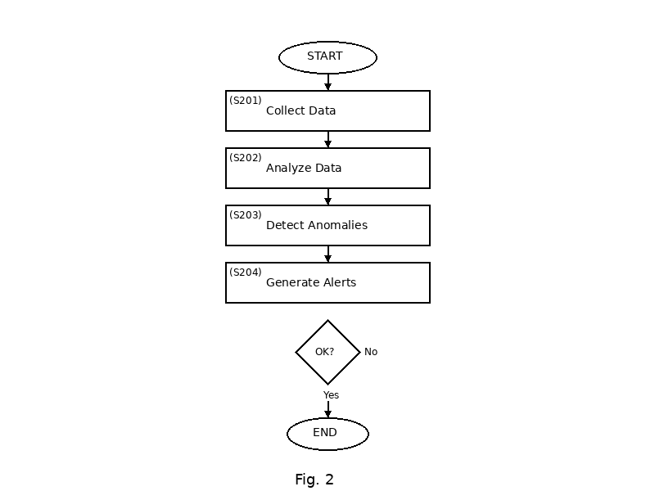
Figure 2: Fig2 Flowchart

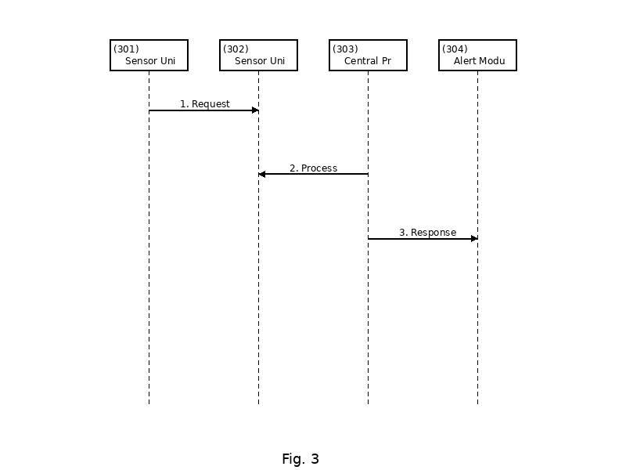
Figure 3: Fig3 Sequence

Dated this 28 December 2025
Signature: _______________________
Applicant: Test Applicant

