stats3 project
Kevin Chen
2025-09-12
1 Here I loaded in my dataset.
mydata <- read.csv("Grad_Admission.csv")[, -1]
2 Printed the first 10 entries.
head(mydata, 10)
## GRE TOEFL Urate SOP LOR CGPA Chance
## 1 337 118 4 4.5 4.5 3.86 92
## 2 324 107 4 4.0 4.5 3.55 76
## 3 316 104 3 3.0 3.5 3.20 72
## 4 322 110 3 3.5 2.5 3.47 80
## 5 314 103 2 2.0 3.0 3.28 65
## 6 330 115 5 4.5 3.0 3.74 90
## 7 321 109 3 3.0 4.0 3.28 75
## 8 308 101 2 3.0 4.0 3.16 68
## 9 302 102 1 2.0 1.5 3.20 50
## 10 323 108 3 3.5 3.0 3.44 45
3 Printing a table of the min/1st quartile/median/mean/3rd quartile/max of GRE, Urate, and GPA.
vars <- mydata[, c("GRE", "Urate", "CGPA")]
summary_table <- data.frame(
Min = apply(vars, 2, min),
Q1 = apply(vars, 2, quantile, 0.25),
Median = apply(vars, 2, median),
Mean = apply(vars, 2, mean),
Q3 = apply(vars, 2, quantile, 0.75),
Max = apply(vars, 2, max)
)
summary_table
## Min Q1 Median Mean Q3 Max
## GRE 290.00 308.00 317.000 316.807500 325.0000 340.00
## Urate 1.00 2.00 3.000 3.087500 4.0000 5.00
## CGPA 2.72 3.27 3.445 3.439525 3.6225 3.97
4 Here’s a histogram for Chance, CGPA, GRE, and TOEFL
hist(mydata$Chance, main="Histogram of Chance", xlab="Chance", col="blue", border="black")
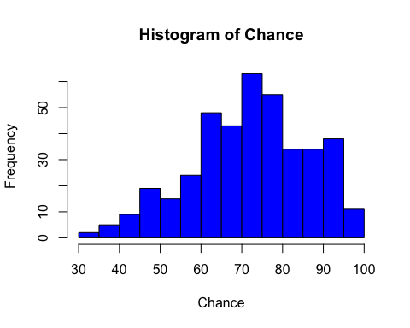
hist(mydata$CGPA, main="Histogram of CGPA", xlab="CGPA", col="green", border="black")
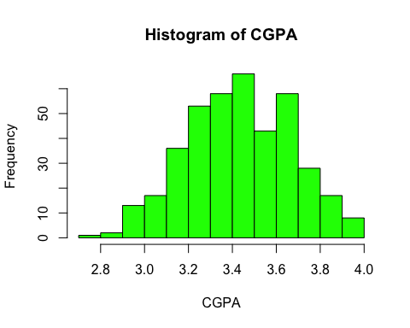
hist(mydata$GRE, main="Histogram of GRE", xlab="GRE", col="red", border="black")
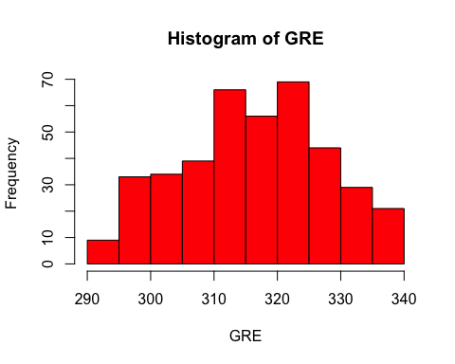
hist(mydata$TOEFL, main="Histogram of TOEFL", xlab="TOEFL", col="yellow", border="black")
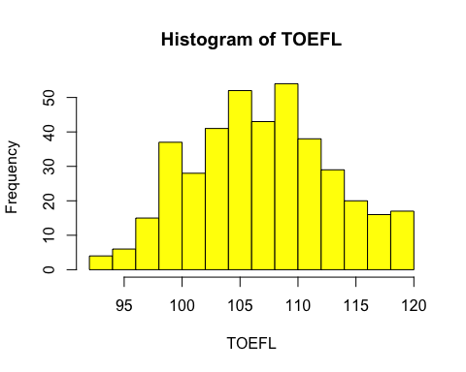 The distribution for chance is left-skewed toward higher values, so this is not normally distributed. The rest of the distributions are more normal. The students in the dataset seems like they are already stronger candidates with higher stats (higher achieving scores/gpa), so this may have caused the chance distribution to be left-skewed.
5 Scatter plots
# GRE vs Chance
plot(mydata$GRE, mydata$Chance, main="Chance vs GRE",
xlab="GRE", ylab="Chance", col="blue", pch=16)
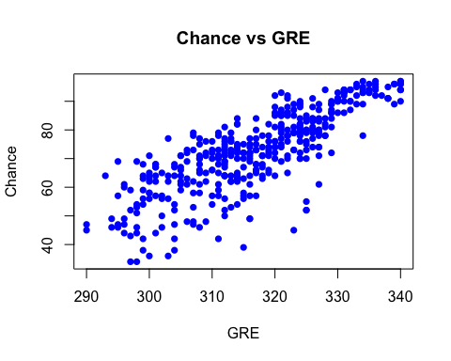
# TOEFL vs Chance
plot(mydata$TOEFL, mydata$Chance, main="Chance vs TOEFL",
xlab="TOEFL", ylab="Chance", col="green", pch=16)
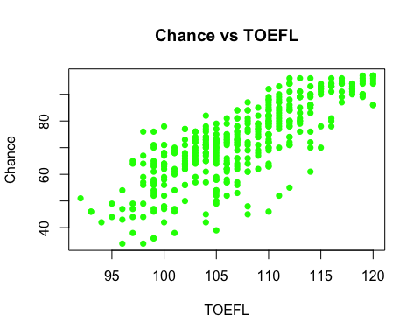
# University Rating vs Chance
plot(mydata$Urate, mydata$Chance, main="Chance vs University Rating",
xlab="University Rating", ylab="Chance", col="red", pch=16)
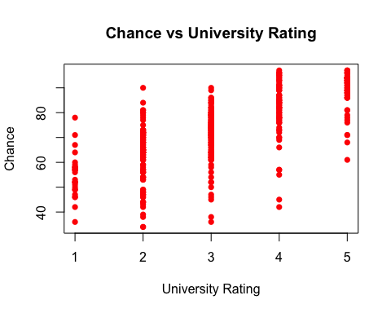
# SOP vs Chance
plot(mydata$SOP, mydata$Chance, main="Chance vs SOP",
xlab="SOP", ylab="Chance", col="purple", pch=16)
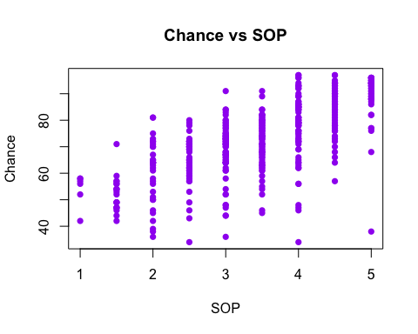
# LOR vs Chance
plot(mydata$LOR, mydata$Chance, main="Chance vs LOR",
xlab="LOR", ylab="Chance", col="orange", pch=16)
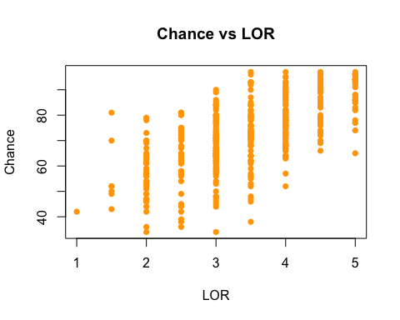
# CGPA vs Chance
plot(mydata$CGPA, mydata$Chance, main="Chance vs CGPA",
xlab="CGPA", ylab="Chance", col="brown", pch=16)
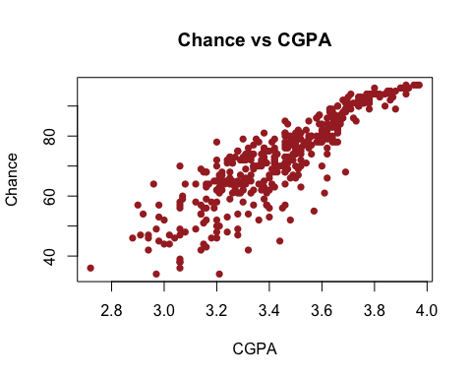 6 Initially from looking at the scatterplots generated, there seems to be a relationship with every variable, especially GRE, TOEFL, and CGPA. Those 3 seems linear enough to be included in a regression model.
7 The relationship between the independent variables and the response variable should be linear, so this assumption of linearity is reasonable. Since each record represents a different student, it is reasonable to infer that observations are independent. We cannot confirm the validity of Homoscedasticity yet without fitting the model first, but the scatter plots do not show any extreme variability changes, so this assumption is likely acceptable. We also cannot check the normality of the residuals yet, but since chance is is fairly continuous and smooth, we expect it to hold. The check for no multicollinearity also cannot be verified yet but the 3 highly correlated variables measures different academic aspects, so high multicollinearity not expected.
8 The 3 best independent variables seems to be GRE, TOEFL, and CGPA
$$Chance=β_{0}+β_{1}\left(GRE\right)+β_{2}\left(TOEFL\right)+β_{3}\left(CGPA\right)+ε$$
9
cor(mydata$Chance, mydata[, c("GRE", "TOEFL", "Urate", "SOP", "LOR", "CGPA")])
## GRE TOEFL Urate SOP LOR CGPA
## [1,] 0.8026105 0.791594 0.7112503 0.6757319 0.6698888 0.8733827
From these correlation coefficients, it is confirmed that the GRE, TOEFL, and CGPA has the highest correlation with the chance response variable. But they all seem to have some positive correlation
10 For each independent variable, we test:
$$H_{0}:ρ=0 \text{(no linear relationship)}$$
$$H_{a}:ρ≠0 \text{(a linear relationship exists)}$$
# Test correlations between Chance and each independent variable
cor.test(mydata$GRE, mydata$Chance)
##
## Pearson's product-moment correlation
##
## data: mydata$GRE and mydata$Chance
## t = 26.843, df = 398, p-value < 2.2e-16
## alternative hypothesis: true correlation is not equal to 0
## 95 percent confidence interval:
## 0.7647419 0.8349536
## sample estimates:
## cor
## 0.8026105
cor.test(mydata$TOEFL, mydata$Chance)
##
## Pearson's product-moment correlation
##
## data: mydata$TOEFL and mydata$Chance
## t = 25.845, df = 398, p-value < 2.2e-16
## alternative hypothesis: true correlation is not equal to 0
## 95 percent confidence interval:
## 0.7519028 0.8255675
## sample estimates:
## cor
## 0.791594
cor.test(mydata$Urate, mydata$Chance)
##
## Pearson's product-moment correlation
##
## data: mydata$Urate and mydata$Chance
## t = 20.186, df = 398, p-value < 2.2e-16
## alternative hypothesis: true correlation is not equal to 0
## 95 percent confidence interval:
## 0.6591685 0.7565413
## sample estimates:
## cor
## 0.7112503
cor.test(mydata$SOP, mydata$Chance)
##
## Pearson's product-moment correlation
##
## data: mydata$SOP and mydata$Chance
## t = 18.288, df = 398, p-value < 2.2e-16
## alternative hypothesis: true correlation is not equal to 0
## 95 percent confidence interval:
## 0.6186712 0.7257010
## sample estimates:
## cor
## 0.6757319
cor.test(mydata$LOR, mydata$Chance)
##
## Pearson's product-moment correlation
##
## data: mydata$LOR and mydata$Chance
## t = 18, df = 398, p-value < 2.2e-16
## alternative hypothesis: true correlation is not equal to 0
## 95 percent confidence interval:
## 0.6120380 0.7206083
## sample estimates:
## cor
## 0.6698888
cor.test(mydata$CGPA, mydata$Chance)
##
## Pearson's product-moment correlation
##
## data: mydata$CGPA and mydata$Chance
## t = 35.776, df = 398, p-value < 2.2e-16
## alternative hypothesis: true correlation is not equal to 0
## 95 percent confidence interval:
## 0.8479462 0.8948062
## sample estimates:
## cor
## 0.8733827
11
# GRE
model_GRE <- lm(Chance ~ GRE, data = mydata)
summary(model_GRE)
##
## Call:
## lm(formula = Chance ~ GRE, data = mydata)
##
## Residuals:
## Min 1Q Median 3Q Max
## -33.613 -4.604 0.408 5.644 18.339
##
## Coefficients:
## Estimate Std. Error t value Pr(>|t|)
## (Intercept) -243.60842 11.78141 -20.68 <2e-16 ***
## GRE 0.99759 0.03716 26.84 <2e-16 ***
## ---
## Signif. codes: 0 '***' 0.001 '**' 0.01 '*' 0.05 '.' 0.1 ' ' 1
##
## Residual standard error: 8.517 on 398 degrees of freedom
## Multiple R-squared: 0.6442, Adjusted R-squared: 0.6433
## F-statistic: 720.6 on 1 and 398 DF, p-value: < 2.2e-16
# TOEFL
model_TOEFL <- lm(Chance ~ TOEFL, data = mydata)
summary(model_TOEFL)
##
## Call:
## lm(formula = Chance ~ TOEFL, data = mydata)
##
## Residuals:
## Min 1Q Median 3Q Max
## -31.252 -5.128 1.328 5.453 21.067
##
## Coefficients:
## Estimate Std. Error t value Pr(>|t|)
## (Intercept) -127.34005 7.74217 -16.45 <2e-16 ***
## TOEFL 1.85993 0.07197 25.84 <2e-16 ***
## ---
## Signif. codes: 0 '***' 0.001 '**' 0.01 '*' 0.05 '.' 0.1 ' ' 1
##
## Residual standard error: 8.725 on 398 degrees of freedom
## Multiple R-squared: 0.6266, Adjusted R-squared: 0.6257
## F-statistic: 667.9 on 1 and 398 DF, p-value: < 2.2e-16
# University Rating
model_Urate <- lm(Chance ~ Urate, data = mydata)
summary(model_Urate)
##
## Call:
## lm(formula = Chance ~ Urate, data = mydata)
##
## Residuals:
## Min 1Q Median 3Q Max
## -38.527 -4.560 1.473 6.341 27.209
##
## Coefficients:
## Estimate Std. Error t value Pr(>|t|)
## (Intercept) 45.0537 1.4463 31.15 <2e-16 ***
## Urate 8.8684 0.4393 20.19 <2e-16 ***
## ---
## Signif. codes: 0 '***' 0.001 '**' 0.01 '*' 0.05 '.' 0.1 ' ' 1
##
## Residual standard error: 10.04 on 398 degrees of freedom
## Multiple R-squared: 0.5059, Adjusted R-squared: 0.5046
## F-statistic: 407.5 on 1 and 398 DF, p-value: < 2.2e-16
# SOP
model_SOP <- lm(Chance ~ SOP, data = mydata)
summary(model_SOP)
##
## Call:
## lm(formula = Chance ~ SOP, data = mydata)
##
## Residuals:
## Min 1Q Median 3Q Max
## -49.748 -5.392 1.823 7.037 22.393
##
## Coefficients:
## Estimate Std. Error t value Pr(>|t|)
## (Intercept) 39.8942 1.8556 21.50 <2e-16 ***
## SOP 9.5708 0.5233 18.29 <2e-16 ***
## ---
## Signif. codes: 0 '***' 0.001 '**' 0.01 '*' 0.05 '.' 0.1 ' ' 1
##
## Residual standard error: 10.53 on 398 degrees of freedom
## Multiple R-squared: 0.4566, Adjusted R-squared: 0.4552
## F-statistic: 334.4 on 1 and 398 DF, p-value: < 2.2e-16
# LOR
model_LOR <- lm(Chance ~ LOR, data = mydata)
summary(model_LOR)
##
## Call:
## lm(formula = Chance ~ LOR, data = mydata)
##
## Residuals:
## Min 1Q Median 3Q Max
## -34.940 -6.256 0.060 7.389 29.325
##
## Coefficients:
## Estimate Std. Error t value Pr(>|t|)
## (Intercept) 35.7256 2.1072 16.95 <2e-16 ***
## LOR 10.6327 0.5907 18.00 <2e-16 ***
## ---
## Signif. codes: 0 '***' 0.001 '**' 0.01 '*' 0.05 '.' 0.1 ' ' 1
##
## Residual standard error: 10.6 on 398 degrees of freedom
## Multiple R-squared: 0.4488, Adjusted R-squared: 0.4474
## F-statistic: 324 on 1 and 398 DF, p-value: < 2.2e-16
# CGPA
model_CGPA <- lm(Chance ~ CGPA, data = mydata)
summary(model_CGPA)
##
## Call:
## lm(formula = Chance ~ CGPA, data = mydata)
##
## Residuals:
## Min 1Q Median 3Q Max
## -27.4598 -2.9585 0.9733 4.1799 18.0757
##
## Coefficients:
## Estimate Std. Error t value Pr(>|t|)
## (Intercept) -107.215 5.034 -21.30 <2e-16 ***
## CGPA 52.231 1.460 35.78 <2e-16 ***
## ---
## Signif. codes: 0 '***' 0.001 '**' 0.01 '*' 0.05 '.' 0.1 ' ' 1
##
## Residual standard error: 6.954 on 398 degrees of freedom
## Multiple R-squared: 0.7628, Adjusted R-squared: 0.7622
## F-statistic: 1280 on 1 and 398 DF, p-value: < 2.2e-16
All of the p-values are significantly less than 0.05 so each variable significantly predicts chance.
12 CGPA and GRE had the highest R-square value
model_CGPA <- lm(Chance ~ CGPA, data = mydata)
model_GRE <- lm(Chance ~ GRE, data = mydata)
# Display ANOVA tables
anova(model_CGPA)
## Analysis of Variance Table
##
## Response: Chance
## Df Sum Sq Mean Sq F value Pr(>F)
## CGPA 1 61898 61898 1279.9 < 2.2e-16 ***
## Residuals 398 19248 48
## ---
## Signif. codes: 0 '***' 0.001 '**' 0.01 '*' 0.05 '.' 0.1 ' ' 1
anova(model_GRE)
## Analysis of Variance Table
##
## Response: Chance
## Df Sum Sq Mean Sq F value Pr(>F)
## GRE 1 52273 52273 720.55 < 2.2e-16 ***
## Residuals 398 28873 73
## ---
## Signif. codes: 0 '***' 0.001 '**' 0.01 '*' 0.05 '.' 0.1 ' ' 1
# For reference, view R-squared values
summary(model_CGPA)$r.squared
## [1] 0.7627973
summary(model_GRE)$r.squared
## [1] 0.6441835
From the ANOVA tables, both GRE and CGPA have significant effects on Chance of Admission.
However, CGPA produces a higher F-statistic and larger R-square, indicating it explains more of the variation in admission chances than GRE.
Therefore, CGPA is the best single predictor among all independent variables.
13
full_model <- lm(Chance ~ GRE + TOEFL + Urate + SOP + LOR + CGPA, data = mydata)
# Show model summary
summary(full_model)
##
## Call:
## lm(formula = Chance ~ GRE + TOEFL + Urate + SOP + LOR + CGPA,
## data = mydata)
##
## Residuals:
## Min 1Q Median 3Q Max
## -27.9145 -2.3808 0.9351 3.5774 16.0571
##
## Coefficients:
## Estimate Std. Error t value Pr(>|t|)
## (Intercept) -141.4185 11.5420 -12.252 < 2e-16 ***
## GRE 0.2270 0.0578 3.928 0.000101 ***
## TOEFL 0.2762 0.1099 2.512 0.012398 *
## Urate 0.5995 0.4821 1.244 0.214367
## SOP -0.2000 0.5604 -0.357 0.721336
## LOR 2.2784 0.5598 4.070 5.68e-05 ***
## CGPA 30.0138 3.0886 9.718 < 2e-16 ***
## ---
## Signif. codes: 0 '***' 0.001 '**' 0.01 '*' 0.05 '.' 0.1 ' ' 1
##
## Residual standard error: 6.446 on 393 degrees of freedom
## Multiple R-squared: 0.7988, Adjusted R-squared: 0.7957
## F-statistic: 260 on 6 and 393 DF, p-value: < 2.2e-16
The Urate and the SOP are not significant at 0.05
14
reduced_model <- lm(Chance ~ GRE + TOEFL + LOR + CGPA, data = mydata)
# View summary and ANOVA comparison
summary(reduced_model)
##
## Call:
## lm(formula = Chance ~ GRE + TOEFL + LOR + CGPA, data = mydata)
##
## Residuals:
## Min 1Q Median 3Q Max
## -27.9694 -2.2884 0.9324 3.6508 16.1704
##
## Coefficients:
## Estimate Std. Error t value Pr(>|t|)
## (Intercept) -146.25106 10.57306 -13.832 < 2e-16 ***
## GRE 0.23112 0.05762 4.011 7.23e-05 ***
## TOEFL 0.29291 0.10756 2.723 0.00675 **
## LOR 2.39604 0.48392 4.951 1.09e-06 ***
## CGPA 30.74029 2.96215 10.378 < 2e-16 ***
## ---
## Signif. codes: 0 '***' 0.001 '**' 0.01 '*' 0.05 '.' 0.1 ' ' 1
##
## Residual standard error: 6.442 on 395 degrees of freedom
## Multiple R-squared: 0.798, Adjusted R-squared: 0.7959
## F-statistic: 390.1 on 4 and 395 DF, p-value: < 2.2e-16
anova(reduced_model)
## Analysis of Variance Table
##
## Response: Chance
## Df Sum Sq Mean Sq F value Pr(>F)
## GRE 1 52273 52273 1259.606 < 2.2e-16 ***
## TOEFL 1 3921 3921 94.486 < 2.2e-16 ***
## LOR 1 4090 4090 98.565 < 2.2e-16 ***
## CGPA 1 4469 4469 107.696 < 2.2e-16 ***
## Residuals 395 16392 41
## ---
## Signif. codes: 0 '***' 0.001 '**' 0.01 '*' 0.05 '.' 0.1 ' ' 1
anova(full_model, reduced_model)
## Analysis of Variance Table
##
## Model 1: Chance ~ GRE + TOEFL + Urate + SOP + LOR + CGPA
## Model 2: Chance ~ GRE + TOEFL + LOR + CGPA
## Res.Df RSS Df Sum of Sq F Pr(>F)
## 1 393 16328
## 2 395 16392 -2 -64.288 0.7737 0.462
Observations: Now all variables are significant, the r-square remained about the same 80%. Now the model is simpler and efficient.
15
# Use the reduced model from Step 14
reduced_model <- lm(Chance ~ GRE + TOEFL + LOR + CGPA, data = mydata)
# Create predictions with both confidence and prediction intervals
predictions <- predict(
reduced_model,
newdata = mydata,
interval = "confidence",
level = 0.95
)
predictions_pred <- predict(
reduced_model,
newdata = mydata,
interval = "prediction",
level = 0.95
)
# Combine both results into one table for clarity
results <- cbind(mydata,
fit = predictions[, "fit"],
conf_low = predictions[, "lwr"],
conf_high = predictions[, "upr"],
pred_low = predictions_pred[, "lwr"],
pred_high = predictions_pred[, "upr"])
# Print first 10 rows
head(results, 10)
## GRE TOEFL Urate SOP LOR CGPA Chance fit conf_low conf_high pred_low
## 1 337 118 4 4.5 4.5 3.86 92 95.63917 94.29855 96.97979 82.90349
## 2 324 107 4 4.0 4.5 3.55 76 79.88311 78.59288 81.17335 67.15263
## 3 316 104 3 3.0 3.5 3.20 72 64.00029 62.59078 65.40979 51.25717
## 4 322 110 3 3.5 2.5 3.47 80 73.04831 71.79269 74.30392 60.32129
## 5 314 103 2 2.0 3.0 3.28 65 64.50634 63.56794 65.44474 51.80669
## 6 330 115 5 4.5 3.0 3.74 90 85.85971 84.29827 87.42115 73.09889
## 7 321 109 3 3.0 4.0 3.28 75 70.27768 68.62735 71.92801 57.50568
## 8 308 101 2 3.0 4.0 3.16 68 61.24101 59.65670 62.82532 48.47737
## 9 302 102 1 2.0 1.5 3.20 50 55.38672 53.71857 57.05487 42.61241
## 10 323 108 3 3.5 3.0 3.44 45 72.96941 71.96779 73.97104 60.26494
## pred_high
## 1 108.37486
## 2 92.61359
## 3 76.74341
## 4 85.77532
## 5 77.20599
## 6 98.62053
## 7 83.04968
## 8 74.00465
## 9 68.16104
## 10 85.67389
16
$$\text{Chance}=−146.25+0.2311\left(\text{GRE}\right)+0.2929\left(\text{TOEFL}\right)+2.3960\left(\text{LOR}\right)+30.7403\left(\text{CGPA}\right)$$
The intercept does not have a practical meaning but it is where the regression line starts from the y intercept. Each slope means for each 1 point of the variable, the chance of admission increases by a certain amount of points on the slope for each variable.
17 This project demonstrates how descriptive statistics and regression analysis provide a structured and evidence-based approach to understanding complex datasets. Descriptive measures offer initial insights, while regression modeling verifies those insights quantitatively and enables prediction. I would recommend future analyses should combine both methods, beginning with exploratory data summaries and progressing to validated regression models, to ensure results are both interpretable and reasonable.
write.csv(predictions, "confidence_intervals.csv", row.names = FALSE)
write.csv(predictions_pred, "prediction_intervals.csv", row.names = FALSE)

