Housing Price Prediction
Kevin Chen
2025-10-30
Abstract This study examines the factors influencing housing prices using a dataset from Kaggle that includes attributes such as property size, number of bedrooms, bathrooms, year built, and neighborhood. A multiple linear regression model is built in R to identify which features are statistically significant predictors of sale price. Preliminary findings suggest that larger properties and newer homes tend to sell for higher prices. This analysis highlights how regression modeling can be applied to estimate real estate values and interpret market behavior.
Objectives The objective of this study is to analyze the key determinants of housing prices using statistical modeling techniques. Specifically, this project aims to identify how structural features (such as square footage, number of bedrooms and bathrooms, and year built) and location-based characteristics influence property values. By developing a multiple linear regression model, the study seeks to quantify the effect of each factor and evaluate how well these variables explain variations in housing prices.
Source https://www.kaggle.com/datasets/muhammadbinimran/housing-price-prediction-data Contains approximately 50,000 oberservations and 6 variables
Environment R on RStudio
Data Exploration
housing <- read.csv("housing_price_dataset.csv")
str(housing)
## 'data.frame': 50000 obs. of 6 variables:
## $ SquareFeet : int 2126 2459 1860 2294 2130 2095 2724 2044 2638 1121 ...
## $ Bedrooms : int 4 3 2 2 5 2 2 4 4 5 ...
## $ Bathrooms : int 1 2 1 1 2 3 1 3 3 2 ...
## $ Neighborhood: chr "Rural" "Rural" "Suburb" "Urban" ...
## $ YearBuilt : int 1969 1980 1970 1996 2001 2020 1993 1957 1959 2004 ...
## $ Price : num 215355 195014 306891 206787 272436 ...
head(housing)
## SquareFeet Bedrooms Bathrooms Neighborhood YearBuilt Price
## 1 2126 4 1 Rural 1969 215355.3
## 2 2459 3 2 Rural 1980 195014.2
## 3 1860 2 1 Suburb 1970 306891.0
## 4 2294 2 1 Urban 1996 206786.8
## 5 2130 5 2 Suburb 2001 272436.2
## 6 2095 2 3 Suburb 2020 198208.8
summary(housing)
## SquareFeet Bedrooms Bathrooms Neighborhood
## Min. :1000 Min. :2.000 Min. :1.000 Length:50000
## 1st Qu.:1513 1st Qu.:3.000 1st Qu.:1.000 Class :character
## Median :2007 Median :3.000 Median :2.000 Mode :character
## Mean :2006 Mean :3.499 Mean :1.995
## 3rd Qu.:2506 3rd Qu.:4.000 3rd Qu.:3.000
## Max. :2999 Max. :5.000 Max. :3.000
## YearBuilt Price
## Min. :1950 Min. :-36588
## 1st Qu.:1967 1st Qu.:169956
## Median :1985 Median :225052
## Mean :1985 Mean :224827
## 3rd Qu.:2003 3rd Qu.:279374
## Max. :2021 Max. :492195
# Histograms
hist(housing$Price)
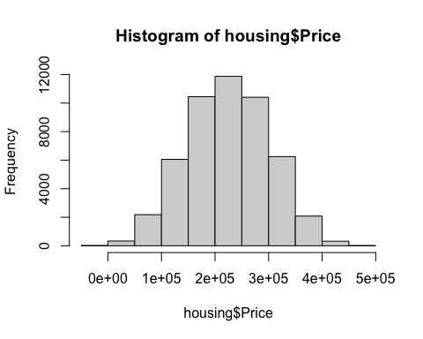
hist(housing$SquareFeet)
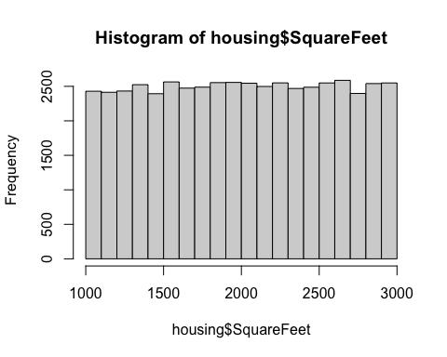
hist(housing$YearBuilt)
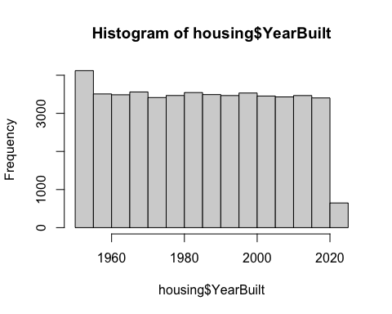
# Bar plot for neighborhood
barplot(table(housing$Neighborhood))
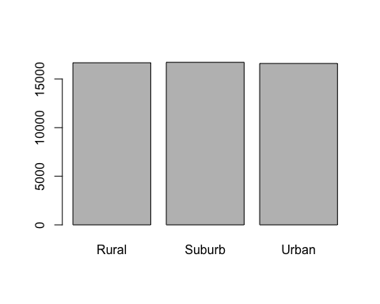
# Scatter plots
plot(housing$SquareFeet, housing$Price,
main="Price vs Square Feet", xlab="Square Feet", ylab="Price", pch=19)
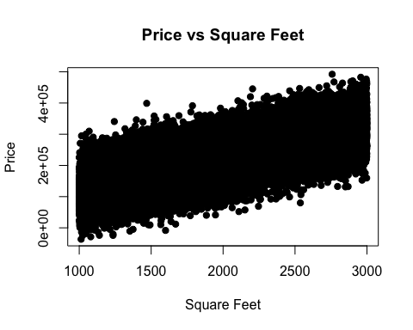
plot(housing$Bedrooms, housing$Price,
main="Price vs Bedrooms", xlab="Bedrooms", ylab="Price", pch=19)
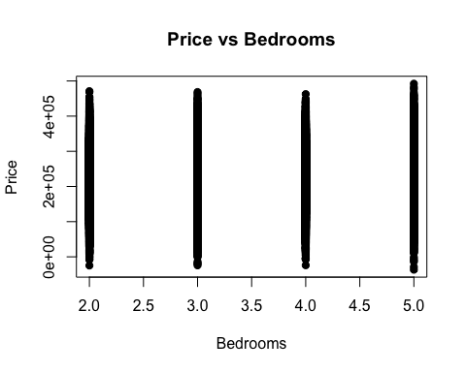 General Assumptions Linearity From the Price vs Square Feet scatterplot, the relationships between these 2 variables appear approximately linear, so assuming linear regression is appropriate.
Independence of Observations The dataset consists of independent housing samples, so the independence assumption is likely valid.
Homoscedasticity and normality of residuals will be confirmed later after fitting the model
Collinearity evaluations
cor(housing[, c("SquareFeet", "Bedrooms", "Bathrooms", "YearBuilt")])
## SquareFeet Bedrooms Bathrooms YearBuilt
## SquareFeet 1.0000000000 -0.002638119 -0.003274733 0.0004817707
## Bedrooms -0.0026381193 1.000000000 0.007405043 0.0031473645
## Bathrooms -0.0032747329 0.007405043 1.000000000 0.0037478596
## YearBuilt 0.0004817707 0.003147365 0.003747860 1.0000000000
library(corrplot)
## corrplot 0.95 loaded
corrplot(cor(housing[, sapply(housing, is.numeric)]), method = "color")
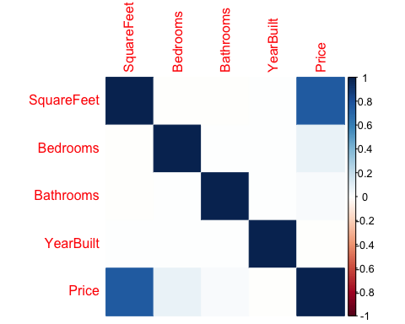
model <- lm(Price ~ SquareFeet + Bedrooms + Bathrooms + YearBuilt, data = housing)
library(car)
## Loading required package: carData
vif(model)
## SquareFeet Bedrooms Bathrooms YearBuilt
## 1.000018 1.000071 1.000079 1.000024
All results were approximately 0 from the correlation matrix and all of the VIF values are approximately 1, signaling no multicollinearity at all.
Check for any missing values
colSums(is.na(housing))
## SquareFeet Bedrooms Bathrooms Neighborhood YearBuilt Price
## 0 0 0 0 0 0
Since there is none, there is no need to change anything.
boxplot(housing$Price, main="Boxplot of House Prices", col="lightblue")
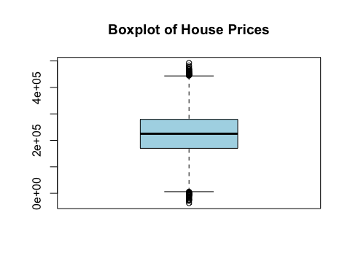
boxplot(housing$SquareFeet, main="Boxplot of Square Feet", col="lightgreen")
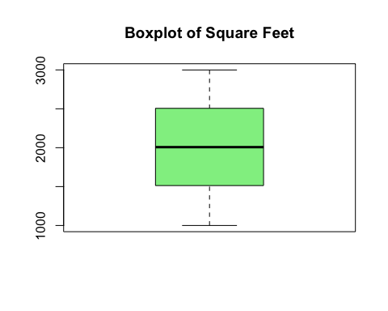
par(mfrow = c(2, 3)) # 2 rows, 3 columns layout
# 1. Price histogram
hist(housing$Price,
breaks = 30,
main = "Price",
xlab = "")
# 2. SquareFeet histogram
hist(housing$SquareFeet,
breaks = 30,
main = "Square Feet",
xlab = "")
# 3. Bedrooms bar chart
barplot(table(housing$Bedrooms),
main = "Bedrooms",
xlab = "")
# 4. Bathrooms bar chart
barplot(table(housing$Bathrooms),
main = "Bathrooms",
xlab = "")
# 5. YearBuilt histogram
hist(housing$YearBuilt,
breaks = 30,
main = "Year Built",
xlab = "")
# 6. Neighborhood bar chart
barplot(table(housing$Neighborhood),
main = "Neighborhood",
xlab = "")
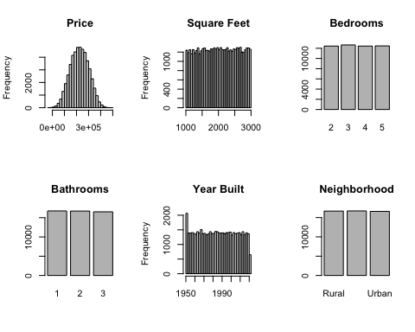
par(mfrow = c(1, 1)) # reset layout
looks like theres outliers in house prices
boxplot.stats(housing$Price)$out
## [1] -24715.2425 -7550.5046 461502.0146 456959.8044 457902.6754 -19871.2511
## [7] 470989.6791 453551.1255 -10608.3595 5796.0586 -23911.0031 -4537.4186
## [13] -13803.6841 452870.6190 492195.2600 444972.1112 -24183.0005 -13692.0261
## [19] -434.0971 468470.3780 446341.3622 -4910.4153 451173.3736 449315.8437
## [25] 276.0635 -8238.8845 -28774.9980 -18159.6857 -4810.7243 468493.8778
## [31] 447752.2778 -4295.9322 3000.8596 462557.5630 -7177.6285 476671.7333
## [37] 467492.8278 3926.8570 445343.4094 -847.8951 2697.8498 -602.2091
## [43] 449584.8573 449113.4464 -36588.1654 448600.0482 -4771.5702 2360.2744
## [49] 460583.8261 -6159.0392 448410.8928 154.7791 447379.2273 455088.6431
## [55] 451838.9888 456955.2445 482577.1634 446757.0512 463977.2385
There seems to be negative numbers in the dataset so I replaced all negative values with 0
housing <- subset(housing, Price > 0)
boxplot(housing$Price, main="Boxplot of House Prices")
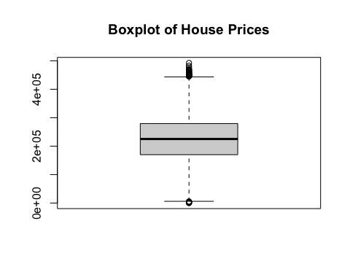
corrplot(cor(housing[, sapply(housing, is.numeric)]), method = "color")

I removed the negative values and replaced them with 0s since house prices cannot be negative. High-end positive outliers were retained since they can represent valid properties.
par(mfrow = c(1, 1))
hist(housing$Price, main="Distribution of Price", col="lightblue")
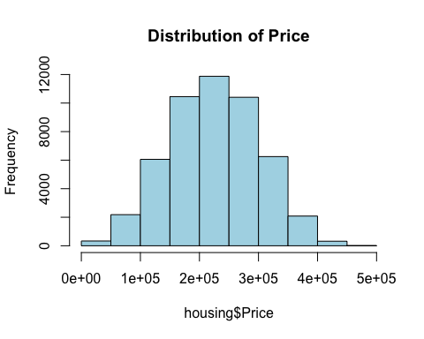
hist(housing$SquareFeet, main="Distribution of Square Feet", col="lightgreen")
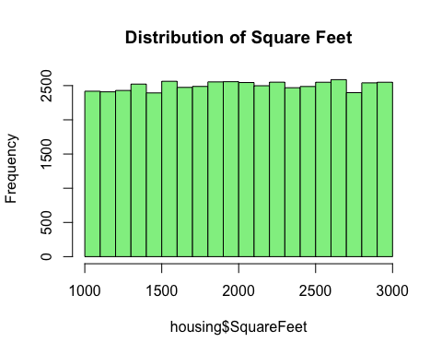
hist(housing$Bedrooms, main="Distribution of Bedrooms", col="lightcoral")
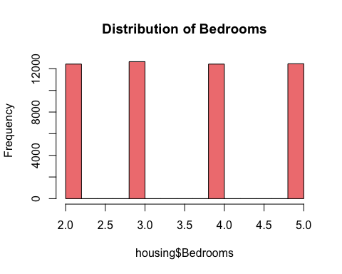
hist(housing$YearBuilt, main="Distribution of Year Built", col="lightgoldenrod")
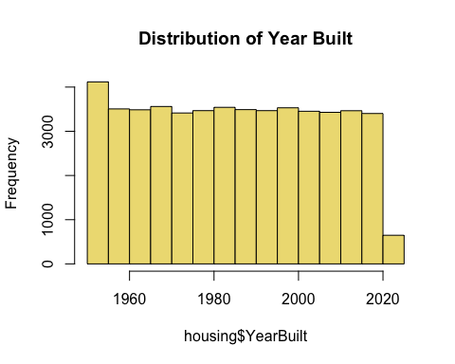
par(mfrow = c(1, 1))
I used histograms to see if any transformations were required for each predictor. Everything appeared normally distributed so no transformations were done.
This turns categorical values into dummy variables
housing$Neighborhood <- as.factor(housing$Neighborhood)
levels(housing$Neighborhood)
## [1] "Rural" "Suburb" "Urban"
Fitting the model
# Univariate regressions
model_sqft <- lm(Price ~ SquareFeet, data = housing)
model_bed <- lm(Price ~ Bedrooms, data = housing)
model_bath <- lm(Price ~ Bathrooms, data = housing)
model_year <- lm(Price ~ YearBuilt, data = housing)
model_neigh <- lm(Price ~ Neighborhood, data = housing)
# Summaries
summary(model_sqft)
##
## Call:
## lm(formula = Price ~ SquareFeet, data = housing)
##
## Residuals:
## Min 1Q Median 3Q Max
## -197538 -34383 -44 33990 227393
##
## Coefficients:
## Estimate Std. Error t value Pr(>|t|)
## (Intercept) 2.596e+04 8.149e+02 31.86 <2e-16 ***
## SquareFeet 9.915e+01 3.904e-01 253.99 <2e-16 ***
## ---
## Signif. codes: 0 '***' 0.001 '**' 0.01 '*' 0.05 '.' 0.1 ' ' 1
##
## Residual standard error: 50210 on 49976 degrees of freedom
## Multiple R-squared: 0.5635, Adjusted R-squared: 0.5635
## F-statistic: 6.451e+04 on 1 and 49976 DF, p-value: < 2.2e-16
summary(model_bed)
##
## Call:
## lm(formula = Price ~ Bedrooms, data = housing)
##
## Residuals:
## Min 1Q Median 3Q Max
## -223493 -54742 23 54616 259811
##
## Coefficients:
## Estimate Std. Error t value Pr(>|t|)
## (Intercept) 207564.2 1115.4 186.10 <2e-16 ***
## Bedrooms 4964.0 303.7 16.34 <2e-16 ***
## ---
## Signif. codes: 0 '***' 0.001 '**' 0.01 '*' 0.05 '.' 0.1 ' ' 1
##
## Residual standard error: 75790 on 49976 degrees of freedom
## Multiple R-squared: 0.005317, Adjusted R-squared: 0.005297
## F-statistic: 267.1 on 1 and 49976 DF, p-value: < 2.2e-16
summary(model_bath)
##
## Call:
## lm(formula = Price ~ Bathrooms, data = housing)
##
## Residuals:
## Min 1Q Median 3Q Max
## -224884 -54806 187 54648 267252
##
## Coefficients:
## Estimate Std. Error t value Pr(>|t|)
## (Intercept) 219667.4 897.9 244.646 < 2e-16 ***
## Bathrooms 2638.1 416.5 6.334 2.41e-10 ***
## ---
## Signif. codes: 0 '***' 0.001 '**' 0.01 '*' 0.05 '.' 0.1 ' ' 1
##
## Residual standard error: 75970 on 49976 degrees of freedom
## Multiple R-squared: 0.0008021, Adjusted R-squared: 0.0007821
## F-statistic: 40.12 on 1 and 49976 DF, p-value: 2.41e-10
summary(model_year)
##
## Call:
## lm(formula = Price ~ YearBuilt, data = housing)
##
## Residuals:
## Min 1Q Median 3Q Max
## -224881 -54905 125 54527 267109
##
## Coefficients:
## Estimate Std. Error t value Pr(>|t|)
## (Intercept) 241604.327 32577.915 7.416 1.22e-13 ***
## YearBuilt -8.398 16.408 -0.512 0.609
## ---
## Signif. codes: 0 '***' 0.001 '**' 0.01 '*' 0.05 '.' 0.1 ' ' 1
##
## Residual standard error: 76000 on 49976 degrees of freedom
## Multiple R-squared: 5.241e-06, Adjusted R-squared: -1.477e-05
## F-statistic: 0.2619 on 1 and 49976 DF, p-value: 0.6088
summary(model_neigh)
##
## Call:
## lm(formula = Price ~ Neighborhood, data = housing)
##
## Residuals:
## Min 1Q Median 3Q Max
## -224600 -54865 235 54635 267986
##
## Coefficients:
## Estimate Std. Error t value Pr(>|t|)
## (Intercept) 224209.4 588.5 380.985 < 2e-16 ***
## NeighborhoodSuburb -906.4 831.7 -1.090 0.27578
## NeighborhoodUrban 3088.5 833.2 3.707 0.00021 ***
## ---
## Signif. codes: 0 '***' 0.001 '**' 0.01 '*' 0.05 '.' 0.1 ' ' 1
##
## Residual standard error: 75980 on 49975 degrees of freedom
## Multiple R-squared: 0.0005056, Adjusted R-squared: 0.0004656
## F-statistic: 12.64 on 2 and 49975 DF, p-value: 3.247e-06
These results showed that square footage was the single most important predictor of price, explaining the largest proportion of variance. Bedroom, bathrooms, and neighborhood also displayed positive and statistically significant effects on price, while year built was not significant in predicting price on its own.
# Example: does SquareFeet's effect depend on Neighborhood?
model_interaction <- lm(Price ~ SquareFeet * Neighborhood, data = housing)
summary(model_interaction)
##
## Call:
## lm(formula = Price ~ SquareFeet * Neighborhood, data = housing)
##
## Residuals:
## Min 1Q Median 3Q Max
## -196665 -34387 -102 34037 227410
##
## Coefficients:
## Estimate Std. Error t value Pr(>|t|)
## (Intercept) 26594.9560 1404.2921 18.938 <2e-16 ***
## SquareFeet 98.7074 0.6740 146.448 <2e-16 ***
## NeighborhoodSuburb -2104.8631 1987.2516 -1.059 0.290
## NeighborhoodUrban 329.9013 1999.9833 0.165 0.869
## SquareFeet:NeighborhoodSuburb 0.6788 0.9543 0.711 0.477
## SquareFeet:NeighborhoodUrban 0.5907 0.9566 0.618 0.537
## ---
## Signif. codes: 0 '***' 0.001 '**' 0.01 '*' 0.05 '.' 0.1 ' ' 1
##
## Residual standard error: 50200 on 49972 degrees of freedom
## Multiple R-squared: 0.5636, Adjusted R-squared: 0.5636
## F-statistic: 1.291e+04 on 5 and 49972 DF, p-value: < 2.2e-16
From this interaction model, the results indicated that only square feet was highly significant and none of the neighborhood or interaction terms were statistically significant. This suggests that the effect of house size on price is consistent across all neighborhoods and no substantial confounding effects were observed.
Comprehensive model
model_full <- lm(Price ~ SquareFeet + Bedrooms + Bathrooms + YearBuilt + Neighborhood, data = housing)
summary(model_full)
##
## Call:
## lm(formula = Price ~ SquareFeet + Bedrooms + Bathrooms + YearBuilt +
## Neighborhood, data = housing)
##
## Residuals:
## Min 1Q Median 3Q Max
## -189092 -34031 -230 33695 227603
##
## Coefficients:
## Estimate Std. Error t value Pr(>|t|)
## (Intercept) 23764.1926 21389.6938 1.111 0.26657
## SquareFeet 99.1681 0.3874 255.965 < 2e-16 ***
## Bedrooms 5080.7529 199.6688 25.446 < 2e-16 ***
## Bathrooms 2826.1022 273.2041 10.344 < 2e-16 ***
## YearBuilt -10.8474 10.7580 -1.008 0.31331
## NeighborhoodSuburb -705.1247 545.4287 -1.293 0.19609
## NeighborhoodUrban 1562.2231 546.4529 2.859 0.00425 **
## ---
## Signif. codes: 0 '***' 0.001 '**' 0.01 '*' 0.05 '.' 0.1 ' ' 1
##
## Residual standard error: 49830 on 49971 degrees of freedom
## Multiple R-squared: 0.5702, Adjusted R-squared: 0.5701
## F-statistic: 1.105e+04 on 6 and 49971 DF, p-value: < 2.2e-16
The comprehensive multiple linear regression model included all predictors. The model explained approximately 57% of the variation in house prices. Among the predictors, sqft, bedrooms, and bathrooms had the largest and most statistically significant effects on price.
Model Selection
model_reduced <- lm(Price ~ SquareFeet + Bedrooms + Bathrooms + Neighborhood, data = housing)
summary(model_reduced)
##
## Call:
## lm(formula = Price ~ SquareFeet + Bedrooms + Bathrooms + Neighborhood,
## data = housing)
##
## Residuals:
## Min 1Q Median 3Q Max
## -188957 -34021 -230 33676 227380
##
## Coefficients:
## Estimate Std. Error t value Pr(>|t|)
## (Intercept) 2232.9701 1239.5940 1.801 0.07165 .
## SquareFeet 99.1679 0.3874 255.965 < 2e-16 ***
## Bedrooms 5080.1184 199.6678 25.443 < 2e-16 ***
## Bathrooms 2825.0620 273.2022 10.341 < 2e-16 ***
## NeighborhoodSuburb -706.8729 545.4260 -1.296 0.19498
## NeighborhoodUrban 1562.3002 546.4530 2.859 0.00425 **
## ---
## Signif. codes: 0 '***' 0.001 '**' 0.01 '*' 0.05 '.' 0.1 ' ' 1
##
## Residual standard error: 49830 on 49972 degrees of freedom
## Multiple R-squared: 0.5702, Adjusted R-squared: 0.5701
## F-statistic: 1.326e+04 on 5 and 49972 DF, p-value: < 2.2e-16
AIC(model_full, model_reduced)
## df AIC
## model_full 8 1222996
## model_reduced 7 1222995
The reduced model produced an AIC of 1,222,995, slightly lower than the full model’s AIC of 1,222,996, indicating a marginally better and more efficient fit. This confirms that the simpler model achieves the same explanatory power with fewer predictors. Therefore, the reduced model was selected as the preferred model for further diagnostics and final evaluation.
# Diagnostic Plots for the reduced model
par(mfrow = c(2, 2))
plot(model_reduced)
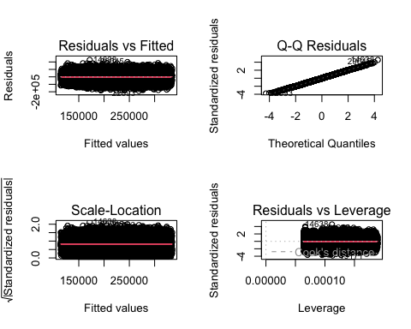
The residuals vs fitted plot showed a random scatter around 0, which suggests that linearity and equal variance assumptions were met The Q-Q plot indicated that residuals were approximately normally distributed, with only minor deviations at the ends. The scale-location plot confirmed that the variance of residuals remained roughly constant across fitted values, indicating homoscedasticity. No highly influential data points were detected, suggesting that no single observation disproportionately affected the model’s estimates. Overall, the model satisfies the key assumptions of linear regression.
set.seed(123) # for reproducibility
train_index <- sample(1:nrow(housing), size = 0.7 * nrow(housing))
train_data <- housing[train_index, ]
test_data <- housing[-train_index, ]
model_final <- lm(Price ~ SquareFeet + Bedrooms + Bathrooms + Neighborhood,
data = train_data)
summary(model_final)
##
## Call:
## lm(formula = Price ~ SquareFeet + Bedrooms + Bathrooms + Neighborhood,
## data = train_data)
##
## Residuals:
## Min 1Q Median 3Q Max
## -182219 -34262 -206 33724 199246
##
## Coefficients:
## Estimate Std. Error t value Pr(>|t|)
## (Intercept) 1962.2910 1484.1213 1.322 0.1861
## SquareFeet 99.4366 0.4637 214.450 <2e-16 ***
## Bedrooms 5163.8780 239.2662 21.582 <2e-16 ***
## Bathrooms 2709.4429 326.8534 8.289 <2e-16 ***
## NeighborhoodSuburb -1197.1146 652.8782 -1.834 0.0667 .
## NeighborhoodUrban 1230.2728 654.6119 1.879 0.0602 .
## ---
## Signif. codes: 0 '***' 0.001 '**' 0.01 '*' 0.05 '.' 0.1 ' ' 1
##
## Residual standard error: 49910 on 34978 degrees of freedom
## Multiple R-squared: 0.5708, Adjusted R-squared: 0.5708
## F-statistic: 9304 on 5 and 34978 DF, p-value: < 2.2e-16
predictions <- predict(model_final, newdata = test_data)
# calculate errors
errors <- test_data$Price - predictions
# RMSE
RMSE <- sqrt(mean(errors^2))
# MAE
MAE <- mean(abs(errors))
# Test R-squared
SSE <- sum(errors^2)
SST <- sum((test_data$Price - mean(test_data$Price))^2)
R2_test <- 1 - SSE/SST
RMSE
## [1] 49629.38
MAE
## [1] 39655.74
R2_test
## [1] 0.5684939
The final regression model was the reduced model which included, SquareFeet, Bedrooms, Bathrooms, and Neighborhood. This model provides a strong and interpretable fit for predicting housing prices. It captures the structural and locational factors influencing home values while maintaining model simplicity and validity.
The final model indicates that house prices are primarily drien by structural features of the home with square footage having the strongest effect, with each additional square foot increasing price by $99. Bedrooms and bathrooms also contribute positively to price, and homes located in urban neighborhoods tend to be priced higher than similar homes in rural areas. Overall, the model shows that larger homes with more rooms and located in urban areas tend to cost more.
Model Performance I split the dataset into 70% training and 30% testing sets and the final model achieved a R-squared of 0.568, which is nearly identical to the training R-squared of 0.571, indicating strong generalization and no overfitting. The prediction errors showed a RMSE of approximately $49,629 and a MAE of $39,656 on the test set. This means that on average, the mode;’s predictions are within $40,000-$50,000 of the actual selling price.

