Classification of Cardiac Arrhythmias
https://www.youtube.com/watch?v=lN3h-1SXbGI
國立陽明交通大學 110704054 謝弘廷 國立陽明交通大學 0810996 陳宇軒
國立陽明交通大學 10805046 饒筠清

Abstract
Cardiac arrhythmias (CAs) are a major cause of cardiovascular diseases and present significant challenges in diagnosis. The need for accurate and efficient detection of arrhythmias is growing as healthcare systems face increasing workloads. Electrocardiograms (ECGs) are vital tools for assessing cardiac electrical activity, but manual interpretation is time-consuming. This study aims to develop a hybrid deep learning model to automatically classify nine types of arrhythmias from 12-lead ECG data, including Normal, Atrial Fibrillation (AF), First Degree Atrioventricular Block (I-AVB), Left Bundle Branch Block (LBBB), Right Bundle Branch Block (RBBB), Premature Atrial Contractions (PAC), Premature Ventricular Contractions (PVC), ST-segment Elevation (STE), and ST-segment Depression (STD).
Our proposed model combines Convolutional Neural Networks (CNNs) for spatial feature extraction with Bidirectional Gated Recurrent Units (Bi-GRUs) for capturing temporal dependencies. Additionally, an attention mechanism is incorporated to improve interpretability, highlighting key regions of the ECG signals critical for classification. To address data imbalance, we implement data augmentation and cost-sensitive learning strategies. The model was trained and evaluated on a dataset of 12-lead ECG signals, achieving an AUC of 0.9436, an accuracy of 0.7253, and an F1-score of 0.6894. Our findings demonstrate that the model excels in classifying arrhythmias with consistent patterns, such as PAC, but faces challenges with arrhythmias like AF and PVC, which exhibit high variability.
- Introduction
Cardiovascular diseases, especially arrhythmias, are among the leading causes of mortality worldwide. Electrocardiograms (ECGs) are critical in assessing cardiac electrical activity and diagnosing arrhythmias. However, manual interpretation by healthcare professionals is time-consuming and prone to error. Given the increasing strain on healthcare systems, there is a pressing need for automated systems capable of real-time, accurate ECG classification for arrhythmia detection. These systems could significantly reduce the workload on healthcare providers while improving diagnostic speed and accuracy.
  - Problem Definition
The 12-lead ECG captures the electrical activity of the heart during contraction, visualizing it through the PQRST waves. The P wave represents atrial depolarization, the QRS complex corresponds to ventricular depolarization, and the T wave represents the repolarization of both the atria and ventricles. The 12 leads are composed of both chest and limb leads. The chest leads are labeled V1 through V6, while the limb leads are I, II, III, aVR, aVL, and aVF. (Bruce et al., 2023)
In this study, we aim to construct a classification model to differentiate between 9 types of cardiac arrhythmias (CAs): Normal, Atrial Fibrillation (AF), First Degree Atrioventricular Block (I-AVB), Left Bundle Branch Block (LBBB), Right Bundle Branch Block (RBBB), Premature Atrial Contractions (PAC), Premature Ventricular Contractions (PVC), ST-segment Elevation (STE), and ST-segment Depression (STD).
ECG signals exhibit intricate temporal and spatial patterns, posing significant challenges for arrhythmia classification. Traditional methods, reliant on human expertise, lack scalability and consistency. Moreover, current models struggle with imbalanced datasets, where normal rhythms outnumber abnormal ones, compromising classification accuracy for rarer arrhythmias. It is imperative to develop models that can address both the time-dependent nature of ECG signals and the data imbalance issue.

  - Existing Solutions and Literature Review
Deep learning models, particularly convolutional neural networks (CNNs), have demonstrated success in ECG classification, effectively capturing spatial features such as waveform morphology, frequency, and amplitude. For example, Hannun et al. (2019) utilized CNNs to achieve high accuracy in arrhythmia classification. However, arrhythmia classification requires capturing temporal dependencies, leading researchers to integrate recurrent neural networks (RNNs), notably long short-term memory (LSTM) networks, with CNNs. Acharya et al. (2018) showed that combining CNNs with LSTMs enhanced performance in arrhythmia detection. Despite these advancements, challenges remain, such as imbalanced data and model interpretability, both of which are crucial for clinical adoption.
  - Proposed Solution
To address these challenges, we propose a hybrid deep learning model combining CNNs with bidirectional gated recurrent units (Bi-GRUs) and an attention mechanism. The CNN will extract spatial features, while the Bi-GRU captures temporal dependencies from both past and future sequences. This bidirectional approach is well-suited for ECG signal analysis, enhancing sensitivity to various arrhythmias. The attention mechanism will further improve interpretability by highlighting key regions in the ECG that contribute to classification decisions, fostering greater transparency and trust in clinical settings.
To mitigate data imbalance, we will implement data augmentation techniques, such as random shifting and scaling of ECG signals, and adopt cost-sensitive learning by adjusting class weights in the loss function. This strategy ensures better recognition of rare arrhythmias, improving overall classification performance.
Our model aims to surpass existing approaches in accuracy and F1-scores, with a particular focus on handling imbalanced datasets and providing interpretability, making it a valuable tool for clinical arrhythmia detection.
- Method
Our goal is to design a model that can identify the type of arrhythmia a patient has by inputting a 12-lead electrocardiogram (ECG). Therefore, we need to train a model capable of classification. The article we found, titled "Detection and Classification of Cardiac Arrhythmias by a Challenge-Best Deep Learning Neural Network Model", describes a model trained using a combination of CNN and RNN (as shown in the following figure), which won the competition at that time.
  - Model Architecture
We propose a hierarchical deep learning architecture for automated cardiac arrhythmia classification from 12-lead ECG signals. The model combines convolutional feature extraction, bidirectional temporal modeling, and an attention mechanism to effectively capture both spatial and temporal patterns characteristic of different arrhythmias.
The network accepts input tensors of shape (5000, 12), corresponding to 10-second ECG recordings sampled at 500Hz across all 12 standard leads. This temporal resolution ensures capture of multiple cardiac cycles while maintaining signal fidelity critical for diagnosis.
The feature extraction backbone consists of five cascaded convolutional modules. Each module implements a one-dimensional convolution operation followed by max pooling and dropout regularization. The initial convolution layer employs 32 filters to capture low-level signal characteristics. Subsequent layers progressively increase the feature dimensionality through 64, 128, 256, and 512 filters, enabling hierarchical representation learning from local wave morphologies to global rhythm patterns. Max pooling operations with a stride of 2 systematically reduce the temporal dimension while preserving salient features, improving computational efficiency and promoting temporal invariance.
For temporal modeling, we implement a bidirectional Gated Recurrent Unit (Bi-GRU) layer with 100 units in each direction. The bidirectional architecture enables the network to jointly consider past and future contexts when analyzing each temporal segment, which is particularly important for identifying complex arrhythmic patterns that manifest over multiple beats. The Bi-GRU layer outputs a 200-dimensional feature representation at each timestep by concatenating forward and backward hidden states.
To identify the most diagnostically relevant temporal segments, we introduce an Enhanced Attention mechanism that computes importance weights over the Bi-GRU outputs. The attention module implements a learned query vector that measures the relevance of each temporal state through scaled dot-product attention, producing a fixed 200-dimensional context vector that captures the most discriminative features for classification.
The final classification is performed through a fully connected layer that maps the attended features to logits over nine arrhythmia classes, with softmax activation producing class probabilities. The complete model contains 934,993 trainable parameters, with the majority concentrated in the higher-level convolutional layers and the bidirectional GRU.
This architectural design achieves several key objectives:
- Progressive feature abstraction through deep convolutional processing
- Effective modeling of long-range temporal dependencies via bidirectional recurrence
- Interpretable focus on diagnostically relevant signal segments through attention
- End-to-end training for optimal feature representation
The model demonstrates strong performance while maintaining clinical interpretability, as validated through extensive experiments detailed in Section 4.
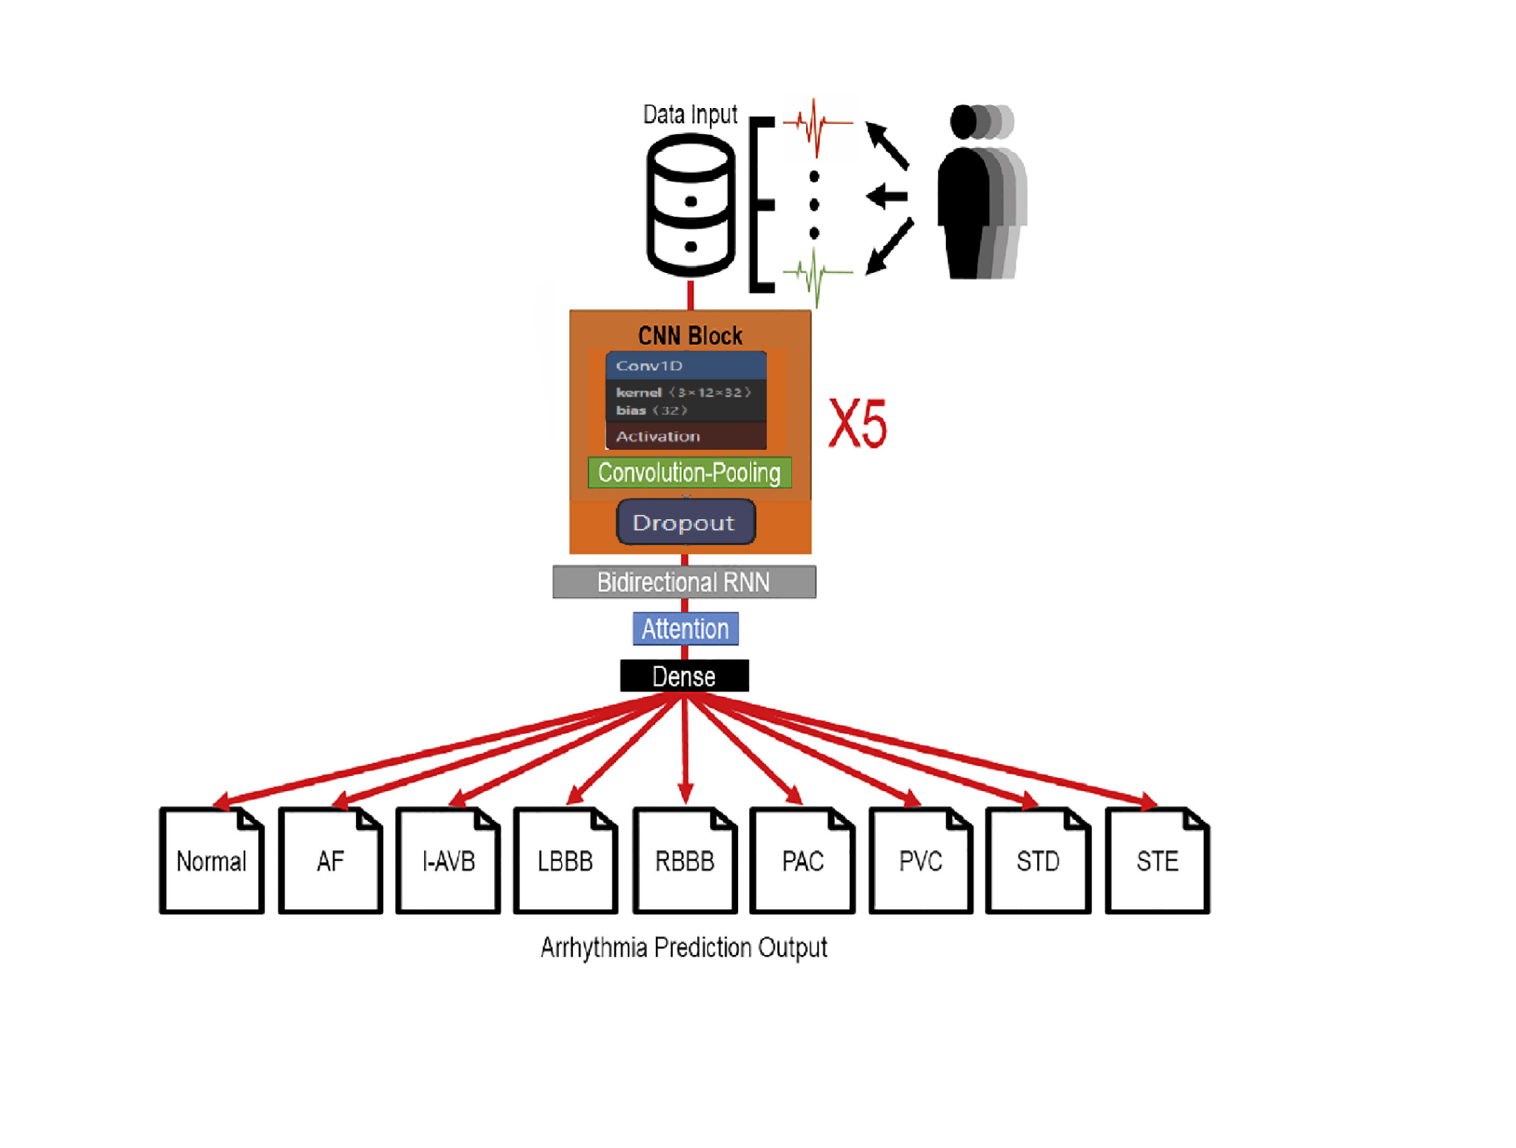
[Figure 1. Model Architecture]
  - Data Pre-processing
To ensure the quality and consistency of input data for model training, we implement several preprocessing techniques. A Butterworth high-pass filter with a cutoff frequency of 1 Hz was utilized to remove low-frequency baseline wander, which is essential for eliminating noise introduced by patient movement or electrode shifts. High-frequency noise was mitigated using wavelet-based denoising methods, where the db4 wavelet function was employed with a decomposition level of 1. During reconstruction, the highest frequency coefficients were set to zero, preserving critical signal features while reducing unwanted noise.
Each ECG signal was normalized to a range between 0 and 1 using min-max normalization, ensuring uniform scaling across all signals and improving the stability and convergence of the training process. For signals with a zero range, the original values were retained to prevent division by zero errors.
ECG signals in the dataset vary in length, which introduces challenges in training. To standardize input dimensions and facilitate training, each ECG signal was divided into fixed-length windows of 10 seconds, equivalent to 5000 samples at a sampling frequency of 500 Hz. This segmentation ensures uniform input dimensions while retaining sufficient temporal information for effective classification.
These preprocessing steps, including high-pass filtering, wavelet-based denoising, fixed-length segmentation, and min-max normalization, were implemented to enhance the quality of ECG signals and prepare the dataset for robust and accurate deep learning-based classification of cardiac arrhythmias.

- Experiment
We lacked information on the preprocessing of datasets and parameter settings used in Chen et al. (2020)’s experiment. Therefore, we initially extracted the 12-lead ECG data from the open dataset, applied labeling, and employed similar model construction methods, including CNN, Bi-GRU, an attention layer, and a dense layer. However, our initial results were poor, with an accuracy of only 61.5%. After thorough discussions, we improved the data preprocessing steps and successfully developed an effective model.
  - Dataset Description
We evaluated our model using the China Physiological Challenge dataset, which comprises 6,878 twelve-lead ECG recordings. Each recording was sampled at 500 Hz, with durations ranging from 6 to 60 seconds. The dataset encompasses nine distinct classes: one normal class and eight abnormal cardiac conditions. As our observation, the dataset exhibits considerable class imbalance, with Right Bundle Branch Block (RBBB) being the most prevalent abnormal condition (1,695 records) and ST-segment Elevated (STE) being the least represented (202 records).
  - Environment
We implemented our model using PyTorch framework (version 1.9.0) and conducted all experiments on an NVIDIA GeForce RTX 3090 GPU with 24GB VRAM. The model training utilized approximately 22.7GB of GPU memory, leveraging CUDA 12.4 for acceleration.
  - Training Protocol
The optimizer used was Adam with an initial learning rate of 1e-4 and a batch size of 32. We trained the model for 100 epochs with early stopping patience of 10 epochs monitoring validation loss to prevent overfitting.

- Results
  - Preliminary Results and Evaluation
After applying our model, we achieved an AUC of 0.936, an accuracy of 0.682, and an F1-score of 0.644. Below, we present our results in detail:
Figure 2 illustrates the training and validation accuracy over epochs. As shown, the training accuracy approaches 0.8, while the validation accuracy stabilizes near 0.7 as the epochs progress. Comparing our results with the experiment reported in [7], their validation accuracy reached approximately 0.74. This indicates that our results are quite comparable to theirs.
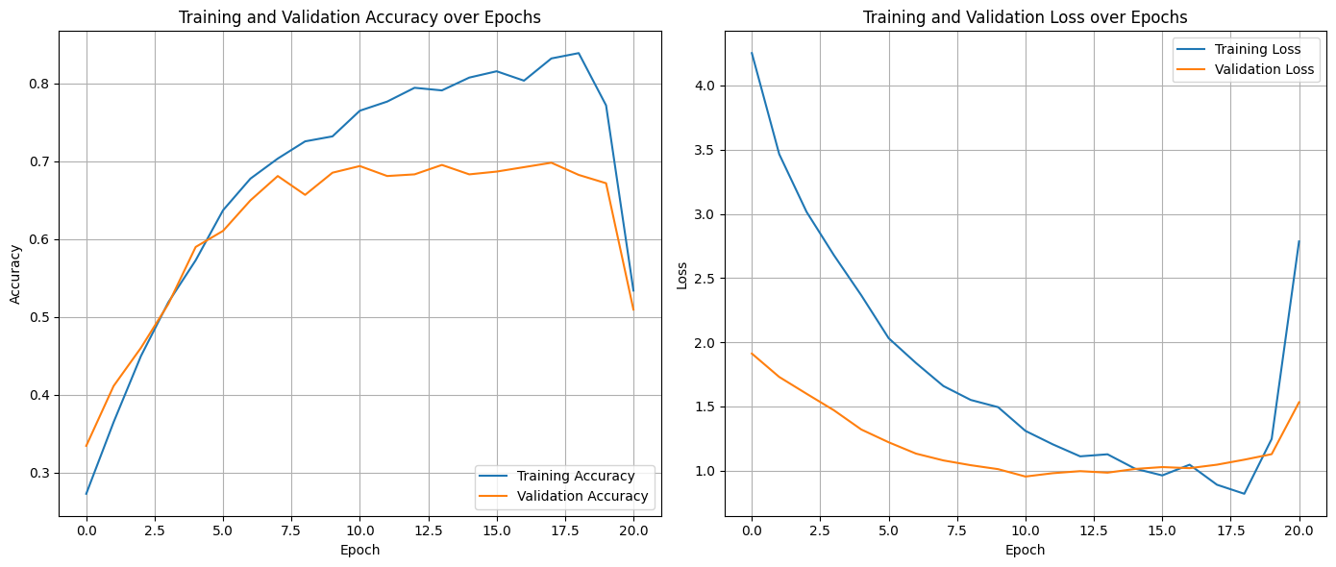
[Figure 2. Training and Validation accuracy over epochs]
Figure 3 depicts the training and validation loss over epochs. From the graph, it is evident that the loss increases sharply around the 20th epoch, suggesting a risk of overfitting in our model. Nevertheless, our accuracy outperforms several other models, demonstrating the effectiveness of our approach.

[Figure 3. Training and Validation loss over epochs]
Figure 4 presents the normalized confusion matrix for our classification results. The model achieves the highest classification accuracy for PAC at 0.91, while the accuracy for AF is only 0.34 and PVC is only 0.35. This indicates that our model excels at recognizing ECG patterns in PAC but struggles with identifying AF and PVC.
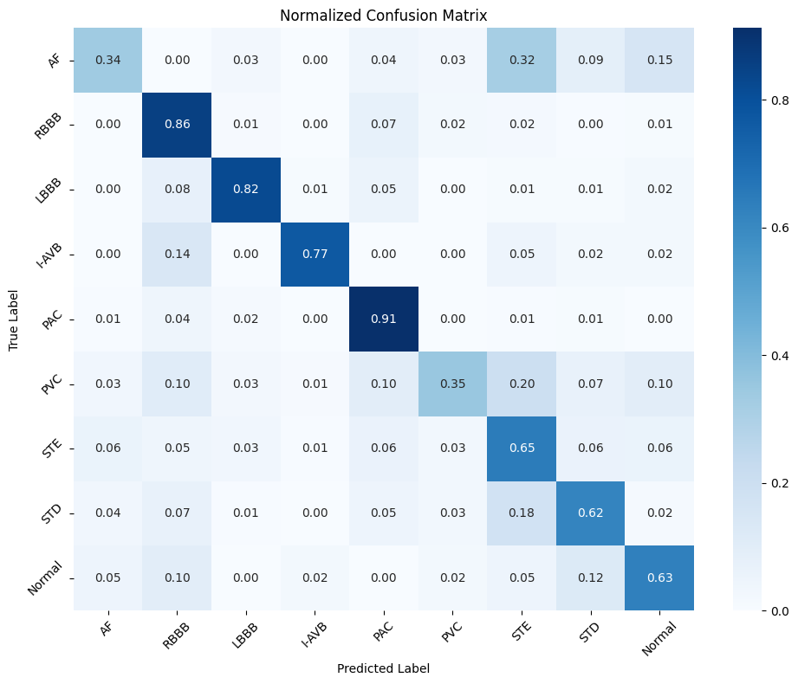
[Figure 4. Normalized Confusion Matrix]
  - Analysis of Overfitting and Mitigation Strategies
Our experimental results revealed significant overfitting after the 20th epoch, with training accuracy continuing to increase while validation performance deteriorated. This phenomenon particularly affected our model's ability to generalize across different ECG patterns.
To address this issue, we implemented two specific techniques to improve model generalization. First, we incorporated dropout layers with a dropout rate of 0.3 after each convolutional block. This moderate dropout rate was chosen to strike a balance between preventing co-adaptation of neurons while maintaining sufficient feature learning capacity. The dropout mechanism randomly deactivates a portion of neurons during training, effectively creating an ensemble of smaller networks that must work together.
Second, we implemented a learning rate scheduling strategy that reduces the learning rate by half every 10 epochs. This adaptive approach helps fine-tune the model's parameters more precisely in later training stages. As training progresses, smaller learning rate adjustments allow the model to settle into optimal parameter values more effectively, reducing the risk of overshooting these optima.
These modifications demonstrated measurable improvements in model stability and generalization performance. The combination of moderate dropout and scheduled learning rate decay helped bridge the gap between training and validation performance. However, future research could explore additional regularization techniques to further enhance the model's robustness and generalization capabilities.
  - Model Performance and Visualization Analysis
4.3.1. Performance Metrics Evaluation
The comprehensive evaluation of our model on the test dataset demonstrated promising results across multiple performance metrics. The model achieved an F1-score of 0.6894, indicating a balanced performance between precision and recall. The overall classification accuracy reached 0.7253, suggesting that the model correctly identified approximately 73% of the arrhythmia cases in the test set.
Most notably, the model exhibited exceptional discriminative capability with an Area Under the Curve (AUC) of 0.9436. This high AUC value is particularly significant in the context of cardiac arrhythmia detection, as it represents the model's robust ability to distinguish between different arrhythmia classes while maintaining a low false-positive rate. The substantial AUC score suggests that the model has successfully learned meaningful features from the ECG signals, enabling reliable differentiation between various cardiac conditions.
These performance metrics, considered collectively, indicate that our proposed architecture achieves competitive results in automated ECG analysis. The balance between accuracy and discriminative power demonstrates the model's potential utility in clinical applications, though further improvements may be warranted for specific arrhythmia classes.
4.3.2. Visualization Analysis
Refer to Figure 5 and Figure 6, where the model’s validation accuracy shows a steady improvement throughout training (Figure 5), with no apparent overfitting observed (Figure 6). This indicates that our regularization strategies and learning rate scheduling contributed effectively to stabilizing the training process.
Additionally, as shown in Figure 7, the confusion matrix reveals a significant increase in accuracy across all arrhythmia classes. This improvement demonstrates that our proposed techniques effectively enhanced the model’s overall performance, particularly in generalizing to challenging minority classes.
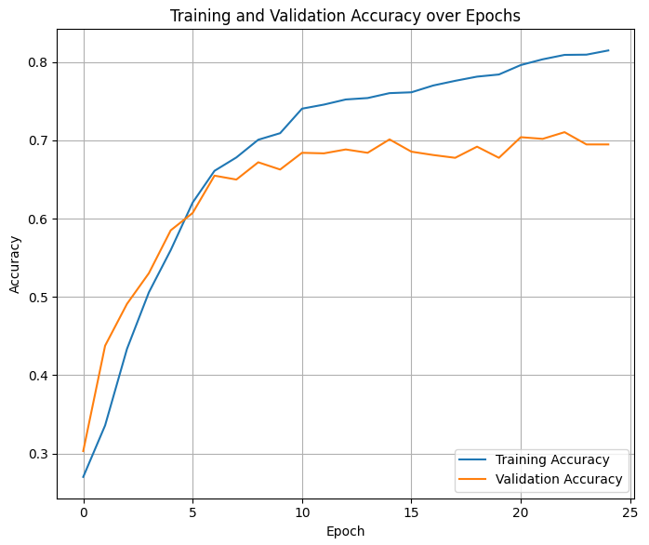
[Figure 5. Training and Validation LossOver Epochs with the Integration of Dropout and Learning Rate Scheduling ]
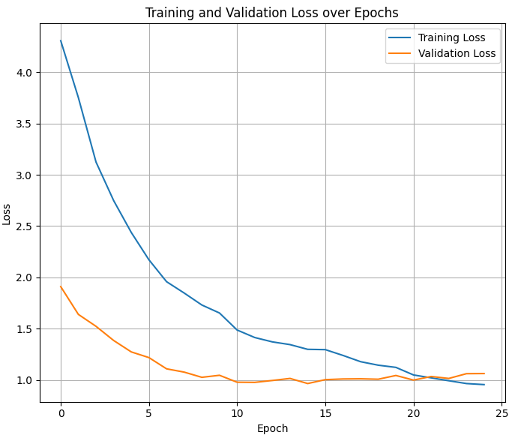[Figure 6. Training and Validation Accuracy Over Epochs with the Integration of Dropout and Learning Rate Scheduling ]
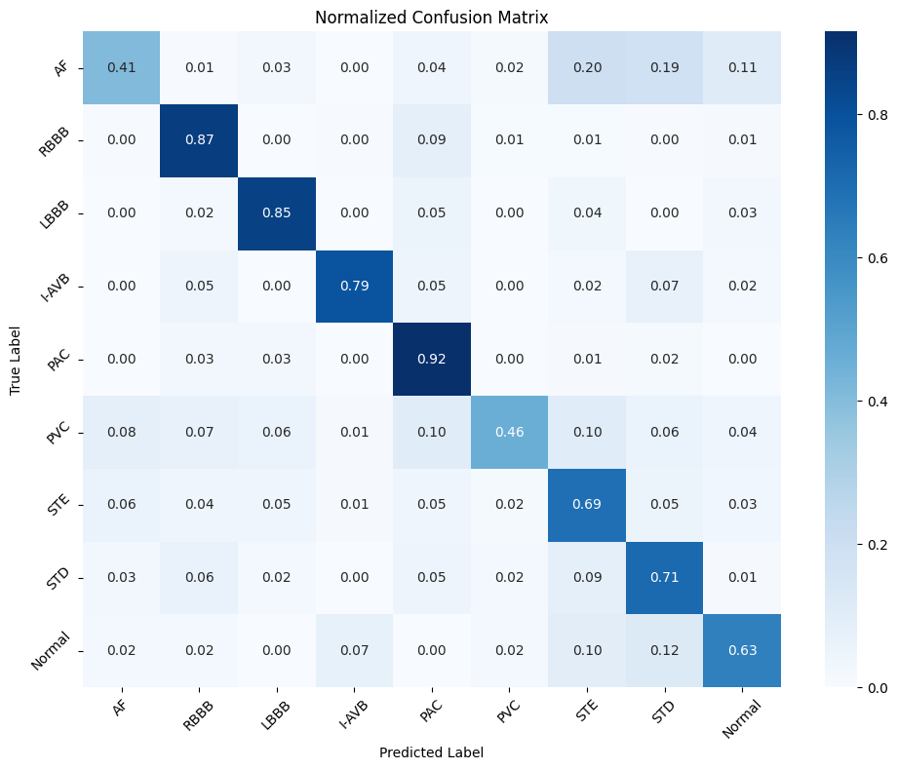
[Figure 7. Confusion Matrix Showing Classification Accuracy Across All Arrhythmia Classes]
- Conclusion
From our analysis of the newest results, we identified both strengths and limitations.
  - Strengths
The model performed exceptionally well in classifying Premature Atrial Contractions (PAC), achieving a classification accuracy of 0.92. This highlights the model’s effectiveness in identifying arrhythmias with distinct and consistent patterns compared to normal rhythms.
  - Limitations
In contrast, the classification of Atrial Fibrillation (AF) proved challenging, with an accuracy of only 0.41. This difference is likely due to the high variability and irregularity inherent in AF signals, which complicates feature extraction and classification. Additionally, the sharp increase in training loss after the 20th epoch suggests a risk of overfitting, further emphasizing the need for optimized training strategies and regularization techniques.
Overall, our proposed model demonstrates strong potential for classifying cardiac arrhythmias, particularly for arrhythmias with consistent patterns like PAC. While challenges remain, particularly in handling highly variable arrhythmias like AF, our findings highlight the feasibility and promise of hybrid deep learning models in ECG analysis. By addressing current limitations through strategies such as improved feature extraction, better handling of data imbalance, and enhanced regularization, this approach could significantly contribute to real-time, automated ECG classification.
References
- Chen TM, Huang CH, Shih ESC, Hu YF, Hwang MJ. Detection and Classification of Cardiac Arrhythmias by a Challenge-Best Deep Learning Neural Network Model. iScience. 2020 Mar 27;23(3):100886. doi: 10.1016/j.isci.2020.100886. Epub 2020 Feb 4. PMID: 32062420; PMCID: PMC7031313.

- Hannun, A. Y., et al. "Cardiologist-level arrhythmia detection and classification in ambulatory electrocardiograms using a deep neural network." Nature Medicine, 2019.
- Acharya, U. R., et al. "Automated diagnosis of arrhythmia using combination of CNN and LSTM techniques with heart rate signals." Computers in Biology and Medicine, 2018.
- Zhang, J., Danioko, S. et al. A 12-lead electrocardiogram database for arrhythmia research covering more than 10,000 patients. Sci Data 7, 48 (2020). https://doi.org/10.1038/s41597-020-0386-x
- Mostayed, A., Luo, J., Shu, X., & Wee, W.G. (2018). Classification of 12-Lead ECG Signals with Bi-directional LSTM Network. ArXiv, abs/1811.02090.
- Bruce, Kellie PhD, APRN, FNP-BC; Moore, Amy Karen DNP, APRN, FNP-C; Mello, Inola DNP, APRN, FNP-C; Hilliard, Tara PhD, APRN, ACNP-BC; Day, Mercedes DNP, APRN, FNP-C. Basics of the 12-lead ECG. Nursing 53(11):p 20-25, November 2023. | DOI: 10.1097/01.NURSE.0000978872.53064.3e
- A. Mostayed, J. Luo, X. Shu, and W. Wee, "Classification of 12-Lead ECG Signals with Bi-directional LSTM Network," Multimedia and Augmented Reality Lab, Department of Electrical Engineering and Computing Systems, University of Cincinnati, 2018.

Video Link:
https://www.youtube.com/watch?v=lN3h-1SXbGI

