Kevin Ducey

Physical Computing

Assignment I: Know Your Symbols

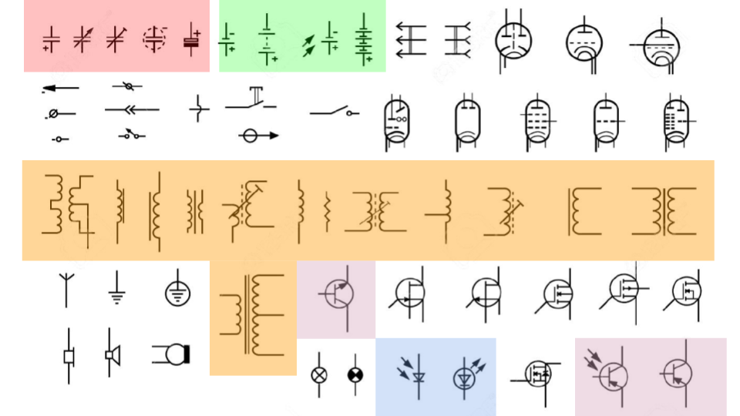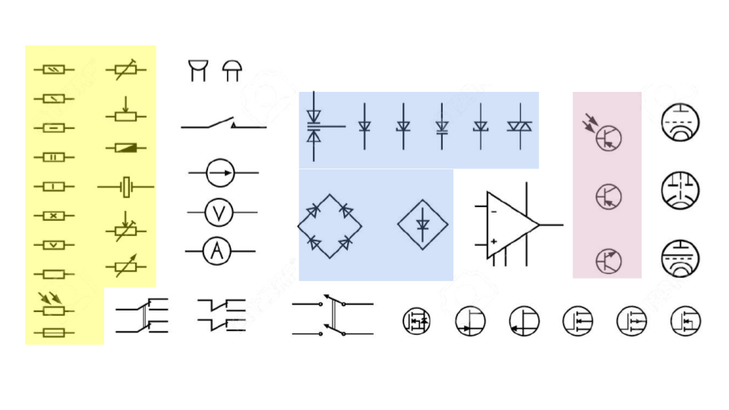

The red highlighted symbols represent different kinds of capacitors. These include components such as variable capacitors, electrolytic/polarized capacitors, and trimmer capacitors. Variable capacitors are those whose capacitance can be altered either physically or electronically.

The green highlighted symbols represent different kinds of batteries. These include components such as solar cell batteries, multi cell batteries, and single cell batteries. Solar cells convert light energy into a potential difference in voltage, yielding electric current when connected to a closed circuit.

The orange highlighted symbols represent different kinds of transformers and inductors. These include components such as with iron core transformers/inductors, primary and secondary tapped transformers and tapped inductors, and trimmer iron dust core transformers. Inductors store energy by making a magnetic field and have particular inductance values. Transformers are used to increase or decrease voltage/current in a circuit.

The pink highlighted symbols represent different kinds of transistors. These include components such as bipolar NPN and PNP transistors, and phototransistors. Phototransistors take in light energy and amplify electric current in a circuit with it.

The blue highlighted symbols represent different kinds of diodes. These includes components such as bridge rectifier diodes, triac diodes, and diode/rectifiers. Diodes are made of metalloids, making them semiconductors, which (for the most part) only allow the flow of current in one direction.