Initial Meeting Notes
Director: Kevin K
Designer: Lucia T. Thomas

Topic: Shaanxi Cuisine (based off the Wikipedia page)
Three basic sections to consider for both mockups: About (general topic intro), History (different types and regions), and Dishes (3-5)
Mockup one: Dynamic, colorful, heavy on the images and color (more artistic)
-Format and text should be designed around the images and stylistic elements.
Ex:
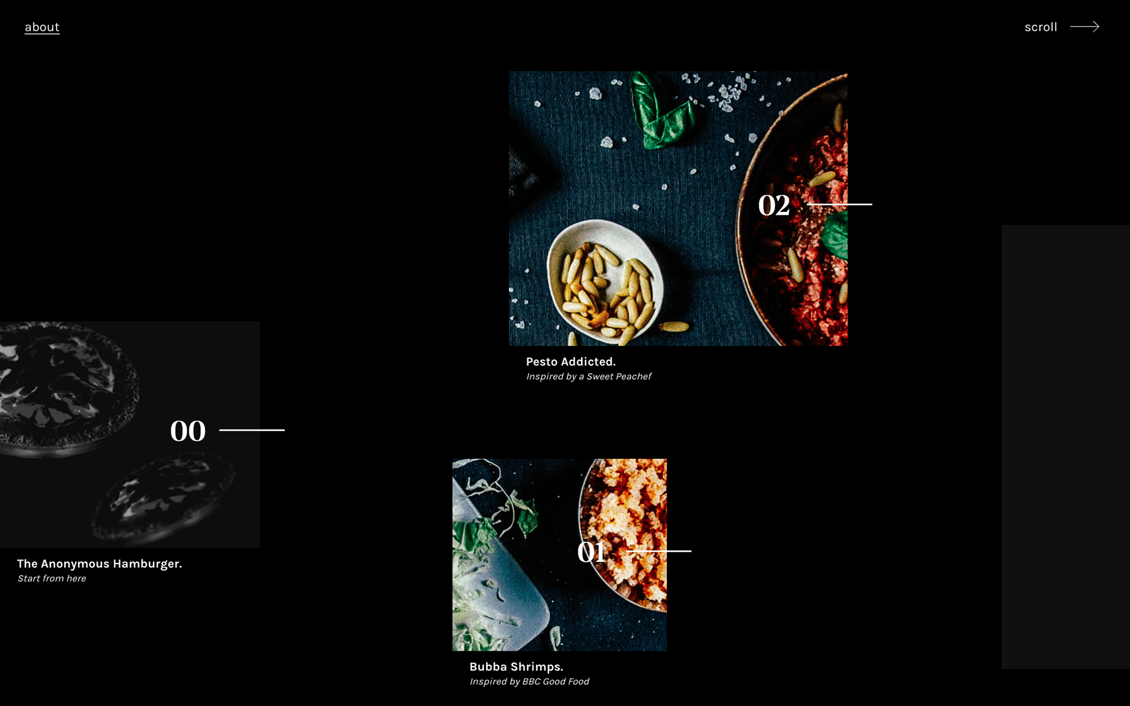

Mockup two: More straightforward, informational design but still designed with care.
-images should be considered and placed around the text and format of the website

Ex:


