
UNIT: EMBEDDED SYSTEMS
COURSE: BACHELOR OF SCIENCE IN COMPUTER SCIENCE
DEPARTMENT: COMPUTING AND INFORMATICS

LECTURER :
GROUP:
NAME | ADDMISION NO.
Scarlet Patience | BSCCS/2024/54567
Omare Levi | BSCCS/2024/56230
Kevin Mburu Gitau | BSCCS/2024/58901

Hybrid Smart Building Access Control System
Project Report

1. Introduction
This report outlines the design and implementation of a hybrid smart building access control system using Cisco Packet Tracer. The project focuses on creating a secure and functional environment with IoT-based access doors and defined clearance levels.

2. Problem Statement
Modern buildings require advanced access control mechanisms to ensure security, safety, and efficient monitoring. The goal of this project is to design a building that integrates IoT-controlled doors, multi-level clearance, logging, and real-time notifications.

3. System Design

3.1 Network Devices
• Cisco ISR 4331 Router
• Cisco 2960-24TT Switch
• Home Gateway (IoT Controller)
• Smart Doors (IoT Doors)
• RFID Cards with 5 Clearance Levels

3.2 Clearance Levels
1. Security – Access to all doors including server door
2. Lab Technician – Main, Lab, Storage
3. Lecturer – Main, Lab
4. Student – Main, Lab
5. Visitor – Main

3.3 System Features
• IoT-controlled access doors
• RFID-based authentication
• Logging of entry attempts
• Real-time notifications to the Security Office
• Remote management over the network

4. Implementation
Below are placeholders for screenshots demonstrating the simulation steps.

Screenshot 1
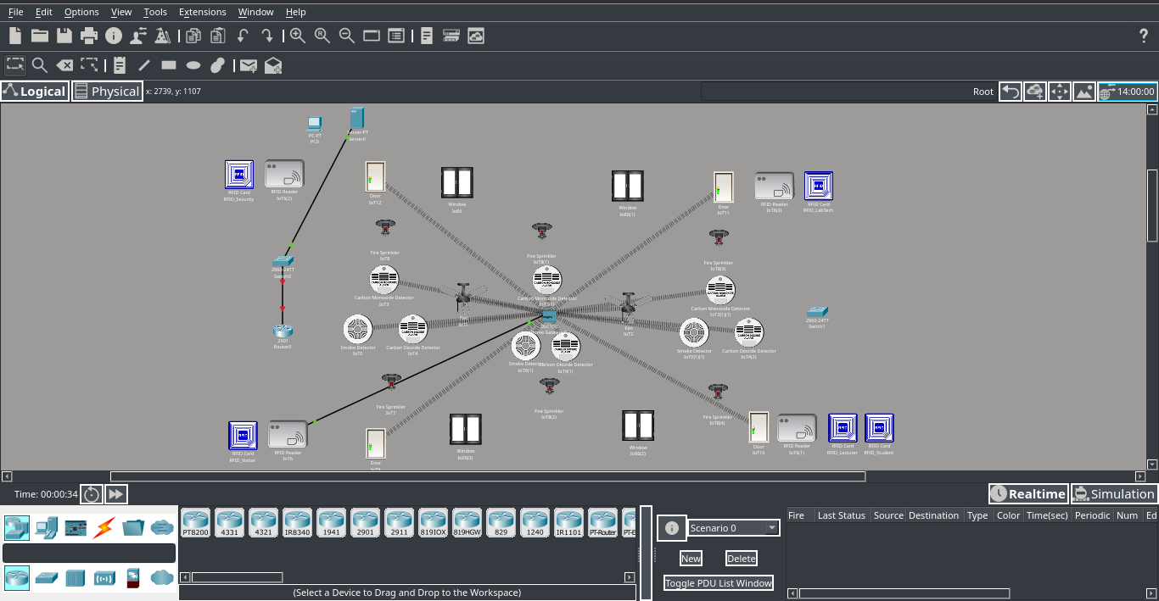

Screenshot 2
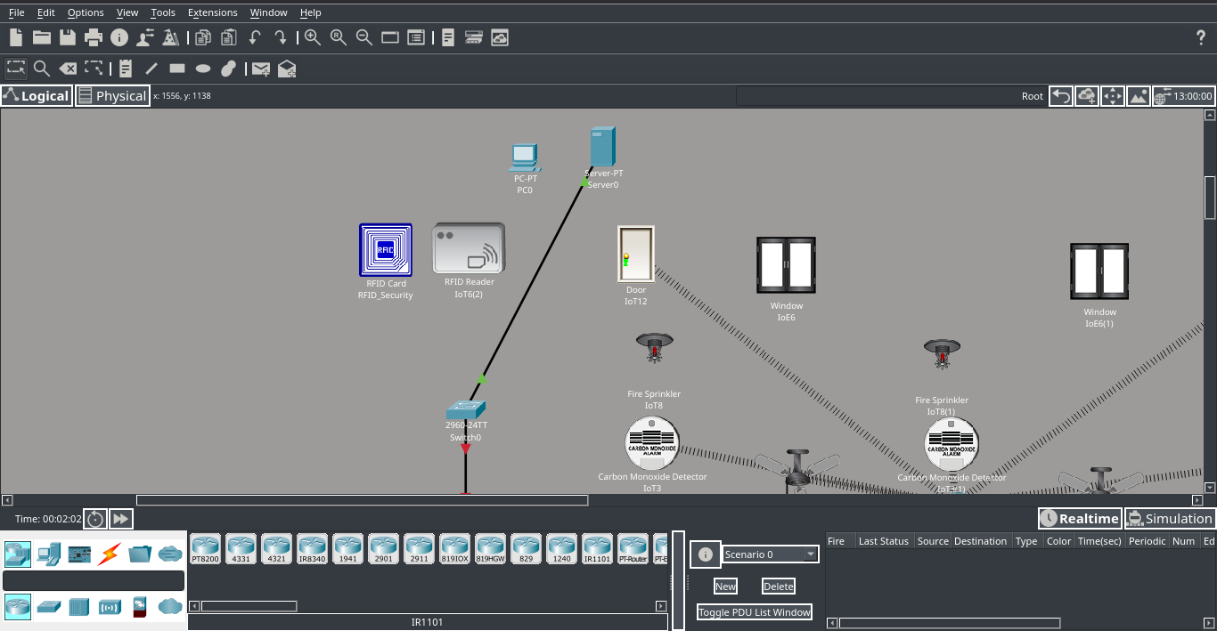

Screenshot 3
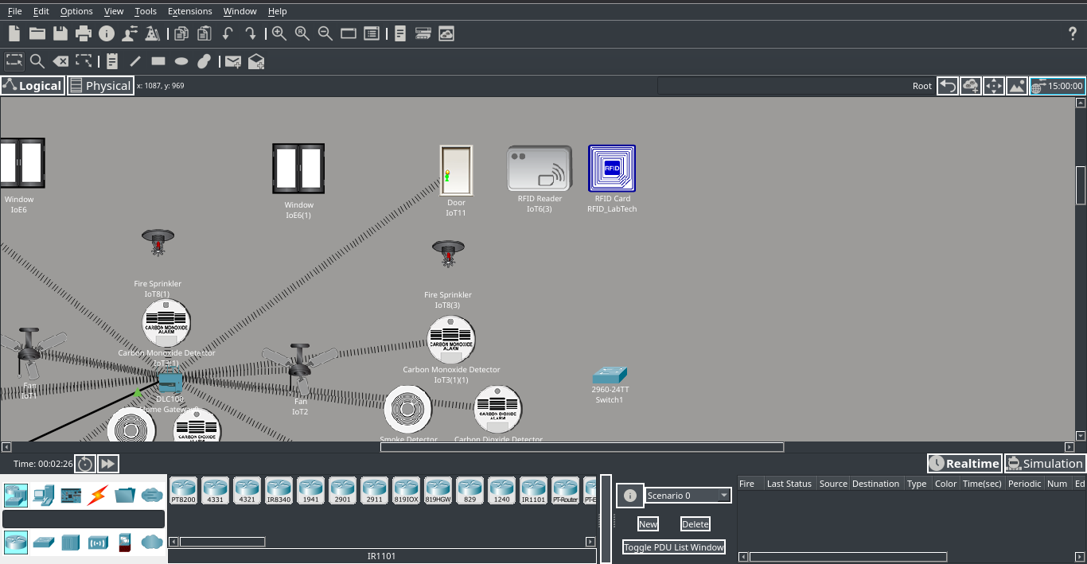

Screenshot 4
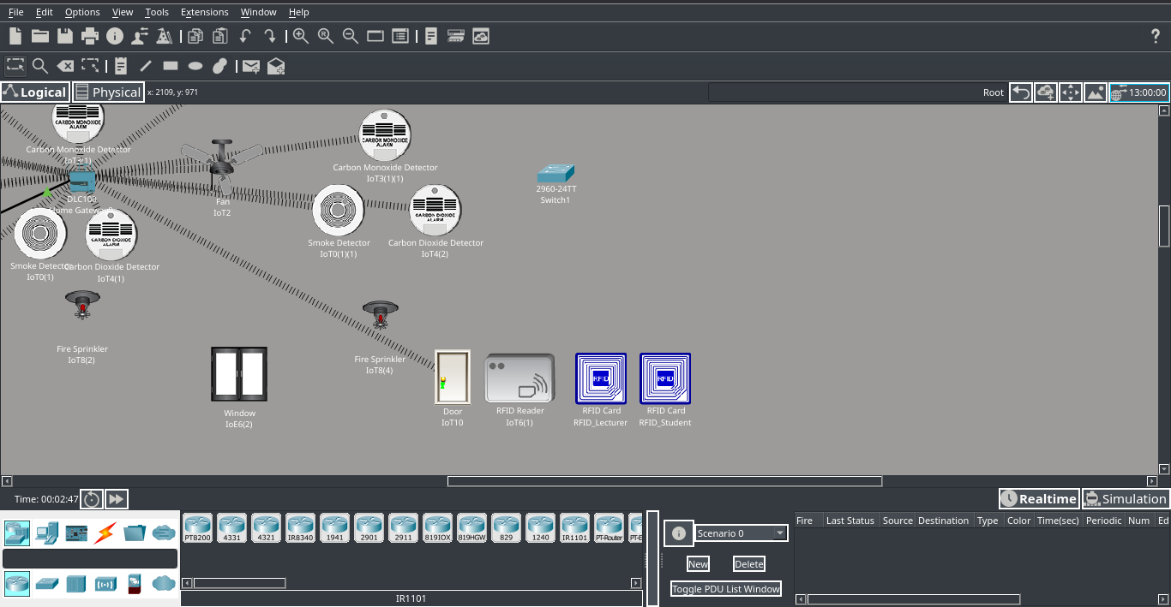

Screenshot 5
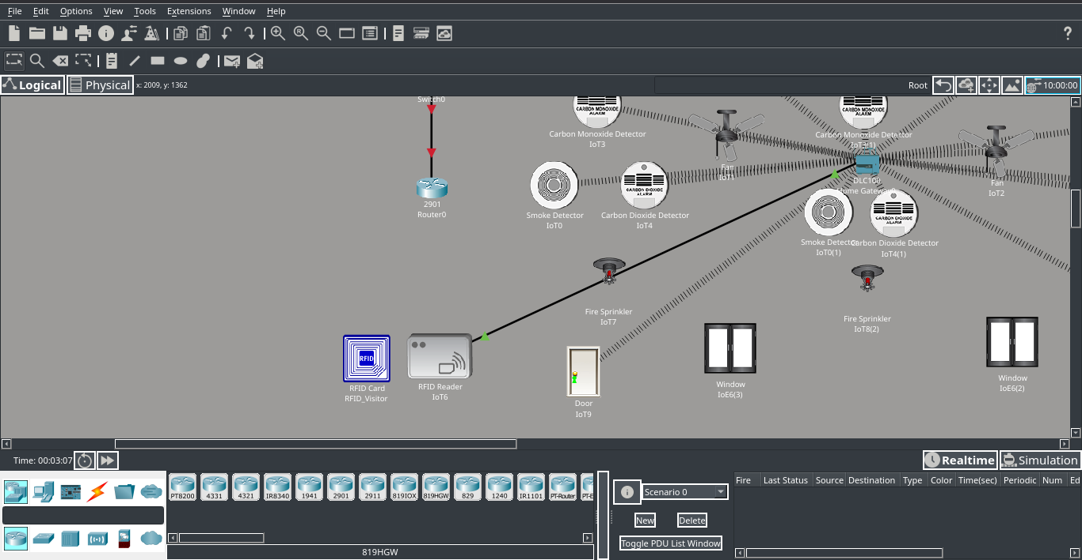

5. Problems Encountered
During system setup, several issues were encountered, including:
• Authentication conflicts between IoT devices and the Home Gateway
• Input/response delays in IoT door scripts
• Incorrect VLAN trunking causing IoT devices to lose connectivity
• Timing issues between RFID triggers and door state changes

6. Future Enhancements

6.1 Real-time Monitoring Dashboard
A centralized dashboard can be added to visualize door activity, alarms, and system health.

6.2 Advanced Logging & Analytics
Logs can be exported to a SIEM for advanced pattern recognition and intrusion detection.

6.3 Environmental Condition Control
Future enhancements will include integrating intelligent environmental control systems to regulate building conditions automatically. This will involve adding smart fans, automated windows, temperature and humidity sensors, and ventilation controls. These devices will work together to maintain optimal air quality and comfort based on real-time sensor data. The system will also support predefined safety rules—such as activating fans during high heat, opening windows when CO₂ levels rise, or sealing rooms during hazardous events. Ultimately, this enhancement will create a more energy-efficient, safe, and comfortable environment.

