Kevin Miller

SWDV 630

Week 8 - Final Project

12/14/2020

**Project Detail**

The project that I have selected is a **Pizza Ordering System.** This system will replicate a real pizza company named Maurizio’s Pizza. Maurizio’s has been open for business since the mid 90’s in Saint Louis , Mo. My father was the first employee hired and worked there in my teen years. I look to replicate the many nuances of the ordering system. Here is a list of what I want to achieve:

* A customer, cashier and chef as the main individual classes.
* Create further classes that will be composed with the main classes for interactions. For example: purchasing class, ordering class, processing class, preparation class will be loaded as a composition to main three classes depending on relevance.
* Implement the SQLAlchemy database activity for storing customer info and orders.
* Main operation is simply initiating an order by customer thereby cashier processes for customer and chef as well.

**Use Cases**

Use cases:

1. Customer ordering pizza
2. Customer cancelling order
3. Customer ordering customized pizza
4. Customer applying discount to order
5. Cashier accepting payment from Customer
6. Customer profile created if not already in the system
7. Cashier sending order to chef
8. Chef sending order to cashier
9. Cashier serving customer.

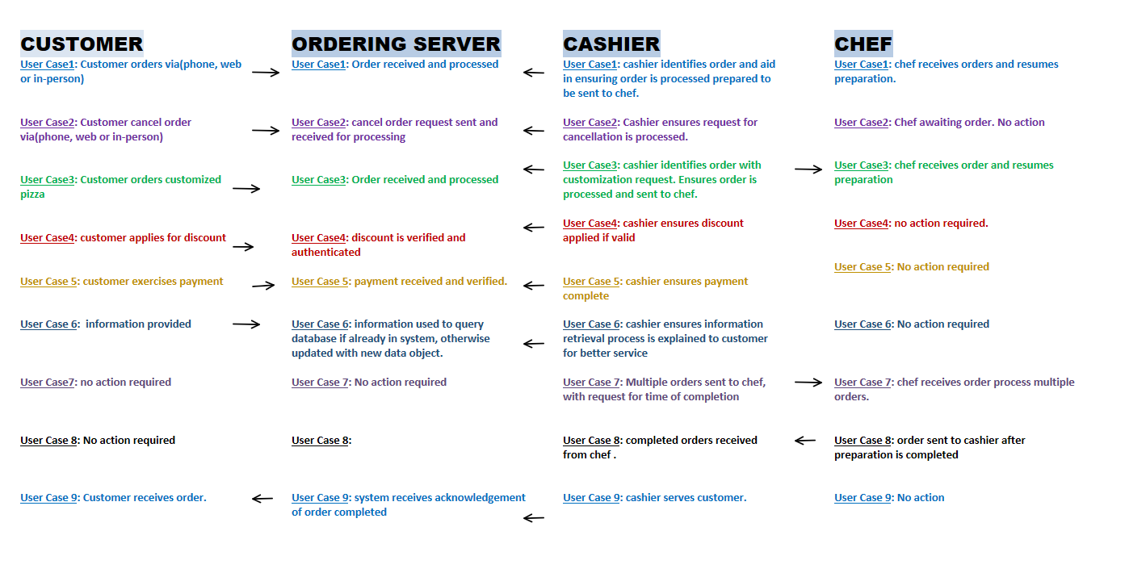

**Elaboration**

|  |  |
| --- | --- |
| USE CASE NAME: | Customer order |
| ID: |  |
| SCENARIO | Customer orders via Web, phone or in person to acquire food item. |
| TRIGGERING EVENT: | Contacting cashier for initiate process. |
| BRIEF DESCRIPTION: | Customer orders via Web, phone or in person to acquire food item. |
| ACTORS: | customer |
| ASSUMPTIONS: | NA |
| FREQUENCY OF USE: | Customer attempting to order |
| RELATED USE CASES: | Customer orders customized pizza |
| STAKEHOLDERS: | owner |
| PRECONDITIONS: | Customer hungry |
| POSTCONDITIONS: | Customer satisfied |
| MAIN COURSE: | NA |
| ALTERNATE COURSE | NA |

|  |  |
| --- | --- |
| USE CASE NAME: | Customer profile updated |
| ID: |  |
| SCENARIO | Information of customer added to database if not already there. |
| TRIGGERING EVENT: | New Customer order |
| BRIEF DESCRIPTION: | Information of customer added to database if not already there. |
| ACTORS: | Customer |
| ASSUMPTIONS: | New customer |