**Assignment**

**Step 1:**

**Business context:** A retail company operating in Rwanda with branches Kigali, Muhanga, Nyanza wants to analyze its sale performance.

**Data challenge:** problem in managing data and how to segment customers for marketing.

**Expected outcome:** finding out customers buying behavior, sales trend and segmentation to support marketing.

**Step 2: Success criteria**

1. Top 5 products per region/ quarter: RANK ()

Expected output: each region should list its top 5 products ranked by sales value.

1. Running monthly sales totals: SUM () OVER ()

Expected output: sales totals that keep increasing from month to month.

1. Month-over-month growth: LAG () / LEAD ()

Expected output: a positive or negative growth rate for each month after the first.

1. Customer quartiles: NTILE (4)

Expected output: division of customers into 4 equal groups, ordered by total spending.

1. 3-month moving average: AVG () OVER ()

Expected output: a smoothed sales trend where each month’s value is averaged with the two months before it.

**step 3: Database schema**

**table customers**

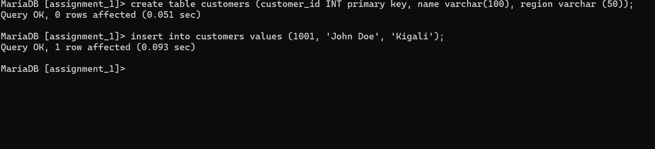

**Table products**

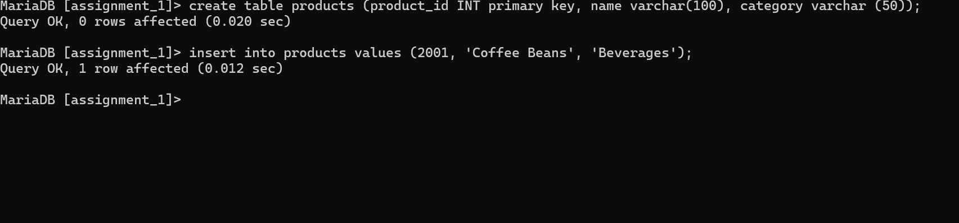

**Table transactions**

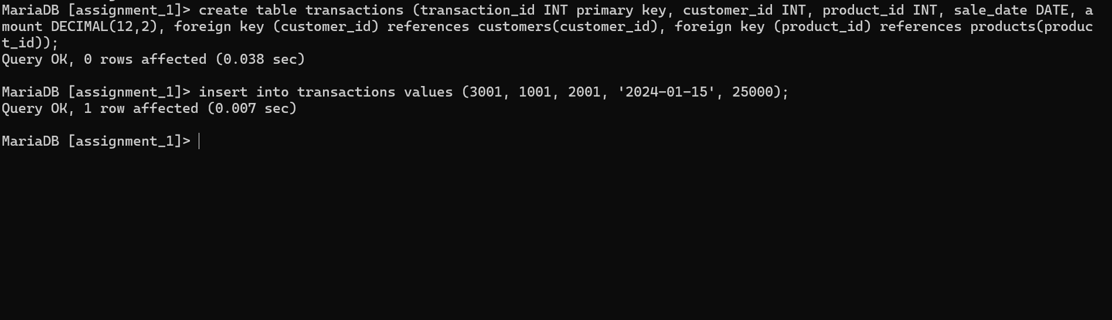

**ER diagram**

**Step 4: window functions implementation**

1. Ranking: RANK ()

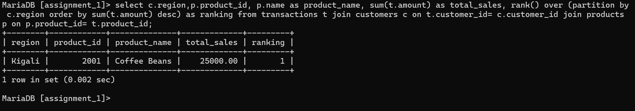

Comment: it shows leading products per region

1. Aggregate: SUM () OVER ()

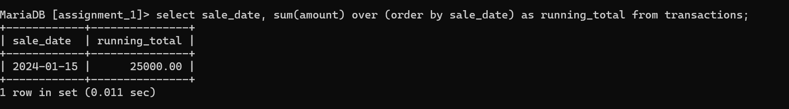

Comment: it shows running total of sales by adding each transaction’s amount in order of the sale_date.

1. Navigation: LAG ()

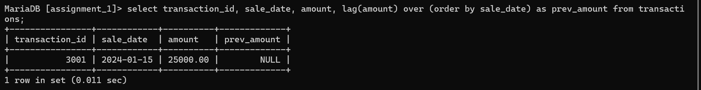

1. Distribution: NTILE (4)

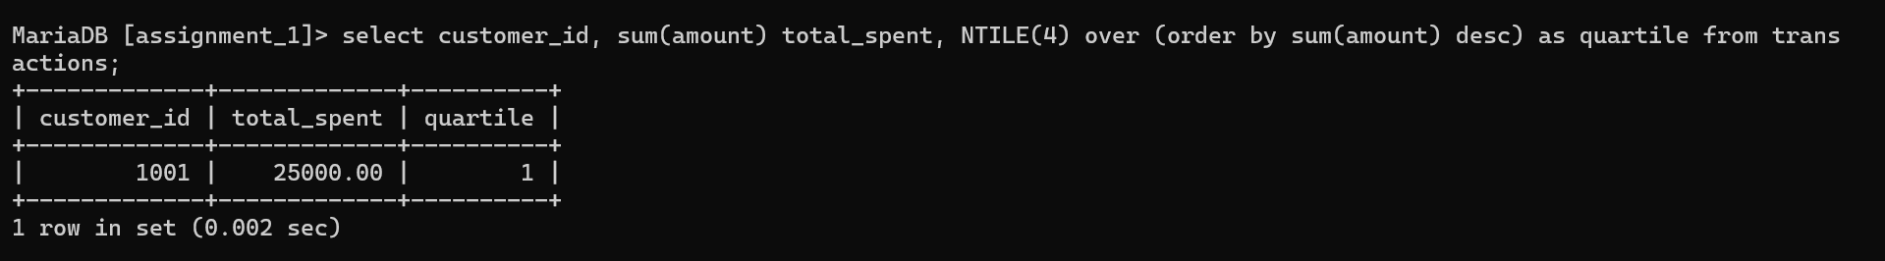

Comment: it shows calculations of the total amount spent by each customer and divides customers into 4 quartiles.