DEGENERACY DETECTION AND MITIGATION IN LIDAR-INERTIAL-VISUAL SLAM

A PROJECT REPORT

Submitted by

KAVINKUMAR S
(CB.EN.P2MFA25004)

in partial fulfilment for the award of the degree
of

MASTER OF TECHNOLOGY
IN
MANUFACTURING AND AUTOMATION


AMRITA SCHOOL OF ENGINEERING, COIMBATORE
AMRITA VISHWA VIDYAPEETHAM
COIMBATORE-641 112
NOVEMBER 2026

AMRITA VISHWA VIDYAPEETHAM
AMRITA SCHOOL OF ENGINEERING, COIMBATORE, 641112
BONAFIDE CERTIFICATE

This is to certify that the thesis entitled “DEGENERACY DETECTION AND MITIGATION IN LIDAR-INERTIAL-VISUAL SLAM” submitted by “KAVINKUMAR S (CB.EN.P2MFA25004)” in partial fulfilment of the requirements for the award of the degree of Master of Technology in MANUFACTURING AND AUTOMATION is a Bonafide record of the work carried out under my guidance and supervision at Amrita School of Engineering, Coimbatore.

Dr. G. Sivasankar
Advisor
Assistant Professor (Sl.Grade)
Department of Mechanical Engineering,

Dr. K. Rameshkumar
Chairman
Department of Mechanical Engineering

The report was examined and the candidate underwent Viva-Voce examination on 13-11-2026

INTERNAL EXAMINER EXTERNAL EXAMINER
AMRITA VISHWA VIDYAPEETHAM
AMRITA SCHOOL OF ENGINEERING, COIMBATORE

DEPARTMENT OF MECHANICAL ENGINEERING

DECLARATION

I, KAVINKUMAR S (CB.EN.P2MFA25004) hereby declare that this project report, entitled as “DEGENERACY DETECTION AND MITIGATION IN LIDAR-INERTIAL-VISUAL SLAM”, is a record of the original work done by me under the guidance of Dr. G. Sivasankar, Department of Mechanical Engineering, Amrita School of Engineering, Coimbatore and that this work has not formed the basis for the award of any degree/diploma/associateship/fellowship or a similar award, to any candidate in any University, to the best of my knowledge.

Signature of the student
Place:

Date:

Dr. G. Sivasankar
Advisor,
Assistant Professor (Sl.Grade),
Department of Mechanical Engineering.

ACKNOWLEDGEMENT

I would like to thank our beloved Chancellor AMMA, Vice-Chancellor, Dr. P. Venkat Rangan and Dean, Engineering, Dr. Sasagan Ramanathan for providing me with excellent infrastructure facilities which greatly helped me to carry out my project work.

I would like to extend my warm thanks to my thesis advisor, Dr. G. Sivasankar, Assistant Professor (Sl.Grade), Department of Mechanical Engineering, Amrita School of Engineering, for guiding me through this project work and for the support and encouragement throughout it.

I would like to thank Dr. K. Rameshkumar, Professor and Chairperson, Department of Mechanical Engineering, and my batch coordinator Dr. Rammohan S, Associate Professor, Department of Mechanical Engineering, Amrita School of Engineering, Amrita Vishwa Vidyapeetham, Coimbatore, for their support.

I thank the members of the review panel for their guidance and feedback throughout this work, and all the technical and non-technical staff of the department for their help and support.

I thank my family and friends for their patience and support during the many long test runs of this work.

ABSTRACT

Mobile robots that map tunnels, mines and long corridors lose their LiDAR odometry when the scene stops constraining a direction of motion. In a corridor with smooth walls the motion along the axis is unobserved, and a camera-based estimator has to carry that direction. Switching methods such as Switch-SLAM choose between LiDAR and visual odometry with one eigenvalue test on the whole registration Hessian, in which rotation (radians) and translation (metres) share one scale.
This work builds a LiDAR-visual-inertial odometry front end on A-LOAM and VINS-Mono that judges the two parts separately. The Schur complements of the A-LOAM Hessian give a rotation block (channel R) and a translation block (channel T), and the translation block sets a per-direction weight between the LiDAR and the VINS-Mono increments. A third channel, the additional T, is computed from the raw keyframe points: the orientation tensor of the surface normals and edge directions bounds the translation information direction by direction, and the same normals correct the heading. Versions F20 to F24 added a VINS-Mono trust check, an anchored hand-over and a guard on A-LOAM's initial guess. The final version, F35, also takes the decision rule of Switch-SLAM into the LiDAR matching: VINS-Mono's motion seeds A-LOAM's scan-to-map step only when the scan is degenerate.
Without loop closure and with frozen settings, F35 gave an ATE RMSE / maximum error of 0.54 / 1.01 m on the SubT-MRS Multi Floor sequence and 2.10 / 3.73 m on Long Corridor, against 1.61 / 3.63 m and 2.42 / 5.09 m published for Switch-SLAM (LiDAR-inertial scan-to-map), and 0.29 / 0.56 m on a Gazebo farm route against 0.38 / 1.10 m. On Corridor02 it gave 1.93 and 2.04 m, and on GEODE stairs 3.26 to 6.36 m where VINS-Mono alone gave 153 to 272 m. On Cave02 it gave 6.23 m, against 4.4 m for an earlier version. With one to three live runs per sequence, only the GEODE comparison with VINS-Mono alone is significant (p = 0.008), and every sequence was used during development, so the results are not a held-out test.
TABLE OF CONTENT
CHAPTER NO | TITLE | PAGE NO
 | ACKNOWLEDGEMENT  ABSTRACT  LIST OF FIGURES  LIST OF TABLES | iv  v  viii  x
1 | Introduction | 1
 | 1.1 Introduction | 1
 | 1.2 LiDAR degeneracy | 1
 | 1.3 Visual-inertial odometry and its failures | 2
 | 1.4 Switching-based LiDAR-visual-inertial fusion | 2
 | 1.5 Problem statement | 3
 | 1.6 Objectives | 3
2 | Literature Review | 4
 | 2.1 Introduction | 4
 | 2.2 Degeneracy detection from the registration Hessian | 4
 | 2.3 Separating rotation and translation | 4
 | 2.4 Geometry-based measures from surface normals | 5
 | 2.5 LiDAR-visual-inertial fusion in degenerate scenes | 5
 | 2.6 Datasets for degenerate environments | 5
 | 2.7 Summary | 6
3 | Methodology | 7
 | 3.1 Introduction | 7
 | 3.2 System overview | 7
 | 3.3 Schur decomposition of the registration Hessian | 9
 | 3.4 Channel T: per-direction translation weight | 9
 | 3.5 Channel R: rotation block and rotation check | 9
 | 3.6 Additional T channel: the orientation tensor | 10
4 | Test Setup | 12
 | 4.1 Introduction | 12
 | 4.2 Computing and software setup | 12
 | 4.3 Datasets | 13
 | 4.4 Safeguards added after the live tests | 14
 | 4.5 Scan-to-map guess from the degeneracy status (F35) | 15
 | 4.6 Tested Configurations and the final configuration | 16
 | 4.7 Evaluation metrics and protocol | 17
 | 4.8 Gazebo farm simulation | 18
 | 4.9 Replay rate and acceptance of runs | 18
 | 4.10 Baselines | 19
5 | Results and Discussion | 21
 | 5.1 Introduction | 21
 | 5.2 First-generation switching node and the threshold study | 22
 | 5.3 Effect of each version (replay) | 23
 | 5.4 Behaviour of the channels in a corridor | 24
 | 5.5 What the status rule puts into the guess | 25
 | 5.6 Live results of the final configuration | 27
 | 5.7 Long Corridor maximum error | 30
 | 5.8 Farm simulation | 31
 | 5.9 Tests with injected faults | 33
 | 5.10 Cave02 and GEODE stairs | 34
 | 5.11 Success rate and hypothesis tests | 36
 | 5.12 Comparison with published results and other tests | 38
 | 5.13 Discussion | 40
6 | Conclusions | 41
 | 6.1 Future scope | 42
 | REFERENCES | 43

LIST OF FIGURES

Figure No | Title | Page No
3.1 | Flowchart of methodology | 7
3.2 | Structure of the fusion: channels R, T, the additional T and the scan-to-map guess | 8
4.1 | Layout of the experimental setup | 12
4.2 | Ground-truth trajectories of the five real sequences (top view) | 14
4.3 | Gazebo agriculture world with the Husky robot | 18
5.1 | Detection quality against trajectory error for the 15 rules | 23
5.2 | Channel T weight, tensor ratio and heading correction, Long Corridor, F35 live run | 25
5.3 | Top-down trajectories of F35 against ground truth (RMSE in brackets) | 28
5.4 | Multi Floor: ground truth (white), F35 (green), A-LOAM output (orange) and VINS-Mono alone (red), same run, map coloured by height | 29
5.5 | Corridor02: ground truth (white), F35 (green), A-LOAM output (orange) and VINS-Mono alone (red), same run, map coloured by height | 30
5.6 | Long Corridor: ground truth (white), F35 (green), A-LOAM output (orange) and VINS-Mono alone (red), same run, map coloured by height | 31
5.7 | Farm L route: ground truth (white), F35 (green), A-LOAM output (orange) and VINS-Mono alone (red), same run, paths only | 33
5.8 | Cave02 and GEODE stairs, F35 live, with A-LOAM's output in the same run | 34
5.9 | Cave02: ground truth (white), F35 (green) and A-LOAM output (orange), same run, map coloured by height; VINS-Mono alone is off the plot | 35
5.10 | GEODE stairs: ground truth (white), F35 (green) and A-LOAM output (orange), same run, map coloured by height; VINS-Mono alone is off the plot | 36
5.11 | F35 against Switch-SLAM (published, LiDAR-inertial scan-to-map) and VINS-Mono alone from the same run | 39
LIST OF TABLES

Table No | Title | Page No
2.1 | Summary of the literature closest to this work | 6
4.1 | Software components | 13
4.2 | Sequences used in this work | 13
4.3 | Configurations used in this work | 16
4.4 | Frozen constants of the final version F35 | 17
4.5 | Replay rates and scans logged per run | 19
5.1 | Overview of the test phases | 21
5.2 | Threshold study on Multi Floor (one live run per rule) | 22
5.3 | Replay of the 12 development logs, mean ATE RMSE / maximum (m) | 24
5.4 | Guess kinds in the F35 live runs (share of scans) and the effect against F24 | 26
5.5 | F26 and F35 on the same sequences, ATE RMSE / maximum (m) | 26
5.6 | Live front-end results of F35 and the baselines, ATE RMSE (m) and improvement of F35 | 27
5.7 | Farm L route, live runs (one each), ATE RMSE / maximum (m) | 32
5.8 | Replays with injected faults, mean ATE RMSE (m) | 33
5.9 | Success rate (ATE ≤ 10 m) / median of the per-run maximum error (m) | 36
5.10 | Hypothesis test at 95 %, H0: M(baseline) = M(F35), H1: M(baseline) > M(F35) | 37
5.11 | Results of this work against published values (ATE RMSE, m) | 38
5.12 | Other tests and corrected claims | 39

CHAPTER 1
INTRODUCTION
1.1 Introduction
Autonomous mobile robots now carry material in factories and warehouses, inspect tunnels and mines, and survey places where a person should not go. Each of these jobs needs the robot to know where it is and what its surroundings look like, which is the problem of simultaneous localization and mapping (SLAM) [1]. A robot that does SLAM well can plan a path, return to a charging point and leave behind a map that people can use. A robot that does it badly drifts, and in a long tunnel a few degrees of heading error become several metres of position error.
Three sensors are common on such robots. A 3D LiDAR measures the geometry of the scene directly and at metric scale, so LiDAR odometry such as LOAM [2] and its successors [3]-[5] is accurate wherever the scene has enough structure. A camera sees texture, and an inertial measurement unit (IMU) measures angular rate and acceleration; visual-inertial odometry (VIO) such as VINS-Mono [6] combines the two. The sensors fail in different places. The LiDAR fails where the geometry repeats itself, and the camera fails in the dark, on bare walls and during fast rotation. The DARPA Subterranean Challenge showed how often both happen underground [7].
1.2 LiDAR degeneracy
A LiDAR odometry estimates the motion between scans by registering the new scan to a map, usually by Gauss-Newton or Levenberg-Marquardt minimisation of point-to-plane and point-to-line distances. The registration Hessian H (6 x 6, three rotation and three translation directions) says how strongly the scan constrains each direction. When the walls of a corridor are smooth and parallel, every plane normal is perpendicular to the corridor axis, so a shift along the axis does not change any residual and H has a near-zero eigenvalue in that direction. The solver still returns an answer, but along that direction it is determined by noise and by the initial guess. Zhang, Kaess and Singh called this degeneracy and proposed to detect it from the eigenvalues of H [8].
The effect is large on real data. In this work A-LOAM [9], run on its own, gave an absolute trajectory error (ATE) of 15.8 m on the 579 m SubT-MRS Long Corridor sequence and 66 m on the 695 m Corridor02 sequence, against 0.5 to 2.1 m for the fused estimates reported later. In the Multi Floor sequence, where a legged robot climbs stairs between floors, A-LOAM alone gave 26.4 m.
1.3 Visual-inertial odometry and its failures
A monocular VIO such as VINS-Mono [6] tracks image features and integrates the IMU between frames. It does not depend on the geometry of the scene, so it keeps working in a corridor, but its scale is observable only through the accelerometer and it drifts slowly in heading. It also needs texture and parallax: a pure in-place rotation gives no parallax, and a dark or featureless wall gives no features. On the sequences of this work VINS-Mono alone gave 1.28 m on Multi Floor, 5.81 m on Long Corridor, 4.03 m on Corridor02 and 10.25 m on Cave02, and on the GEODE stairs sequence it lost track repeatedly and reached 150 to 270 m. The LiDAR is the better sensor where the geometry is rich, and the VIO is the better sensor along a degenerate direction.
1.4 Switching-based LiDAR-visual-inertial fusion
Switch-SLAM [10] runs LiDAR-inertial and visual-inertial odometry side by side and switches the initial pose of the LiDAR odometry to the visual estimate when it detects LiDAR degeneracy. The detector compares the eigenvalues of the registration Hessian with a threshold derived from the semicircle law of random matrices. Two features of this design leave room for improvement. The test is applied to the whole Hessian, in which rotation is measured in radians and translation in metres, so a rotation problem can be hidden by the larger translation numbers and the reverse. The decision is also all or nothing: the whole pose comes from one source, although in a corridor only one translation direction is lost and the other five are still well constrained by the LiDAR. The detector trusts the solver's own Hessian, and a solver that converges to a wrong minimum can report a confident Hessian.
1.5 Problem statement
To build a LiDAR-inertial-visual odometry that detects LiDAR degeneracy separately for rotation and translation, using the Schur complements of the registration Hessian, adds a check computed from the raw scan geometry that does not depend on the solver, and uses both to weight the LiDAR and VIO motion direction by direction instead of switching between them.
1.6 Objectives
- To separate the rotation and translation information of the A-LOAM registration Hessian with Schur complements (channels R and T) and use the translation block to weight the LiDAR and VINS-Mono increments per direction.
- To add an independent channel from the raw keyframe geometry, the orientation tensor of surface normals and edges, that checks the translation information and corrects the heading (the additional T channel).
- To choose the scan-to-map initial guess of A-LOAM from the degeneracy status given by the rules of Switch-SLAM (F35), with three safeguards: a VIO-trust check, an anchored hand-over and a guard on the mapping guess.
- To implement the method live in ROS on A-LOAM and VINS-Mono and test it on the SubT-MRS Multi Floor and Long Corridor sequences, Corridor02, Cave02, GEODE stairs and a Gazebo farm simulation.
- To compare the final version with VINS-Mono alone, A-LOAM alone and the published Switch-SLAM results on Farm, Multi Floor and Long Corridor, with frozen settings and without loop closure.
CHAPTER 2
LITERATURE REVIEW
2.1 Introduction
This chapter reviews how degeneracy has been detected from the registration Hessian, how rotation and translation have been separated, how surface-normal statistics have been used as a geometry-based measure, and how LiDAR, visual and inertial odometry have been combined in degenerate scenes.
2.2 Degeneracy detection from the registration Hessian
Gelfand et al. [11] analysed the stability of point-to-plane ICP through the eigenvectors of the 6 x 6 covariance of the constraint and sampled points so that weak directions are covered. Zhang, Kaess and Singh [8] defined a degeneracy factor as the smallest eigenvalue of the Hessian and projected the solution update onto the well-constrained subspace (solution remapping). Their threshold is a constant chosen per sensor setup. Hinduja et al. [12] carried the same idea into a factor graph by adding only the constrained directions of a registration factor, and applied it to underwater SLAM.
Later work made the test less ad hoc. Hatleskog and Alexis [13] propagated the point noise into the eigenvalues and decided degeneracy with a probabilistic test instead of a fixed threshold. Nubert et al. [14] learned localizability from simulated data. X-ICP [15] computed localizability per direction from the contribution of each point and constrained the optimisation in the weak directions, and a field study [16] compared detection and mitigation strategies of this kind on real data from several robots.
2.3 Separating rotation and translation
The eigenvalues of the full Hessian mix two units. A rotation eigenvalue scales with the square of the range of the points, a translation eigenvalue does not, so a threshold that suits one is wrong for the other. DCReg [17] separates the two with Schur complements: the rotation block is the rotation information left after the translation has been estimated, and the reverse. On the SubT-MRS Cave02 and GEODE stairs sequences, where rotation and translation are strongly coupled, it reported localisation errors of a few centimetres where minimum-eigenvalue detection failed. DCReg is a registration method; it does not fuse a second sensor.
2.4 Geometry-based measures from surface normals
The distribution of the surface normals of a scan describes which directions the scene can constrain, without reference to any solver. The Bingham distribution [18] is the standard model for axial data such as normals, and its sufficient statistic is the second-moment orientation tensor T = (1/n) sum n n^{T} [19]. Orientation tensors of second and fourth order are also used to describe fibre orientation in composites [20]. In LiDAR odometry, LF-GICP [21] builds a planarity-weighted normal tensor of the map and uses its smallest eigenvalue to gate a reweighting of the registration, arguing that the Gauss-Newton Hessian can hide degeneracy. The orientation tensor as a solver-independent degeneracy measure is therefore prior art; LF-GICP is LiDAR-only and does not use the tensor to correct heading.
2.5 LiDAR-visual-inertial fusion in degenerate scenes
Tightly coupled LiDAR-inertial odometries such as LIO-SAM [4] and FAST-LIO2 [5] use the IMU to bridge short degenerate stretches, but do not use a camera. LVI-SAM [22] couples a visual-inertial and a LiDAR-inertial subsystem; the visual system gives the initial guess of the LiDAR scan matching, and the LiDAR depth helps the visual features. RELEAD [23] constrains the LiDAR optimisation in non-localizable directions and fuses it with VIO in a graph. ORB-SLAM3 [24] is a feature-based visual-inertial SLAM with maps and relocalisation, but it has no LiDAR. Switch-SLAM [10], described in Section 1.4, is the closest system to this work. Its status rule (Section 4.5) is reused in the final version, and its published results (Table II of that paper, without loop closure) are the targets used in Chapter 5.
2.6 Datasets for degenerate environments
SubT-MRS [25] provides LiDAR, camera and IMU data from legged, wheeled and handheld platforms in tunnels, caves, corridors and stairwells, with ground-truth trajectories; its Multi Floor and Long Corridor sequences are used by Switch-SLAM. GEODE [26] provides several LiDAR types in degenerate scenes, including a stairwell with a map-based ground truth. Both are used in this work, together with a Gazebo [27] farm world; Switch-SLAM also evaluated its method on simulated Gazebo scenes, including a farm.
Table 2.1: Summary of the literature closest to this work
Work | Contribution | Limitation for this problem
Zhang et al., 2016 [8] | Smallest Hessian eigenvalue as degeneracy factor; solution remapping | Fixed threshold; rotation and translation in one matrix
Tuna et al., 2024 [15] | Per-direction localizability from point contributions (X-ICP) | LiDAR only; thresholds per platform
Hatleskog and Alexis, 2024 [13] | Noise-propagated probabilistic degeneracy test | LiDAR only; uses the solver's Hessian
Hu et al., 2026 [17] | Schur-complement separation of rotation and translation (DCReg) | Registration only; no camera or VIO
Im, 2026 [21] | Orientation tensor of map normals as solver-independent measure | LiDAR only; no heading use; preprint
Shan et al., 2021 [22] | Visual-inertial guess for LiDAR matching (LVI-SAM) | No per-direction degeneracy weighting
Lee et al., 2024 [10] | Switches the LiDAR initial pose to VIO when degenerate (Switch-SLAM) | Whole-Hessian test; all-or-nothing switch

2.7 Summary
Three points come out of the review. Rotation and translation degeneracy have different causes and units and are better judged separately, and the Schur complement is a clean way to do it . The methods that separate them work on the LiDAR alone and rely on the solver's own Hessian. The fusion systems that add a camera, switch the whole pose or the initial guess and do not weight directions. No system found in this review combines Schur-separated channels with an independent check from the raw geometry inside a LiDAR-visual-inertial fusion. That combination is the subject of this work.
CHAPTER 3
METHODOLOGY
3.1 Introduction
The work was done in the order of Figure 3.1. After a first-generation switching node and a study of 15 detection rules (Section 5.2), the fusion channels were designed and their constants frozen on recorded runs. Live runs then exposed failures that replays had not shown; each was fixed by a small, testable change (F20 to F24), and F35 changed only A-LOAM's initial guess. Every live test had a pass rule written before it was run, and every run is reported.
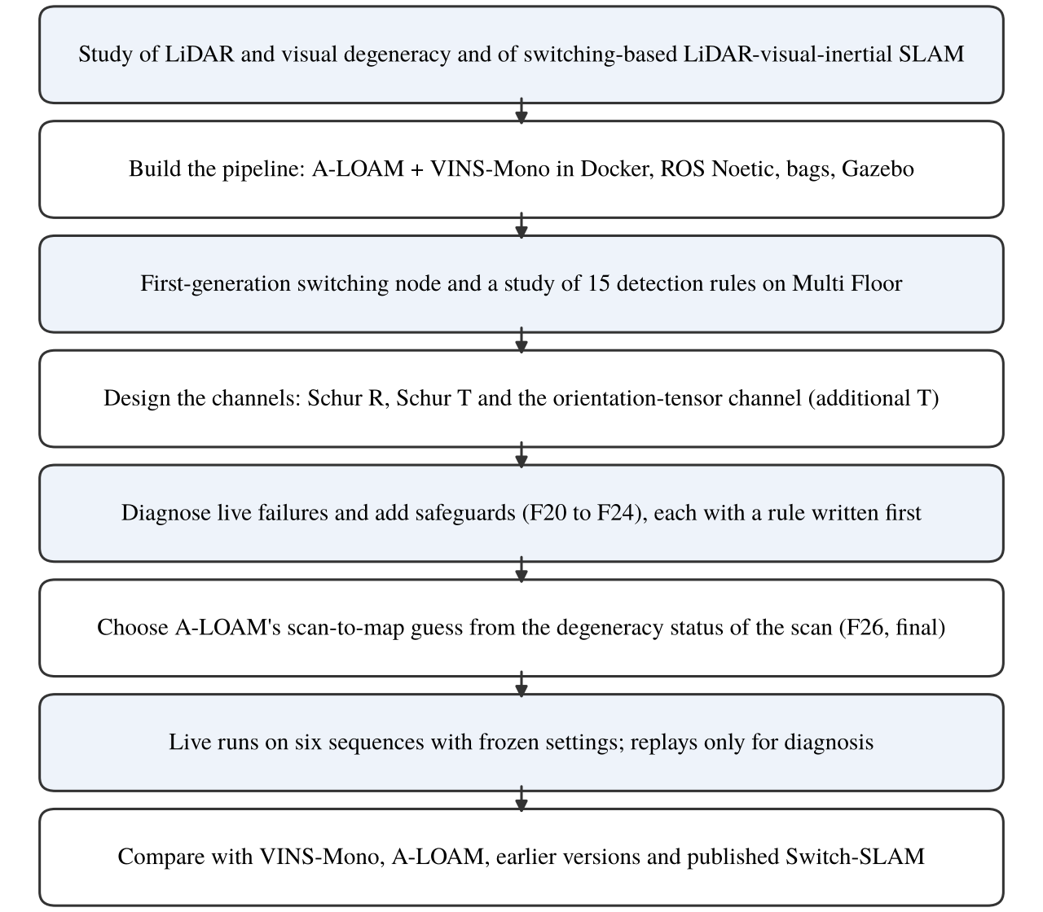
Figure 3.1: Flowchart of methodology
3.2 System overview
The fusion splits the work by direction (Figure 3.2). For every LiDAR scan the node receives A-LOAM's scan-to-map pose and Hessian and the pose of VINS-Mono. Rotation comes from VINS-Mono. Translation comes from the LiDAR along the directions the scan constrains and from VINS-Mono along the others. Where VINS-Mono is unusable (warm-up, loss, or a failed trust check), the LiDAR carries the whole step. The node forms the LiDAR increment (rotation vector φ_{L}, translation Δt_{L}) and the VINS increment (φ_{V}, Δt_{V}) since the previous scan and blends them with two 3 x 3 weights:
φ = W_{R} φ_{L} + (I - W_{R}) φ_{V} (3.1)
Δt = W_{t} Δt_{L} + (I - W_{t}) Δt_{V} (3.2)
The fused pose is the previous fused pose composed with this increment. W = 0 means the VIO carries a direction, W = I means the LiDAR carries it. For the first 20 s after VINS-Mono starts (T_{warm}) the output is LiDAR only, because a monocular VIO needs time to settle its scale; the same warm-up is repeated after VINS-Mono is lost (mode VO_FAIL: no message, a jump above 1 m or 0.5 rad, or a restart). The loop is closed: the fused pose, moved forward by a step chosen as in Section 4.5, is A-LOAM's initial guess for the next scan. A-LOAM here has no IMU of its own; inertial information reaches the LiDAR side only through VINS-Mono's pose.
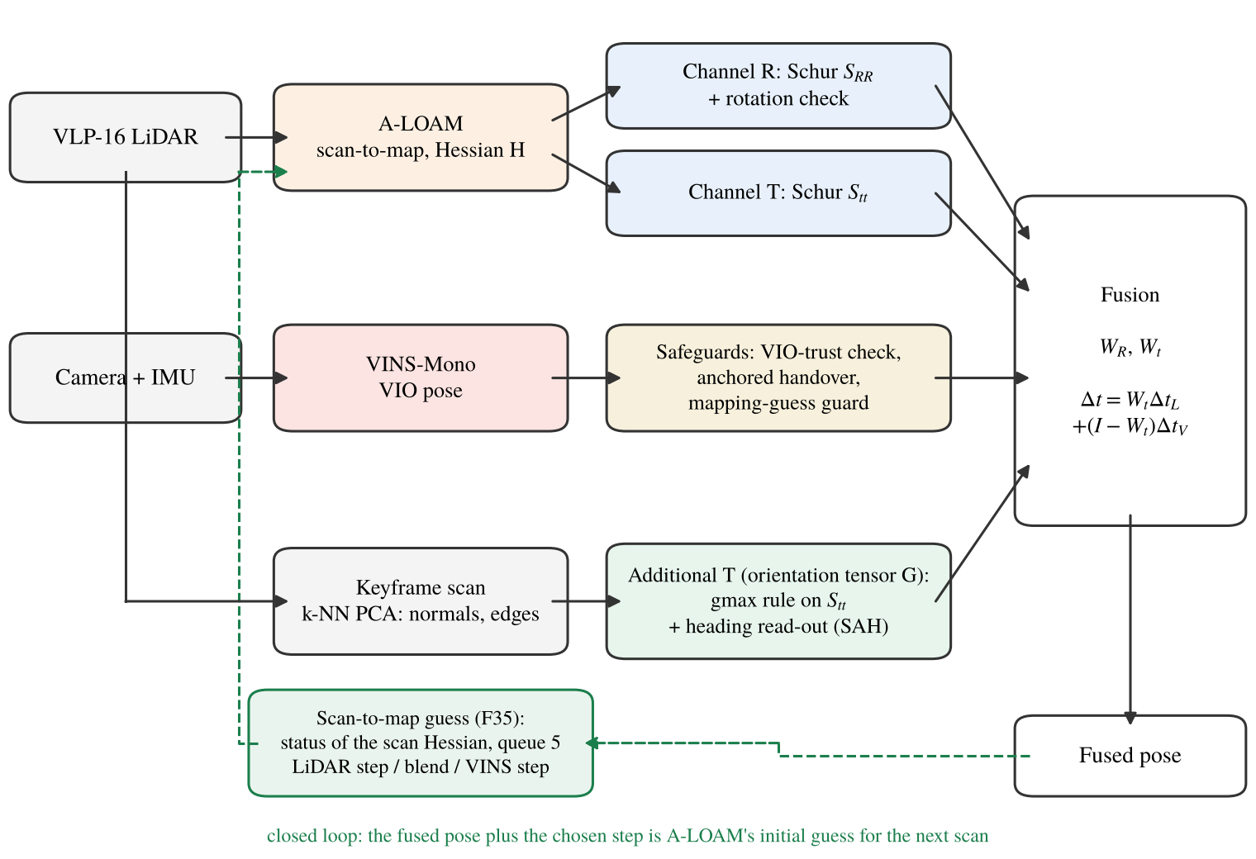
Figure 3.2: Structure of the fusion: channels R, T, the additional T and the scan-to-map guess
3.3 Schur decomposition of the registration Hessian
The A-LOAM Hessian is partitioned into rotation (R) and translation (t) blocks, with rotation in radians and translation in metres:
H = [ H_{RR} H_{Rt} ; H_{tR} H_{tt} ] (3.3)
The Schur complements give the information about one part after the other part has been estimated from the same data:
S_{RR} = H_{RR} - H_{Rt} H_{tt}⁻¹ H_{tR} (3.4)
S_{tt} = H_{tt} - H_{tR} H_{RR}⁻¹ H_{Rt} (3.5)
S_{tt} is the translation information that is left once the scan's rotation is free, and S_{RR} the reverse. Each is a 3 x 3 matrix in one unit, so its eigenvalues can be compared within the block. In a corridor S_{tt} has one small eigenvalue along the axis and two large ones across it.
3.4 Channel T: per-direction translation weight
The translation block is turned into a weight by treating the LiDAR increment as a measurement with information c_{T} S_{tt} and the VIO increment as a prior with information γ I:
W_{t} = (c_{T} S_{tt} + γ I)⁻¹ c_{T} S_{tt} (3.6)
Along an eigenvector of S_{tt} with eigenvalue λ the weight is c_{T}λ / (c_{T}λ + γ): close to 1 where the scene constrains the motion and close to 0 along a degenerate axis. There is no switching threshold; the condition-number gate of earlier versions is disabled (KAPPA_TH = 10⁹). The scale c_{T} = 0.03 was chosen once on Multi Floor recordings (smallest mean ATE, middle of the plateau) and has not been changed since. γ = 1 normally; Section 4.4 describes when it changes.
3.5 Channel R: rotation block and rotation check
With A-LOAM the VINS-Mono rotation was better than the LiDAR rotation on most sequences: an active rotation weight (c_{R} > 0) improved Long Corridor in early replays, while on Multi Floor, Corridor02 and Cave02 the VIO rotation gave the lower error, and an open-loop replay of the F35 logs with c_{R} from 10⁻⁵ to 3 x 10⁻³ gave Cave02 2.4 m higher at every setting (Table 5.12). In normal operation c_{R} = 0, the rotation comes from the VIO and S_{RR} is monitored. A rotation check compares the VIO and LiDAR rotations over 2 s and 10 s windows; when they disagree by more than 0.402 rad and 0.585 rad (the largest values on 19 Multi Floor recordings), the LiDAR rotation carries the step with W_{R} = (S_{RR} + 10⁻³ I)⁻¹ S_{RR}. The check closed on no fused scan of four sequences and on 3.6 % of those of GEODE, so it acts as a safeguard for strong disagreement.
3.6 Additional T channel: the orientation tensor
3.6.1 Tensor from the keyframe scan
For each LiDAR keyframe the 12 nearest neighbours of every point are found and their covariance is decomposed (eigenvalues λ₁ ≤ λ₂ ≤ λ₃). A point is planar when (λ₂ - λ₁)/λ₃ > 0.5, with normal n, and linear when (λ₃ - λ₂)/λ₃ > 0.5, with direction d. A plane constrains translation along its normal; an edge constrains translation in the plane perpendicular to its direction. The geometric orientation tensor counts both:
G = ( Σ_{planar} n n^{T} + ½ Σ_{linear} (I - d d^{T}) ) / (n_{p} + n_{l}) (3.7)
G has trace 1 and uses no correspondences, no solver state and no threshold. Between keyframes it is rotated into the current LiDAR frame. Planar normals alone understate the support that A-LOAM has from edge features such as door frames and pipes, so edge directions are included; rules built on planar normals alone gave corridor errors 0.26 to 1.0 m higher in replay.
3.6.2 Combining the tensor with S_{tt}
The tensor is scaled to the same total information as the solver, B = tr(H_{tt}) G, and combined with A = S_{tt} by a basis-free matrix rule. Several rules were compared by replay on clean data and under injected faults (Section 5.9). The final version uses the generalised maximum:
S'_{tt} = B^{½} max(M, I) B^{½}, M = B^{-½} A B^{-½} (3.8)
where max(M, I) raises every generalised eigenvalue below 1 to 1. Along each direction the combined information is the larger of what the solver and the raw geometry support, and S'_{tt} replaces S_{tt} in Equation 3.6. F20 used the opposite rule (the minimum, a fail-safe cap). The maximum was chosen in a pre-registered comparison because it scored best over the clean and fault cells and on a farm bag that the comparison had not used; protection against a solver that is confident but wrong comes from the VIO-trust check of Section 4.4.
3.6.3 Heading from the same normals
The second read-out of the normals corrects heading, which VINS-Mono cannot observe and which dominates the error in long corridors. The near-vertical planar normals of a keyframe are levelled with the VIO gravity direction, and their horizontal directions form an axial histogram h(θ) (0.5° bins over 180°). The heading error is the shift, searched over ±15°, that best aligns h(θ) with a reference histogram learned in the world frame; it passes through a Kalman update and is applied at no more than 0.25° per scan. It switches itself off when the structure is not distinct (a null-model test against random directions, a unique correlation peak, a chi-square gate and a drift gate). This structure-anchored heading (SAH) depends on the even-order orientation tensors of the same normals; the fourth order matters, because with two equally strong perpendicular wall families the second-order tensor is isotropic and carries no heading information.
CHAPTER 4
TEST SETUP
4.1 Introduction
This chapter describes the computing setup, the datasets, the Gazebo farm simulation and the procedure used for every run. The same scripts were used for all configurations, so a difference between two results comes from the configuration and from run-to-run variation, not from the procedure.
4.2 Computing and software setup
All live runs were made on one laptop running Ubuntu with Docker. ROS Noetic runs in separate containers on a Docker network, with the ROS master in the A-LOAM container (Figure 4.1). A-LOAM and the fusion node share one container, VINS-Mono runs in a second one, bags are played from a third, throw-away container, and a fourth container with the full ROS desktop shows the run live in RViz. roscore is restarted for every run so that no state carries over. The laptop has a Ryzen 5 5600H CPU, an Nvidia GTX 1650 GPU with 4 GB of video memory and 16 GB of RAM.
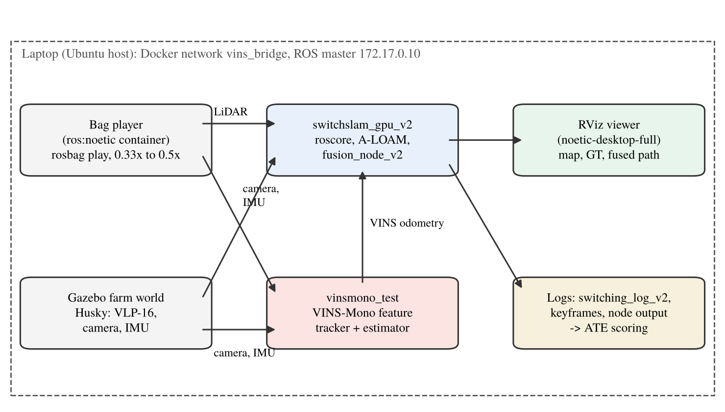
Figure 4.1: Layout of the experimental setup
Table 4.1: Software components
Component | Role | Notes
ROS Noetic, Docker | Middleware, isolation | One container per subsystem
A-LOAM [9] | LiDAR scan-to-map odometry | Publishes pose and 6 x 6 Hessian; initial guess from the fusion
VINS-Mono [6] | Monocular visual-inertial odometry | Configuration per sequence, not tuned
fusion_node_v2 (this work) | Channels R, T, additional T; safeguards; status guess | Python; settings by environment variables
Gazebo [27] + Husky model | Farm simulation | VLP-16, camera and IMU plugins
RViz viewer, scoring scripts | Live display, ATE and maximum error | Umeyama SE(3), no scale

4.3 Datasets
Five real sequences and one simulated route were used (Table 4.2, Figure 4.2): four from SubT-MRS [25], recorded at Carnegie Mellon University and in the Laurel Caverns, and one from GEODE [26], all with a 16-beam Velodyne LiDAR at 10 Hz, a camera and an IMU.
Table 4.2: Sequences used in this work
Sequence | Platform | Duration / path | LiDAR, camera, IMU topics | Ground truth | Role
SubT-MRS Multi Floor (Floor01) | Legged robot, building with stairs | 3 bags, 417 s, 273 m | /velodyne_packets (converted), camera, /imu/data | ground_truth_path.csv | Calibration of c_{T} and the safeguard constants
SubT-MRS Long Corridor (Corridor01) | Wheeled RC car | 279 s, 579 m, loop (start-end 3.3 m) | /velodyne_packets (converted), /camera_1/image_raw (24 Hz), /imu/data | corridor01_gt.txt, 1,385 poses at 5 Hz | Development (SAH, hand-over)
SubT-MRS Corridor02 (RC1) | Wheeled RC car | 893 s, 695 m; stationary for 70 s | /velodyne_points, /camera_1/image_raw, /imu/data | corridor02_gt.txt | First held out for F8; development for SAH
SubT-MRS Cave02 (Laurel Caverns) | Handheld | 956 s, 475 m; stationary for 45 s | /velodyne_points (9,471 scans), /camera_1/image_raw, /imu/data | cave02_gt.txt, 4,731 poses at 5 Hz | Control for SAH; development for F25 to F27
GEODE stairs, device α | Handheld, stairwell | 345 s, 301 m; 3,456 scans | /velodyne_points (VLP-16), /imu/data (100 Hz), stereo images at 10 Hz | stairs_alpha.txt, 3,447 poses | First test of F24; development for F25 to F27
Farm L route (Gazebo) | Husky robot, field | 323 s moving, 79 to 81 m | /velodyne_points (VLP-16), RGB 640 x 480 at 60 Hz, /imu/data (200 Hz) | Gazebo model pose, 20 Hz | Development (F24 guard); F35 run

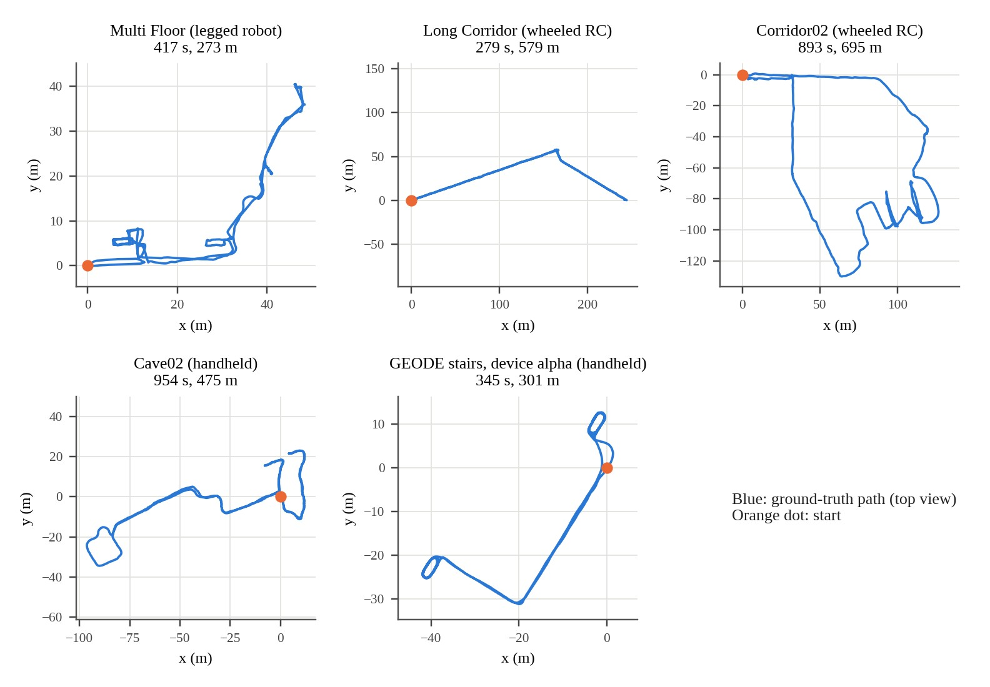
Figure 4.2: Ground-truth trajectories of the five real sequences (top view)
The SubT-MRS ground truth was obtained by registering the LiDAR against a survey map together with the platform odometry, so it is not fully independent of the sensors being tested and is weakest where the LiDAR degenerates; on Corridor02 its heading jumps by several degrees at some times, so only the position error is reliable there. The GEODE ground truth was obtained against a terrestrial laser scan. The residual time offsets between bag and ground truth were 0.03 s (Corridor02) and 0.04 s (Long Corridor).
4.4 Safeguards added after the live tests
VIO-trust check (F21). For every scan the ratio of VINS and LiDAR path lengths over 10 s windows inside one VINS segment is formed, and r is the RMS of ln(|Δt_{V}|/|Δt_{L}|). While r stays at or below 0.157 (and a fast 5 s version at or below 0.277), γ = 1 in Equation 3.6; otherwise γ = 0 and the LiDAR carries the step. Both references, and the guard constant below, were set from six Multi Floor calibration replays. A LiDAR guard works the other way: while the VINS is trusted, a LiDAR path that runs more than 4.325 m ahead of the VINS path within 2 s marks the LiDAR step as failed.
Anchored hand-over (F22, F23). In the live Long Corridor runs of F20 the fused heading jumped by 6 to 7° at the first fused scan: the warm-up had already integrated a fast turn with the LiDAR rotation, and VINS-Mono, which lagged by about 5°, added its catch-up of the same turn. At every entry into the fused mode the rotation is now reset to
R_{f} = R_{off} R_{vL}, R_{off} = mean_{k} ( R_{A,k} R_{vL,k}^{T} ) (4.1)
where R_{vL} is the LiDAR orientation predicted by VINS-Mono, R_{A,k} the A-LOAM orientation at warm-up scan k, and the mean is a robust chordal mean over all warm-up scans of the current VINS segment. VINS-Mono then continues from a reference consistent with itself, so its catch-up removes the transient instead of adding it.
Mapping-guess guard (F24). In a live farm run of F23 the error reached 5.3 m in the first 18 s, while VINS-Mono was failing. The likely cause, not proven by that single run, is that VINS steps of 1 to 3 m were passed into A-LOAM's initial guess and A-LOAM's odometry followed them. In F24 a VINS step counts as usable for the guess only when the previous mode was not VO_FAIL and the step is within the jump limits (1 m, 0.5 rad). The fused output itself is unchanged by this rule.
4.5 Scan-to-map guess from the degeneracy status (F35)
Up to F24 the guess for A-LOAM's scan-to-map matching was the last fused pose moved by the VINS-Mono step wherever that step was usable, and the last fused pose with no motion otherwise. On Cave02 and GEODE the no-motion guess was used on 13.5 % and 78 % of the scans, while VINS-Mono was starting or failing, and where the scan is well constrained the VINS step only adds VINS-Mono's noise to a match that does not need it.
F35 chooses the guess with the status rule of Switch-SLAM [10]. The six eigenvalues of H are computed and the three smallest, scaled to unit length, are compared with the published thresholds [0.12, 0.27, 0.48]; the scan is degenerate if any of them is below its threshold. The flags of the last five scans form a status queue. With Δ_{L} the A-LOAM scan-to-scan increment and Δ_{V} the VINS-Mono increment, the step added to the last fused pose is
Δ_{g} = Δ_{L} (none flagged), w Δ_{L} + (1 - w) Δ_{V} (mixed), Δ_{V} (all flagged) (4.2)
with w = min(1, √3 λ̄₁) from the smallest scaled eigenvalue (Eq. 13 of Switch-SLAM). A VINS step that fails the F24 guard counts as absent. Only A-LOAM's starting point changes; the output is still the fusion of Equations 3.1 and 3.2. The output is not switched or remapped as in Switch-SLAM: that structure, with A-LOAM's pose as the output and our channels as the detector, was tested as F30 to F34; the weighted fusion was lower on every sequence they were run on (Table 5.12).
A variant, F26, drives the same queue with channels R, T and the additional T instead of the published thresholds. It put the VINS step into the guess on 73 % of the Long Corridor scans (F35: 2 %). On the four sequences with runs the reading rule written beforehand gave no change against F35: Corridor02 was higher (2.82 against 1.99 m) and the others were inconclusive. F35 remains the final version. Table 5.5 sets F26 and F35 side by side on every sequence.
4.6 Tested Configurations and the final configuration
Each configuration is a set of environment variables passed to the fusion node; Table 4.3 lists those referred to in this report. No constant was fitted to a test sequence after F20; the new constants of F21 come from Multi Floor, F22 to F24 add none, and the thresholds of F35 are the published ones.
Table 4.3: Configurations used in this work
Config | Settings | Purpose
F0 | VINS-Mono only | Visual-inertial control
F1 / F2 | c_{T} 0.003, κ gate 15.7 / Otsu [28] | First gated method
F3 | c_{T} 0.003, no gate | Gate ablation
F4 / F5 | LiDAR only, with / without VINS prediction | LiDAR baselines
F7 to F10 | c_{T} 0.01 / 0.03 / 0.1 / 0.3, no gate | Weight sweep; F8 = channel T
F11 / F13 / F15 | Isotropic / per-direction 0-1 / diagonal H_{tt} | Weighting ablation
F12 | Hard switch with the Switch-SLAM rule | Switching baseline
F14 | W = I (LiDAR translation always) | LiDAR-translation baseline
F16 | F8 + SAH | Channel T and heading
F20 | F16 + Schur R, rotation check, OT min rule | R, T and additional T
F21 | OT gmax rule; VIO-trust check; LiDAR guard | VINS scale failures
F22 / F23 | F20 / F21 + anchored hand-over | Heading step at hand-over
F24 | F23 + mapping-guess guard | Farm start transient
F25A | F24, no hand-over while VINS is distrusted | Not adopted
F26 | F24 + guess from the status given by our channels | No change shown against F35
F27 | F24 + A-LOAM step instead of no motion | Not adopted
F30 to F34 | Switch-SLAM structure with our channels | Not adopted
F35 | F24 + guess from the degeneracy status | Final configuration
SW / SWI | Switch-SLAM in this stack (SWI: gyro prior) | Reproduction attempt

F35 is chosen as the final version. It keeps all three channels and every safeguard of F24 and changes only A-LOAM's starting point. Against F24 it was lower on GEODE, Cave02 and the farm, level on Multi Floor and Long Corridor and higher on Corridor02, each from one to four runs (Section 5.5). Its constants are listed in Table 4.4.
Table 4.4: Frozen constants of the final version F35
Constant | Value | Source
c_{T} (translation information scale) | 0.03 | Multi Floor, once
c_{R} (rotation, normal operation) | 0 | Replay: the VIO rotation gave the lower error with A-LOAM
Warm-up T_{warm} | 20 s | Design value
Jump limits | 1 m, 0.5 rad | Design value
Rotation check references | 0.402 rad / 2 s, 0.585 rad / 10 s | Largest on 19 Multi Floor recordings
VIO-trust references | 0.157 (10 s), 0.277 (5 s) | Largest on six Multi Floor replays
LiDAR guard | 4.325 m over 2 s | Six Multi Floor replays
Tensor k-NN, planarity / linearity | 12, 0.5 / 0.5 | Shared with SAH
SAH search, step limit | ±15°, 0.25° per scan | Developed on Long Corridor and Corridor02
Status thresholds, queue | 0.12, 0.27, 0.48; 5 scans | Published values of Switch-SLAM
Guess blend weight w | min(1, √3 λ̄₁) | Switch-SLAM, Eq. 13

4.7 Evaluation metrics and protocol
The accuracy measure is the absolute trajectory error [29]. The estimated positions p_{i} are aligned to the ground truth g_{i} by the rigid transformation (R, t) that minimises the squared error, without scale (Umeyama [30]), over the full span of the run, and
ATE = ( (1/N) Σ_{i} || R p_{i} + t - g_{i} ||² )^{½} (4.3)
The maximum of ||R p_{i} + t - g_{i}|| is reported beside it, as in Switch-SLAM, and all results are front end only, without loop closure. A replay feeds the logged A-LOAM and VINS-Mono poses of a run through the real fusion node; it is exact for the fusion but open loop, because A-LOAM is not re-seeded. Only live runs are compared with published numbers, and differences below max(0.1 m, 10 %) are treated as ties.
The statistics follow Ganesan et al. [31]: minimum, median, maximum and mean per environment, a success rate (here a run with ATE ≤ 10 m), and a one-sided test of H₀: M(baseline) = M(proposed) against H₁: M(baseline) > M(proposed) at 95 %, here the exact Mann-Whitney U test on separate live runs, with the Welch t-test beside it where both groups have two or more runs. With n₁ and n₂ runs the exact test cannot go below p = 1 / C(n₁ + n₂, n₂). Cave02 and GEODE were first held out, but the F24 results on them led to F25 to F27, so all six sequences are development data for F35.
4.8 Gazebo farm simulation
The farm test uses the Clearpath agriculture world in Gazebo with a Husky robot carrying a VLP-16 LiDAR (10 Hz), an RGB camera (640 x 480, 60 Hz) and an IMU (200 Hz), the sensor set given for the simulated robot of Switch-SLAM (Figure 4.3). A waypoint driver moves the robot along an L-shaped route, (0, 0) to (0, -40) to (-40, -40), at 0.25 m/s, turning in place at the start and at the corner. The ground truth is the Gazebo model pose. After Gazebo, A-LOAM, VINS-Mono (initialised by a short wiggle) and the fusion node are started, the robot is reset to the origin and the driver starts once the node is fused. The early runs used a camera looking to the robot's right; the F24 and F35 runs of Section 5.8 used the same camera facing forward.
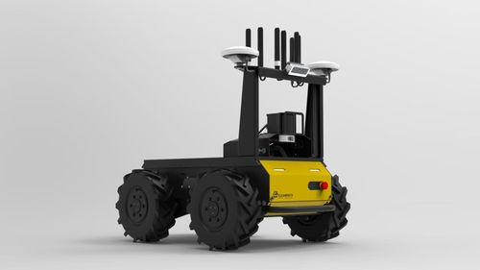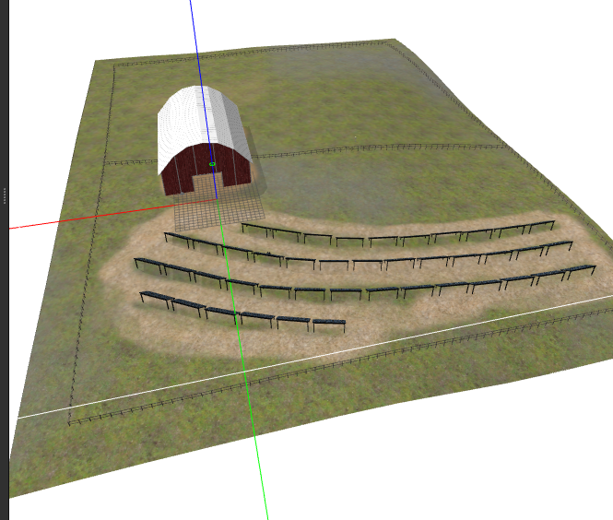
Figure 4.3: Gazebo agriculture world with the Husky robot
4.9 Replay rate and acceptance of runs
A replay can lose scans if the computer cannot process them in real time, so the replay rate was lowered where needed, chosen from the row counts alone before any error was seen, and runs were accepted only if they contained enough scans (Table 4.5). The fusion node writes one log row per scan (fused, A-LOAM and VINS-Mono poses, weights, Hessian, tensor and heading values, guess kind, mode) and stores the keyframe scans for replays and map renders. Failed starts and diverged runs are reported, not discarded.
Table 4.5: Replay rates and scans logged per run
Sequence | Rate | Scans per run (ideal) | Note
Multi Floor | 1.0x | 3,100-3,400 (about 4,170) | About 20-25 % of scans skipped; all F0-F10 results at this rate
Long Corridor | 1.0x | 2,758-2,774 (about 2,777) | Complete
Corridor02, attempt 1 | 1.0x | 4,628-5,554 (about 8,900) | About 40 % skipped; all 8 runs discarded before scoring
Corridor02 | 0.33x | 8,191-8,282 | Used for all later Corridor02 results
F16 on Long Corridor / Multi Floor / Corridor02 | 0.5x / 0.5x / 0.33x | 2,775 / 4,082-4,110 / 8,265-8,355 | Heading worker never skips a keyframe
Cave02 | 0.5x | 9,441-9,454 | Complete
F20 to F35 on Multi Floor / Long Corridor / Corridor02 | 0.5x / 0.5x / 0.33x | 4,086 / 2,776 / 8,391-8,418 | Complete (F35 counts)
F24 to F27 on Cave02 / GEODE | 0.5x / 0.5x | 9,452 / 3,307-3,353 | Complete; GEODE at 0.25x gave no gain

4.10 Baselines
The baselines are VINS-Mono alone (F0 runs; on GEODE and the farm, the VINS-Mono output logged in the fused runs, which is valid because VINS-Mono takes no input from the fusion), A-LOAM alone (F5), F8 (channel T only) and F24. Switch-SLAM's published front-end results [10] (Multi Floor 1.61 / 3.63 m, Long Corridor 2.42 / 5.09 m, Farm 0.38 / 1.10 m, RMSE / maximum) are the external targets; an implementation of Switch-SLAM in this stack did not reproduce them (Table 5.12).
Three of the ten datasets of Switch-SLAM are compared here: Multi Floor, Long Corridor and the farm. The comparison is not like for like. Switch-SLAM matches each scan to its map with a LiDAR-inertial front end, starts the match from a guess propagated with the IMU, and switches between the LiDAR and visual estimates. A-LOAM has no IMU, and this work blends the two estimates direction by direction. The published values are means of three runs, while the values here come from one to four runs, cover the front end only and are scored with the protocol of Section 4.7.
CHAPTER 5
RESULTS AND DISCUSSION
5.1 Introduction
This chapter reports the tests in the order they were made, followed by the final results and the comparison with published work. Table 5.1 gives an overview. Section 5.2 covers the first-generation switching node, Sections 5.3 to 5.5 the effect of each version and what the channels and the guess rule do inside a run, Sections 5.6 to 5.10 the live results of the final version, Section 5.11 the statistical tests, Section 5.12 the comparison with published values and the other tests, and Section 5.13 the discussion. Unless stated otherwise, every value is the full-span ATE RMSE in metres with rigid SE(3) alignment and no scale.
Table 5.1: Overview of the test phases
Phase | Test | Kind | Scale
1 | Old detector checks, Gazebo log | Synthetic + simulation | 400-800 trials; 4,017 frames
2 | Verification of the redesign (S1-S7) | Synthetic ICP Monte Carlo | 5 seeds, 200-4,000 runs per check
3 | Old vs new pipeline, 2 x 2 x 2 factorial | Synthetic 30 m drive | 5 scenarios x 5 seeds x 8 pipelines
4 | Channel T statistics | Real log + simulation | 3,932 frames; 1,500-3,000 repetitions
5-6 | Old node reference; 15 detection rules | Live ROS | 3 + 15 runs
7-8 | Fusion node: offline evidence, F0-F5, c_{T} sweep | Replay + live | 40 runs
9-10 | Loop closure; weighting ablation | Offline | 11 recordings; 12 logs x 9 rules
11 | Long Corridor | Live + replay | 15 runs
12 | Corridor02 test | Live + replay | 17 scored runs
13-14 | Yaw-drift diagnosis; SAH development | Replay with ground truth | 12 logs x 7 versions
15-18 | SAH live (F16), six runs per sequence, back end | Live + offline | 21 runs; 18 back-end runs
19 | Cave02 control | Live | 9 runs
20-21 | Improvement replays; statistical tests | Offline | Replays of the F8 and F16 logs
22 | Orientation-tensor channel; injected faults; F20 | Replay + live | 12 logs per rule; F20 live on four sequences
23 | F21 to F24: VIO-trust check, hand-over, guess guard | Replay + live | Multi Floor, Long Corridor, farm
24 | F24 on all sequences; Switch-SLAM in this stack | Live | 20 F24 runs (with phase 26)
25 | F25 to F27: guess rules; forward-camera farm rig | Live | F25A 2, F35 6, F27 2 runs
26 | F35 and F27 repeats; F30 to F34 and F26; c_{R} replay | Live + replay | F35 3 and F27 2 more; 15 runs of F30 to F34 and F26; 56 replays

5.2 First-generation switching node and the threshold study
The old switching node gave 1.39 ± 0.14 m on Multi Floor over three runs, against 1.32 m for VINS-Mono alone. Its logs showed three faults: the LiDAR-only mode used scan-to-scan odometry instead of the scan-to-map result, the VINS and LiDAR world frames (8 to 62° apart) were mixed without a rotation, and the largest error came from the VINS start-up transient.
Fifteen detection rules were then run live, one run each, with only the rule changed in the node (Table 5.2). The labels were the A-LOAM drift terciles in 8 s windows on bags 1 and 2 of Multi Floor, which none of the detectors can see, and each rule was scored by Youden's index J = TPR - FPR. An offline screen had predicted J for every rule beforehand, and 13 of the 15 predictions were within 0.05.
Table 5.2: Threshold study on Multi Floor (one live run per rule)
Rule | Description | ATE (m) | Flagged | TPR | FPR | J
A1 | Switch-SLAM semicircle | 3.05 | 0.891 | 0.907 | 0.884 | 0.023
A2 | κ(S) > 10 (DCReg) | 12.49 | 0.551 | 0.742 | 0.495 | 0.247
A3 | κ(S) > 50 | 15.98 | 0.029 | 0.061 | 0.019 | 0.042
A4 | Diagonal κ > 10 | 13.70 | 0.559 | 0.734 | 0.479 | 0.255
A5 | λ_{min}(S) < 100 | 10.88 | 0.741 | 0.969 | 0.803 | 0.166
A6 | Never flag | 17.67 | 0.000 | 0.000 | 0.000 | 0.000
A7 | κ(H) > 10 | 1.38 | 0.979 | 0.970 | 0.992 | -0.022
A8 | κ(S_{RR}) > 15.7 (Otsu) | 16.27 | 0.334 | 0.584 | 0.105 | 0.479
B1 | λ_{min}(T) < 0.15 (old channel T) | 7.50 | 0.838 | 0.973 | 0.858 | 0.115
B2 | κ(T) > 10 | 14.66 | 0.575 | 0.717 | 0.562 | 0.155
B3 | λ_{min}(T) ≤ 0.045 | 16.12 | 0.245 | 0.293 | 0.307 | -0.014
B4 | Woodcock K < 1 | 3.26 | 0.823 | 0.803 | 0.885 | -0.082
B5 | Demantke class | 11.97 | 0.725 | 0.894 | 0.630 | 0.264
C1 | A2 or B3 | 10.80 | 0.658 | 0.751 | 0.599 | 0.152
C2 | A2 or B2 | 8.39 | 0.739 | 0.847 | 0.735 | 0.112

The best detector was A8, the condition number of the rotational Schur block with a threshold found by Otsu's method [28] (J = 0.479, precision 0.817). The old channel T was checked against a rule set before the runs, which required it to add at least 0.05 to J: combined with the Schur test it gave J of 0.152 (C1) and 0.112 (C2) against 0.247 for A2. The more important finding is shown in Figure 5.1. The ATE did not follow the detection quality; it followed the share of time in which control was handed to VINS-Mono (Spearman correlation -0.95). Rules that flagged almost everything (A7) gave a low error because they used VINS-Mono most of the time, and the lowest error on this sequence came from VINS-Mono alone. On this sequence a switching system cannot be judged by how well it detects degeneracy, and switching throws away LiDAR translation that is still good. This result led directly to the per-direction weighting of Chapter 3.
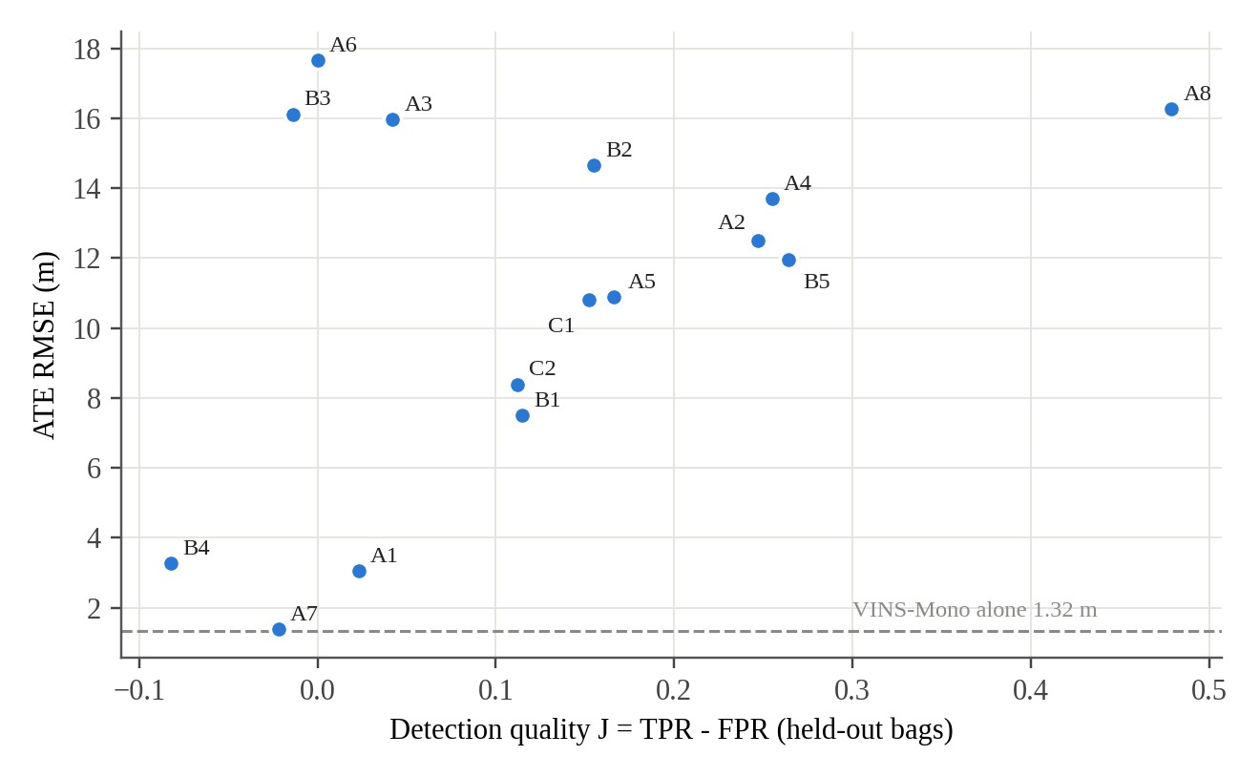
Figure 5.1: Detection quality against trajectory error for the 15 rules
5.3 Effect of each version (replay)
Table 5.3 replays the 12 development logs (6 Multi Floor, 3 Long Corridor, 3 Corridor02) through each version. Because the replay is open loop, F24 equals F23 here, and F35, which changes only A-LOAM's starting point, cannot be replayed at all. The largest single step is the heading read-out: from F8 to F16 the Long Corridor error fell from 4.53 to 1.98 m. The tensor cap of F20 is neutral on clean data (within 0.03 m of F16). The gmax rule and the VIO check of F21 improve Corridor02 by 0.14 m. The anchored hand-over lowers the Long Corridor maximum from 5.48 to 3.57 m (F20 to F22) and from 5.39 to 3.51 m (F21 to F23), and lowers Multi Floor by about 0.05 m.
Table 5.3: Replay of the 12 development logs, mean ATE RMSE / maximum (m)
Version | Multi Floor (6) | Long Corridor (3) | Corridor02 (3)
F8 (channel T only) | 0.626 / 1.33 | 4.533 / 12.89 | 2.119 / 3.77
F16 (T + heading) | 0.560 / 1.06 | 1.983 / 5.42 | 1.709 / 2.85
F20 | 0.558 / 1.06 | 2.010 / 5.48 | 1.710 / 2.87
F21 | 0.583 / 1.10 | 1.970 / 5.39 | 1.571 / 2.65
F22 | 0.506 / 0.99 | 1.743 / 3.57 | 1.709 / 2.87
F23 = F24 (open loop) | 0.531 / 1.03 | 1.703 / 3.51 | 1.569 / 2.64
Switch-SLAM (published, LiDAR-inertial) | 1.61 / 3.63 | 2.42 / 5.09 | not reported

5.4 Behaviour of the channels in a corridor
Figure 5.2 shows the channels during the live Long Corridor run of F35. After the 20 s warm-up the largest eigenvalue of W_{t} stays near 0.9 (median 0.91): across the corridor the LiDAR carries the motion. The smallest eigenvalue, along the corridor axis, has a median of 0.69, so VINS-Mono carries about a third of the motion along the axis and more in the weakest stretches. The tensor ratio λ'/λ has a median of 1.003 and a 95th percentile of 1.07, so the raw geometry rarely claims more than the solver. The heading read-out accumulates up to -4.7° of correction, in steps where distinct wall structure is seen and flat where it switches itself off.
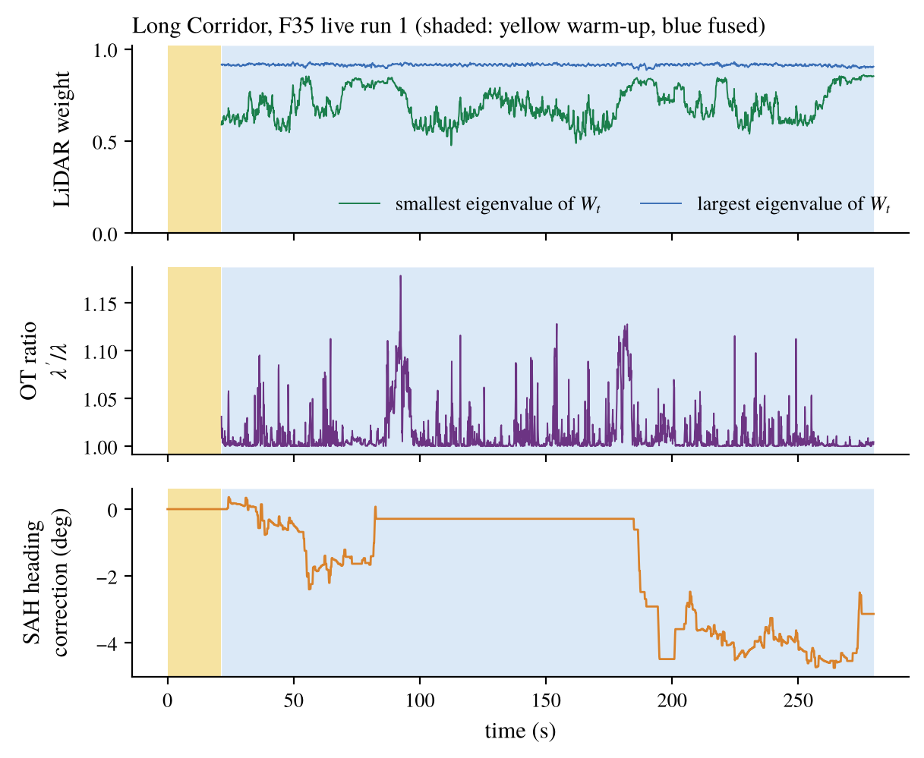
Figure 5.2: Channel T weight, tensor ratio and heading correction, Long Corridor, F35 live run
5.5 What the status rule puts into the guess
Table 5.4 counts the guess kinds in the F35 logs. On the five real sequences the published thresholds flag few scans, so the guess is A-LOAM's own scan-to-scan step on 94 to 100 % of them, and on Cave02 on every scan. F35 is therefore close to F24 with A-LOAM's usual guess. The farm route is the exception: the rule flagged the last 25 m of the L and the standing time at the end, and the VINS step was used on 32 % of the scans. In F24 the VINS step was used on every scan where it passed the guard, and the no-motion guess on the rest (13.5 % of the Cave02 scans and 78 % of the GEODE scans).
Table 5.4: Guess kinds in the F35 live runs (share of scans) and the effect against F24
Sequence | A-LOAM step | Blend | VINS step | F35 against F24, ATE (m)
Multi Floor | 98.5 % | 0.5 % | 1.0 % | 0.54 against 0.45 to 1.01 (tie)
Long Corridor | 95.4 % | 2.8 % | 1.7 % | 2.10 against 1.75 to 2.15 (tie)
Corridor02 (2 runs) | 97.7 to 97.8 % | 1.4 to 1.5 % | 0.8 % | 1.93, 2.04 against 1.29, 1.47 (higher)
Cave02 | 100 % | 0 % | 0 % | 6.23 against 7.08 to 7.55 (lower)
GEODE stairs (3 runs) | 93.6 to 95.3 % | 2.3 to 3.4 % | 2.3 to 2.9 % | mean 5.04 against 7.23 (lower)
Farm L route | 67 % | 0.6 % | 32 % | 0.29 against 0.47 (lower)

The effect follows the health of VINS-Mono. Where it starts late or fails (Cave02, GEODE), dropping its motion from the guess helped: every 120 s block of the Cave02 run of F35 was lower than in the F24 run, by 2.0 to 2.3 m in the first 240 s and 0.6 to 0.9 m later. Where it is healthy and the scan is not flagged (Corridor02, no VO_FAIL), keeping its motion in the guess was better by about 0.5 m. Both comparisons rest on one to four runs per version.
F26 and F35 differ only in how the status of the scan is decided for A-LOAM's initial guess: F26 uses our own channels R, T and the additional T, and F35 uses the published thresholds. Table 5.5 compares them. F35 was lower on Multi Floor (0.54 against 0.66 and 0.80 m) and on Corridor02 (1.99 against 2.82 m), so the published thresholds added something there. On Long Corridor, GEODE and the farm the two gave similar results, within the tie band or within the spread of the runs. With one to three runs per entry this is an indication, not a test.
Table 5.5: F26 and F35 on the same sequences, ATE RMSE / maximum (m)
Sequence | F26 (channels only) | F35 (final, thresholds and channels) | Reading
Multi Floor | 0.80 / 1.37; 0.66 / 1.12 | 0.54 / 1.01 | F35 lower (one run)
Long Corridor | 1.99 / 3.54; 2.40 / 4.51 | 2.10 / 3.73 | Similar
Corridor02 | 2.82 / 5.19 | 1.93 / 3.46; 2.04 / 3.46 | F35 lower
GEODE stairs | 4.72 / 17.33; 4.39 / 10.65; 6.02 / 20.55 (mean 5.04) | 6.36 / 14.07; 3.26 / 7.81; 5.51 / 15.25 (mean 5.04) | Same mean
Farm L route | 0.292 / 0.583 (first 4,000 rows) | 0.290 / 0.562 | Similar
Cave02 | no run | 6.23 / 10.56 | Not compared

5.6 Live results of the final configuration
Table 5.6 gives every live front-end result of F35 with the baselines in the format of Table 1 of [31]: minimum, median, maximum and mean ATE over the live runs, the mean of the per-run maximum error, and the improvement of F35, (baseline mean - F35 mean) / baseline mean. An upward arrow means F35 has the lower error. F35 is lower than VINS-Mono alone and A-LOAM alone on every sequence, by 39 to 98 %. Against F8 it is lower on Multi Floor (12 %), Long Corridor (54 %) and Corridor02 (6 %) and higher on Cave02 (39 %). Against F24 the mean is lower on Multi Floor, Cave02, GEODE and the farm and about equal on Long Corridor, but on Multi Floor the F35 run lies inside the F24 spread (0.45 to 1.01 m). On Corridor02 the F24 mean includes its run of 104 m, while its median (1.47 m) is lower than that of F35 (1.99 m).
Table 5.6: Live front-end results of F35 and the baselines, ATE RMSE (m) and improvement of F35
Sequence | Method | n | Min | Median | Max | Mean | Impr. | Max err., mean | Impr.
Multi Floor | VINS-Mono alone | 3 | 1.25 | 1.29 | 1.29 | 1.277 | ↑ 57.7 % | 2.47 | ↑ 59.1 %
 | A-LOAM alone | 3 | 13.20 | 30.69 | 35.43 | 26.44 | ↑ 98.0 % | 49.38 | ↑ 98.0 %
 | F8 | 9 | 0.47 | 0.59 | 0.77 | 0.617 | ↑ 12.4 % | 1.34 | ↑ 24.8 %
 | F24 | 3 | 0.45 | 0.69 | 1.01 | 0.717 | ↑ 24.7 % | 1.30 | ↑ 22.1 %
 | F35 | 1 | 0.54 | 0.54 | 0.54 | 0.540 | - | 1.01 | -
Long Corridor | VINS-Mono alone | 3 | 5.65 | 5.66 | 6.13 | 5.813 | ↑ 63.9 % | 15.54 | ↑ 76.0 %
 | A-LOAM alone | 3 | 11.21 | 13.21 | 23.01 | 15.81 | ↑ 86.7 % | - | -
 | F8 | 3 | 3.97 | 4.76 | 4.87 | 4.533 | ↑ 53.7 % | 12.89 | ↑ 71.1 %
 | F24 | 3 | 1.75 | 2.12 | 2.15 | 2.007 | ↓ 4.6 % | 4.80 | ↑ 22.3 %
 | F35 | 1 | 2.10 | 2.10 | 2.10 | 2.100 | - | 3.73 | -
Corridor02 | VINS-Mono alone | 3 | 4.02 | 4.03 | 4.03 | 4.027 | ↑ 50.7 % | 6.75 | ↑ 48.7 %
 | A-LOAM alone | 3 | 46.53 | 58.57 | 92.95 | 66.02 | ↑ 97.0 % | - | -
 | F8 | 3 | 2.07 | 2.10 | 2.19 | 2.120 | ↑ 6.4 % | 3.76 | ↑ 8.1 %
 | F24 | 3 | 1.29 | 1.47 | 104.00 | 35.59 | ↑ 94.4 % | 51.46 | ↑ 93.3 %
 | F35 | 2 | 1.93 | 1.99 | 2.04 | 1.985 | - | 3.46 | -
Cave02 | VINS-Mono alone | 3 | 10.21 | 10.26 | 10.26 | 10.243 | ↑ 39.2 % | - | -
 | F8 | 3 | 4.31 | 4.40 | 4.71 | 4.473 | ↓ 39.3 % | 6.75 to 7.74 | ↓
 | F24 | 3 | 7.08 | 7.11 | 7.55 | 7.247 | ↑ 14.0 % | 12.06 | ↑ 12.4 %
 | F35 | 1 | 6.23 | 6.23 | 6.23 | 6.230 | - | 10.56 | -
GEODE stairs | VINS-Mono alone | 7 | 153.1 | 186.6 | 271.6 | 204.6 | ↑ 97.5 % | 808.7 | ↑ 98.5 %
 | F24 | 4 | 6.15 | 6.81 | 9.15 | 7.228 | ↑ 30.2 % | 18.25 | ↑ 32.2 %
 | F35 | 3 | 3.26 | 5.51 | 6.36 | 5.043 | - | 12.38 | -
Farm L route | VINS-Mono alone | 2 | 4.31 | 9.39 | 14.47 | 9.390 | ↑ 96.9 % | 16.76 | ↑ 96.6 %
 | A-LOAM alone | 1 | 0.478 | 0.478 | 0.478 | 0.478 | ↑ 39.3 % | 0.98 | ↑ 42.5 %
 | F8 (sideways camera) | 1 | 0.490 | 0.490 | 0.490 | 0.490 | ↑ 40.8 % | 0.75 | ↑ 25.1 %
 | F24 (same rig) | 1 | 0.472 | 0.472 | 0.472 | 0.472 | ↑ 38.6 % | 1.07 | ↑ 47.4 %
 | F35 | 1 | 0.290 | 0.290 | 0.290 | 0.290 | - | 0.56 | -

Figure 5.3 shows the F35 trajectories on the four sequences with the clearest structure; the fused paths follow the ground truth where VINS-Mono alone drifts in heading (Long Corridor) or in scale (farm). A-LOAM's own mapped pose, seeded by the fusion, scored lower than the fused output on Long Corridor (1.00 against 2.10 m) and Corridor02 run 1 (1.17 against 1.93 m), and higher on Multi Floor (1.92 against 0.54 m) and Corridor02 run 2 (2.52 against 2.04 m), so a rule for choosing between the two is open.
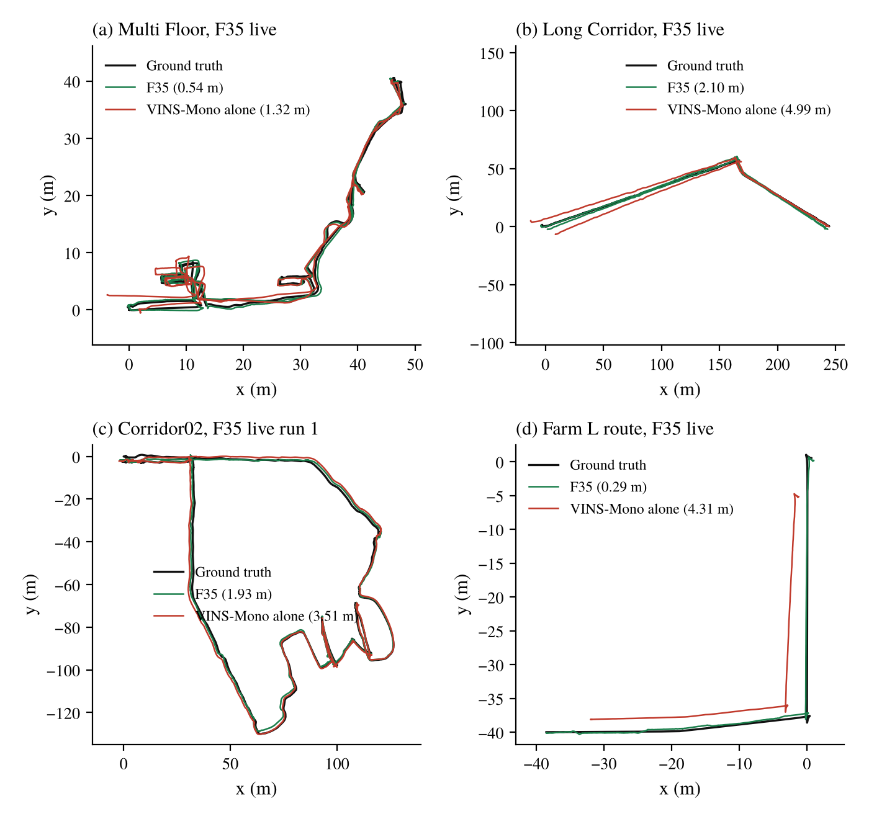
Figure 5.3: Top-down trajectories of F35 against ground truth (RMSE in brackets)
5.6.1 Multi Floor
Figure 5.4 shows the Multi Floor run of F35 on the map built in that run. The F35 path (0.54 / 1.01 m) stays closest to the ground truth. In the same run A-LOAM's own output scored 1.92 / 5.26 m and VINS-Mono alone 1.32 / 4.77 m. The published value for Switch-SLAM, a LiDAR-inertial system, is 1.61 / 3.63 m.
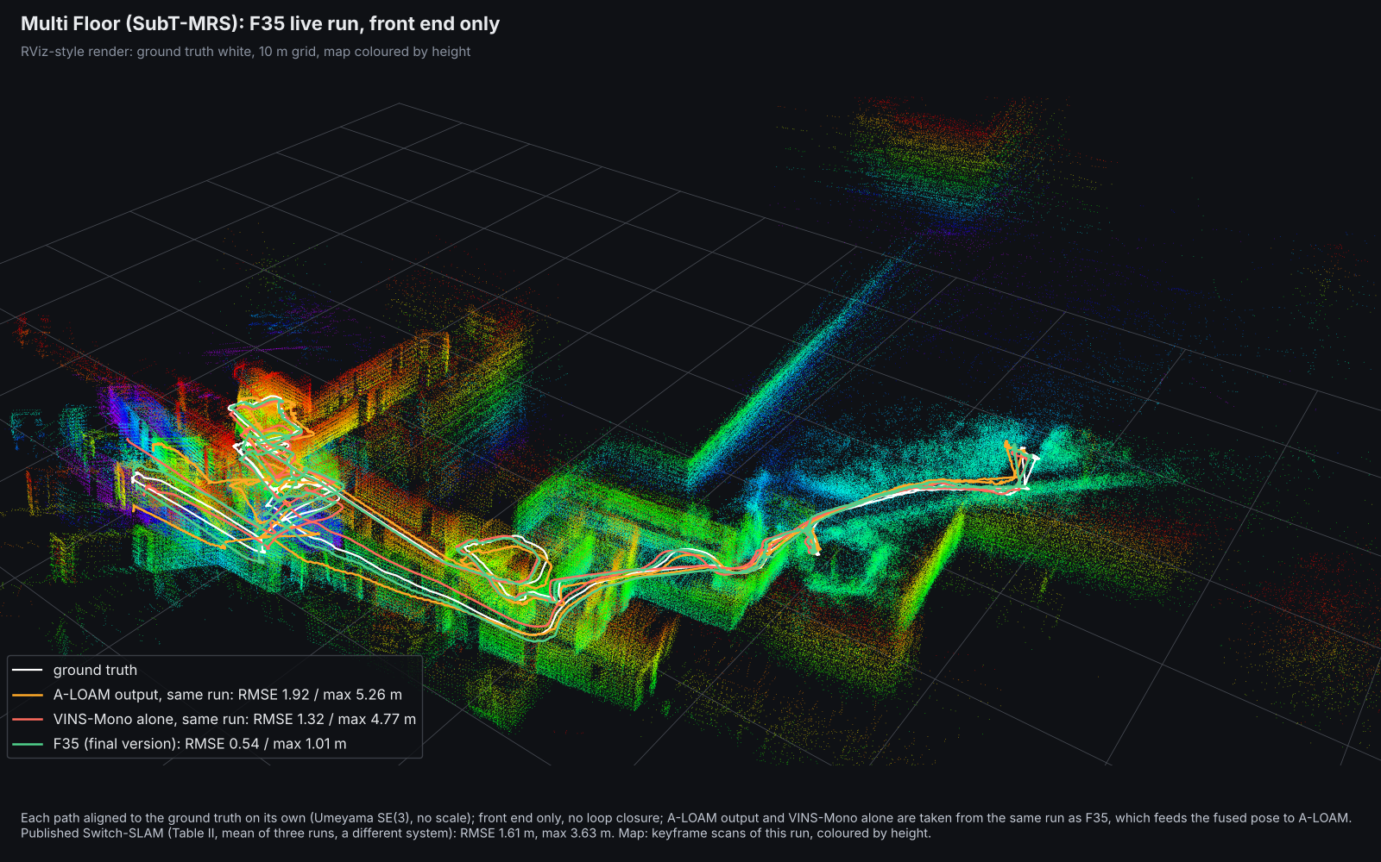
Figure 5.4: Multi Floor: ground truth (white), F35 (green), A-LOAM output (orange) and VINS-Mono alone (red), same run, map coloured by height
5.6.2 Corridor02
Figure 5.5 shows the first F35 run on Corridor02 (1.93 / 3.46 m; the second run gave 2.04 / 3.46 m). In the same run A-LOAM's own output scored 1.17 / 2.12 m and VINS-Mono alone 3.51 / 8.35 m, so on this sequence A-LOAM's own output was lower than the fused path. No Switch-SLAM value is published for this sequence.
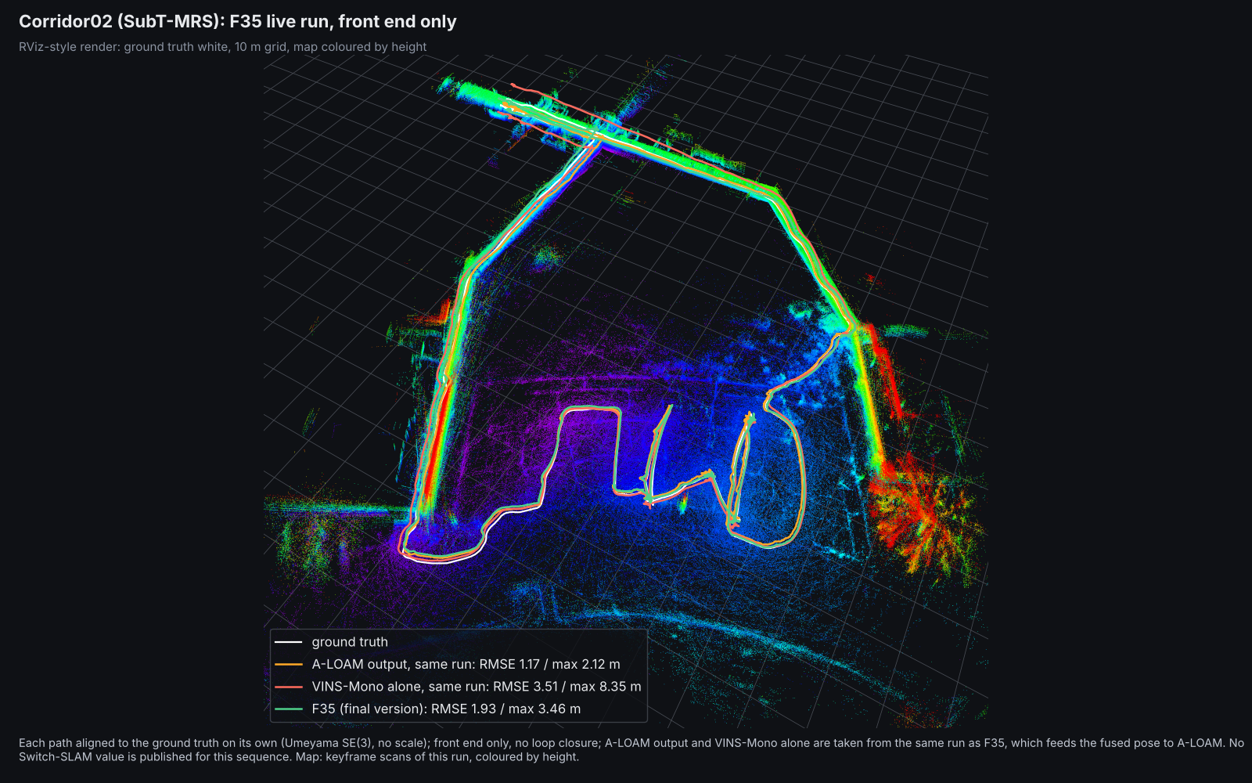
Figure 5.5: Corridor02: ground truth (white), F35 (green), A-LOAM output (orange) and VINS-Mono alone (red), same run, map coloured by height
5.7 Long Corridor maximum error
In two of the three Long Corridor runs of F24 the maximum error (5.31 and 5.57 m) exceeded Switch-SLAM's 5.09 m. In run 1 it occurred at 9.6 s, inside the LiDAR-only warm-up, when A-LOAM's direction of travel was 3.4° off the ground truth; the start is 135 m from the centroid of the path, about which the full-span alignment pivots, so a 2° heading error there becomes about 5 m. After 30 s the error stayed between 0.8 and 2.3 m. The F35 run stayed within the bound (3.73 m), as did the two F26 runs (3.54 and 4.51 m). A shorter warm-up of 10 or 5 s was replayed: it lowered the replayed Long Corridor maximum from 3.51 to 2.97 and 2.85 m but raised Multi Floor from 0.531 to 0.596 and 0.623 m, because VINS-Mono's scale is poorly observed in its first seconds, so the warm-up was not changed.
Figure 5.6 shows the Long Corridor run of F35. In the same run A-LOAM's own output scored 1.00 / 2.50 m and VINS-Mono alone 4.99 / 10.85 m, against 2.10 / 3.73 m for F35 and 2.42 / 5.09 m published for Switch-SLAM.
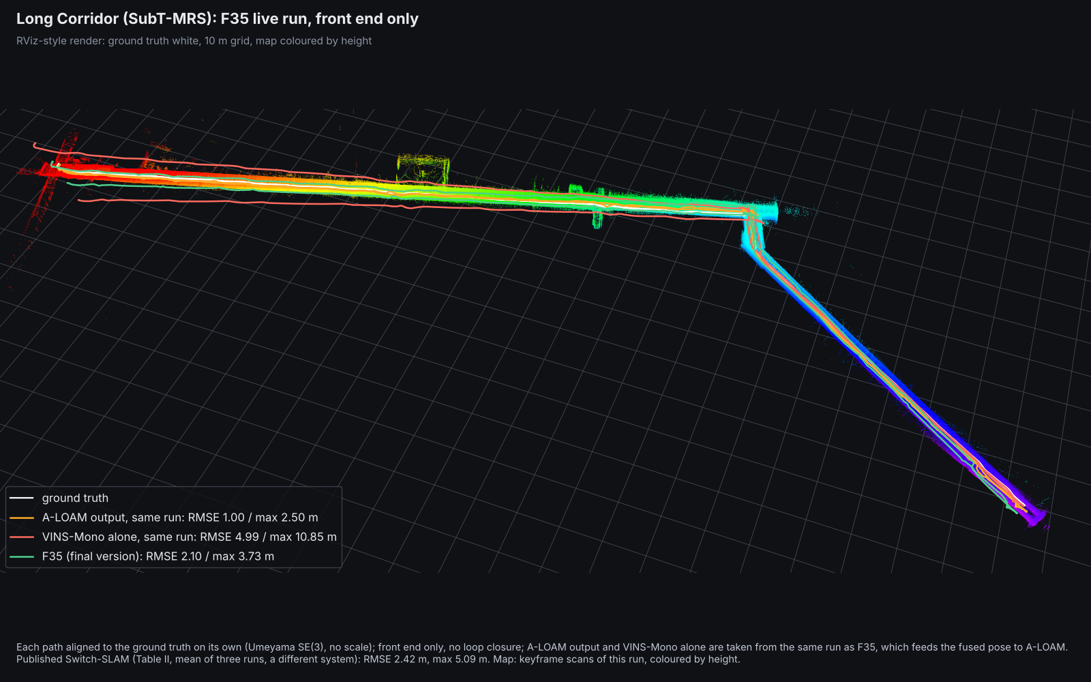
Figure 5.6: Long Corridor: ground truth (white), F35 (green), A-LOAM output (orange) and VINS-Mono alone (red), same run, map coloured by height
5.8 Farm simulation
Table 5.7 lists every live farm run in the order they were made, one run per version. The pass rule was RMSE ≤ 0.38 m and maximum ≤ 1.10 m. F20 gave 2.45 m in a run where VINS-Mono alone was 16.2 m: without a VIO-trust check the fused pose followed the failing VINS. F21 kept the error at 0.50 m with VINS-Mono alone at 3.45 m. F23 had a 5.3 m excursion in the first 18 s after the reset, all of it in the warm-up and VO_FAIL modes; F24, with the guard on A-LOAM's initial guess, had none. With the camera facing forward, F24 gave 0.472 / 1.068 m in a run where VINS-Mono alone drifted to 14.5 m, and F35 gave 0.290 / 0.562 m, inside both parts of the rule.
Table 5.7: Farm L route, live runs (one each), ATE RMSE / maximum (m)
Version | Camera | Fused output | VINS-Mono alone (same run) | Rule met
A-LOAM alone | - | 0.478 / 0.977 | - | max only
F8 | sideways | 0.490 / 0.750 | 1.222 / 5.70 | max only
F20 | sideways | 2.448 / 6.087 | 16.17 / 52.5 | no
F21 | sideways | 0.496 / 0.995 | 3.453 / 16.99 | max only
F23 | sideways | 0.496 / 5.308 | 22.23 / 222.5 | no
F24 | sideways | 0.657 / 0.897 | 2.067 / 3.31 | max only
F24 | forward | 0.472 / 1.068 | 14.47 / 26.57 | max only
F35 (final) | forward | 0.290 / 0.562 | 4.31 / 6.95 | yes
Switch-SLAM (published, LiDAR-inertial) | not stated | 0.38 / 1.10 | - | -

The farm values are not like for like with the published one. The route used here is about 80 m long, while the published farm sequence is 536 m and includes fast-rotation and plane-only stretches. Each version here has one run.
The two forward-camera runs are not a clean pair: VINS-Mono takes no input from the fusion, yet it gave 14.5 m in the F24 run and 4.3 m in the F35 run on the same rig. In the F35 run the A-LOAM output itself scored 0.312 m, and the LiDAR carried 99 % of the translation weight because the VIO-trust check distrusted a VINS-Mono path that was 20 % short, so the result is essentially A-LOAM's scan-to-map pose with the VINS step in the guess on the degenerate stretch. Rescaling VINS-Mono to the LiDAR path length lowered the sideways-camera farm replay to 0.34 to 0.37 m but raised Corridor02 by 0.58 m, and was not adopted.
Figure 5.7 shows the paths of the farm run of F35, with the paths of A-LOAM (0.312 / 0.627 m) and VINS-Mono alone (4.31 / 6.95 m) from the same run. The Gazebo world is not recorded, so only the paths are drawn.
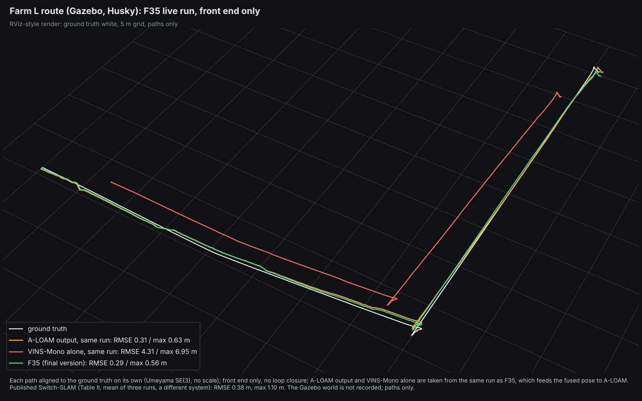
Figure 5.7: Farm L route: ground truth (white), F35 (green), A-LOAM output (orange) and VINS-Mono alone (red), same run, paths only
5.9 Tests with injected faults
Two faults were injected into the logged runs and replayed. In the LiDAR fault (FL) the LiDAR position slides along the weakest Schur direction at 0.2 m/s for three 20 s windows, while its Hessian is replaced by an isotropic one, so the solver looks confident and is wrong. In the VIO fault (FV) VINS-Mono is given a scale error. Table 5.8 gives the means. Against the LiDAR fault the min-rule tensor cap of F20 helped in 12 of 12 logs (sign test p = 0.0005), by 2 to 5 %. The VIO-trust check of F21 removed most of the VIO fault (Multi Floor 2.35 to 0.71 m, Long Corridor 4.89 to 2.61 m) and cut the GEODE error from 18.3 to 10.6 m, at a cost of 0.2 to 0.6 m under the LiDAR fault.
Table 5.8: Replays with injected faults, mean ATE RMSE (m)
Cell | F16 | F20 | F21
Multi Floor, LiDAR fault | 3.81 | 3.72 | 3.89
Multi Floor, VIO fault | 2.11 | 2.35 | 0.71
Long Corridor, LiDAR fault | 3.72 | 3.62 | 4.24
Long Corridor, VIO fault | 4.81 | 4.89 | 2.61
Corridor02, LiDAR fault | 4.81 | 4.56 | 4.88
Corridor02, VIO fault | 4.03 | 4.02 | 3.58
GEODE stairs, no fault (A-LOAM alone 10.3) | 17.8 | 18.3 | 10.60

5.10 Cave02 and GEODE stairs
Cave02 and GEODE stairs are the two sequences where A-LOAM and VINS-Mono are both weak (Figure 5.8).
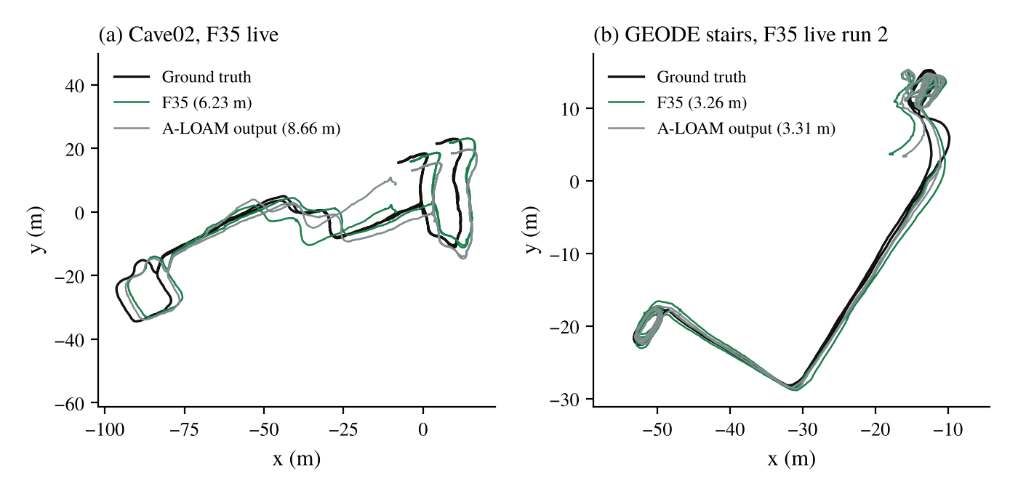
Figure 5.8: Cave02 and GEODE stairs, F35 live, with A-LOAM's output in the same run
5.10.1 Cave02
On Cave02 F35 is 2.4 m below A-LOAM's own output (6.23 against 8.66 m) but 1.8 m above the earlier F8 and F16 runs (4.47 and 4.40 m). In the F24 runs the error with each segment after 300 s aligned on its own was only 0.67 to 0.70 m, and the full-span error came from a stall at 285 to 305 s, where the ground truth moved 6 m and the estimate 1.5 m, while the scan's translation information was about half its usual level and VINS-Mono was distrusted. The reason for this difference from F8 and F16 is not yet identified. Figure 5.9 shows the F35 run (6.23 / 10.56 m) with A-LOAM's output from the same run (8.66 / 15.99 m); VINS-Mono alone is off the plot in this run.
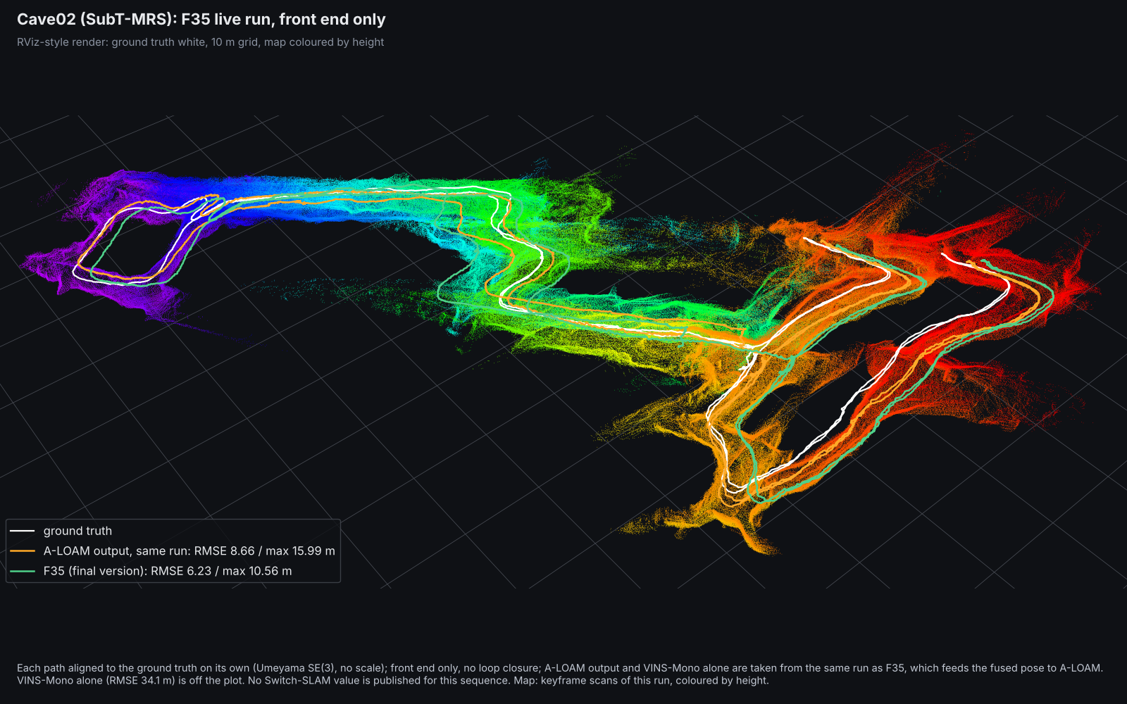
Figure 5.9: Cave02: ground truth (white), F35 (green) and A-LOAM output (orange), same run, map coloured by height; VINS-Mono alone is off the plot
5.10.2 GEODE stairs
On GEODE VINS-Mono lost its scale (0.02 to 0.07 in the F24 runs) and the node was in the warm-up or VO_FAIL mode on 73 to 88 % of the scans, so the fused output is close to A-LOAM's own (6.36 against 6.39 m, 3.26 against 3.31 m, 5.51 against 4.58 m). The error is mostly vertical (the stairwell descends 23 m); with each 30 to 60 s segment aligned on its own it is only 0.2 to 3.7 m. Figure 5.10 shows the first F35 run on the stairwell (6.36 / 14.07 m) with A-LOAM's output from the same run (6.39 / 12.75 m); VINS-Mono alone is off the plot.
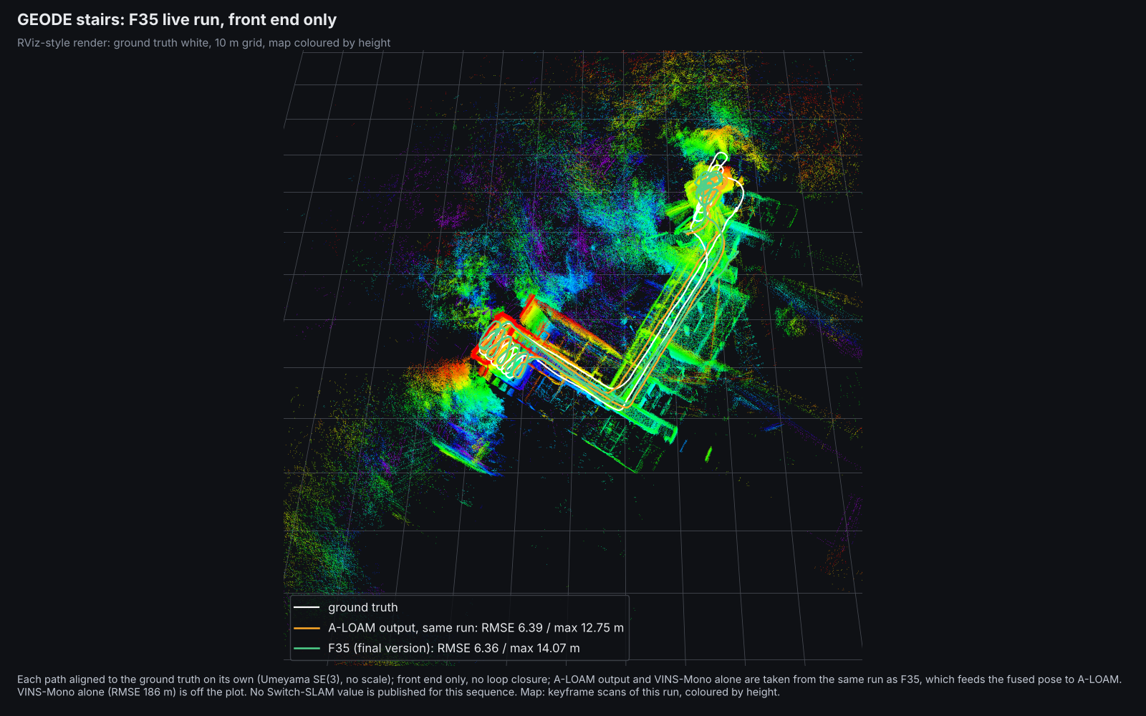
Figure 5.10: GEODE stairs: ground truth (white), F35 (green) and A-LOAM output (orange), same run, map coloured by height; VINS-Mono alone is off the plot
5.11 Success rate and hypothesis tests
Table 5.9 gives the success rate (share of runs with ATE ≤ 10 m) and the median of the per-run maximum error, in the format of Table 2 of [31]. A run counts as failed when its ATE exceeds 10 m, and failed runs are printed with their numbers; a dash in the tables means not applicable or not recorded, not a failed run. Every F35 run met the bound. VINS-Mono alone did not meet it on Cave02 (10.2 m, just over the bound) or GEODE, A-LOAM alone did not meet it on the three SubT-MRS sequences where it was run, and one of three F24 Corridor02 runs did not meet it.
Table 5.9: Success rate (ATE ≤ 10 m) / median of the per-run maximum error (m)
Sequence | VINS-Mono alone | A-LOAM alone | F8 | F24 | F35
Multi Floor | 100 % / 2.51 | 0 % / 58.50 | 100 % / 1.24 | 100 % / 1.24 | 100 % / 1.01
Long Corridor | 100 % / 15.24 | 0 % / - | 100 % / 13.15 | 100 % / 5.31 | 100 % / 3.73
Corridor02 | 100 % / 6.75 | 0 % / - | 100 % / 3.72 | 67 % / 2.68 | 100 % / 3.46
Cave02 | 0 % / - | not run | 100 % / 6.75 to 7.74 | 100 % / 11.78 | 100 % / 10.56
GEODE stairs | 0 % / 730.6 | not run | not run | 100 % / 16.78 | 100 % / 14.07
Farm L route | 50 % / 16.76 | 100 % / 0.98 | 100 % / 0.75 | 100 % / 1.07 | 100 % / 0.56

Table 5.10 gives the one-sided tests in the format of Table 3 of [31]. With one F35 run against three baseline runs the exact test cannot go below p = 0.25, so only Corridor02 (two F35 runs) and GEODE (three) can reject. F35 is significantly lower than VINS-Mono alone on GEODE (all 21 pairs, p = 0.008, Welch p = 1.7 x 10⁻⁵). On Corridor02 it is lower than VINS-Mono alone, A-LOAM alone and F8 in every pair, but the exact test stops at p = 0.10; the Welch test rejects against VINS-Mono alone (p = 0.008) and A-LOAM alone (p = 0.022). Against F24 no test rejects; on GEODE F35 is lower in 11 of 12 pairs (p = 0.057).
Table 5.10: Hypothesis test at 95 %, H₀: M(baseline) = M(F35), H₁: M(baseline) > M(F35)
Baseline | Sequence | n (base / F35) | F35 lower in | p, ATE | p, max | Welch p, ATE | Reject H₀
VINS-Mono alone | Multi Floor | 3 / 1 | 3 of 3 | 0.25 | 0.25 | - | No
 | Long Corridor | 3 / 1 | 3 of 3 | 0.25 | 0.25 | - | No
 | Corridor02 | 3 / 2 | 6 of 6 | 0.10 | 0.10 | 0.008 | No (Welch yes)
 | Cave02 | 3 / 1 | 3 of 3 | 0.25 | - | - | No
 | GEODE stairs | 7 / 3 | 21 of 21 | 0.008 | 0.008 | 1.7 x 10⁻⁵ | Yes
A-LOAM alone | Multi Floor | 3 / 1 | 3 of 3 | 0.25 | 0.25 | - | No
 | Long Corridor | 3 / 1 | 3 of 3 | 0.25 | 0.25 | - | No
 | Corridor02 | 3 / 2 | 6 of 6 | 0.10 | 0.10 | 0.022 | No (Welch yes)
F8 | Multi Floor | 9 / 1 | 6.5 of 9 | 0.40 | 0.10 | - | No
 | Long Corridor | 3 / 1 | 3 of 3 | 0.25 | 0.25 | - | No
 | Corridor02 | 3 / 2 | 6 of 6 | 0.10 | 0.10 | 0.093 | No
 | Cave02 | 3 / 1 | 0 of 3 | 1.00 | 1.00 | - | No (F35 higher)
F24 | Multi Floor | 3 / 1 | 2 of 3 | 0.50 | 0.50 | - | No
 | Long Corridor | 3 / 1 | 2 of 3 | 0.50 | 0.50 | - | No
 | Corridor02 | 3 / 2 | 2 of 6 | 0.80 | 0.80 | 0.21 | No
 | Cave02 | 3 / 1 | 3 of 3 | 0.25 | 0.25 | - | No
 | GEODE stairs | 4 / 3 | 11 of 12 | 0.057 | 0.114 | 0.065 | No

The farm has one run per method, so no test is possible there, and the published Switch-SLAM values are single numbers that can be compared but not tested. The tests show that F35 is reliably better than VINS-Mono alone where VINS-Mono fails; against F24 they show no significant difference. Ganesan et al. used 100 runs per environment, and one to nine runs per cell sets the statistical scope of this work.
5.12 Comparison with published results and other tests
Table 5.11 collects the results of this work on each sequence with the published values. The published numbers were read from the papers; their alignment and span are not always stated, so differences below about 0.1 m are treated as ties. Against Switch-SLAM, the closest published LiDAR-visual-inertial system, F35 is lower on Multi Floor (0.54 against 1.61 m; maximum 1.01 against 3.63 m), on Long Corridor (2.10 against 2.42 m; 3.73 against 5.09 m) and on the farm (0.29 against 0.38 m; 0.56 against 1.10 m), each from one run. The baselines are not identical: our VINS-Mono alone on Multi Floor (1.28 m) is far better than the 6.30 m listed for VINS-Mono in Switch-SLAM's table, so part of the margin comes from the setup and the evaluation (Figure 5.11).
Table 5.11: Results of this work against published values (ATE RMSE, m)
Sequence | This work, F35 (A-LOAM + VINS-Mono) | Earlier versions of this work | Switch-SLAM [published, LiDAR-inertial scan-to-map]; replica in this stack (A-LOAM) | Other published values
Multi Floor | 0.54 (n = 1) | F24 0.45 to 1.01; F8 0.617; F8 + loops 0.347 | 1.61; SW 5.03, 5.44 | SuperLoc 0.315 [32]; challenge 0.401 / 0.577 [25]
Long Corridor | 2.10 (n = 1) | F24 1.75 to 2.15; F16 2.27; F16 + loops 1.54 | 2.42; SW 12.58, 13.12 | SuperLoc 0.817 [32]; challenge 1.254 [25]
Corridor02 | 1.93, 2.04 | F24 1.29, 1.47 (one run 104); F24 + loops 1.11 | not reported | none found for LiDAR-visual-inertial systems
Cave02 | 6.23 (n = 1) | F8 4.47; F16 4.40; F24 7.08 to 7.55 | not reported | none found for LiDAR-visual-inertial systems
GEODE stairs α | 3.26 to 6.36 (n = 3) | F24 6.15 to 9.15; F16 17.5 to 19.8 | not reported | RELEAD 0.57; R3LIVE 4.54; FAST-LIO2 4.69; DLIO 4.89; LIO-SAM 6.30; LVI-SAM failed [26]
Farm L route | 0.29 (n = 1) | F24 0.47 (same rig), 0.66 (sideways camera) | 0.38 | -

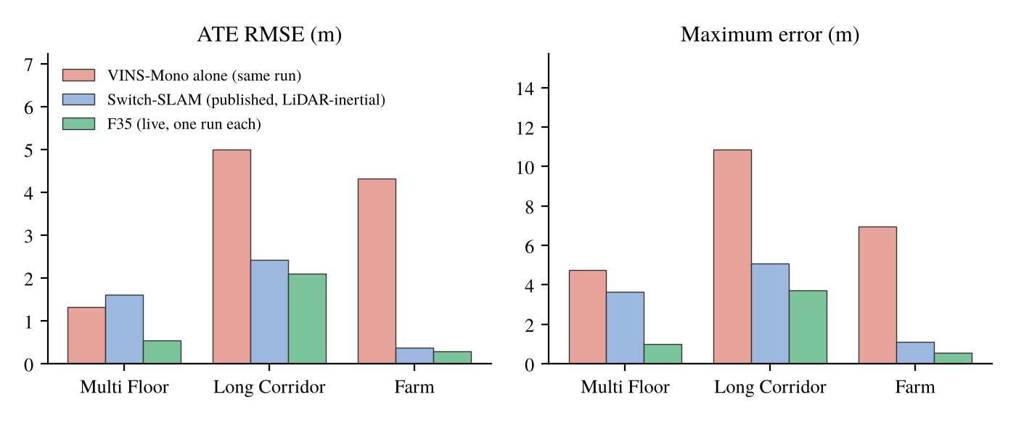
Figure 5.11: F35 against Switch-SLAM (published, LiDAR-inertial scan-to-map) and VINS-Mono alone from the same run
The best published front ends on Multi Floor and Long Corridor are LiDAR-inertial (SuperLoc 0.315 and 0.817 m), well below F35, and on GEODE RELEAD (0.57 m) is far below it while the other published systems are at the level of F35. For Corridor02 and Cave02 the only published values found are for LiDAR-inertial systems, which have a different structure from this work, so they are not listed. The other tests and corrected claims are kept in Table 5.12 because they explain the design.
Table 5.12: Other tests and corrected claims
Item | Outcome
Weighted fusion with a biased LiDAR (synthetic) | 42.9 cm against 14.4 cm for the old pipeline
Detection rules on Multi Floor | VINS-Mono alone lowest
Old channel T as a second detector | Did not meet its pre-set test live and offline
κ gate on the LiDAR correction | F3 below F1 in 3 of 3 runs
Degeneracy-aware loop weights | Isotropic weights gave the lower error (0.605 against 0.309 m)
F8 on Long Corridor | 4.53 m against the Switch-SLAM 2.42 m
F8 on Corridor02 | F14 and F12 lower; loop closure made no difference
Heading from the LiDAR map | Not used (Multi Floor 1.58 to 1.64 m)
SAH v3, v4, v5 | Superseded by v7; v7 does not pass two Corridor02 stress cases
Shorter warm-up; VINS scale correction | Each helped one sequence and raised the error on another
Active LiDAR rotation weight (F35 replay) | No gain shown; Cave02 2.4 m higher at every c_{R} > 0
F25A hand-over trust; standstill hold | No gain on GEODE
Switch-SLAM in this stack (SW, SWI) | Long Corridor 12.6 to 13.8 m against 2.42 m published; not run on Corridor02, Cave02 and GEODE
Switch-SLAM structure, our channels (F30 to F34) | GEODE 9.7 to 195.6 m; Long Corridor 3.89 to 4.29 m
F24 on Corridor02, run 2 | 104 m; cause not yet identified
F24 family on Cave02 | 6.2 to 7.6 m against 4.4 m for F16; cause not yet identified
"99.8 % corridor detection" | Withdrawn: a simulator artefact (fixed voxel grid)
Raw Hessian "6 times over-confident" | Corrected to 4.0 in standard deviation (ANEES 48)
Switch-SLAM's 0.103 as a 95 % χ² value | It is the lower 5 % point of χ² with 2 d.o.f.
Multi Floor described as an underground mine | It is a multi-floor building at CMU
A-LOAM alone on Corridor02 short of computing time | Withdrawn after the 0.2x run (still 68 m)
Cave02 and GEODE as held-out sequences for F35 | Withdrawn: both were used to design F25 to F27
COIN-LIO 0.45 m quoted for GEODE α | It is on device β; best on α is RELEAD 0.57 m

5.13 Discussion
Channel T is what makes the fusion work at all (Long Corridor 15.8 m for A-LOAM and 5.81 m for VINS-Mono, 4.53 m with channel T alone), and the heading read-out gave the largest single gain (4.53 to about 2.0 m). The tensor rule on S_{tt} comes into play under faults, channel R watches the rotation information (its check engaged on 3.6 % of the GEODE scans), and the safeguards of F21 to F24 each removes one observed failure. The status guess of F35 replaced the no-motion guess used on Cave02 and GEODE and lowered the error there; Corridor02 was higher by about
0.5 m.
The threshold study and the F30 to F34 tests agree that a switching system is judged by how much control of the output pose is handed to VINS-Mono; with A-LOAM, the weighted fusion gave a lower error than the switch-and-remap structure on every sequence it was tested on.
F35 has one to three live runs per sequence, and its three GEODE runs spread over 3.1 m. All six sequences were used during development, so the F35 results are development results and a held-out sequence is the next test. On Cave02 the final version gave 6.23 m against 4.4 m for the earlier F8 and F16 versions; the reason for the difference has not yet been identified.
CHAPTER 6
CONCLUSIONS
A LiDAR-visual-inertial odometry was built on A-LOAM and VINS-Mono in which LiDAR degeneracy is judged in three channels that set per-direction weights between the LiDAR and VIO motion, and F35, which also chooses A-LOAM's initial guess by Switch-SLAM's degeneracy status, was selected as the final version. The main findings are:
- Weighting translation by the Schur block S_{tt} lets the LiDAR carry the well-constrained directions, and the heading read-out of the orientation tensor channel gave the largest single gain (Long Corridor 4.53 to 1.98 m).
- The error of a switching system follows the share of time handed to VINS-Mono (Spearman -0.95 over 15 detection rules), not the detection quality, which is why the method weights instead of switching.
- Without loop closure, F35 gave 0.54 / 1.01 m on Multi Floor, 2.10 / 3.73 m on Long Corridor and 0.29 / 0.56 m on the farm, below Switch-SLAM's 1.61 / 3.63, 2.42 / 5.09 and 0.38 / 1.10 m, each from one run.
- This comparison with Switch-SLAM is not like for like: Switch-SLAM uses a LiDAR-inertial front end with an IMU-propagated guess, A-LOAM has no IMU, and the published values are means of three runs.
- On GEODE F35 gave 3.26 to 6.36 m and was significantly better than VINS-Mono alone (153 to 272 m, p = 0.008); against F24 it was lower in 11 of 12 pairs, not significantly (p = 0.057).
- F26 decided the status from our own channels instead of the published thresholds. It gave similar results to F35 on Long Corridor, GEODE and the farm and higher ones on Multi Floor (0.66 and 0.80 against 0.54 m) and Corridor02 (2.82 against 1.99 m), so the published thresholds added something on those two sequences.
- The status guess lowered the error where VINS-Mono starts late or fails. Against F24, F35 was lower on GEODE, Cave02 and the farm and level on Multi Floor and Long Corridor, and Corridor02 was higher by about 0.5 m. On Cave02 F35 gives 6.23 m against 4.4 m for the earlier F8 and F16 versions, and all results are development results.
6.1 Future scope
The next step is a held-out test on a sequence that played no part in the design, with three or more runs each of F35 and F24 and the reading rule written first. A rule for choosing between the fused output and A-LOAM's own mapped pose, which was lower on Long Corridor and Corridor02, and the reason for the Cave02 difference are the open points. Three extensions follow. The first is IMU preintegration in A-LOAM's initial guess; a gyro rotation prior is a cheaper first step, but it gave mixed results when tried in the Switch-SLAM replica, so it needs a proper test. The second is loop closure on every sequence, which was run here only offline on some recordings. The third is the Switch-SLAM replica on Corridor02, Cave02 and GEODE, where it was not run, using a replica version chosen first by a rule written beforehand.
REFERENCES
[1] C. Cadena et al., "Past, present, and future of simultaneous localization and mapping: Toward the robust-perception age," IEEE Trans. Robot., vol. 32, no. 6, pp. 1309-1332, Dec. 2016, doi: 10.1109/TRO.2016.2624754.
[2] J. Zhang and S. Singh, "LOAM: Lidar odometry and mapping in real-time," in Proc. Robot.: Sci. Syst. (RSS), Berkeley, CA, USA, Jul. 2014, doi: 10.15607/RSS.2014.X.007.
[3] T. Shan and B. Englot, "LeGO-LOAM: Lightweight and ground-optimized lidar odometry and mapping on variable terrain," in Proc. IEEE/RSJ Int. Conf. Intell. Robots Syst. (IROS), Madrid, Spain, Oct. 2018, pp. 4758-4765, doi: 10.1109/IROS.2018.8594299.
[4] T. Shan, B. Englot, D. Meyers, W. Wang, C. Ratti, and D. Rus, "LIO-SAM: Tightly-coupled lidar inertial odometry via smoothing and mapping," in Proc. IEEE/RSJ Int. Conf. Intell. Robots Syst. (IROS), Las Vegas, NV, USA, 2020, pp. 5135-5142, doi: 10.1109/IROS45743.2020.9341176.
[5] W. Xu, Y. Cai, D. He, J. Lin, and F. Zhang, "FAST-LIO2: Fast direct LiDAR-inertial odometry," IEEE Trans. Robot., vol. 38, no. 4, pp. 2053-2073, Aug. 2022, doi: 10.1109/TRO.2022.3141876.
[6] T. Qin, P. Li, and S. Shen, "VINS-Mono: A robust and versatile monocular visual-inertial state estimator," IEEE Trans. Robot., vol. 34, no. 4, pp. 1004-1020, Aug. 2018, doi: 10.1109/TRO.2018.2853729.
[7] K. Ebadi et al., "Present and future of SLAM in extreme environments: The DARPA SubT challenge," IEEE Trans. Robot., vol. 40, pp. 936-959, 2024, doi: 10.1109/TRO.2023.3323938.
[8] J. Zhang, M. Kaess, and S. Singh, "On degeneracy of optimization-based state estimation problems," in Proc. IEEE Int. Conf. Robot. Autom. (ICRA), Stockholm, Sweden, May 2016, pp. 809-816, doi: 10.1109/ICRA.2016.7487211.
[9] T. Qin and S. Cao, "A-LOAM: Advanced implementation of LOAM," GitHub repository, HKUST Aerial Robotics Group. [Online]. Available: https://github.com/HKUST-Aerial-Robotics/A-LOAM
[10] J. Lee et al., "Switch-SLAM: Switching-based LiDAR-inertial-visual SLAM for degenerate environments," IEEE Robot. Autom. Lett., vol. 9, no. 8, pp. 7270-7277, Aug. 2024, doi: 10.1109/LRA.2024.3421792.
[11] N. Gelfand, L. Ikemoto, S. Rusinkiewicz, and M. Levoy, "Geometrically stable sampling for the ICP algorithm," in Proc. 4th Int. Conf. 3-D Digit. Imag. Model. (3DIM), Banff, AB, Canada, Oct. 2003, pp. 260-267, doi: 10.1109/IM.2003.1240258.
[12] A. Hinduja, B.-J. Ho, and M. Kaess, "Degeneracy-aware factors with applications to underwater SLAM," in Proc. IEEE/RSJ Int. Conf. Intell. Robots Syst. (IROS), Macau, China, Nov. 2019, pp. 1293-1299, doi: 10.1109/IROS40897.2019.8968577.
[13] J. Hatleskog and K. Alexis, "Probabilistic degeneracy detection for point-to-plane error minimization," IEEE Robot. Autom. Lett., vol. 9, no. 12, pp. 11234-11241, Dec. 2024, doi: 10.1109/LRA.2024.3484153.
[14] J. Nubert, E. Walther, S. Khattak, and M. Hutter, "Learning-based localizability estimation for robust LiDAR localization," in Proc. IEEE/RSJ Int. Conf. Intell. Robots Syst. (IROS), Kyoto, Japan, Oct. 2022, pp. 17-24, doi: 10.1109/IROS47612.2022.9982257.
[15] T. Tuna, J. Nubert, Y. Nava, S. Khattak, and M. Hutter, "X-ICP: Localizability-aware LiDAR registration for robust localization in extreme environments," IEEE Trans. Robot., vol. 40, pp. 452-471, 2024, doi: 10.1109/TRO.2023.3335691.
[16] T. Tuna, J. Nubert, P. Pfreundschuh, C. Cadena, S. Khattak, and M. Hutter, "Informed, constrained, aligned: A field analysis on degeneracy-aware point cloud registration in the wild," IEEE Trans. Field Robot., vol. 2, pp. 485-515, 2025, doi: 10.1109/TFR.2025.3576053.
[17] X. Hu, X. Chen, M. Jia, J. Wu, P. Tan, and S. L. Waslander, "DCReg: Decoupled characterization for efficient degenerate LiDAR registration," Int. J. Robot. Res., early access, Aug. 2026, doi: 10.1177/02783649261465040.
[18] C. Bingham, "An antipodally symmetric distribution on the sphere," Ann. Statist., vol. 2, no. 6, pp. 1201-1225, Nov. 1974, doi: 10.1214/aos/1176342874.
[19] K. V. Mardia and P. E. Jupp, Directional Statistics. Chichester, U.K.: Wiley, 2000, doi: 10.1002/9780470316979.
[20] S. G. Advani and C. L. Tucker III, "The use of tensors to describe and predict fiber orientation in short fiber composites," J. Rheol., vol. 31, no. 8, pp. 751-784, 1987, doi: 10.1122/1.549945.
[21] E. Im, "LF-GICP: Parameter-free degeneracy-aware LiDAR odometry via a voxel-normal localizability field," Aug. 2026, arXiv:2608.19522.
[22] T. Shan, B. Englot, C. Ratti, and D. Rus, "LVI-SAM: Tightly-coupled lidar-visual-inertial odometry via smoothing and mapping," in Proc. IEEE Int. Conf. Robot. Autom. (ICRA), Xi'an, China, May 2021, pp. 5692-5698, doi: 10.1109/ICRA48506.2021.9561996.
[23] Z. Chen et al., "RELEAD: Resilient localization with enhanced LiDAR odometry in adverse environments," in Proc. IEEE Int. Conf. Robot. Autom. (ICRA), Yokohama, Japan, May 2024, pp. 3999-4005, doi: 10.1109/ICRA57147.2024.10611074.
[24] C. Campos, R. Elvira, J. J. G. Rodriguez, J. M. M. Montiel, and J. D. Tardos, "ORB-SLAM3: An accurate open-source library for visual, visual-inertial, and multimap SLAM," IEEE Trans. Robot., vol. 37, no. 6, pp. 1874-1890, Dec. 2021, doi: 10.1109/TRO.2021.3075644.
[25] S. Zhao et al., "SubT-MRS dataset: Pushing SLAM towards all-weather environments," in Proc. IEEE/CVF Conf. Comput. Vis. Pattern Recognit. (CVPR), Seattle, WA, USA, Jun. 2024, pp. 22647-22657.
[26] Z. Chen et al., "Heterogeneous LiDAR dataset for benchmarking robust localization in diverse degenerate scenarios," Int. J. Robot. Res., vol. 45, no. 1, pp. 6-22, Jan. 2026, doi: 10.1177/02783649251344967.
[27] N. Koenig and A. Howard, "Design and use paradigms for Gazebo, an open-source multi-robot simulator," in Proc. IEEE/RSJ Int. Conf. Intell. Robots Syst. (IROS), Sendai, Japan, Sep. 2004, pp. 2149-2154, doi: 10.1109/IROS.2004.1389727.
[28] N. Otsu, "A threshold selection method from gray-level histograms," IEEE Trans. Syst., Man, Cybern., vol. 9, no. 1, pp. 62-66, Jan. 1979, doi: 10.1109/TSMC.1979.4310076.
[29] J. Sturm, N. Engelhard, F. Endres, W. Burgard, and D. Cremers, "A benchmark for the evaluation of RGB-D SLAM systems," in Proc. IEEE/RSJ Int. Conf. Intell. Robots Syst. (IROS), Vilamoura, Portugal, Oct. 2012, pp. 573-580, doi: 10.1109/IROS.2012.6385773.
[30] S. Umeyama, "Least-squares estimation of transformation parameters between two point patterns," IEEE Trans. Pattern Anal. Mach. Intell., vol. 13, no. 4, pp. 376-380, Apr. 1991, doi: 10.1109/34.88573.
[31] S. Ganesan, B. Ramalingam, and R. E. Mohan, "A hybrid sampling-based RRT* path planning algorithm for autonomous mobile robot navigation," Expert Syst. Appl., vol. 258, Art. no. 125206, Dec. 2024, doi: 10.1016/j.eswa.2024.125206.
[32] S. Zhao, H. Zhu, Y. Gao, B. Kim, Y. Qiu, A. M. Johnson, and S. Scherer, "SuperLoc: The key to robust LiDAR-inertial localization lies in predicting alignment risks," in Proc. IEEE Int. Conf. Robot. Autom. (ICRA), 2025, pp. 14080-14086.

