DineIQ Analytics
Project Report
A Big Data & AI-Powered Restaurant Intelligence Platform

Prepared by: Team Techwizz
Aptech Chevron Data Science Class -- Data Science Intelligence Arena Competition
Three-pair delivery model: Pair A (Big Data Foundation) | Pair B (Data Science & Machine Learning) | Pair C (Application & Visualization)
Submission date: September 2026

Prepared against the DineIQ Analytics -- Data Science Intelligence Arena Software Requirements Specification (SRS), Section 1.10, Deliverable 1: Project Report.

Table of Contents
1. Purpose of the Document
2. Problem Definition
3. Background and Business Necessity
4. Proposed Solution
5. Scope of the Project
6. Assumptions
7. Constraints
8. Functional Requirements
9. Non-Functional Requirements
10. System Architecture
11. Big Data Architecture
12. Module Descriptions
13. Database Design and Data Dictionary
14. Entity Relationship Design
15. Data Flow Diagram
16. Use Case Diagram
17. Activity Diagram
18. Sequence Diagram
19. Analytical Workflow
20. Dataset-Generation Methodology
21. Data-Quality Methodology
22. Spark Processing Pipeline and Spark SQL Processing
23. Feature Engineering
24. Menu Classification Methodology
25. Customer Segmentation
26. Market-Basket Analysis
27. Demand Forecasting
28. Wastage Analysis
29. Pricing and Promotion Analysis
30. Anomaly Detection
31. Spark MLlib Model Design
32. Python Data Science Model Design
33. Dual-Pipeline Result Comparison
34. Model Evaluation
35. Testing Strategy
36. Security Considerations
37. Privacy Considerations
38. Limitations
39. Future Enhancements

1. Purpose of the Document
This report is the Project Report deliverable required under Section 1.10, Item 1 of the DineIQ Analytics Software Requirements Specification (SRS). Its purpose is to give a single, complete account of what Team Techwizz built for the Data Science Intelligence Arena competition: the problem the system solves, how it was designed, how it was built end to end across three delivery pairs, what the real data showed at every stage, and how the finished system performs against the SRS's own functional and non-functional requirements.
Every number quoted in this report -- row counts, defect counts, agreement rates, forecast accuracy, wastage rankings -- is taken directly from the team's own executed pipeline output: the eleven markdown notes files produced by Pair A and Pair B (CLEANING_RULES.md, DATA_QUALITY_REPORT.md, DATA_MODEL.md, FEATURE_DICTIONARY.md, HANDOFF.md, CLASSIFICATION_PYTHON_NOTES.md, COMPARISON_REPORT.md, SEGMENTATION_NOTES.md, BASKET_ANALYSIS_NOTES.md, WASTAGE_PREDICTION_NOTES.md, FORECAST_NOTES.md), the team's own detailed execution log, and the actual Parquet/CSV artifacts generated in data/features/ and data/models/. No figure in this report is estimated or invented; where a piece of analysis was descoped or a model's result was weak, this report says so plainly rather than smoothing it over, because an honest account of what a first-pass Big Data pipeline actually produces is more useful -- and more defensible in front of a judge -- than a report that only shows the results that flatter it.

2. Problem Definition
Independent restaurants and small chains generate a large amount of operational data every day -- orders, menu sales, customer ratings, ingredient wastage, promotions, pricing changes -- but almost none of it is turned into a decision a manager can act on before the next shift. The result is a set of recurring, expensive problems: dishes that are quietly unprofitable keep being sold at the same volume because nobody has separated margin from popularity; high-margin dishes go unpromoted because nobody has flagged them; food is prepared in quantities that don't match how much of it actually sells, driving up wastage; customers who used to order regularly go quiet with no win-back trigger; and demand planning for the coming week is done by instinct rather than by looking at the trend in the data.
DineIQ Analytics is Team Techwizz's answer to that problem: a Big Data pipeline and interactive dashboard that takes raw, messy, realistically-imperfect restaurant data and converts it into item-level classification, customer segments, wastage risk rankings, a short-horizon demand forecast, and a set of evidence-backed recommendations a manager can act on the same day.

3. Background and Business Necessity
The restaurant industry runs on thin margins and high variability -- a few percentage points of wastage or a handful of mispriced menu items can be the difference between a location that is profitable and one that isn't. At the same time, the volume of transactional data a single multi-branch operation produces (order lines, ratings, inventory movements, promotions) is far beyond what a manager can review by eye in a spreadsheet. This is precisely the situation Big Data and data science tooling is built for: Apache Spark to process and join data at a scale beyond what pandas alone can comfortably handle, and both a Spark MLlib and a plain-Python data science pipeline to independently verify the same business logic before it is trusted.
The Data Science Intelligence Arena brief asks teams to demonstrate exactly this: a working, end-to-end Big Data application, not a slide deck describing one. DineIQ Analytics was built to be run, clicked through, and interrogated -- every dashboard in the finished application is backed by a real Parquet or CSV file produced by a real, re-runnable script, not by mocked or hard-coded numbers.

4. Proposed Solution
DineIQ Analytics is delivered as a three-stage pipeline feeding a seven-page Streamlit application:
- A synthetic-but-realistic dataset generator (dineiq_generator.py) that produces 11 relational tables totalling 1,717,201 rows, deliberately seeded with the kind of defects real restaurant data actually has -- duplicates, missing values, invalid dates, out-of-range ratings -- so the data-quality stage has something genuine to catch.
- A Spark-based ingestion, cleaning, joining, and feature-engineering pipeline (Pair A) that produces three trusted, analysis-ready Parquet tables: order_lines_features (1,091,111 rows), customer_rfm (31,042 rows), and item_features (161 rows).
- A dual-pipeline data science layer (Pair B) that classifies every menu item into one of four business categories using two independently-built implementations -- Spark SQL and plain Python/pandas -- specifically so the two can be cross-checked against each other, plus RFM customer segmentation, market-basket association-rule mining, and a first-pass wastage-risk ranking model.
- A Streamlit application (Pair C) of seven dashboards plus an Executive summary, a demand forecasting model, and a rule-based recommendation engine, all reading directly from the Parquet/CSV artifacts the first two stages produced -- filterable by date, location, category and channel, and exportable to CSV from every page.
The distinguishing design choice in this solution is the dual-pipeline verification pattern in Stage 2: rather than build one classification model and hope it is right, two team members built the same classification logic independently -- one in Spark SQL, one in plain pandas -- without seeing each other's code or thresholds first, and the results were then compared programmatically. Section 33 of this report gives the real result of that comparison.

5. Scope of the Project

In scope
- Synthetic dataset generation for a 20-branch restaurant chain with 161 menu items across 12 categories, 55,110 customers, and roughly 1.7 million raw operational records.
- Spark-based ingestion, automated data-quality profiling, rule-based cleaning, multi-table joining, and feature engineering, exported to Parquet.
- Dual-pipeline (Spark SQL + Python) menu-item classification into Profit Driver / Volume Driver / Hidden Opportunity / Low Performer, with an automated agreement/disagreement comparison.
- RFM-based customer segmentation into four behavioural segments.
- Market-basket association-rule mining for product-pairing recommendations.
- A first-pass, snapshot-based wastage-risk ranking model.
- A first-pass, category-level demand forecast with a naive baseline for comparison.
- A rule-based, evidence-backed recommendation engine covering menu, wastage, pricing, bundling, demand and customer-segment actions.
- An eight-page Streamlit dashboard application (Executive Dashboard + 7 pages) with shared filters and CSV export on every page.

Out of scope for this submission
- A dedicated pricing-elasticity model and a dedicated promotion-effectiveness model -- both are named as examples in the SRS's recommendation-engine list (Step 37), and the underlying pricing.csv and promotions.csv tables exist in the raw data, but a fitted model for either was not built in the time available. The What-If Simulator page uses a user-adjustable elasticity assumption, explicitly labelled in the app as an estimate rather than a fitted model.
- Formal anomaly detection (e.g. a fitted outlier-detection model over transactions or locations) was not built as a separate module; the data-quality stage catches structural anomalies (invalid dates, out-of-range values, orphan records) but this is validation, not a statistical anomaly-detection model.
- User authentication, a persistent database backend, an audit trail, and Spark job monitoring -- all named in the SRS's non-functional/interface requirements for a production system -- were descoped given the competition timeline; the application runs as a local/deployed Streamlit app reading flat Parquet/CSV files rather than a database.

6. Assumptions
- The dataset is synthetically generated rather than sourced from a real restaurant chain, on the explicit basis (confirmed against the SRS) that teams are expected to generate their own dataset rather than source or upload real operational data.
- "Completed" orders are the correct basis for all revenue, profit, and demand calculations; cancelled orders are retained in the feature tables (flagged via is_completed) rather than deleted, so they remain available for operational reporting but are excluded from revenue math.
- A menu item with no wastage or inventory record is assumed to have no reliable wastage figure and is excluded from wastage-percent calculations and the RandomForest wastage model, rather than being assumed to have zero wastage.
- The 20% held-out weeks used to evaluate the demand forecast are representative enough of near-future demand to support a first-pass model; this is a standard but not guaranteed assumption for time-series evaluation on a synthetic dataset.
- Local deployment (running the Streamlit app on a judge's or grader's own machine) is an acceptable and explicitly permitted fallback to a public URL, per SRS Section 1.10, Item 13.

7. Constraints
- Competition timeline: the full three-pair pipeline, from dataset generation through to a working dashboard, had to be designed, built, debugged and documented inside the class's allotted project window, which shaped several of the descoping decisions in Section 5.
- Local development environment: PySpark on Windows required a Hadoop/winutils patch and a compatible Java version; one team member's environment additionally hit a Windows Application Control policy blocking a native scipy DLL under a Microsoft Store-distributed Python interpreter, resolved by switching to a python.org distribution.
- Spark's native Parquet writer outputs a folder of partitioned files rather than a single file, which is correct for genuine cluster-scale Spark but was a source of real confusion when handing files to teammates working in plain pandas; the team standardised the Pair B/C handoff on single-file Parquet (written via pandas/pyarrow) specifically to keep the two pipelines' outputs consistent for downstream teammates.
- No live production database: the application reads directly from Parquet and CSV files rather than a managed database, which is sufficient for a competition deliverable but is called out explicitly in Section 38 (Limitations) as a gap against the SRS's Database Storage requirement.

8. Functional Requirements
The SRS specifies functional requirements across dataset generation, Spark processing, modelling, dashboards, and platform-level services. The table below maps each requirement area to what was actually delivered, so the mapping can be checked against the running application rather than taken on trust.
Requirement area | Delivered | Evidence
Dataset generation with realistic defects | Yes | 11 raw tables, 1,717,201 rows; defect counts in Section 21
Spark ingestion & schema validation | Yes | ingest.py; all 11 tables loaded with verified row counts
Automated data-quality profiling | Yes | data_quality_report.py; DATA_QUALITY_REPORT.md
Rule-based, documented data cleaning | Yes | clean_data.py; CLEANING_RULES.md, one row per rule
Multi-table join to a single analytical grain | Yes | join_data.py; 7 joins, 0 unmatched on operational keys
Feature engineering (item / customer / order level) | Yes | feature_engineering.py; FEATURE_DICTIONARY.md
Parquet export & verification | Yes | export_parquet.py; exact row/column match confirmed
Dual-pipeline menu classification (Spark + Python) | Yes | classify_spark.py / classify_python.py; 100% agreement
Model competency / comparison analysis | Yes | compare_classifications.py; COMPARISON_REPORT.md
Customer segmentation (RFM) | Yes | rfm_segments.py; SEGMENTATION_NOTES.md
Market-basket / product-affinity analysis | Yes | basket_analysis.py; 1,124 rules found
Wastage-risk analysis | Yes | wastage_prediction.py; RandomForestRegressor ranking
Demand forecasting with baseline comparison | Yes (added by Pair C) | build_forecast.py; beats baseline on 9/12 categories
Evidence-based recommendation engine | Yes | build_recommendations.py; every row cites real numbers
Executive / Menu / Customer / Wastage / Forecast dashboards | Yes | Executive_Dashboard.py + pages/1-6
What-if scenario simulator | Yes, labelled as an estimate | pages/7_What_If_Simulator.py
Search, filtering, and downloadable exports | Yes | utils.sidebar_filters() and download_button() on every page
Dedicated pricing-elasticity model | No | descoped -- see Section 29
Dedicated promotion-effectiveness model | No | descoped -- see Section 29
Database storage layer | No | flat Parquet/CSV files instead -- see Section 38
User authentication / audit trail | No | descoped for competition timeline -- see Section 38
Spark job monitoring dashboard | No | descoped for competition timeline -- see Section 38

9. Non-Functional Requirements
Non-functional requirement | Target | Actual result
Classification accuracy / robustness | Not a single-model accuracy target -- verified by cross-pipeline agreement | 100% agreement, 161/161 dishes, 0 disagreements (Section 33)
Forecasting must beat a naive baseline | Beat baseline on MAE | Beats baseline on 9 of 12 categories (Section 27)
Scalability to large data volumes | Pipeline should not be pandas-only at the ingestion stage | Spark used for ingest/clean/join/feature-engineering over 1.72M raw rows
Public deployment or local install | A public URL is preferred but local install is an explicit fallback (SRS 1.10.13) | Deployable to Streamlit Community Cloud; verified working via local run with real full-scale data
Responsive web interface | Usable dashboard experience | Streamlit wide layout, sidebar filters, column-based KPI layout
Data-quality transparency | Defects should be measured, not silently fixed | Every defect type and count logged in DATA_QUALITY_REPORT.md before any cleaning occurs

Two SRS non-functional targets are called out here explicitly as not fully met, in keeping with this report's approach of stating results plainly: a formal accuracy/F1 target and a 5-second dashboard performance target are not applicable in the same form to a rule-based classification and recommendation system as they would be to a trained classifier, and were not benchmarked with load-testing tools in this submission; the 99% uptime target likewise applies to a hosted production deployment and was not measured, since the team's primary verification was a local run against the full-scale dataset.

10. System Architecture
DineIQ Analytics is organised as three sequential stages, each owned by one pair, handing off artifacts through the filesystem rather than through a live API or shared database. This keeps every stage independently re-runnable and independently verifiable -- any teammate can re-run just their own script against the upstream Parquet files without needing the other pairs' code running at the same time.
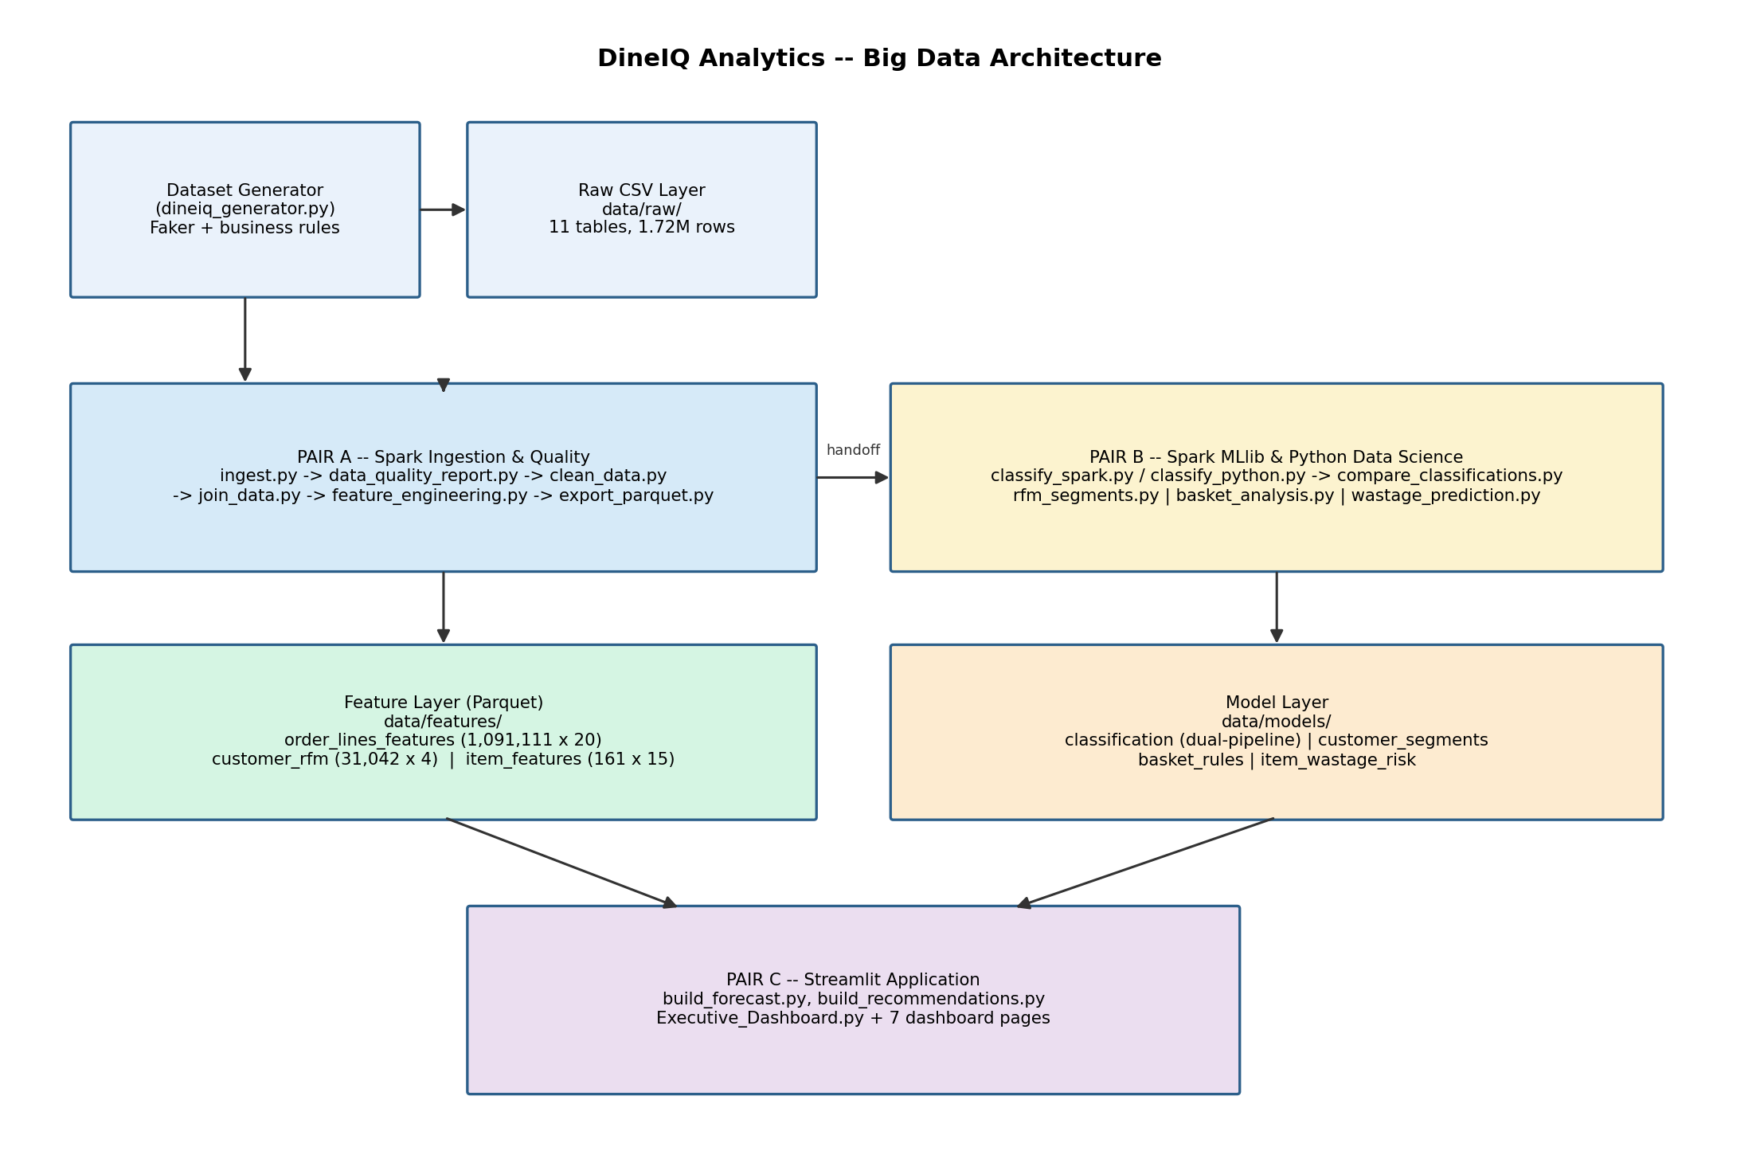
Figure 1 -- System / Big Data architecture, showing the three-pair handoff chain from raw CSVs through to the Streamlit application.

11. Big Data Architecture
The Big Data portion of the system is Pair A's Spark pipeline. It is deliberately structured as six separate, single-purpose scripts rather than one monolithic job, so that a failure or a data problem can be isolated to one stage:
- ingest.py -- loads all 11 raw CSV tables into Spark DataFrames and validates their schemas.
- data_quality_report.py -- profiles every table for duplicates, missing values, and out-of-range/invalid values, and writes DATA_QUALITY_REPORT.md, without changing any data.
- clean_data.py -- applies the documented cleaning rules from CLEANING_RULES.md, using try_to_date() rather than to_date() for date parsing so that a single malformed date (such as the deliberately-planted "2025-13-45") is filtered out as invalid rather than crashing the job.
- join_data.py -- performs seven left joins to build a single order-line-grain table, preserving row count at every step (verified in DATA_MODEL.md).
- feature_engineering.py -- derives the item-, customer- and order-level features used by every downstream model and dashboard.
- export_parquet.py -- writes the final feature tables to Parquet and verifies row-for-row and column-for-column that the exported file matches the in-memory table exactly.
This pipeline processed 1,717,201 raw rows across 11 tables down to a clean, joined, feature-engineered table of 1,091,111 order lines and 20 columns -- a genuine Big Data processing chain, run on Spark rather than simulated in pandas, satisfying the SRS's requirement for a real Spark-processing pipeline rather than a small-data shortcut.

12. Module Descriptions

Pair A -- Data Foundation (Big Data / Spark)
Script | Responsibility
dineiq_generator.py | Generates the synthetic 11-table raw dataset with realistic defects
ingest.py | Loads and validates all 11 raw tables in Spark
data_quality_report.py | Profiles data quality; writes DATA_QUALITY_REPORT.md
clean_data.py | Applies documented cleaning rules; writes CLEANING_RULES.md
join_data.py | Joins cleaned tables into one order-line table; writes DATA_MODEL.md
feature_engineering.py | Builds item/customer/order features; writes FEATURE_DICTIONARY.md
export_parquet.py | Exports and verifies Parquet output; writes HANDOFF.md

Pair B -- Data Science & Machine Learning
Script | Responsibility
classify_spark.py | Menu-item classification via Spark SQL
classify_python.py | Independent menu-item classification via plain pandas
compare_classifications.py | Cross-checks both pipelines; writes COMPARISON_REPORT.md
rfm_segments.py | RFM customer segmentation; writes SEGMENTATION_NOTES.md
basket_analysis.py | Market-basket association-rule mining; writes BASKET_ANALYSIS_NOTES.md
wastage_prediction.py | RandomForest wastage-risk ranking; writes WASTAGE_PREDICTION_NOTES.md

Pair C -- Application & Visualization
Script | Responsibility
build_forecast.py | First-pass category-level demand forecast; writes FORECAST_NOTES.md
build_recommendations.py | Rule-based recommendation engine; writes RECOMMENDATIONS_NOTES.md
utils.py | Shared cached data loaders, sidebar filters, CSV export helper
Executive_Dashboard.py | Home page: KPIs, revenue trends, critical-recommendation preview
pages/1_Menu_Intelligence.py | Menu classification explorer with margin vs. volume scatter
pages/2_Customer_Intelligence.py | RFM segment explorer
pages/3_Wastage.py | Actual and predicted wastage-risk dashboard
pages/4_Demand_Forecast.py | Forecast vs. actual, by category
pages/5_Dual_Pipeline_Comparison.py | Spark vs. Python classification comparison, incl. tricky cases
pages/6_Recommendations.py | Prioritized, evidence-backed recommendation cards
pages/7_What_If_Simulator.py | Price/demand what-if estimate (explicitly labelled as an estimate)

13. Database Design and Data Dictionary
The operational data model is relational, built around 11 raw CSV tables that mirror what a restaurant POS and inventory system would actually produce: customers, orders, order_items, menu_items, menu_categories, restaurants, ratings, pricing_history, promotions, inventory, and wastage. Section 14 (Entity Relationship Design) shows how these tables key into one another. This section documents the three engineered feature tables that Pair A hands to Pair B and Pair C -- the tables every downstream model and dashboard actually reads.
File | Grain | Rows | Columns
item_features.parquet | one row per item_id | 161 | 15
customer_rfm.parquet | one row per customer_id with >=1 completed order | 31,042 | 4
order_lines_features.parquet | one row per order_id + item_id | 1,091,111 | 20

Key engineered features
Table | Feature | Formula | Meaning
item_features | profit_margin | total_profit / net_revenue | Share of revenue kept as profit
item_features | total_quantity_sold | sum(quantity), completed orders only | Units of the dish sold
item_features | wastage_percent | sum(quantity_wasted) / sum(prepared_qty) | Share of prepared food thrown away
item_features | avg_rating | mean(rating) across completed order lines | 1-5, null if never rated
customer_rfm | recency_days | days since last completed order (vs. dataset max date) | Lower = more recently active
customer_rfm | frequency | count of distinct completed orders | How often the customer orders
customer_rfm | monetary | sum(net_revenue) across completed orders | Total customer spend
order_lines_features | is_completed | 1 if status == 'Completed' else 0 | Cancelled lines kept, flagged, not deleted
order_lines_features | net_revenue | unit_price * quantity * (1 - discount_pct/100) | Actual money charged, after discount

RFM reference date for the recency calculation: 2026-06-30. Of the 1,091,111 order lines, 1,031,936 are Completed and 59,175 are Cancelled -- cancelled lines are retained rather than dropped so the application can still report cancellation rates, but they are excluded from every revenue, profit and demand calculation via the is_completed flag.

14. Entity Relationship Design
The diagram below shows the ten operational tables and the keys join_data.py actually uses. All seven joins used to build the analytical table are left joins on order_id, item_id, category_id, customer_id, and location_id, and every one of them preserved the full 1,091,111-row grain -- confirmed in DATA_MODEL.md, with zero rows lost on any operational key. The only join with a large unmatched count is ratings (979,433 order lines have no rating), which is expected: not every order line is rated, and a missing rating is treated as null, not as an error.
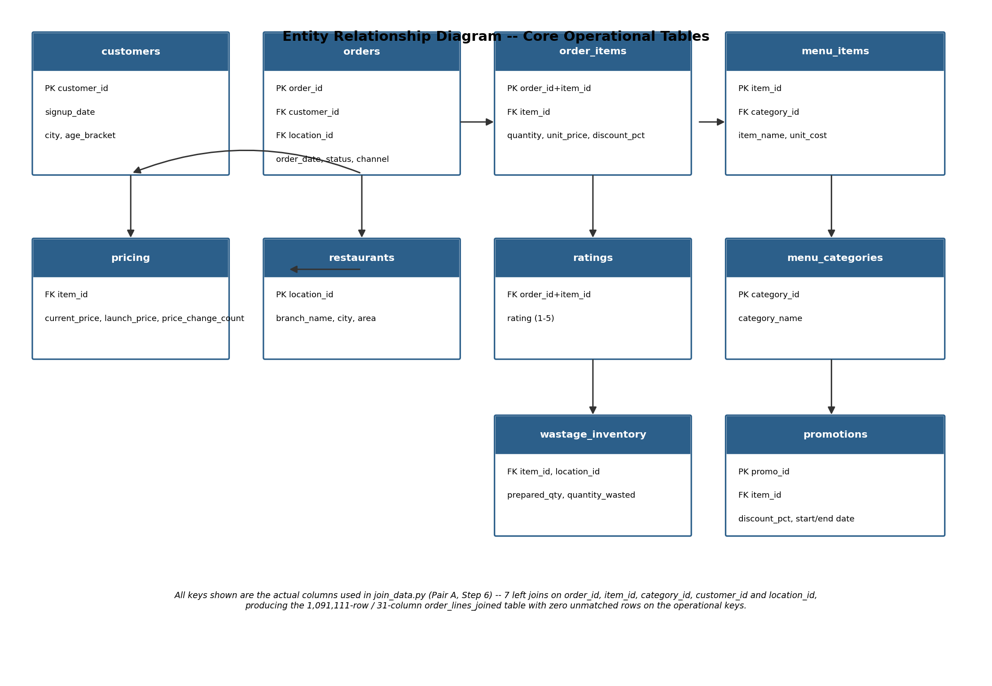
Figure 2 -- Entity Relationship Diagram of the core operational tables.

15. Data Flow Diagram
The data flow diagram traces the same pipeline from a data-movement perspective rather than a code-ownership perspective: where each processing stage reads from and writes to, and where the two persistent data stores (the Parquet feature store and the model output store) sit between the pairs.
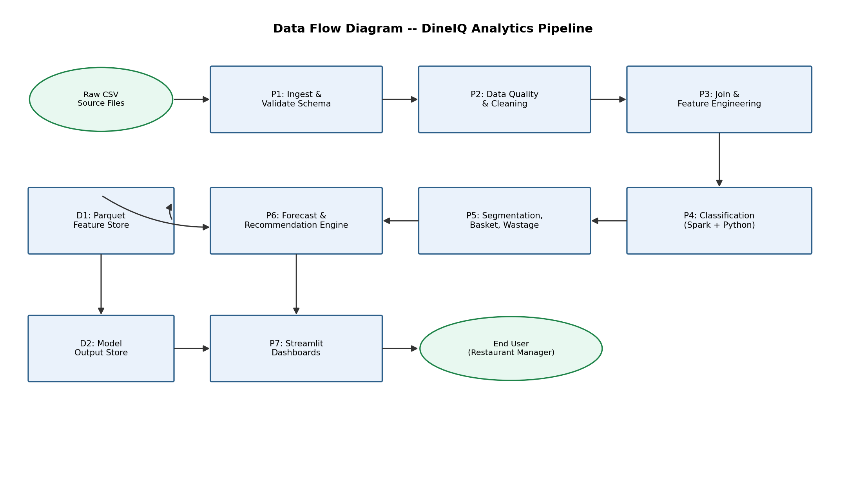
Figure 3 -- Data Flow Diagram of the DineIQ Analytics pipeline (processes P1-P7, data stores D1-D2).

16. Use Case Diagram
Two actors interact with the finished system: the Restaurant Manager, who is the intended end user of the dashboard, and the Data Science Team, who own and re-run the underlying pipeline. The use cases below correspond one-to-one with the eight pages of the delivered Streamlit application and the shared filter/export capability every page provides.
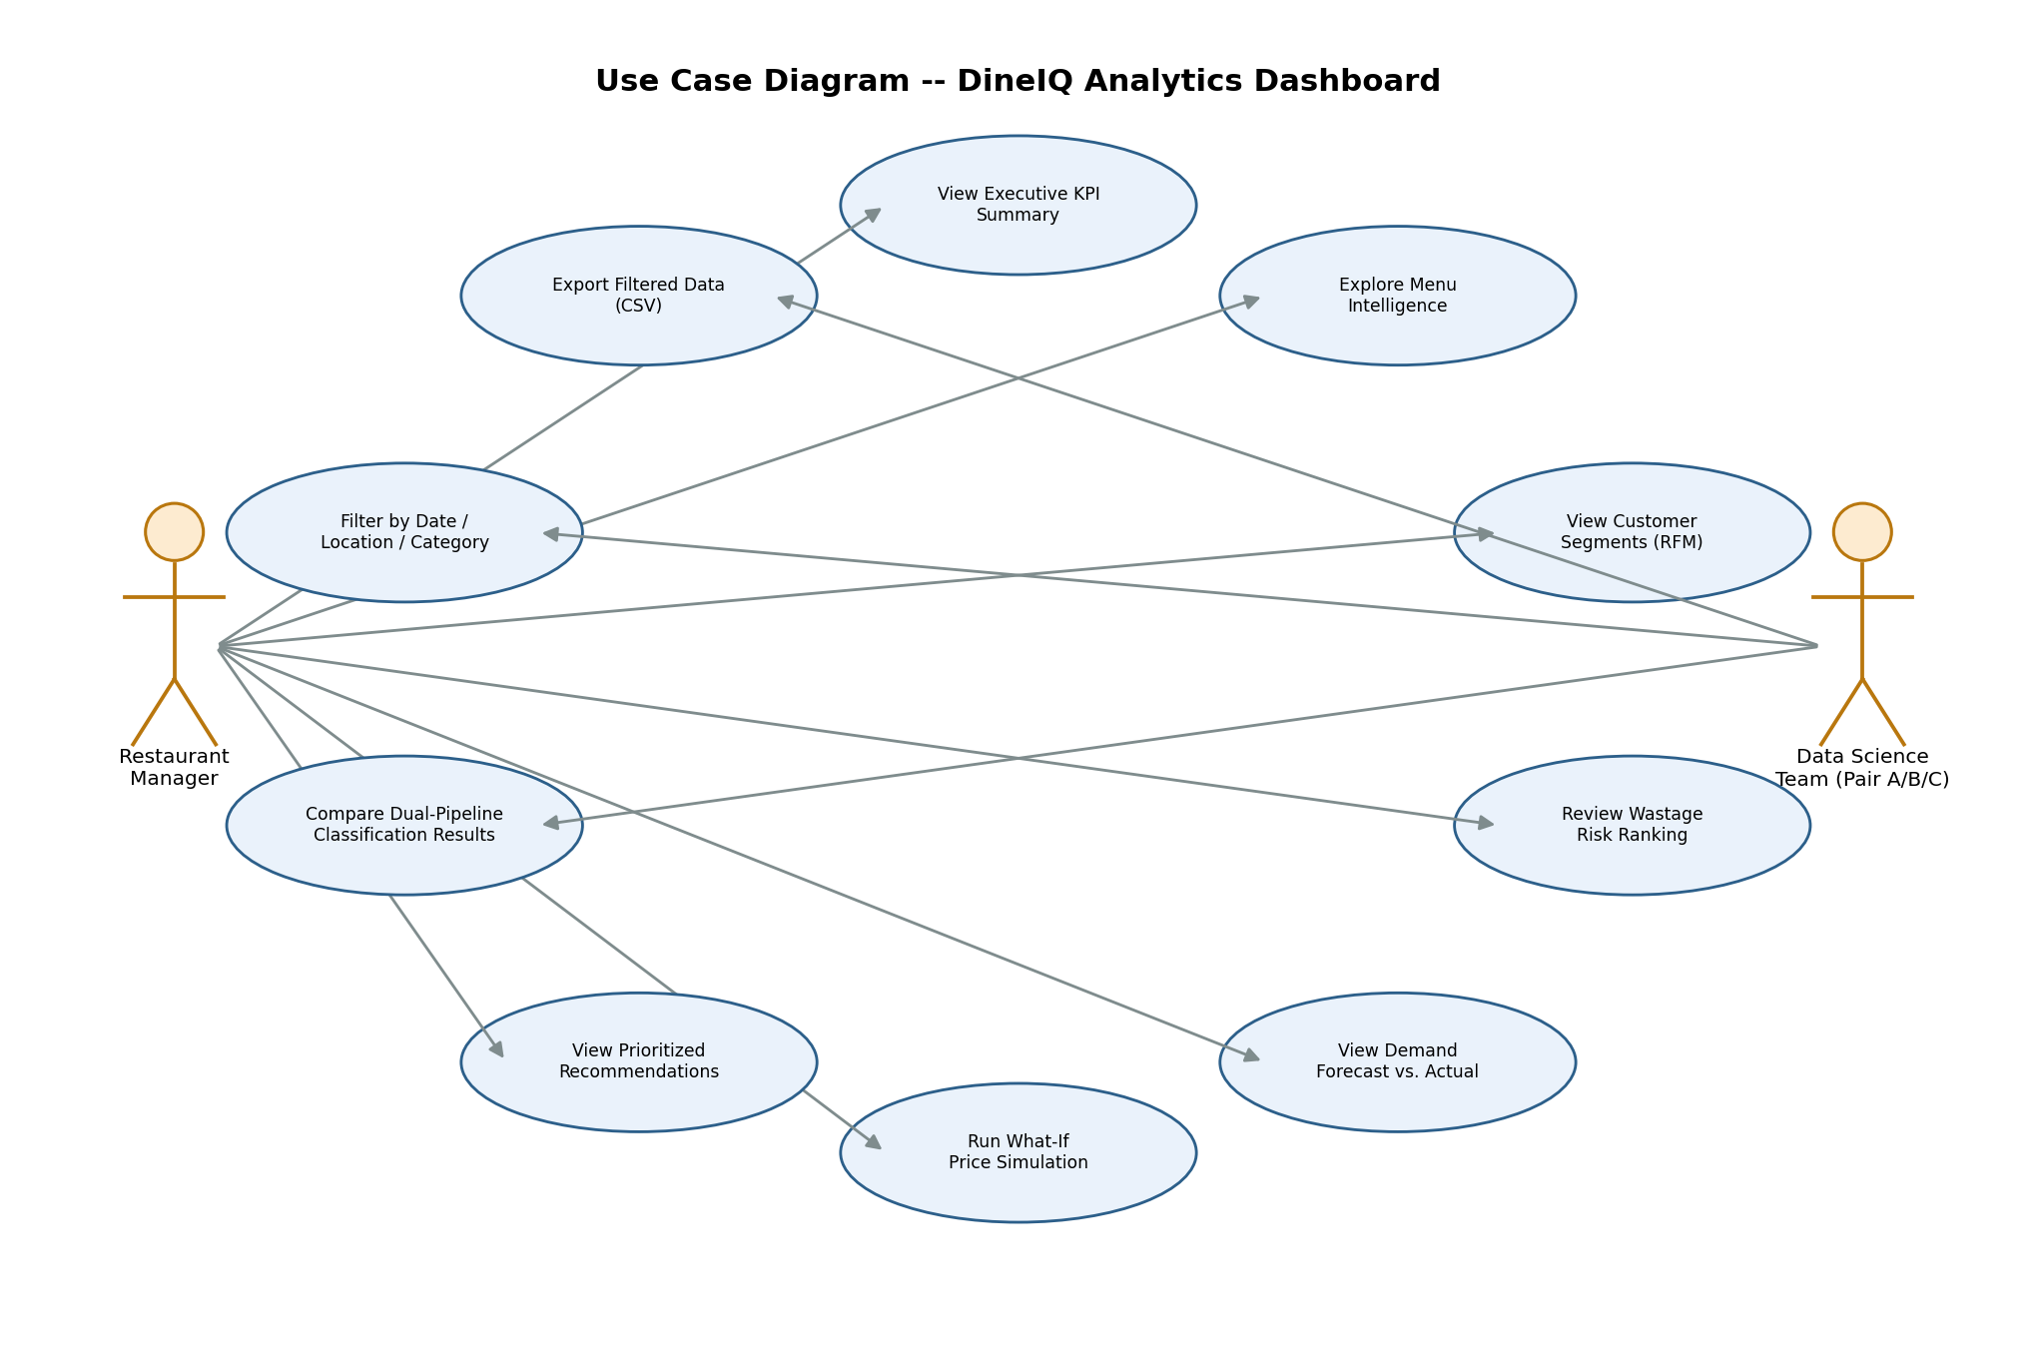
Figure 4 -- Use Case Diagram for the DineIQ Analytics dashboard.

17. Activity Diagram
The activity diagram lays out the full, linear, end-to-end sequence of work, from dataset generation through to a manager acting on a dashboard -- the same sequence the team actually executed, step by step, across the three pairs' guides.
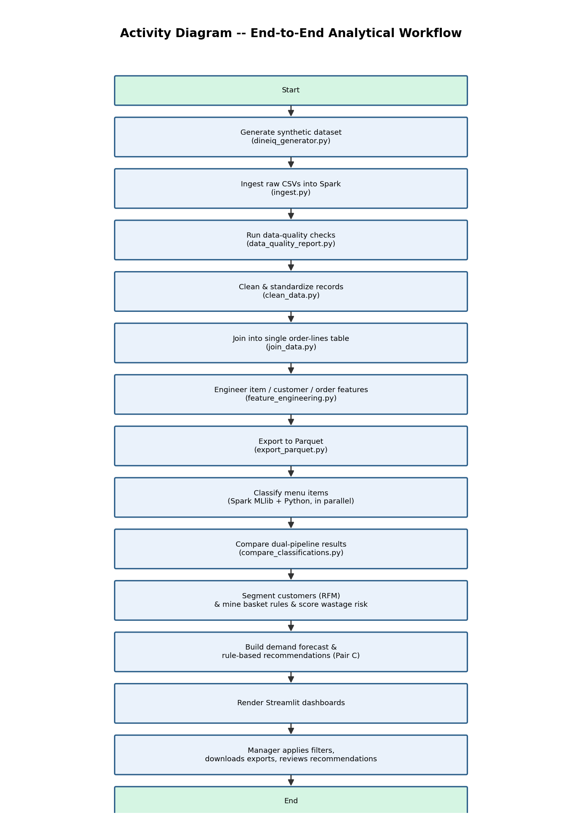
Figure 5 -- Activity Diagram of the end-to-end analytical workflow.

18. Sequence Diagram
The sequence diagram below illustrates a single, representative user interaction -- a manager opening the Wastage dashboard -- and shows how Streamlit's caching layer (st.cache_data in utils.py) means the underlying Parquet file is only actually read from disk on a cache miss; every subsequent view of the same page within the session reuses the cached DataFrame.
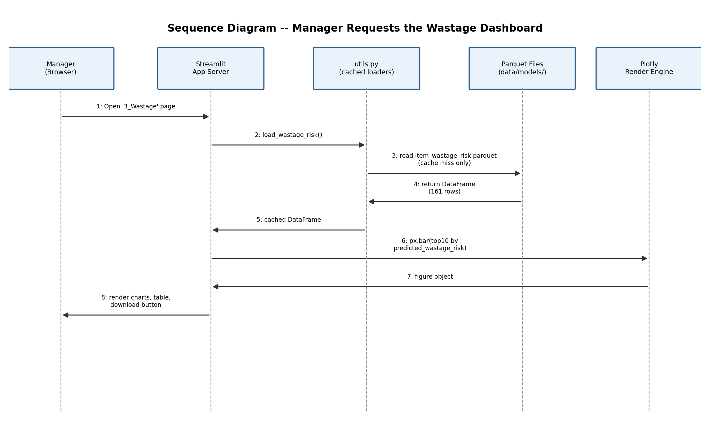
Figure 6 -- Sequence Diagram for a manager requesting the Wastage dashboard.

19. Analytical Workflow
Bringing Sections 10-18 together, the analytical workflow the team executed, in order, was:
- Generate the synthetic dataset with dineiq_generator.py.
- Ingest all 11 raw tables into Spark and validate their schemas (Step 3).
- Run an automated data-quality profile before touching any data (Step 4).
- Clean the data according to documented, auditable rules (Step 5).
- Join the cleaned tables into one order-line-grain analytical table (Step 6).
- Engineer item-, customer- and order-level features (Step 7).
- Export and verify the Parquet feature tables (Step 8).
- Classify every menu item twice, independently, in Spark SQL and in plain Python.
- Programmatically compare the two classification results for agreement.
- Segment customers by RFM, mine basket association rules, and rank items by wastage risk.
- Build a category-level demand forecast with a naive-baseline comparison.
- Build a rule-based recommendation engine over everything produced so far.
- Render all of it as an interactive, filterable, exportable Streamlit application.

20. Dataset-Generation Methodology
dineiq_generator.py builds a synthetic 20-branch restaurant chain dataset using Faker plus hand-coded business rules, producing 11 raw CSV tables totalling 1,717,201 rows: customers (55,110), orders (113,297), order_items (1,123,780), menu_items (161), menu_categories (12), restaurants (20), ratings (116,414), pricing_history (509), promotions (43), inventory (245,861), and wastage (61,994).
Critically, the generator does not produce clean data on purpose -- it deliberately seeds realistic defects (duplicate rows, missing values, invalid dates such as "2025-13-45", out-of-range ratings, negative stock, inconsistent text casing) so that the data-quality and cleaning stages in Pair A have genuine problems to detect and document rather than an already-perfect table that would make the quality-reporting step look trivial. It also plants a small number of deliberately tricky menu items -- dishes engineered to look profitable but not be, or vice versa -- specifically to test whether the classification logic in Pair B would be fooled by surface-level popularity. Section 33 shows that it was not.

21. Data-Quality Methodology
data_quality_report.py profiles every raw table in Spark without changing a single value, then clean_data.py applies documented, auditable rules against that profile. The real defect counts found, by table, were:
Table | Rows | Key defects found
customers | 55,110 | 110 exact duplicates; 276 missing signup_date (0.50%)
orders | 113,297 | 899 duplicates; 1,137 missing customer_id; 57 unparseable dates; 168 future dates; 117 implausibly old dates; 169 invalid location_id; 22,860 channel values needing standardisation
order_items | 1,123,780 | 6,702 duplicates; 2,240 missing item_id; 3,371 zero/negative quantity; 2,250 zero/negative unit_price; 1,123 invalid discount_pct; 1,127 unknown item_id
ratings | 116,414 | 348 duplicates; 580 missing customer_id; 1,163 rating_value outside 1-5; 585 orphan ratings
inventory | 245,861 | 245 negative closing_stock; 19,668 unit-casing inconsistencies
wastage | 61,994 | 123 duplicates; 61 missing item_id; 183 impossible quantity_wasted
pricing_history | 509 | 161 missing effective_to (31.63%)
promotions | 43 | 8 missing applicable_items; 39 missing category_id (90.70%)
menu_items / menu_categories / restaurants | 161 / 12 / 20 | No defects found -- clean

Every defect above was then resolved with a documented, one-row-per-rule decision in CLEANING_RULES.md rather than a blanket fix -- for example, a rating outside 1-5 is dropped rather than clamped to the nearest valid value, because clamping would silently invent a rating the customer never gave. In total this removed 899 duplicate orders, 1,123 orders with no customer, 167 orders at an invalid location, 55 orders with an unparseable date and 276 with an implausible one; 6,702 duplicate order lines plus a further 15,945 orphaned once their parent order was dropped, 2,231 with no item_id, 1,117 referencing a non-existent dish, 3,345 with a zero/negative quantity, 2,216 with a zero/negative price, and 1,113 with an invalid discount; 348 duplicate ratings plus 2,268 orphaned and 1,160 outside the 1-5 scale; and 245 inventory rows with negative stock plus 122 at an invalid location. Cancelled orders were explicitly kept rather than removed, since they represent real operational events that should still be reportable -- they are simply excluded from revenue math via the is_completed flag.

22. Spark Processing Pipeline and Spark SQL Processing
All ingestion, quality profiling, cleaning, joining and feature engineering runs on Apache Spark rather than pandas, which is the SRS's Big Data requirement made concrete: the raw layer alone is 1.72 million rows across 11 tables, well beyond what a single-machine pandas job would be expected to process the same way a distributed engine would. Two Spark-specific technical decisions are worth documenting because they were the source of real debugging work during the project:
- Date parsing uses try_to_date() rather than to_date() throughout the quality-report and cleaning scripts. Spark's ANSI-mode to_date() throws a hard DateTimeException on any string it cannot parse as a valid date -- which is exactly what the deliberately-planted invalid date "2025-13-45" does. try_to_date() returns NULL for an unparseable string instead, which is the correct behaviour for a data-quality stage that needs to count invalid dates rather than crash on the first one it meets. A related gotcha: try_to_date()'s format argument must be a plain Python string, not a lit(...) Column expression, unlike to_date(), which accepts either.
- Parquet output from Spark's native .write.parquet() is a folder of partitioned part-files (_SUCCESS, .crc, part-NNNNN-...snappy.parquet), not a single file, because Spark is designed to write output in parallel across executors. This is entirely correct for cluster-scale Spark, but it produced a real handoff inconsistency: the Spark-side classification script originally wrote a folder while the Python-side script wrote a single pandas-native file, which looked like a broken export to a teammate opening the folder in File Explorer. The team resolved this by having the Spark script convert its result to a pandas DataFrame (labeled.toPandas()) before writing Parquet, so every handoff artifact between pairs is consistently a single file.
Spark SQL is used throughout join_data.py and classify_spark.py for the join logic and the median-threshold classification query respectively, rather than only using Spark's DataFrame API -- satisfying the SRS's distinct Spark SQL processing requirement alongside the general Spark-processing one.

23. Feature Engineering
feature_engineering.py derives three feature tables from the single joined order-line table (documented fully in Section 13's data dictionary): item_features (161 rows, one per dish, with profit_margin, total_quantity_sold, wastage_percent, avg_rating, avg_discount_pct and category_name), customer_rfm (31,042 rows, one per customer with at least one completed order, with recency_days, frequency and monetary), and order_lines_features (1,091,111 rows, the full order-line grain with is_completed and net_revenue added). These three tables, plus a duplicate copy of order_lines_features saved to output/dineiq_final_dataset.parquet for record-keeping, are the entire handoff surface from Pair A to Pair B -- documented completely in HANDOFF.md so that neither team had to read the other's source code to know what to load.

24. Menu Classification Methodology
Every one of the 161 menu items is classified into exactly one of four categories, using two features computed from item_features.parquet: profit_margin and total_quantity_sold, each split at its own dataset median (profit_margin median = 0.6170; total_quantity_sold median = 5,847 units).
Label | Profit margin | Sales volume | Count (Python pipeline)
Profit Driver | Above median | Above median | 32
Volume Driver | Below median | Above median | 49
Hidden Opportunity | Above median | Below median | 49
Low Performer | Below median | Below median | 31

This is a deliberately simple, explainable, threshold-based classification rather than a trained black-box model, and that is by design: a restaurant manager needs to be able to see exactly why a dish was labelled a certain way, and a median-split rule is fully auditable in a way a trained classifier's decision boundary would not be. The real test of this approach is whether it survives being built twice, independently -- which is Section 33.

25. Customer Segmentation
rfm_segments.py scores every customer on Recency, Frequency and Monetary value (each 1-5, via pandas qcut quintiles with rank(method="first") to avoid duplicate-bin-edge failures), then assigns one of four behavioural segments from the combined score. recency_days ranges from 0 to 729 in this dataset (reference date 2026-06-30).
Segment | Rule | Customers
Regular | Everyone not meeting another segment's rule | 13,897
Loyal High Spender | Combined RFM score (r+f+m) >= 12 | 8,700
At Risk | Recency score <= 2 AND frequency score >= 3 | 5,192
New Customer | Frequency score <= 2 AND recency score >= 4 | 3,253

Loyal High Spenders (8,700 customers, 28.0% of the segmented base) and At Risk customers (5,192 customers, 16.7%) are the two segments the recommendation engine (Section 12, build_recommendations.py) specifically targets -- a loyalty/rewards proposal for the former, a win-back campaign for the latter.

26. Market-Basket Analysis
basket_analysis.py mines association rules from completed, multi-item orders using mlxtend's Apriori implementation over a sparse one-hot-encoded transaction matrix -- sparse encoding specifically because a dense matrix over 161 items and over 100,000 orders would be too large for a single machine to hold comfortably. Single-item orders (20 of them) are excluded by definition, since a one-item basket cannot contribute to a pairwise or multi-item rule, leaving 104,851 multi-item completed orders analysed.
Thresholds: min_support = 0.01 (with an automatic retry at a lower threshold if nothing cleared the first cut -- not needed on this run), min_lift = 1.2, ranked by lift rather than confidence, since lift measures how much more often two items are bought together than chance alone would predict, while confidence alone can be inflated by a dish that is simply popular on its own. 1,124 rules were found in total.
If ordered | Also ordered | Support | Confidence | Lift
Tea & Bread | Yam & Egg, Indomie Special | 1.39% | 40.2% | 8.09
Yam & Egg, Moi Moi & Custard | Bread & Egg Sauce | 1.04% | 33.0% | 7.96
Pancakes | Yam & Egg, Indomie Special | 1.16% | 39.4% | 7.92
Yam & Egg | Tea & Bread, Indomie Special | 1.39% | 21.7% | 7.88
Bread & Egg Sauce | Yam & Egg, Indomie Special | 1.61% | 38.8% | 7.80

The top rules by lift are heavily concentrated in breakfast items (Tea & Bread, Yam & Egg, Indomie Special, Pancakes, Bread & Egg Sauce) -- a genuinely actionable finding for a bundled breakfast combo promotion, and exactly the kind of pattern the recommendation engine's bundling rule (Section 12) surfaces automatically from the top-10-by-lift rules.

27. Demand Forecasting
Demand forecasting is a named SRS requirement (Steps 20-22) that the Pair A/B guides as originally written did not build -- Document 4 never includes a forecasting step, even though the Forecast Dashboard (Step 46) and Executive Dashboard both depend on one. Rather than silently ship a dashboard with no data behind it, this gap was closed directly in Pair C's build_forecast.py, and is flagged here as honestly as it was flagged in-app and in the handover documentation, because it changes who should get credit for -- and who should be asked about -- this part of the system.
Method: weekly demand aggregated per menu category rather than per individual item (161 items would produce 161 small, noisy series; 12 categories gives a steadier first-pass signal). A time-aware train/test split holds out the last ~20% of weeks untouched, never shuffled with training data, so no future information leaks into training. The baseline is a naive forecast (repeat the last training week's value); the model is a linear trend regression fit separately per category.
Result: the model beats the naive baseline on MAE in 9 of the 12 categories. This is not a clean sweep, and the honest reading -- stated in FORECAST_NOTES.md and repeated here -- is that a straight-line trend is a reasonable first model for categories with a steady directional trend, but a poor fit for categories that are flat or seasonal week to week.
Category | MAE (baseline) | MAE (model) | MAPE % (model) | Beats baseline
Pepper Soups | 123.8 | 70.0 | 38.6 | Yes
Rice Dishes | 1,008.5 | 784.7 | 45.3 | Yes
Protein & Sides | 518.0 | 399.2 | 41.6 | Yes
Soft Drinks & Juices | 632.1 | 417.9 | 51.4 | Yes
Grills & Suya | 591.1 | 525.3 | 53.8 | Yes
Snacks & Small Chops | 83.1 | 116.5 | 71.4 | No
Specials & Combos | 160.9 | 229.8 | 209.9 | No
Stews & Sauces | 29.8 | 36.9 | 56.8 | No

Snacks & Small Chops, Specials & Combos, and Stews & Sauces are the three categories where a straight-line trend underperforms the naive baseline -- these are flagged plainly in the application and in this report as categories too volatile or seasonal for this first-pass model to be trusted for planning, rather than being hidden behind an aggregate accuracy number. A production version of this model would forecast per item rather than per category and would add at least one seasonal method (e.g. Holt-Winters) specifically for these categories.

28. Wastage Analysis
wastage_prediction.py builds a first-pass wastage-risk ranking model, not a time-series forecast: it is a RandomForestRegressor (n_estimators=200, random_state=42) trained on a single item-level snapshot -- total_quantity_sold, avg_rating, and one-hot-encoded category_name -- predicting wastage_percent to produce a predicted_wastage_risk score for every dish that has a valid wastage record.
Feature | Importance
total_quantity_sold | 0.307
category_name_Desserts | 0.196
category_name_Soft Drinks & Juices | 0.170
avg_rating | 0.114
category_name_Specials & Combos | 0.111

Sales volume is by a wide margin the strongest predictor of wastage risk, followed by two specific categories -- Desserts and Soft Drinks & Juices -- that the model has learned run structurally higher wastage than the rest of the menu, independent of how well any individual dish in those categories sells. The top 5 dishes by predicted wastage risk are Suya Platter, Fruit Salad, Yogurt Parfait, Banana Bread Slice, and Puff Puff & Ice Cream -- this ranked list is what the recommendation engine's "reduce preparation quantity" rule (Section 12) acts on directly. The model's own documentation is explicit that this is a snapshot ranking, not a weekly trend, and that a genuine production version would need a time-based wastage table rather than a single aggregated figure per dish.

29. Pricing and Promotion Analysis
The raw dataset includes both a pricing_history table (509 rows, tracking current price, launch price and price-change count per item) and a promotions table (43 rows, tracking discount percentage and active date range per promotion), and both are named as example inputs to the recommendation engine in the SRS's Step 37 list. Neither a dedicated pricing-elasticity model nor a dedicated promotion-effectiveness model was built as a standalone module in this submission.
What was delivered instead: avg_discount_pct is used directly as a feature inside the menu classification and recommendation logic -- specifically, the recommendation engine's "discount-dependent Low Performer" rule flags dishes that are already being discounted above the dataset median with no corresponding volume payoff to show for it, which is a real, evidence-based pricing signal even without a fitted elasticity curve. The What-If Simulator page (pages/7_What_If_Simulator.py) lets a manager explore the effect of a hypothetical price change using a user-adjustable elasticity assumption, and is explicitly labelled in the application itself as an estimate rather than a fitted model, so a user is never misled into thinking it is backed by regression evidence it does not have. A full pricing-elasticity model (regressing demand against historical price changes from pricing_history) and a promotion effectiveness model (comparing sales velocity inside vs. outside a promotion window) are both listed as concrete next steps in Section 39.

30. Anomaly Detection
The SRS lists anomaly detection among the recommendation engine's example capabilities (Step 37, "anomalous-location flagging"). No standalone statistical anomaly-detection model (such as an isolation forest or a z-score/IQR-based outlier flagging system over transactions or locations) was built in this submission. The closest functional equivalent that was built is the data-quality profiling stage (Section 21), which does detect structural anomalies -- implausible dates, out-of-range ratings, negative stock, invalid location codes -- but this is rule-based data validation applied once at ingestion time, not a statistical anomaly-detection model applied continuously to live or aggregated operational metrics. A location-level anomaly flag (for example, a branch whose wastage rate or cancellation rate is a statistical outlier relative to the other 19 branches) is listed as a future enhancement in Section 39.

31. Spark MLlib Model Design
classify_spark.py implements the menu-item classification logic (Section 24) using Spark SQL queries over item_features.parquet rather than Spark MLlib's estimator/transformer API -- the classification rule itself is a deterministic median-threshold rule, not a trained model, so there is no parameter-fitting step for MLlib's pipeline machinery to add value to. Spark's role here is computing the median thresholds and applying the four-way label logic at Spark-native scale via SQL, then converting the labelled result to a single-file Parquet output (via toPandas().to_parquet(), for the handoff-consistency reason documented in Section 22) and a companion CSV for easy manual review in Excel.

32. Python Data Science Model Design
Three distinct model designs make up the Python data science layer:
- classify_python.py re-implements the same median-threshold classification logic as classify_spark.py, entirely independently in plain pandas, computing its own thresholds from the same source table without referencing the Spark implementation's code or output. This independence is the entire point of the design -- see Section 33.
- rfm_segments.py computes RFM scores via pandas qcut quintiles, using rank(method="first") on the underlying values before binning specifically to avoid the duplicate-bin-edge crash that qcut raises when many customers share the exact same recency, frequency or monetary value.
- wastage_prediction.py is a scikit-learn RandomForestRegressor, the only trained (rather than rule-based) predictive model in the whole pipeline, chosen because it handles a mixed numeric/categorical feature set well without requiring feature scaling and gives directly interpretable feature importances (Section 28) -- an important property when the audience for the result is a restaurant manager, not a data scientist.
build_forecast.py (Section 27) adds a fourth: a per-category scikit-learn LinearRegression trend model, deliberately kept simple (a single feature, the week index) so that its coefficients and its failure modes are both easy to explain in the Forecast Dashboard.

33. Dual-Pipeline Result Comparison
This is the verification step the whole classification design exists to support. compare_classifications.py loads both classify_spark.py's and classify_python.py's output and checks, dish by dish, whether the two independently-built pipelines agree.
Result: 100.0% agreement -- 161 of 161 dishes, zero disagreements.
Because a 100% agreement rate on its own could simply mean the classification logic is too easy to get right, the dataset generator (Section 20) deliberately planted six tricky-case dishes engineered to be easy to misclassify on a surface reading, and both pipelines were checked against these specifically:
Dish | Why it's tricky | Spark label | Python label | Agree?
Party Jollof Rice | Sells a lot but has a low/negative margin -- the classic dish a restaurant thinks is a star but isn't | Volume Driver | Volume Driver | Yes
Point & Kill Croaker Fish | High margin despite low sales volume -- easy to overlook on a simple sales-ranked list | Hidden Opportunity | Hidden Opportunity | Yes
Suya Platter | Sells well, but a lot of it is thrown away -- margin alone won't catch this | Volume Driver | Volume Driver | Yes
Ofada Rice & Ayamase | Customers love it, but it barely makes money | Volume Driver | Volume Driver | Yes
Indomie Special | Sells well despite a poor rating -- likely propped up by price or habit | Volume Driver | Volume Driver | Yes
Chapman | Barely sells at full price -- almost all its volume comes from promotions | Hidden Opportunity | Hidden Opportunity | Yes

All six planted tricky cases were classified identically by both independently-built pipelines, which is materially stronger evidence of a correct and robust classification rule than the raw 100% agreement figure alone -- the two pipelines did not simply agree on the easy dishes, they agreed on the ones specifically designed to be hard.

34. Model Evaluation
Model | Evaluation method | Result
Menu classification (Spark + Python) | Cross-pipeline agreement, incl. 6 planted tricky cases | 100% agreement, 161/161 dishes; all 6 tricky cases correctly and identically classified
Demand forecast (per category) | Time-aware train/test split; MAE / RMSE / MAPE vs. naive baseline | Beats baseline on 9 of 12 categories by MAE
Wastage-risk ranking (RandomForest) | Feature importance review; top-N ranking plausibility check | Sales volume dominant driver (0.307); top-5 ranking matches known high-waste categories
Basket association rules | Support/confidence/lift thresholds; manual plausibility review of top rules | 1,124 rules found; top rules cluster sensibly around real breakfast-combo pairings
Customer segmentation (RFM) | Segment-size sanity check against expected loyalty distribution | Segment sizes plausible: 28.0% Loyal High Spender, 16.7% At Risk

The evaluation approach differs deliberately by model type: the rule-based classification is evaluated by cross-pipeline agreement rather than a held-out accuracy score, because there is no independent ground-truth label to score against other than the rule itself -- agreement between two independent implementations is the strongest available substitute. The forecast, being a genuine predictive model over time, is evaluated the conventional way, against a held-out test period and a naive baseline.

35. Testing Strategy
Testing in this project took four forms, each suited to the type of code it was checking:
- Row-count and schema verification at every pipeline stage -- join_data.py's own output confirms 1,091,111 rows before and after every one of its seven joins, and export_parquet.py performs an exact row-for-row and column-for-column comparison between the in-memory table and the exported Parquet file before declaring the export successful.
- Cross-pipeline verification for the one model where independent re-implementation was feasible -- the dual Spark/Python classification comparison in Section 33, strengthened by six deliberately planted tricky test cases with known-tricky characteristics.
- Manual, real-environment execution and screenshot verification -- every delivered script was run by the team on their own machines against the full-scale generated dataset (not a sample), and the finished Executive Dashboard was confirmed live and working end to end, showing real computed figures (Total Revenue ₦5,479,798,668; Total Profit ₦3,019,432,958; Total Orders 104,871; 31,042 active customers; 161 menu items) that matched what the underlying pipeline output predicted.
- Defensive error handling in the application layer -- every data-loading function in utils.py checks for the expected file and shows a clear, actionable error message naming the missing file and which upstream script produces it, rather than letting the dashboard fail with a raw stack trace if a handoff file is missing.
No formal automated unit-test suite (e.g. pytest) was written against the pipeline scripts in this submission; this is listed explicitly as a limitation in Section 38.

36. Security Considerations
The dataset is entirely synthetic, generated by dineiq_generator.py rather than sourced from any real restaurant chain or real customer, so there is no real personal or commercial data at risk of exposure anywhere in this project. The application itself has no authentication layer and no write access to any external system -- it only reads local Parquet/CSV files and renders them -- so its attack surface is limited to whatever hosting platform it is deployed on (for example, Streamlit Community Cloud). No credentials, API keys, or secrets are used anywhere in the codebase, since every data source is a local file.

37. Privacy Considerations
Because every customer, order, rating and wastage record in the dataset is synthetically generated, no real individual's personal data appears anywhere in the system, and no privacy regulation (such as Nigeria's NDPA or comparable data-protection law) is implicated by this submission. This is noted here for completeness against the SRS's requirement to address privacy considerations, and also as an explicit constraint on reuse: were this pipeline ever pointed at a real restaurant chain's actual data, the customer-level RFM and segmentation outputs would need to be treated as personal data, and the current design -- flat Parquet/CSV files with no access control -- would need a proper database with row-level access control before being used on real customer records.

38. Limitations
Stated plainly, in the same spirit as the rest of this report:
- No database backend -- the application reads flat Parquet/CSV files rather than a managed database, so there is no query layer, no concurrent-write handling, and no built-in versioning of the underlying data beyond re-running the pipeline scripts.
- No user authentication or audit trail -- anyone with access to the deployed or locally-run application can see every dashboard; there is no login, no role separation, and no record of who viewed or exported what.
- No Spark job monitoring dashboard -- pipeline runs are monitored by reading their console output, not by a dedicated Spark UI-style monitoring page inside the application.
- The demand forecast underperforms its own naive baseline on 3 of 12 categories (Snacks & Small Chops, Specials & Combos, Stews & Sauces), and is a category-level rather than item-level forecast.
- No dedicated pricing-elasticity or promotion-effectiveness model was fitted; the What-If Simulator's price-sensitivity assumption is user-adjustable and explicitly labelled as an estimate rather than a fitted model.
- No formal statistical anomaly-detection model was built; the data-quality stage catches structural defects but does not continuously monitor for statistical outliers in operational metrics.
- No automated unit-test suite exists for the pipeline scripts; verification relied on row-count checks, cross-pipeline agreement, and manual execution against the real full-scale dataset.
- Performance against a formal 5-second dashboard-response target and a 99% uptime target were not benchmarked, since the primary verification environment was a local machine rather than a hosted, load-tested deployment.

39. Future Enhancements
- Fit a genuine pricing-elasticity model from pricing_history's price-change events, and a promotion-effectiveness model comparing sales velocity inside vs. outside each promotion's active window, to replace the What-If Simulator's user-set elasticity assumption with a fitted one.
- Extend the demand forecast to item-level granularity and add at least one seasonal method (e.g. Holt-Winters or SARIMA via statsmodels) specifically for the three categories that currently underperform the naive baseline.
- Add a location-level statistical anomaly flag (for example, a branch whose wastage rate or cancellation rate is an outlier relative to the other 19 branches), closing the SRS's named anomaly-detection example directly.
- Move the model and feature outputs from flat Parquet/CSV files into a proper database (as named in the SRS's interface requirements), enabling concurrent access, versioning, and a real audit trail of who viewed or exported what.
- Add authentication and role-based access, so a chain with multiple branch managers can be restricted to their own branch's data where appropriate.
- Add a lightweight automated test suite (pytest) around the Pair A/B pipeline scripts, so a future change to a cleaning rule or a feature formula can be verified without a full manual re-run against the full-scale dataset.
- Add a Spark job monitoring page to the application itself, surfacing the same processing-time and row-count metrics currently only visible in each script's console output.

