I have write the functions needed for this assignment and publish the code to github: <https://github.com/Kevinwm99/homework_1>, along with the results. However, I will also capture the image here in case you can’t open it. The details for implementing each question will be in the source code, please refer to it. If you need to explain the code again, please call my name in the next class.

**Discussion:**

The filter (3x3) and (5x5) have the same effect for blurring the image. The larger the filter is the more blur we get in the result.

*Original image*

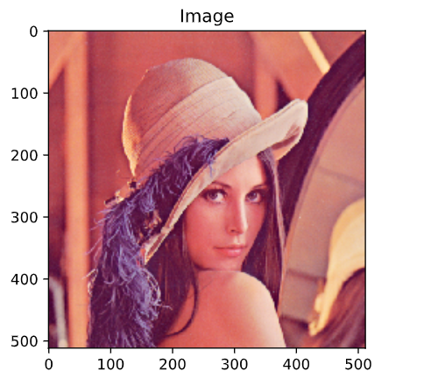

After using (3x3) filter:

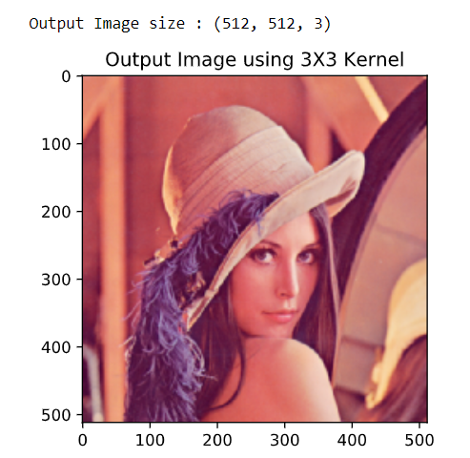

After using (5x5) filter:

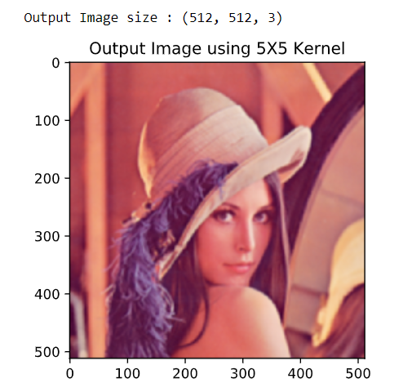

The convolution filter will mix up all the pixels in the image, but still remain the edges.

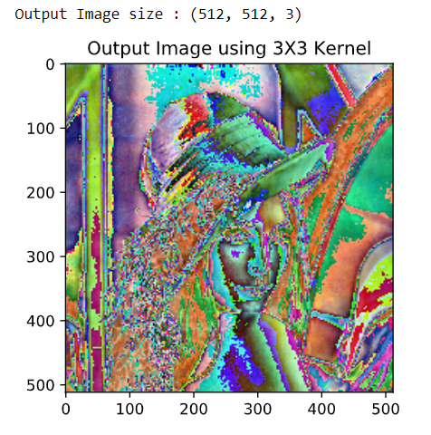

The (7x7) gaussian filter will darken the image and blur it as well:

