Spectrum Graph
Description: This document provides complete procedure to draw below spectrum graphs.
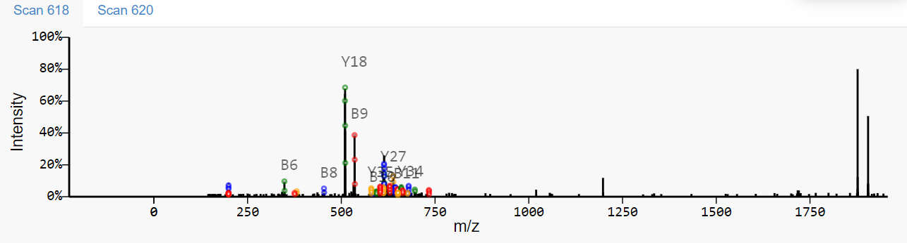
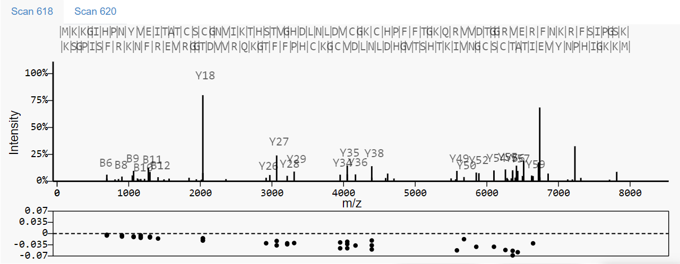

Files Required:
- Invokespectrum.js
- Spectrumparameters.js
- Spectrumgraph.js
- graphFeatures.js
Procedure:

