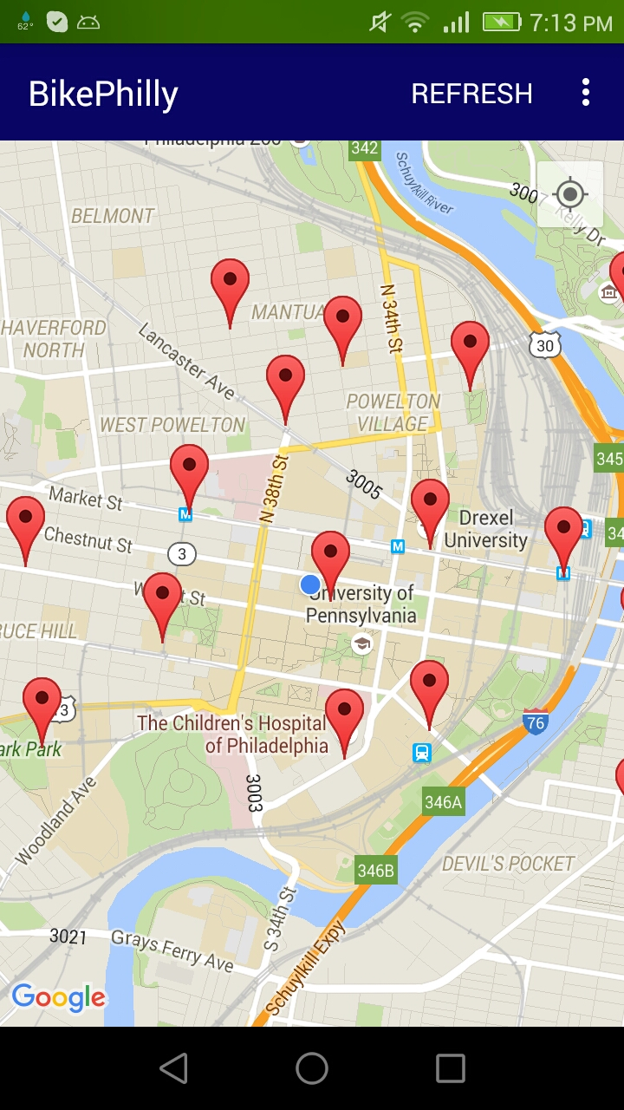 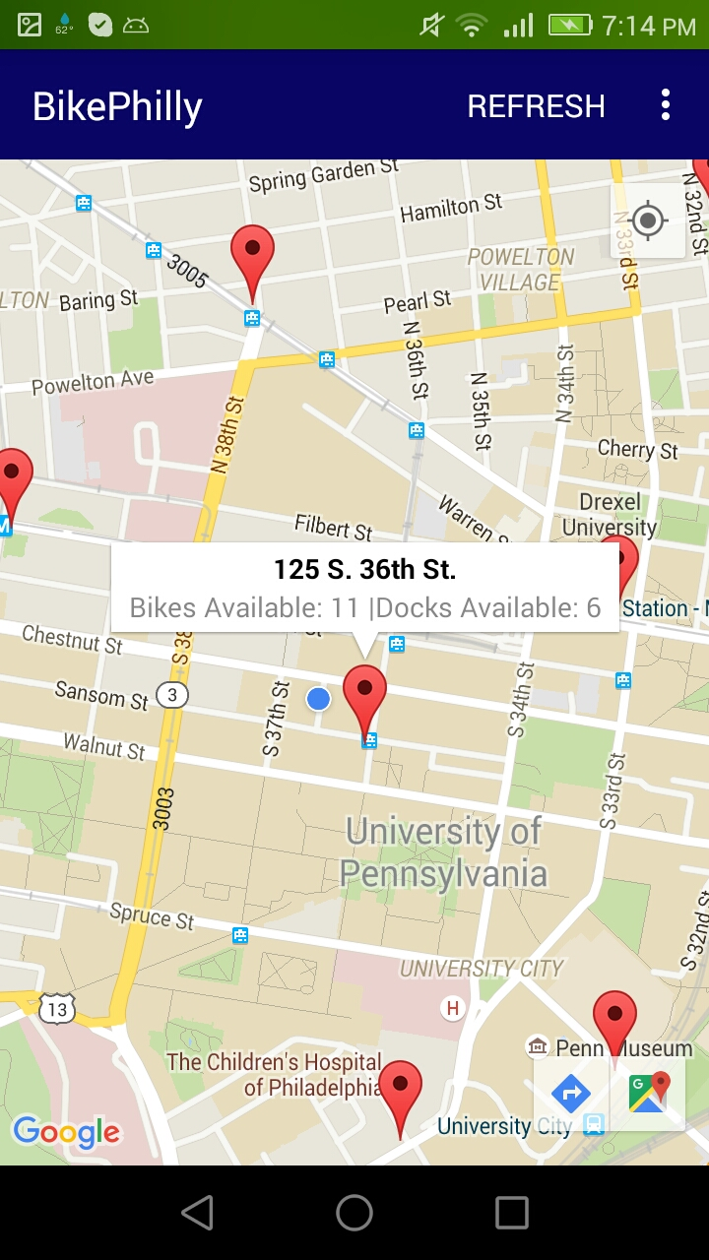

# BIKE PHILLY USER MANUAL

*Bike Philly* is a simple mobile application on Android that shows nearby Indego bike stations.

Open the app. The blue dot is where you are. The red markers are Indego bike stations in your surrounding area.

You can pan and zoom in or out the map just like you do with other Google Maps.

The toolbar on the top lets you refresh the page if needed. You can also access information about this application from there.

# BIKE PHILLY USER MANUAL

If you click on one of the markers, an info window will pop up. Inside the info window, you can see the address of the bike station, how many bikes are available and how many docks are vacant.

When you click on a marker, two icons on the bottom right side will show up. These icons will direct you to Google Map mobile app. This is useful when you want to get the direction to the bike station.

The icon on the upper right side of the map sets the camera view to your current location if you get too far away.

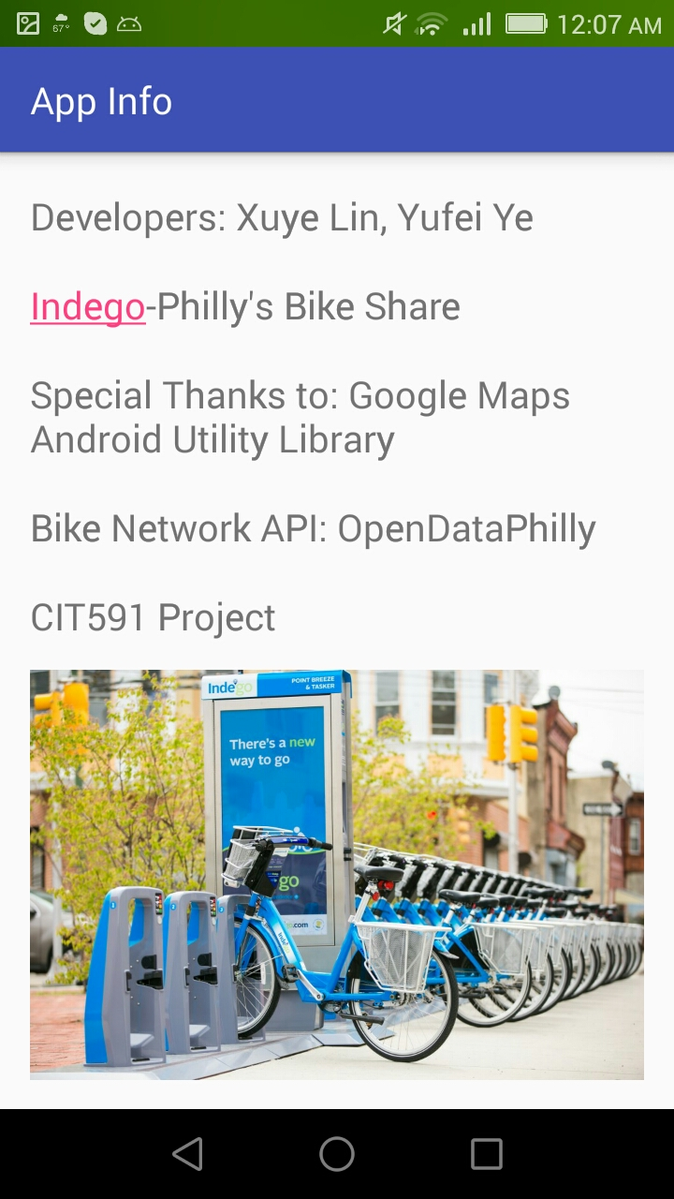

# BIKE PHILLY USER MANUAL

Click on the right side button on the toolbar. You will see an ‘App Info’ page that contains information about this app. This app is intended for users of the Indego bike network. If you click on ‘Indego’ you will be redirected to rideindego.com website.

You can go back to the map or exit using Android’s own navigation bar on the bottom.