This handout is a prelude to a data collection project comprised of having 10 individuals record numerous measurements around their body (measured in **centimeters**), along with general information that does not require measuring. Your name will be encrypted using a hash function known as MD5, so your measurements and identifying data will remain confidential throughout the project. Below, you will find the various measurements you need to take, which could take 20+ minutes. Covariates labeled with (left, right) means you will need to measure both the left and right appendages for that field, separated by a comma. Diagrams are shown on the next page, which will show you how to take the measurements yourself for each field and are annotated by the abbreviations listed in the table below.

**AREA FOR RESPONDENT**

|  |  |
| --- | --- |
| ***COVARIATE*** | ***MEASUREMENT*** |
| Name (first name, last initial) |  |
| Dominant writing hand |  |
| Dominant eye for seeing |  |
| Eye color |  |
| Dominant swinging hand |  |
| Age |  |
| Gender |  |
| Ethnicity |  |
| Height  *Standing height of the individual with no shoes on. H on diagram.* |  |
| Head height  *Height from the top of the head to below the chin. HH on diagram.* |  |
| Head circumference  Distance around the head, measured above the eyes/ears. HC on diagram. |  |
| Hand length (left, right)  *Length of the hand from the middle finger to the wrist (just below the palm). HL on diagram.* |  |
| Hand width (left, right)  *Width of a fully stretched hand from the pinky finger to the thumb. HW on diagram.* |  |
| Hand to elbow (left, right)  *Length from the middle finger to the elbow. HE on diagram.* |  |
| Elbow to armpit (left, right)  *Length from the elbow to the arm pit. EA on diagram.* |  |
| Arm reach (left, right)  *Length from floor to the extended arm maximum point, standing flatfooted. AR on diagram.* |  |
| Arm span  *Length from each middle finger, with fully extended arms. AS on diagram.* |  |
| Foot length (left, right)  *Length of the foot from the largest toe to the back of the heel. FL on diagram.* |  |
| Floor to knee pit (left, right)  *Distance from the floor to the knee pit. FK on diagram.* |  |
| Floor to hip (left, right)  *Distance from the floor to the hip. FH on diagram.* |  |
| Floor to navel  *Distance from the floor to the navel (belly button). FN on diagram.* |  |
| Floor to armpit (left, right)  *Distance from the floor to the arm pit. FA on diagram.* |  |

**DATA COLLECTOR USE ONLY**

|  |  |
| --- | --- |
| ***COVARIATE*** | ***EVALUATION*** |
| Quality (1-10) |  |
| Minutes |  |
| To be completed later? |  |
| Notes |  |

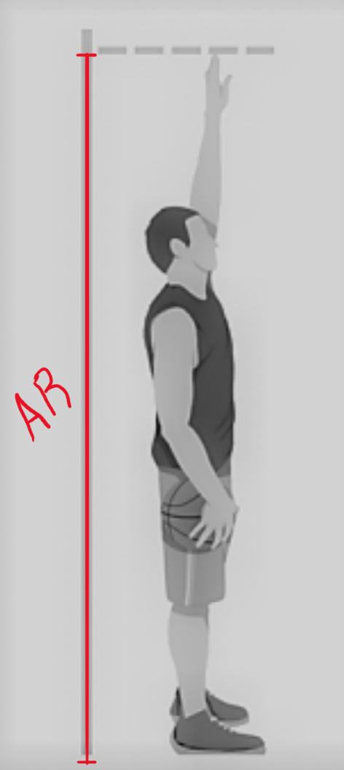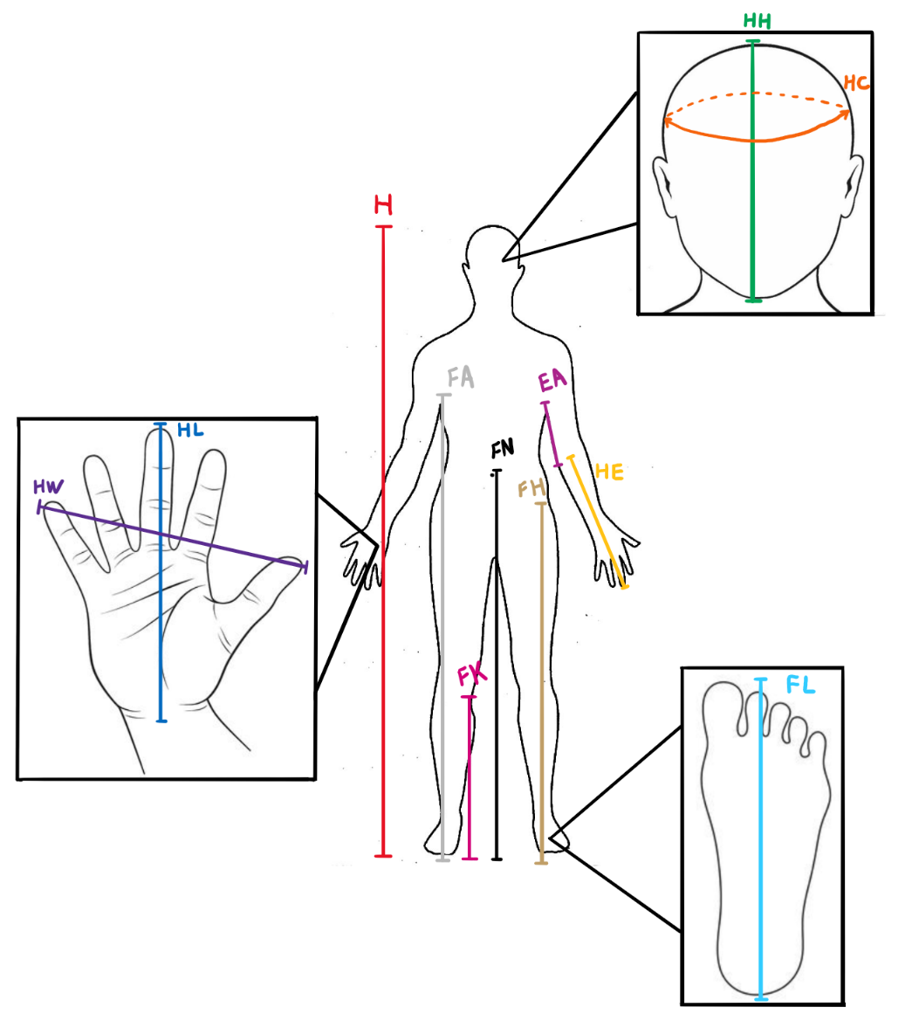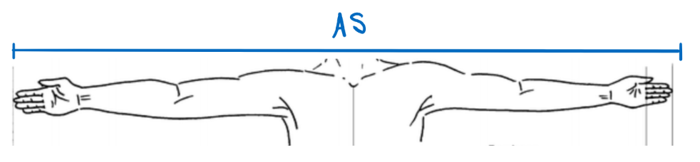

How to measure arm reach.

How to measure arm span.

How to measure height, head height, head circumference, hand length, hand width, hand to elbow, elbow to armpit, foot length, floor to knee pit, floor to hip, floor to navel, and floor to armpit.