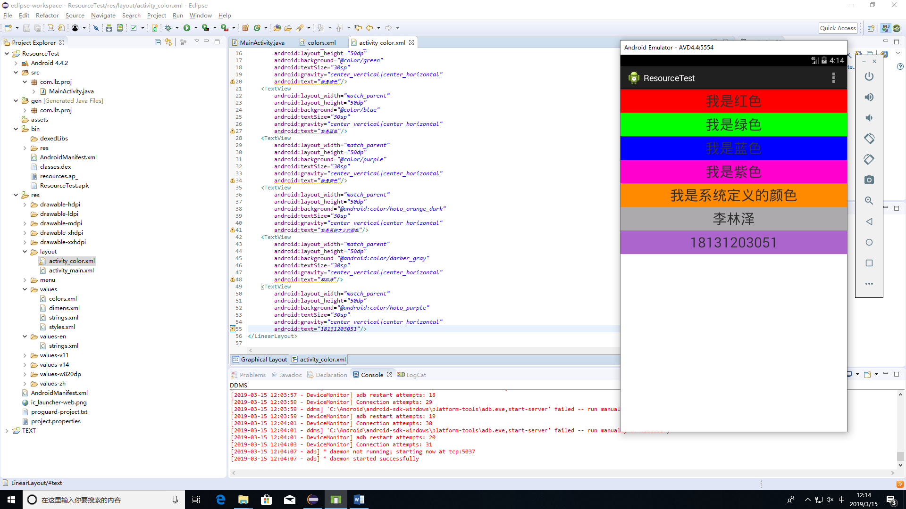<?xml version=*"1.0"* encoding=*"utf-8"*?>

<LinearLayout xmlns:android=*"http://schemas.android.com/apk/res/android"*

android:layout_width=*"match_parent"*

android:layout_height=*"match_parent"*

android:orientation=*"vertical"* >

<TextView

android:layout_width=*"match_parent"*

android:layout_height=*"50dp"*

android:background=*"@color/red"*

android:textSize=*"30sp"*

android:gravity=*"center_vertical|center_horizontal"*

android:text=*"我是红色"*/>

<TextView

android:layout_width=*"match_parent"*

android:layout_height=*"50dp"*

android:background=*"@color/green"*

android:textSize=*"30sp"*

android:gravity=*"center_vertical|center_horizontal"*

android:text=*"我是绿色"*/>

<TextView

android:layout_width=*"match_parent"*

android:layout_height=*"50dp"*

android:background=*"@color/blue"*

android:textSize=*"30sp"*

android:gravity=*"center_vertical|center_horizontal"*

android:text=*"我是蓝色"*/>

<TextView

android:layout_width=*"match_parent"*

android:layout_height=*"50dp"*

android:background=*"@color/purple"*

android:textSize=*"30sp"*

android:gravity=*"center_vertical|center_horizontal"*

android:text=*"我是紫色"*/>

<TextView

android:layout_width=*"match_parent"*

android:layout_height=*"50dp"*

android:background=*"@android:color/holo_orange_dark"*

android:textSize=*"30sp"*

android:gravity=*"center_vertical|center_horizontal"*

android:text=*"我是系统定义的颜色"*/>

<TextView

android:layout_width=*"match_parent"*

android:layout_height=*"50dp"*

android:background=*"@android:color/darker_gray"*

android:textSize=*"30sp"*

android:gravity=*"center_vertical|center_horizontal"*

android:text=*"李林泽"*/>

<TextView

android:layout_width=*"match_parent"*

android:layout_height=*"50dp"*

android:background=*"@android:color/holo_purple"*

android:textSize=*"30sp"*

android:gravity=*"center_vertical|center_horizontal"*

android:text=*"18131203051"*/>

</LinearLayout>

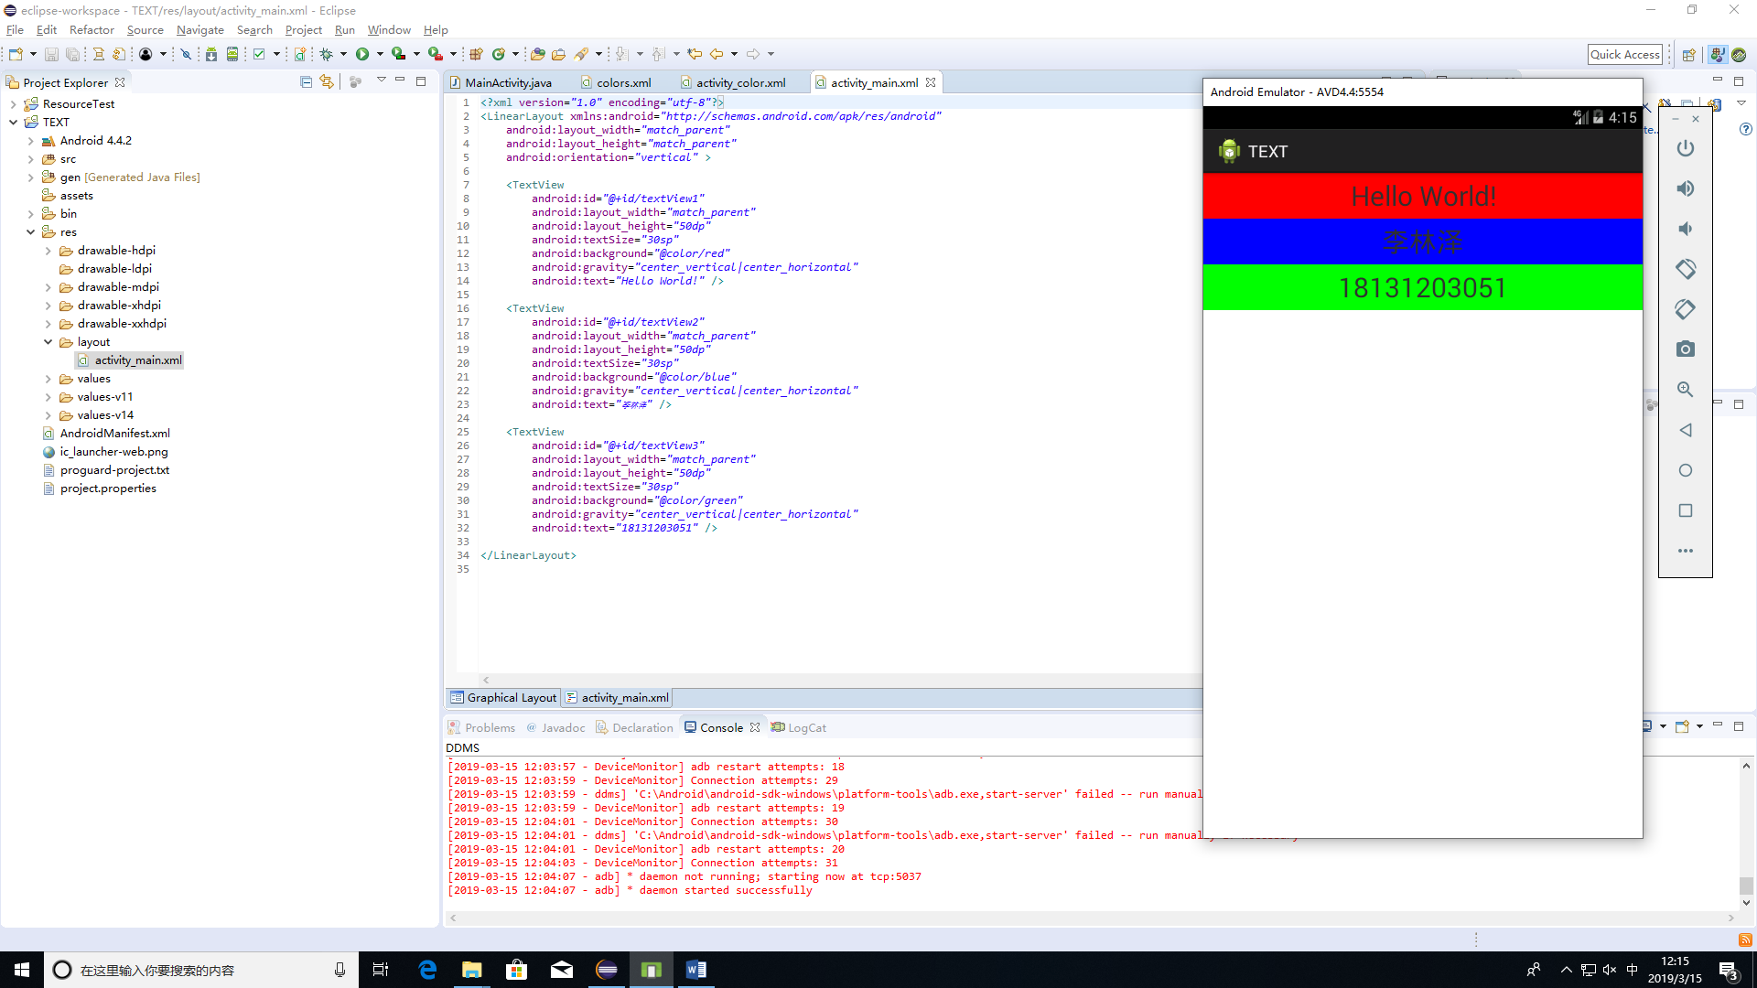<?xml version=*"1.0"* encoding=*"utf-8"*?>

<LinearLayout xmlns:android=*"http://schemas.android.com/apk/res/android"*

android:layout_width=*"match_parent"*

android:layout_height=*"match_parent"*

android:orientation=*"vertical"* >

<TextView

android:id=*"@+id/textView1"*

android:layout_width=*"match_parent"*

android:layout_height=*"50dp"*

android:textSize=*"30sp"*

android:background=*"@color/red"*

android:gravity=*"center_vertical|center_horizontal"*

android:text=*"Hello World!"* />

<TextView

android:id=*"@+id/textView2"*

android:layout_width=*"match_parent"*

android:layout_height=*"50dp"*

android:textSize=*"30sp"*

android:background=*"@color/blue"*

android:gravity=*"center_vertical|center_horizontal"*

android:text=*"李林泽"* />

<TextView

android:id=*"@+id/textView3"*

android:layout_width=*"match_parent"*

android:layout_height=*"50dp"*

android:textSize=*"30sp"*

android:background=*"@color/green"*

android:gravity=*"center_vertical|center_horizontal"*

android:text=*"18131203051"* />

</LinearLayout>

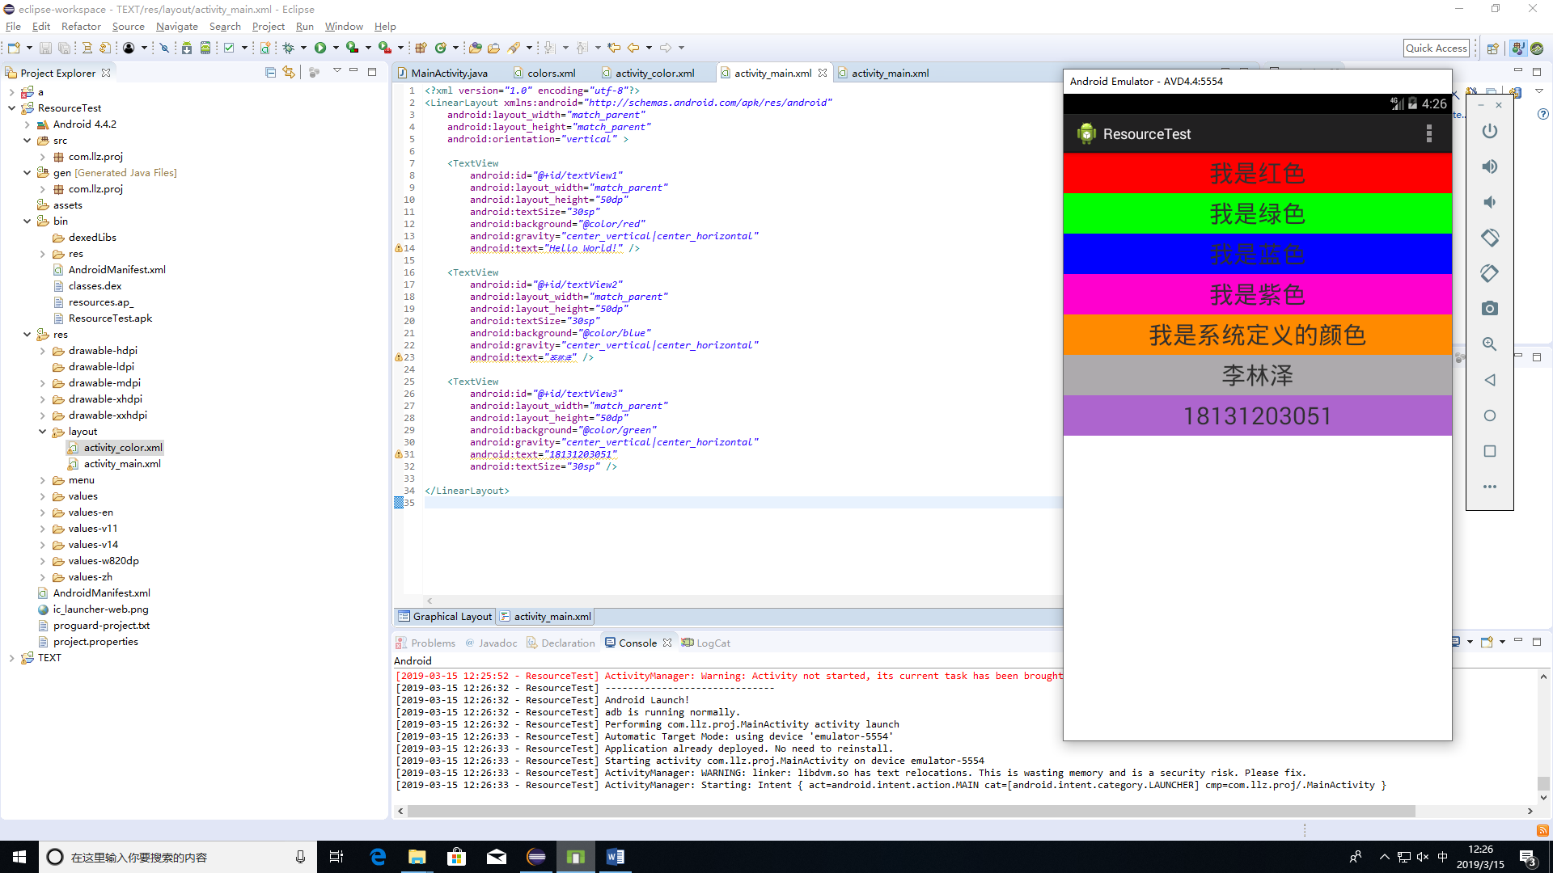

<?xml version=*"1.0"* encoding=*"utf-8"*?>

<LinearLayout xmlns:android=*"http://schemas.android.com/apk/res/android"*

android:layout_width=*"match_parent"*

android:layout_height=*"match_parent"*

android:orientation=*"vertical"* >

<TextView

android:id=*"@+id/textView1"*

android:layout_width=*"match_parent"*

android:layout_height=*"50dp"*

android:textSize=*"30sp"*

android:background=*"@color/red"*

android:gravity=*"center_vertical|center_horizontal"*

android:text=*"Hello World!"* />

<TextView

android:id=*"@+id/textView2"*

android:layout_width=*"match_parent"*

android:layout_height=*"50dp"*

android:textSize=*"30sp"*

android:background=*"@color/blue"*

android:gravity=*"center_vertical|center_horizontal"*

android:text=*"李林泽"* />

<TextView

android:id=*"@+id/textView3"*

android:layout_width=*"match_parent"*

android:layout_height=*"50dp"*

android:background=*"@color/green"*

android:gravity=*"center_vertical|center_horizontal"*

android:text=*"18131203051"*

android:textSize=*"30sp"* />

</LinearLayout>

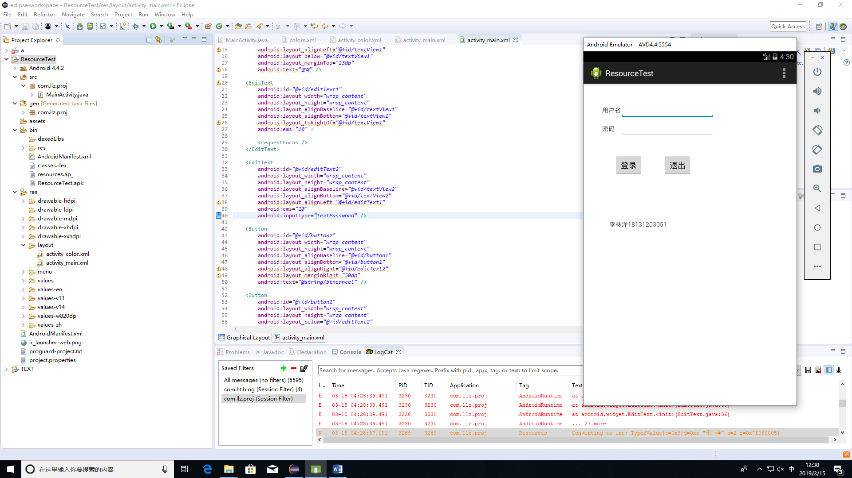

<RelativeLayout xmlns:android=*"http://schemas.android.com/apk/res/android"*

xmlns:tools=*"http://schemas.android.com/tools"*

android:layout_width=*"match_parent"*

android:layout_height=*"match_parent"*

android:paddingBottom=*"@dimen/activity_vertical_margin"*

android:paddingLeft=*"@dimen/activity_horizontal_margin"*

android:paddingRight=*"@dimen/activity_horizontal_margin"*

android:paddingTop=*"@dimen/activity_vertical_margin"*

tools:context=*"com.llz.proj.MainActivity"* >

<TextView

android:id=*"@+id/textView2"*

android:layout_width=*"wrap_content"*

android:layout_height=*"wrap_content"*

android:layout_alignLeft=*"@+id/textView1"*

android:layout_below=*"@+id/textView1"*

android:layout_marginTop=*"23dp"*

android:text=*"密码"* />

<EditText

android:id=*"@+id/editText1"*

android:layout_width=*"wrap_content"*

android:layout_height=*"wrap_content"*

android:layout_alignBaseline=*"@+id/textView1"*

android:layout_alignBottom=*"@+id/textView1"*

android:layout_toRightOf=*"@+id/textView1"*

android:ems=*"10"* >

<requestFocus />

</EditText>

<EditText

android:id=*"@+id/editText2"*

android:layout_width=*"wrap_content"*

android:layout_height=*"wrap_content"*

android:layout_alignBaseline=*"@+id/textView2"*

android:layout_alignBottom=*"@+id/textView2"*

android:layout_alignLeft=*"@+id/editText1"*

android:ems=*"10"*

android:inputType=*"textPassword"* />

<Button

android:id=*"@+id/button2"*

android:layout_width=*"wrap_content"*

android:layout_height=*"wrap_content"*

android:layout_alignBaseline=*"@+id/button1"*

android:layout_alignBottom=*"@+id/button1"*

android:layout_alignRight=*"@+id/editText2"*

android:layout_marginRight=*"50dp"*

android:text=*"@string/btncancel"* />

<Button

android:id=*"@+id/button1"*

android:layout_width=*"wrap_content"*

android:layout_height=*"wrap_content"*

android:layout_below=*"@+id/editText2"*

android:layout_marginTop=*"49dp"*

android:layout_toRightOf=*"@+id/textView2"*

android:text=*"@string/btnok"* />

<TextView

android:id=*"@+id/textView1"*

android:layout_width=*"wrap_content"*

android:layout_height=*"wrap_content"*

android:layout_alignParentLeft=*"true"*

android:layout_alignParentTop=*"true"*

android:layout_marginLeft=*"26dp"*

android:layout_marginTop=*"34dp"*

android:text=*"@string/username"*/>

<TextView

android:id=*"@+id/textView3"*

android:layout_width=*"wrap_content"*

android:layout_height=*"wrap_content"*

android:layout_alignLeft=*"@+id/textView2"*

android:layout_below=*"@+id/button1"*

android:layout_marginLeft=*"16dp"*

android:layout_marginTop=*"100dp"*

android:text=*"李林泽18131203051"* />

</RelativeLayout>