**1、例7.17 显示工资最高的前3名雇员的名称和工资。**

SET SERVEROUTPUT ON

DECLARE

V_ename VARCHAR2(10);

V_sal NUMBER(5);

CURSOR emp_cursor IS

SELECT ename,sal scomm FROM emp ORDER BY sal DESC;

BEGIN

OPEN emp_cursor;

FOR I IN 1..3 LOOP

FETCH emp_cursor INTO v_ename,v_sal;

dbms_output.put_line(v_ename||','||v_sal);

END LOOP;

CLOSE emp_cursor;

END;

/

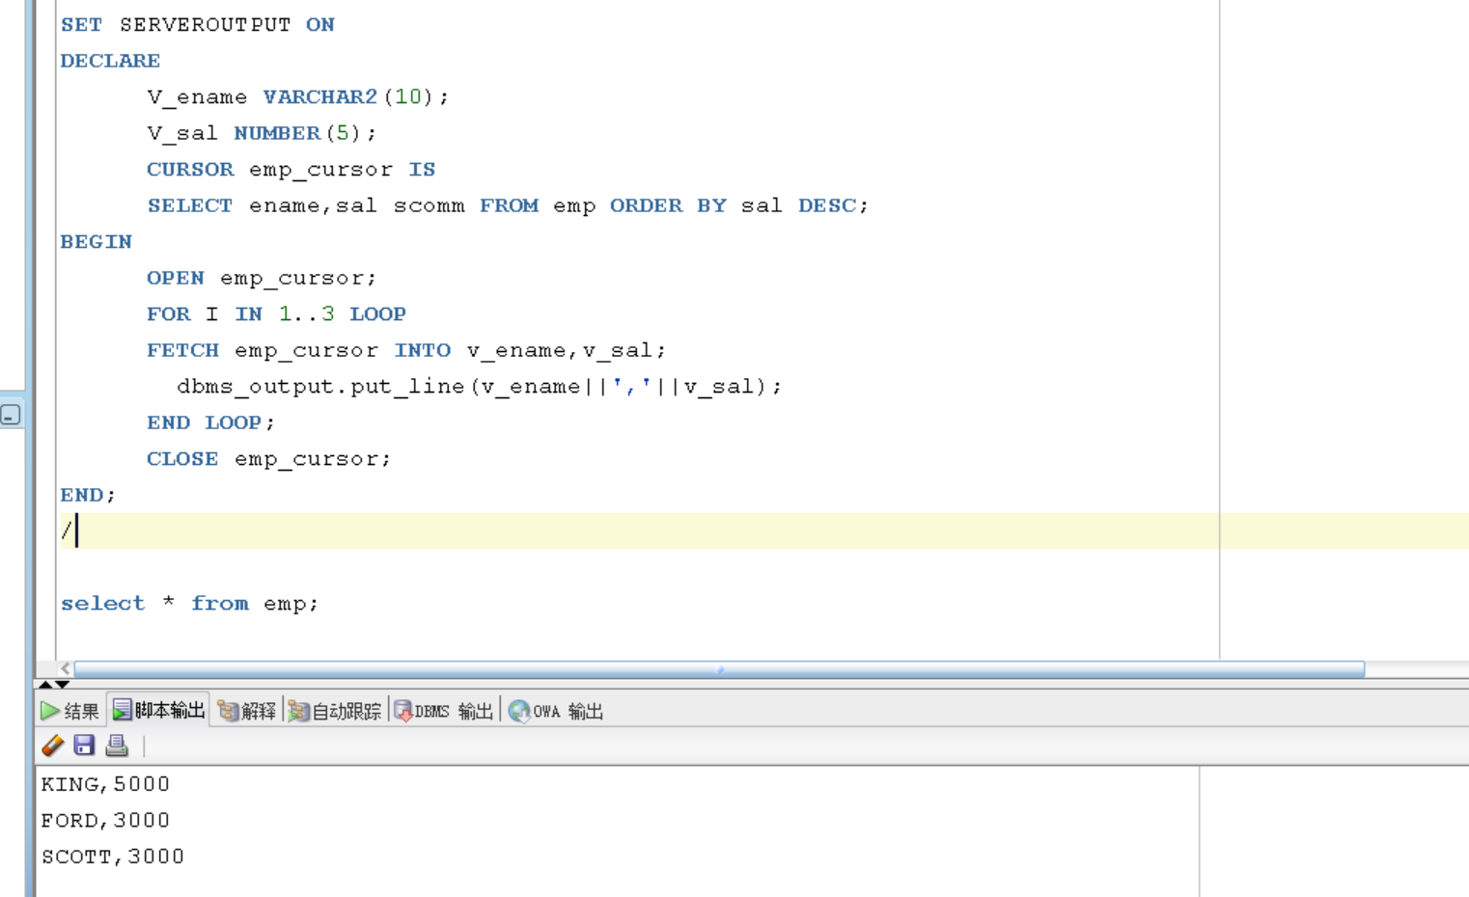

**2、迁移题：显示工资最低的前10名雇员的名称和工资，部门编号。**

SET SERVEROUTPUT ON

DECLARE

V_ename VARCHAR2(10);

V_sal NUMBER(5);

V_deptno VARCHAR2(10);

CURSOR emp_cursor IS

SELECT ename,sal scomm, deptno FROM emp ORDER BY sal;

BEGIN

OPEN emp_cursor;

FOR I IN 1..10 LOOP

FETCH emp_cursor INTO v_ename,v_sal, v_deptno;

dbms_output.put_line(v_ename||','||v_sal||','||V_deptno);

END LOOP;

CLOSE emp_cursor;

END;

/

