实 验 三

一、实验名称
包的安装与载入
二、实验平台
1、操作系统：windows 7
2、软件：Rstudio
三、实验目的
了解包的概念，掌握包的安装与载入方法。
四、实验内容及实验步骤
1）用library( )函数或(.packages(all.available=TRUE))列出所有已安装的包的清单。
2）用(.packages())查看已加载的包清单。
3）用library（“包名称”）加载已安装的包。
4）用library（help=”包名”）查看帮助文档中包的信息及函数列表。
5）install.packages(“packages name”)安装包,用此函数安装fortunes包并加载，用library( )函数查看包清单。在控制台输入fortunes()，fortunes(161)等观察运行结果。
6）安装maptools包并加载，利用sunrise()函数计算某天天安门广场升旗时间。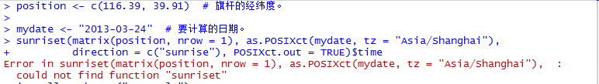
7）卸载包detach(packages:包名),用此函数卸载fortunes,用library( )函数查看包清单。
五、实验报告
1．给出源代码及运行截图。
library()
.packages()
install.packages("fortunes")
fortunes()
library("maptools")
position <- c(116.39, 39.91)
date <- "2017-10-01"
sunriset(matrix(position, nrow = 1),
as.POSIXct(date, tz = "Asia/Shanghai"),
direction = c("sunrise"), POSIXct.out = TRUE)$time
sunriset(matrix(position, nrow = 1),
as.POSIXct(date, tz = "Asia/Shanghai"),
direction = c("sunset"), POSIXct.out = TRUE)$time

R version 4.1.1 (2021-08-10) -- "Kick Things"
Copyright (C) 2021 The R Foundation for Statistical Computing
Platform: x86_64-w64-mingw32/x64 (64-bit)

R is free software and comes with ABSOLUTELY NO WARRANTY.
You are welcome to redistribute it under certain conditions.
Type 'license()' or 'licence()' for distribution details.

R is a collaborative project with many contributors.
Type 'contributors()' for more information and
'citation()' on how to cite R or R packages in publications.

Type 'demo()' for some demos, 'help()' for on-line help, or
'help.start()' for an HTML browser interface to help.
Type 'q()' to quit R.

Error: '\? is an unrecognized escape in character string starting ""E:\?
[Workspace loaded from E:/课程资料/第三学期/数据仓库/.RData]

> .libPaths()
[1] "G:/R-4.1.1/library"
> install.packages("fortunes")
Warning in install.packages :
'lib = "G:/R-4.1.1/library"' is not writable
Warning in install.packages :
cannot create dir 'C:\Users\KevonLin\OneDrive\??', reason 'Invalid argument'
Error in install.packages : unable to create ‘C:/Users/KevonLin/OneDrive/??/R/win-library/4.1’
> install.packages("fortunes")
trying URL 'https://cran.rstudio.com/bin/windows/contrib/4.1/fortunes_1.5-4.zip'
Content type 'application/zip' length 210393 bytes (205 KB)
downloaded 205 KB

package ‘fortunes’ successfully unpacked and MD5 sums checked

The downloaded binary packages are in
C:\Users\KevonLin\AppData\Local\Temp\Rtmpmcvys0\downloaded_packages
> .libPaths()
[1] "G:/R-4.1.1/library"
> .libPaths("G:\R-4.1.1\package")
Error: '\R' is an unrecognized escape in character string starting ""G:\R"
> .libPaths()
[1] "G:/R-4.1.1/library"
> install.packages("maptools")
还安装相依关系‘sp’

trying URL 'https://cran.rstudio.com/bin/windows/contrib/4.1/sp_1.4-5.zip'
Content type 'application/zip' length 1825295 bytes (1.7 MB)
downloaded 1.7 MB

trying URL 'https://cran.rstudio.com/bin/windows/contrib/4.1/maptools_1.1-2.zip'
Content type 'application/zip' length 2171710 bytes (2.1 MB)
downloaded 2.1 MB

package ‘sp’ successfully unpacked and MD5 sums checked
package ‘maptools’ successfully unpacked and MD5 sums checked

The downloaded binary packages are in
C:\Users\KevonLin\AppData\Local\Temp\Rtmpmcvys0\downloaded_packages
> fortunes()
Error in fortunes() : could not find function "fortunes"
> fortunes::fortune()

Mathematical conventions are just that, conventions. They differ by
field of mathematics. Don't ask us why matrix rows are numbered down but
graphs are numbered up the y axis, nor why x comes before y but row
before column. But the matrix layout has always seemed illogical to me.
-- Brian D. Ripley (answering a question why the layouts of print(x)
and image(x) are different)
R-help (August 2004)

> position <- c(116.39, 39.91)
> date <- "2017-10-01"
> sunriset(matrix(position, nrow = 1),
+ as.POSIXct(mydate, tz = "Asia/Shanghai"),
+ direction = c("sunrise"), POSIXct.out = TRUE)$time
Error in sunriset(matrix(position, nrow = 1), as.POSIXct(mydate, tz = "Asia/Shanghai"), :
could not find function "sunriset"
> sunriset(matrix(position, nrow = 1),
+ as.POSIXct(mydate, tz = "Asia/Shanghai"),
+ direction = c("sunset"), POSIXct.out = TRUE)$time
Error in sunriset(matrix(position, nrow = 1), as.POSIXct(mydate, tz = "Asia/Shanghai"), :
could not find function "sunriset"
> position <- c(116.39, 39.91)
> date <- "2017-10-01"
> sunriset(matrix(position, nrow = 1),
+ as.POSIXct(date, tz = "Asia/Shanghai"),
+ direction = c("sunrise"), POSIXct.out = TRUE)$time
Error in sunriset(matrix(position, nrow = 1), as.POSIXct(date, tz = "Asia/Shanghai"), :
could not find function "sunriset"
> sunriset(matrix(position, nrow = 1),
+ as.POSIXct(date, tz = "Asia/Shanghai"),
+ direction = c("sunset"), POSIXct.out = TRUE)$time
Error in sunriset(matrix(position, nrow = 1), as.POSIXct(date, tz = "Asia/Shanghai"), :
could not find function "sunriset"
> library("maptools")
载入需要的程辑包：sp
Checking rgeos availability: FALSE
Please note that 'maptools' will be retired by the end of 2023,
plan transition at your earliest convenience;
some functionality will be moved to 'sp'.
Note: when rgeos is not available, polygon geometry computations in maptools depend on gpclib,
which has a restricted licence. It is disabled by default;
to enable gpclib, type gpclibPermit()
> position <- c(116.39, 39.91)
> date <- "2017-10-01"
> sunriset(matrix(position, nrow = 1),
+ as.POSIXct(date, tz = "Asia/Shanghai"),
+ direction = c("sunrise"), POSIXct.out = TRUE)$time
[1] "2017-10-01 06:10:25 CST"
> sunriset(matrix(position, nrow = 1),
+ as.POSIXct(date, tz = "Asia/Shanghai"),
+ direction = c("sunset"), POSIXct.out = TRUE)$time
[1] "2017-10-01 17:57:14 CST"
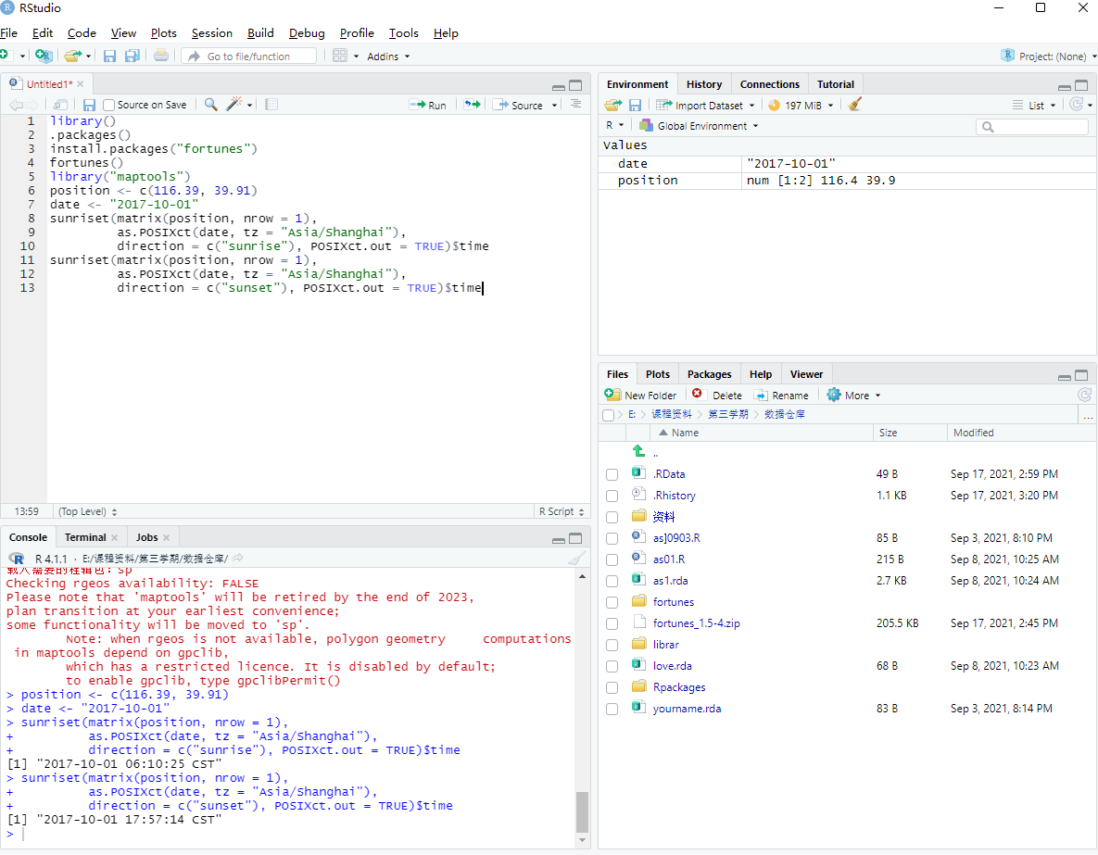
2．解题过程中出现的问题。
1) 安装package时目录不可写
2） Error in sunriset(matrix(position, nrow = 1), as.POSIXct(date, tz = "Asia/Shanghai"), :
could not find function "sunriset"
3．解决方案（列出遇到的问题和解决办法）。
1） 修改libPath()输出的目录的权限为可写
2）使用library("maptools")加载函数库

