Desktop Organizer — Project Briefing
As of 5 October 2026

Summary
Desktop Organizer 1.3.0 is built, tested and packaged for Windows, but not yet published or sold. It sorts files in the Desktop, Downloads, Documents or any chosen folder into a folder structure the user picks, and every run can be undone.
- Built: a Windows app with an installer and portable zip, 127 automated tests, and four tagged releases (1.0.0 to 1.3.0, all on 5 October 2026).
- Pricing: every feature is free for now; the Free vs Premium split is planned but not switched on.
- Before launch: licensing and payments, publishing the first release on GitHub, and code signing so Windows stops warning about the installer.

What's built
The app grew from a 107-line script into a full desktop app in four releases. Every feature below is working and free today.
Area | What users get | Release
App window | Folder list, live preview of every move, untick files to skip them, filter, light/dark theme | 1.0
Any folder | Desktop, Documents, Downloads, Pictures, Music, Videos or any folder; follows OneDrive redirects | 1.0
Folder structures | 5 ready-made layouts plus a builder with 11 placeholders, e.g. Work/{category}/{year} | 1.0
Categories | User-defined groups such as Invoices = pdf | 1.0
Undo | Any run can be reversed from History; files are never overwritten | 1.0
Safety | Refuses drive roots, the user folder and system folders; warns on code and Docker projects | 1.0
Command line | Preview, organize, undo, history, folders, structure and categories commands | 1.0
Rules | Conditions on name, type, size and age; move somewhere or leave alone; per-folder scope | 1.1
Auto-organize | Per folder: when new files arrive, hourly or daily; waits for downloads to finish | 1.1
Tray and startup | Keeps running in the tray, notifications, start with Windows | 1.1
Duplicates | Finds identical files and moves extra copies to the Recycle Bin | 1.1
One copy at a time | Opening the app again brings the running copy forward | 1.2
Updates | Check for updates from GitHub Releases; optional weekly check, off by default | 1.2
Error handling | Rotating log file; a friendly error dialog with details to copy | 1.2
Find a file | Search by name to see where the organizer moved a file, from where and when | 1.3
File versions | Keeps the last 4 saved versions of files in protected folders; restore any, or bring back deleted files | 1.3
Recycle Bin recovery | Lists deleted items with their original location and puts them back | 1.3

How it's built and shipped
One build command produces the installer and the portable zip; only code signing is missing.
Part | Choice | Why
Language and UI | Python 3.10 with PySide6 (Qt) | Native-looking app; free for commercial use under the LGPL
Engine | A core package with no UI code | The window and the command line share it; it is tested on its own
Undo log and settings | SQLite and a JSON file in %APPDATA%\DesktopOrganizer | Each move is logged as it happens, so even an interrupted run can be undone
Packaging | PyInstaller, then an Inno Setup installer | 25 MB per-user installer with no admin rights, plus a 34 MB portable zip
Versioning | Semantic versions (MAJOR.MINOR.PATCH) from one source file | A bump script updates the version and the changelog together
Quality | 127 automated tests, including headless tests of the window | Tests use fake Desktop, Downloads and Recycle Bin folders, never the real ones

The code is on the desktop-app branch with tags v1.0.0 to v1.3.0. It has not been pushed to GitHub or merged into master, and no GitHub release exists yet, so the update checker has nothing to offer until one is published.

Business model
The plan is a generous free tier that people keep using, and a one-time or monthly Premium upgrade for automation. Nothing is gated yet; the split below is the proposal.
Free | Premium
Organize the Desktop with one click | Any folder (Downloads, Documents, drives)
Find a file; restore from the Recycle Bin | File versions (last 4 saves of protected files)
Preview before moving, undo the last run | Full undo history
Ready-made structures and categories | Custom structure builder and rules
Exclusions, light and dark theme | Auto-organize, tray, start with Windows
 | Duplicate finder, stats

- Proposed price: about US$15–25 one-time, or about US$3 a month. These figures are a starting estimate, not market-tested.
- Payments: a merchant-of-record service such as Lemon Squeezy or Paddle, which handles global sales tax and issues license keys. This matters from Jamaica, where Stripe is not directly available (to confirm before choosing).
- Trial: 14 days of Premium on first install.
- Locked features: shown with a lock icon that opens the upgrade screen, rather than hidden.

SWOT
The product is ahead of its distribution: the strengths are in the app, while the weaknesses are reach and trust.
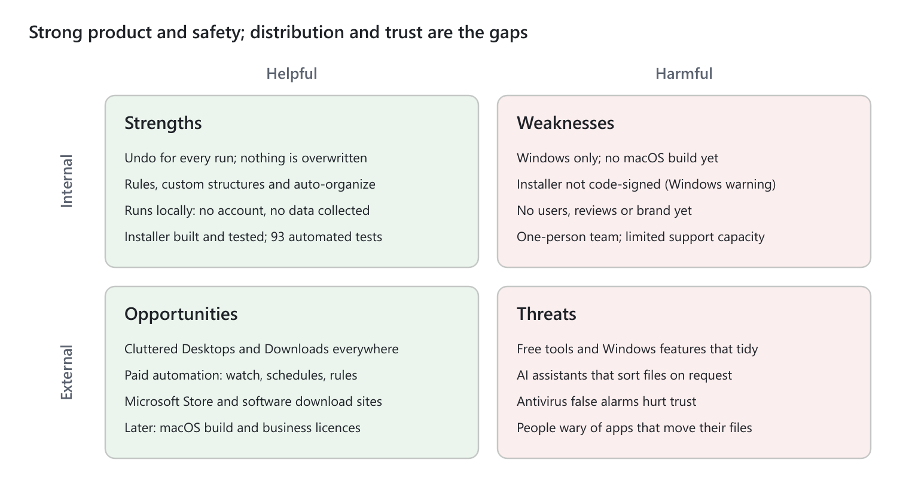
SWOT: strengths, weaknesses, opportunities and threats
The weaknesses and threats share one fix list: code signing, a clear free tier, and the safety features shown up front.

PESTEL
The outside factors that matter most are technological and legal: Windows trust warnings, and selling software across borders. This is an assessment from general knowledge, not market research.
Factor | What's happening | What it means for the app | Impact
Political | Governments are pushing digital skills and small online businesses; little regulation targets desktop utilities | Low direct exposure; local small-business support may help with launch costs | Low
Economic | Buyers are price-sensitive about utilities, and free tools exist; payment services take a fee per sale | Keep a strong free tier and a low one-time price; sell in US dollars to avoid currency swings | Medium
Social | Remote work and constant downloads leave Desktops and Downloads folders cluttered; people fear apps that move their files | Real, everyday need; undo, preview and the Recycle Bin are what earn trust | High
Technological | Windows warns about unsigned installers and antivirus can flag packaged Python apps; Windows and AI tools are adding built-in tidying | Code signing is needed before launch; the edge is user control and rules, not just tidying | High
Environmental | Software runs locally with no cloud servers | Little impact; removing duplicates frees storage, a small positive | Low
Legal | Sales tax on digital goods applies in many countries; privacy laws cover personal data; open-source licences have conditions | A merchant-of-record handles sales tax; the app collects no data, which keeps privacy simple; PySide6's LGPL terms need a notice in the app; an end-user licence should limit liability for lost files | Medium

Competitors
There are at least seven direct alternatives, in two groups: rule-based organizers, and a newer wave of AI sorters. Prices and features were checked on each product's own site on 5 October 2026, except where noted.
App | Platform | What it does | Price
Windows Storage Sense | Windows (built in) | Deletes old files from Downloads and the Recycle Bin to free space; does not sort files into folders | Free
DropIt | Windows | Drag-and-drop and folder-watching rules with 21 actions; open source, last release October 2018 | Free
File Juggler | Windows | Rules on name, date, size and text inside PDFs and Word files; renames and moves | About US$40–50 one-time (from reviews); 30-day trial
Stardock Fences 6 | Windows | Groups desktop icons into boxes on the Desktop; tidies the view rather than the folders | From US$9.99; sold as a 1-year subscription
Hazel 6 | macOS only | Watches folders, sorts, renames, tags and cleans the Trash by rules | US$42 one-time (family US$65)
FileSensei | Windows, macOS | Watches Downloads; rules plus local AI; dry-run preview and one-click undo | Free for 100 sorts a month; Pro US$29 one-time
Sortio | Windows, macOS, Linux | AI reads file contents, renames and routes files; preview and undo; cloud AI by default | Pro US$14.99 a month or US$99 a year

Preview and undo are no longer rare: the newest tools (FileSensei, Sortio) have both. The open gaps are price, privacy and how much control the user keeps.

What can make it unique
The strongest position is the safest file organizer for Windows, with a one-time price and nothing sent online. Most of that already exists in 1.3; the rest is a short list of additions.
Edge | Why it stands out | Status
Safety as the headline | Full undo history for any run, never overwrites, refuses system folders, warns on code and Docker projects, waits for downloads to finish | Built; needs to lead the marketing
Recovery built in | Find where any file went, restore the last 4 versions of protected files, and bring back Recycle Bin items in one window. None of the tools above combine organizing with recovery | Built
See every destination first | Placeholder layouts such as Work/{category}/{year} show the exact folder per file before anything moves | Built
Private by design | Works offline with no account; the only network use is an update check the user turns on. Sortio sends file names to a cloud AI by default | Built
Fair one-time price | Undercuts File Juggler and Hazel; no subscription like Sortio or Fences; no monthly cap on the free tier like FileSensei | Price to be set
Ready-made setups | One-click setups for students, freelancers and photographers, so new users get value in a minute | To build
Optional local AI | Sort invoices, receipts and contracts by what is inside them, using a model on the user's own PC (Premium) | To build
Content conditions | Rules that read text inside PDFs and Word files, matching File Juggler | To build
Safe clean-up of old files | Old Downloads go to the Recycle Bin, not permanently deleted as with Storage Sense | To build

The message to test with first users: “Tidy any folder in one click. See where every file goes first, and undo anything.”

Roadmap
Four releases are done; licensing (1.4) is next and waits on the pricing decisions below. No dates are set yet.
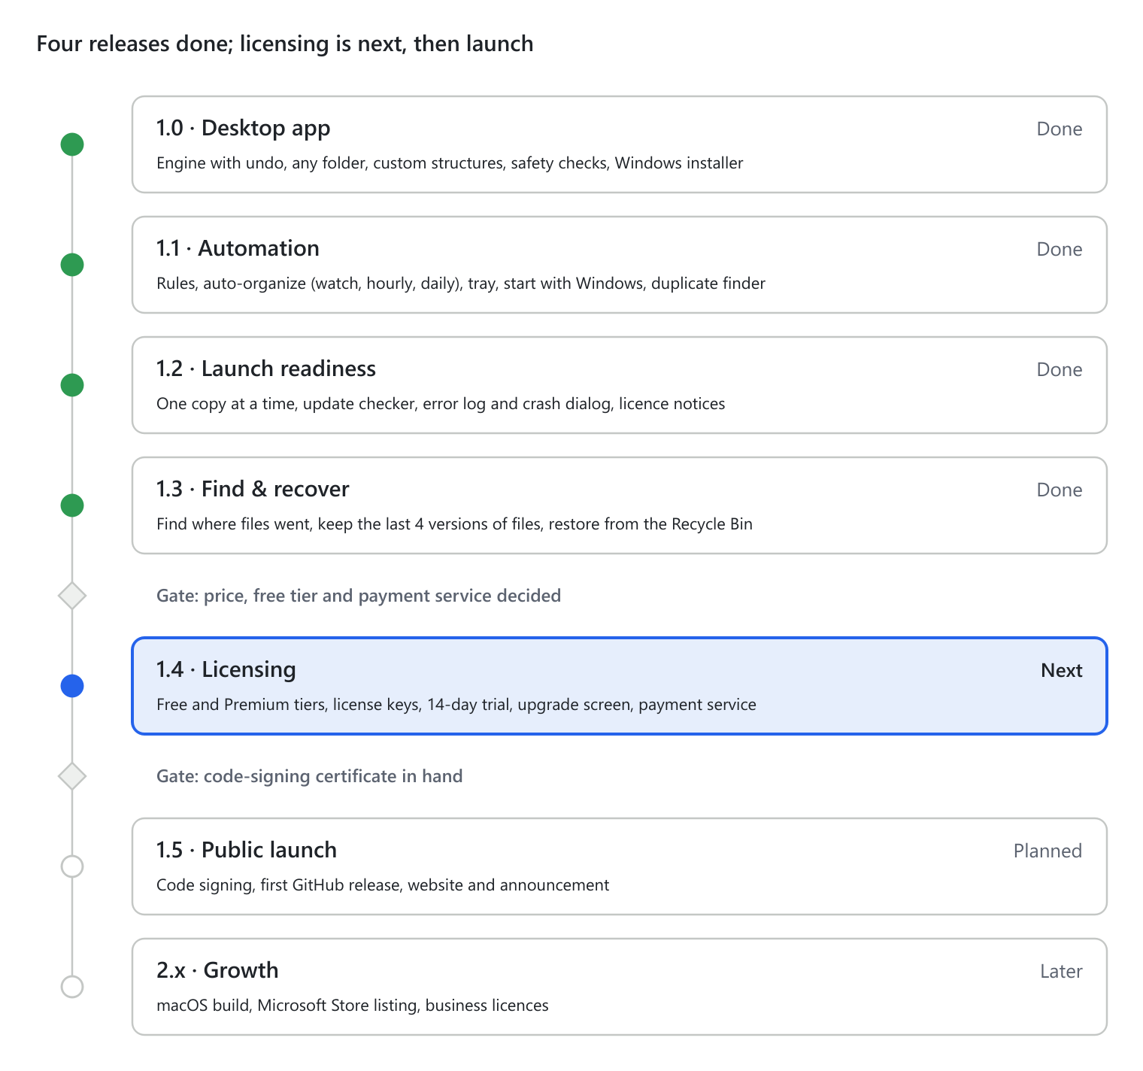
Roadmap: 7 releases and 2 gates, not to scale
Each gate is a decision from the owner, not engineering work; the work after each gate is ready to start.

Risks
The biggest risk is moving a user's files somewhere they did not expect; most of the design exists to make that recoverable.
Risk | How it's handled
Files moved to the wrong place | Preview before every manual run; every move logged and undoable; nothing overwritten; extra copies go to the Recycle Bin, never deleted
Breaking a project or system folder | Refuses drive roots, the user folder and system folders; warns before code and Docker projects
Moving a file that is still downloading | Unfinished downloads are skipped; auto-organize waits until a file has stopped changing
“Windows protected your PC” warning scares buyers | Code signing planned before launch; until then, a note in the user guide
Crashes nobody can diagnose | Errors go to a log file and a dialog with details users can copy into a report
Antivirus flags the app | Built as a folder rather than one self-extracting file; signing and submitting to Microsoft reduces it further
Licence keys get shared or cracked | Keep protection simple; desktop licences can always be bypassed, so effort goes into the product

During development a test once moved 47 real Desktop files. They were all restored, and the tests now use fake folders only.

Decisions needed
Six decisions block the move from a finished app to a product on sale.
☐ Choose the payment and licensing service (Lemon Squeezy, Paddle or another) and confirm it pays out to Jamaica.
☐ Set the Premium price and whether it is one-time, monthly or both.
☐ Confirm which features stay free (see Business model).
☐ Buy a code-signing certificate, or accept the Windows warning for an early release.
☐ Push the code to GitHub, merge the desktop-app branch into master, and publish the first release so update checks work.
☐ Agree the positioning: the safest organizer for Windows, one-time price, nothing sent online.

Sources
- Windows Storage Sense — Microsoft Support
- DropIt — official site
- File Juggler and its trial and licensing FAQ; price from XDA Developers and other reviews
- Stardock Fences and the Fences 6 release announcement
- Hazel and the Noodlesoft store
- FileSensei — official site
- Sortio — official site

