Desktop Organizer — User Guide
Version 1.2 for Windows · 5 October 2026

Welcome
Desktop Organizer tidies your Desktop, Downloads, Documents or any folder by sorting loose files into folders, in a layout you choose. You always see where each file will go before anything moves, and any run can be undone.
This guide covers version 1.2 for Windows. All features are currently free.

Install and first run
There are two ways to get the app; both need Windows 10 or 11 (64-bit) and no administrator rights.
Download | Choose it when
DesktopOrganizer-1.2.0-Setup.exe | You want a normal install with a Start menu entry and an uninstaller
DesktopOrganizer-1.2.0-portable.zip | You don't want to install anything: unzip it anywhere and run DesktopOrganizer.exe

- Run the installer and follow the steps. Tick Create a desktop shortcut if you want one.
- If Windows shows “Windows protected your PC”, click More info, then Run anyway. This appears because the installer is not yet code-signed.
- The app opens on your Desktop. Nothing moves until you click Organize.
Only one copy of the app runs at a time. Opening it again, from the Start menu or a shortcut, brings the running copy forward, even when it is hidden in the tray.
To uninstall, use Settings › Apps in Windows. Your settings and undo history are kept, so a reinstall picks up where you left off.

The main window
Your folders are on the left; on the right is a preview of where every loose file in the selected folder will go.
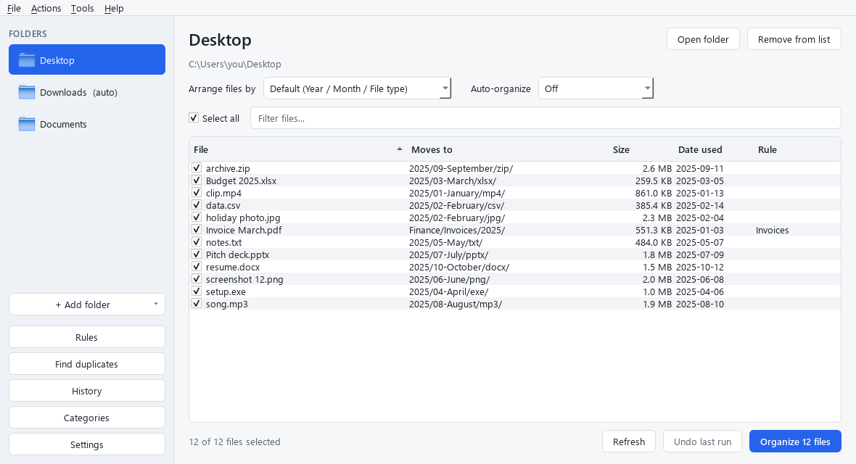
The main window: folders on the left, the preview of each move on the right
Part | What it does
Folders list | The folders you organize. (auto) means auto-organize is on for that folder
+ Add folder | Add Documents, Downloads, Pictures, Music, Videos or any folder you choose
Rules, Find duplicates, History, Categories, Settings | Open those tools; each is explained below
Arrange files by | The folder layout used for the selected folder
Auto-organize | Off, or organize automatically: when new files arrive, every hour or every day
Select all and Filter files | Tick or untick files, or narrow the list by name
Preview table | Each file, the folder it moves to, its size, the date used, and the rule that applied (if any)
Refresh | Re-read the folder (it also refreshes by itself when files change)
Undo last run | Put back every file from the most recent run
Organize N files | Move the ticked files

The app only moves loose files at the top of a folder. Subfolders and the files inside them are never touched, so running it again is safe.

Organize a folder, and undo
Organizing takes three clicks, and one more puts everything back.
- Click a folder in the Folders list.
- Check the Moves to column. Untick any file you want to leave where it is.
- Click Organize N files, then Yes to confirm.
- A summary shows how many files moved. Click Undo there if you change your mind.
To undo later, click Undo last run, or open History, pick any run and click Undo this run.
- Undo returns each file to its original place and removes folders the run created, once they are empty.
- If a new file now has the same name, the returned file is renamed, e.g. report (restored 1).pdf. Nothing is overwritten.
- If two files would land in the same folder with the same name, the second gets a number, e.g. notes_1.txt.
- Files that are open in another app may be skipped. The summary lists them; close the app and organize again.
The app never moves shortcuts (.lnk, .url), hidden or system files, Office lock files (~$...) or files that are still downloading.

Add other folders
You can organize any number of folders, each with its own layout.
- Click + Add folder.
- Pick Documents, Downloads, Pictures, Music or Videos, or Choose another folder... to browse.
- The folder appears in the list. Select it to see its preview.
To stop organizing a folder, select it and click Remove from list. No files are moved or deleted. Open folder opens it in File Explorer.
If Windows has moved your Desktop or Documents into OneDrive, the app finds the right place by itself.
Safety checks. Some folders are refused because organizing them would break your computer:
- the top of a drive, such as C:\
- your whole user folder
- Windows, Program Files and other system folders
Folders that look like a software or Docker project (they contain .git, Dockerfile, package.json and similar) show a yellow warning. Moving their files would likely break the project, so you are asked before anything happens.

Choose or build your folder structure
Each folder can use a ready-made layout or one you design; pick it from Arrange files by. Default uses the layout set in Settings.
Layout | Report.pdf from January 2025 goes to
File type | pdf/
Category | Documents/
Year / Month | 2025/01-January/
Year / Month / File type (the default) | 2025/01-January/pdf/
Year / Month / Category | 2025/01-January/Documents/

Build your own. Choose Build my own... at the bottom of the list. Type the folders you want with / between levels, and click a placeholder to insert it. Plain words are kept as typed. The preview underneath shows where your real files would go, and OK stays greyed out until the layout is valid.
Placeholder | Example | Placeholder | Example
{year} | 2025 | {quarter} | Q1
{month} | 01-January | {type} | pdf
{month_num} | 01 | {category} | Documents
{month_name} | January | {size} | Small, Medium, Large or Huge
{month_short} | Jan | {first_letter} | R
{day} | 05

Examples:
- {category}/{year} gives Documents/2025/
- Work/{year}/{month_name} gives Work/2025/January/
- {type}/{size} gives pdf/Small/
Sizes: Small is under 1 MB, Medium under 100 MB, Large under 1 GB, and Huge is anything bigger. The date used is the earlier of when the file was created or last changed.

Categories and rules
Categories change what {category} means; rules send particular files somewhere specific, ahead of the layout.
Categories. Built-in categories include Images, Documents, Spreadsheets, Presentations, Videos, Audio, Archives, Installers, Code and Fonts; anything else is Other. To make your own, open Categories, click Add category, type a name such as Invoices and its file types such as pdf, docx, then Save. Your categories are checked before the built-in ones.
Rules. Open Rules and click Add. A rule has:
Part | Choices
When | all of these are true or any of these is true
Conditions | Name contains · Name starts with · Name matches (e.g. IMG_*.jpg) · Type is (e.g. pdf, docx) · Larger than (MB) · Smaller than (MB) · Older than (days) · Newer than (days)
Then | Move to a folder (placeholders allowed), or Leave in place
Applies to | All folders, or one folder

Example: Name contains invoice and Type is pdf, then Move to Finance/Invoices/{year}.
- While you edit, the window shows how many files in the current folder the rule matches.
- Rules are checked from top to bottom; the first match wins. Use Up and Down to reorder them.
- Untick a rule to switch it off without deleting it.
- In the preview, the Rule column shows which rule moved each file.

Auto-organize, the tray and starting with Windows
Auto-organize moves new files for you, so a folder stays tidy without clicking Organize.
- Select a folder in the Folders list.
- Choose an option from Auto-organize: When new files arrive, Every hour or Every day.
- The folder now shows (auto) in the list.
- A file is only moved once it has stopped changing for about 10 seconds, so downloads and files being saved are left until they are finished.
- Automatic runs use the folder's layout and your rules. They appear in History and can be undone like any other run.
- Every hour and Every day check the folder at most once an hour or once a day, starting from its last run.
- After an automatic run, a notification says how many files moved. You can turn this off in Settings.
The tray. Closing the window keeps the app running as an icon in the system tray, near the clock, so auto-organize keeps working. Click the icon to open the window again, or right-click it for:
Tray menu | What it does
Open Desktop Organizer | Show the window
Run auto-organize now | Check every auto-organize folder straight away
Pause auto-organize | Stop automatic runs until you untick it
Quit | Close the app completely

To make closing the window quit the app, untick Keep running in the system tray in Settings. Auto-organize then only works while the window is open.
Start with Windows. In Settings, tick Start when I sign in to Windows. The app then starts in the tray each time you sign in, with no window.

Find duplicates
Find duplicates looks for files with exactly the same contents and moves the extra copies to the Recycle Bin, where you can restore them.
- Click Find duplicates. It opens on the selected folder; use Choose folder... to pick another.
- Leave Include subfolders ticked to search inside subfolders too.
- Click Scan and wait for the progress bar to finish.
- Each set shows how many copies there are and their size. The oldest copy is left unticked so it is kept; the others are ticked.
- Change the ticks if you want to keep a different copy, then click Move selected to Recycle Bin.
- Files are compared by their contents, not their names. Two files only count as duplicates if they are identical.
- At least one copy in each set must stay unticked; the app will not remove every copy.
- Hidden folders and folders such as .git and node_modules are skipped.

Settings, history and your data
Open Settings to change how the app behaves; changes apply when you click Save.
Setting | What it does
Theme | Match system, Light or Dark
Default structure | The layout used by every folder set to Default
Leave hidden and system files alone | On by default
Never move types | File types that always stay put; .lnk and .url (shortcuts) by default
Never move files named | Exact file names that always stay put, e.g. desktop.ini
Keep running in the system tray | Closing the window hides it instead of quitting
Show a notification after auto-organizing | A short message after each automatic run
Start when I sign in to Windows | Starts the app in the tray at sign-in
Check for updates once a week | Off by default. When on, the app asks GitHub once a week whether a newer version exists

History lists every run with its date, folder, layout, number of files and status, plus the total number of files organized so far. Select a run and click Undo this run to reverse it.
Your data. Settings and the undo history are stored in %APPDATA%\DesktopOrganizer (settings.json and history.db), with a small log in its logs folder. The app works offline and needs no account. It only goes online to check for updates, when you click Help › Check for updates... or turn on the weekly check.
Updates. Choose Help › Check for updates.... If a newer version exists, click Download, then run the new installer over the old one; your folders, rules and history are kept.
Shortcut | Action
Ctrl+O | Choose a folder to add
F5 | Refresh the preview
Ctrl+Enter | Organize the ticked files
Ctrl+Z | Undo the last run
Ctrl+R | Rules
Ctrl+D | Find duplicates
Ctrl+H | History
Ctrl+Q | Quit

Troubleshooting and FAQ
Problem or question | What to do
“Windows protected your PC” when installing | Click More info, then Run anyway. The installer is safe but not yet code-signed.
A file wasn't moved | It may be open in another app, still downloading, hidden, an excluded type, or matched by a Leave in place rule. Close the app using it and organize again.
“This folder can't be organized” | It is a drive, your whole user folder or a system folder. Add a folder inside it instead.
Files went somewhere unexpected | Check the Rule column: rules come before the layout. Click Undo last run to put them back.
Undo says a file couldn't be restored | The file was moved or deleted after the run. Look for it in the folder it was moved to.
Auto-organize isn't doing anything | Make sure the app is running (look for the tray icon) and that Pause auto-organize is not ticked. Every hour waits an hour after the last run.
I closed the window but the app is still running | It is in the tray. Right-click the tray icon and choose Quit.
Does it touch files in subfolders? | No. Only loose files at the top of a folder are moved.
A “Something went wrong” message appeared | No files are lost; every move can be undone from History. Click Copy details and include them when you report the problem, or Open log folder to find the log.
Opening the app again doesn't open a second window | That's intended: only one copy runs, and opening it again brings the existing window forward.
Does it need the internet or collect data? | No. Everything stays on your computer. It only contacts GitHub to check for updates, and only when you ask or turn on the weekly check.
Does uninstalling delete my files? | No. Your organized files stay where they are, and your settings are kept.

