Screenshots or program listings must be copied into appropriate cells in the following table.
Save this evidence document as evidence_ followed by your centre number_ candidate number, for example, evidence_ zz999_9999 and insert your name, centre number and candidate number into the header above.
Examiners must be able to read the contents including any screenshots without the use of a magnifying glass. Answers that are not readable or are missing will not be awarded any marks.
Save this evidence document at regular intervals, for example every 10 minutes.
Question 1
Part 1(a)
{Copy and paste program code listing for Question 1(a) here}
global Animals #array contain 10 elements string

Part 1(b)
{Copy and paste program code listing for Question 1(b) here}
Animals = []
Animals.append("horse")
Animals.append("lion")
Animals.append("rabbit")
Animals.append("mouse")
Animals.append("bird")
Animals.append("deer")
Animals.append("whale")
Animals.append("elephant")
Animals.append("kangaroo")
Animals.append("tiger")

Part 1(c)
{Copy and paste program code listing for Question 1(c) here}

def SortDescending():
ArrayLength = len(Animals)
for X in range(0, ArrayLength - 1):
for Y in range(0, ArrayLength - X - 1):
if Animals[Y][0] < Animals[Y+1][0]:
Temp = Animals[Y]
Animals[Y] = Animals[Y+1]
Animals[Y+1] = Temp

Part 1(d)(i)
{Copy and paste program code listing for Question 1(d)(i) here}

SortDescending()
for i in range(0, 10):
print(Animals[i])

Part 1(d)(ii)
{Copy and paste the screenshot for Question 1(d)(ii) here}

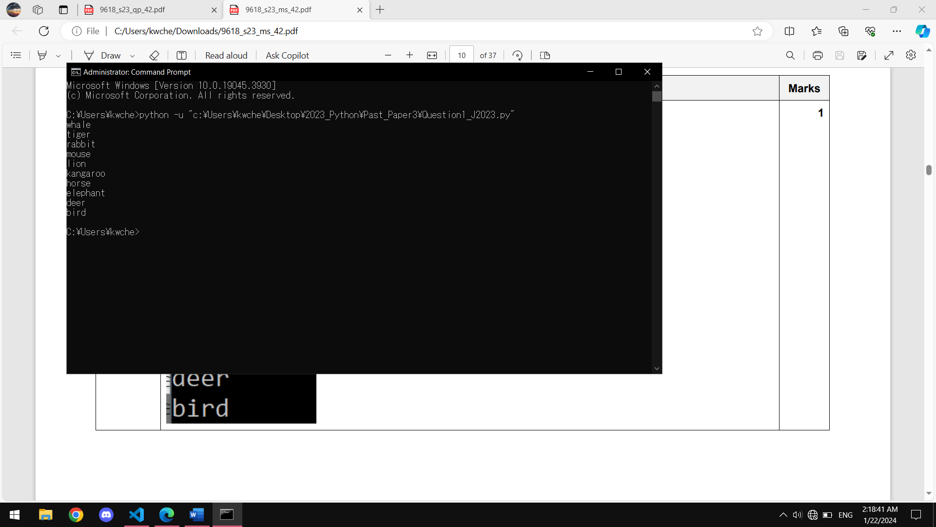

Question 2
Part 2(a)
{Copy and paste program code listing for Question 2(a) here}

Part 2(b)
{Copy and paste program code listing for Question 2(b) here}

Part 2(c)
{Copy and paste program code listing for Question 2(c) here}

Part 2(d)
{Copy and paste program code listing for Question 2(d) here}

Part 2(e)
{Copy and paste program code listing for Question 2(e) here}

Part 2(f)(i)
{Copy and paste program code listing for Question 2(f)(i) here}

Part 2(f)(ii)
{Copy and paste screenshot for Question 2(f)(ii) here}

Question 3
Part 3(a)(i)
{Copy and paste program code listing for Question 3(a)(i) here}

Part 3(a)(ii)
{Copy and paste program code listing for Question 3(a)(ii) here}

Part 3(a)(iii)
{Copy and paste program code listing for Question 3(a)(iii) here}

Part 3(a)(iv)
{Copy and paste program code listing for Question 3(a)(iv) here}

Part 3(b)(i)
{Copy and paste program code listing for Question 3(b)(i) here}

Part 3(b)(ii)
{Copy and paste program code listing for Question 3(b)(ii) here}

Part 3(c)
{Copy and paste program code listing for Question 3(c) here}

Part 3(d)
{Copy and paste program code listing for Question 3(d) here}

Part 3(e)(i)
{Copy and paste program code listing for Question 3(e)(i) here}

Part 3(e)(ii)
{Copy and paste screenshot for Question 3(e)(ii) here}

