Screenshots or program listings must be copied into appropriate cells in the following table.
Save this evidence document as evidence_ followed by your centre number_ candidate number, for example, evidence_ zz999_9999 and insert your name, centre number and candidate number into the header above.
Examiners must be able to read the contents including any screenshots without the use of a magnifying glass. Answers that are not readable or are missing will not be awarded any marks.
Save this evidence document at regular intervals, for example every 10 minutes.
Question 1
Part 1(a)(i)
{Copy and paste program code listing for Question 1(a)(i) here}
#DECALRE DataArray : ARRAY[0:24] OF INTEGER
DataArray = []

Part 1(a)(ii)
{Copy and paste program code listing for Question 1(a)(ii) here}

def main():
with open("Data.txt") as File:
for line in File:
DataArray.append(line.strip())

Part 1(b)(i)
{Copy and paste program code listing for Question 1(b)(i) here}

def PrintArray(IntArray):
MyOutput = ""
for ThisInt in IntArray:
MyOutput = MyOutput + str(ThisInt) + " "
print(MyOutput)

PrintArray(DataArray)

Part 1(b)(ii)
{Copy and paste program code listing for Question 1(b)(ii) here}

def main():
with open("Data.txt") as File:
for line in File:
DataArray.append(line.strip())

PrintArray(DataArray)

Part 1(b)(iii)
{Copy and paste the screenshot for Question 1(b)(iii) here}

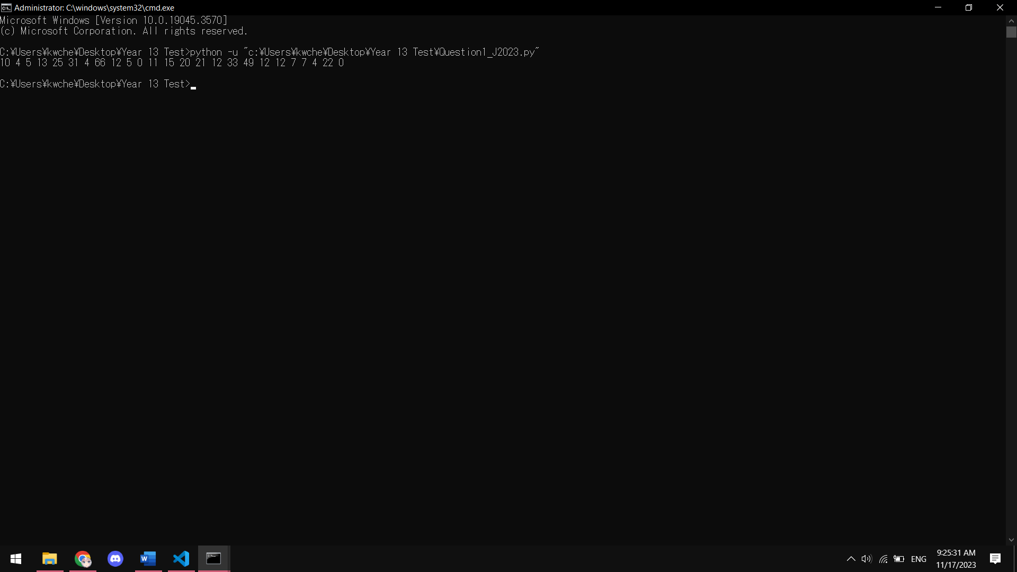

Part 1(c)
{Copy and paste program code listing for Question 1(c) here}
def LinearSearch(IntArray, SearchValue):
Occurrence = 0
for ThisInt in IntArray:
if int(ThisInt) == SearchValue:
Occurrence += 1
return Occurrence

Part 1(d)(i)
{Copy and paste program code listing for Question 1(d)(i) here}

def main():
with open("Data.txt") as File:
for line in File:
DataArray.append(line.strip())
PrintArray(DataArray)

InputError = True
RangeError = True
while InputError or RangeError:

try:
UserInput = int(input("Whole number between 0 and 100: "))
InputError = False
except ValueError:
print("### Please Re-enter a Integer ###")

if not InputError:
if UserInput >= 0 and UserInput <= 100:
RangeError = False
else:
print("### Please Re-enter a Integer between 0 and 100 ###")

print(f"The number {UserInput} is found {LinearSearch(DataArray, UserInput)} times")

Part 1(d)(ii)
{Copy and paste the screenshot for Question 1(d)(ii) here}

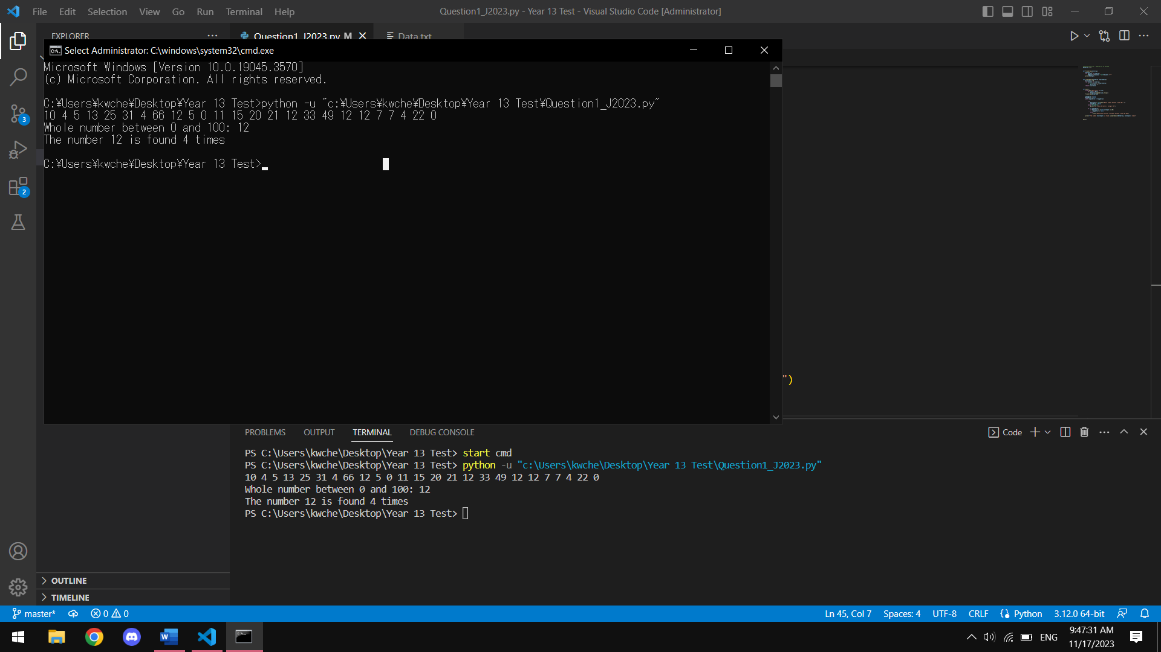

Question 2
Part 2(a)(i)
{Copy and paste program code listing for Question 2(a)(i) here}

class Vehicle:

# DECLARE ID : STRING
# DECLARE MaxSpeed : INTEGER
# DECLARE CurrentSpeed : INTEGER
# DECLARE IncreaseAmount : INTEGER
# DECLARE HorizontalPosition : INTEGER

def __init__(self, ID, MaxSpeed, IncreaseAmount):
self.__ID = ID
self.__MaxSpeed = MaxSpeed
self.__IncreaseAmount = IncreaseAmount
self.__CurrentSpeed = 0
self.__HorizontalPosition = 0

Part 2(a)(ii)
{Copy and paste program code listing for Question 2(a)(ii) here}
def GetCurrentSpeed(self):
return self.__CurrentSpeed

def GetIncreaseAmount(self):
return self.__IncreaseAmount

def GetMaxSpeed(self):
return self.__MaxSpeed

def GetHorizontalPosition(self):
return self.__HorizontalPosition

Part 2(a)(iii)
{Copy and paste program code listing for Question 2(a)(iii) here}

def SetCurrentSpeed(self, CurrentSpeed):
self.__CurrentSpeed = CurrentSpeed

def SetHorizontalPosition(self, HorizontalPosition):
self.__HorizontalPosition = HorizontalPosition

Part 2(a)(iv)
{Copy and paste program code listing for Question 2(a)(iv) here}

def IncreaseSpeed(self):
self.__CurrentSpeed += self.__IncreaseAmount
self.__HorizontalPosition += self.__CurrentSpeed

Part 2(b)(i)
{Copy and paste program code listing for Question 2(b)(i) here}

class Helicopter(Vehicle):

def __init__(self, ID, MaxSpeed, IncreaseAmount, VerticalChange, MaxHeight):
super().__init__(ID, MaxSpeed, IncreaseAmount)

self.__VerticalChange = VerticalChange
self.__MaxHeight = MaxHeight
self.__VerticalPosition = 0

Part 2(b)(ii)
{Copy and paste program code listing for Question 2(b)(ii) here}

def IncreaseSpeed(self):
if self.__VerticalPosition + self.__VerticalChange < self.__MaxHeight:
self.__VerticalPosition += self.__VerticalChange
else:
self.__VerticalChange = self.__MaxHeight

if super().GetCurrentSpeed() + super().GetIncreaseAmount() < super().GetMaxSpeed():
super().SetCurrentSpeed(super().GetCurrentSpeed() + super().GetIncreaseAmount())
else:
super().SetCurrentSpeed(super().GetMaxSpeed())

super().SetHorizontalPosition(super().GetHorizontalPosition() + super().GetCurrentSpeed())

Part 2(c)
{Copy and paste program code listing for Question 2(c) here}

def Output(MyVehicle):
print(f"Your Horizontal Position: {MyVehicle.GetHorizontalPosition()}")
print(f"Your Speed: {MyVehicle.GetCurrentSpeed()}")
if str(type(MyVehicle)) == "<class '__main__.Helicopter'>":
print(f"Your Vertical Position: {MyVehicle.GetVerticalPosition()}")

Part 2(d)(i)
{Copy and paste program code listing for Question 2(d)(i) here}

def main():
NewCar = Vehicle("Tiger", 100, 20)
NewHelicopter = Helicopter("Lion", 350, 40, 3, 100)
NewCar.IncreaseSpeed()
NewCar.IncreaseSpeed()
Output(NewCar)
NewHelicopter.IncreaseSpeed()
NewHelicopter.IncreaseSpeed()
Output(NewHelicopter)

main()

Part 2(d)(ii)
{Copy and paste screenshot for Question 2(d)(ii) here}

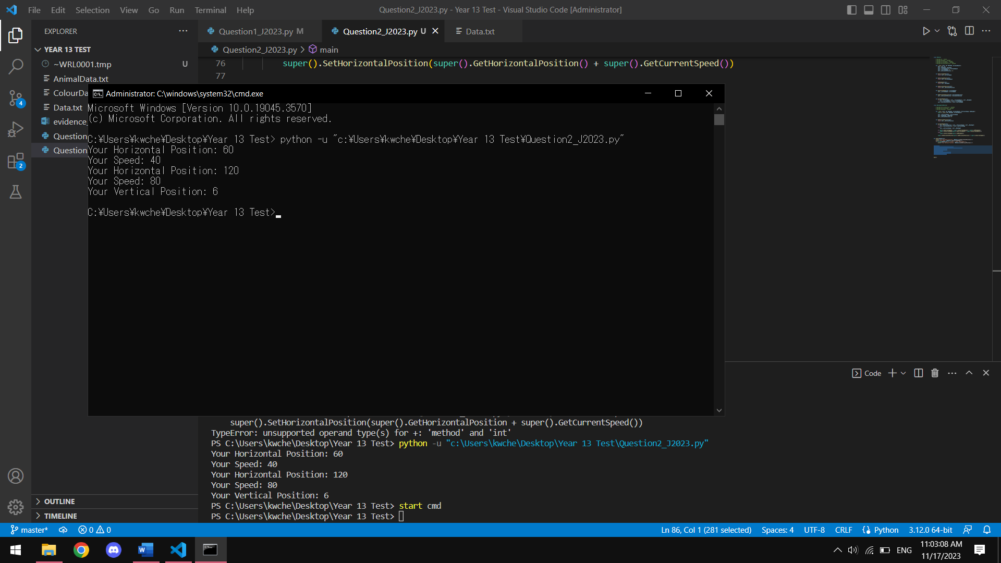

Question 3
Part 3(a)
{Copy and paste program code listing for Question 3(a) here}
# DECLARE Animal : ARRAY[0:19]
# DECLARE Colour : ARRAY[0:19]
# DECLARE AnimalTopPointer : INTEGER
# DECLARE ColourTopPointer : INTEGER
global Animal
global Colour
global AnimalTopPointer
global ColourTopPointer
Animal = []
Colour = []
AnimalTopPointer = 0
ColourTopPointer = 0

Part 3(b)(i)
{Copy and paste program code listing for Question 3(b)(i) here}
def PushAnimal(DataToPush):
global AnimalTopPointer
global ColourTopPointer
if AnimalTopPointer == 20:
return False
else:
Animal.append(DataToPush)
AnimalTopPointer += 1
return True

Part 3(b)(ii)
{Copy and paste program code listing for Question 3(b)(ii) here}

def PopAnimal():
global AnimalTopPointer
global ColourTopPointer
if AnimalTopPointer == 0:
return ""
else:
ReturnData = Animal[AnimalTopPointer - 1]
AnimalTopPointer -= 1
return ReturnData

Part 3(b)(iii)
{Copy and paste program code listing for Question 3(b)(iii) here}

def ReadData():
try:
global AnimalTopPointer
global ColourTopPointer

AnimalFile = open("AnimalData.txt", 'r')
for thisLine in AnimalFile:
PushAnimal(thisLine)
AnimalFile.close()
except IOError:
print("File doesn't exist")

Part 3(b)(iv)
{Copy and paste program code listing for Question 3(b)(iv) here}

def PushColour(DataToPush):
global AnimalTopPointer
global ColourTopPointer
if ColourTopPointer == 10:
return False
else:
Colour.append(DataToPush)
ColourTopPointer += 1
return True

Part 3(b)(v)
{Copy and paste program code listing for Question 3(b)(v) here}

def ReadData():
try:
global AnimalTopPointer
global ColourTopPointer

AnimalFile = open("AnimalData.txt", 'r')
for thisLine in AnimalFile:
PushAnimal(thisLine)
AnimalFile.close()

ColourFile = open('ColourData.txt', 'r')
for thisLine in ColourFile:
PushColour(thisLine)
ColourFile.close()
except IOError:
print("File doesn't exist")

Part 3(c)
{Copy and paste program code listing for Question 3(c) here}

def OutputItem():
global AnimalTopPointer
global ColourTopPointer
AnimalPoped = PopAnimal()
ColourPoped = PopColour()
if ColourPoped == "":
print("No colour")
PushAnimal(AnimalPoped)
else:
if AnimalPoped == "":
print("No Animal")
PushColour(ColourPoped)
else:
ColourPoped = ColourPoped.strip()
AnimalPoped = AnimalPoped.strip()
print(f"{ColourPoped} {AnimalPoped}")

Part 3(d)(i)
{Copy and paste program code listing for Question 3(d)(i) here}

def main():
ReadData()
for _ in range(4):
OutputItem()
main()

Part 3(d)(ii)
{Copy and paste screenshot for Question 3(d)(ii) here}
