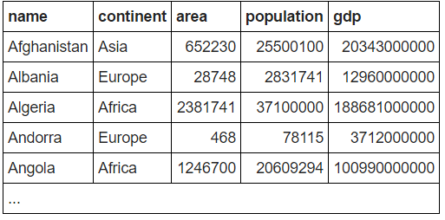

3. Give the name and the per capita GDP for those countries with a population of at least 200 million.Top of Form

SELECT name, gdp/population FROM world

WHERE population >200000000

4. Show the name and population in millions for the countries of the continent 'South America'. Divide the population by 1000000 to get population in millions.

SELECT name, population/1000000 FROM world

WHERE continent = 'South America';

5. Show the name and population for France, Germany, Italy

SELECT name, population FROM world

WHERE name in ('France', 'Germany', 'Italy');

6. Show the countries which have a name that includes the word 'United'

SELECT name FROM world WHERE name LIKE '%United%'

7. Two ways to be big: A country is big if it has an area of more than 3 million sq km or it has a population of more than 250 million. Show the countries that are big by area or big by population. Show name, population and area.

SELECT name, population, area FROM world

WHERE area > 3000000 OR population > 250000000

8. Exclusive OR (XOR). Show the countries that are big by area or big by population but not both. Show name, population and area.

* Australia has a big area but a small population, it should be included.
* Indonesia has a big population but a small area, it should be included.
* China has a big population and big area, it should be excluded.
* United Kingdom has a small population and a small area, it should be excluded.

SELECT name, population, area FROM world

WHERE (area > 3000000 AND population <= 250000000) OR (area <= 3000000 AND population > 250000000)

9. Show the name and population in millions and the GDP in billions for the countries of the continent 'South America'. Use the [ROUND](http://sqlzoo.net/wiki/ROUND) function to show the values to two decimal places. For South America show population in millions and GDP in billions both to 2 decimal places.

SELECT name, ROUND(population/1000000, 2), ROUND(gdp/1000000000, 2) FROM world WHERE continent = 'South America';

10. Show the name and per-capita GDP for those countries with a GDP of at least one trillion (1000000000000; that is 12 zeros). Round this value to the nearest 1000. Show per-capita GDP for the trillion dollar countries to the nearest $1000.

Top of Form

SELECT name, round(gdp/population, -3) FROM world

WHERE gdp > 1000000000000

11. The [CASE](http://sqlzoo.net/wiki/CASE) statement shown is used to substitute North America for Caribbean in the third column.

Show the name - but substitute Australasia for Oceania - for countries beginning with N.

SELECT name, continent,

CASE WHEN continent='Caribbean' THEN 'North America'

ELSE continent END

FROM world

WHERE name LIKE 'N%'

12. Show the name and the continent - but substitute Eurasia for Europe and Asia; substitute America - for each country in North America or South America or Caribbean. Show countries beginning with A or B

SELECT name,

CASE WHEN continent = 'Europe' OR continent = 'Asia' THEN 'Eurasia'

WHEN continent LIKE '%america%' OR continent = 'Caribbean' THEN 'America'

ELSE continent END

FROM world

WHERE name like 'a%' OR name like 'b%'

13. Put the continents right...

* Oceania becomes Australasia
* Countries in Eurasia and Turkey go to Europe/Asia
* Caribbean islands starting with 'B' go to North America, other Caribbean islands go to South America
* Order by country name in ascending order
* Test your query using the WHERE clause with the following:

SELECT name, continent,

CASE WHEN continent = 'Oceania' THEN 'Australasia'

WHEN continent = 'Eurasia' OR name = 'Turkey' THEN 'Europe/Asia'

WHEN continent = 'Caribbean' AND name LIKE 'b%' THEN 'North America'

WHEN continent = 'Caribbean' AND name NOT LIKE 'b%' THEN 'South America'

ELSE continent END

FROM world

ORDER BY name