MAT3024 Regression Analysis Assignment
2024-07-17

Group Members
Chong Kai Yuan (21081609)
Ethan Lee Jia Hua (21089750)
Daniel Chin Wei Jian (20095204)
Darren Yap Yee Shern (21001235)
Harreesh Dev Chandrasager (20083200)
Nur’ Aliah Syamimi Binti Muhammad Sazali (21081765)

Introduction & Problem Statement

Predicting Wine Quality Using Regression Analysis
Wine quality assessment is a crucial aspect of the wine industry. The ability to predict wine quality based on various chemical properties can significantly enhance decision-making processes in viticulture. Chemical analysis has long been an established method for determining wine quality, with factors such as acidity, sugar content, and alcohol levels known to influence taste and overall consumer satisfaction (Marianthi Basalekou et al., 2023).
Consumers rely heavily on quality ratings when selecting wines. Accurate predictions of wine quality enable producers to better meet consumer expectations, resulting in higher satisfaction and repeat purchases (Corduas et al., 2013). This study aims to identify and quantify the impact of different physicochemical properties on the quality ratings of white Vinho Verde wines.

Determining Key Physicochemical Factors Influencing Wine Quality
Our primary objective is to create a regression model that highlights the most significant factors contributing to wine quality. The analysis will focus on identifying the key physicochemical properties that influence wine quality and quantifying their impact. As such, our task will help winemakers optimize their production processes and improve the quality of their wines.

Data Processing
Load the use of all relevant packages used under this assignment
library(car)
library(MASS)
library(dplyr)
library(olsrr)
library(leaps)
library(psych)
library(moments)
library(ggplot2)
library(pastecs)
library(corrplot)
library(tidyverse)
library(AICcmodavg)
library(rmdformats)
library(kableExtra)
library(ggThemeAssist)
options(scipen=10)
Import dataset into R Studio
Dataset<-read.csv("winequality-white.csv", sep =";")
str(Dataset)
## 'data.frame': 4898 obs. of 12 variables:
## $ fixed.acidity : num 7 6.3 8.1 7.2 7.2 8.1 6.2 7 6.3 8.1 ...
## $ volatile.acidity : num 0.27 0.3 0.28 0.23 0.23 0.28 0.32 0.27 0.3 0.22 ...
## $ citric.acid : num 0.36 0.34 0.4 0.32 0.32 0.4 0.16 0.36 0.34 0.43 ...
## $ residual.sugar : num 20.7 1.6 6.9 8.5 8.5 6.9 7 20.7 1.6 1.5 ...
## $ chlorides : num 0.045 0.049 0.05 0.058 0.058 0.05 0.045 0.045 0.049 0.044 ...
## $ free.sulfur.dioxide : num 45 14 30 47 47 30 30 45 14 28 ...
## $ total.sulfur.dioxide: num 170 132 97 186 186 97 136 170 132 129 ...
## $ density : num 1.001 0.994 0.995 0.996 0.996 ...
## $ pH : num 3 3.3 3.26 3.19 3.19 3.26 3.18 3 3.3 3.22 ...
## $ sulphates : num 0.45 0.49 0.44 0.4 0.4 0.44 0.47 0.45 0.49 0.45 ...
## $ alcohol : num 8.8 9.5 10.1 9.9 9.9 10.1 9.6 8.8 9.5 11 ...
## $ quality : int 6 6 6 6 6 6 6 6 6 6 ...

Dataset Description: Wine Quality Dataset
The dataset provided is considered for vinho verde, a unique product from Minho from the northwest region in Portugal and was collected from May (2004) to February (2007). Note that both red and white wine datasets were available, but the white wine dataset was chosen for analysis.
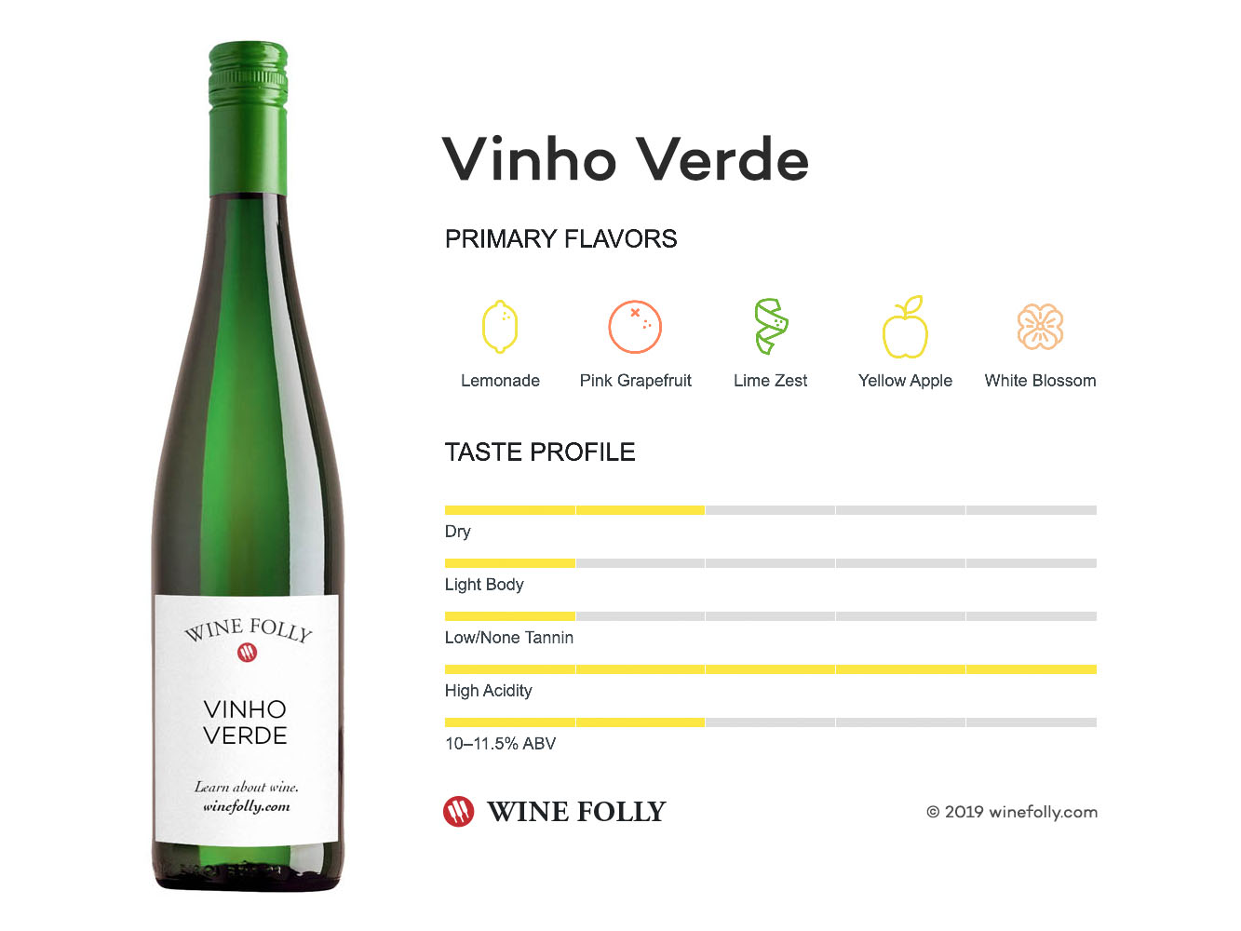
Figure 1: Vinho Verde White Wine

Variables Involved under considered dataset:
- Sulphates (g(potassium sulphate)/dm³)
- Chlorides (g(sodium chloride)/dm³)
- Volatile acidity (g(acetic acid)/dm³)
- Fixed acidity (g(tartaric acid)/dm³)
- Total sulfur dioxide (mg/dm³)
- Free sulfur dioxide (mg/dm³)
- Residual sugar (g/dm³)
- Citric acid (g/dm³)
- Density (g/cm³)
- Alcohol (vol.%)
- pH level
- Quality
This Dataset consists of 4898 observations based on 12 variables
Data source: Wine Quality Dataset

Preliminary Regression Metrics and Diagnostic Measures
Here we provide a summary of all the key regressionary metrics used during our analysis.
- Akaike Information Criterion ($AIC$) : measures relative and estimated quality of different statistical models; a lower value indicates a better-fitting model
- Bayesian Information Criterion ($BIC$) : similar to AIC but with stricter penalty in regards to the number of parameters being fitted in the model; a lower value indicates a better-fitting model
- R-squared ($R^{2}$) : statistical measure representing total proportion of variance explained by the regressor variables; values range from 0 to 1 with higher values indicating a higher quality model
- Residual Standard Error ($s$) : measures the standard deviation of the residuals in a regression model; a lower value indicates smaller residuals and thus indicates a better fitted model
- Variation Inflation Factor ($VIF$) : indicates how much the variance of the regression coefficients are inflated due to multicollinearity issues; values above 5 are considered as problematic and indicates the predictor is highly collinear
- Ols Mallows Cp ($Cp$) : measures the quality of the fitted model while also considering its overall complexity; values close to the number of predictors plus one suggests a good model

Data Analysis

Descriptive Statistics
round(stat.desc(Dataset),2)
## fixed.acidity volatile.acidity citric.acid residual.sugar
## nbr.val 4898.00 4898.00 4898.00 4898.00
## nbr.null 0.00 0.00 19.00 0.00
## nbr.na 0.00 0.00 0.00 0.00
## min 3.80 0.08 0.00 0.60
## max 14.20 1.10 1.66 65.80
## range 10.40 1.02 1.66 65.20
## sum 33574.75 1362.83 1636.87 31305.15
## median 6.80 0.26 0.32 5.20
## mean 6.85 0.28 0.33 6.39
## SE.mean 0.01 0.00 0.00 0.07
## CI.mean.0.95 0.02 0.00 0.00 0.14
## var 0.71 0.01 0.01 25.73
## std.dev 0.84 0.10 0.12 5.07
## coef.var 0.12 0.36 0.36 0.79
## chlorides free.sulfur.dioxide total.sulfur.dioxide density
## nbr.val 4898.00 4898.00 4898.00 4898.00
## nbr.null 0.00 0.00 0.00 0.00
## nbr.na 0.00 0.00 0.00 0.00
## min 0.01 2.00 9.00 0.99
## max 0.35 289.00 440.00 1.04
## range 0.34 287.00 431.00 0.05
## sum 224.19 172939.00 677690.50 4868.75
## median 0.04 34.00 134.00 0.99
## mean 0.05 35.31 138.36 0.99
## SE.mean 0.00 0.24 0.61 0.00
## CI.mean.0.95 0.00 0.48 1.19 0.00
## var 0.00 289.24 1806.09 0.00
## std.dev 0.02 17.01 42.50 0.00
## coef.var 0.48 0.48 0.31 0.00
## pH sulphates alcohol quality
## nbr.val 4898.00 4898.00 4898.00 4898.00
## nbr.null 0.00 0.00 0.00 0.00
## nbr.na 0.00 0.00 0.00 0.00
## min 2.72 0.22 8.00 3.00
## max 3.82 1.08 14.20 9.00
## range 1.10 0.86 6.20 6.00
## sum 15616.13 2399.27 51498.88 28790.00
## median 3.18 0.47 10.40 6.00
## mean 3.19 0.49 10.51 5.88
## SE.mean 0.00 0.00 0.02 0.01
## CI.mean.0.95 0.00 0.00 0.03 0.02
## var 0.02 0.01 1.51 0.78
## std.dev 0.15 0.11 1.23 0.89
## coef.var 0.05 0.23 0.12 0.15

INTERPRETATION
From the complete summary of the dataset, several key observations emerge regarding specific variables:
- Citric Acid: Among all regressors, citric acid exhibited the smallest minimum value across all observations.
- Total Sulfur Dioxide: This variable had the highest maximum value, the widest range, and the largest standard error of the mean.
Interestingly, when applying linear modeling techniques to our updated full model, both citric acid and total sulfur dioxide were found to be statistically insignificant. This lack of significance may be partially attributable to the distinctive properties they exhibit, as mentioned above.

Visualizing the dependent variable
# construct histogram
hist_data <- hist(Dataset$quality, breaks = seq(3, 10, by = 1), plot = FALSE, right = FALSE)
hist_df <- data.frame(midpoints = hist_data$mids, counts = hist_data$counts)
ggplot(Dataset, aes(x = quality)) +
geom_histogram(breaks = seq(3, 9, by = 1), fill = "grey", color = "white", closed = "left", boundary = 3) +
geom_line(data = hist_df, aes(x = midpoints, y = counts), color = "red", size = 1) +
geom_point(data = hist_df, aes(x = midpoints, y = counts), color = "red", size = 2) +
labs(title = "Figure 2: Histogram of Wine Quality",
x = "Quality of Wine",
y = "Frequency") +
theme(plot.title = element_text(hjust=0.5)) +
scale_x_continuous(breaks = seq(3, 9, by = 1)) # Customize x-axis labels to show end values
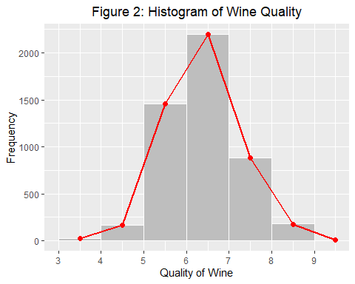
skewness_value<-skewness(Dataset$quality)
skewness_value
## [1] 0.1557487
INTERPRETATION
- The histogram shows a roughly bell-shaped curve, which suggests that the data might be approximately normally distributed. Many statistical methods, including linear regression, assume that the residuals of the model (differences between observed and predicted values) are normally distributed. Thus, A bell-shaped histogram for quality suggests that the response variable itself is normally distributed, which is a good starting point for meeting this assumption.
- The mean quality score is 5.88 as identified when using the stat.desc() function, this is consistent with the peak of the histogram around 6. This suggests that the mean is a good measure of central tendency for this data.

Fitting the Full Model
Here, we observe the model using the entirety of the wine dataset in terms of its AIC, BIC, Residual standard error and its R². Additionally, we investigate the whether each of the predictor variables appear to be statistically significant in predicting our dependent variable
# fitting full model
full_model<-lm(quality~.,data=Dataset)
summary(full_model)
# extracting and finding relevant metrics
Residual_standard_error_full_model<-summary(full_model)$sigma
R_squared_full_model<-summary(full_model)$r.squared
full_model_AIC<-AIC(full_model)
full_model_BIC<-BIC(full_model)
# constructing table
table_1 <- data.frame(
Metrics = c("AIC", "BIC", "R-squared", "Residual standard error"),
full_model = c(full_model_AIC, full_model_BIC, R_squared_full_model, Residual_standard_error_full_model))
# formatting table
table_1$full_model <- format(table_1$full_model, digits = 5)
# displaying table
knitr::kable(table_1, caption = "Table 1: Metrics from the Full Model") %>%
kable_styling(bootstrap_options = "striped", full_width = F)
##
## Call:
## lm(formula = quality ~ ., data = Dataset)
##
## Residuals:
## Min 1Q Median 3Q Max
## -3.8348 -0.4934 -0.0379 0.4637 3.1143
##
## Coefficients:
## Estimate Std. Error t value Pr(>|t|)
## (Intercept) 150.1928425 18.8041772 7.987 1.71e-15 ***
## fixed.acidity 0.0655200 0.0208737 3.139 0.00171 **
## volatile.acidity -1.8631771 0.1137933 -16.373 < 2e-16 ***
## citric.acid 0.0220902 0.0957696 0.231 0.81759
## residual.sugar 0.0814828 0.0075273 10.825 < 2e-16 ***
## chlorides -0.2472765 0.5465423 -0.452 0.65097
## free.sulfur.dioxide 0.0037328 0.0008441 4.422 9.99e-06 ***
## total.sulfur.dioxide -0.0002857 0.0003781 -0.756 0.44979
## density -150.2841806 19.0745080 -7.879 4.04e-15 ***
## pH 0.6863437 0.1053791 6.513 8.10e-11 ***
## sulphates 0.6314765 0.1003856 6.291 3.44e-10 ***
## alcohol 0.1934757 0.0242214 7.988 1.70e-15 ***
## ---
## Signif. codes: 0 '***' 0.001 '**' 0.01 '*' 0.05 '.' 0.1 ' ' 1
##
## Residual standard error: 0.7514 on 4886 degrees of freedom
## Multiple R-squared: 0.2819, Adjusted R-squared: 0.2803
## F-statistic: 174.3 on 11 and 4886 DF, p-value: < 2.2e-16

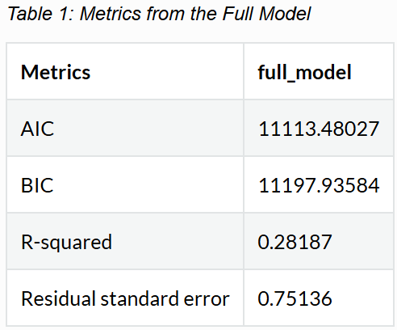
Observation of Full Model
From the output of the summary of the dataset, we can observe that three predictor variables can be highlighted and appears to not be statistically significant. Those variables being:
- Citric Acid (g/dm³)
- Total sulfur dioxide (mg/dm³)
- Chlorides (g(sodium chloride)/dm³)
From here we can start making the hypothesis that when performing the variable selection process to find our “best” regression model, it is more likely than not that one or several of these variables will likely not be included under the fitted model.

Investigating Problematic Data Points
Before we proceed into building our regression models, it is crucial to ensure the reliability and accuracy of our current dataset by investigating any potentially problematic observation points. In here, we decided to take into account the following metrics:
- Leverage (h_{ii}) - may affect regression coefficients
- Cook’s Distance (D_{i}) - to observe influential points
- Studentized Residuals (r_{i}) - to observe potential outliers
Observation points that exceed tolerated thresholds in these diagnostic measures will then be considered as problematic. Consequently, an updated full model will be created after removing these problematic points, ensuring a more robust and accurate predictive model.

Visualizing Model using Diagnostic Plots
par(mfrow=c(1,2))
plot(full_model,which=2, main="Figure 3(a)") # QQ Residuals
plot(full_model,which=5, main="Figure 3(b)") # Residuals vs Leverage
INTERPRETATION
QQ Residuals: The lines curve at the ends, implying that under the full model, the residuals have heavier tails than a normal distribution, this acts as an indicator for the presence of outliers in the dataset.
Residuals vs Leverage: Presence of observations clearly outside the Cook’s distance contour lines, indicating presence of influential points within the Dataset.
Now, we will make use of the following thresholds in deciding which observations points are considered problematic which should be removed from our dataset.
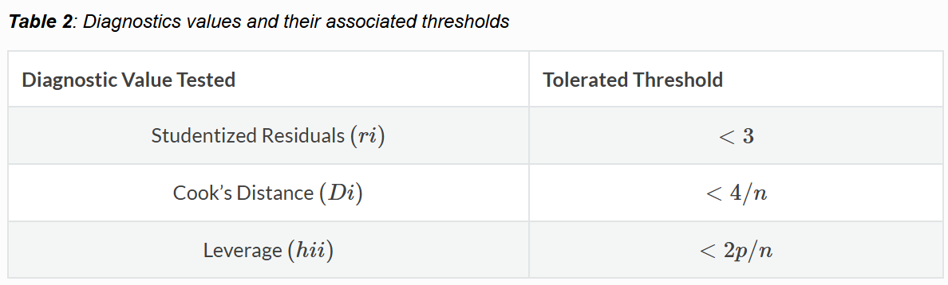
Under different applications, the threshold for the cook’s distance may also be $<1$, however, we decided to use the threshold of $<4/n$ instead being that in this way, the number of observations in the dataset is taken into account when performing our investigation of problematic observation points.
# studentized residuals
studentized_residuals_full_model<-studres(full_model)
# cooks distance
cd_full_model<-cooks.distance(full_model)
# leverage
hat_values_full_model<-hatvalues(full_model)
# plot for visualization
par(mfrow=c(1,3))
plot(studentized_residuals_full_model, main="Figure 4(a): Studentized residuals \nvisualization", ylab="Studentized Residuals",xlab="Observation point")
abline(h=3,col="red")
abline(h=-3,col="red")
plot(cd_full_model, main="Figure 4(b): Cook's distance \nvisualization", ylab="cooks distance",xlab="Observation point")
abline(h = 4/(nrow(Dataset)), col = "red")
plot(hat_values_full_model, main="Figure 4(c): Leverage \nvisualization",ylab="leverage", xlab="Observation point")
abline(h= 2 * (length(full_model$coefficients)) / nrow(Dataset),col ="red")
# indicate all flagged points that need to be removed
high_studentized_residual_points<-which(studentized_residuals_full_model>(abs(3)))
high_leverage_points<-which(hat_values_full_model>(2*(length(full_model$coefficients))/nrow(Dataset)))
high_cooks_distance_points<-which(cd_full_model>(4/nrow(Dataset)))
all_potential_issues<-unique(c(high_studentized_residual_points,high_leverage_points,high_cooks_distance_points))
# create updated full model
updated_Dataset<-Dataset[-all_potential_issues, ]

Fitting Updated Full Model
# fitting updated full model and observing observations
updated_full_model<-lm(quality~.,data=updated_Dataset)
str(updated_Dataset)
## 'data.frame': 4470 obs. of 12 variables:
## $ fixed.acidity : num 7 6.3 8.1 7.2 7.2 8.1 6.2 7 6.3 8.1 ...
## $ volatile.acidity : num 0.27 0.3 0.28 0.23 0.23 0.28 0.32 0.27 0.3 0.22 ...
## $ citric.acid : num 0.36 0.34 0.4 0.32 0.32 0.4 0.16 0.36 0.34 0.43 ...
## $ residual.sugar : num 20.7 1.6 6.9 8.5 8.5 6.9 7 20.7 1.6 1.5 ...
## $ chlorides : num 0.045 0.049 0.05 0.058 0.058 0.05 0.045 0.045 0.049 0.044 ...
## $ free.sulfur.dioxide : num 45 14 30 47 47 30 30 45 14 28 ...
## $ total.sulfur.dioxide: num 170 132 97 186 186 97 136 170 132 129 ...
## $ density : num 1.001 0.994 0.995 0.996 0.996 ...
## $ pH : num 3 3.3 3.26 3.19 3.19 3.26 3.18 3 3.3 3.22 ...
## $ sulphates : num 0.45 0.49 0.44 0.4 0.4 0.44 0.47 0.45 0.49 0.45 ...
## $ alcohol : num 8.8 9.5 10.1 9.9 9.9 10.1 9.6 8.8 9.5 11 ...
## $ quality : int 6 6 6 6 6 6 6 6 6 6 ...
# inbestigating updated full model
summary(updated_full_model)
# extracting and finding relevant metrics
Residual_standard_error_updated_full_model<-summary(updated_full_model)$sigma
R_squared_updated_full_model<-summary(updated_full_model)$r.squared
updated_full_model_AIC<-AIC(updated_full_model)
updated_full_model_BIC<-BIC(updated_full_model)
# constructing the table
table_2 <- data.frame(
Metrics = c("AIC", "BIC", "R-squared", "Residual standard error"),
full_model = c(full_model_AIC, full_model_BIC, R_squared_full_model, Residual_standard_error_full_model),
updated_full_model = c(updated_full_model_AIC, updated_full_model_BIC, R_squared_updated_full_model, Residual_standard_error_updated_full_model))
# formatting table
table_2$full_model <- format(table_2$full_model, digits = 5)
table_2$updated_full_model <- format(table_2$updated_full_model, digits = 5)
# display updated table
knitr::kable(table_2, caption = "Table 3: Comparison of Original vs Updated Full Model") %>%
kable_styling(bootstrap_options = "striped", full_width = F)
##
## Call:
## lm(formula = quality ~ ., data = updated_Dataset)
##
## Residuals:
## Min 1Q Median 3Q Max
## -1.98635 -0.47870 -0.04531 0.44472 2.18522
##
## Coefficients:
## Estimate Std. Error t value Pr(>|t|)
## (Intercept) 178.1641778 23.0787764 7.720 1.43e-14 ***
## fixed.acidity 0.1110092 0.0228811 4.852 1.27e-06 ***
## volatile.acidity -1.7635996 0.1185578 -14.875 < 2e-16 ***
## citric.acid 0.0642252 0.0982086 0.654 0.51317
## residual.sugar 0.0871529 0.0085888 10.147 < 2e-16 ***
## chlorides -2.9133938 0.9265630 -3.144 0.00168 **
## free.sulfur.dioxide 0.0040293 0.0008528 4.725 2.38e-06 ***
## total.sulfur.dioxide -0.0003297 0.0003679 -0.896 0.37022
## density -178.8304217 23.3912821 -7.645 2.54e-14 ***
## pH 0.8673713 0.1077638 8.049 1.06e-15 ***
## sulphates 0.6937781 0.0996787 6.960 3.89e-12 ***
## alcohol 0.1474818 0.0287033 5.138 2.89e-07 ***
## ---
## Signif. codes: 0 '***' 0.001 '**' 0.01 '*' 0.05 '.' 0.1 ' ' 1
##
## Residual standard error: 0.6528 on 4458 degrees of freedom
## Multiple R-squared: 0.3274, Adjusted R-squared: 0.3258
## F-statistic: 197.3 on 11 and 4458 DF, p-value: < 2.2e-16

INTERPRETATION
By inspection, the new dataset has 4470 observations which shows that a total of 428 observation points have been removed. At first glance, we can see that after removing the problematic points, the updated model evidently exhibit better model properties. It has a lower AIC and BIC value, which indicates that the model has an improved fit and better performance relative to the previous model. Additionally, it has a smaller residual standard error, which shows that the predictions of the model are more accurate while having less variability. The R-squared value is also higher, indicating that a greater proportion of the variance in the dependent variable is explained by the independent variables in the model which is ideal for a regression model.
Additionally, from the output of the summary of the updated dataset, we can see that now only two of the predictor variables appears to not be statistically significant. Those variables being:
- Citric Acid (g/dm³)
- Total sulfur dioxide (mg/dm³)
This strengthens our previous assumption that these variables have a higher chance of being excluded from the “best” regression model later when performing the variable selection process.

Inspecting Updated Model using Diagnostic Plots
par(mfrow=c(1,2))
plot(updated_full_model,which=2, main="Figure 5(a):") # QQ Residuals
plot(updated_full_model,which=5, main="Figure 5(b):") # Residuals vs Leverage

INTERPRETATION
QQ Residuals: Seem to follow along the 45 degree reference line. This shows that under the new model, the residuals are better suited by assuming a normal distribution, which is an ideal condition for regression analysis.
Residuals vs Leverage: There appear to be no points that lie outside the designated Cook’s distance contour lines, indicating that there are no overly influential points under the new model.

Finding “Best” Regression Model

Investigating Correlation
# finding correlation values between all variables
correlation_matrix<-round(cor(updated_Dataset),2)
# visualize correlation in a diagram
par(mfrow=c(1,2))
corrplot::corrplot(correlation_matrix, title="Figure 6(a) : Correlation Plot \nbetween Regressors",mar=c(0,0,3,0))
corrplot(correlation_matrix, method = "number", number.cex = 0.45,title="Figure 6(b) : Correlation Plot \nbetween Regressors",mar=c(0,0,3,0))
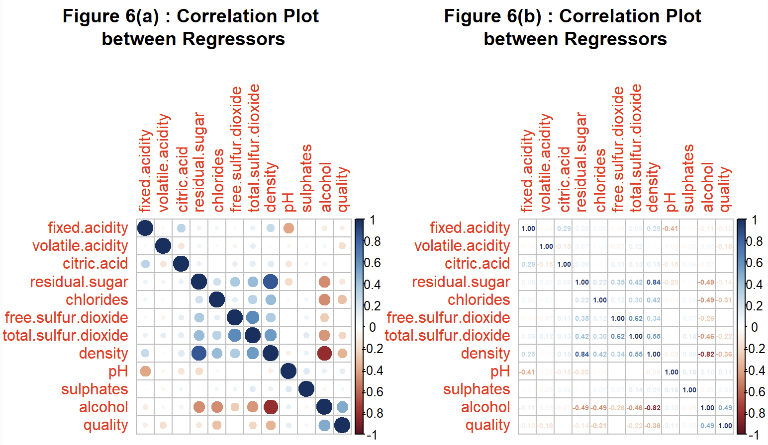
INTERPRETATION
We can separate the interpretation into 2 parts:
- Dependent variable with the regressor variables:
By referring to the last row under the correlation plot, we can identify the correlation between the dependent variable against all 11 other independent variables under this dataset. We notice out of all variables, there are two variables that stand out, that being alcohol (vol.%) and also density (g/cm³). The exact correlation values are 0.49 and -0.36 respectively and a higher value indicates a stronger linear relationship and the potential to be a valuable predictor of y.
- Regressor variables with each other (multicollinearity)
By referring to the upper or lower non-diagonal entries under the correlation plot, we observe that there appears to be very little correlation between the x variables, some of which are even orthogonal (no linear relationship between the regressors) and thus indicating that issues of multicollinearity is minimal under this dataset. In other words, this means that it is likely each predictor provides unique and valuable information in predicting the dependent variable. However, there are two exceptions when observing the correlation plot:
- Alcohol & Density : correlation value of -0.82
- Density & Residual sugar : correlation value of 0.84
plota = ggplot(Dataset, aes(x = alcohol, y = density)) +
geom_point() + # Add points
geom_smooth(method = "lm", se = FALSE, color = "red") +
labs(title = "Figure 7(a): Alcohol vs density",
x = "Alcohol",
y = "Density") + theme(plot.title = element_text(hjust=0.5))
plotb = ggplot(Dataset, aes(x = residual.sugar, y = density)) +
geom_point() + # Add points
geom_smooth(method = "lm", se = FALSE, color = "red") +
labs(title = "Figure 7(b): Residual sugar vs density",
x = "Residual sugar",
y = "Density") + theme(plot.title = element_text(hjust=0.5))
require(gridExtra)
grid.arrange(plota,plotb, ncol=2)

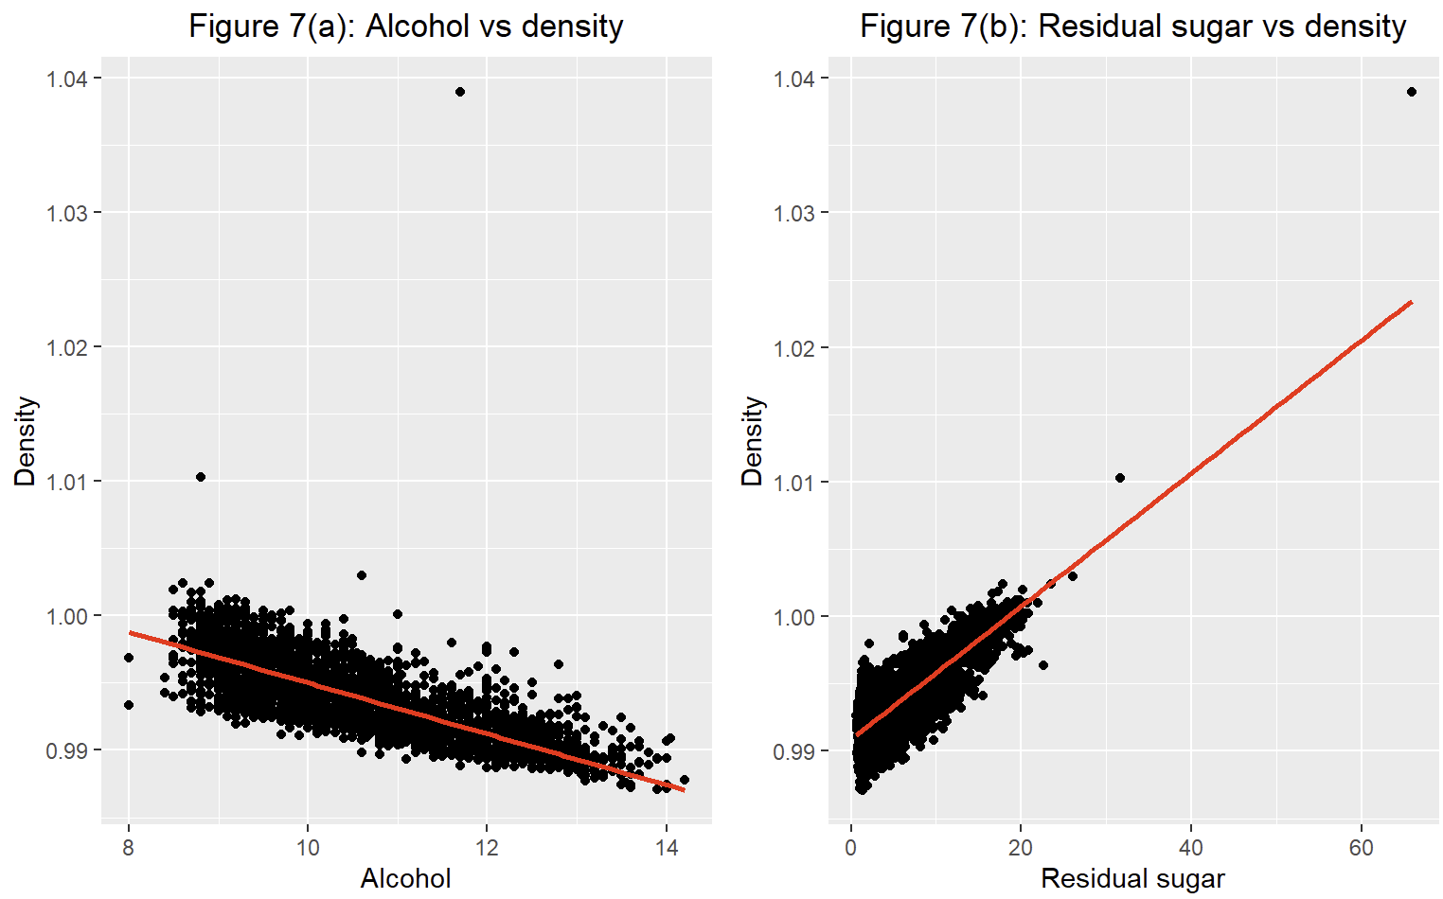

Both are relatively high in terms of their correlation, thus further investigation into their multicollinearity properties should be investigated using other diagnostics. In this case, we will make use of the “variance inflation factor”. Note that we will use the threshold as VIF values $>5$ being considered to have high multicollinearity problems.

Investigating Multicollinearity for Full Model
# investigating multicollinearity under model
cat("===================================================================================================","\n","\n")
cat("( VIF: updated full model )","\n","\n")
vif_updated_full_model<-vif(updated_full_model)
vif_updated_full_model
cat("===================================================================================================","\n","\n")
## ===================================================================================================
##
## ( VIF: updated full model )
##
## fixed.acidity volatile.acidity citric.acid
## 3.502695 1.129971 1.157082
## residual.sugar chlorides free.sulfur.dioxide
## 18.945214 1.395005 1.836549
## total.sulfur.dioxide density pH
## 2.373692 47.964676 2.604507
## sulphates alcohol
## 1.168026 12.698705
## ===================================================================================================
##

# pinpoint key predictors with high vif values
vif_alcohol_full_model <- vif_updated_full_model['alcohol']
vif_density_full_model <- vif_updated_full_model['density']
vif_residual_sugar_full_model <- vif_updated_full_model['residual.sugar']
# constructing table
table_3 <- data.frame(
vif_full_model = c(vif_alcohol_full_model, vif_residual_sugar_full_model, vif_density_full_model ))
#display table
knitr::kable(table_3, caption = "Table 4: High VIF values under the Updated Full Model ") %>%
kable_styling(bootstrap_options = "striped", full_width = F)

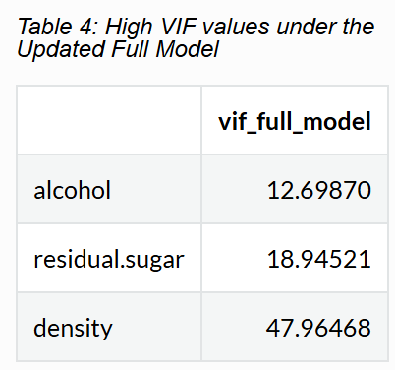
INTERPRETATION
Under the updated full model, these three variables exhibit high multicollinearity indications. Thus when building our regression models later, we will need to take into account these values and make appropriate adjustments if necessary.

Fitting Simple Linear Model
With the updated dataset, we are now ready to start finding our “best” regression model. We will employ the use of a forward step procedure where we start with including one regressor variable in our model, and work our way up towards the best regression model by adding one regressor variable at a time.
In order to determine the first variable that should be included under the simple linear regression model, we will make use of the variable with the highest correlation value to our dependent variable, i.e. Alcohol (vol.%). Note that from here on out, “best_model_x” will refer to a the fitted model in respect to “x” number of variables, for example best_model_1 refers to 1 predictor being fitted in the model, or basically the best simple linear regression model.

# fitting the "best" simple linear model
best_model_1<-lm(quality~alcohol,data = updated_Dataset)
summary(best_model_1)
# extracting and finding relevant metrics
Residual_standard_error_best_model_1<-summary(best_model_1)$sigma
R_squared__best_model_1<-summary(best_model_1)$r.squared
best_model_1_AIC<-AIC(best_model_1)
best_model_1_BIC<-BIC(best_model_1)
# displaying results
table_4 <- data.frame(
Metrics = c("AIC", "BIC", "R-squared", "Residual standard error"),
updated_full_model = c(updated_full_model_AIC, updated_full_model_BIC, R_squared_updated_full_model, Residual_standard_error_updated_full_model),
best_model_1 = c(best_model_1_AIC, best_model_1_BIC, R_squared__best_model_1, Residual_standard_error_best_model_1))
# formatting table
table_4$best_model_1 <- format(table_4$best_model_1, digits = 5)
table_4$updated_full_model <- format(table_4$updated_full_model, digits = 5)
# display table of simple model and full model
knitr::kable(table_4, caption = "Table 5: Comparison of Full vs Simple Linear Model ") %>%
kable_styling(bootstrap_options = "striped", full_width = F)
##
## Call:
## lm(formula = quality ~ alcohol, data = updated_Dataset)
##
## Residuals:
## Min 1Q Median 3Q Max
## -2.20806 -0.52864 -0.01572 0.46514 2.14457
##
## Coefficients:
## Estimate Std. Error t value Pr(>|t|)
## (Intercept) 2.521459 0.090578 27.84 <2e-16 ***
## alcohol 0.320574 0.008558 37.46 <2e-16 ***
## ---
## Signif. codes: 0 '***' 0.001 '**' 0.01 '*' 0.05 '.' 0.1 ' ' 1
##
## Residual standard error: 0.6936 on 4468 degrees of freedom
## Multiple R-squared: 0.239, Adjusted R-squared: 0.2388
## F-statistic: 1403 on 1 and 4468 DF, p-value: < 2.2e-16

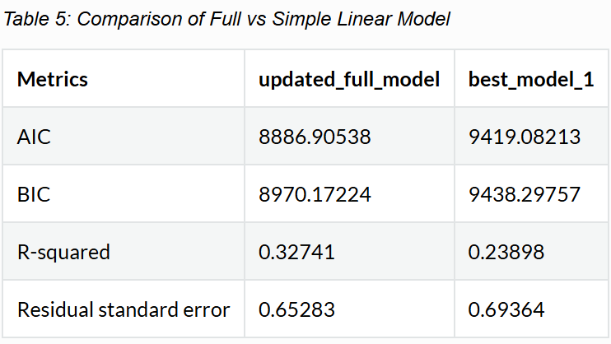

INTERPRETATION
When comparing the metrics above with the simple linear model against the new full model, it is apparent that the simple linear model have values that are less ideal, such as a higher AIC and Residual standard error. However, this is to be expected as only one regressor has been added, in theory, as we add more explanatory variables, the metrics will eventually get more and more ideal until it reaches its optimum value stance where we can conclude the best model has been found.

Fitting Multiple Linear Model
To decide on the next variables added, we decided to see which of the remaining regressor variables when added to the current model has the best statistical significance ,i.e. the lowest p-value. Then by setting our stopping criterion based on a p-value of 0.05, any variables when added to the model results in a p-value greater than 0.05 will be deemed as non significant and the best model will have been determined.
cortable = as.data.frame(cor(updated_Dataset))
cortablefiltered = subset(cortable, select = quality)
numbering = seq(12)
names = names(cortable)
data1 = data.frame(cortablefiltered, numbering, names)
data1 = data1[-12,]
data1$quality = abs(data1$quality)
pairs = c(NULL)
naming = names[-12]
naming = naming[-11]
nametest = naming
a = 12
b= 10
for (i in 1:a) {
pvalue = c(NULL)
AIC = c(NULL)
count = c(NULL)
stop = FALSE
framefull = data1 %>% arrange(desc(quality))
pairs[1] = framefull[1,3]
cat("\nquality ~", pairs[i], "+ \n")
for (j in 1:b) {
formula = as.formula(paste("quality ~",pairs[i]," + ", nametest[j]))
pvalue[j] = (summary(lm(formula, data = updated_Dataset))$coefficients)[i+2,4]
AIC[j] = summary(glm(formula, data = updated_Dataset))$aic
cat("\n\n")
print(summary(lm(formula, data = updated_Dataset))$coefficients)
count[j] = j
}
framefull2 = data.frame(pvalue, nametest, count)
framefull2 = framefull2 %>% arrange(pvalue)
nametest = nametest[-framefull2[1,3]]
pairs[i+1] = paste(c(pairs[i], framefull2[1,2]), collapse = " + ")
b = b - 1
cat("\n", i," iteration done\n")
cat("\nCurrent AIC: ", summary(glm(as.formula(paste("quality ~",pairs[i])), data = updated_Dataset))$aic, "\n\n")
print(AIC)
cat("\nP-values for each of next variables\n")
print(pvalue)
print("==========================================================")
if (pvalue[framefull2[1,3]]>0.05){
stop = TRUE
formula2 = paste("quality ~", pairs[i])
print(summary(glm(formula2, data = updated_Dataset)))
break
}
if (stop){break}
}
##
## quality ~ alcohol +
##
##
## Estimate Std. Error t value Pr(>|t|)
## (Intercept) 2.89341627 0.134079289 21.579890 2.489220e-98
## alcohol 0.31711142 0.008595353 36.893358 2.484199e-260
## fixed.acidity -0.04902708 0.013046307 -3.757928 1.735128e-04
##
##
## Estimate Std. Error t value Pr(>|t|)
## (Intercept) 2.9531655 0.09196732 32.11103 9.602901e-204
## alcohol 0.3278254 0.00832984 39.35554 4.175346e-291
## volatile.acidity -1.8709469 0.11534011 -16.22113 1.531971e-57
##
##
## Estimate Std. Error t value Pr(>|t|)
## (Intercept) 2.4312823 0.098370455 24.715575 1.617611e-126
## alcohol 0.3220096 0.008575948 37.547984 2.053794e-268
## citric.acid 0.2278051 0.097206895 2.343508 1.914697e-02
##
##
## Estimate Std. Error t value Pr(>|t|)
## (Intercept) 1.96701077 0.111189405 17.690631 9.646230e-68
## alcohol 0.36095935 0.009738901 37.063664 1.993538e-262
## residual.sugar 0.02020446 0.002385842 8.468485 3.331427e-17
##
##
## Estimate Std. Error t value Pr(>|t|)
## (Intercept) 3.0686182 0.12840453 23.898053 6.973219e-119
## alcohol 0.2920822 0.00976276 29.917999 2.035546e-179
## chlorides -5.6945346 0.95083910 -5.988957 2.277688e-09
##
##
## Estimate Std. Error t value Pr(>|t|)
## (Intercept) 2.06969415 0.1019149214 20.30806 8.978000e-88
## alcohol 0.34208060 0.0087838140 38.94443 6.735226e-286
## free.sulfur.dioxide 0.00641216 0.0006862682 9.34352 1.433473e-20
##
##
## Estimate Std. Error t value Pr(>|t|)
## (Intercept) 2.4529188782 0.1254825164 19.5478936 1.023184e-81
## alcohol 0.3241192472 0.0096655641 33.5334021 4.293517e-220
## total.sulfur.dioxide 0.0002261661 0.0002865465 0.7892824 4.299889e-01
##
##
## Estimate Std. Error t value Pr(>|t|)
## (Intercept) -31.54804 6.29284861 -5.013316 5.557128e-07
## alcohol 0.38600 0.01479154 26.095992 7.608848e-140
## density 33.58283 6.20231923 5.414559 6.466238e-08
##
##
## Estimate Std. Error t value Pr(>|t|)
## (Intercept) 1.5119267 0.235704118 6.414511 1.559320e-10
## alcohol 0.3164725 0.008584471 36.865689 5.434529e-260
## pH 0.3300271 0.071165754 4.637443 3.628207e-06
##
##
## Estimate Std. Error t value Pr(>|t|)
## (Intercept) 2.2369583 0.10424707 21.458237 2.681675e-97
## alcohol 0.3229069 0.00854159 37.804072 1.350621e-271
## sulphates 0.5339578 0.09780526 5.459397 5.036464e-08
##
## 1 iteration done
##
## Current AIC: 9419.082
##
## [1] 9406.973 9165.243 9415.590 9349.889 9385.334 9334.565 9420.459 9391.841
## [9] 9399.613 9391.356
##
## P-values for each of next variables
## [1] 1.735128e-04 1.531971e-57 1.914697e-02 3.331427e-17 2.277688e-09
## [6] 1.433473e-20 4.299889e-01 6.466238e-08 3.628207e-06 5.036464e-08
## [1] "=========================================================="
##
## quality ~ alcohol + volatile.acidity +
##
##
## Estimate Std. Error t value Pr(>|t|)
## (Intercept) 3.37591042 0.13353091 25.281864 6.436872e-132
## alcohol 0.32398039 0.00835978 38.754655 1.704027e-283
## volatile.acidity -1.88602142 0.11516038 -16.377347 1.374014e-58
## fixed.acidity -0.05526277 0.01267849 -4.358783 1.337280e-05
##
##
## Estimate Std. Error t value Pr(>|t|)
## (Intercept) 2.949746808 0.100978100 29.211748 8.025553e-172
## alcohol 0.327869408 0.008348053 39.274954 4.490153e-290
## volatile.acidity -1.869574125 0.116560479 -16.039520 2.468220e-56
## citric.acid 0.007836203 0.095522685 0.082035 9.346226e-01
##
##
## Estimate Std. Error t value Pr(>|t|)
## (Intercept) 2.30173419 0.109225979 21.07314 4.635369e-94
## alcohol 0.37822859 0.009471332 39.93404 1.808240e-298
## volatile.acidity -2.01377992 0.114667955 -17.56184 8.120558e-67
## residual.sugar 0.02493961 0.002323451 10.73387 1.484097e-26
##
##
## Estimate Std. Error t value Pr(>|t|)
## (Intercept) 3.3983335 0.126643230 26.833914 3.479904e-147
## alcohol 0.3040305 0.009528518 31.907432 1.955228e-201
## volatile.acidity -1.8323275 0.115268213 -15.896208 2.168681e-55
## chlorides -4.7258041 0.927138291 -5.097194 3.589718e-07
##
##
## Estimate Std. Error t value Pr(>|t|)
## (Intercept) 2.533678977 0.103460704 24.489288 2.204552e-124
## alcohol 0.346880754 0.008554964 40.547307 2.437112e-306
## volatile.acidity -1.809422818 0.114634296 -15.784306 1.169336e-54
## free.sulfur.dioxide 0.005752526 0.000669272 8.595199 1.133681e-17
##
##
## Estimate Std. Error t value Pr(>|t|)
## (Intercept) 2.6718338611 0.1225133814 21.808506 2.782159e-100
## alcohol 0.3434056863 0.0094537181 36.324934 2.284160e-253
## volatile.acidity -1.9360844611 0.1167170300 -16.587849 5.156729e-60
## total.sulfur.dioxide 0.0009779298 0.0002818065 3.470217 5.249575e-04
##
##
## Estimate Std. Error t value Pr(>|t|)
## (Intercept) -41.8619220 6.12979034 -6.829258 9.682299e-12
## alcohol 0.4142627 0.01443364 28.701202 2.072109e-166
## volatile.acidity -1.9580837 0.11528630 -16.984530 9.606749e-63
## density 44.1947408 6.04426706 7.311844 3.106579e-13
##
##
## Estimate Std. Error t value Pr(>|t|)
## (Intercept) 2.1285584 0.232464000 9.156508 7.979901e-20
## alcohol 0.3244013 0.008364044 38.785224 7.016623e-284
## volatile.acidity -1.8459216 0.115343186 -16.003734 4.253663e-56
## pH 0.2676855 0.069326174 3.861247 1.144054e-04
##
##
## Estimate Std. Error t value Pr(>|t|)
## (Intercept) 2.7032547 0.105500293 25.623196 3.225193e-135
## alcohol 0.3297132 0.008318704 39.635164 1.181577e-294
## volatile.acidity -1.8430143 0.115204183 -15.997807 4.654453e-56
## sulphates 0.4569428 0.095250186 4.797291 1.660683e-06
##
## 2 iteration done
##
## Current AIC: 9165.243
##
## [1] 9148.268 9167.237 9053.387 9141.314 9093.905 9155.206 9114.050 9152.346
## [9] 9144.268
##
## P-values for each of next variables
## [1] 1.337280e-05 9.346226e-01 1.484097e-26 3.589718e-07 1.133681e-17
## [6] 5.249575e-04 3.106579e-13 1.144054e-04 1.660683e-06
## [1] "=========================================================="
##
## quality ~ alcohol + volatile.acidity + residual.sugar +
##
##
## Estimate Std. Error t value Pr(>|t|)
## (Intercept) 2.74925461 0.143771416 19.12240 2.074964e-78
## alcohol 0.37480495 0.009475546 39.55497 1.266795e-293
## volatile.acidity -2.03215226 0.114454359 -17.75513 3.311630e-68
## residual.sugar 0.02530221 0.002319056 10.91057 2.267096e-27
## fixed.acidity -0.05973964 0.012520909 -4.77119 1.889860e-06
##
##
## Estimate Std. Error t value Pr(>|t|)
## (Intercept) 2.33203979 0.115033794 20.272650 1.742616e-87
## alcohol 0.37812093 0.009472511 39.917708 2.987491e-298
## volatile.acidity -2.02867218 0.116034178 -17.483402 2.953601e-66
## residual.sugar 0.02510752 0.002332109 10.766011 1.056840e-26
## citric.acid -0.07951761 0.094665399 -0.839986 4.009612e-01
##
##
## Estimate Std. Error t value Pr(>|t|)
## (Intercept) 2.72831924 0.140122066 19.471018 4.103434e-81
## alcohol 0.35521768 0.010575802 33.587776 1.022300e-220
## volatile.acidity -1.97561291 0.114652305 -17.231341 1.803848e-64
## residual.sugar 0.02460455 0.002318669 10.611498 5.362782e-26
## chlorides -4.43562175 0.916174748 -4.841458 1.332450e-06
##
##
## Estimate Std. Error t value Pr(>|t|)
## (Intercept) 2.106437058 0.1137007819 18.526144 7.010613e-74
## alcohol 0.383812966 0.0094824370 40.476195 2.050960e-305
## volatile.acidity -1.947486373 0.1147805155 -16.967047 1.272022e-62
## residual.sugar 0.021000522 0.0024083442 8.719901 3.867215e-18
## free.sulfur.dioxide 0.004089122 0.0006905886 5.921213 3.435491e-09
##
##
## Estimate Std. Error t value Pr(>|t|)
## (Intercept) 2.2293543827 0.1286586761 17.327665 3.770532e-65
## alcohol 0.3819004760 0.0100797589 37.887858 1.266076e-272
## volatile.acidity -2.0307260324 0.1157659974 -17.541645 1.133726e-66
## residual.sugar 0.0243537456 0.0023877104 10.199623 3.656643e-24
## total.sulfur.dioxide 0.0003047922 0.0002863208 1.064513 2.871540e-01
##
##
## Estimate Std. Error t value Pr(>|t|)
## (Intercept) 56.04161520 12.542367656 4.468185 8.083808e-06
## alcohol 0.31034393 0.018448853 16.821855 1.286081e-61
## volatile.acidity -2.01231466 0.114446251 -17.583054 5.729616e-67
## residual.sugar 0.04308934 0.004829039 8.922965 6.504028e-19
## density -53.46350897 12.477393766 -4.284830 1.867294e-05
##
##
## Estimate Std. Error t value Pr(>|t|)
## (Intercept) 0.99723915 0.248946012 4.005845 6.280163e-05
## alcohol 0.37774453 0.009436955 40.028221 1.152222e-299
## volatile.acidity -1.98929335 0.114324613 -17.400394 1.150646e-65
## residual.sugar 0.02725599 0.002348821 11.604116 1.078346e-30
## pH 0.40382652 0.069311662 5.826242 6.067429e-09
##
##
## Estimate Std. Error t value Pr(>|t|)
## (Intercept) 2.00976459 0.121683614 16.516312 1.581326e-59
## alcohol 0.38150573 0.009461560 40.321654 1.989762e-303
## volatile.acidity -1.98622706 0.114426441 -17.358113 2.295272e-65
## residual.sugar 0.02552721 0.002318808 11.008766 7.881223e-28
## sulphates 0.50578081 0.094098395 5.375021 8.047703e-08
##
## 3 iteration done
##
## Current AIC: 9053.387
##
## [1] 9032.655 9054.680 9031.982 9020.424 9054.252 9037.044 9021.532 9026.557
##
## P-values for each of next variables
## [1] 0.000001889859870 0.400961226510513 0.000001332449888 0.000000003435491
## [5] 0.287153981531523 0.000018672937600 0.000000006067429 0.000000080477034
## [1] "=========================================================="
##
## quality ~ alcohol + volatile.acidity + residual.sugar + free.sulfur.dioxide +
##
##
## Estimate Std. Error t value Pr(>|t|)
## (Intercept) 2.522101416 0.1490253920 16.923971 2.533915e-62
## alcohol 0.380382463 0.0094974116 40.051172 5.983687e-300
## volatile.acidity -1.968120924 0.1146563602 -17.165388 5.250393e-64
## residual.sugar 0.021568930 0.0024072611 8.959946 4.681829e-19
## free.sulfur.dioxide 0.003838619 0.0006916922 5.549606 3.028867e-08
## fixed.acidity -0.053890075 0.0125237717 -4.303023 1.720898e-05
##
##
## Estimate Std. Error t value Pr(>|t|)
## (Intercept) 2.148171675 0.1186281428 18.108449 8.830487e-71
## alcohol 0.383731358 0.0094821165 40.468956 2.598299e-305
## volatile.acidity -1.968399266 0.1160209271 -16.965898 1.296848e-62
## residual.sugar 0.021192812 0.0024132511 8.781851 2.254304e-18
## free.sulfur.dioxide 0.004144843 0.0006920263 5.989430 2.271249e-09
## citric.acid -0.116488442 0.0944996790 -1.232686 2.177578e-01
##
##
## Estimate Std. Error t value Pr(>|t|)
## (Intercept) 2.534654975 0.1433181439 17.685514 1.053620e-67
## alcohol 0.360695606 0.0105752163 34.107634 8.478602e-227
## volatile.acidity -1.908862395 0.1147600089 -16.633516 2.522123e-60
## residual.sugar 0.020648985 0.0024032735 8.592025 1.165090e-17
## free.sulfur.dioxide 0.004104297 0.0006888328 5.958336 2.744261e-09
## chlorides -4.460136449 0.9126646898 -4.886939 1.060061e-06
##
##
## Estimate Std. Error t value Pr(>|t|)
## (Intercept) 2.2765821872 0.1282766226 17.747444 3.767682e-68
## alcohol 0.3737171748 0.0101125408 36.955814 4.452257e-261
## volatile.acidity -1.8697124164 0.1178759870 -15.861690 3.656345e-55
## residual.sugar 0.0215790310 0.0024149223 8.935704 5.808811e-19
## free.sulfur.dioxide 0.0054740270 0.0008433231 6.491020 9.454901e-11
## total.sulfur.dioxide -0.0009950132 0.0003483246 -2.856569 4.302258e-03
##
##
## Estimate Std. Error t value Pr(>|t|)
## (Intercept) 55.111742386 12.4963139555 4.410240 1.056860e-05
## alcohol 0.316818059 0.0184124856 17.206697 2.691739e-64
## volatile.acidity -1.946515227 0.1145629448 -16.990793 8.707039e-63
## residual.sugar 0.038929856 0.0048624823 8.006169 1.496850e-15
## free.sulfur.dioxide 0.004059882 0.0006893126 5.889753 4.151771e-09
## density -52.731321694 12.4312080416 -4.241850 2.261757e-05
##
##
## Estimate Std. Error t value Pr(>|t|)
## (Intercept) 0.89366447 0.2488055543 3.591819 3.319147e-04
## alcohol 0.38302718 0.0094529024 40.519532 5.805015e-306
## volatile.acidity -1.92843882 0.1144627017 -16.847749 8.531664e-62
## residual.sugar 0.02340842 0.0024405147 9.591591 1.398570e-21
## free.sulfur.dioxide 0.00384641 0.0006897841 5.576252 2.602556e-08
## pH 0.37902090 0.0692223352 5.475413 4.604406e-08
##
##
## Estimate Std. Error t value Pr(>|t|)
## (Intercept) 1.847388828 0.1247303072 14.811066 1.730408e-48
## alcohol 0.386519124 0.0094727507 40.803261 1.274626e-309
## volatile.acidity -1.925882797 0.1145569043 -16.811582 1.515218e-61
## residual.sugar 0.021779144 0.0024070025 9.048243 2.124276e-19
## free.sulfur.dioxide 0.003846276 0.0006904696 5.570522 2.689007e-08
## sulphates 0.468842808 0.0940176682 4.986752 6.373251e-07
##
## 4 iteration done
##
## Current AIC: 9020.424
##
## [1] 9003.921 9020.903 8998.573 9014.260 9004.443 8992.504 8997.592
##
## P-values for each of next variables
## [1] 0.00001720897861 0.21775781028881 0.00000106006138 0.00430225810900
## [5] 0.00002261756801 0.00000004604406 0.00000063732512
## [1] "=========================================================="
##
## quality ~ alcohol + volatile.acidity + residual.sugar + free.sulfur.dioxide + pH +
##
##
## Estimate Std. Error t value Pr(>|t|)
## (Intercept) 1.358952862 0.3217528101 4.223593 2.452303e-05
## alcohol 0.381187234 0.0094828916 40.197363 8.183524e-302
## volatile.acidity -1.943911062 0.1146102015 -16.961065 1.402411e-62
## residual.sugar 0.023291264 0.0024399106 9.545950 2.155617e-21
## free.sulfur.dioxide 0.003746392 0.0006908555 5.422830 6.176113e-08
## pH 0.308794699 0.0757408517 4.076990 4.641670e-05
## fixed.acidity -0.031190990 0.0136856185 -2.279107 2.270771e-02
##
##
## Estimate Std. Error t value Pr(>|t|)
## (Intercept) 0.922775577 0.2577359509 3.5803138 3.468344e-04
## alcohol 0.383007541 0.0094538711 40.5133025 7.138728e-306
## volatile.acidity -1.936074453 0.1158211253 -16.7160736 6.876099e-61
## residual.sugar 0.023448122 0.0024424557 9.6002242 1.288553e-21
## free.sulfur.dioxide 0.003869021 0.0006918172 5.5925486 2.371198e-08
## pH 0.374544922 0.0699948454 5.3510358 9.183356e-08
## citric.acid -0.041278873 0.0952512243 -0.4333684 6.647681e-01
##
##
## Estimate Std. Error t value Pr(>|t|)
## (Intercept) 1.314150073 0.2621579277 5.012818 5.571619e-07
## alcohol 0.359571003 0.0105420089 34.108395 8.409758e-227
## volatile.acidity -1.889046332 0.1144342017 -16.507708 1.811932e-59
## residual.sugar 0.023079348 0.0024349535 9.478353 4.075963e-21
## free.sulfur.dioxide 0.003859031 0.0006879628 5.609361 2.153452e-08
## pH 0.383346954 0.0690445675 5.552167 2.985161e-08
## chlorides -4.523775424 0.9097030771 -4.972804 6.846833e-07
##
##
## Estimate Std. Error t value Pr(>|t|)
## (Intercept) 1.029496511 0.2518112178 4.088366 4.420656e-05
## alcohol 0.371151932 0.0100863224 36.797548 3.979523e-259
## volatile.acidity -1.836275121 0.1175991962 -15.614691 1.476534e-53
## residual.sugar 0.024212822 0.0024495398 9.884641 8.310249e-23
## free.sulfur.dioxide 0.005457031 0.0008403180 6.494007 9.271191e-11
## pH 0.398899888 0.0693977723 5.748022 9.630879e-09
## total.sulfur.dioxide -0.001166330 0.0003483585 -3.348072 8.204991e-04
##
##
## Estimate Std. Error t value Pr(>|t|)
## (Intercept) 81.830637762 12.9785722781 6.305057 3.159729e-10
## alcohol 0.279887309 0.0190273604 14.709729 7.254141e-48
## volatile.acidity -1.920036312 0.1139877770 -16.844230 9.030878e-62
## residual.sugar 0.051808367 0.0051611773 10.038091 1.835641e-23
## free.sulfur.dioxide 0.003713448 0.0006872048 5.403700 6.868016e-08
## pH 0.516551285 0.0723710520 7.137540 1.103829e-12
## density -80.956399620 12.9793218033 -6.237337 4.863112e-10
##
##
## Estimate Std. Error t value Pr(>|t|)
## (Intercept) 0.822089449 0.248935002 3.302426 9.660684e-04
## alcohol 0.385417314 0.009452741 40.773076 3.198775e-309
## volatile.acidity -1.912448907 0.114315483 -16.729570 5.556138e-61
## residual.sugar 0.023774590 0.002437585 9.753338 2.973466e-22
## free.sulfur.dioxide 0.003670158 0.000689799 5.320620 1.084799e-07
## pH 0.332754855 0.069973656 4.755430 2.042663e-06
## sulphates 0.397473654 0.094984036 4.184636 2.911168e-05
##
## 5 iteration done
##
## Current AIC: 8992.504
##
## [1] 8989.304 8994.316 8969.805 8983.291 8955.707 8976.999
##
## P-values for each of next variables
## [1] 0.0227077114663887 0.6647680804733489 0.0000006846833440 0.0008204990645198
## [5] 0.0000000004863112 0.0000291116778756
## [1] "=========================================================="
##
## quality ~ alcohol + volatile.acidity + residual.sugar + free.sulfur.dioxide + pH + density +
##
##
## Estimate Std. Error t value Pr(>|t|)
## (Intercept) 148.093538027 20.5265184103 7.214742 6.318350e-13
## alcohol 0.199079575 0.0271612803 7.329536 2.727508e-13
## volatile.acidity -1.867945074 0.1144663346 -16.318729 3.416403e-58
## residual.sugar 0.075876211 0.0077450163 9.796779 1.953937e-22
## free.sulfur.dioxide 0.003893723 0.0006873181 5.665096 1.561805e-08
## pH 0.836022609 0.1054096634 7.931176 2.722856e-15
## density -148.590937542 20.7836757977 -7.149406 1.013520e-12
## fixed.acidity 0.090860894 0.0218324604 4.161734 3.217901e-05
##
##
## Estimate Std. Error t value Pr(>|t|)
## (Intercept) 86.489302507 13.461978109 6.424710 1.459339e-10
## alcohol 0.273896430 0.019574583 13.992453 1.427307e-43
## volatile.acidity -1.895822641 0.115486740 -16.415934 7.574162e-59
## residual.sugar 0.053351433 0.005295162 10.075505 1.266205e-23
## free.sulfur.dioxide 0.003635402 0.000689762 5.270517 1.424604e-07
## pH 0.538526032 0.074308295 7.247186 4.989311e-13
## density -85.706639932 13.481571887 -6.357318 2.258646e-10
## citric.acid 0.128235716 0.098510732 1.301744 1.930712e-01
##
##
## Estimate Std. Error t value Pr(>|t|)
## (Intercept) 74.068149837 13.093948597 5.656670 1.639834e-08
## alcohol 0.270766415 0.019124292 14.158245 1.511097e-44
## volatile.acidity -1.888201655 0.114053083 -16.555464 8.595401e-60
## residual.sugar 0.048689231 0.005208206 9.348560 1.368691e-20
## free.sulfur.dioxide 0.003737243 0.000686021 5.447710 5.376749e-08
## pH 0.506356891 0.072286750 7.004837 2.842438e-12
## density -72.843164898 13.107385780 -5.557414 2.897465e-08
## chlorides -3.752548467 0.917231400 -4.091169 4.367782e-05
##
##
## Estimate Std. Error t value Pr(>|t|)
## (Intercept) 75.5754966546 13.6675453473 5.529559 3.393627e-08
## alcohol 0.2825023100 0.0191092923 14.783505 2.560028e-48
## volatile.acidity -1.8785088577 0.1174775076 -15.990370 5.226930e-56
## residual.sugar 0.0499598629 0.0053139437 9.401655 8.354978e-21
## free.sulfur.dioxide 0.0044610069 0.0008572924 5.203600 2.042355e-07
## pH 0.5149153374 0.0723706178 7.114978 1.297981e-12
## density -74.6375719697 13.6820266098 -5.455155 5.157687e-08
## total.sulfur.dioxide -0.0005338286 0.0003660875 -1.458199 1.448560e-01
##
##
## Estimate Std. Error t value Pr(>|t|)
## (Intercept) 100.830570297 13.3236994927 7.567761 4.584983e-14
## alcohol 0.258999685 0.0192825634 13.431808 2.371489e-40
## volatile.acidity -1.894930367 0.1136369717 -16.675298 1.309187e-60
## residual.sugar 0.059041080 0.0052854891 11.170410 1.358778e-28
## free.sulfur.dioxide 0.003427191 0.0006863237 4.993550 6.154175e-07
## pH 0.482107900 0.0723332693 6.665092 2.966599e-11
## density -100.064420652 13.3288536177 -7.507354 7.243001e-14
## sulphates 0.574779379 0.0973099097 5.906689 3.749962e-09
##
## 6 iteration done
##
## Current AIC: 8955.707
##
## [1] 8940.390 8956.010 8940.971 8955.578 8922.892
##
## P-values for each of next variables
## [1] 0.000032179006410 0.193071247830624 0.000043677823329 0.144855983104451
## [5] 0.000000003749962
## [1] "=========================================================="
##
## quality ~ alcohol + volatile.acidity + residual.sugar + free.sulfur.dioxide + pH + density + sulphates +
##
##
## Estimate Std. Error t value Pr(>|t|)
## (Intercept) 197.856655207 21.5912816086 9.163729 7.475892e-20
## alcohol 0.141194150 0.0282239297 5.002640 5.872465e-07
## volatile.acidity -1.816347859 0.1140748882 -15.922416 1.464862e-55
## residual.sugar 0.094357890 0.0081333020 11.601425 1.112773e-30
## free.sulfur.dioxide 0.003614482 0.0006847052 5.278888 1.361441e-07
## pH 0.921297387 0.1055244992 8.730649 3.523426e-18
## density -199.034226703 21.8643899611 -9.103123 1.295431e-19
## sulphates 0.705193831 0.0996325944 7.077943 1.691636e-12
## fixed.acidity 0.127132630 0.0223098687 5.698493 1.286526e-08
##
##
## Estimate Std. Error t value Pr(>|t|)
## (Intercept) 105.116761513 13.7795385997 7.628467 2.885889e-14
## alcohol 0.253476859 0.0198070969 12.797275 7.498672e-37
## volatile.acidity -1.872425514 0.1151220583 -16.264698 7.872272e-58
## residual.sugar 0.060457876 0.0054115965 11.171911 1.336871e-28
## free.sulfur.dioxide 0.003355287 0.0006888189 4.871072 1.148387e-06
## pH 0.502708331 0.0742790097 6.767838 1.476578e-11
## density -104.435684204 13.8025038524 -7.566430 4.631756e-14
## sulphates 0.573006712 0.0973155001 5.888134 4.192529e-09
## citric.acid 0.119595872 0.0981521115 1.218475 2.231080e-01
##
##
## Estimate Std. Error t value Pr(>|t|)
## (Intercept) 93.075901799 13.4317180668 6.929560 4.824933e-12
## alcohol 0.249772672 0.0193772304 12.890009 2.361449e-37
## volatile.acidity -1.862852865 0.1136987752 -16.384107 1.242473e-58
## residual.sugar 0.055924013 0.0053297303 10.492841 1.840235e-25
## free.sulfur.dioxide 0.003450354 0.0006851154 5.036165 4.936957e-07
## pH 0.471765285 0.0722469320 6.529901 7.316945e-11
## density -91.957356281 13.4490042610 -6.837484 9.149198e-12
## sulphates 0.576313100 0.0971360489 5.933051 3.198641e-09
## chlorides -3.773277227 0.9137428849 -4.129474 3.702447e-05
##
##
## Estimate Std. Error t value Pr(>|t|)
## (Intercept) 93.4692723728 13.9372151813 6.706453 2.242930e-11
## alcohol 0.2618580347 0.0193433994 13.537333 6.000429e-41
## volatile.acidity -1.8434993928 0.1171650684 -15.734207 2.486728e-54
## residual.sugar 0.0568930699 0.0054179402 10.500867 1.693749e-25
## free.sulfur.dioxide 0.0043405348 0.0008541872 5.081480 3.898150e-07
## pH 0.4795155950 0.0723296730 6.629583 3.766839e-11
## density -92.6267291862 13.9547142430 -6.637666 3.567937e-11
## sulphates 0.5845074998 0.0974364748 5.998857 2.144355e-09
## total.sulfur.dioxide -0.0006556745 0.0003652259 -1.795257 7.268039e-02
##
## 7 iteration done
##
## Current AIC: 8922.892
##
## [1] 8892.471 8923.404 8907.837 8921.663
##
## P-values for each of next variables
## [1] 0.00000001286526 0.22310803958521 0.00003702446865 0.07268038605135
## [1] "=========================================================="
##
## quality ~ alcohol + volatile.acidity + residual.sugar + free.sulfur.dioxide + pH + density + sulphates + fixed.acidity +
##
##
## Estimate Std. Error t value Pr(>|t|)
## (Intercept) 199.442918587 21.6946202114 9.1931971 5.715813e-20
## alcohol 0.139071000 0.0283654706 4.9028272 9.782399e-07
## volatile.acidity -1.803287550 0.1153885008 -15.6279659 1.214570e-53
## residual.sugar 0.094846592 0.0081594908 11.6240823 8.605486e-31
## free.sulfur.dioxide 0.003567939 0.0006875163 5.1896068 2.200997e-07
## pH 0.929219386 0.1060515786 8.7619571 2.682810e-18
## density -200.651777153 21.9704846827 -9.1327879 9.903216e-20
## sulphates 0.702664944 0.0996938757 7.0482258 2.090304e-12
## fixed.acidity 0.125736496 0.0223876873 5.6163236 2.069160e-08
## citric.acid 0.073991450 0.0981542646 0.7538282 4.509922e-01
##
##
## Estimate Std. Error t value Pr(>|t|)
## (Intercept) 182.306130477 22.1029986397 8.248027 2.097525e-16
## alcohol 0.145369017 0.0282241701 5.150515 2.709724e-07
## volatile.acidity -1.798683790 0.1140874024 -15.765840 1.549327e-54
## residual.sugar 0.088465355 0.0083284284 10.622095 4.804610e-26
## free.sulfur.dioxide 0.003614544 0.0006839878 5.284516 1.320512e-07
## pH 0.870438790 0.1065912949 8.166134 4.105862e-16
## density -183.016739211 22.4010783635 -8.169997 3.978384e-16
## sulphates 0.693724252 0.0995919585 6.965665 3.746133e-12
## fixed.acidity 0.114772255 0.0226148389 5.075086 4.030790e-07
## chlorides -2.976533003 0.9246428689 -3.219116 1.295077e-03
##
##
## Estimate Std. Error t value Pr(>|t|)
## (Intercept) 191.2206288324 22.5545461936 8.478141 3.071730e-17
## alcohol 0.1457828681 0.0285817890 5.100551 3.527191e-07
## volatile.acidity -1.7889781990 0.1172024116 -15.264005 2.579614e-51
## residual.sugar 0.0922456297 0.0083939757 10.989504 9.711712e-28
## free.sulfur.dioxide 0.0041308665 0.0008522517 4.847003 1.295996e-06
## pH 0.9087908988 0.1062373934 8.554341 1.608200e-17
## density -192.3058112880 22.8422412120 -8.418868 5.062424e-17
## sulphates 0.7074694417 0.0996572921 7.099023 1.455185e-12
## fixed.acidity 0.1239404862 0.0225292452 5.501316 3.980621e-08
## total.sulfur.dioxide -0.0003740801 0.0003676149 -1.017587 3.089295e-01
##
## 8 iteration done
##
## Current AIC: 8892.471
##
## [1] 8893.902 8884.097 8893.433
##
## P-values for each of next variables
## [1] 0.450992200 0.001295077 0.308929475
## [1] "=========================================================="
##
## quality ~ alcohol + volatile.acidity + residual.sugar + free.sulfur.dioxide + pH + density + sulphates + fixed.acidity + chlorides +
##
##
## Estimate Std. Error t value Pr(>|t|)
## (Intercept) 183.737942060 22.2244059621 8.2673950 1.787906e-16
## alcohol 0.143586408 0.0283716576 5.0609101 4.340549e-07
## volatile.acidity -1.788066865 0.1153686565 -15.4987231 8.254152e-53
## residual.sugar 0.088915333 0.0083604520 10.6352303 4.188674e-26
## free.sulfur.dioxide 0.003576202 0.0006868149 5.2069378 2.006251e-07
## pH 0.877373886 0.1071818358 8.1858449 3.495190e-16
## density -184.478080237 22.5258357615 -8.1896220 3.388808e-16
## sulphates 0.691733215 0.0996503926 6.9416005 4.435280e-12
## fixed.acidity 0.113721534 0.0226795787 5.0142701 5.530142e-07
## chlorides -2.952595216 0.9255093822 -3.1902380 1.431411e-03
## citric.acid 0.060953589 0.0981385616 0.6210972 5.345674e-01
##
##
## Estimate Std. Error t value Pr(>|t|)
## (Intercept) 176.8088006498 22.9840523934 7.6926731 1.761998e-14
## alcohol 0.1492518651 0.0285736065 5.2234171 1.836578e-07
## volatile.acidity -1.7754346441 0.1171608523 -15.1538215 1.278453e-50
## residual.sugar 0.0867272282 0.0085635824 10.1274472 7.546697e-24
## free.sulfur.dioxide 0.0040573165 0.0008516999 4.7637867 1.960290e-06
## pH 0.8603454164 0.1072200419 8.0241101 1.296576e-15
## density -177.4459776399 23.2937924915 -7.6177367 3.133071e-14
## sulphates 0.6958176112 0.0996235191 6.9844713 3.281928e-12
## fixed.acidity 0.1121883392 0.0228085237 4.9187024 9.025575e-07
## chlorides -2.9396450250 0.9256336500 -3.1758191 1.504327e-03
## total.sulfur.dioxide -0.0003207542 0.0003676247 -0.8725045 3.829802e-01
##
## 9 iteration done
##
## Current AIC: 8884.097
##
## [1] 8885.711 8885.334
##
## P-values for each of next variables
## [1] 0.5345674 0.3829802
## [1] "=========================================================="
##
## Call:
## glm(formula = formula2, data = updated_Dataset)
##
## Coefficients:
## Estimate Std. Error t value Pr(>|t|)
## (Intercept) 182.306130 22.102999 8.248 < 2e-16 ***
## alcohol 0.145369 0.028224 5.151 2.71e-07 ***
## volatile.acidity -1.798684 0.114087 -15.766 < 2e-16 ***
## residual.sugar 0.088465 0.008328 10.622 < 2e-16 ***
## free.sulfur.dioxide 0.003615 0.000684 5.285 1.32e-07 ***
## pH 0.870439 0.106591 8.166 4.11e-16 ***
## density -183.016739 22.401078 -8.170 3.98e-16 ***
## sulphates 0.693724 0.099592 6.966 3.75e-12 ***
## fixed.acidity 0.114772 0.022615 5.075 4.03e-07 ***
## chlorides -2.976533 0.924643 -3.219 0.0013 **
## ---
## Signif. codes: 0 '***' 0.001 '**' 0.01 '*' 0.05 '.' 0.1 ' ' 1
##
## (Dispersion parameter for gaussian family taken to be 0.4261068)
##
## Null deviance: 2824.8 on 4469 degrees of freedom
## Residual deviance: 1900.4 on 4460 degrees of freedom
## AIC: 8884.1
##
## Number of Fisher Scoring iterations: 2

INTERPRETATION
By inspection, we can conclude that the our current best fitted model consists of the following variables in the specified order:
- Alcohol (vol.%)
- Volatile acidity (g(acetic acid)/dm³)
- Residual sugar (g/dm³)
- Free sulfur dioxide (mg/dm³)
- pH level
- Density (g/cm³)
- Sulphates (g(potassium sulphate)/dm³)
- Fixed acidity (g(tartaric acid)/dm³)
- Chlorides (g(sodium chloride)/dm³)
For further investigation and verification, we will also see how the other values (AIC, BIC, R-squared, Residual standard error) change as each new variable is fitted, if it is consistent with our findings, we should observe a trend where each of the values become more ideal with every variable included at each step.
# fitting each of the models as best_model_x
# Create an empty list to store the models
best_models <- list()
# Loop through each element in pairs
for (i in 1:9) {
formula <- as.formula(paste("quality ~", pairs[i]))
best_models[[i]] <- lm(formula, data = updated_Dataset)
assign(paste0("best_model_", i), best_models[[i]])
}
# finding the relevant values for each of the models
model_names <- paste0("best_model_", 1:9)
# Loop through each model
for (i in 1:9) {
model <- get(model_names[i])
assign(paste0("Residual_standard_error_", model_names[i]), summary(model)$sigma)
assign(paste0("R_squared_", model_names[i]), summary(model)$r.squared)
assign(paste0(model_names[i], "_AIC"), AIC(model))
assign(paste0(model_names[i], "_BIC"), BIC(model))}
table_5 <- data.frame(
Metrics = c("AIC", "BIC", "R-squared", "Residual standard error"))
# Loop through each model to extract metrics and store them in the data frame
for (i in 1:9) {
model <- get(model_names[i])
aic_value <- AIC(model)
bic_value <- BIC(model)
r_squared_value <- summary(model)$r.squared
residual_standard_error <- summary(model)$sigma
table_5[paste0("best_model_", i)] <- c(aic_value, bic_value, r_squared_value, residual_standard_error)}
# formatting the table
for (i in 1:9) {
column_name <- paste0("best_model_", i)
table_5[[column_name]] <- format(table_5[[column_name]], digits = 5)}
# displaying the table
knitr::kable(table_5, caption = "Table 6: Comparison of all Fitted Models") %>%
kable_styling(bootstrap_options = "striped", full_width = F)

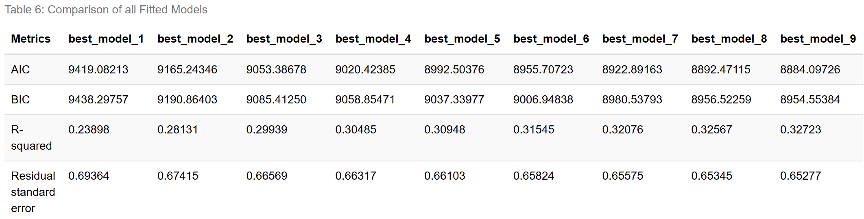

INTERPRETATION
We can observe that for every new variable added, the metric values become more ideal for every model until best_model_9. To further investigate the quality of our model, we check on the Mallows $Cp$ value.

Checking Mallows Cp
# checking Mallows Cp for the current best model fitted
ols_best_model_9<-ols_mallows_cp(best_model_9,updated_full_model)
ols_best_model_9
## [1] 9.18884
INTERPRETATION
Under the model, we can observe that the Mallows $Cp$ value of 9.18884 which is seemingly lower than th ideal value of $k+1=p=12$ which indicates that the the current model might be underfitting the data.

Reinvestigating Multicollinearity Properties
Despite all the metrics pointing towards the conclusion that we have fitted the best model, it is also essential to consider multicollinearity in addition to traditional model evaluation metrics such as R-squared, AIC, BIC, and residual standard error. Hence we need to evaluate the presence of multicollinear issues for each model starting from the model including two regressor variables and so forth. Again, we will make use of the VIF values to investigate multicollinearity.
# seeing vif for each model
cat("===================================================================================================","\n","\n")
cat("( VIF: 2 Predictor Model )","\n","\n")
car::vif(mod=best_model_2)%>%sort()
cat("\n")
cat("===================================================================================================","\n","\n")
cat("( VIF: 3 Predictor Model )","\n","\n")
car::vif(mod=best_model_3)%>%sort()
cat("\n")
cat("===================================================================================================","\n","\n")
cat("( VIF: 4 Predictor Model )","\n","\n")
car::vif(mod=best_model_4)%>%sort()
cat("\n")
cat("===================================================================================================","\n","\n")
cat("( VIF: 5 Predictor Model )","\n","\n")
car::vif(mod=best_model_5)%>%sort()
cat("\n")
cat("===================================================================================================","\n","\n")
cat("( VIF: 6 Predictor Model )","\n","\n")
car::vif(mod=best_model_6)%>%sort()
cat("\n")
cat("===================================================================================================")
## ===================================================================================================
##
## ( VIF: 2 Predictor Model )
##
## alcohol volatile.acidity
## 1.002888 1.002888
##
## ===================================================================================================
##
## ( VIF: 3 Predictor Model )
##
## volatile.acidity alcohol residual.sugar
## 1.016578 1.329738 1.333360
##
## ===================================================================================================
##
## ( VIF: 4 Predictor Model )
##
## volatile.acidity free.sulfur.dioxide alcohol residual.sugar
## 1.026343 1.166973 1.343023 1.443502
##
## ===================================================================================================
##
## ( VIF: 5 Predictor Model )
##
## volatile.acidity pH free.sulfur.dioxide alcohol
## 1.027292 1.048168 1.171813 1.343333
## residual.sugar
## 1.491945
##
## ===================================================================================================
##
## ( VIF: 6 Predictor Model )
##
## volatile.acidity pH free.sulfur.dioxide alcohol
## 1.027436 1.155421 1.172941 5.488864
## residual.sugar density
## 6.729140 14.526068
##
## ===================================================================================================

INTERPRETATION
We have observed that each model starting from 2 predictor variables to 5 predictor variables have VIF values $<5$ which shows no potential multicollinearity problems. However, it is only when the 6th predictor, density, was added where we observe that there exists VIF values that exceed 5, specifically
- Density : 14.526068
- Residual Sugar : 6.729140
- Alcohol : 5.488864
This observation is consistent with when we investigated multicollinearity for the updated full model where density had a high correlation value with both alcohol alongside residual sugar. It is with reasonable assumption that density is the root predictor in which is resulting in the presence of multicollinear issues and thus, provides justification into removing this variable from our current best model.

Fitting “Best” Model without Density Variable
Now, we will observe how the different metrics have changed after removing the density predictor variable.
# fitting best model without density
updated_model<-lm(quality~ alcohol + volatile.acidity + residual.sugar + free.sulfur.dioxide + pH + sulphates + fixed.acidity + chlorides, data=updated_Dataset)
summary(updated_model)
##
## Call:
## lm(formula = quality ~ alcohol + volatile.acidity + residual.sugar +
## free.sulfur.dioxide + pH + sulphates + fixed.acidity + chlorides,
## data = updated_Dataset)
##
## Residuals:
## Min 1Q Median 3Q Max
## -2.00525 -0.48472 -0.03287 0.43924 2.16545
##
## Coefficients:
## Estimate Std. Error t value Pr(>|t|)
## (Intercept) 1.744579 0.330347 5.281 0.000000135 ***
## alcohol 0.359512 0.010545 34.092 < 2e-16 ***
## volatile.acidity -1.887133 0.114406 -16.495 < 2e-16 ***
## residual.sugar 0.023340 0.002430 9.603 < 2e-16 ***
## free.sulfur.dioxide 0.003563 0.000689 5.171 0.000000243 ***
## pH 0.258770 0.076429 3.386 0.000716 ***
## sulphates 0.428830 0.094858 4.521 0.000006321 ***
## fixed.acidity -0.033216 0.013639 -2.435 0.014917 *
## chlorides -4.654505 0.908164 -5.125 0.000000310 ***
## ---
## Signif. codes: 0 '***' 0.001 '**' 0.01 '*' 0.05 '.' 0.1 ' ' 1
##
## Residual standard error: 0.6576 on 4461 degrees of freedom
## Multiple R-squared: 0.3172, Adjusted R-squared: 0.3159
## F-statistic: 259 on 8 and 4461 DF, p-value: < 2.2e-16
# recheck multicollinearity
cat("===================================================================================================","\n","\n")
cat("( VIF: Updated Best model without density variable )","\n","\n")
car::vif(mod=updated_model)%>%sort()
cat("\n")
cat("===================================================================================================")
## ===================================================================================================
##
## ( VIF: Updated Best model without density variable )
##
## volatile.acidity sulphates free.sulfur.dioxide fixed.acidity
## 1.037130 1.042603 1.181440 1.226738
## pH chlorides residual.sugar alcohol
## 1.291279 1.320928 1.495393 1.689441
##
## ===================================================================================================

INTERPRETATION
After removing the density variable, it aligns with our assumption where the model should no longer have any indication of multicollinearity issues as evidenced with all the VIF values being below the threshold of 5 and the maximum value being only 1.689441 in respect to the alcohol variable. However, we should reinvestigate how this removal has affected the other metrics which can help in determining the overall quality of the model.
# extracting the relevant metrics
Residual_standard_error_updated_model<-summary(updated_model)$sigma
R_squared_updated_model<-summary(updated_model)$r.squared
updated_model_AIC<-AIC(updated_model)
updated_model_BIC<-BIC(updated_model)
ols_updated_model<-ols_mallows_cp(updated_model,updated_full_model)
# constructing the table
table_6 <- data.frame(
Metrics = c("AIC", "BIC", "R-squared", "Residual standard error", "Mallows Cp"),
initial_best_model = c(best_model_9_AIC, best_model_9_BIC, R_squared_best_model_9, Residual_standard_error_best_model_9,ols_best_model_9),
updated_best_model = c(updated_model_AIC, updated_model_BIC, R_squared_updated_model, Residual_standard_error_updated_model,ols_updated_model))
# formatting the table
table_6$initial_best_model <- format(table_6$initial_best_model, digits = 5)
table_6$updated_best_model <- format(table_6$updated_best_model, digits = 5)
# displaying the table
knitr::kable(table_6, caption = "Table 7: Comparison of Best Model vs Model without Density Variable ") %>%
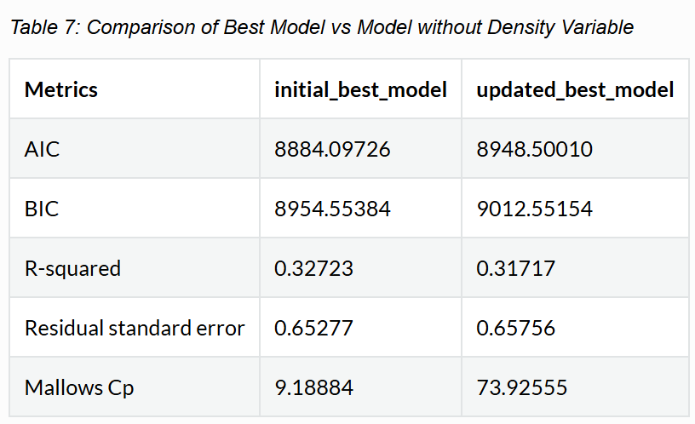

INTERPRETATION
From our analysis, we observe that the removal of the density variable has actually led to these metric values exhibiting less ideal values instead. In particular, we can observe that the Mallows $Cp$ is much higher than the number of predictors in the model which indicates that under this new model, it displays biasness and does not fit the data well. In such cases, the benefits of improved predictive accuracy and better model performance may outweigh the drawbacks of multicollinearity. Hence, while multicollinearity can complicate the interpretation of individual coefficients, the overall enhancement in model quality justifies retaining the collinear variable

Investigating Problematic Data Points
To further improve the model we should reinvestigate problematic points under the best model. It is important to note that even after removing some influential points during the initial fitting of the updated full model, it is possible to encounter new influential points under the subsequent models as we fit different models with varying numbers and combinations of predictors. Each model may highlight different data points as problematic, necessitating a thorough review and adjustment to ensure the final model’s robustness and accuracy.
# studentized residuals
studentized_residuals_best_model_9<-studres(best_model_9)
# cooks distance
cd_best_model_9<-cooks.distance(best_model_9)
# leverage
hat_values_best_model_9<-hatvalues(best_model_9)
# plot for visualization
par(mfrow=c(1,3))
plot(studentized_residuals_best_model_9, main="Figure 8(a): Studentized residuals \nvisualization", ylab="Studentized Residuals",xlab="Observation point")
abline(h=3,col="red")
abline(h=-3,col="red")
plot(cd_best_model_9, main="Figure 8(b): Cook's distance \nvisualization", ylab="cooks distance",xlab="Observation point")
abline(h = 4/(nrow(updated_Dataset)), col = "red")
plot(hat_values_best_model_9, main="Figure 8(c): Leverage \nvisualization",ylab="leverage", xlab="Observation point")
abline(h= 2 * (length(best_model_9$coefficients)) / nrow(updated_Dataset),col ="red")
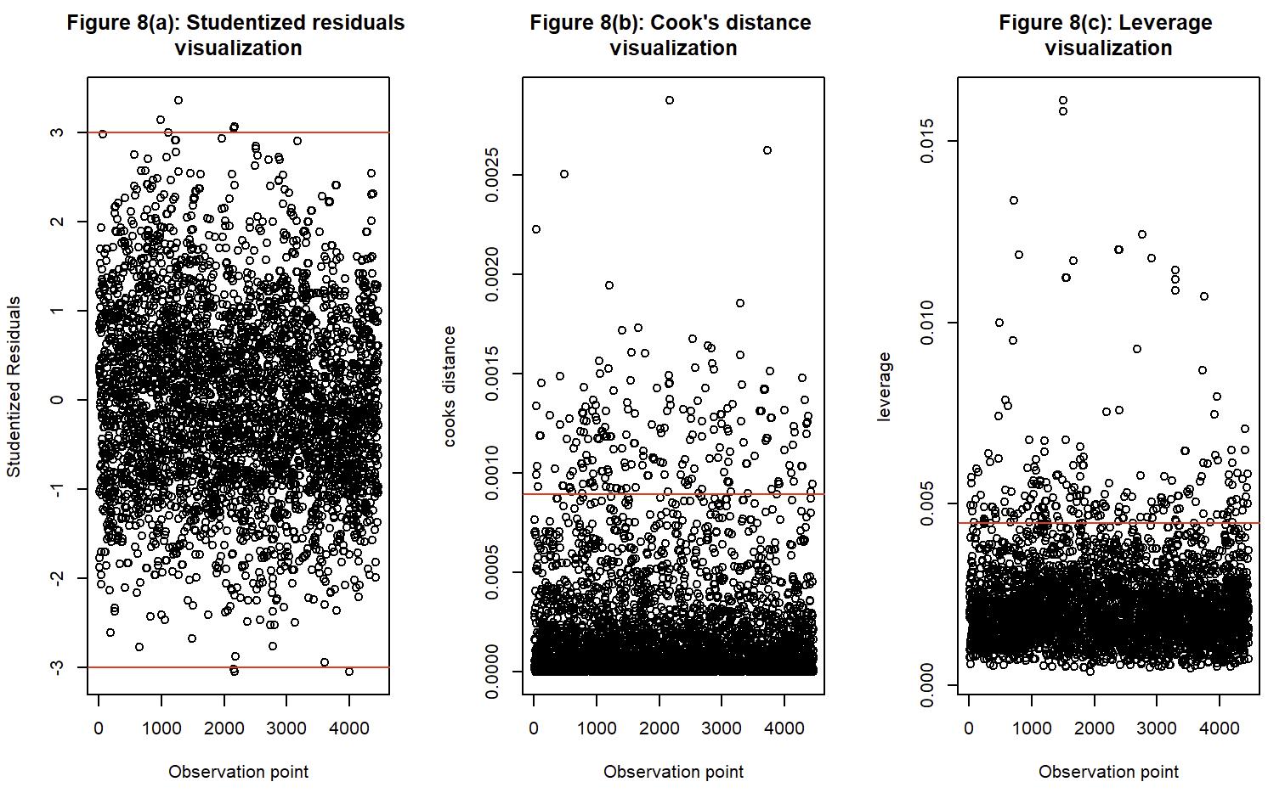
high_studentized_residual_points_2<-which(studentized_residuals_best_model_9>(abs(3)))
high_leverage_points_2<-which(hat_values_best_model_9>(2*(length(best_model_9$coefficients))/nrow(updated_Dataset)))
high_cooks_distance_points_2<-which(cd_best_model_9>(4/nrow(updated_Dataset)))
all_potential_issues_2<-unique(c(high_studentized_residual_points_2,high_leverage_points_2,high_cooks_distance_points_2))
# create finalized dataset
finalized_Dataset<-updated_Dataset[-all_potential_issues_2, ]
# fitting finalized best model
finalized_best_model<-lm(quality~alcohol + volatile.acidity + residual.sugar + free.sulfur.dioxide + pH + density + sulphates + fixed.acidity + chlorides,data=finalized_Dataset)
finalized_full_model<-lm(quality~.,data=finalized_Dataset)
summary(finalized_best_model)
# comparing initial best model with finalized model
Residual_standard_error_finalized_best_model<-summary(finalized_best_model)$sigma
R_squared_finalized_best_model<-summary(finalized_best_model)$r.squared
finalized_best_model_AIC<-AIC(finalized_best_model)
finalized_best_model_BIC<-BIC(finalized_best_model)
ols_finalized_best_model<-ols_mallows_cp(finalized_best_model,finalized_full_model)
# constructing the table
table_7 <- data.frame(
Metrics = c("AIC", "BIC", "R-squared", "Residual standard error", "Mallows Cp"),
initial_best_model = c(best_model_9_AIC, best_model_9_BIC, R_squared_best_model_9, Residual_standard_error_best_model_9,ols_best_model_9),
finalized_best_model = c(finalized_best_model_AIC, finalized_best_model_BIC, R_squared_finalized_best_model, Residual_standard_error_finalized_best_model,ols_finalized_best_model))
# formatting the table
table_7$initial_best_model <- format(table_7$initial_best_model, digits = 5)
table_7$finalized_best_model <- format(table_7$finalized_best_model, digits = 5)
# displaying the table
knitr::kable(table_7, caption = "Table 8: Comparison of Initial vs Finalized Best Model ") %>%
kable_styling(bootstrap_options = "striped", full_width = F)
##
## Call:
## lm(formula = quality ~ alcohol + volatile.acidity + residual.sugar +
## free.sulfur.dioxide + pH + density + sulphates + fixed.acidity +
## chlorides, data = finalized_Dataset)
##
## Residuals:
## Min 1Q Median 3Q Max
## -1.82796 -0.44728 -0.03295 0.43411 1.81323
##
## Coefficients:
## Estimate Std. Error t value Pr(>|t|)
## (Intercept) 205.6980507 22.6036111 9.100 < 2e-16 ***
## alcohol 0.1103980 0.0286650 3.851 0.000119 ***
## volatile.acidity -1.6708200 0.1179816 -14.162 < 2e-16 ***
## residual.sugar 0.0923997 0.0084717 10.907 < 2e-16 ***
## free.sulfur.dioxide 0.0043974 0.0006704 6.560 0.0000000000607736 ***
## pH 1.1097245 0.1071075 10.361 < 2e-16 ***
## density -207.2098617 22.9063769 -9.046 < 2e-16 ***
## sulphates 0.7512165 0.0974882 7.706 0.0000000000000163 ***
## fixed.acidity 0.1446669 0.0225925 6.403 0.0000000001695433 ***
## chlorides -4.7363543 1.1195804 -4.230 0.0000238403825246 ***
## ---
## Signif. codes: 0 '***' 0.001 '**' 0.01 '*' 0.05 '.' 0.1 ' ' 1
##
## Residual standard error: 0.5863 on 4015 degrees of freedom
## Multiple R-squared: 0.3746, Adjusted R-squared: 0.3732
## F-statistic: 267.2 on 9 and 4015 DF, p-value: < 2.2e-16

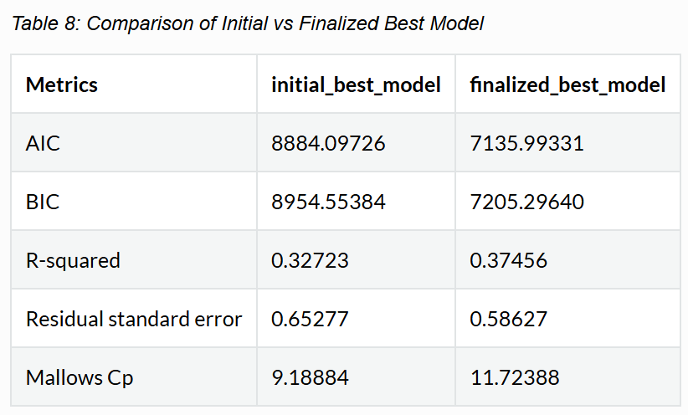

INTERPRETATION
Initially, our best model had a Mallows’ $Cp$ value of 9.18. After removing the influential points and recalculating, the $Cp$​ value changed to 11.72 which is much closer to the ideal value of 12 which indicates that model adequately explains the variance in the response variable. Additionally, when examining other metrics, the updated model shows a clear improvement: the AIC and BIC values are lower, indicating a better balance between model fit and complexity; and additionally the R-squared value is higher alongside a smaller residual standard error value. These improvements in key performance indicators justify that the updated model, is overall a better fitted model.

Verification of Results
Now that we have identified our best model, we can make further investigation and verification using inbuilt functions designed for model selection. Specifically, we will utilize forward stepwise selection, backward stepwise selection, all-subsets regression (also known as all possible subsets or best subsets regression) and the best subsets regression. By comparing our manually selected best model with those identified by these automated procedures, we can validate our findings and ensure that we have indeed chosen the most accurate and efficient model.
# fitting null model necessary for the following model selection techniques
nullmodel<-lm(quality~1,data=updated_Dataset)
summary(nullmodel)
##
## Call:
## lm(formula = quality ~ 1, data = updated_Dataset)
##
## Residuals:
## Min 1Q Median 3Q Max
## -1.892 -0.892 0.108 0.108 2.108
##
## Coefficients:
## Estimate Std. Error t value Pr(>|t|)
## (Intercept) 5.89195 0.01189 495.5 <2e-16 ***
## ---
## Signif. codes: 0 '***' 0.001 '**' 0.01 '*' 0.05 '.' 0.1 ' ' 1
##
## Residual standard error: 0.795 on 4469 degrees of freedom

All Subsets Regression
# Using all subsets selection
best_step_model<-step(nullmodel,scope=list(lower=nullmodel, upper=updated_full_model,direction = "both"))
summary(best_step_model)
## Start: AIC=-2049.49
## quality ~ 1
##
## Df Sum of Sq RSS AIC
## + alcohol 1 675.07 2149.7 -3268.2
## + density 1 363.49 2461.3 -2663.2
## + chlorides 1 264.87 2559.9 -2487.6
## + total.sulfur.dioxide 1 134.29 2690.5 -2265.2
## + volatile.acidity 1 90.73 2734.1 -2193.4
## + residual.sugar 1 58.39 2766.4 -2140.9
## + pH 1 34.45 2790.4 -2102.3
## + fixed.acidity 1 28.87 2795.9 -2093.4
## + sulphates 1 6.10 2818.7 -2057.2
## <none> 2824.8 -2049.5
## + free.sulfur.dioxide 1 0.38 2824.4 -2048.1
## + citric.acid 1 0.06 2824.8 -2047.6
##
## Step: AIC=-3268.23
## quality ~ alcohol
##
## Df Sum of Sq RSS AIC
## + volatile.acidity 1 119.58 2030.2 -3522.1
## + free.sulfur.dioxide 1 41.21 2108.5 -3352.7
## + residual.sugar 1 33.97 2115.8 -3337.4
## + chlorides 1 17.12 2132.6 -3302.0
## + sulphates 1 14.25 2135.5 -3296.0
## + density 1 14.02 2135.7 -3295.5
## + pH 1 10.30 2139.4 -3287.7
## + fixed.acidity 1 6.77 2143.0 -3280.3
## + citric.acid 1 2.64 2147.1 -3271.7
## <none> 2149.7 -3268.2
## + total.sulfur.dioxide 1 0.30 2149.4 -3266.9
## - alcohol 1 675.07 2824.8 -2049.5
##
## Step: AIC=-3522.07
## quality ~ alcohol + volatile.acidity
##
## Df Sum of Sq RSS AIC
## + residual.sugar 1 51.06 1979.1 -3633.9
## + free.sulfur.dioxide 1 33.04 1997.1 -3593.4
## + density 1 24.02 2006.1 -3573.3
## + chlorides 1 11.74 2018.4 -3546.0
## + sulphates 1 10.41 2019.8 -3543.0
## + fixed.acidity 1 8.60 2021.5 -3539.0
## + pH 1 6.75 2023.4 -3535.0
## + total.sulfur.dioxide 1 5.46 2024.7 -3532.1
## <none> 2030.2 -3522.1
## + citric.acid 1 0.00 2030.2 -3520.1
## - volatile.acidity 1 119.58 2149.7 -3268.2
## - alcohol 1 703.92 2734.1 -2193.4
##
## Step: AIC=-3633.92
## quality ~ alcohol + volatile.acidity + residual.sugar
##
## Df Sum of Sq RSS AIC
## + free.sulfur.dioxide 1 15.42 1963.7 -3666.9
## + pH 1 14.93 1964.2 -3665.8
## + sulphates 1 12.72 1966.4 -3660.8
## + chlorides 1 10.34 1968.8 -3655.3
## + fixed.acidity 1 10.04 1969.1 -3654.7
## + density 1 8.10 1971.0 -3650.3
## <none> 1979.1 -3633.9
## + total.sulfur.dioxide 1 0.50 1978.6 -3633.1
## + citric.acid 1 0.31 1978.8 -3632.6
## - residual.sugar 1 51.06 2030.2 -3522.1
## - volatile.acidity 1 136.67 2115.8 -3337.4
## - alcohol 1 706.70 2685.8 -2271.1
##
## Step: AIC=-3666.89
## quality ~ alcohol + volatile.acidity + residual.sugar + free.sulfur.dioxide
##
## Df Sum of Sq RSS AIC
## + pH 1 13.10 1950.6 -3694.8
## + sulphates 1 10.88 1952.8 -3689.7
## + chlorides 1 10.45 1953.2 -3688.7
## + fixed.acidity 1 8.11 1955.6 -3683.4
## + density 1 7.88 1955.8 -3682.9
## + total.sulfur.dioxide 1 3.58 1960.1 -3673.1
## <none> 1963.7 -3666.9
## + citric.acid 1 0.67 1963.0 -3666.4
## - free.sulfur.dioxide 1 15.42 1979.1 -3633.9
## - residual.sugar 1 33.44 1997.1 -3593.4
## - volatile.acidity 1 126.61 2090.3 -3389.6
## - alcohol 1 720.52 2684.2 -2271.7
##
## Step: AIC=-3694.81
## quality ~ alcohol + volatile.acidity + residual.sugar + free.sulfur.dioxide +
## pH
##
## Df Sum of Sq RSS AIC
## + density 1 16.86 1933.7 -3731.6
## + chlorides 1 10.75 1939.8 -3717.5
## + sulphates 1 7.62 1943.0 -3710.3
## + total.sulfur.dioxide 1 4.89 1945.7 -3704.0
## + fixed.acidity 1 2.27 1948.3 -3698.0
## <none> 1950.6 -3694.8
## + citric.acid 1 0.08 1950.5 -3693.0
## - pH 1 13.10 1963.7 -3666.9
## - free.sulfur.dioxide 1 13.59 1964.2 -3665.8
## - residual.sugar 1 40.20 1990.8 -3605.6
## - volatile.acidity 1 124.03 2074.6 -3421.2
## - alcohol 1 717.41 2668.0 -2296.8
##
## Step: AIC=-3731.6
## quality ~ alcohol + volatile.acidity + residual.sugar + free.sulfur.dioxide +
## pH + density
##
## Df Sum of Sq RSS AIC
## + sulphates 1 15.003 1918.7 -3764.4
## + fixed.acidity 1 7.477 1926.2 -3746.9
## + chlorides 1 7.227 1926.5 -3746.3
## + total.sulfur.dioxide 1 0.921 1932.8 -3731.7
## <none> 1933.7 -3731.6
## + citric.acid 1 0.734 1933.0 -3731.3
## - free.sulfur.dioxide 1 12.652 1946.4 -3704.5
## - density 1 16.856 1950.6 -3694.8
## - pH 1 22.073 1955.8 -3682.9
## - residual.sugar 1 43.659 1977.4 -3633.8
## - alcohol 1 93.751 2027.5 -3522.0
## - volatile.acidity 1 122.933 2056.7 -3458.1
##
## Step: AIC=-3764.42
## quality ~ alcohol + volatile.acidity + residual.sugar + free.sulfur.dioxide +
## pH + density + sulphates
##
## Df Sum of Sq RSS AIC
## + fixed.acidity 1 13.866 1904.8 -3794.8
## + chlorides 1 7.307 1911.4 -3779.5
## + total.sulfur.dioxide 1 1.385 1917.3 -3765.6
## <none> 1918.7 -3764.4
## + citric.acid 1 0.638 1918.1 -3763.9
## - free.sulfur.dioxide 1 10.723 1929.4 -3741.5
## - sulphates 1 15.003 1933.7 -3731.6
## - pH 1 19.103 1937.8 -3722.1
## - density 1 24.236 1943.0 -3710.3
## - residual.sugar 1 53.656 1972.4 -3643.1
## - alcohol 1 77.580 1996.3 -3589.2
## - volatile.acidity 1 119.572 2038.3 -3496.2
##
## Step: AIC=-3794.84
## quality ~ alcohol + volatile.acidity + residual.sugar + free.sulfur.dioxide +
## pH + density + sulphates + fixed.acidity
##
## Df Sum of Sq RSS AIC
## + chlorides 1 4.416 1900.4 -3803.2
## <none> 1904.8 -3794.8
## + total.sulfur.dioxide 1 0.442 1904.4 -3793.9
## + citric.acid 1 0.243 1904.6 -3793.4
## - alcohol 1 10.686 1915.5 -3771.8
## - free.sulfur.dioxide 1 11.899 1916.8 -3769.0
## - fixed.acidity 1 13.866 1918.7 -3764.4
## - sulphates 1 21.392 1926.2 -3746.9
## - pH 1 32.548 1937.4 -3721.1
## - density 1 35.384 1940.2 -3714.6
## - residual.sugar 1 57.471 1962.3 -3664.0
## - volatile.acidity 1 108.255 2013.1 -3549.8
##
## Step: AIC=-3803.21
## quality ~ alcohol + volatile.acidity + residual.sugar + free.sulfur.dioxide +
## pH + density + sulphates + fixed.acidity + chlorides
##
## Df Sum of Sq RSS AIC
## <none> 1900.4 -3803.2
## + total.sulfur.dioxide 1 0.324 1900.1 -3802.0
## + citric.acid 1 0.164 1900.3 -3801.6
## - chlorides 1 4.416 1904.8 -3794.8
## - fixed.acidity 1 10.975 1911.4 -3779.5
## - alcohol 1 11.304 1911.7 -3778.7
## - free.sulfur.dioxide 1 11.900 1912.3 -3777.3
## - sulphates 1 20.675 1921.1 -3756.8
## - pH 1 28.415 1928.8 -3738.9
## - density 1 28.442 1928.9 -3738.8
## - residual.sugar 1 48.077 1948.5 -3693.5
## - volatile.acidity 1 105.914 2006.3 -3562.8
##
## Call:
## lm(formula = quality ~ alcohol + volatile.acidity + residual.sugar +
## free.sulfur.dioxide + pH + density + sulphates + fixed.acidity +
## chlorides, data = updated_Dataset)
##
## Residuals:
## Min 1Q Median 3Q Max
## -1.99007 -0.48040 -0.04752 0.44836 2.19096
##
## Coefficients:
## Estimate Std. Error t value Pr(>|t|)
## (Intercept) 182.306130 22.102999 8.248 < 2e-16 ***
## alcohol 0.145369 0.028224 5.151 2.71e-07 ***
## volatile.acidity -1.798684 0.114087 -15.766 < 2e-16 ***
## residual.sugar 0.088465 0.008328 10.622 < 2e-16 ***
## free.sulfur.dioxide 0.003615 0.000684 5.285 1.32e-07 ***
## pH 0.870439 0.106591 8.166 4.11e-16 ***
## density -183.016739 22.401078 -8.170 3.98e-16 ***
## sulphates 0.693724 0.099592 6.966 3.75e-12 ***
## fixed.acidity 0.114772 0.022615 5.075 4.03e-07 ***
## chlorides -2.976533 0.924643 -3.219 0.0013 **
## ---
## Signif. codes: 0 '***' 0.001 '**' 0.01 '*' 0.05 '.' 0.1 ' ' 1
##
## Residual standard error: 0.6528 on 4460 degrees of freedom
## Multiple R-squared: 0.3272, Adjusted R-squared: 0.3259
## F-statistic: 241 on 9 and 4460 DF, p-value: < 2.2e-16

Forward Stepwise Selection
# Using forward stepwise selction
forward_model<-step(nullmodel,scope=list(lower=nullmodel,upper=updated_full_model,direction="forward"))
summary(forward_model)
## Start: AIC=-2049.49
## quality ~ 1
##
## Df Sum of Sq RSS AIC
## + alcohol 1 675.07 2149.7 -3268.2
## + density 1 363.49 2461.3 -2663.2
## + chlorides 1 264.87 2559.9 -2487.6
## + total.sulfur.dioxide 1 134.29 2690.5 -2265.2
## + volatile.acidity 1 90.73 2734.1 -2193.4
## + residual.sugar 1 58.39 2766.4 -2140.9
## + pH 1 34.45 2790.4 -2102.3
## + fixed.acidity 1 28.87 2795.9 -2093.4
## + sulphates 1 6.10 2818.7 -2057.2
## <none> 2824.8 -2049.5
## + free.sulfur.dioxide 1 0.38 2824.4 -2048.1
## + citric.acid 1 0.06 2824.8 -2047.6
##
## Step: AIC=-3268.23
## quality ~ alcohol
##
## Df Sum of Sq RSS AIC
## + volatile.acidity 1 119.58 2030.2 -3522.1
## + free.sulfur.dioxide 1 41.21 2108.5 -3352.7
## + residual.sugar 1 33.97 2115.8 -3337.4
## + chlorides 1 17.12 2132.6 -3302.0
## + sulphates 1 14.25 2135.5 -3296.0
## + density 1 14.02 2135.7 -3295.5
## + pH 1 10.30 2139.4 -3287.7
## + fixed.acidity 1 6.77 2143.0 -3280.3
## + citric.acid 1 2.64 2147.1 -3271.7
## <none> 2149.7 -3268.2
## + total.sulfur.dioxide 1 0.30 2149.4 -3266.9
## - alcohol 1 675.07 2824.8 -2049.5
##
## Step: AIC=-3522.07
## quality ~ alcohol + volatile.acidity
##
## Df Sum of Sq RSS AIC
## + residual.sugar 1 51.06 1979.1 -3633.9
## + free.sulfur.dioxide 1 33.04 1997.1 -3593.4
## + density 1 24.02 2006.1 -3573.3
## + chlorides 1 11.74 2018.4 -3546.0
## + sulphates 1 10.41 2019.8 -3543.0
## + fixed.acidity 1 8.60 2021.5 -3539.0
## + pH 1 6.75 2023.4 -3535.0
## + total.sulfur.dioxide 1 5.46 2024.7 -3532.1
## <none> 2030.2 -3522.1
## + citric.acid 1 0.00 2030.2 -3520.1
## - volatile.acidity 1 119.58 2149.7 -3268.2
## - alcohol 1 703.92 2734.1 -2193.4
##
## Step: AIC=-3633.92
## quality ~ alcohol + volatile.acidity + residual.sugar
##
## Df Sum of Sq RSS AIC
## + free.sulfur.dioxide 1 15.42 1963.7 -3666.9
## + pH 1 14.93 1964.2 -3665.8
## + sulphates 1 12.72 1966.4 -3660.8
## + chlorides 1 10.34 1968.8 -3655.3
## + fixed.acidity 1 10.04 1969.1 -3654.7
## + density 1 8.10 1971.0 -3650.3
## <none> 1979.1 -3633.9
## + total.sulfur.dioxide 1 0.50 1978.6 -3633.1
## + citric.acid 1 0.31 1978.8 -3632.6
## - residual.sugar 1 51.06 2030.2 -3522.1
## - volatile.acidity 1 136.67 2115.8 -3337.4
## - alcohol 1 706.70 2685.8 -2271.1
##
## Step: AIC=-3666.89
## quality ~ alcohol + volatile.acidity + residual.sugar + free.sulfur.dioxide
##
## Df Sum of Sq RSS AIC
## + pH 1 13.10 1950.6 -3694.8
## + sulphates 1 10.88 1952.8 -3689.7
## + chlorides 1 10.45 1953.2 -3688.7
## + fixed.acidity 1 8.11 1955.6 -3683.4
## + density 1 7.88 1955.8 -3682.9
## + total.sulfur.dioxide 1 3.58 1960.1 -3673.1
## <none> 1963.7 -3666.9
## + citric.acid 1 0.67 1963.0 -3666.4
## - free.sulfur.dioxide 1 15.42 1979.1 -3633.9
## - residual.sugar 1 33.44 1997.1 -3593.4
## - volatile.acidity 1 126.61 2090.3 -3389.6
## - alcohol 1 720.52 2684.2 -2271.7
##
## Step: AIC=-3694.81
## quality ~ alcohol + volatile.acidity + residual.sugar + free.sulfur.dioxide +
## pH
##
## Df Sum of Sq RSS AIC
## + density 1 16.86 1933.7 -3731.6
## + chlorides 1 10.75 1939.8 -3717.5
## + sulphates 1 7.62 1943.0 -3710.3
## + total.sulfur.dioxide 1 4.89 1945.7 -3704.0
## + fixed.acidity 1 2.27 1948.3 -3698.0
## <none> 1950.6 -3694.8
## + citric.acid 1 0.08 1950.5 -3693.0
## - pH 1 13.10 1963.7 -3666.9
## - free.sulfur.dioxide 1 13.59 1964.2 -3665.8
## - residual.sugar 1 40.20 1990.8 -3605.6
## - volatile.acidity 1 124.03 2074.6 -3421.2
## - alcohol 1 717.41 2668.0 -2296.8
##
## Step: AIC=-3731.6
## quality ~ alcohol + volatile.acidity + residual.sugar + free.sulfur.dioxide +
## pH + density
##
## Df Sum of Sq RSS AIC
## + sulphates 1 15.003 1918.7 -3764.4
## + fixed.acidity 1 7.477 1926.2 -3746.9
## + chlorides 1 7.227 1926.5 -3746.3
## + total.sulfur.dioxide 1 0.921 1932.8 -3731.7
## <none> 1933.7 -3731.6
## + citric.acid 1 0.734 1933.0 -3731.3
## - free.sulfur.dioxide 1 12.652 1946.4 -3704.5
## - density 1 16.856 1950.6 -3694.8
## - pH 1 22.073 1955.8 -3682.9
## - residual.sugar 1 43.659 1977.4 -3633.8
## - alcohol 1 93.751 2027.5 -3522.0
## - volatile.acidity 1 122.933 2056.7 -3458.1
##
## Step: AIC=-3764.42
## quality ~ alcohol + volatile.acidity + residual.sugar + free.sulfur.dioxide +
## pH + density + sulphates
##
## Df Sum of Sq RSS AIC
## + fixed.acidity 1 13.866 1904.8 -3794.8
## + chlorides 1 7.307 1911.4 -3779.5
## + total.sulfur.dioxide 1 1.385 1917.3 -3765.6
## <none> 1918.7 -3764.4
## + citric.acid 1 0.638 1918.1 -3763.9
## - free.sulfur.dioxide 1 10.723 1929.4 -3741.5
## - sulphates 1 15.003 1933.7 -3731.6
## - pH 1 19.103 1937.8 -3722.1
## - density 1 24.236 1943.0 -3710.3
## - residual.sugar 1 53.656 1972.4 -3643.1
## - alcohol 1 77.580 1996.3 -3589.2
## - volatile.acidity 1 119.572 2038.3 -3496.2
##
## Step: AIC=-3794.84
## quality ~ alcohol + volatile.acidity + residual.sugar + free.sulfur.dioxide +
## pH + density + sulphates + fixed.acidity
##
## Df Sum of Sq RSS AIC
## + chlorides 1 4.416 1900.4 -3803.2
## <none> 1904.8 -3794.8
## + total.sulfur.dioxide 1 0.442 1904.4 -3793.9
## + citric.acid 1 0.243 1904.6 -3793.4
## - alcohol 1 10.686 1915.5 -3771.8
## - free.sulfur.dioxide 1 11.899 1916.8 -3769.0
## - fixed.acidity 1 13.866 1918.7 -3764.4
## - sulphates 1 21.392 1926.2 -3746.9
## - pH 1 32.548 1937.4 -3721.1
## - density 1 35.384 1940.2 -3714.6
## - residual.sugar 1 57.471 1962.3 -3664.0
## - volatile.acidity 1 108.255 2013.1 -3549.8
##
## Step: AIC=-3803.21
## quality ~ alcohol + volatile.acidity + residual.sugar + free.sulfur.dioxide +
## pH + density + sulphates + fixed.acidity + chlorides
##
## Df Sum of Sq RSS AIC
## <none> 1900.4 -3803.2
## + total.sulfur.dioxide 1 0.324 1900.1 -3802.0
## + citric.acid 1 0.164 1900.3 -3801.6
## - chlorides 1 4.416 1904.8 -3794.8
## - fixed.acidity 1 10.975 1911.4 -3779.5
## - alcohol 1 11.304 1911.7 -3778.7
## - free.sulfur.dioxide 1 11.900 1912.3 -3777.3
## - sulphates 1 20.675 1921.1 -3756.8
## - pH 1 28.415 1928.8 -3738.9
## - density 1 28.442 1928.9 -3738.8
## - residual.sugar 1 48.077 1948.5 -3693.5
## - volatile.acidity 1 105.914 2006.3 -3562.8
##
## Call:
## lm(formula = quality ~ alcohol + volatile.acidity + residual.sugar +
## free.sulfur.dioxide + pH + density + sulphates + fixed.acidity +
## chlorides, data = updated_Dataset)
##
## Residuals:
## Min 1Q Median 3Q Max
## -1.99007 -0.48040 -0.04752 0.44836 2.19096
##
## Coefficients:
## Estimate Std. Error t value Pr(>|t|)
## (Intercept) 182.306130 22.102999 8.248 < 2e-16 ***
## alcohol 0.145369 0.028224 5.151 2.71e-07 ***
## volatile.acidity -1.798684 0.114087 -15.766 < 2e-16 ***
## residual.sugar 0.088465 0.008328 10.622 < 2e-16 ***
## free.sulfur.dioxide 0.003615 0.000684 5.285 1.32e-07 ***
## pH 0.870439 0.106591 8.166 4.11e-16 ***
## density -183.016739 22.401078 -8.170 3.98e-16 ***
## sulphates 0.693724 0.099592 6.966 3.75e-12 ***
## fixed.acidity 0.114772 0.022615 5.075 4.03e-07 ***
## chlorides -2.976533 0.924643 -3.219 0.0013 **
## ---
## Signif. codes: 0 '***' 0.001 '**' 0.01 '*' 0.05 '.' 0.1 ' ' 1
##
## Residual standard error: 0.6528 on 4460 degrees of freedom
## Multiple R-squared: 0.3272, Adjusted R-squared: 0.3259
## F-statistic: 241 on 9 and 4460 DF, p-value: < 2.2e-16

Backward Stepwise Selection
# Using forward stepwise selction
backward_model<-step(updated_full_model,direction = "backward")
summary(backward_model)
## Start: AIC=-3800.41
## quality ~ fixed.acidity + volatile.acidity + citric.acid + residual.sugar +
## chlorides + free.sulfur.dioxide + total.sulfur.dioxide +
## density + pH + sulphates + alcohol
##
## Df Sum of Sq RSS AIC
## - citric.acid 1 0.182 1900.1 -3802.0
## - total.sulfur.dioxide 1 0.342 1900.3 -3801.6
## <none> 1899.9 -3800.4
## - chlorides 1 4.214 1904.1 -3792.5
## - free.sulfur.dioxide 1 9.513 1909.4 -3780.1
## - fixed.acidity 1 10.031 1910.0 -3778.9
## - alcohol 1 11.251 1911.2 -3776.0
## - sulphates 1 20.646 1920.6 -3754.1
## - density 1 24.910 1924.8 -3744.2
## - pH 1 27.610 1927.5 -3737.9
## - residual.sugar 1 43.883 1943.8 -3700.3
## - volatile.acidity 1 94.306 1994.2 -3585.9
##
## Step: AIC=-3801.98
## quality ~ fixed.acidity + volatile.acidity + residual.sugar +
## chlorides + free.sulfur.dioxide + total.sulfur.dioxide +
## density + pH + sulphates + alcohol
##
## Df Sum of Sq RSS AIC
## - total.sulfur.dioxide 1 0.324 1900.4 -3803.2
## <none> 1900.1 -3802.0
## - chlorides 1 4.298 1904.4 -3793.9
## - free.sulfur.dioxide 1 9.670 1909.8 -3781.3
## - fixed.acidity 1 10.310 1910.4 -3779.8
## - alcohol 1 11.627 1911.7 -3776.7
## - sulphates 1 20.788 1920.9 -3755.3
## - density 1 24.728 1924.8 -3746.2
## - pH 1 27.437 1927.5 -3739.9
## - residual.sugar 1 43.706 1943.8 -3702.3
## - volatile.acidity 1 97.856 1998.0 -3579.5
##
## Step: AIC=-3803.21
## quality ~ fixed.acidity + volatile.acidity + residual.sugar +
## chlorides + free.sulfur.dioxide + density + pH + sulphates +
## alcohol
##
## Df Sum of Sq RSS AIC
## <none> 1900.4 -3803.2
## - chlorides 1 4.416 1904.8 -3794.8
## - fixed.acidity 1 10.975 1911.4 -3779.5
## - alcohol 1 11.304 1911.7 -3778.7
## - free.sulfur.dioxide 1 11.900 1912.3 -3777.3
## - sulphates 1 20.675 1921.1 -3756.8
## - pH 1 28.415 1928.8 -3738.9
## - density 1 28.442 1928.9 -3738.8
## - residual.sugar 1 48.077 1948.5 -3693.5
## - volatile.acidity 1 105.914 2006.3 -3562.8
##
## Call:
## lm(formula = quality ~ fixed.acidity + volatile.acidity + residual.sugar +
## chlorides + free.sulfur.dioxide + density + pH + sulphates +
## alcohol, data = updated_Dataset)
##
## Residuals:
## Min 1Q Median 3Q Max
## -1.99007 -0.48040 -0.04752 0.44836 2.19096
##
## Coefficients:
## Estimate Std. Error t value Pr(>|t|)
## (Intercept) 182.306130 22.102999 8.248 < 2e-16 ***
## fixed.acidity 0.114772 0.022615 5.075 4.03e-07 ***
## volatile.acidity -1.798684 0.114087 -15.766 < 2e-16 ***
## residual.sugar 0.088465 0.008328 10.622 < 2e-16 ***
## chlorides -2.976533 0.924643 -3.219 0.0013 **
## free.sulfur.dioxide 0.003615 0.000684 5.285 1.32e-07 ***
## density -183.016739 22.401078 -8.170 3.98e-16 ***
## pH 0.870439 0.106591 8.166 4.11e-16 ***
## sulphates 0.693724 0.099592 6.966 3.75e-12 ***
## alcohol 0.145369 0.028224 5.151 2.71e-07 ***
## ---
## Signif. codes: 0 '***' 0.001 '**' 0.01 '*' 0.05 '.' 0.1 ' ' 1
##
## Residual standard error: 0.6528 on 4460 degrees of freedom
## Multiple R-squared: 0.3272, Adjusted R-squared: 0.3259
## F-statistic: 241 on 9 and 4460 DF, p-value: < 2.2e-16

Best Subsets Regression
# Using Best Subsets Regression
best_subsets_model<-regsubsets(quality~.,data=updated_Dataset, nbest=1,nvmax=11)
plot(best_subsets_model, main= "Figure 9: BIC against Regressors")
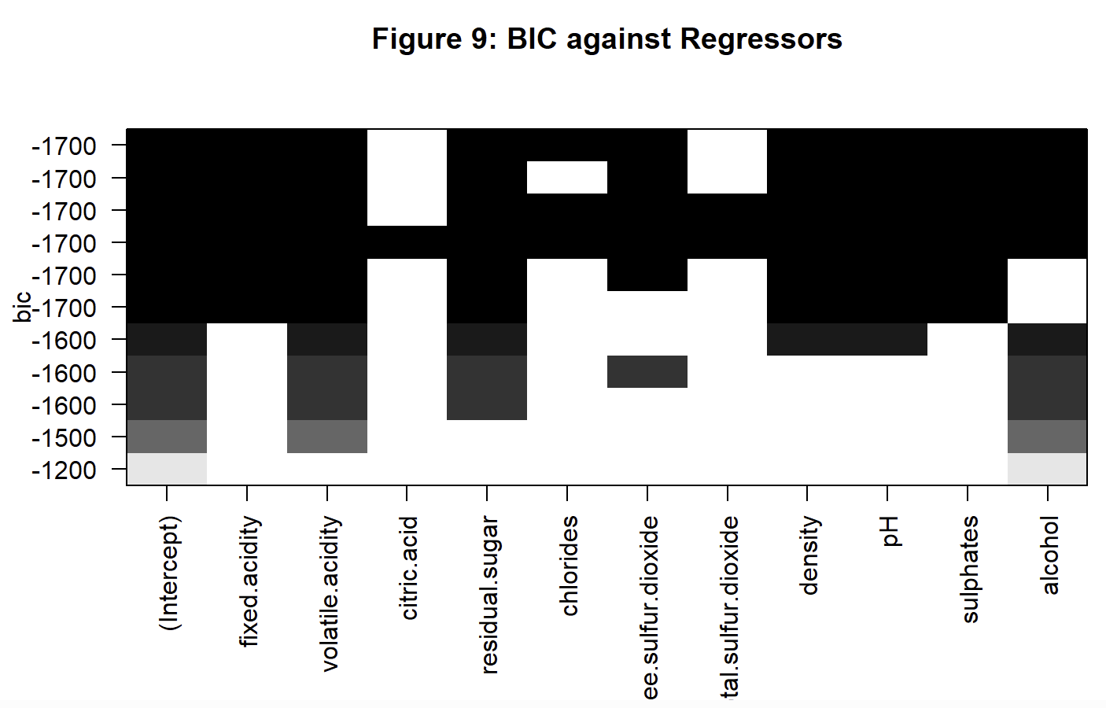
INTERPRETATION
After conducting best subsets regression and stepwise regression, we found that all results interestingly enough produced the same best model as our previously identified one. Both methods systematically evaluated different combinations of predictors and, despite their different approaches, consistently pointed to the same model as the optimal choice. This convergence of results allows for a greater confidence in the accuracy and effectiveness of our final best model.

Justify the Inclusion of Variable
As such, we can say that the best model fitted according to our steps is shown as follows:
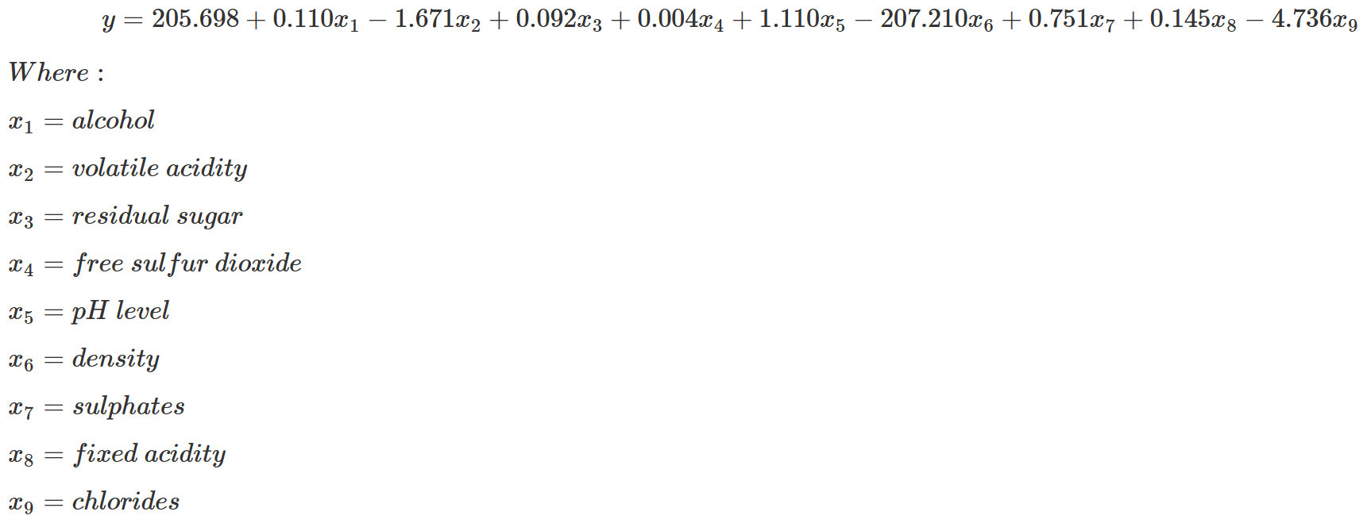
- Volatile and Fixed Acids
  - Responsible for the wine’s freshness and vitality
  - Good acid balance - zesty, crisp character.
  - Good structure and aging.
Exclusion of Citric acid : Not significant - Weak organic acid (Not much effect as compared to other fixed acids) - Microbial instability - Growth of unwanted microbes
(Jamescharleswine, 2023)

- Residual Sugars
  - Natural grape sugars leftover.
  - Affects a wine’s sweetness.
  - Sweet Wine: 45 g/l.
- (Wu, 2020)

- Alcohol Content
  - Subtle impression of sweetness.
  - Hint of bitterness
  - Less Content – Flat and Dull
- (LiquidLINE Blog – Things That Affect the Wine Quality, n.d.-b)

- Chlorides
  - Saltiness of a wine
- (Application Note #105 -Chloride in Wine by Titration, n.d.)

- Density
  - Lower density is preffered
  - Higher density - imbalance composition

- Total and Free Sulphur Dioxide
  - Preservative
  - Continuously monitor sulfur dioxide levels until wine is bottled.
  - Act as a cushion for FSO2.
  - FSO2 is lost, chemical equilibrium in the wine shifts so that some of the S02 can be released to its free state.
- (Admin, 2018) & (Comfort, 2008)
- pH Level
  - Low pH wines will taste tart and crisp
  - Higher pH wines are more susceptible to bacterial growth
  - 3.0 to 3.4 for white wines.
  - 3.3 to 3.6 for red wines.
- (Edison, 2022)

- Sulphates
  - Potassium Metabisulfite (derivatives of SO2)
  - Antioxidant to maintain the wine’s colour, flavour, and aroma.
  - Also a result of the lightly oxidizing environment represented by wooden casks.
  - Low sulfate levels could attribute to wine being stored in stainless steel containers.
- (Contributors, 2021)

Conclusion and Recommendation
Based on the results obtained, the following may contribute to higher wine quality:
- High alcohol level (over 10)
By harvesting grapes later in the season, particularly 1-2 months after the regular harvest time will allow them to accumulate more sugars which will result in higher alcohol content. This is a result of the yeast molecules having more sugar available to convert to alcohol during fermentation (Puckette, 2016). Other than that, winemakers can utilize cryoextraction, which involves freezing grapes and removing water in the form of ice to increase alcohol content in wine. This method does so by further concentrating sugars (Tatum, 2016).

- Low density (under 0.998)
In order to achieve low density wines, winemakers should maintain optimal fermentation temperatures (32°C to 35°C) to enable the fermentation process to be completed efficiency. This will reduce residual sugars which will lead to a lower wine density (Liszkowska & Berlowska, 2021). Besides that, winemakers can blend the wine with another wine with a lower alcohol content or even water, although it is strictly regulated and rarely used, to reduce alcohol content which will in turn reduce density (Sullivan, 2023).

- Increased pH (over 3)
In order to raise the alkalinity of wine, winemakers can add chemical compounds, such as potassium carbonate and calcium carbonate. They help neutralize acidity by reacting with the tartaric acid in wine to precipitate calcium tartrate or potassium bitartrate out of the solution (Pambianchi, n.d.). Malolactic fermentation (MLF) can also help increase the pH of wines. This method is a secondary fermentation process where lactic acid bacteria convert malic acid into lactic acid, which is a weaker acid which reduces the acidity of the wine. This also helps to add complexity and softness to the wine, especially red wine and some white wines, like Chardonnay (Lonvaud-Funel, 2022).
By implementing the above techniques, Vinho Verde will be able to meet consumer expectations on a more prestigious level and maintain their reputation as the top wine brand in Portugal.

References
- Admin. (2018, February 27). Total Sulfur Dioxide – Why it Matters, Too! Midwest Grape and Wine Industry Institute. https://www.extension.iastate.edu/wine/total-sulfur-dioxide-why-it-matters-too/
- Application Note #105 -Chloride in Wine by Titration. (n.d.). https://mantech-inc.com/wp-content/uploads/2014/07/105-Chloride-in-Wine-by-Titration.pdf
- Comfort, S. (2008, December 5). About Acidity and Adding Acid to Must/Wine | MoreWine. Morewinemaking.com. https://morewinemaking.com/articles/Acidifying_must
- Contributors, W. E. (2021, June 22). What to Know About Sulfites in Wine. WebMD. https://www.webmd.com/diet/what-to-know-sulfites-in-wine
- Corduas, M., Cinquanta, L., & Ievoli, C. (2013). The importance of wine attributes for purchase decisions: A study of Italian consumers’ perception. Food Quality and Preference, 28(2), 407–418. https://doi.org/10.1016/j.foodqual.2012.11.007
- Edison, T. (2022, January 26). Is Wine Acidic or Alkaline? [Guide to pH in Winemaking]. Wineturtle.com. https://wineturtle.com/wine-acidic-alkaline-basic/
- Jamescharleswine. (2023, September 26). The role of acids, sugars, and tannins in wine quality. James Charles Winery. https://jamescharleswine.com/the-role-of-acids-sugars-and-tannins-in-wine-quality/#:~:text=Role%3A%20Acids%20are%20essential%20in,tartaric%2C%20malic%2C%20and%20citric
- LiquidLINE Blog – Things that Affect the Wine Quality. (n.d.). OPSIS LiquidLINE. https://www.liquidline.se/blog/things-that-affect-the-wine-quality/#:~:text=The%20alcohol%20in%20wine%20gives,much%20and%20not%20too%20little.
- Liszkowska, W., & Berlowska, J. (2021). Yeast Fermentation at Low Temperatures: Adaptation to Changing Environmental Conditions and Formation of Volatile Compounds. Molecules, 26(4). https://doi.org/10.3390/molecules26041035
- Lonvaud-Funel, A. (2022). Malolactic fermentation and its effects on wine quality and safety. Elsevier EBooks, 105–139. https://doi.org/10.1016/b978-0-08-102065-4.00008-0
- Marianthi Basalekou, Panagiotis Tataridis, Georgakis, K., & Christos Tsintonis. (2023). Measuring Wine Quality and Typicity. Beverages, 9(2), 41–41. https://doi.org/10.3390/beverages9020041
- Pambianchi, D. (n.d.). Monitoring & Adjusting pH. WineMakerMag.com. https://winemakermag.com/technique/1650-monitoring-adjusting-ph
- Puckette, M. (2016, October 3). Late Harvest Wines and Why They’re Awesome. Wine Folly. https://winefolly.com/tips/late-harvest-wines-and-why-theyre-awesome/
- Sullivan, S. P. (2023, May 4). Basics: The Why, When and How of Wine Blending | Wine Enthusiast. Www.wineenthusiast.com. https://www.wineenthusiast.com/culture/wine/wine-blending/
- Tatum, M. (2024, May 16). What is Cryoextraction? (with pictures). DelightedCooking. https://www.delightedcooking.com/what-is-cryoextraction.htm
- Wu, S. (2020, July 16). What is residual sugar in wine? – Ask Decanter. Decanter. https://www.decanter.com/learn/residual-sugar-46007/#:~:text=The%20amount%20of%20residual%20sugar,be%20consumed%20by%20the%20yeast

