**EXERCISE 4**

**SAMPLING PATTERNS AND GRAPH CUTS**

For running the codes seamlessly, the directory structure must not be changed since paths are hardcoded relative to each other.

1. **ANALYZING SAMPLING PATTERNS**

For Task 1.1 (Periodograms), running ../PART I/code/main_task11.py produces the plot of input data points taken from 1.txt files and the plot of averaged periodograms of each dataset.

For Task 1.2 (PCF), running ../PART I/code/main_task12.py produces the plots of estimated PCF’s.

* The periodograms and the PCF’s for the provided algorithms.
  + For computing the periodograms of sampling patterns, the steps explained in the exercise sheet is implemented.
  + For PCF’s the estimation function is:

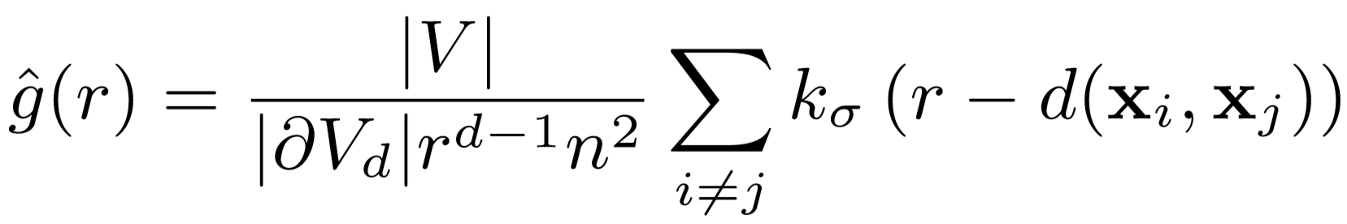

The for normalization (to be able to utilize a generic range for and ) is computed according to [1] ([2] can also be used since it is the generalized expression for high dimensional spaces and yields the following expression for ):

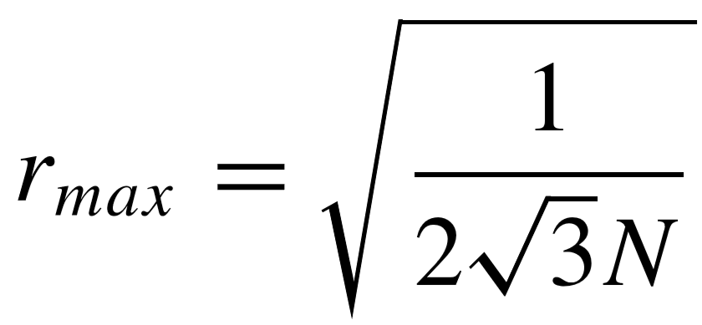

While the data points are normalized with , the size of the volume , that the data points lie inside is normalized by since the volume in our case is 2 dimensional.

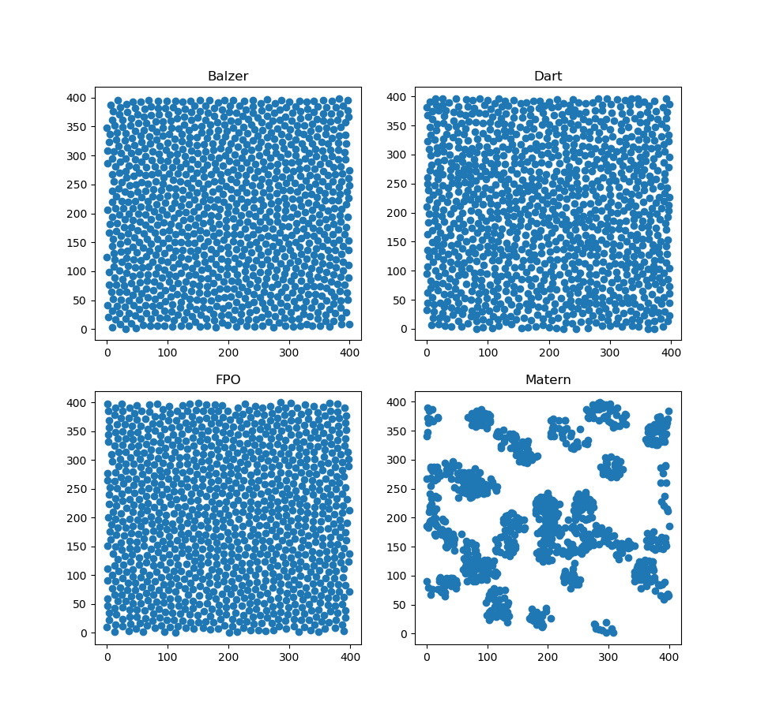

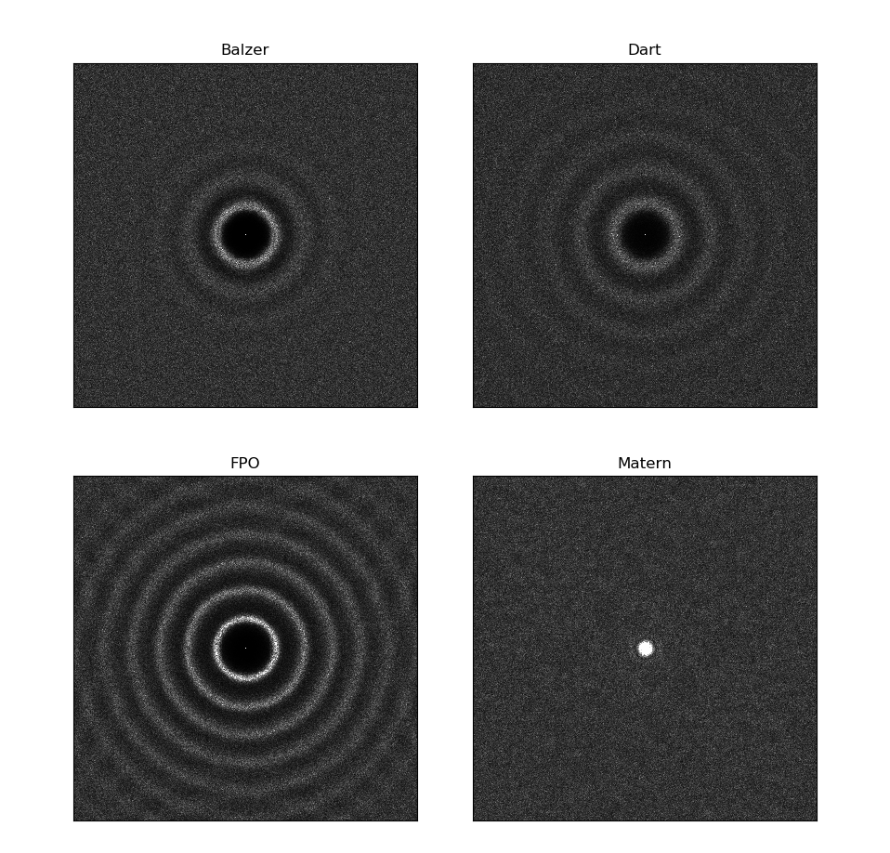

**Periodograms:**

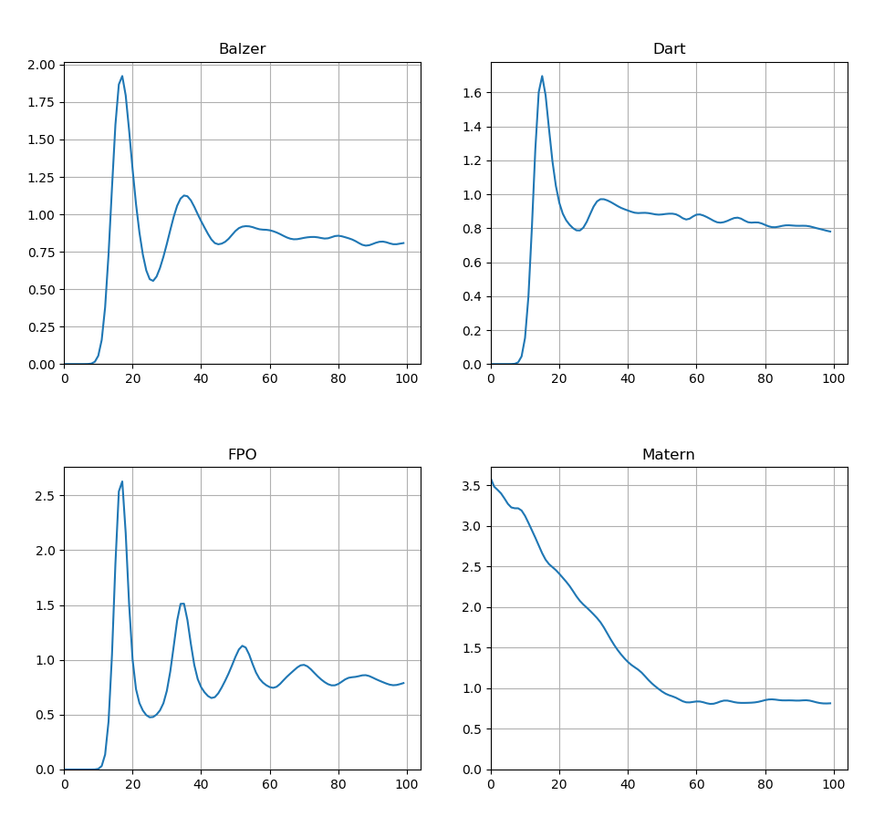

**PCFs:**

The recommended and values do not provide visually nice results. Also, all functions should converge to 1, but they keep decreasing as the r value increases. Both artifacts are possibly caused by a small bug in the code that I am not able to find.

Used parameters:

* Why do we have to avereage over multiple point sets for each algorithm when computing the periodograms, but not when computing the PCF’s?

As [3] suggests, unlike the spectral measures (e.g. periodograms), the smoothing level() makes the PCF estimates smooth and indistinguishable for different instances of the same distribution. Therefore, while still depending on the smoothing level, the PCF generalizes well to the different samples of the same point process, giving the algorithm an inherent statistical analysis power. In essence, smoothing effect comes from the Gaussian kernel which performs weighted averaging on the pairwise differences while fundamentally determines the contributions of different pairwise differences.

Whereas periodograms are calculated without any smoothing and each periodogram only reflects the characteristics of only one point distribution. The generalization as well as statistical significance is achieved by simple averaging here.

Also, [3] states that small values of in PCF analysis will cause ﬂuctuations in the density estimation and make the estimator change from one instance of a point distribution to another, becoming similar to the problem of periodograms.

* Are PCF’s suﬃcient to describe the provided point patterns, as they are only one dimensional, while the periodograms are two dimensional. Do the periodograms contain more information for the provided patterns?

In general, for any point distribution, second order product density measures the joint probability of having points at locations and at the same time. For isotropic cases, any and locations boils down to distance because of the translation and rotation invariance. Consequently, as [3] points out, interpretation of PCF is directly linked to the distribution of the distances between pairs of points. **Therefore, with the provided isotropic patterns, the amount of information that both methods provide is same**, in fact, since PCF generalizes well and easier to interpret, it may be more advantageous to utilize. However, in general if there are multiple datasets from the same point process is available (for statistical significance) and isotropy information is not known, periodograms can provide more information thanks to preserving information on different dimensions.

1. **INTERACTIVE SEGMENTATION WITH GRAPH CUT**

[1] A. Lagae and P. Dutre. A Comparison of Methods for Generating Poisson Disk Distributions. Computer Graphics Forum. Volume 27(1), pp. 114-129, 2008.

[2] M. Gamito and S. Maddock. Accurate multidimensional poisson-disk sampling. ACM Trans. Graph. 2, 8:1–8:19. December 2009.

[3] A. C. Oztireli and M. Gross. Analysis and synthesis of point distributions based on pair correlation. *ACM Trans. Graph. (Proc. of ACM SIGGRAPH ASIA)*, 31(6), 2012.