**EXERCISE 5**

**RIGID TRANSFORM BLENDING AND VARIATIONAL METHODS**

1. **UNDERSTANDING AND UTILIZING DUAL QUARTERNIONS**

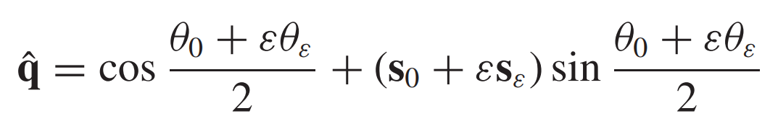**Question 1:** How do dual quaternions represent rotations and translations?

For a dual quaternion written expressed as:

As [1] states in the Appendix A.3, intuitively,

* is the angle of rotation
* represents the the direction of the axis of rotation (in the degenerate case with = 0, it represents the direction of the translation vector)
* is the amount of translation along vector
* is the center of rotation

Therefore any rotation and translation can be expressed in the form of a dual quaternion.

**Question 2:** What is the advantage of representing rigid transformations with dual quaternions for blending?

* Does not produce artifacts like collapsing elbows and candy wrapper twists (unlike linear blending) [1, 2]
* Works for more than two rigid transformations (approximation with weighted averaging). This is very useful for skinning, where it is often needed to blend more than two joint transformations. [1]
* Faster (also produces less artifacts) than log-matrix and spherical blending. [1, 2]

**Question 3:** Briefly explain one fundamental disadvantage of using quaternion based shortest path blending for rotations as compared to linear blend skinning?

Dual quaternions can cause a “flipping artifact”, which occurs with 2D rotations of more than 180 degrees like a joint rotation around only the shoulder of a human model. This is a caused by the inherent shortest path property of the algorithm. For example, when rotating from 179 to 181 degrees, skin discontinuously changes its shape, because the other rotation direction becomes shorter. [1]

**Question 4:** For a dual quaternion , prove that .

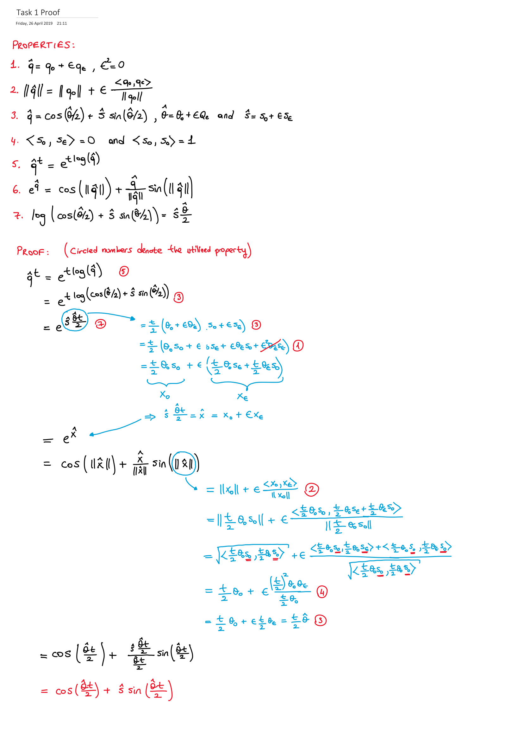

**Question 5:** Consider rigid transformations in the 2D xy-plane. For these transformations, the rotation is always around the z (or −z)-axis, i.e. s0 is fixed to the z-axis. On the other hand, a dual quaternion encodes translations only along s0, which are in this case always zero, since we can only translate in the xy-plane. Then, how can a dual quaternion represent a rotation and translation in the xy-plane?

There can be two different interpretations for the solution of this question.

* If the intermediate step of rotating the object around its center of mass is implicit, then can be interpreted as the center of rotation from first image to third image indicated by red dot in the fourth image below.
* If the intermediate step is explicitly performed, then from first image to second image is pure rotation and from second image to third image is pure translation (degenerate case) where represents the direction of the translation vector. Nevertheless, correctly combining these two dual quaternions results in the same dual quaternion with the above one.

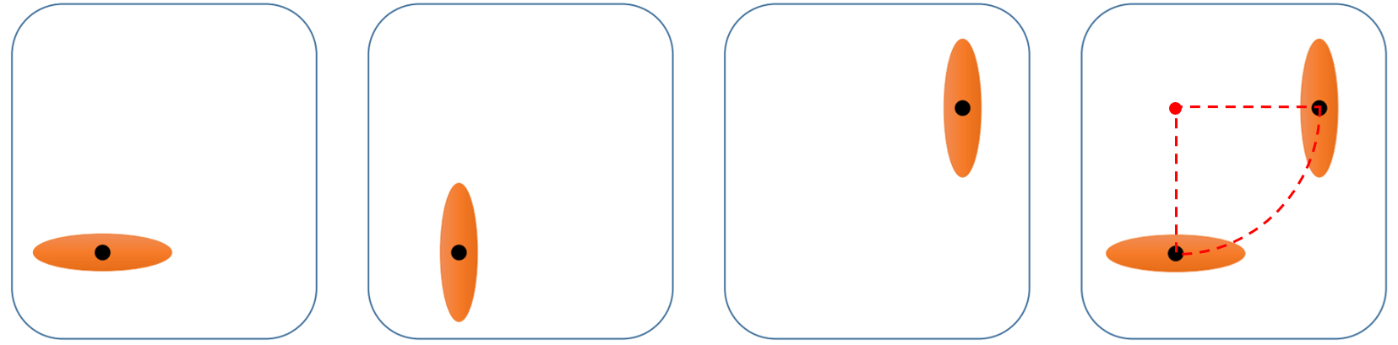

1. **VARIATIONAL METHODS – DENOISING PROBLEMS**

**Task 1: Gaussian Filtering (**

* Apply the filter multiple time and show the denoised images at different steps

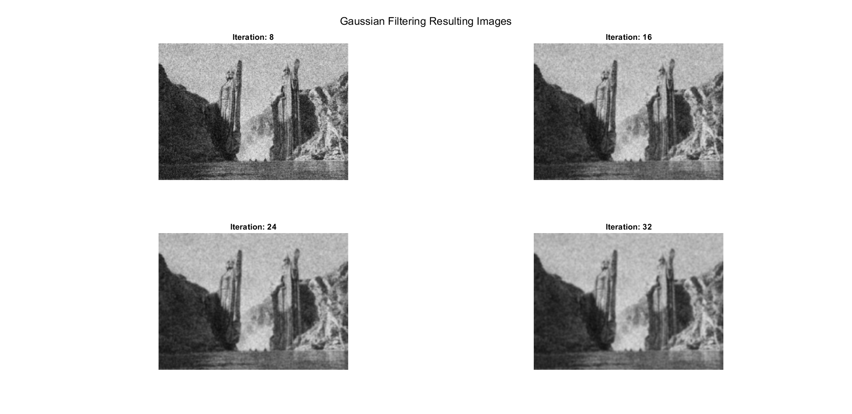

* At each step, compute the error and plot its evolution

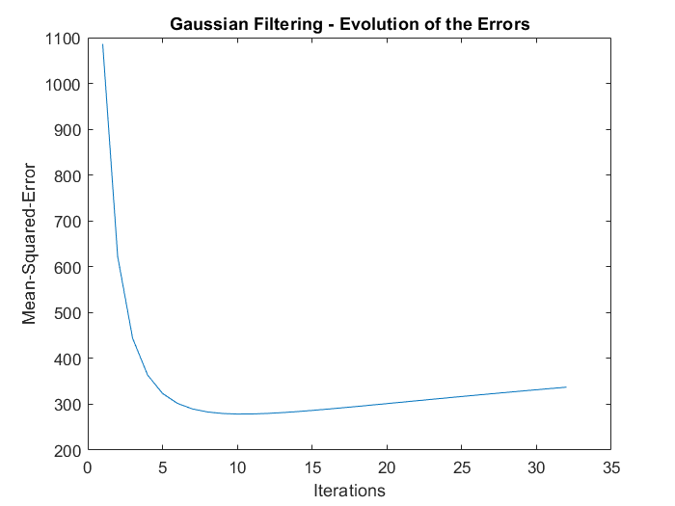

Example run mean-squared-error after heat diffusion = 278.1173 (at iteration 10)

**Task 2: Heat Diffusion (**

* Show the evolution of denoising over diffusion by printing denoised images at different steps

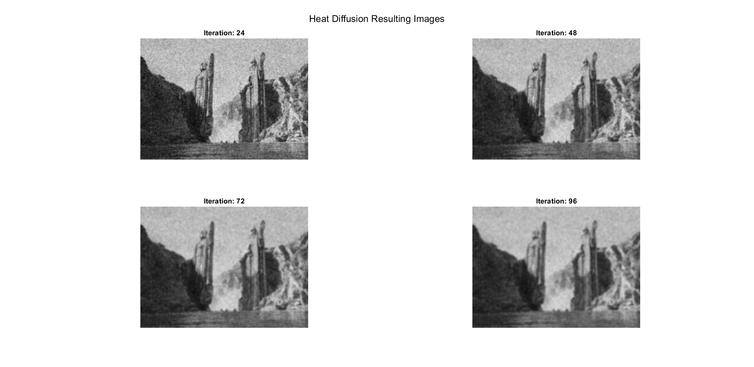

* Show the evolution of the errors over iterations

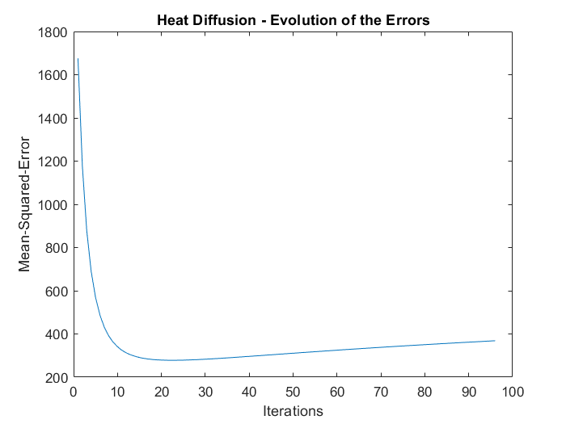

Example run mean-squared-error after heat diffusion = 277.4881 (at iteration 23)

**Task 3: Variational Approach ()**

* Derive the energy function to obtain the Euler-Lagrange equation.

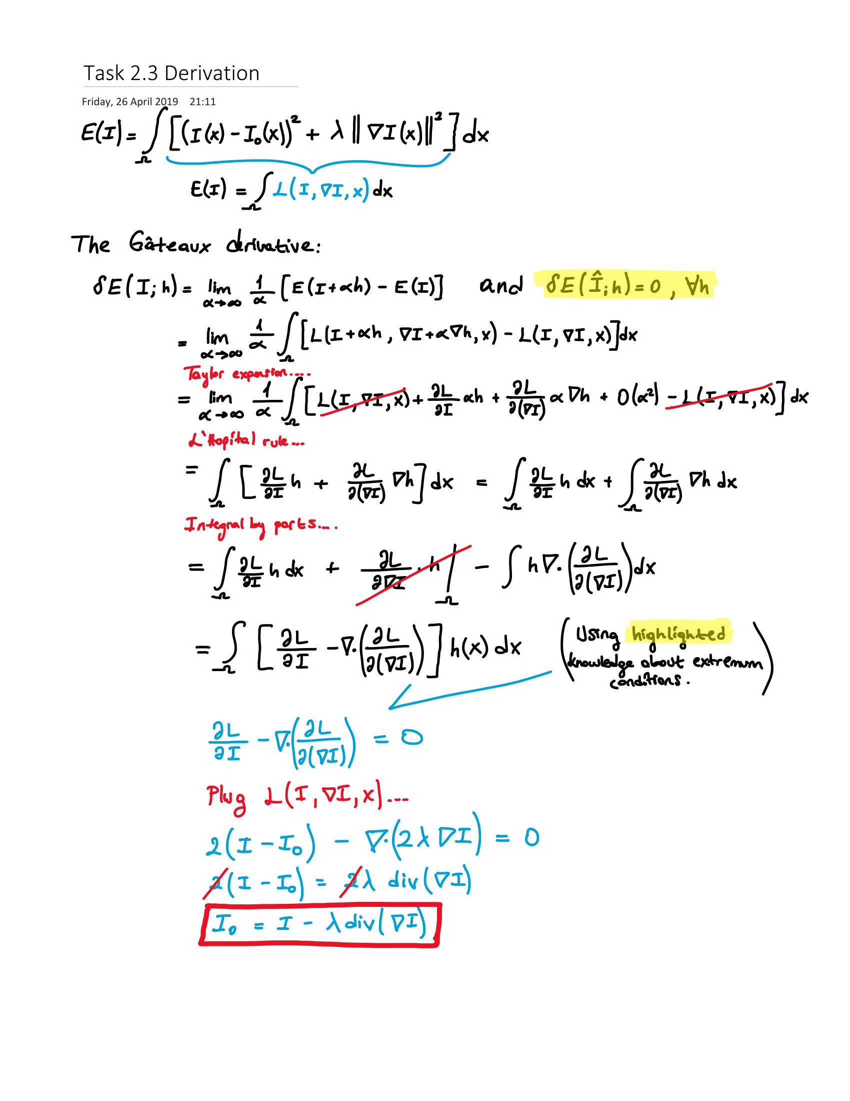

* Show the denoised image that you obtain

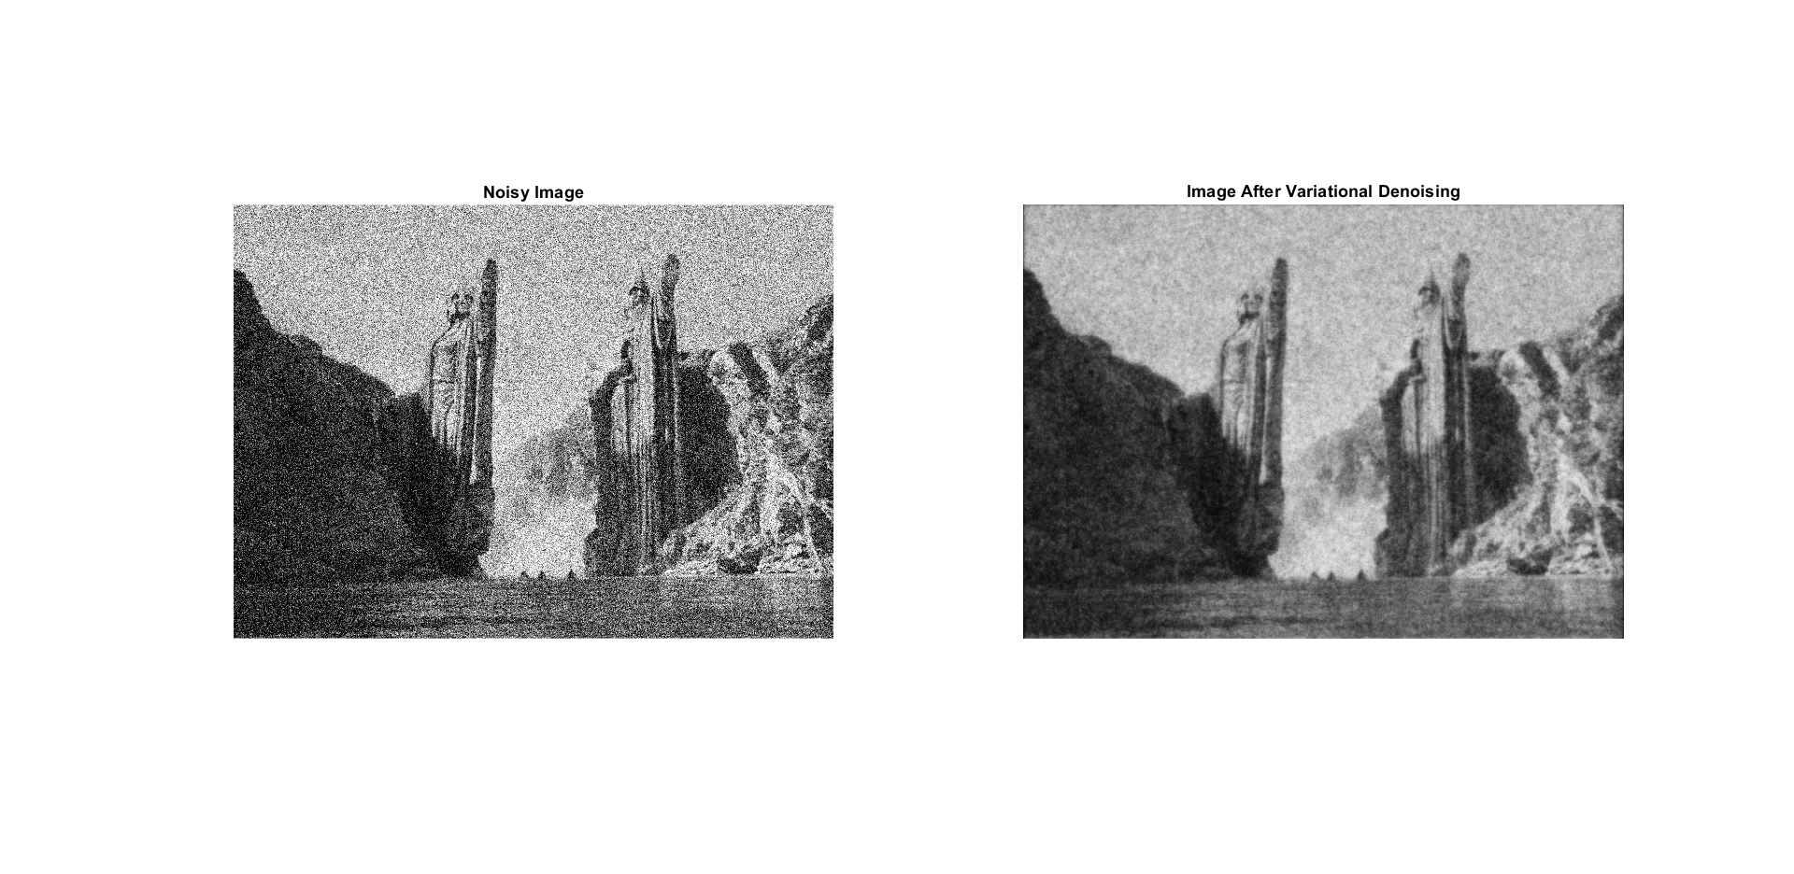

Example run mean-squared-error after variational denoising = 310.9981

**Task 4: Comparison**

* How can you describe the results? Does any of these methods give better results than the others?
  + All methods achieve similar best mean-squared-errors with,
    - Gaussian Filtering: 278.1173
    - Heat Diffusion: 277.4881
    - Variational Denoising: 310.9981
  + Although variational denoising results in the worst error value, we know that it preserves edges better. In fact, when the original image is provided as input to the algorithms, Gaussian filtering and heat diffusion quickly disrupts the edges and introduces blur. On the other hand, variational denoising smooths out only the sea and the cliff areas before converging to a global optimum of the problem formulation. Also, the number of iterations for Gaussian filtering and heat diffusion is an important parameter to be decided on which makes them not robust to different kinds of scenes. Therefore, one can claim that variational denoising is the better algorithm for the case, despite the higher error value.
* What are the benefits and drawbacks of each methods?
  + Gaussian Filtering
    - + Very simple to implement
    - – Boundary conditions are not intuitive
    - – Kernel size and sigma are important hidden parameters and must be provided
    - – Operations are local and does not provide information about global optimality
    - – Does not preserve edges
    - – It is an iterative method which gives rise to performance concerns and determining optimal number of iterations
  + Heat Diffusion
    - + Very simple to implement
    - + Boundary conditions are more intuitive, Neumann condition is a reasonable choice
    - o Kernel size is fixed but time step has to be given as an important hidden parameter
    - – Operations are local and does not provide information about global optimality
    - – Does not preserve edges
    - – It is an iterative method which gives rise to performance concerns, determining optimal number of iteration and makes other parameters hidden
  + Variational Denoising
    - + Transparent formulation with global optimality criterion
    - + One can show existence and uniqueness of solutions
    - + No boundary conditions (No hidden assumptions)
    - + Many optimization methods available, solving such a linear system can be much faster than performing iterative methods
    - + No hidden parameters, only parameter is lambda which directly affects the globally optimal solution
    - + Can preserve edges better than other methods
    - o Coefficient matrix can get very large with large images, slowing down linear solver but there are very good sparse linear solvers available.
    - – More complicated to implement
* Can you explain the motivations behind each of the methods?
  + Frequency response of a Gaussian filter acts as a low pass filter in frequency domain, so it preserves the low frequency components of the image and prevents the high frequency components like noise (and edges).
  + Like physical heat diffusion equation, local extremums of intensity values which corresponds to “hot” or “cold” locations caused by noise are smoothed out with heat transfer to/from its surroundings over time.
  + With variational approach, the problem is defined as energy minimization problem where the total energy is defined with a data term and smoothness term. This problem can be solved using partial differential equations in function space where function space is constructed by all possible images. And most importantly, this problem formulation has a unique, globally optimum solution.

**References**

[1] L. Kavan and S. Collins. Geometric Skinning with Approximate Dual Quaternion Blending. *ACM Transactions on Graphics*, Vol. 27, No. 4, Article 105, October 2008.

[2] L. Kavan. Accompanying video for paper "Geometric Skinning with Approximate Dual Quaternion Blending, *ACM Transactions on Graphics*, 2008". <https://www.youtube.com/watch?v=LUOJccOZfWQ>.