4.6.13 CRC
Overview
Applications will periodically confirm that hardware block registers and memory regions are unchanged
as part of a system self-check. Typically used in conjunction with the DMAC block to scan a range or
chained ranges of memory locations and calculate one of a number of CRC values over the range. The
block is accessed by an APB4 interface on the Fabric Interconnect.
Features
• CRC16 or CRC32
• Input Byte or word based MSB shift
• Result Byte or word based MSB shift
• Result data bit inversion
Operation
The block diagram of the CRC logic is shown below.
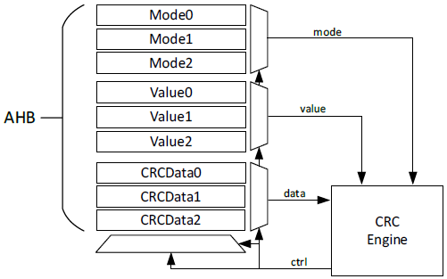
The CRC block is controlled through AHB accesses. The CRC can have three (3) independent CRC
calculations simultaneously. Each calculation is controlled by a mode register and an initial value referred
to as a context. These are accessed per the memory map and register definitions in section 5.15.
The CRC engine uses one of two polynomials as selected by the Context Mode Register for the selected
context:
CCITT-32:
𝑥32 + 𝑥26 + 𝑥23 + 𝑥22 + 𝑥16 + 𝑥12 + 𝑥11 + 𝑥10 + 𝑥8 + 𝑥7 + 𝑥5 + 𝑥4 + 𝑥2 + 𝑥1 + 1
CCITT-16:
𝑥16 + 𝑥12 + 𝑥5 + 1
The mode register also controls the bit and byte ordering of input data as shown in the following figures.
Original 7 6 5 4 3 2 1 0
LSB First 0 1 2 3 4 5 6 7
MSB First 7 6 5 4 3 2 1 0
Figure 59 Bit positioning
Original 31 … 24 23 … 16 15 … 8 7 … 0
LSB First 7 … 0 15 … 8 23 … 16 31 … 24
MSB First 31 … 24 23 … 16 15 … 8 7 … 0
Figure 60 Byte Positioning
The mode register also controls whether the CRC result is inverted when read by the AHB interface.
Each context is initialized with a mode and initial value and then the CRC is calculated upon each write
to the CRC_DATA register with the result written back to the Context Value register. The CRC is
calculated based on the current value in the Context Value register and the written data.
Writes of byte, halfword and word are allowed. Any other sizes will result in the data value of all 0s being
processed by the CRC Engine.
Upon writing the last data, the result is read from the Context Value register.

