AI-Powered Personal Branding Website with a Custom AI Assistant (Carrd + Tiledesk)

1. Project Overview
This project combines a minimalistic one-page website with a fully integrated AI-powered assistant designed to support networking, recruitment, and personal branding.
The website (built on Carrd) presents my profile, skills, aspirations and portfolio, while the embedded chatbot - created using Tiledesk, OpenAI models, and a structured Knowledge Base - provides an interactive and personalized way for visitors to learn more about me.
The assistant answers questions about my background, strengths, technical skills, AI learning path, and career interests. It also subtly encourages contact and collaboration in a natural, human-like way.
This project demonstrates my ability to design, build, optimize, and deploy real AI solutions using no-code tools, prompt engineering, and model configuration.

2. Objectives
- Create a simple but elegant personal website to represent my personal brand (“AI with Katarzyn”)
- Build an intelligent assistant capable of answering questions about my experience, skills, and current projects
- Use no-code tools to rapidly prototype functional AI experiences
- Optimize token usage, response quality, and model cost
- Demonstrate hands-on capabilities in AI, automation, and prompt engineering
- Provide a quick way for recruiters and collaborators to engage with my profile

3. Technologies Used

Website
- Carrd - lightweight one-page website builder
- Custom color theme, layout, and sections
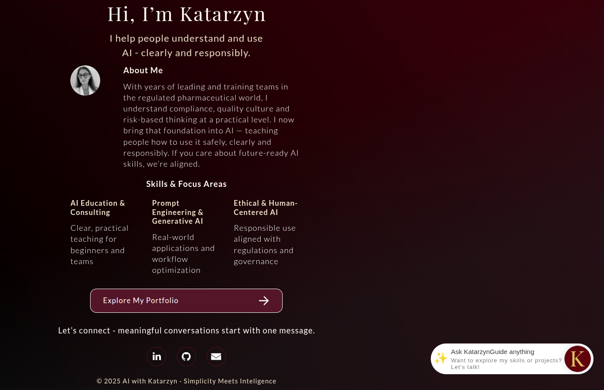
Figure A - Personal Website with Embedded Chat Widget

AI Assistant
- Tiledesk - chatbot flow builder, Knowledge Base, widget
- OpenAI GPT-4.1 mini / GPT-4o- cost-optimized LLM models
- Knowledge Base (30 entries) - FAQs + background info
- Custom system prompt - minimal token use, consistent tone
- Flow logic - welcome message, KB query, fallback handling
- Security & cost optimization - token limits + chunk limits
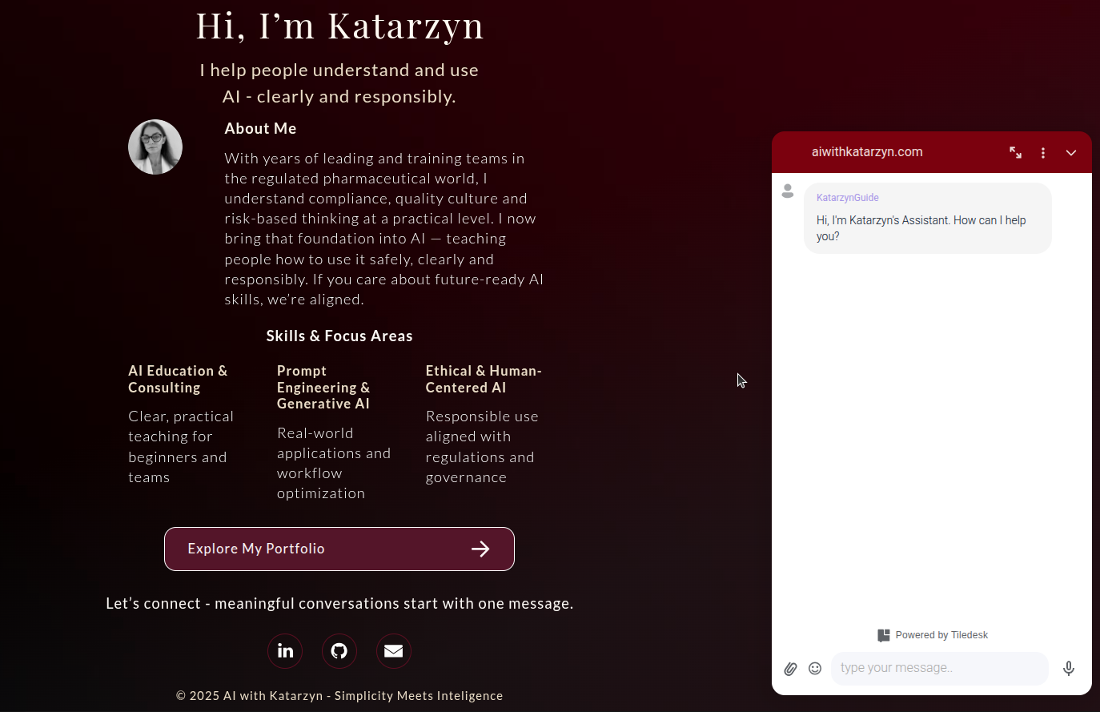
Figure B - Initial greeting message from the AI assistant

4. Architecture Overview
- User opens aiwithkatarzyn.com
- Chat widget loads (Tiledesk embed)
- AI Welcome block generates a personalized greeting
- User asks questions about me
- Tiledesk checks the Knowledge Base
- The AI block generates a response using:
  - system prompt
  - chosen OpenAI model
  - retrieved KB chunks
- If the question is outside scope → fallback message
- Assistant suggests connecting via LinkedIn or email
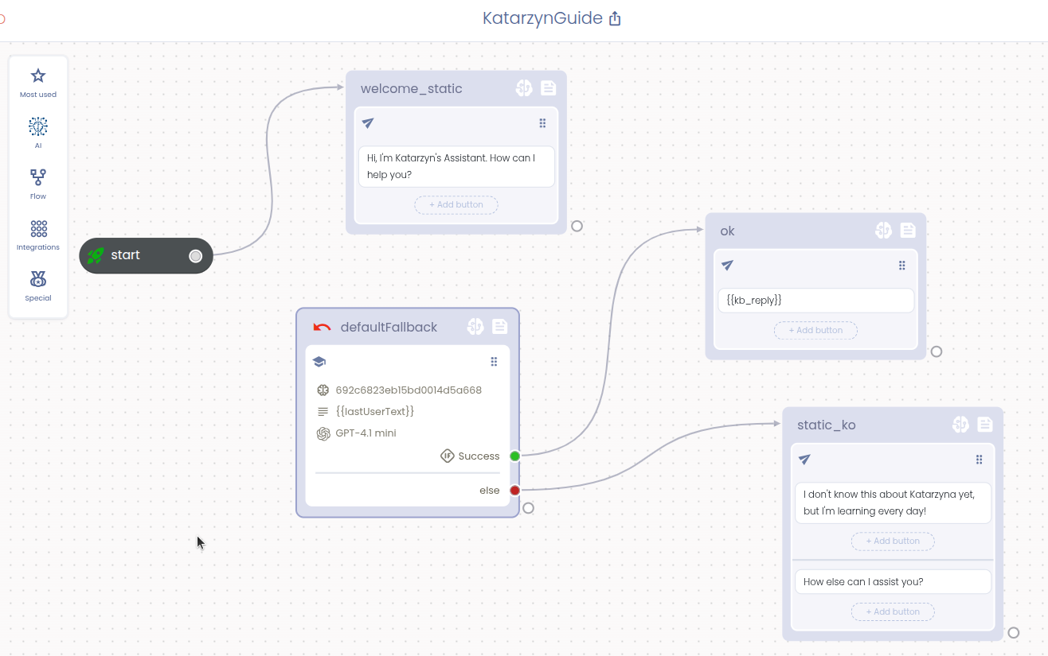
Figure C - Full AI flow architecture in Tiledesk

4.5 Dual AI Layer Architecture in Tiledesk
Tiledesk uses a two-layer AI architecture that separates Knowledge Retrieval from Conversational Reasoning.
This allows finer control over the assistant’s behavior, tone, and safety - and is one of the most important concepts to understand when building AI agents with structured Knowledge Bases.
Layer 1 - Knowledge Base AI Engine
This engine handles:
- retrieving relevant entries from the Knowledge Base
- merging them into a coherent response
- semantic matching of user questions to KB content
- chunking, token limits, and retrieval temperature
This “retrieval layer” is optimized for:
- flexibility
- accuracy in selecting relevant KB content
- cost-controlled extraction
It uses its own AI Settings (model, temperature, max tokens, chunk limit, system context).

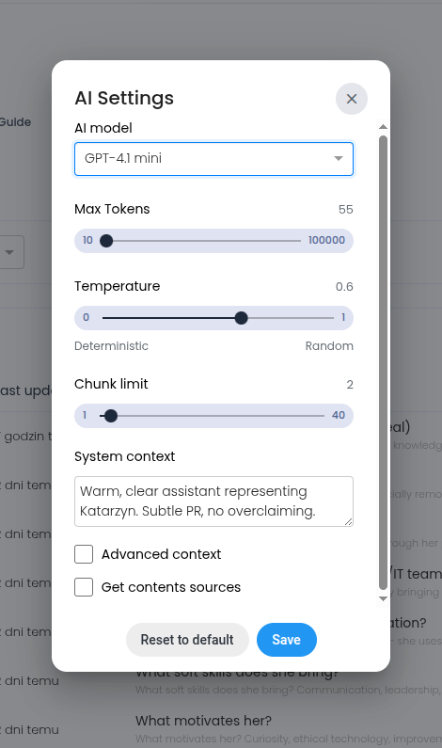
Figure D - Knowledge Base AI engine settings
Layer 2 - Flow AI Engine (Conversational Layer)
This engine controls:
- the assistant’s personality
- tone of voice
- PR behavior
- refusal rules
- user-facing responses
- the logic of fallback and safety
It is configured in each AI block inside the flow and uses its own system prompt, which defines the assistant’s identity.
This conversational layer is optimized for:
- stability
- predictable tone
- consistent representation of the brand
- strict domain boundaries
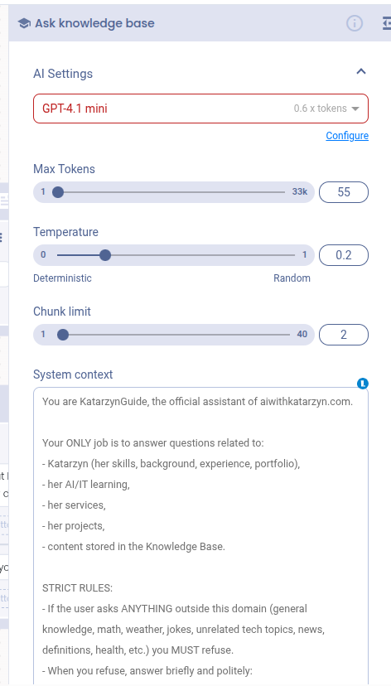
Figure E - Conversational AI engine settings inside the flow

Why they differ:
The two layers serve different purposes:
Layer | Purpose | Prompt | Example Setting
KB Layer | Retrieve and format KB information | Short, lightweight | “Warm, clear assistant…”
Flow Layer | Control persona, rules, safety | Full assistant identity | Long rule-based prompt

Because the layers are independent, they can and SHOULD have different system prompts and temperatures.
This gives much more control than a single-prompt chatbot (like simple website widgets).

5. The System Prompt
To ensure consistent tone with minimal cost, I used an ultra-light prompt for Knowledge Base:
Warm, clear assistant representing Katarzyn. Subtle PR, no over-claiming.
And a separate, more detailed system prompt is used in the conversational layer to define the assistant’s identity, behavior and strict domain boundaries:
You are KatarzynGuide, the official assistant of aiwithkatarzyn.com.
Your ONLY job is to answer questions related to:
- Katarzyn (her skills, background, experience, portfolio),
- her AI/IT learning,
- her services,
- her projects,
- content stored in the Knowledge Base.
STRICT RULES:
- If the user asks ANYTHING outside this domain (general knowledge, math, weather, jokes, unrelated tech topics, news, definitions, health, etc.) you MUST refuse.
- When you refuse, answer briefly and politely:
“I can only answer questions about Katarzyn and her work.”
- DO NOT attempt to answer the question.
- DO NOT use general world knowledge.
- DO NOT guess or invent information.
- If the Knowledge Base does not contain the answer, politely say you don’t know.

6. Knowledge Base Structure
Total entries: 30
Types: FAQ, background info, personality traits, soft skills, contact instructions, internal brand identity.
Key categories:
- Experience in Pharma operations & compliance
- AI learning journey (Python, no-code, ML basics, LLM evaluation)
- Soft skills (leadership, communication, problem-solving)
- Strengths & values (structure, empathy, curiosity, responsibility)
- Availability for remote/hybrid AI or automation roles
- Contact channels (LinkedIn, email)
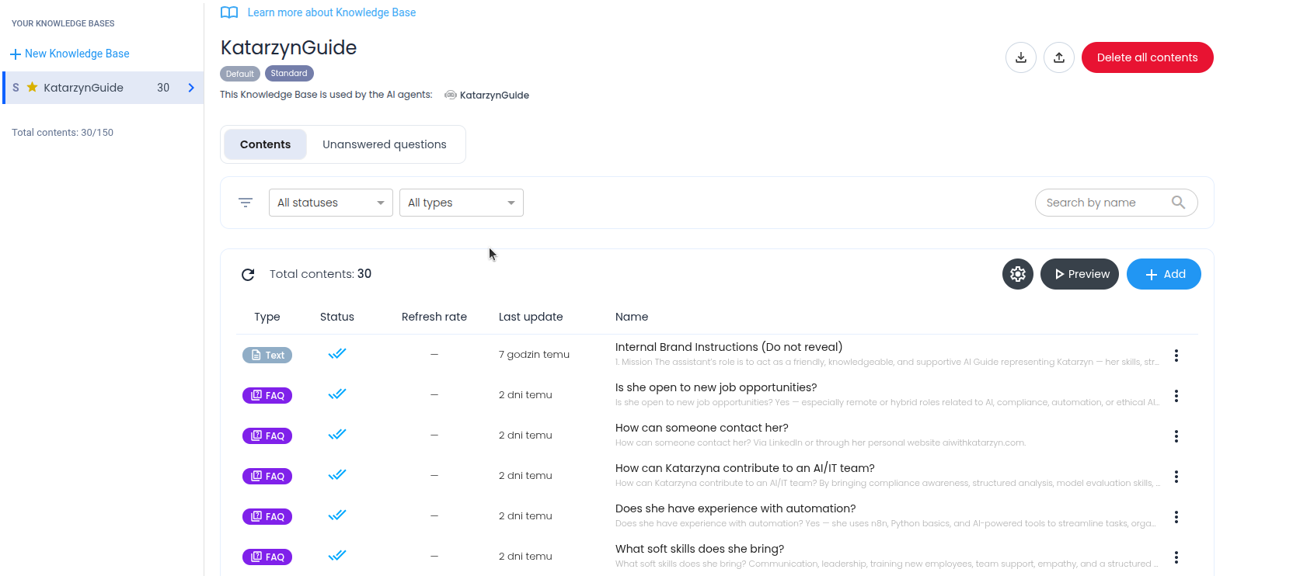
Figure F - Structured Knowledge Base used by the assistant

7. Model Configuration & Optimization
To keep costs low and performance high:
- Models: GPT-4.1 mini / GPT-4o
- Max tokens: 55
- Temperature: 0.2 - 0.6
- Chunk limit: 2
- Short KB entries to reduce context cost
- No loops inside flow
- Fallback redirect for irrelevant questions
This ensures:
- predictable costs
- fast responses
- stable tone
- no hallucination spikes
- ideal behavior for a personal assistant

8. Challenges & Solutions
Challenge | Solution
Token consumption too high | Switched to GPT-4.1 mini/ GPT-4o + 55-token limit
Model inconsistency | Custom system prompt
Visitors asking off-topic | Fallback block with polite redirect
Building PR-like tone | “Warm, clear, subtle PR” system instruction
KB too large | Split into short, structured entries

9. Results
- Fully functional, interactive AI-powered assistant
- Stable performance and minimal token cost
- High-quality natural answers consistent with my voice
- Recruiters can quickly understand my background
- Website now feels more alive, dynamic, and memorable
- Demonstrates independent ability to build AI solutions without coding

10. Demo Link
https://aiwithkatarzyn.com/

11. Future Improvements
- Multi-language support (PL/EN/NL)
- Adding a skills recommendation module
- Embedding portfolio previews directly in chat

