# Lab 7: Tunnelling and Web Security

**Objective**: In this lab we will investigate the usage of SSL/TLS and VPN tunnels.

🕮 **Web link (Weekly activities):** https://asecuritysite.com/esecurity/unit07

## A Web cryptography assessment

The ssllabs tool (<https://ssllabs.com>) can be used to assess the security of the cryptography used on a Web site. You will be given a range of Web sites to scan in the lab, and you should pick three sites from the list. Now perform a test on them, and determine:

|  |  |  |  |
| --- | --- | --- | --- |
| **Site** | **Site 1:** | **Site 2:** | **Site 3:** |
| What grade does the site get? |  |  |  |
| The digital certificate key size and type? |  |  |  |
| Does the name of the site match the name on the server? |  |  |  |
| Who is the signer of the digital certificate? |  |  |  |
| The expiry date on the digital certificate? |  |  |  |
| What is the hashing method on the certificate? |  |  |  |
| If it uses RSA keys, what is the e value that is used in the encryption (Me mod N)? |  |  |  |
| Determine a weak cipher suite used and example why it might be weak? |  |  |  |
| Is SSL v2 supported? |  |  |  |
| If SSL v2 was supported, what problems might there be with the site (this will require some research)? |  |  |  |
| Outline the usage of TLS 1.0/1.1 and 1.2, and identify a problem if one of these TLS versions were not supported? |  |  |  |
| Is the site vulnerable to Heartbleed?  Is the site vulnerable to DROWN?  Is the site vulnerable to BEAST?  Is the site vulnerable to POODLE? |  |  |  |

Research questions:

What does TLS_ECDHE_RSA_WITH_AES_256_CBC_SHA384 identify?

If a site gets a ‘T’ grade, what is the problem?

If the site was susceptible to Poodle, what is the vulnerability?

A.2 We will now create a Python program which calls up the SSLlabs assessment. First create a CSV file (sites.csv) with your sites in it:

web,site

Cloudflare,www.cloudflare.com

BBC,bbc.co.uk

Next enter the following code and run the

import requests

import time

import sys

import logging

API = 'https://api.ssllabs.com/api/v2/'

def requestAPI(path, payload={}):

'''This is a helper method that takes the path to the relevant

API call and the user-defined payload and requests the

data/server test from Qualys SSL Labs.

Returns JSON formatted data'''

url = API + path

try:

response = requests.get(url, params=payload)

except requests.exception.RequestException:

logging.exception('Request failed.')

sys.exit(1)

data = response.json()

return data

def resultsFromCache(host, publish='off', startNew='off', fromCache='on', all='done'):

path = 'analyze'

payload = {

'host': host,

'publish': publish,

'startNew': startNew,

'fromCache': fromCache,

'all': all

}

data = requestAPI(path, payload)

return data

def newScan(host, publish='off', startNew='on', all='done', ignoreMismatch='on'):

path = 'analyze'

payload = {

'host': host,

'publish': publish,

'startNew': startNew,

'all': all,

'ignoreMismatch': ignoreMismatch

}

results = requestAPI(path, payload)

payload.pop('startNew')

while results['status'] != 'READY' and results['status'] != 'ERROR':

time.sleep(30)

results = requestAPI(path, payload)

return results

import csv

with open('sites.csv') as csvfile:

reader = csv.DictReader(csvfile)

for row in reader:

url = row['site'].strip()

a = newScan(url)

with open("out3.txt", "a") as myfile:

myfile.write(str(row['web'])+"\n"+str(a)+"\n\n\n")

print row['web']

Note that it will can take a few minutes to perform a single scan. By reading the out3.txt file, outline your findings:

Site name: Site rating:

Other significant details:

Site name: Site rating:

Other significant details:

## B Viewing details

|  |  |  |
| --- | --- | --- |
| **No** | **Description** | **Result** |
| **B.1** | Go to your Kali Linux instance. Run Wireshark and capture traffic from your main network connection. Start a Web browser, and go to **Google.com**.  Stop Wireshark and identify some of your connection details: | Your IP address and TCP port:  Google’s Web server IP address and TCP port:  Which SSL/TLS version is used:  By examining the Wireshark trace, which encryption method is used for the tunnel:  By examining the Wireshark trace, which hash method is used for the tunnel:  By examining the Wireshark trace, what is the length of the encryption key:  By examining the certificate from the browser which encryption method is used for the tunnel:  By examining the certificate from the browser, which hash method is used for the tunnel:  By examining the certificate from the browser is the length of the encryption key: |
| **B.2** | Run Wireshark and capture traffic from your main network connection. Start a Web browser, and go to **https://twitter.com**.  Stop Wireshark and identify some of your connection details: | Your IP address and TCP port:  Twitter’s Web server IP address and TCP port:  Which SSL/TLS version is used:  By examining the Wireshark trace, which encryption method is used for the tunnel:  By examining the Wireshark trace, which hash method is used for the tunnel:  By examining the Wireshark trace, what is the length of the encryption key:  By examining the certificate from the browser which encryption method is used for the tunnel:  By examining the certificate from the browser, which hash method is used for the tunnel:  By examining the certificate from the browser is the length of the encryption key: |

## C OpenSSL

|  |  |  |
| --- | --- | --- |
| **No** | **Description** | **Result** |
| **C.1** | Go to your Kali Linux instance, and make a connection to the **www.live.com** Web site:  openssl s_client -connect www.live.com:443 | Which SSL/TLS method has been used:  Which method is used on the encryption key on the certificate, and what is the size of the public key?  Which is the handshaking method that has been used to create the encryption key?  Which TLS version is used for the tunnel?  Which encryption method is used for the tunnel:  Which hash method is used for the tunnel:  What is the length of the encryption key:  What is the serial number of the certificate:  Who has signed the certificate: |

## D Examining traces

|  |  |  |
| --- | --- | --- |
| **No** | **Description** | **Result** |
| **D.1** | Download the following file, and examine the trace with Wireshark:  http://asecuritysite.com/log/ssl.zip | Client IP address and TCP port:  Web server IP address and TCP port:  Which SSL/TLS method has been used:  Which encryption method is used for the tunnel:  Which hash method is used for the tunnel:  What is the length of the encryption key: |
| **D.2** | Download the following file, and examine the trace with Wireshark:  http://asecuritysite.com/log/https.zip | Client IP address and TCP port:  Web server IP address and TCP port:  Which SSL/TLS method has been used:  Which encryption method is used for the tunnel:  Which hash method is used for the tunnel:  What is the length of the encryption key: |
| **D.3** | Download the following file, and examine the trace with Wireshark:  http://asecuritysite.com/log/heart.zip | Client IP address and TCP port:  Web server IP address and TCP port:  Which SSL/TLS method has been used:  Which encryption method is used for the tunnel:  Which hash method is used for the tunnel:  What is the length of the encryption key: |
| **D.4** | Download the following file, and examine the trace with Wireshark:  http://asecuritysite.com/log/ipsec.zip | Which is the IP address of the client and of the server:  Which packet number identifies the start of the VPN connection (Hint: look for UDP Port 500):  Determine one of the encryption and hashing methods that the client wants to use:  Now determine the encryption and hashing methods that are agreed in the ISAKMP: |
|  | Download the following file, and examine the trace with Wireshark:  http://asecuritysite.com/log/tor.zip | Which TCP port does the client use to send to?  What is the IP address of the Tor node that the client connects to?  What is strange about the packet size?  Is SSL/TLS used for the connection?  Can you trace any content in the conversation?  Can you determine the Web site that is being connected to? |

## E TLS Connection

**E.1** We will now create our own SSL/TLS server and client in Python. First, we need to generate a certificate for our server:

openssl req -new -x509 -days 365 -nodes -out mycert.pem -keyout mycert.pem

Next we will create a server which will listen on Port 443, and support two cipher suites ('AES256+ECDH:AES256+EDH'):

import socket, ssl

context = ssl.SSLContext(ssl.PROTOCOL_TLSv1)

context.load_cert_chain(certfile="mycert.pem")

def handle(conn):

conn.write(b'GET / HTTP/1.1\n')

print(conn.recv().decode())

while True:

sock = socket.socket()

sock.bind(('', 443))

sock.listen(5)

context = ssl.create_default_context(ssl.Purpose.CLIENT_AUTH)

context.load_cert_chain(certfile="mycert.pem")

context.options |= ssl.OP_NO_TLSv1 | ssl.OP_NO_TLSv1_1 # optional

context.set_ciphers('AES256+ECDH:AES256+EDH')

while True:

conn = None

ssock, addr = sock.accept()

try:

conn = context.wrap_socket(ssock, server_side=True)

handle(conn)

except ssl.SSLError as e:

print(e)

finally:

if conn:

conn.close()

Now we will create the client to connect on Port 443. As we have a self-signed certificate, we will disable the checking of the host and certificate (remember to change the IP address to the address of your local host):

import socket, ssl

HOST, PORT = **'10.10.10.10'**, 443

def handle(conn):

conn.write(b'GET / HTTP/1.1\n')

print(conn.recv().decode())

def main():

sock = socket.socket(socket.AF_INET)

context = ssl.create_default_context(ssl.Purpose.SERVER_AUTH)

**context.check_hostname = False**

**context.verify_mode=ssl.CERT_NONE**

context.options |= ssl.OP_NO_TLSv1 | ssl.OP_NO_TLSv1_1

conn = context.wrap_socket(sock, server_hostname=HOST)

try:

conn.connect((HOST, PORT))

handle(conn)

finally:

conn.close()

if __name__ == '__main__':

main()

Now run Wireshark (sudo wireshark &), and capture from the Ethernet port (a sample run is show in in Figure 1). Now run the server, and then run the client. Stop Wireshark and determine:

The cipher suites sent from client to the server (‘Client Hello’):

The cipher suite selected by the server (‘Server Hello’):

If we change the code to:

context.set_ciphers(‘HIGH’)

What are the cipher suites sent from server, and which cipher suite is selected by the client:

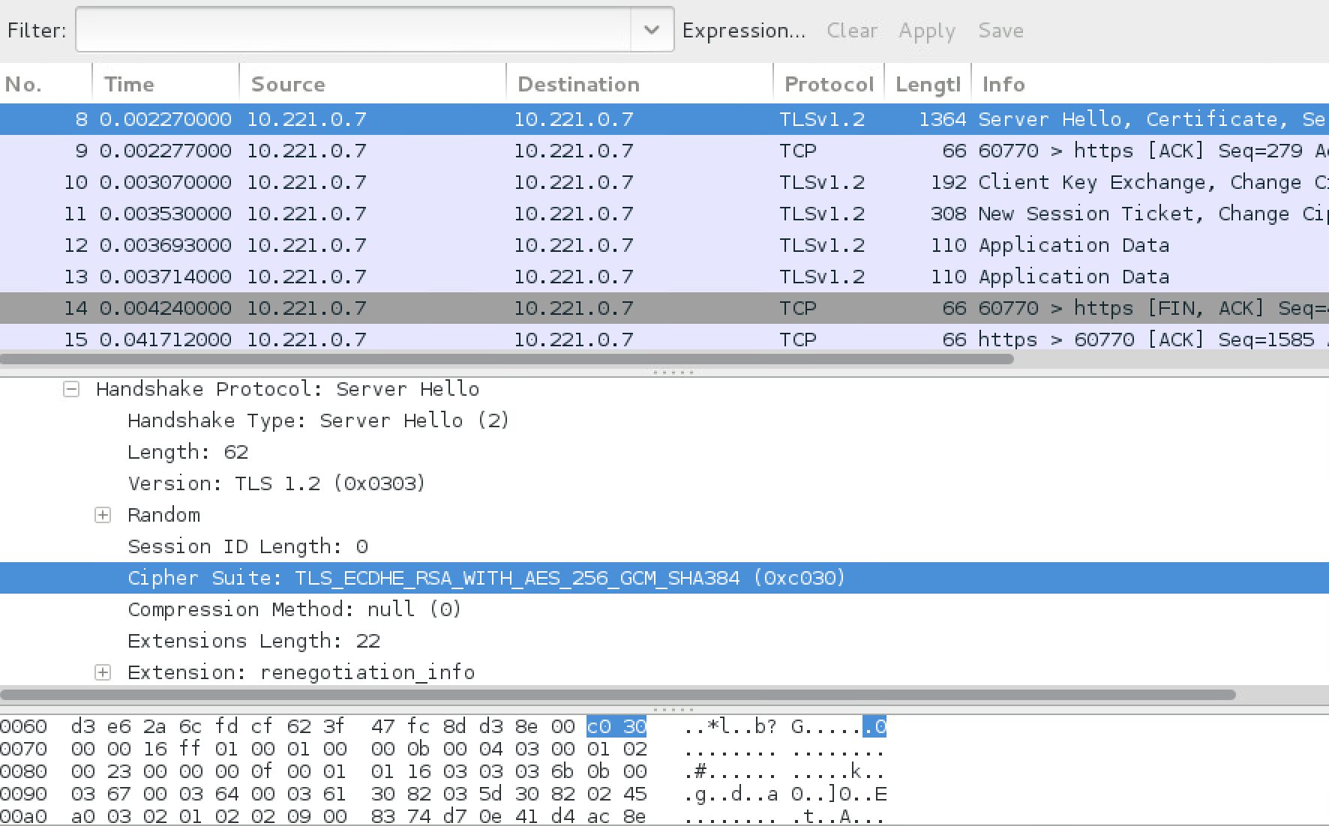

**Figure 1:** Sample capture

Now select your own cipher suits to accept. The possible settings are given next. You can use the “+” (to add), “-“ (to take away), and “!” (for not).

Key exchange:

* **kRSA**, **aRSA**, **RSA.** RSA Key exchange.
* **kDHE**, **kEDH**, **DH.** Ephemeral DH key agreement.
* **DHE**, **EDH.** Cipher suites using authenticated ephemeral DH key agreement.
* **kEECDH**, **kECDHE**, **ECDH**. Cipher suites using ephemeral ECDH key agreement.
* **ECDHE**, **EECDH.** Cipher suites using authenticated ephemeral ECDH key agreement.
* **aECDSA**, **ECDSA**. Cipher suites with ECDSA authentication.

Encryption:

* **AES128**, **AES256**, **AES.**
* **AESGCM.**
* **AESCCM**, **AESCCM8.**
* **ARIA128**, **ARIA256**, **ARIA.**
* **CAMELLIA128**, **CAMELLIA256**, **CAMELLIA.**
* **CHACHA20.**
* **3DES.**
* **DES.**
* **RC4.**
* **RC2.**
* **IDEA**.

Hashing methods:

* **MD5**
* **SHA1**, **SHA**
* **SHA256**, **SHA384**
* **aGOST**
* **kGOST**
* **GOST94**
* **GOST89MAC.**

We can also use: HIGH (256-bit); MEDIUM (128-bit); LOW (56-bit or 64-bit).

## G Secure services

**G.1** Determine your IP address with ipconfig, and then using nmap, show the running servers on the server:

ifconfig

nmap *<ip>*

What are the servers that are running:

Open a Web browser on your server, and open up the home page with:

http://<ip>

What is contained on the home page:

**G.2** Now to the /var/www/html folder and show that there is a file named index.html. Connect to the sftp service by determining your IP address (<ip>) and use the command:

sftp sftpuser@<ip>

Now run the following commands, and determine the output:

pwd

ls

cd sftpuser

put index.html

Now exit from sftp and try and locate the file you have copied. Go back to sftp, and now see if you can copy a file to the /home/napier folder.

Now start wireshark (with sudo wireshark &), and capture your session.

Now login into your local host with the ssh server:

ssh napier@localhost

Now start wireshark (with sudo wireshark &), and capture your session.

## What I should have learnt from this lab?

The key things learnt:

* How do perform a cryptography assessment on a Web site (using ssllabs) and in how to spot weaknesses.
* Able to interpret an SSL/TLS session, and identity the important elements of the Client Hello, and the Server Hello.

## Notes

To setup your python to run Python 2.7:

sudo update-alternatives --set python /usr/bin/python2.7

To install a Python library use:

easy_install libname