Ivan Capistran

01282924

Lab 07

UnbufferedSimulation

First test

Results for simulation: 1 clerks, 2 customers with service times of 10

Total time: 10

Number of customers serviced: 1

bank.Customer:[arrival=0, service=10, departure=10]

Total service time: 10

Total system time: 10

// Here there was only one clerk available so only one customer got serviced.

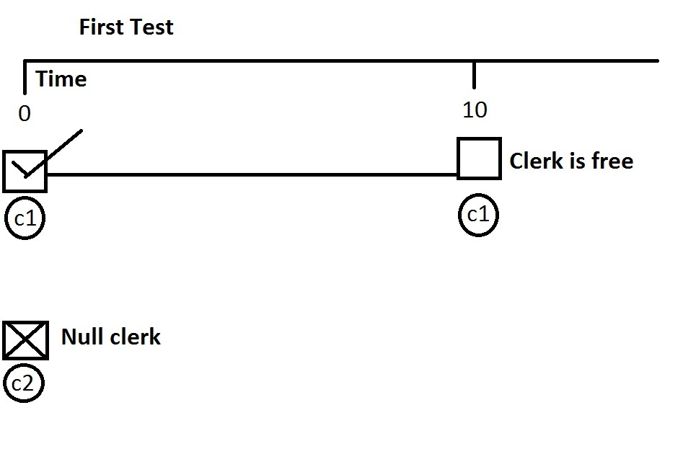

Second test

Results for simulation: 2 clerks, 2 customers with service times of 10

Total time: 10

Number of customers serviced: 2

bank.Customer:[arrival=0, service=10, departure=10]

bank.Customer:[arrival=0, service=10, departure=10]

Total service time: 20

Total system time: 20

//Here 2 customers arrived and there were 2 available clerks. Both customers were serviced by //clerks and there were only 2 new additions of serviced_finished events to the eventQueue

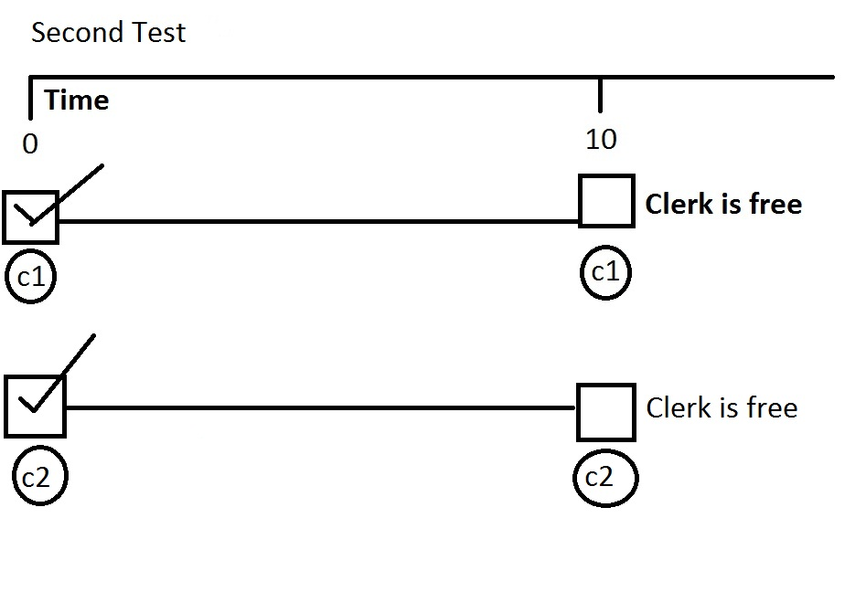

Third test

Results for simulation: Notes example with 3 clerks and customer service time 30

Total time: 87

Number of customers serviced: 5

bank.Customer:[arrival=0, service=30, departure=30]

bank.Customer:[arrival=10, service=30, departure=40]

bank.Customer:[arrival=15, service=30, departure=45]

bank.Customer:[arrival=37, service=30, departure=67]

bank.Customer:[arrival=57, service=30, departure=87]

Total service time: 150

Total system time: 150

//Here customers were generated at specific times in the notesExampleSimulation method.

//When all three clerks are busy the customers generated at time 20, and 25 are not //“serviced”.

//so when customer 6 and 7 arrive with time arrivals of 37 and 57 there are clerks available for both of them.

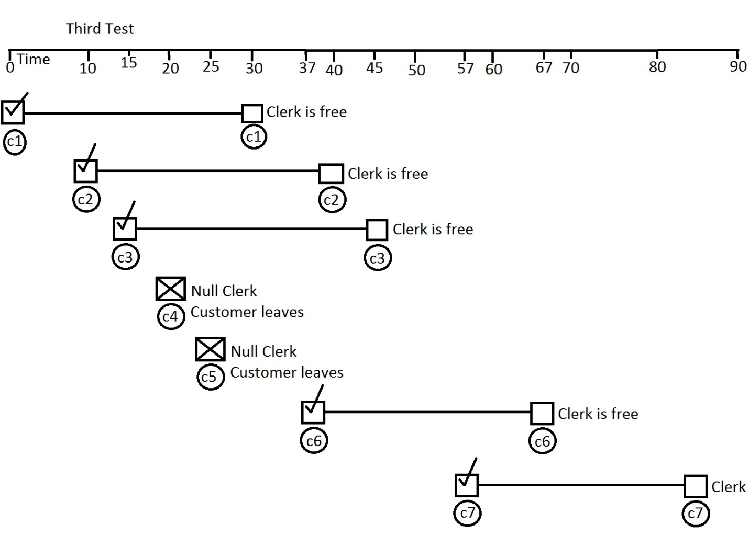

BufferedSimulation

BufferedSimulationTester class written by Ivan Capistran

Custom Test 1: 5 clerks, 20 customers, departure time 10

Results for simulation: 5 clerks, 20 customers with service times of 10

Total time: 40

Number of customers serviced: 20

bank.Customer:[arrival=0, service=10, departure=10]

bank.Customer:[arrival=0, service=10, departure=10]

bank.Customer:[arrival=0, service=10, departure=10]

bank.Customer:[arrival=0, service=10, departure=10]

bank.Customer:[arrival=0, service=10, departure=10]

bank.Customer:[arrival=0, service=10, departure=20]

bank.Customer:[arrival=0, service=10, departure=20]

bank.Customer:[arrival=0, service=10, departure=20]

bank.Customer:[arrival=0, service=10, departure=20]

bank.Customer:[arrival=0, service=10, departure=20]

bank.Customer:[arrival=0, service=10, departure=30]

bank.Customer:[arrival=0, service=10, departure=30]

bank.Customer:[arrival=0, service=10, departure=30]

bank.Customer:[arrival=0, service=10, departure=30]

bank.Customer:[arrival=0, service=10, departure=30]

bank.Customer:[arrival=0, service=10, departure=40]

bank.Customer:[arrival=0, service=10, departure=40]

bank.Customer:[arrival=0, service=10, departure=40]

bank.Customer:[arrival=0, service=10, departure=40]

bank.Customer:[arrival=0, service=10, departure=40]

Total service time: 200

Total system time: 500

// Here there were 5 clerks and 20 customers.

//When all 5 clerks were filled first, the rest of the 20 customers were put in the LinkedQueue. When the first 5 customers started leaving the rest of the customers in line were serviced by free clerks.

Custom Test 1

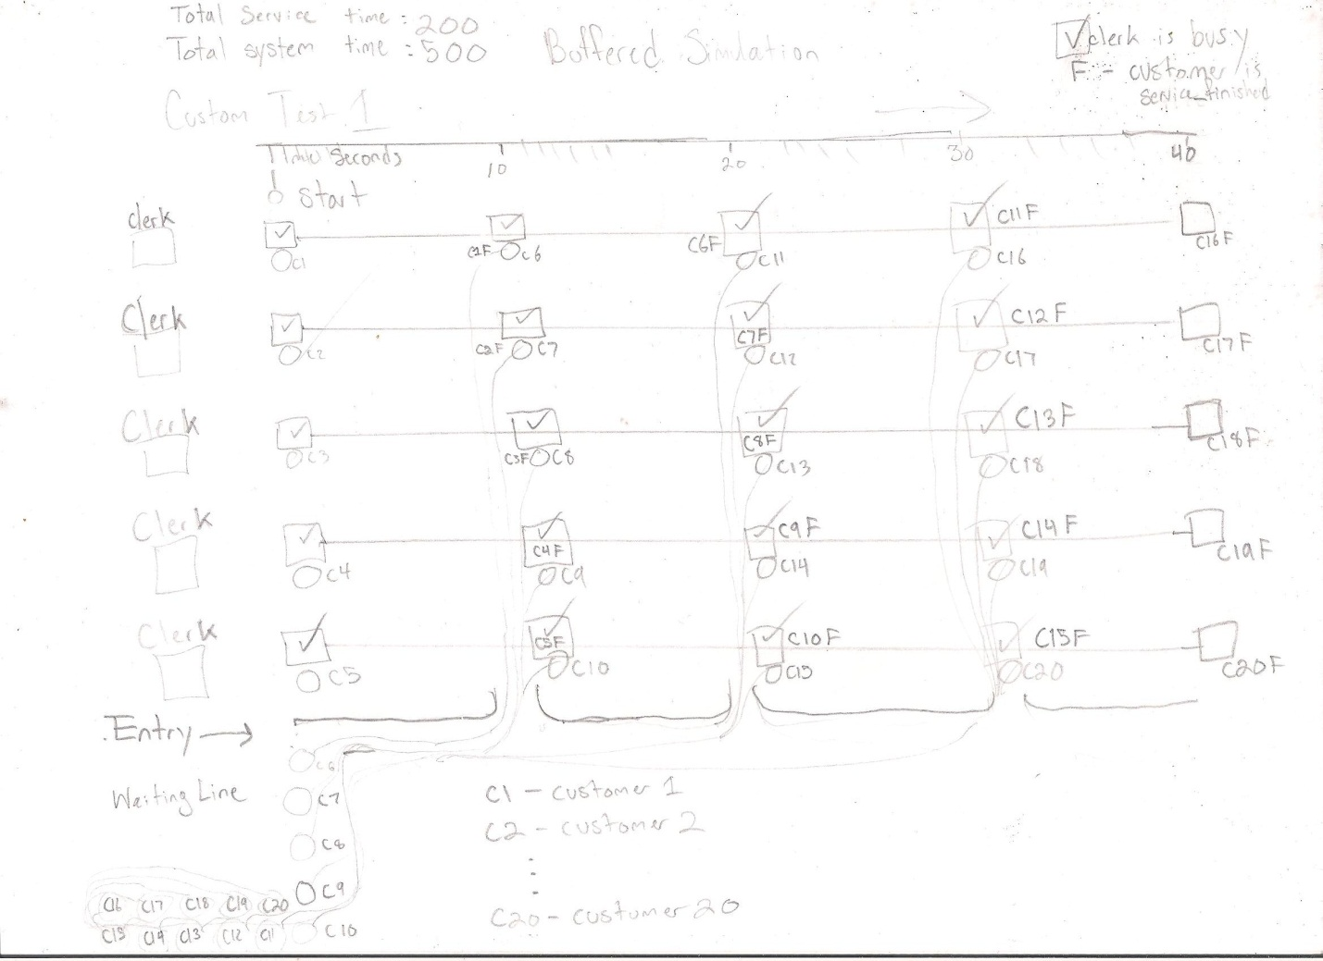

Custom Test 2 : 10 clerks, 12 customers, 30 departure time

Results for simulation: 10 clerks, 12 customers with service times of 30

Total time: 60

Number of customers serviced: 12

bank.Customer:[arrival=0, service=30, departure=30]

bank.Customer:[arrival=0, service=30, departure=30]

bank.Customer:[arrival=0, service=30, departure=30]

bank.Customer:[arrival=0, service=30, departure=30]

bank.Customer:[arrival=0, service=30, departure=30]

bank.Customer:[arrival=0, service=30, departure=30]

bank.Customer:[arrival=0, service=30, departure=30]

bank.Customer:[arrival=0, service=30, departure=30]

bank.Customer:[arrival=0, service=30, departure=30]

bank.Customer:[arrival=0, service=30, departure=30]

bank.Customer:[arrival=0, service=30, departure=60]

bank.Customer:[arrival=0, service=30, departure=60]

Total service time: 360

Total system time: 420

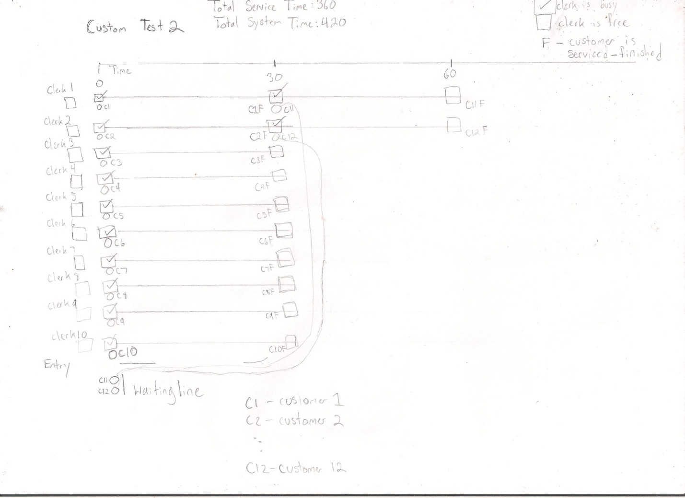

Custom Test 3: Random Simulation 15 clerks

Results for simulation: 15 Clerks

Total time: 165

Number of customers serviced: 15

bank.Customer:[arrival=7, service=9, departure=16]

bank.Customer:[arrival=2, service=23, departure=25]

bank.Customer:[arrival=37, service=22, departure=59]

bank.Customer:[arrival=33, service=35, departure=68]

bank.Customer:[arrival=66, service=6, departure=72]

bank.Customer:[arrival=30, service=44, departure=74]

bank.Customer:[arrival=41, service=45, departure=86]

bank.Customer:[arrival=55, service=38, departure=93]

bank.Customer:[arrival=93, service=7, departure=100]

bank.Customer:[arrival=57, service=44, departure=101]

bank.Customer:[arrival=91, service=12, departure=103]

bank.Customer:[arrival=78, service=35, departure=113]

bank.Customer:[arrival=108, service=7, departure=115]

bank.Customer:[arrival=86, service=30, departure=116]

bank.Customer:[arrival=147, service=18, departure=165]  
Total service time: 375  
Total system time: 375

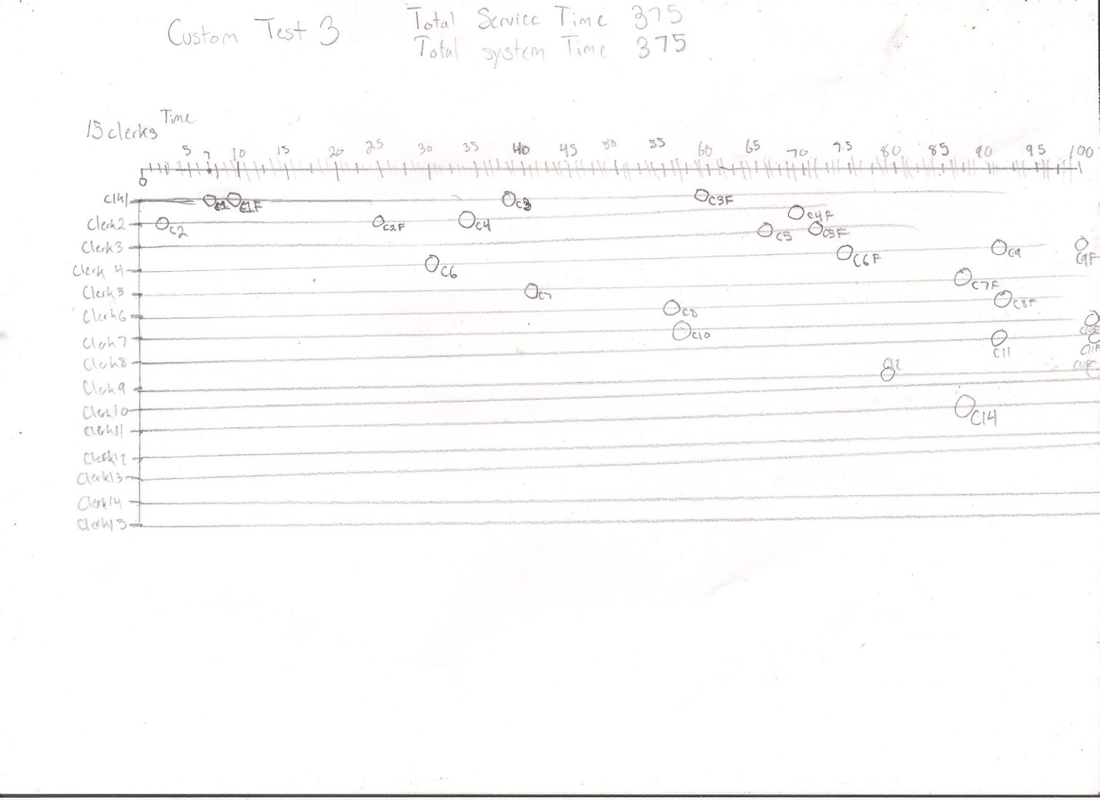

Custom Test 4: Notes example Simulation

Results for simulation: Notes example with 7 clerks and customer service time 20

Total time: 77

Number of customers serviced: 7

bank.Customer:[arrival=0, service=20, departure=20]

bank.Customer:[arrival=10, service=20, departure=30]

bank.Customer:[arrival=15, service=20, departure=35]

bank.Customer:[arrival=20, service=20, departure=40]

bank.Customer:[arrival=25, service=20, departure=45]

bank.Customer:[arrival=37, service=20, departure=57]

bank.Customer:[arrival=57, service=20, departure=77]

Total service time: 140

Total system time: 140

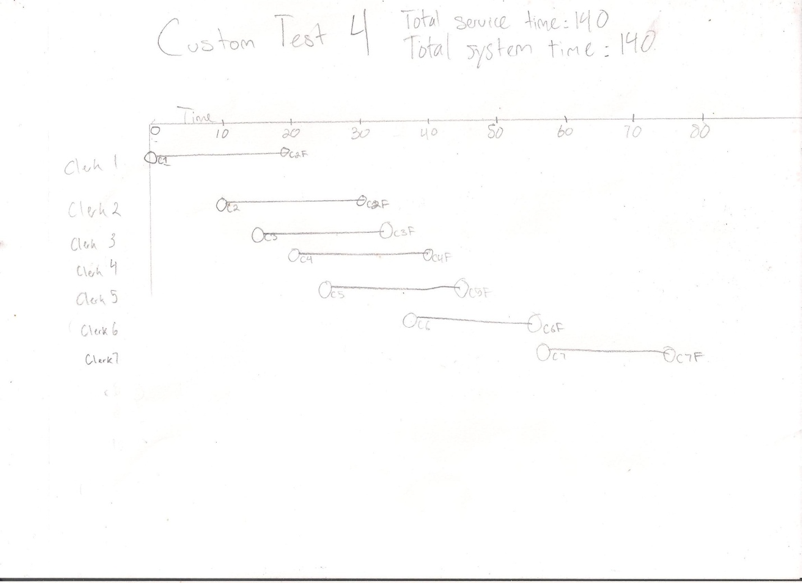

First test

Results for simulation: 1 clerks, 2 customers with service times of 10

Total time: 20

Number of customers serviced: 2

bank.Customer:[arrival=0, service=10, departure=10]

bank.Customer:[arrival=0, service=10, departure=20]

Total service time: 20

Total system time: 30

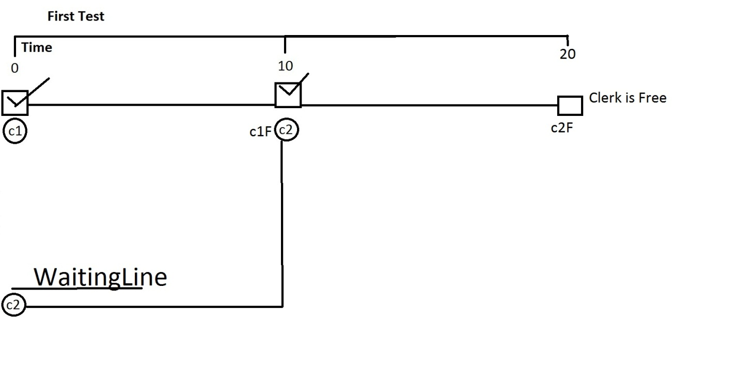

Second test

Results for simulation: 2 clerks, 2 customers with service times of 10

Total time: 10

Number of customers serviced: 2

bank.Customer:[arrival=0, service=10, departure=10]

bank.Customer:[arrival=0, service=10, departure=10]

Total service time: 20

Total system time: 20



Third test

Results for simulation: Notes example with 3 clerks and customer service time 30

Total time: 90

Number of customers serviced: 7

bank.Customer:[arrival=0, service=30, departure=30]

bank.Customer:[arrival=10, service=30, departure=40]

bank.Customer:[arrival=15, service=30, departure=45]

bank.Customer:[arrival=20, service=30, departure=60]

bank.Customer:[arrival=25, service=30, departure=70]

bank.Customer:[arrival=37, service=30, departure=75]

bank.Customer:[arrival=57, service=30, departure=90]

Total service time: 210

Total system time: 246

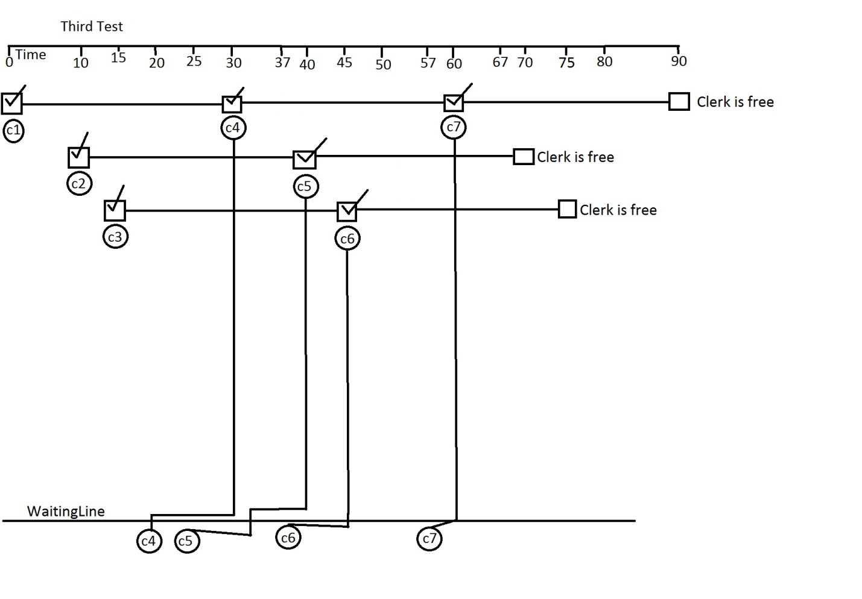

//Explanation  
// Similarities – Both classes service the customer in the handleEvent method

// Differences   
//UnbufferedSimulation  
// When a customer event is passed through the handleEvent method  
//the customer will not be serviced whenever clerks are not available.

//BufferedSimulation   
// this class has a waiting line so to say that will hold the customer object to be ready to be serviced when the next clerk is available. The waiting line is a LinkedQueue that is initialized in the constructer. In the handleEvent class whenever a CUSTOMER_ARIVAL event is passed, the first if statement catches it and then it will check if there is an available clerk or not. If there is an available clerk then the customer is serviced, if there is not an available clerk then the customer is added to the LinkedQueue. When a SERVICED_FINISHED event passes through the handleEvent method it will be caught by the else if statement block and when the clerk is free it then will check the LinkedQueue and select the first customers that are “waiting in line”.