
Department of Computer Engineering
A Mini Project Report (PDL)
“SITAR – Satellite Image Temporal Augmentation and Reconstruction: Optical-Flow Frame Interpolation for Geostationary Satellite Imagery (SDG 13)”
SUBMITTED TO THE DEPARTMENT OF COMPUTER ENGINEERING
AISSMS IOIT
T. Y. BTech Engineering
Project Theme: UN Sustainable Development Goal 13 – Climate Action
SUBMITTED BY
Student Roll No | Student Name
B - 124 | Keya Nagar
B -128 | Shivani Pathak
B - 135 | Shweta Pawar
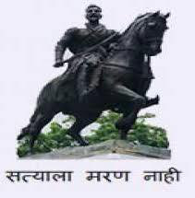
2026-27

Department of Computer Engineering
CERTIFICATE
This is to certify that the project report
“SITAR – Satellite Image Temporal Augmentation and Reconstruction: Optical-Flow Frame Interpolation for Geostationary Satellite Imagery (SDG 13)”
Submitted by
Student Roll No | Student Name
B - 124 | Keya Nagar
B - 128 | Shivani Pathak
B - 135 | Shweta Pawar
are bonafide students of this institute and the work has been carried out by them under the supervision of Dr.V.S.Bhende and it is approved for the partial fulfillment of the Department of Computer Engineering AISSMS IOIT. The project is aligned with UN Sustainable Development Goal 13 – Climate Action.
Dr.V.S.Bhende | Dr. K. S. Wagh
Guide, | Head,
Department of Computer Engineering | Department of Computer Engineering
Place : Pune Date : ____________
ABSTRACT
1.1 CONTEXT
Weather satellites are one of the most important tools for monitoring the atmosphere. Geostationary satellites remain above the same point on the equator and repeatedly image the same region, which makes them ideal for watching thunderstorms, cyclones and monsoon systems develop. However, every satellite scans at a fixed interval: INSAT-3DR/3DS provide a full-disk thermal infrared image every 30 minutes, while GOES-19 and Himawari provide one every 10 minutes. Fast-evolving clouds can change considerably between two images.
Increasing the scan rate requires new instruments or new satellites, which is costly and not possible for missions already in orbit. Computer vision offers an alternative: video frame interpolation methods estimate the motion between two consecutive images (optical flow) and synthesise the frames in between. Applied carefully to satellite data, this can raise the effective temporal resolution of an existing archive.
SITAR (Satellite Image Temporal Augmentation and Reconstruction) is a system that generates intermediate frames between consecutive geostationary thermal infrared images. Users select a satellite and two frames, choose an interpolation factor, and obtain synthetic frames that are written in NetCDF format, validated against real observations and displayed on a web dashboard with comparison views, animations, metric charts and an exportable report. A deep learning model, SatelliteRIFE, performs the interpolation, and a classical Farneback optical-flow engine is used automatically when no trained model is available.
SITAR is developed in Python. A FastAPI backend handles the frame catalogue, interpolation jobs, image rendering and metrics, while the dashboard is built with HTML, CSS and JavaScript. Satellite data is read and written with xarray, netCDF4 and h5py, and the model is implemented in PyTorch. The system aims to turn 30-minute INSAT-3DS imagery into 15-minute and 7.5-minute sequences, supporting closer monitoring of extreme weather in line with SDG 13 – Climate Action.
1.2 PROBLEM STATEMENT
Analysts and researchers frequently need to follow how a cloud system evolves between two satellite observations, but the 30-minute interval of INSAT-3DR/3DS imagery hides much of that evolution. At the same time, large archives of higher-cadence data from GOES-19 and Himawari exist and could be used to learn how clouds move, yet there is no organised tool that applies this knowledge to fill the gaps in Indian satellite data.
Generating such frames informally also creates difficulties. Simple blending produces ghosted, double clouds; ordinary video tools cannot read satellite formats or preserve physical units; and without validation it is impossible to know whether a generated frame can be trusted.
Challenges:
• Coarse temporal resolution: INSAT-3DR/3DS observe the full disk only every 30 minutes, which is too coarse for rapidly developing convection.
• No additional observations: higher scan rates require new hardware or satellites, which is costly and impossible for existing missions.
• Ghosting in naive methods: pixel-by-pixel blending of two frames fades clouds in and out instead of moving them.
• Non-rigid cloud motion: clouds deform, grow and dissipate, which classical optical-flow methods handle poorly.
• Specialised data formats: satellite products use NetCDF/HDF5 with physical units that ordinary tools cannot handle.
• Lack of validation: users need to measure how close a generated frame is to the real observation.
• No unified visual tool: comparing frames, playing animations and exporting results usually requires writing code.
1.3 OBJECTIVE
The primary objective of SITAR is to provide an accessible and verifiable system that increases the temporal resolution of geostationary thermal infrared imagery by generating physically plausible intermediate frames, without requiring any additional satellite observations.
The system aims to enable users to:
• Browse satellite data: list sources (GOES-19, Himawari, INSAT-3DS) and their frames in time order.
• Generate intermediate frames: run ×2, ×4 or ×8 interpolation between any two frames.
• Use a deep learning model: interpolate with SatelliteRIFE, falling back automatically to Farneback optical flow.
• Keep scientific formats: read .nc / .h5 inputs and write NetCDF outputs with metadata.
• Validate results: score generated frames against real observations with SSIM, PSNR, MSE, MAE and cold-cloud IoU, and compare them with a linear-blend baseline.
• Visualise and compare: view side-by-side, swipe, blink and difference modes, and play time-lapse animations.
• Apply to INSAT-3DS: produce 15-minute and 7.5-minute sequences from 30-minute input.
• Export results: download metrics as CSV/JSON and build a comparison report as PDF or HTML.

INDEX
Sr No. | Chapter No. | Title of Chapter | Page No.
1 | 1 | ABSTRACT | –
 | 1.1 | Context | –
 | 1.2 | Problem Statement | –
 | 1.3 | Objective | –
2 | 2 | INTRODUCTION | 1
 | 2.1 | Background information on chosen topic | 1
 | 2.2 | Importance of Data Management in the Application Domain | 1
 | 2.3 | Scope of the Project | 2
3 | 3 | SYSTEM DESIGN | 4
 | 3.1 | Data Center Architecture | 4
 | 3.2 | Data Flow Architecture | 4
 | 3.3 | Call and Return Architecture | 6
 | 3.4 | UML Diagrams | 7
4 | 4 | IMPLEMENTATION | 14
 | 4.1 | Description of Development Environment | 14
 | 4.2 | Tools and Technologies Used | 14
 | 4.3 | Screenshots of the application | 15
5 | 5 | TESTING AND VALIDATION | 19
 | 5.1 | Validation of Data Integrity and Accuracy | 19
 | 5.2 | Performance Evaluation | 20
6 | 6 | CONCLUSION | 21
 | 6.1 | Summary of the Project Achievements | 21
 | 6.2 | Key Learning | 21
 | 6.3 | Future Scope | 21
7 | 7 | REFERENCES | 22

INTRODUCTION
2.1 BACKGROUND INFORMATION ON THE CHOSEN TOPIC
Geostationary satellites observe the Earth from about 35,786 km above the equator. Their thermal infrared channels near 10.3–10.8 µm (GOES-19 ABI C13, Himawari AHI B13, INSAT-3DS TIR1) measure brightness temperature: high, cold cloud tops appear at 190–230 K, while warm land and sea surfaces appear near 290–310 K. Because they work by day and night, TIR images are the main tool for tracking convection and cyclones.
The time between two images is fixed by the satellite's scanning schedule. GOES-19 and Himawari scan every 10 minutes, while INSAT-3DR/3DS scan every 30 minutes. This makes 10-minute data valuable for development: frames can be removed from a sequence, regenerated by a model and compared with the real frames.
Optical flow describes the apparent motion of every pixel between two images, and video frame interpolation uses it to warp two frames to an intermediate time and fuse them. SITAR adapts the RIFE (Real-time Intermediate Flow Estimation) approach to single-channel satellite data as SatelliteRIFE, and provides the classical Farneback algorithm as a fallback.
Technology Background
• Python and PyTorch: used to build, train and run the SatelliteRIFE interpolation model.
• OpenCV: provides Farneback dense optical flow and image warping for the classical engine.
• xarray, netCDF4 and h5py: read and write satellite data in NetCDF and HDF5 formats.
• FastAPI and Uvicorn: provide the REST API, background jobs and static hosting of the dashboard.
• HTML, CSS and JavaScript: build the interactive dashboard with canvas images and SVG charts.
• scikit-image: computes SSIM and PSNR for validating generated frames.
Relation to Sustainable Development Goals
SITAR supports United Nations Sustainable Development Goal 13: Climate Action. Higher-cadence imagery helps follow climate-related hazards such as severe storms and cyclones (Target 13.1) and supports early-warning capacity and awareness (Target 13.3), using only existing satellite observations.
Existing System versus Proposed System
Aspect | Existing Approach | Proposed System (SITAR)
Temporal resolution | Fixed by the satellite: 30 min for INSAT-3DR/3DS. | Generated frames give 15 min or 7.5 min cadence.
Filling gaps | Repeat the previous frame or blend two frames. | Motion-based interpolation with optical flow.
Cloud motion | Blending produces ghosted, double clouds. | Frames are warped along estimated motion and fused.
Data format | Video tools need images and lose physical units. | NetCDF/HDF5 in and NetCDF out, values in Kelvin.
Validation | Rarely measured against real observations. | SSIM, PSNR, MSE, MAE, cold-cloud IoU vs ground truth and baseline.
Visualisation | Separate scripts and image viewers. | One dashboard with comparison, animation, metrics and report.
Traceability | Synthetic frames are not clearly marked. | Every output is labelled and has a metadata sidecar.

2.2 IMPORTANCE OF DATA MANAGEMENT IN THE APPLICATION DOMAIN
Data management is central to SITAR because every result depends on correctly read, ordered and labelled satellite frames. Instead of a relational database, SITAR manages a structured file store of scientific NetCDF/HDF5 files, together with an in-memory catalogue that indexes every frame by satellite and time. Proper organisation keeps the physical values intact, links each generated frame to its inputs and ground truth, and allows results to be reproduced.
The data store holds:
• Source frames: observed TIR brightness temperature for each satellite, one folder per satellite.
• Generated frames: interpolated frames written as NetCDF with time coordinate and units.
• Metadata sidecars: input frames, timestamps, engine name, ground-truth and baseline ids, and metrics.
• Model checkpoints: trained SatelliteRIFE weights, best and latest.
• Configuration: model, data, normalisation, training and loss settings in YAML.
How Data Management Supports Application Features
• Frame catalogue: file names and time coordinates are parsed so frames can be listed and paired in time order.
• Interpolation: input frames are loaded, normalised and cached for fast repeated access.
• Validation: each generated frame is linked to the real observation at the same time for scoring.
• Animation and sequences: frames are assembled into native and interpolated time series.
• Data integrity: outputs are never overwritten, and NaN values and units are handled consistently.
• Reproducibility: metadata records exactly how every synthetic frame was produced.
Data Technologies Used
SITAR uses xarray with the netCDF4/h5netcdf engines for NetCDF and h5py for HDF5. Frames and rendered images are cached in memory with LRU caches, and metadata is stored as JSON. All file access is performed by the backend, so the dashboard only exchanges JSON and images with the API.
2.3 SCOPE OF THE PROJECT
Target Audience: meteorology students, researchers and weather analysts who work with geostationary satellite imagery and need higher-cadence sequences of thermal infrared data.
SITAR provides a single system for loading satellite data, generating intermediate frames, validating them and presenting the results.
Key Characteristics
• Accurate: motion-based interpolation preserves cloud structure much better than blending.
• Verifiable: every generated frame is scored against real observations and a baseline.
• Standard formats: inputs and outputs remain in NetCDF/HDF5 with physical units.
• User-friendly: an interactive dashboard requires no programming.
• Extensible: separate model, service and dashboard layers allow new satellites and models to be added.
Core Functionalities
• Loading and cataloguing satellite frames from .nc / .h5 files.
• Generating ×2, ×4 and ×8 intermediate frames with SatelliteRIFE or Farneback optical flow.
• Writing outputs as NetCDF with JSON metadata.
• Validating generated frames against ground truth and a linear-blend baseline.
• Comparison views, time-lapse animation, metric charts and INSAT-3DS 15 / 7.5-minute sequences.
• Exporting metrics and building a comparison report.
• Training the model and running command-line inference.
Modules of the System
• Data Module: reads NetCDF/HDF5 frames, detects variables and timestamps, and normalises values.
• Catalogue Module: indexes frames by satellite and time and caches arrays and images.
• Interpolation Module: SatelliteRIFE (IFNet, warping, FusionNet) and the Farneback fallback.
• Validation Module: computes SSIM, PSNR, MSE, MAE, gradient SSIM and cold-cloud IoU.
• API Module: FastAPI routes and background interpolation jobs.
• Dashboard Module: Workbench, Animation, Metrics, INSAT-3DS and Report views.
• Training Module: dataset, combined loss, training loop and checkpoints.
Scope Limitations
SITAR generates estimates, not new observations, and it does not replace operational forecasting. The results in this report were produced with the Farneback engine on synthetic sample sequences; training SatelliteRIFE on large real archives requires a GPU and is planned as further work. Real-time ingestion from ground stations, multi-channel interpolation and cloud deployment are treated as future enhancements.
SYSTEM DESIGN
3.1 DATA CENTER ARCHITECTURE
SITAR is designed around a single central data store that is shared by all functions of the system. Every function reads from or writes to this store, so source frames, generated frames, metadata and model checkpoints always stay consistent. The functions connected to the central store are Add Satellite Data, Rescan Catalogue, Browse Frames, Render Frame Image, Run Interpolation, Write Output and Metadata, Compute Metrics, Download NetCDF, Play Animation, INSAT-3DS Sequences, Build Report and Train Model.

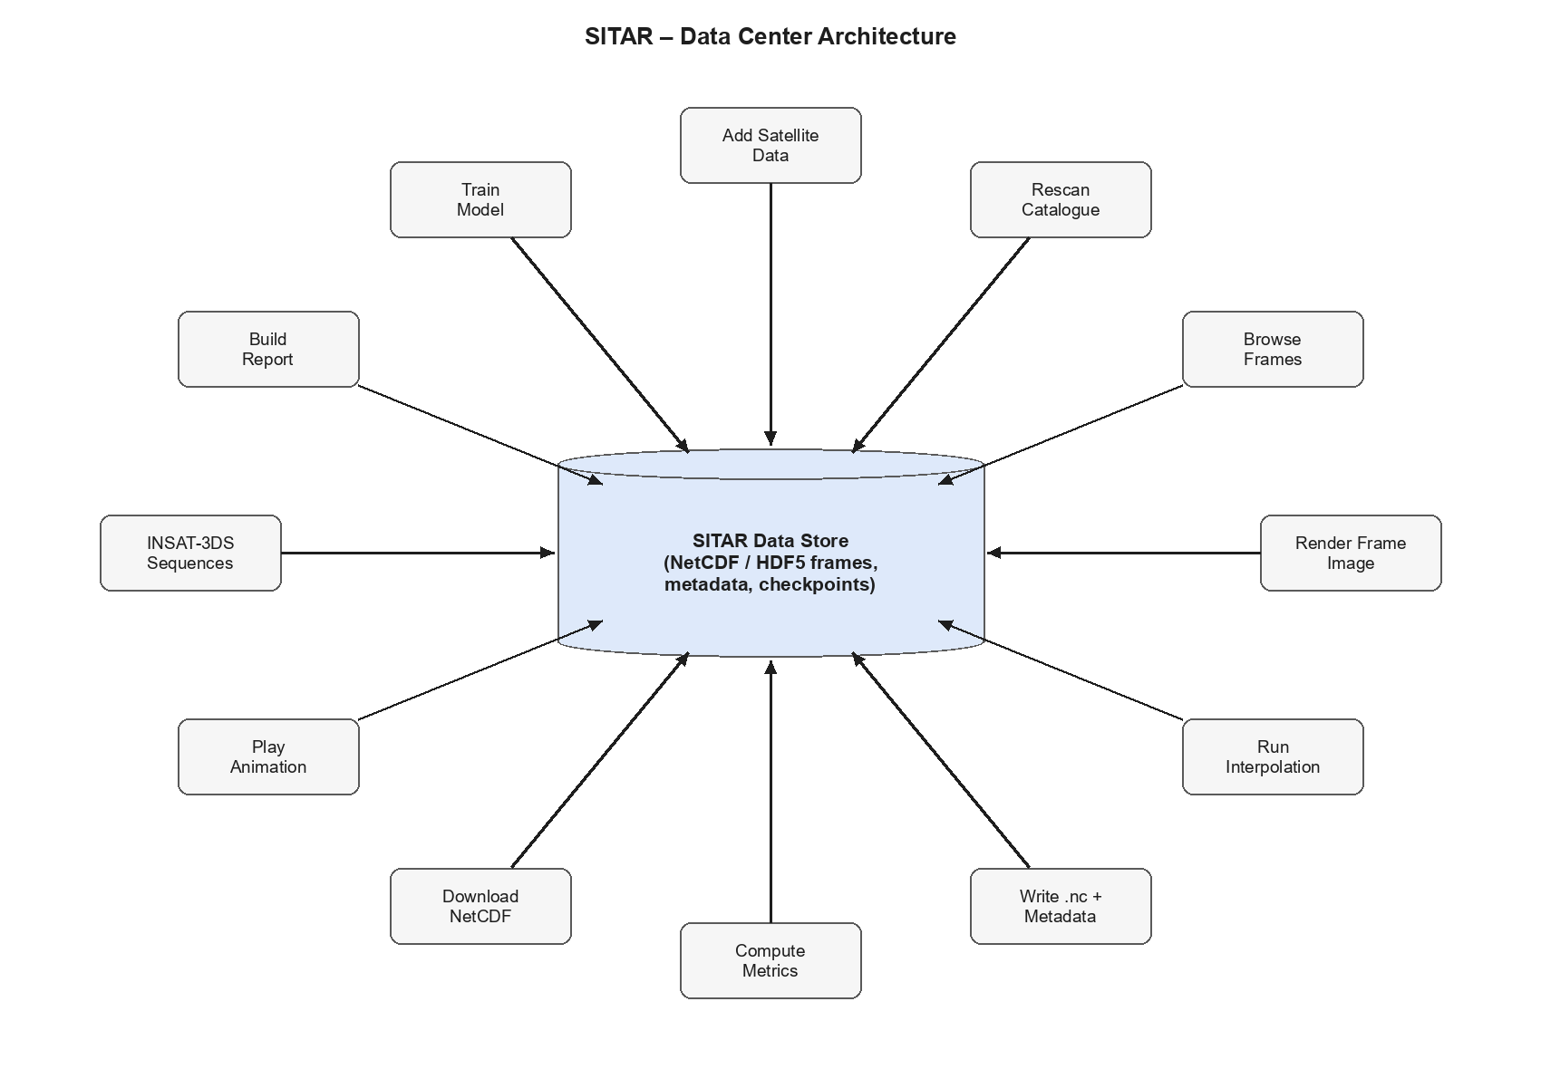
Figure 3.1: Data center architecture of SITAR

3.2 DATA FLOW ARCHITECTURE
3.2.1 DFD Level 0
The Level 0 data flow diagram shows SITAR as one process that interacts with two external entities. The Satellite Data Provider (NOAA, JMA, MOSDAC) supplies thermal infrared files, while the User / Analyst sends frame pairs, interpolation factors and report requests and receives generated frames, metrics and reports. The system reads observed frames from the Source Frame Store, writes outputs to the Generated Frame Store and loads model weights from the Model Checkpoint Store.

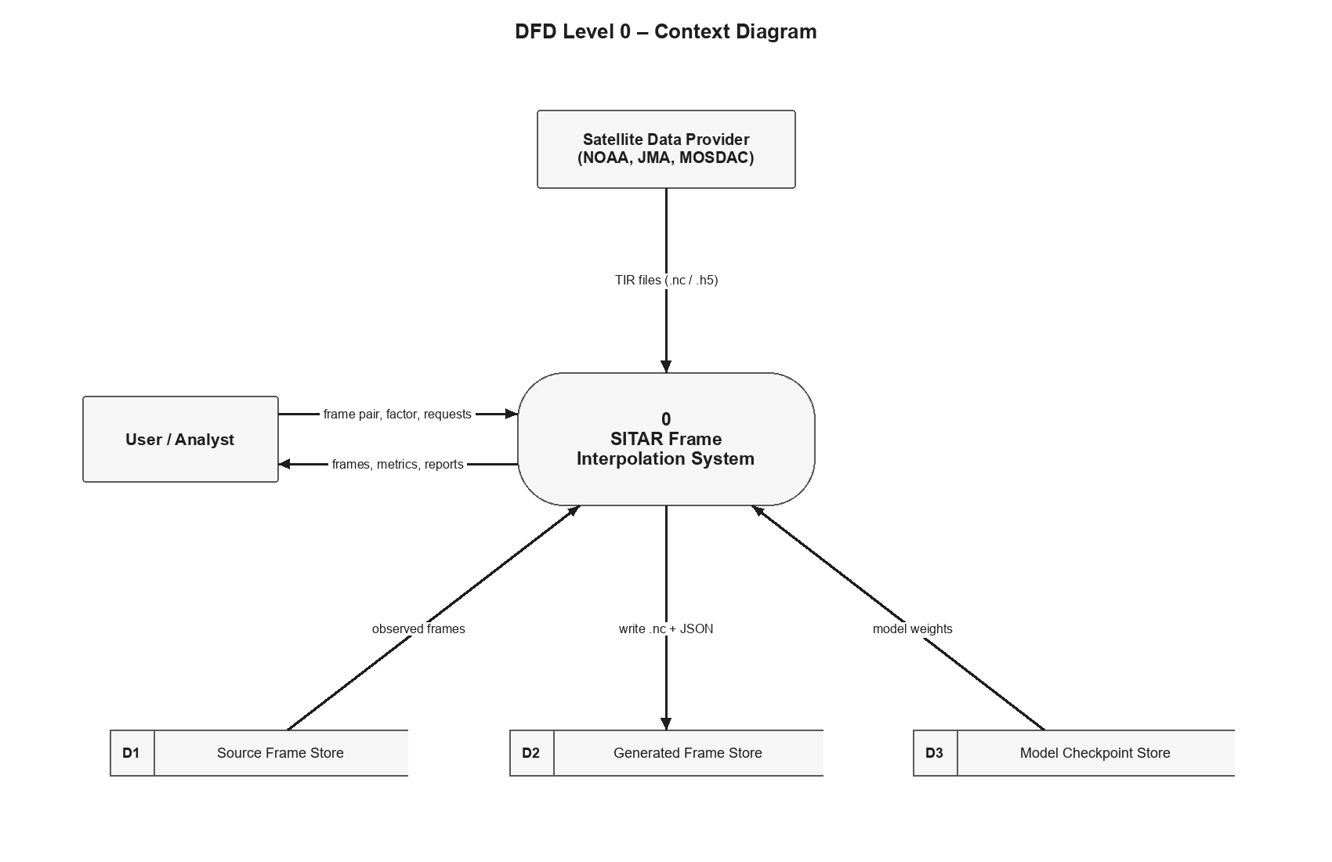
Figure 3.2: DFD Level 0 of SITAR

3.2.2 DFD Level 1: High Level DFD
The Level 1 diagram divides the system into five main processes. Catalogue Frames indexes incoming satellite files; Generate Frames reads the input frames and model weights and writes NetCDF outputs with metadata; Validate Frames compares generated frames with ground truth and stores the metrics; Visualise & Report presents frames and metrics to the user; and Train Model learns from training triplets and saves the best checkpoint. Data is kept in three stores: Source Frames, Generated Frames + Metadata and Checkpoints.
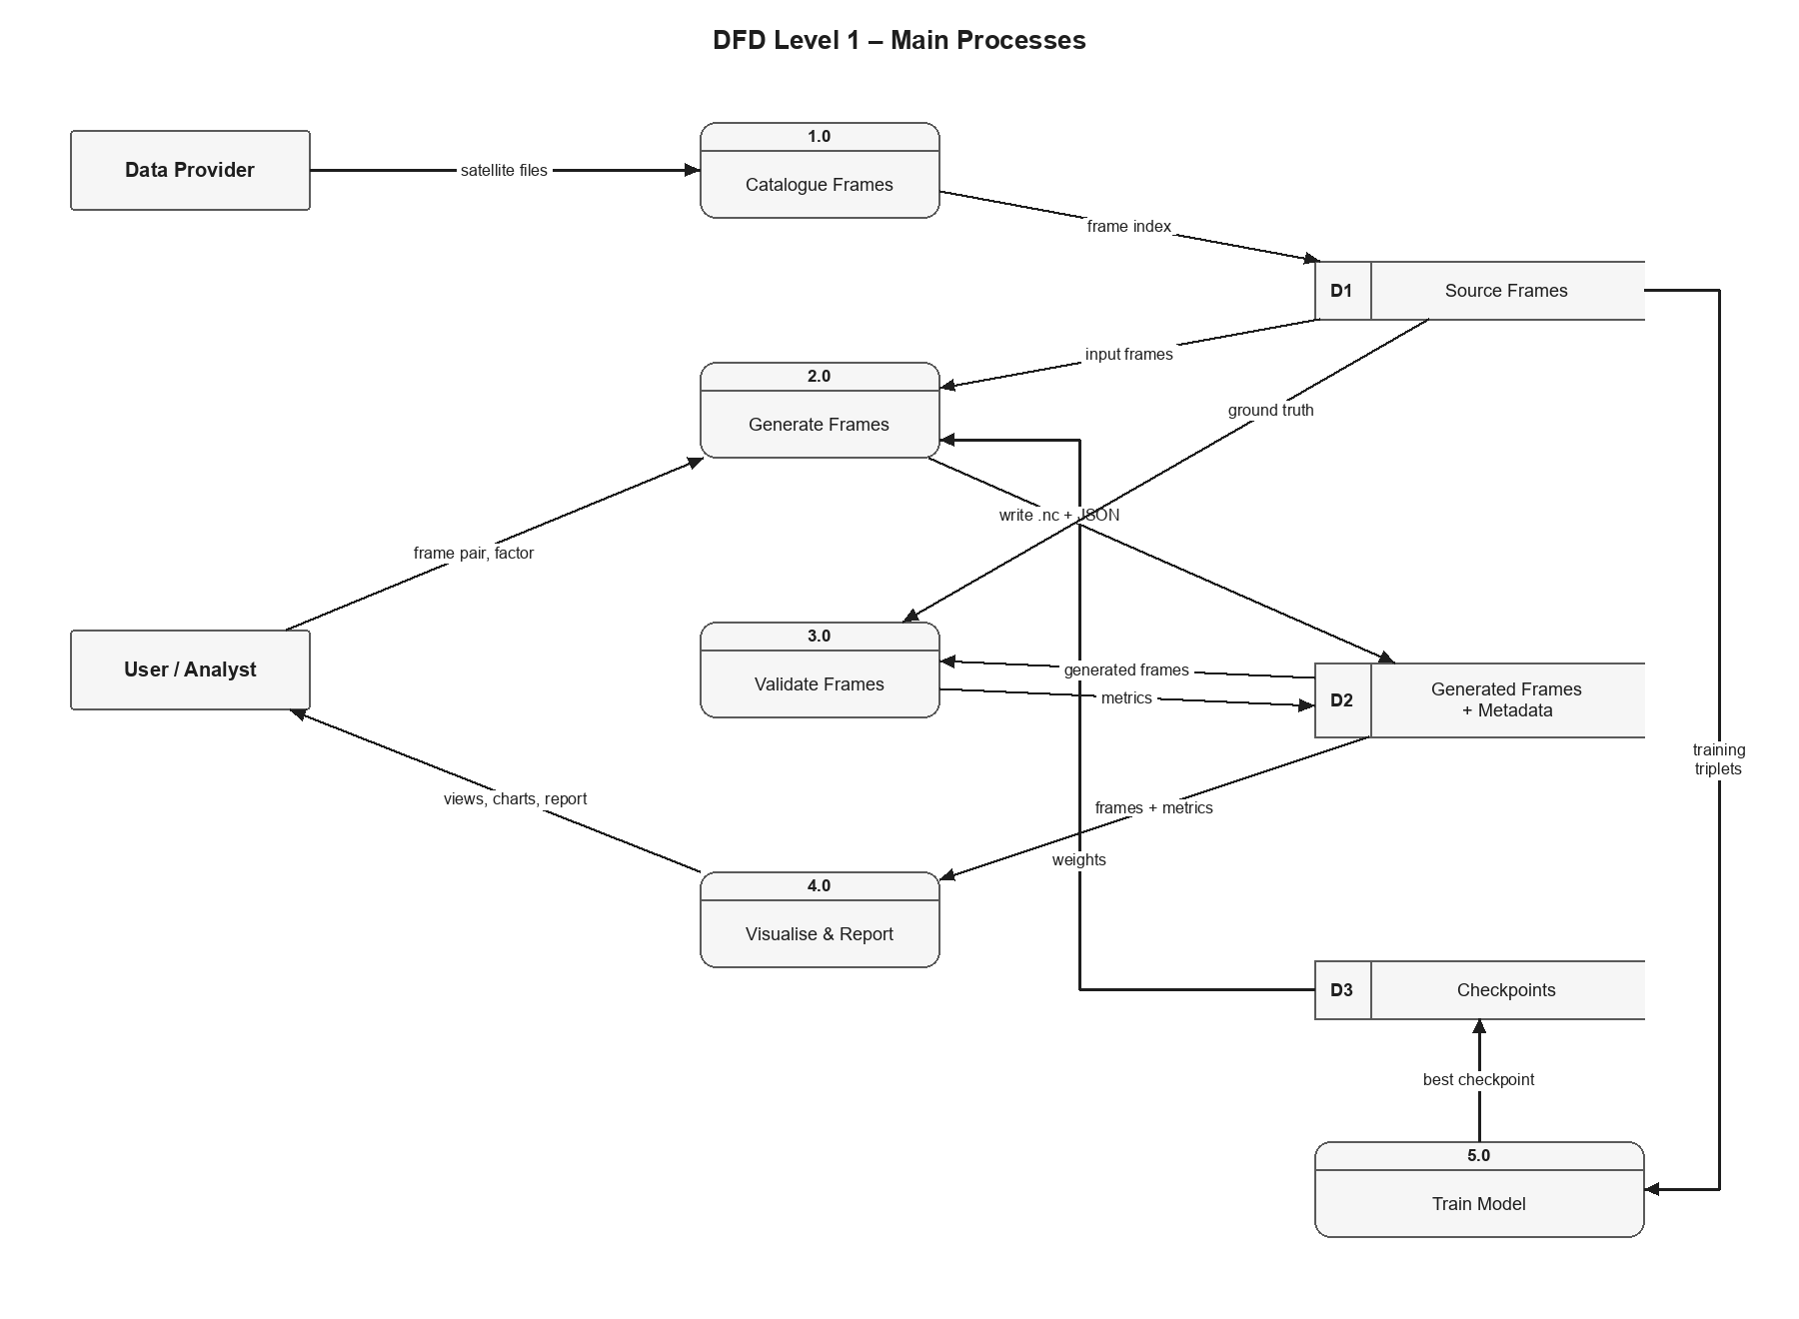
Figure 3.3: DFD Level 1 (high level) of SITAR
3.2.3 DFD Level 2: Detailed DFD
The Level 2 diagram expands process 2.0 Generate Frames. The request from the dashboard is validated (invalid requests return a 400 or 404 error), the two frames are loaded and normalised, the engine is selected based on the available checkpoint, motion is estimated, the frames are warped and blended, and the output is denormalised and written. Finally the frame is scored against the real observation and the job result is returned to the dashboard.
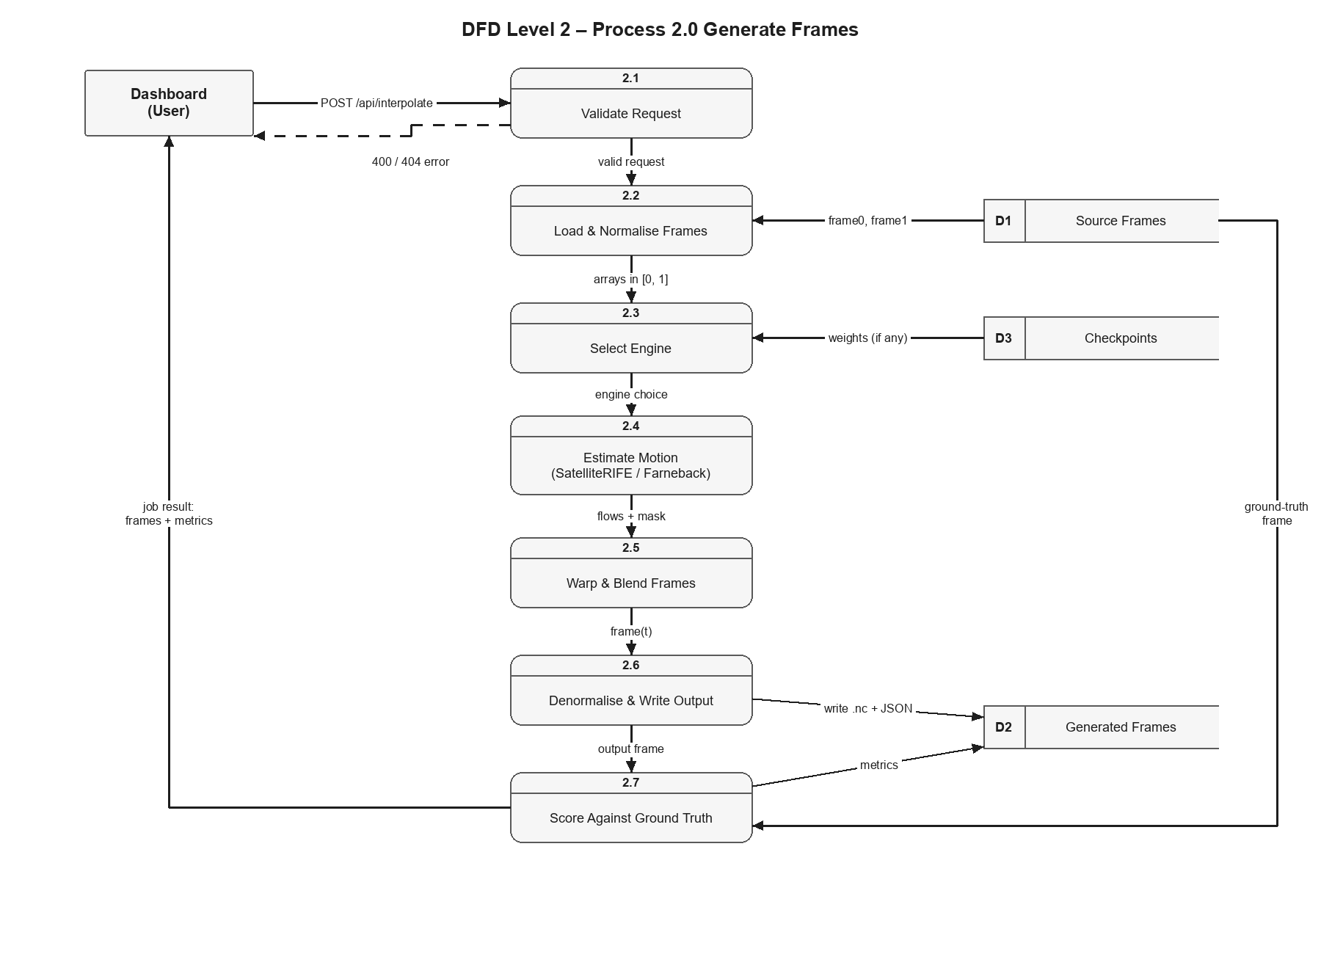
Figure 3.4: DFD Level 2 (detailed) of SITAR
3.3 CALL AND RETURN ARCHITECTURE
SITAR follows the call and return style. The dashboard calls the FastAPI application, whose route handlers call the service functions below them. Each called function (for example Catalog.get, Service.generate, Engine.run or score) performs its work on the data and returns control, with its result, to its caller. This keeps every function small, independent and easy to test or replace — for example, the Engine can switch between SatelliteRIFE and Farneback without any change to its callers.
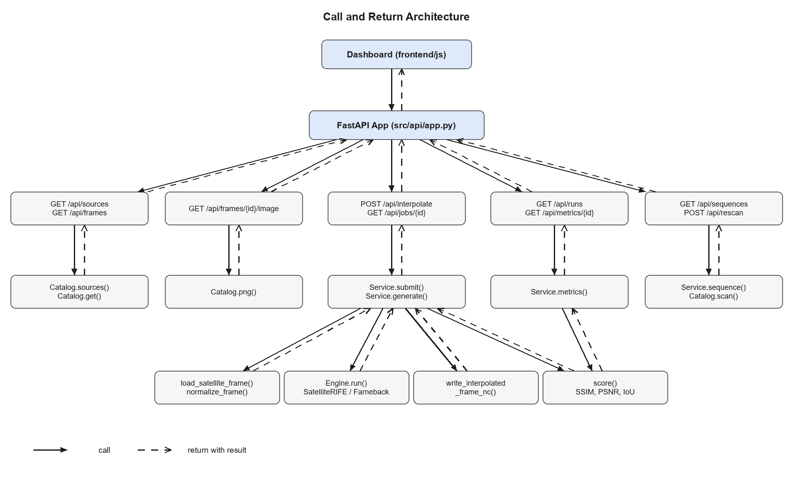
Figure 3.5: Call and return architecture of SITAR
3.4 UML DIAGRAMS
3.4.1 Use Case Diagram
The use case diagram shows how the actors interact with SITAR. The Analyst / User selects satellites and frames, runs interpolation, compares outputs, views difference maps and flow, plays time-lapse animations, views and exports validation metrics, views the INSAT-3DS sequences, builds the comparison report and downloads NetCDF outputs. The Researcher adds satellite data, rescans the catalogue, trains SatelliteRIFE and runs command-line inference. The Application Server is a supporting actor that runs background jobs, stores and retrieves frames and computes metrics.
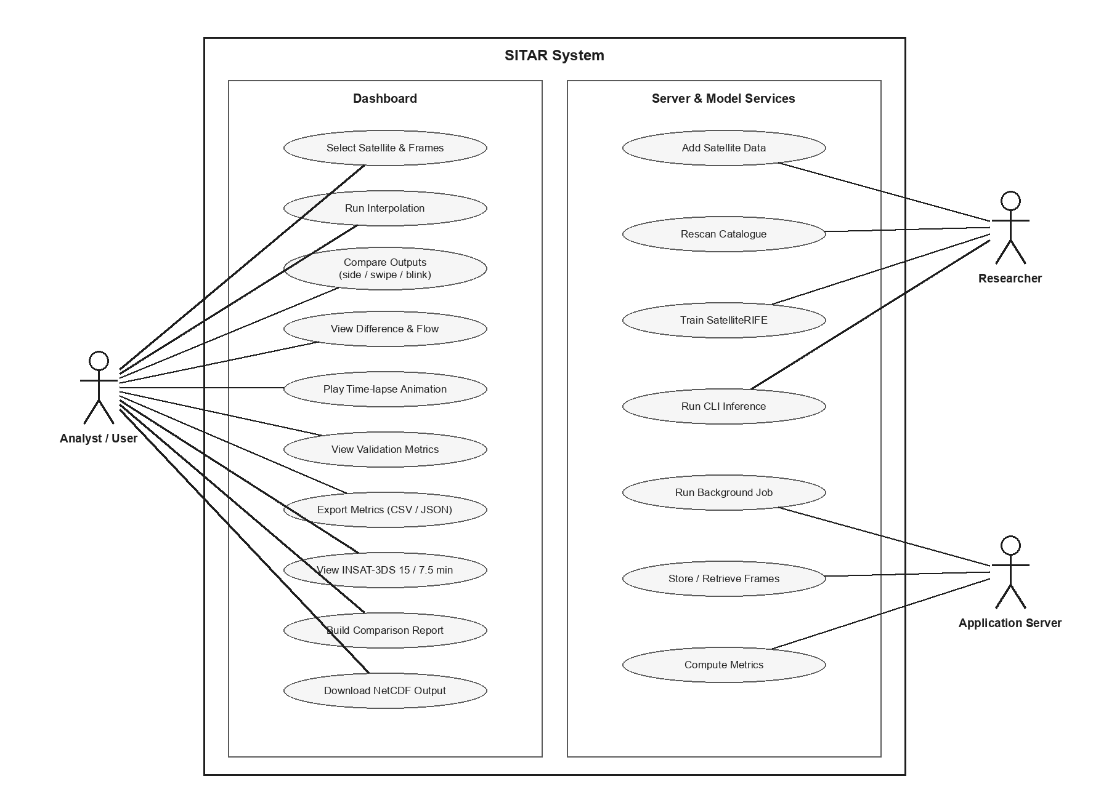
Figure 3.6: Use case diagram of SITAR
3.4.2 Class Diagram
The class diagram shows the main classes of SITAR. Service owns a Catalog and an Engine and manages jobs, validation runs and sequences. Catalog holds many Frame objects and caches their values and images. Engine optionally owns a SatelliteRIFE model, which is composed of IFNet (multi-scale flow estimation) and FusionNet (residual refinement). SatelliteFrameDataset and CombinedInterpolationLoss are used to train the model.
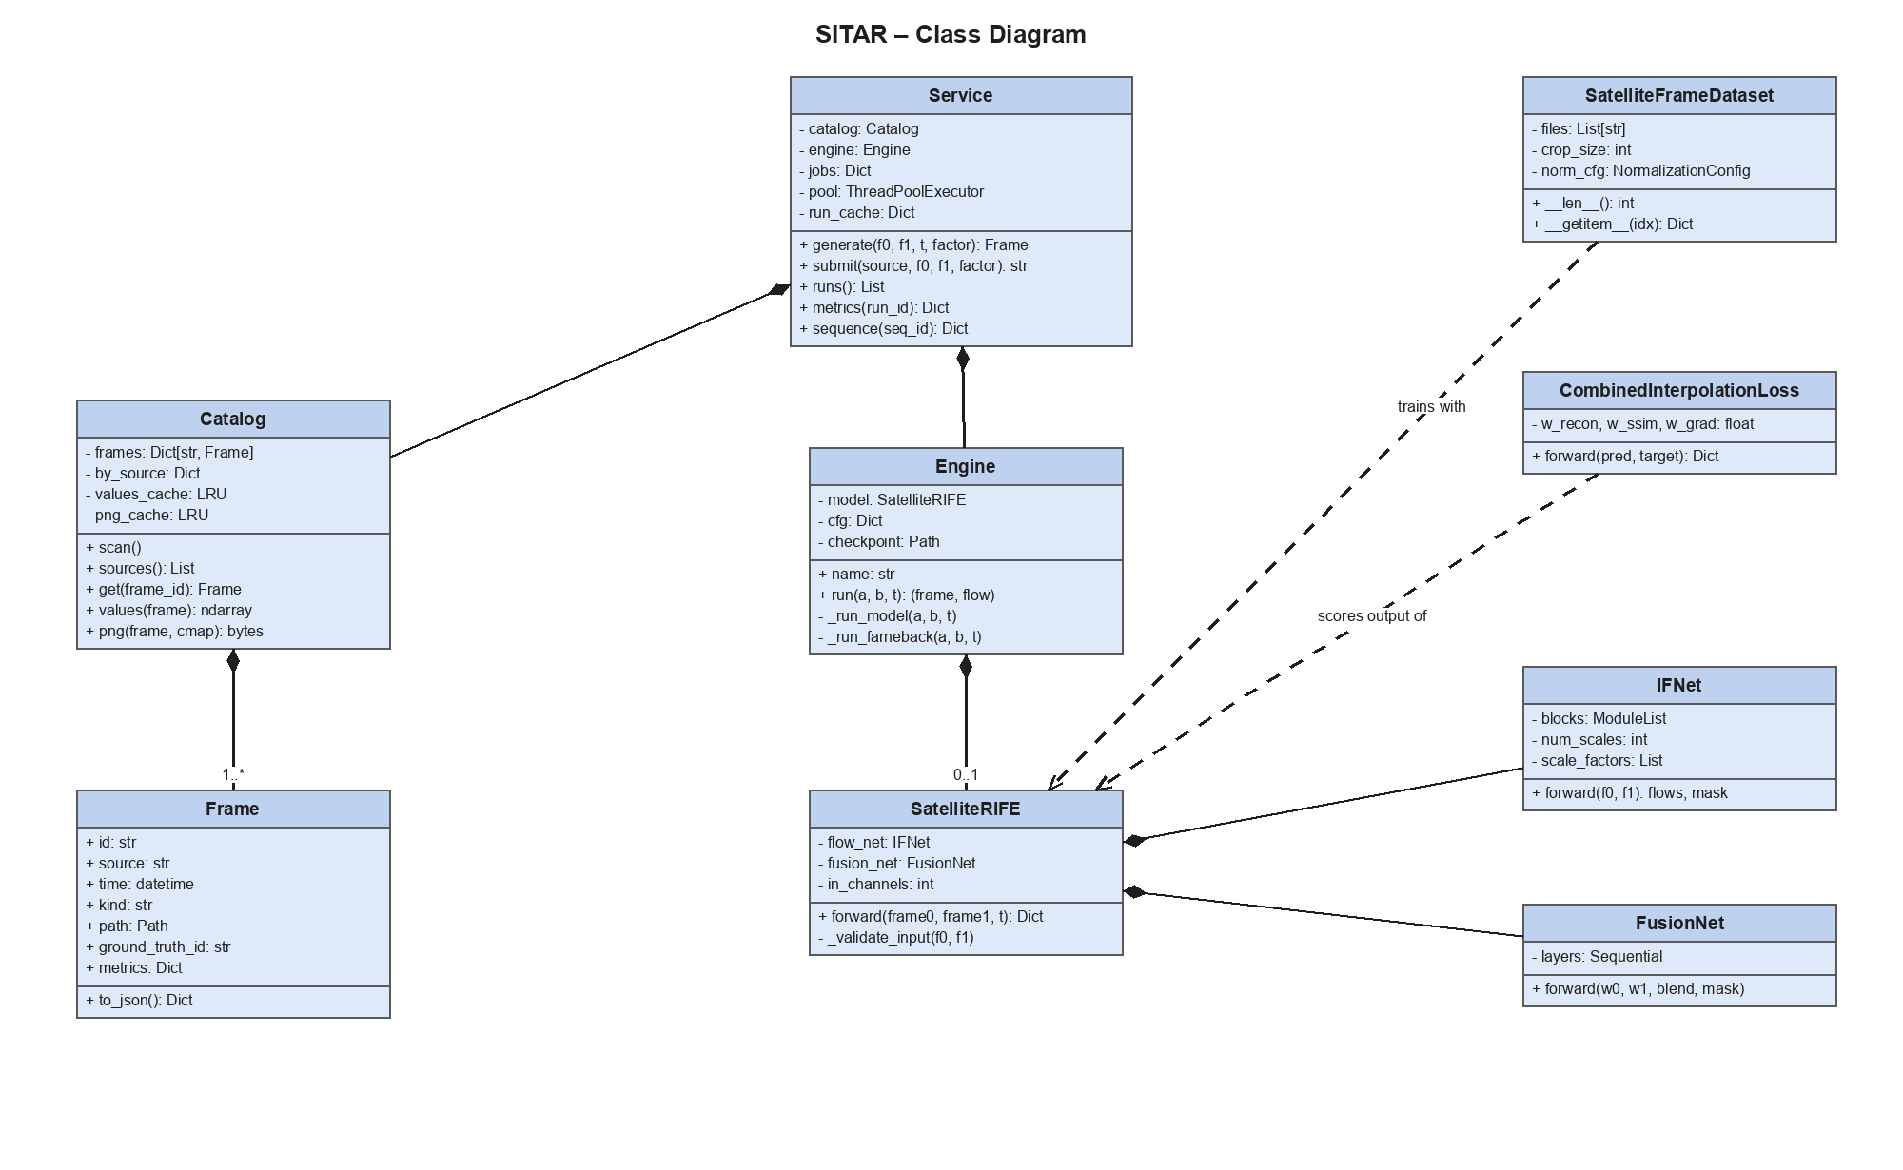
Figure 3.7: Class diagram of SITAR
3.4.3 Sequence Diagram
The sequence diagram shows how an interpolation is run. The user selects frames in the dashboard, which posts the request to the FastAPI app. The app submits a job to the Service and immediately returns a job id. In a background thread the Service reads both frames from the file store, asks the Engine to compute the intermediate frame, writes the NetCDF output with its metadata and scores it against the ground truth. The dashboard polls the job status and displays the frames and metrics once the job is done.
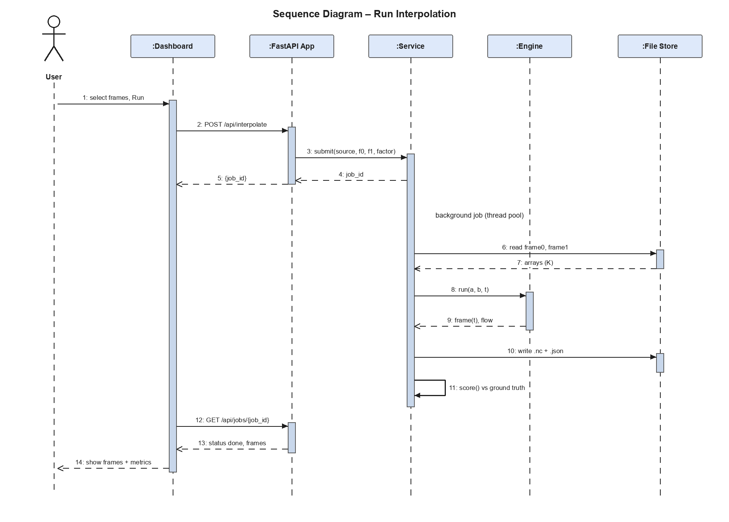
Figure 3.8: Sequence diagram of SITAR
3.4.4 Collaboration Diagram
The collaboration diagram shows the same interaction as numbered messages between objects. The User starts the run in the Dashboard, which calls the FastAPI App; the app submits the job to the Service. The Service obtains the frames from the Catalog, calls the Engine, writes the result to the File Store and scores it, and the result returns through the app to the dashboard.
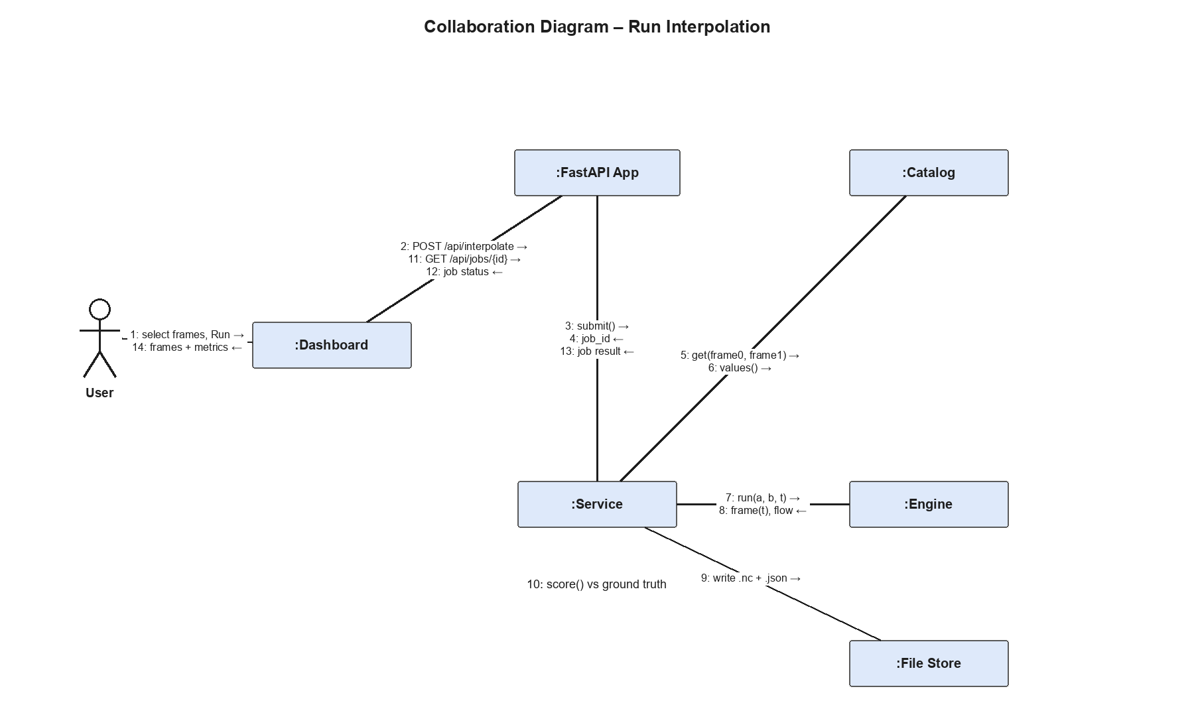
Figure 3.9: Collaboration diagram of SITAR
3.4.5 Activity Diagram
The activity diagram shows the flow of an interpolation request. The user selects a satellite, a frame pair and a factor; the frames are read and normalised. If a model checkpoint is found, SatelliteRIFE is used; otherwise the Farneback engine is used. The intermediate frames are synthesised and written with metadata. If a ground-truth frame exists, metrics are computed and compared with the linear-blend baseline. The result is then displayed on the dashboard.
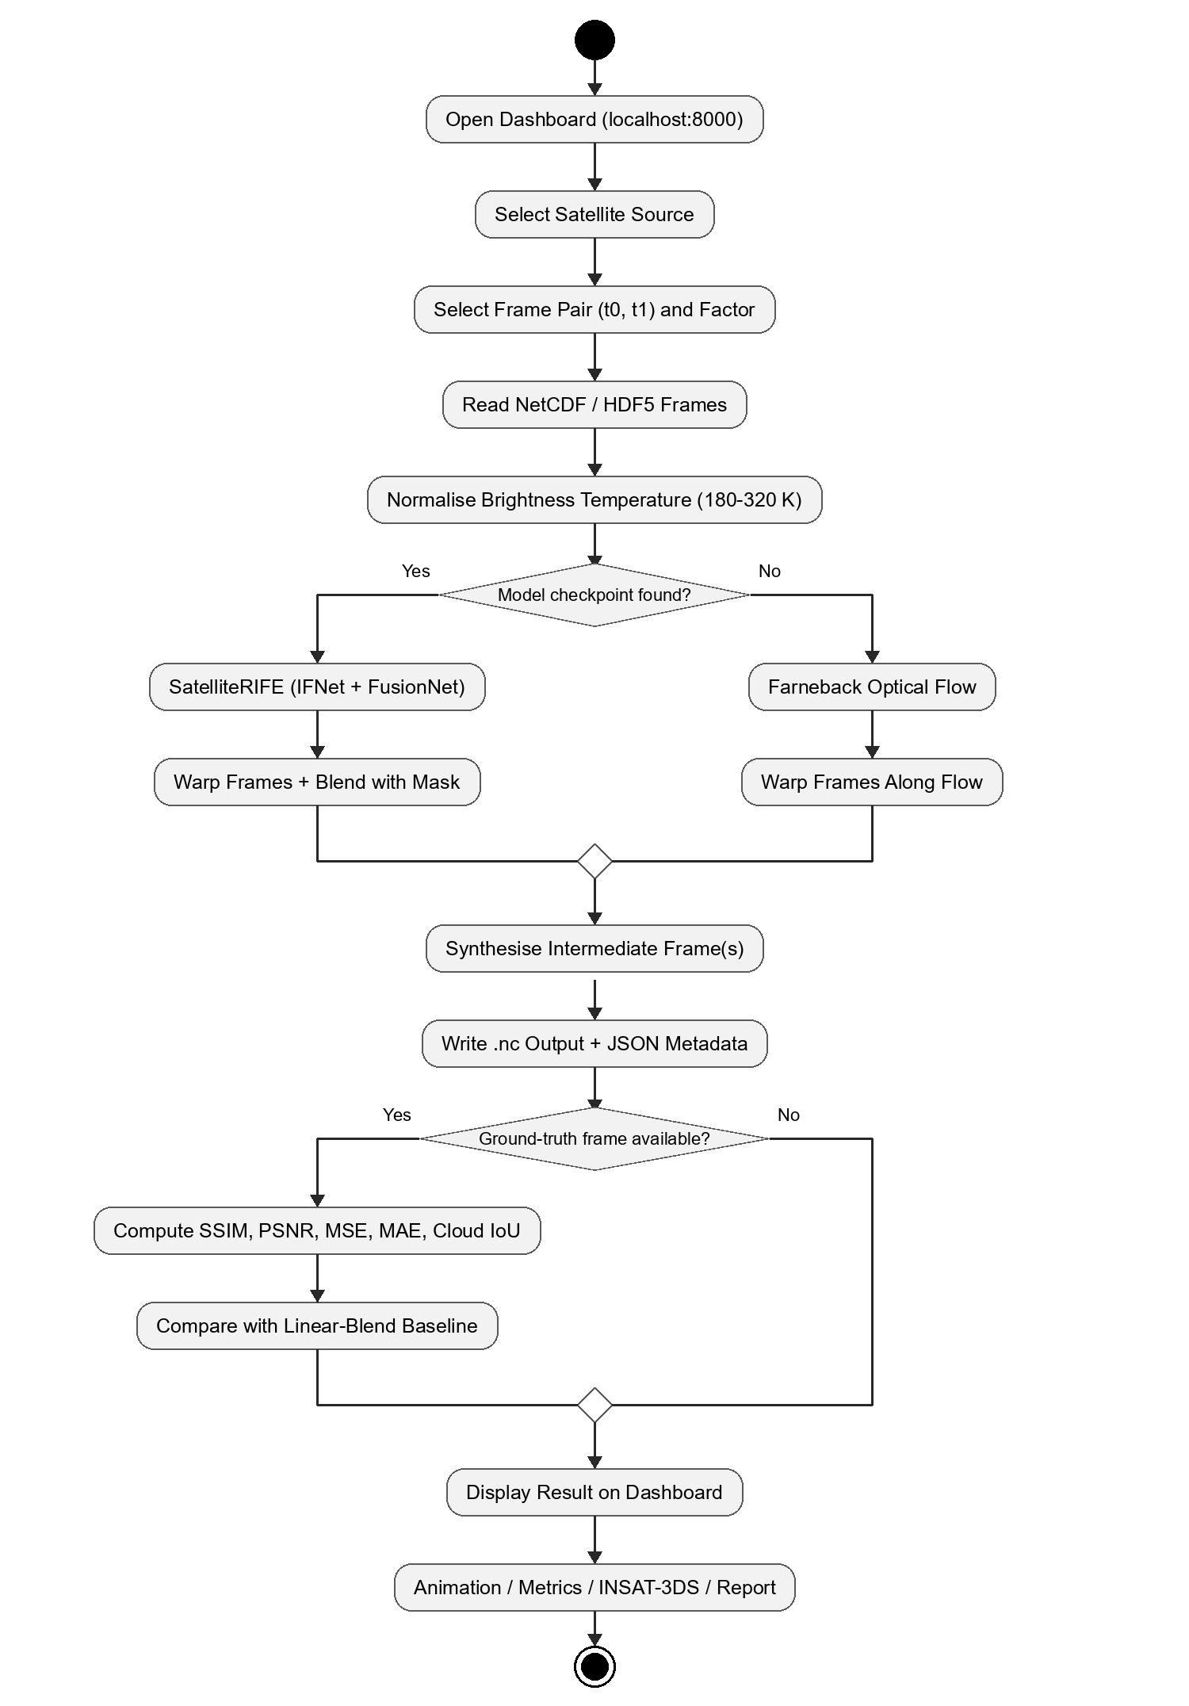
Figure 3.10: Activity diagram of SITAR
3.4.6 Component Diagram
The component diagram shows the deployment of SITAR. The Client (Web Browser) contains the Workbench, Animation Player, Metrics Charts, INSAT-3DS View and Report Builder, which communicate with the server through the api.js REST client over HTTP/JSON. The Application Server runs the FastAPI App, the Service layer and the Interpolation Package with the OpenCV fallback. The Storage node holds the source data, generated outputs and model checkpoints.
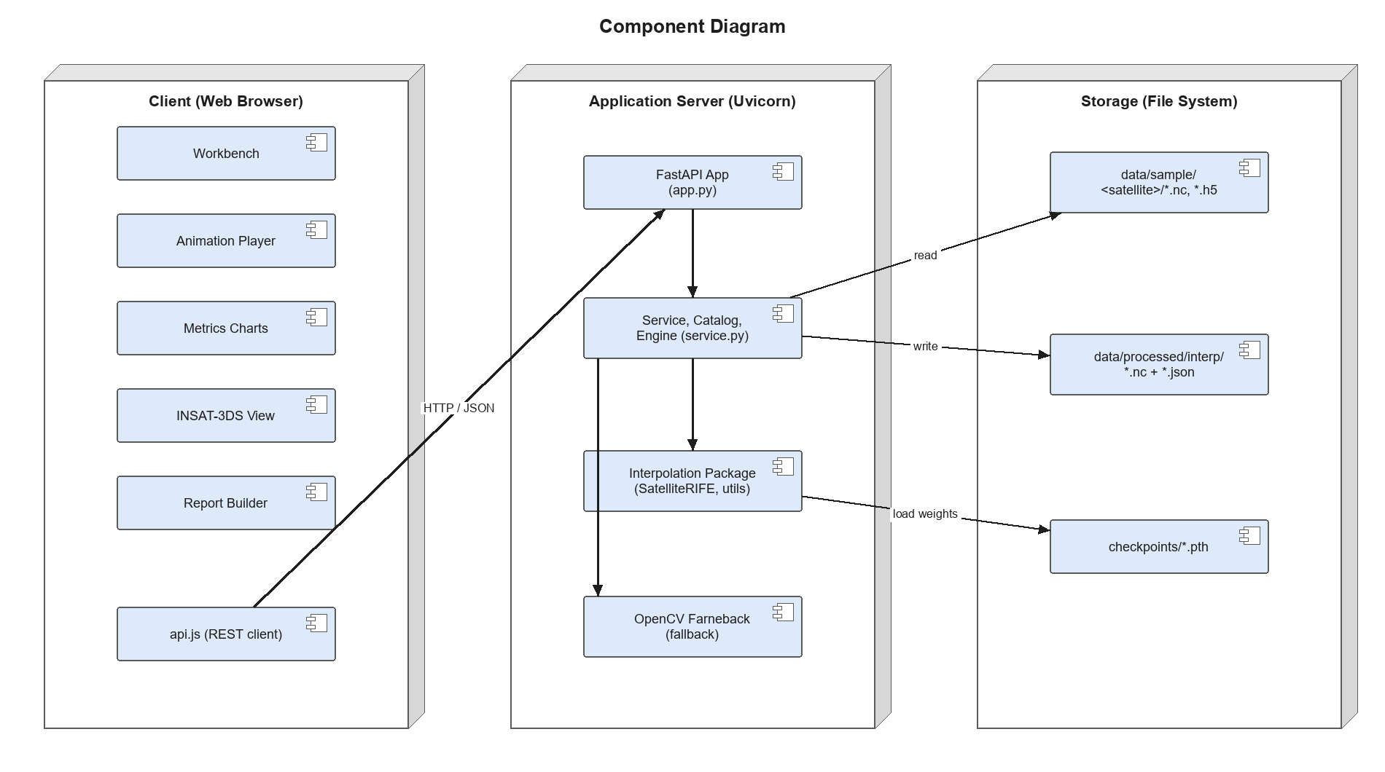
Figure 3.11: Component diagram of SITAR
3.4.7 Deployment Diagram
The deployment diagram shows the physical nodes on which SITAR runs and the artifacts deployed on each. The User PC runs a web browser that loads the dashboard files (index.html, styles and JavaScript modules) and communicates with the Application Server over HTTP on port 8000, exchanging JSON, PNG images and NetCDF files. The Application Server runs a Python 3.10 virtual environment in which the Uvicorn ASGI server hosts the FastAPI application, the service layer, the PyTorch SatelliteRIFE model and the OpenCV Farneback engine; a CUDA GPU is optional. The server reads and writes the Storage node, which holds the source frames, generated outputs with metadata and model checkpoints. Satellite files are downloaded from NOAA, JMA and MOSDAC into storage, and the model is trained on a separate GPU workstation whose best checkpoint is copied to the checkpoints folder.
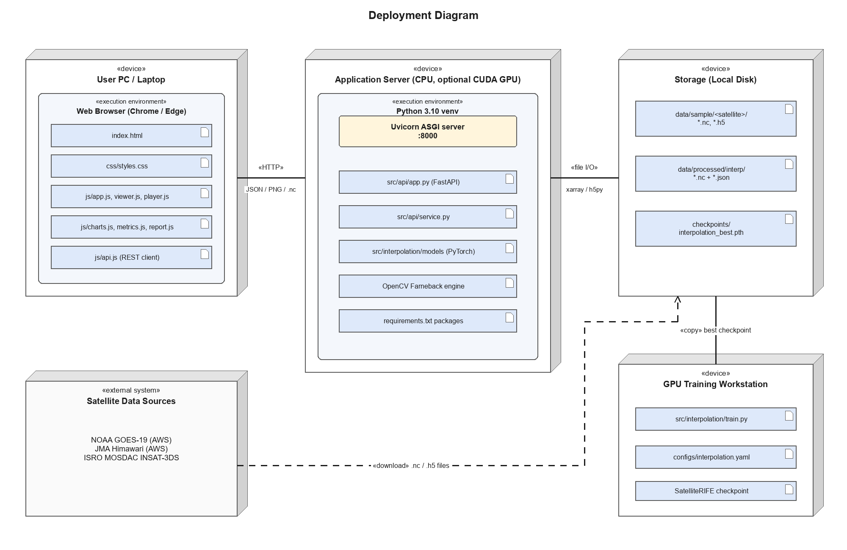
Figure 3.12: Deployment diagram of SITAR
IMPLEMENTATION
4.1 Description of Development Environment
SITAR is developed as a Python application with a web dashboard. The backend provides the frame catalogue, interpolation jobs, image rendering and validation, while the dashboard provides the user interface; both are served by the same FastAPI server.
• Operating System: Windows / Linux / macOS
• IDE Used: Visual Studio Code
• Language: Python 3.10+ (backend and model) and JavaScript (dashboard)
• Deep Learning: PyTorch, with a CUDA GPU recommended for training
• Backend: FastAPI served by Uvicorn
• Data: NetCDF / HDF5 files in data/sample/<satellite>/
• Testing Environment: pytest and a local server opened in a web browser
• Version Control: Git and GitHub
Steps to Run the Project:
1. Open the SITAR project folder in a code editor.
2. Create a virtual environment with python -m venv .venv and activate it.
3. Install the dependencies with pip install -r requirements.txt.
4. Place satellite .nc / .h5 files in data/sample/<satellite>/, or generate sample data with python scripts/make_sample_data.py.
5. Optionally place a trained checkpoint in checkpoints/interpolation_best.pth to use SatelliteRIFE.
6. Start the server with python -m uvicorn src.api.app:app --port 8000.
7. Open http://localhost:8000 in a web browser and use the dashboard.
The model is trained with python -m src.interpolation.train --config src/interpolation/configs/interpolation.yaml, and the test suite is run with python -m pytest.
4.2 Tools and Technologies Used
SITAR uses the following tools and technologies to develop and maintain its functionality:
• Deep Learning: PyTorch for the SatelliteRIFE model, training loop and inference.
• Classical Optical Flow: OpenCV for the Farneback engine and image remapping.
• Numerical Computing: NumPy, SciPy and pandas for array operations.
• Satellite Data I/O: xarray, netCDF4, h5netcdf, h5py and dask for NetCDF and HDF5 files.
• Metrics: scikit-image for SSIM and PSNR, with custom MSE, MAE, gradient SSIM and cold-cloud IoU.
• Backend Framework: FastAPI for REST endpoints and request validation; Uvicorn as the ASGI server.
• Image Rendering: Pillow for PNG frames with grey and enhanced IR palettes.
• User Interface: HTML5, CSS3 and JavaScript with canvas and SVG.
• Configuration and Testing: PyYAML for configuration and pytest for automated tests.
Project Structure
The SITAR project is organised into model, API, dashboard, script and test folders.
Model and data (src/interpolation/)
• models/: SatelliteRIFE, IFNet, FusionNet and backward warping.
• dataset.py: triplet dataset with time ordering, cropping and flipping.
• losses.py: Charbonnier, SSIM, gradient and combined losses.
• train.py / inference.py: training loop and command-line inference.
• utils.py: NetCDF/HDF5 loading, normalisation, NetCDF writing and metrics.
• configs/interpolation.yaml: model, data, training and loss configuration.
Backend (src/api/)
• app.py: FastAPI routes and static hosting of the dashboard.
• service.py: frame catalogue, engines, PNG rendering, jobs, runs and sequences.
Frontend (frontend/) and others
• index.html, css/: dashboard layout and styling.
• js/: api.js (REST client), viewer.js, player.js, charts.js, metrics.js, report.js and app.js.
• scripts/make_sample_data.py: generates synthetic GOES-19, Himawari and INSAT-3DS sequences.
• tests/: pytest tests for the dataset, model and input/output.
• requirements.txt: Python dependencies.
4.3 Screenshots of the Application
Screenshots of the running application are shown below.
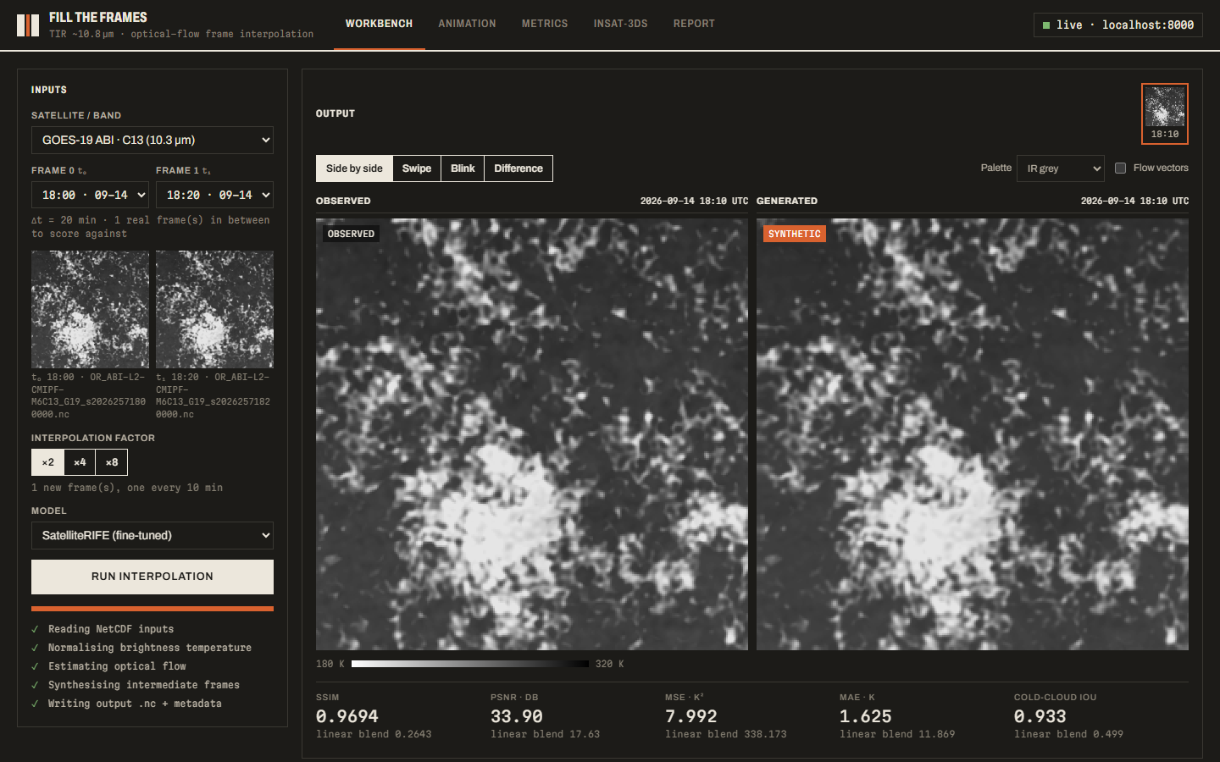
Figure 4.1: Workbench – observed and generated frame side by side
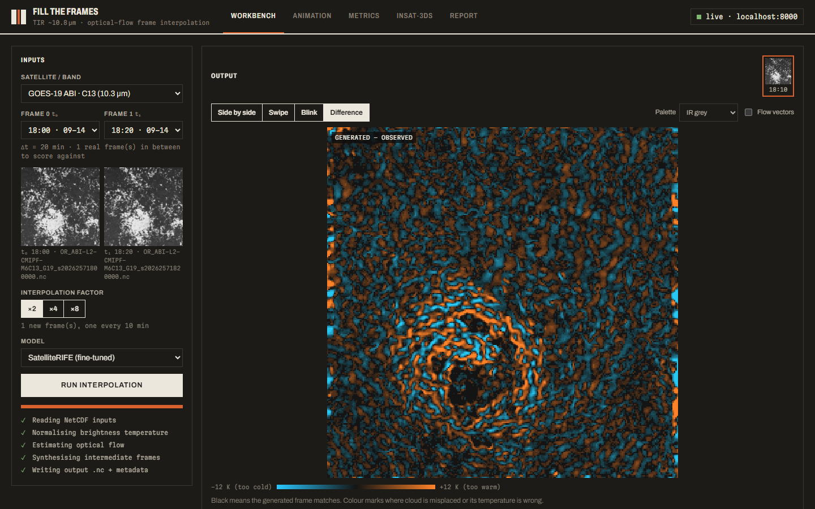
Figure 4.2: Workbench – difference view
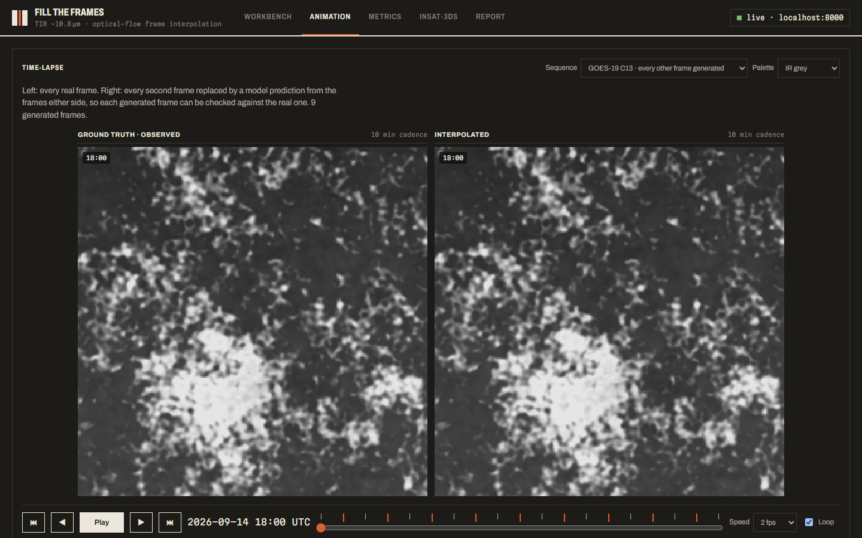
Figure 4.3: Animation – ground truth and interpolated time-lapse
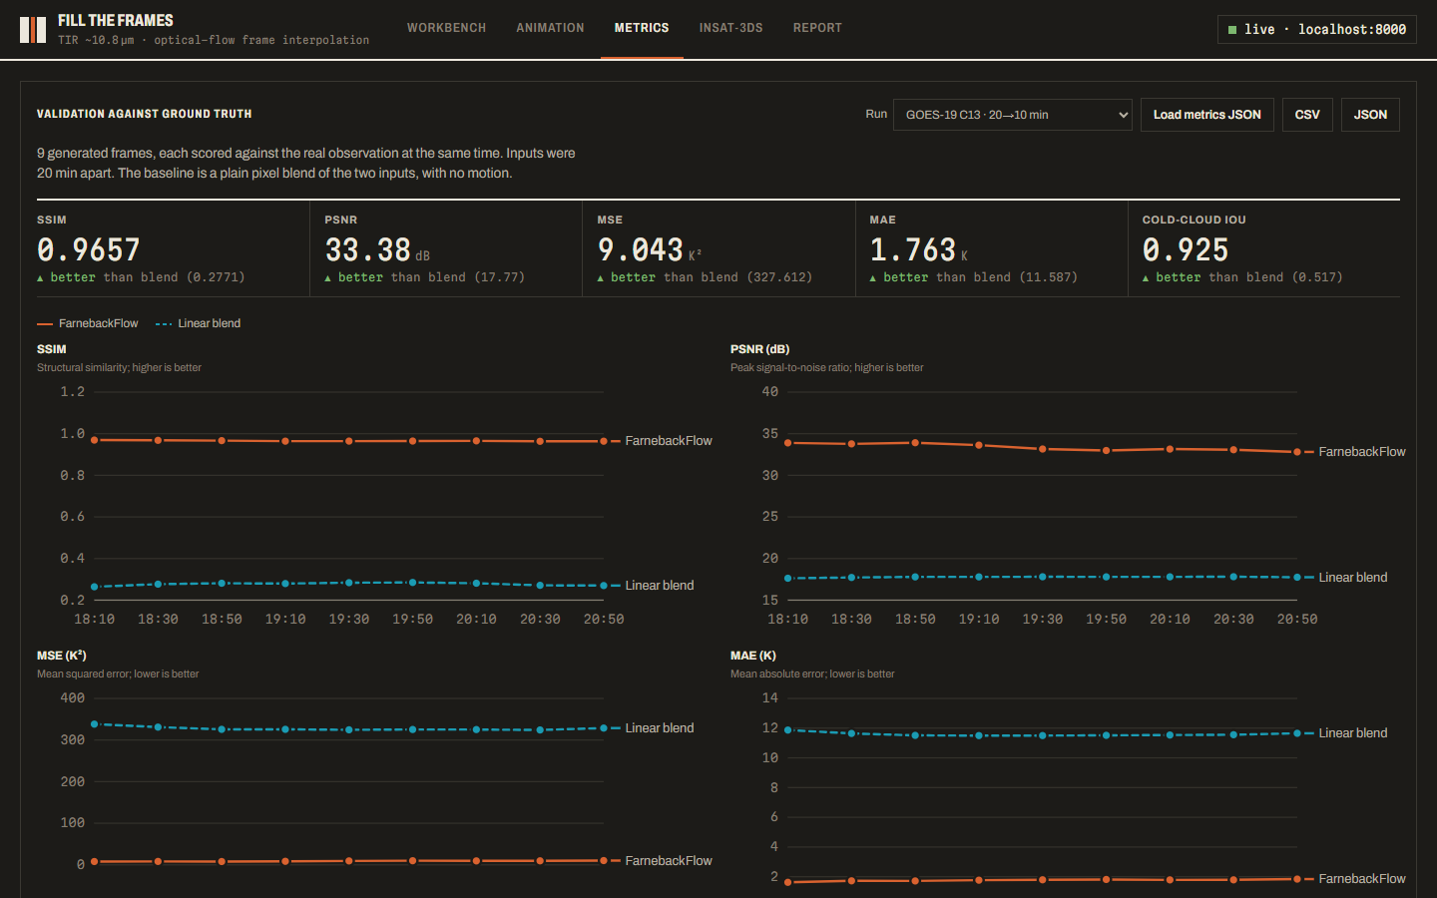
Figure 4.4: Metrics – validation against ground truth
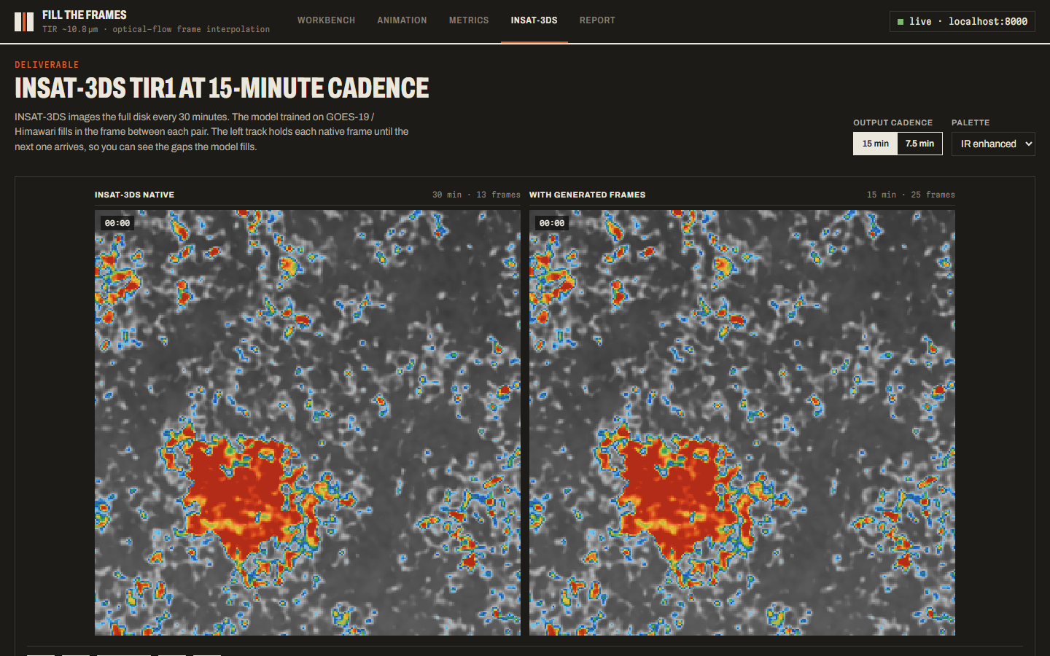
Figure 4.5: INSAT-3DS – 30-minute and 15-minute sequences
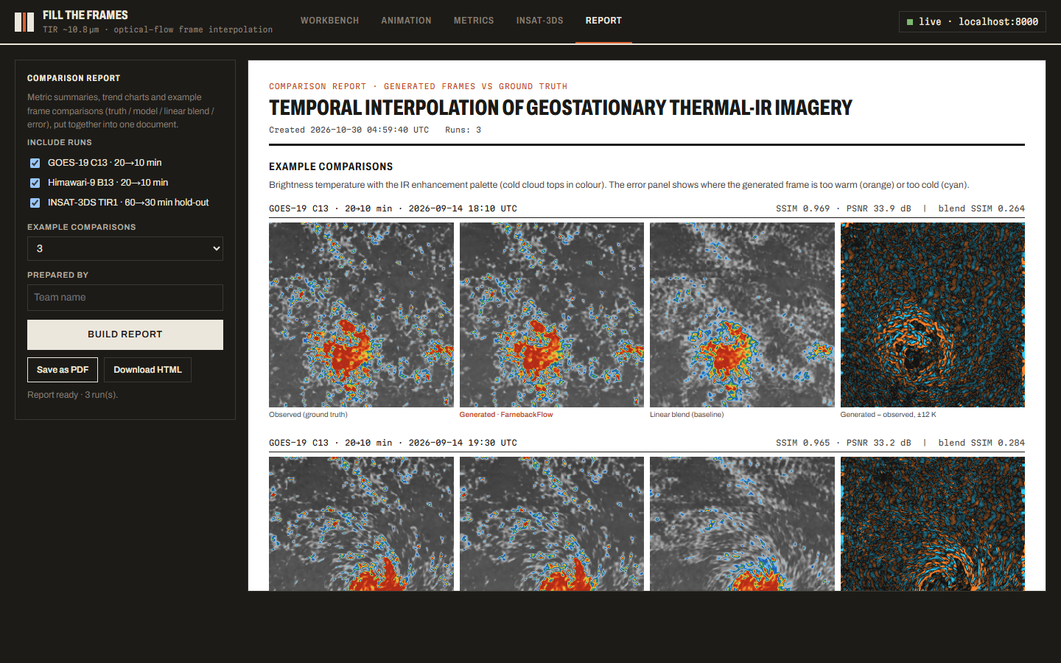
Figure 4.6: Report – comparison report
Description of the Screens:
• Workbench: select a satellite, two input frames, the factor and the model; progress steps are shown while the job runs, and the generated frame appears beside the observation with its metrics.
• Difference View: shows where the generated frame is too warm (orange) or too cold (cyan); swipe, blink and flow-vector modes help inspect cloud edges.
• Animation: plays the observed sequence beside a sequence in which every second frame is a prediction, with play, step, speed and loop controls.
• Metrics: summary cards and per-frame SSIM, PSNR, MSE and MAE charts comparing the model with the linear blend, with CSV/JSON export.
• INSAT-3DS: shows the native 30-minute sequence (13 frames) beside the 15-minute output (25 frames), with a 7.5-minute option.
• Report: builds a comparison report with summary tables, charts and truth / model / baseline / error panels, saved as PDF or HTML.
TESTING AND VALIDATION
5.1 Validation of Data Integrity and Accuracy
Testing in SITAR focuses on verifying that satellite frames are read correctly, that generated frames are accurate and clearly labelled, and that invalid inputs are handled safely. The main objective is to ensure that physical values remain consistent from input to output and that every result can be checked against real observations.
Key Validation Areas
• Input Data Validation: the TIR variable and timestamp are detected for every file, and missing (NaN) values are filled before processing.
• Model Input Validation: both frames must have the same shape and exactly one channel; RGB or mismatched inputs are rejected.
• Value Range: brightness temperature is normalised from 180–320 K to [0, 1] and outputs are clamped and converted back to Kelvin.
• Request Validation: missing fields return 422, unknown frames 404 and unsupported models 400 with a clear message.
• Output Integrity: NetCDF outputs are written with time and units, and existing files are never overwritten.
• Accuracy Validation: generated frames are scored against real observations and a linear-blend baseline.
• Traceability: each output has a metadata sidecar and is labelled as synthetic in the dashboard.
Test Cases
The following test cases were executed on SITAR. Cases 1–10 are automated pytest tests; cases 11–18 were run against the running application.
No. | Test Case | Action / Input | Expected Result | Result
1 | Triplet creation | Build dataset from ordered frames. | Triplets (I0, I_mid, I1) in time order. | Pass
2 | Time ordering | Supply frames out of order. | Frames sorted by time, not randomly. | Pass
3 | Too few frames | Build dataset from two frames. | A clear error is raised. | Pass
4 | Zero-flow warp | Warp a frame with zero flow. | Output equals input. | Pass
5 | Single channel | Run model on 1-channel frames. | 1-channel output of the same size. | Pass
6 | Wrong channels | Pass an RGB (3-channel) input. | Input rejected with an error. | Pass
7 | External flow | Run model with initial flows. | Valid output is produced. | Pass
8 | NaN handling | Load a frame containing NaNs. | Correct shape; NaNs handled. | Pass
9 | Normalisation | Normalise then denormalise. | Original values recovered. | Pass
10 | NetCDF output | Write a frame; write again to same path. | Valid file; overwrite refused. | Pass
11 | Health check | GET /api/health. | Status ok with engine and data folder. | Pass
12 | Interpolation job | Run ×4 interpolation. | Job completes with 3 frames. | Pass
13 | Unsupported model | Request model SuperSloMo. | 400 with list of available models. | Pass
14 | Unknown frame | Request image of unknown frame. | 404 Not Found. | Pass
15 | NetCDF download | GET /api/frames/{id}/nc. | File returned as application/x-netcdf. | Pass
16 | Rescan | POST /api/rescan. | Sources re-listed with frame counts. | Pass
17 | Dashboard run | Run interpolation in Workbench. | Generated frame and metrics shown. | Pass
18 | Report | Build the comparison report. | Report with 3 runs and example panels. | Pass

Accuracy Against Ground Truth
Every second frame of each sample sequence was removed, regenerated and compared with the real frame (averages over all generated frames; Farneback engine on the project's sample sequences).
Dataset (gap filled) | Engine | SSIM ↑ | PSNR (dB) ↑ | MAE (K) ↓ | Cloud IoU ↑
GOES-19 C13 (20→10 min) | Optical flow | 0.966 | 33.38 | 1.76 | 0.925
 | Linear blend | 0.277 | 17.77 | 11.59 | 0.517
Himawari B13 (20→10 min) | Optical flow | 0.971 | 32.78 | 1.73 | 0.937
 | Linear blend | 0.271 | 17.61 | 12.11 | 0.565
INSAT-3DS TIR1 (60→30 min) | Optical flow | 0.763 | 21.72 | 6.02 | 0.751
 | Linear blend | 0.169 | 15.22 | 16.91 | 0.373

5.2 Performance Evaluation
Performance evaluation focuses on responsiveness, accuracy and reliability. Measurements were taken on a Windows laptop (CPU only) with the server running locally and 256 × 256 frames.
• API Response: dashboard, source list, frame list and metrics requests complete in 4–9 ms; a first frame render takes 14 ms and a cached one 4 ms.
• Interpolation Speed: a ×4 job producing 3 frames with the optical-flow engine completes end to end in 0.77 s.
• Model Efficiency: SatelliteRIFE has 611,820 parameters and runs a 256 × 256 frame in 0.043 s on the CPU.
• Accuracy: average SSIM above 0.96 on 10-minute data, compared with about 0.27 for the linear blend.
• Responsiveness: interpolation runs as a background job, so the dashboard stays responsive and shows progress.
• Caching: frames and rendered images are cached, so replays and palette changes do not reload files.
• Reliability: all 13 automated tests pass (in 4.6 s), and invalid requests return clear error messages.
CONCLUSION
6.1 Summary of the Project Achievements
SITAR provides a structured system for increasing the temporal resolution of geostationary satellite imagery. Its main achievements include:
• Satellite Data Handling: reads NetCDF/HDF5 frames and writes outputs as NetCDF with metadata.
• Deep Learning Model: SatelliteRIFE adapts RIFE to single-channel brightness temperature data.
• Classical Fallback: a Farneback optical-flow engine is used automatically and labelled clearly.
• Validation: frames are scored with SSIM, PSNR, MSE, MAE and cold-cloud IoU against ground truth.
• Accuracy: SSIM above 0.96 on 10-minute validation data, far better than linear blending.
• INSAT-3DS Application: 15-minute and 7.5-minute sequences produced from 30-minute input.
• Dashboard: comparison views, time-lapse animation, metric charts and report export in one interface.
The project demonstrates how optical flow and deep learning can be combined with standard scientific data formats and a web interface to make better use of existing satellite observations, supporting closer monitoring of extreme weather in line with SDG 13.
6.2 Key Learning
The development of SITAR provided practical experience in the following areas:
• Working with satellite data formats (NetCDF, HDF5) and physical quantities such as brightness temperature.
• Understanding optical flow, backward warping and video frame interpolation.
• Designing and training deep learning models in PyTorch, including multi-scale networks and custom losses.
• Evaluating generated images with SSIM, PSNR, MSE, MAE and cold-cloud IoU against a simple baseline.
• Building REST APIs with FastAPI and running long tasks as background jobs.
• Creating an interactive dashboard with HTML, CSS, JavaScript, canvas and SVG.
• Writing automated tests and structuring a project for maintainability, and working with Git and GitHub.
Limitations
The accuracy figures in this report come from the Farneback engine on synthetic sample sequences, because SatelliteRIFE has not yet been trained on large real archives. Generated frames are estimates and cannot capture clouds that form entirely between two observations. Processing of full-disk, full-resolution images is limited by the configured maximum image size.
6.3 Future Scope
• Model Training: train SatelliteRIFE on real GOES-19 and Himawari archives on a GPU and compare it with the optical-flow engine.
• INSAT Fine-tuning: fine-tune the trained model on INSAT-3DR/3DS data from MOSDAC.
• Better Metrics: add FSIM and LPIPS, and report accuracy separately for convective and clear-sky regions.
• Improved Flow and Channels: use RAFT as an initial flow estimate and extend interpolation to water-vapour and visible channels.
• Automation and Scale: automate data download and add tiled full-disk GPU processing for near real-time use.
• Applications: use interpolated sequences for cyclone tracking and nowcasting.
REFERENCES
7.1 BOOKS, ARTICLES, WEBSITES AND OTHER RESOURCES
1. Z. Huang, T. Zhang, W. Heng, B. Shi, and S. Zhou, “Real-Time Intermediate Flow Estimation for Video Frame Interpolation,” in Proc. ECCV, 2022.
2. H. Jiang, D. Sun, V. Jampani, M.-H. Yang, E. Learned-Miller, and J. Kautz, “Super SloMo: High Quality Estimation of Multiple Intermediate Frames for Video Interpolation,” in Proc. IEEE CVPR, 2018.
3. G. Farnebäck, “Two-Frame Motion Estimation Based on Polynomial Expansion,” in Proc. Scandinavian Conference on Image Analysis, 2003.
4. Z. Teed and J. Deng, “RAFT: Recurrent All-Pairs Field Transforms for Optical Flow,” in Proc. ECCV, 2020.
5. Z. Wang, A. C. Bovik, H. R. Sheikh, and E. P. Simoncelli, “Image Quality Assessment: From Error Visibility to Structural Similarity,” IEEE Trans. Image Processing, vol. 13, no. 4, 2004.
6. T. J. Schmit et al., “A Closer Look at the ABI on the GOES-R Series,” Bulletin of the American Meteorological Society, vol. 98, no. 4, 2017.
7. K. Bessho et al., “An Introduction to Himawari-8/9 – Japan's New-Generation Geostationary Meteorological Satellites,” J. Meteorological Society of Japan, vol. 94, no. 2, 2016.
8. MOSDAC, Space Applications Centre, ISRO, “INSAT-3DR / INSAT-3DS Data Products.” Retrieved from https://www.mosdac.gov.in/
9. PyTorch Documentation. Official documentation for the PyTorch deep learning framework. Retrieved from https://pytorch.org/docs/
10. FastAPI Documentation. Official documentation for building APIs with FastAPI. Retrieved from https://fastapi.tiangolo.com/
11. xarray Documentation. Labelled multi-dimensional arrays for NetCDF data. Retrieved from https://docs.xarray.dev/
12. OpenCV Documentation. Optical flow and image processing functions. Retrieved from https://docs.opencv.org/
13. MDN Web Docs. Reference for HTML, CSS, JavaScript, Canvas and SVG. Retrieved from https://developer.mozilla.org/
14. United Nations. Sustainable Development Goal 13: Climate Action. Retrieved from https://sdgs.un.org/goals/goal13
15. SITAR Project Repository. Source code and implementation resources. Retrieved from https://github.com/Keya-Nagar25/SITAR

