

实验报告

|  |  |
| --- | --- |
| 姓名： | 强珂阳 |
| 学号： | 57118106 |

东南大学网络空间安全学院

School of Cyber Science & Engineering

Southeast University

2020年9月

TASK1：Manipulating Environment Variables

1.1 printenv

[09/01/20]seed@VM:~$ printenv

XDG_VTNR=7

XDG_SESSION_ID=c1

XDG_GREETER_DATA_DIR=/var/lib/lightdm-data/seed

CLUTTER_IM_MODULE=xim

SESSION=ubuntu

ANDROID_HOME=/home/seed/android/android-sdk-linux

GPG_AGENT_INFO=/home/seed/.gnupg/S.gpg-agent:0:1

TERM=xterm-256color

VTE_VERSION=4205

XDG_MENU_PREFIX=gnome-

SHELL=/bin/bash

DERBY_HOME=/usr/lib/jvm/java-8-oracle/db

QT_LINUX_ACCESSIBILITY_ALWAYS_ON=1

LD_PRELOAD=/home/seed/lib/boost/libboost_program_options.so.1.64.0:/home/seed/lib/boost/libboost_filesystem.so.1.64.0:/home/seed/lib/boost/libboost_system.so.1.64.0

WINDOWID=62914570

UPSTART_SESSION=unix:abstract=/com/ubuntu/upstart-session/1000/1482

GNOME_KEYRING_CONTROL=

GTK_MODULES=gail:atk-bridge:unity-gtk-module

USER=seed

LS_COLORS=rs=0:di=01;34:ln=01;36:mh=00:pi=40;33:so=01;35:do=01;35:bd=40;33;01:cd=40;33;01:or=40;31;01:mi=00:su=37;41:sg=30;43:ca=30;41:tw=30;42:ow=34;42:st=37;44:ex=01;32:*.tar=01;31:*.tgz=01;31:*.arc=01;31:*.arj=01;31:*.taz=01;31:*.lha=01;31:*.lz4=01;31:*.lzh=01;31:*.lzma=01;31:*.tlz=01;31:*.txz=01;31:*.tzo=01;31:*.t7z=01;31:*.zip=01;31:*.z=01;31:*.Z=01;31:*.dz=01;31:*.gz=01;31:*.lrz=01;31:*.lz=01;31:*.lzo=01;31:*.xz=01;31:*.bz2=01;31:*.bz=01;31:*.tbz=01;31:*.tbz2=01;31:*.tz=01;31:*.deb=01;31:*.rpm=01;31:*.jar=01;31:*.war=01;31:*.ear=01;31:*.sar=01;31:*.rar=01;31:*.alz=01;31:*.ace=01;31:*.zoo=01;31:*.cpio=01;31:*.7z=01;31:*.rz=01;31:*.cab=01;31:*.jpg=01;35:*.jpeg=01;35:*.gif=01;35:*.bmp=01;35:*.pbm=01;35:*.pgm=01;35:*.ppm=01;35:*.tga=01;35:*.xbm=01;35:*.xpm=01;35:*.tif=01;35:*.tiff=01;35:*.png=01;35:*.svg=01;35:*.svgz=01;35:*.mng=01;35:*.pcx=01;35:*.mov=01;35:*.mpg=01;35:*.mpeg=01;35:*.m2v=01;35:*.mkv=01;35:*.webm=01;35:*.ogm=01;35:*.mp4=01;35:*.m4v=01;35:*.mp4v=01;35:*.vob=01;35:*.qt=01;35:*.nuv=01;35:*.wmv=01;35:*.asf=01;35:*.rm=01;35:*.rmvb=01;35:*.flc=01;35:*.avi=01;35:*.fli=01;35:*.flv=01;35:*.gl=01;35:*.dl=01;35:*.xcf=01;35:*.xwd=01;35:*.yuv=01;35:*.cgm=01;35:*.emf=01;35:*.ogv=01;35:*.ogx=01;35:*.aac=00;36:*.au=00;36:*.flac=00;36:*.m4a=00;36:*.mid=00;36:*.midi=00;36:*.mka=00;36:*.mp3=00;36:*.mpc=00;36:*.ogg=00;36:*.ra=00;36:*.wav=00;36:*.oga=00;36:*.opus=00;36:*.spx=00;36:*.xspf=00;36:

QT_ACCESSIBILITY=1

LD_LIBRARY_PATH=/home/seed/source/boost_1_64_0/stage/lib:/home/seed/source/boost_1_64_0/stage/lib:

XDG_SESSION_PATH=/org/freedesktop/DisplayManager/Session0

XDG_SEAT_PATH=/org/freedesktop/DisplayManager/Seat0

SSH_AUTH_SOCK=/run/user/1000/keyring/ssh

DEFAULTS_PATH=/usr/share/gconf/ubuntu.default.path

SESSION_MANAGER=local/VM:@/tmp/.ICE-unix/1770,unix/VM:/tmp/.ICE-unix/1770

XDG_CONFIG_DIRS=/etc/xdg/xdg-ubuntu:/usr/share/upstart/xdg:/etc/xdg

DESKTOP_SESSION=ubuntu

PATH=/home/seed/bin:/usr/local/sbin:/usr/local/bin:/usr/sbin:/usr/bin:/sbin:/bin:/usr/games:/usr/local/games:.:/snap/bin:/usr/lib/jvm/java-8-oracle/bin:/usr/lib/jvm/java-8-oracle/db/bin:/usr/lib/jvm/java-8-oracle/jre/bin:/home/seed/android/android-sdk-linux/tools:/home/seed/android/android-sdk-linux/platform-tools:/home/seed/android/android-ndk/android-ndk-r8d:/home/seed/.local/bin

QT_IM_MODULE=ibus

QT_QPA_PLATFORMTHEME=appmenu-qt5

XDG_SESSION_TYPE=x11

PWD=/home/seed

JOB=dbus

XMODIFIERS=@im=ibus

JAVA_HOME=/usr/lib/jvm/java-8-oracle

GNOME_KEYRING_PID=

LANG=en_US.UTF-8

GDM_LANG=en_US

MANDATORY_PATH=/usr/share/gconf/ubuntu.mandatory.path

COMPIZ_CONFIG_PROFILE=ubuntu-lowgfx

IM_CONFIG_PHASE=1

GDMSESSION=ubuntu

SESSIONTYPE=gnome-session

GTK2_MODULES=overlay-scrollbar

SHLVL=1

HOME=/home/seed

XDG_SEAT=seat0

LANGUAGE=en_US

LIBGL_ALWAYS_SOFTWARE=1

GNOME_DESKTOP_SESSION_ID=this-is-deprecated

XDG_SESSION_DESKTOP=ubuntu

LOGNAME=seed

DBUS_SESSION_BUS_ADDRESS=unix:abstract=/tmp/dbus-ETxA1ziiTY

J2SDKDIR=/usr/lib/jvm/java-8-oracle

XDG_DATA_DIRS=/usr/share/ubuntu:/usr/share/gnome:/usr/local/share/:/usr/share/:/var/lib/snapd/desktop

QT4_IM_MODULE=xim

LESSOPEN=| /usr/bin/lesspipe %s

INSTANCE=

XDG_RUNTIME_DIR=/run/user/1000

DISPLAY=:0

XDG_CURRENT_DESKTOP=Unity

GTK_IM_MODULE=ibus

J2REDIR=/usr/lib/jvm/java-8-oracle/jre

LESSCLOSE=/usr/bin/lesspipe %s %s

XAUTHORITY=/home/seed/.Xauthority

_=/usr/bin/printenv

[09/01/20]seed@VM:~$ printenv PWD

/home/seed

[09/01/20]seed@VM:~$ env | grep PWD

PWD=/home/seed

1.2 export and unset

**用export新定义环境变量MYENV，再用export -p命令列出当前的环境变量**

[09/01/20]seed@VM:~$ export MYENV

[09/01/20]seed@VM:~$ export -p



**可以看到已经有刚刚定义的MYENV，赋值再次查看**

[09/01/20]seed@VM:~$ MYENV=111

[09/01/20]seed@VM:~$ export -p



**再用unset命令，已经没有MYENV**

[09/01/20]seed@VM:~$ unset MYENV

[09/01/20]seed@VM:~$ export -p

declare -x ANDROID_HOME="/home/seed/android/android-sdk-linux"

declare -x CLUTTER_IM_MODULE="xim"

declare -x COMPIZ_CONFIG_PROFILE="ubuntu"

declare -x DBUS_SESSION_BUS_ADDRESS="unix:abstract=/tmp/dbus-hlXbs0wmlC"

declare -x DEFAULTS_PATH="/usr/share/gconf/ubuntu.default.path"

declare -x DERBY_HOME="/usr/lib/jvm/java-8-oracle/db"

declare -x DESKTOP_SESSION="ubuntu"

declare -x DISPLAY=":0"

declare -x GDMSESSION="ubuntu"

declare -x GDM_LANG="en_US"

declare -x GNOME_DESKTOP_SESSION_ID="this-is-deprecated"

declare -x GNOME_KEYRING_CONTROL=""

declare -x GNOME_KEYRING_PID=""

declare -x GPG_AGENT_INFO="/home/seed/.gnupg/S.gpg-agent:0:1"

declare -x GTK2_MODULES="overlay-scrollbar"

declare -x GTK_IM_MODULE="ibus"

declare -x GTK_MODULES="gail:atk-bridge:unity-gtk-module"

declare -x HOME="/home/seed"

declare -x IM_CONFIG_PHASE="1"

declare -x INSTANCE=""

declare -x J2REDIR="/usr/lib/jvm/java-8-oracle/jre"

declare -x J2SDKDIR="/usr/lib/jvm/java-8-oracle"

declare -x JAVA_HOME="/usr/lib/jvm/java-8-oracle"

declare -x JOB="dbus"

declare -x LANG="en_US.UTF-8"

declare -x LANGUAGE="en_US"

declare -x LD_LIBRARY_PATH="/home/seed/source/boost_1_64_0/stage/lib:/home/seed/source/boost_1_64_0/stage/lib:"

declare -x LD_PRELOAD="/home/seed/lib/boost/libboost_program_options.so.1.64.0:/home/seed/lib/boost/libboost_filesystem.so.1.64.0:/home/seed/lib/boost/libboost_system.so.1.64.0"

declare -x LESSCLOSE="/usr/bin/lesspipe %s %s"

declare -x LESSOPEN="| /usr/bin/lesspipe %s"

declare -x LIBGL_ALWAYS_SOFTWARE="1"

declare -x LOGNAME="seed"

declare -x LS_COLORS="rs=0:di=01;34:ln=01;36:mh=00:pi=40;33:so=01;35:do=01;35:bd=40;33;01:cd=40;33;01:or=40;31;01:mi=00:su=37;41:sg=30;43:ca=30;41:tw=30;42:ow=34;42:st=37;44:ex=01;32:*.tar=01;31:*.tgz=01;31:*.arc=01;31:*.arj=01;31:*.taz=01;31:*.lha=01;31:*.lz4=01;31:*.lzh=01;31:*.lzma=01;31:*.tlz=01;31:*.txz=01;31:*.tzo=01;31:*.t7z=01;31:*.zip=01;31:*.z=01;31:*.Z=01;31:*.dz=01;31:*.gz=01;31:*.lrz=01;31:*.lz=01;31:*.lzo=01;31:*.xz=01;31:*.bz2=01;31:*.bz=01;31:*.tbz=01;31:*.tbz2=01;31:*.tz=01;31:*.deb=01;31:*.rpm=01;31:*.jar=01;31:*.war=01;31:*.ear=01;31:*.sar=01;31:*.rar=01;31:*.alz=01;31:*.ace=01;31:*.zoo=01;31:*.cpio=01;31:*.7z=01;31:*.rz=01;31:*.cab=01;31:*.jpg=01;35:*.jpeg=01;35:*.gif=01;35:*.bmp=01;35:*.pbm=01;35:*.pgm=01;35:*.ppm=01;35:*.tga=01;35:*.xbm=01;35:*.xpm=01;35:*.tif=01;35:*.tiff=01;35:*.png=01;35:*.svg=01;35:*.svgz=01;35:*.mng=01;35:*.pcx=01;35:*.mov=01;35:*.mpg=01;35:*.mpeg=01;35:*.m2v=01;35:*.mkv=01;35:*.webm=01;35:*.ogm=01;35:*.mp4=01;35:*.m4v=01;35:*.mp4v=01;35:*.vob=01;35:*.qt=01;35:*.nuv=01;35:*.wmv=01;35:*.asf=01;35:*.rm=01;35:*.rmvb=01;35:*.flc=01;35:*.avi=01;35:*.fli=01;35:*.flv=01;35:*.gl=01;35:*.dl=01;35:*.xcf=01;35:*.xwd=01;35:*.yuv=01;35:*.cgm=01;35:*.emf=01;35:*.ogv=01;35:*.ogx=01;35:*.aac=00;36:*.au=00;36:*.flac=00;36:*.m4a=00;36:*.mid=00;36:*.midi=00;36:*.mka=00;36:*.mp3=00;36:*.mpc=00;36:*.ogg=00;36:*.ra=00;36:*.wav=00;36:*.oga=00;36:*.opus=00;36:*.spx=00;36:*.xspf=00;36:"

declare -x MANDATORY_PATH="/usr/share/gconf/ubuntu.mandatory.path"

declare -x OLDPWD

declare -x PATH="/home/seed/bin:/usr/local/sbin:/usr/local/bin:/usr/sbin:/usr/bin:/sbin:/bin:/usr/games:/usr/local/games:.:/snap/bin:/usr/lib/jvm/java-8-oracle/bin:/usr/lib/jvm/java-8-oracle/db/bin:/usr/lib/jvm/java-8-oracle/jre/bin:/home/seed/android/android-sdk-linux/tools:/home/seed/android/android-sdk-linux/platform-tools:/home/seed/android/android-ndk/android-ndk-r8d:/home/seed/.local/bin"

declare -x PWD="/home/seed"

declare -x QT4_IM_MODULE="xim"

declare -x QT_ACCESSIBILITY="1"

declare -x QT_IM_MODULE="ibus"

declare -x QT_LINUX_ACCESSIBILITY_ALWAYS_ON="1"

declare -x QT_QPA_PLATFORMTHEME="appmenu-qt5"

declare -x SESSION="ubuntu"

declare -x SESSIONTYPE="gnome-session"

declare -x SESSION_MANAGER="local/VM:@/tmp/.ICE-unix/1688,unix/VM:/tmp/.ICE-unix/1688"

declare -x SHELL="/bin/bash"

declare -x SHLVL="1"

declare -x SSH_AUTH_SOCK="/run/user/1000/keyring/ssh"

declare -x TERM="xterm-256color"

declare -x UPSTART_SESSION="unix:abstract=/com/ubuntu/upstart-session/1000/1394"

declare -x USER="seed"

declare -x VTE_VERSION="4205"

declare -x WINDOWID="60817418"

declare -x XAUTHORITY="/home/seed/.Xauthority"

declare -x XDG_CONFIG_DIRS="/etc/xdg/xdg-ubuntu:/usr/share/upstart/xdg:/etc/xdg"

declare -x XDG_CURRENT_DESKTOP="Unity"

declare -x XDG_DATA_DIRS="/usr/share/ubuntu:/usr/share/gnome:/usr/local/share/:/usr/share/:/var/lib/snapd/desktop"

declare -x XDG_GREETER_DATA_DIR="/var/lib/lightdm-data/seed"

declare -x XDG_MENU_PREFIX="gnome-"

declare -x XDG_RUNTIME_DIR="/run/user/1000"

declare -x XDG_SEAT="seat0"

declare -x XDG_SEAT_PATH="/org/freedesktop/DisplayManager/Seat0"

declare -x XDG_SESSION_DESKTOP="ubuntu"

declare -x XDG_SESSION_ID="c1"

declare -x XDG_SESSION_PATH="/org/freedesktop/DisplayManager/Session0"

declare -x XDG_SESSION_TYPE="x11"

declare -x XDG_VTNR="7"

declare -x XMODIFIERS="@im=ibus"

TASK2：Passing Environment Variables from Parent Process to Child Process

**先保留child process的printenv，输出结果**

XDG_VTNR=7

XDG_SESSION_ID=c1

XDG_GREETER_DATA_DIR=/var/lib/lightdm-data/seed

CLUTTER_IM_MODULE=xim

SESSION=ubuntu

ANDROID_HOME=/home/seed/android/android-sdk-linux

GPG_AGENT_INFO=/home/seed/.gnupg/S.gpg-agent:0:1

TERM=xterm-256color

VTE_VERSION=4205

XDG_MENU_PREFIX=gnome-

SHELL=/bin/bash

DERBY_HOME=/usr/lib/jvm/java-8-oracle/db

QT_LINUX_ACCESSIBILITY_ALWAYS_ON=1

LD_PRELOAD=/home/seed/lib/boost/libboost_program_options.so.1.64.0:/home/seed/lib/boost/libboost_filesystem.so.1.64.0:/home/seed/lib/boost/libboost_system.so.1.64.0

WINDOWID=60817418

UPSTART_SESSION=unix:abstract=/com/ubuntu/upstart-session/1000/1394

GNOME_KEYRING_CONTROL=

GTK_MODULES=gail:atk-bridge:unity-gtk-module

USER=seed

LS_COLORS=rs=0:di=01;34:ln=01;36:mh=00:pi=40;33:so=01;35:do=01;35:bd=40;33;01:cd=40;33;01:or=40;31;01:mi=00:su=37;41:sg=30;43:ca=30;41:tw=30;42:ow=34;42:st=37;44:ex=01;32:*.tar=01;31:*.tgz=01;31:*.arc=01;31:*.arj=01;31:*.taz=01;31:*.lha=01;31:*.lz4=01;31:*.lzh=01;31:*.lzma=01;31:*.tlz=01;31:*.txz=01;31:*.tzo=01;31:*.t7z=01;31:*.zip=01;31:*.z=01;31:*.Z=01;31:*.dz=01;31:*.gz=01;31:*.lrz=01;31:*.lz=01;31:*.lzo=01;31:*.xz=01;31:*.bz2=01;31:*.bz=01;31:*.tbz=01;31:*.tbz2=01;31:*.tz=01;31:*.deb=01;31:*.rpm=01;31:*.jar=01;31:*.war=01;31:*.ear=01;31:*.sar=01;31:*.rar=01;31:*.alz=01;31:*.ace=01;31:*.zoo=01;31:*.cpio=01;31:*.7z=01;31:*.rz=01;31:*.cab=01;31:*.jpg=01;35:*.jpeg=01;35:*.gif=01;35:*.bmp=01;35:*.pbm=01;35:*.pgm=01;35:*.ppm=01;35:*.tga=01;35:*.xbm=01;35:*.xpm=01;35:*.tif=01;35:*.tiff=01;35:*.png=01;35:*.svg=01;35:*.svgz=01;35:*.mng=01;35:*.pcx=01;35:*.mov=01;35:*.mpg=01;35:*.mpeg=01;35:*.m2v=01;35:*.mkv=01;35:*.webm=01;35:*.ogm=01;35:*.mp4=01;35:*.m4v=01;35:*.mp4v=01;35:*.vob=01;35:*.qt=01;35:*.nuv=01;35:*.wmv=01;35:*.asf=01;35:*.rm=01;35:*.rmvb=01;35:*.flc=01;35:*.avi=01;35:*.fli=01;35:*.flv=01;35:*.gl=01;35:*.dl=01;35:*.xcf=01;35:*.xwd=01;35:*.yuv=01;35:*.cgm=01;35:*.emf=01;35:*.ogv=01;35:*.ogx=01;35:*.aac=00;36:*.au=00;36:*.flac=00;36:*.m4a=00;36:*.mid=00;36:*.midi=00;36:*.mka=00;36:*.mp3=00;36:*.mpc=00;36:*.ogg=00;36:*.ra=00;36:*.wav=00;36:*.oga=00;36:*.opus=00;36:*.spx=00;36:*.xspf=00;36:

QT_ACCESSIBILITY=1

LD_LIBRARY_PATH=/home/seed/source/boost_1_64_0/stage/lib:/home/seed/source/boost_1_64_0/stage/lib:

XDG_SESSION_PATH=/org/freedesktop/DisplayManager/Session0

XDG_SEAT_PATH=/org/freedesktop/DisplayManager/Seat0

SSH_AUTH_SOCK=/run/user/1000/keyring/ssh

DEFAULTS_PATH=/usr/share/gconf/ubuntu.default.path

SESSION_MANAGER=local/VM:@/tmp/.ICE-unix/1688,unix/VM:/tmp/.ICE-unix/1688

XDG_CONFIG_DIRS=/etc/xdg/xdg-ubuntu:/usr/share/upstart/xdg:/etc/xdg

DESKTOP_SESSION=ubuntu

PATH=/home/seed/bin:/usr/local/sbin:/usr/local/bin:/usr/sbin:/usr/bin:/sbin:/bin:/usr/games:/usr/local/games:.:/snap/bin:/usr/lib/jvm/java-8-oracle/bin:/usr/lib/jvm/java-8-oracle/db/bin:/usr/lib/jvm/java-8-oracle/jre/bin:/home/seed/android/android-sdk-linux/tools:/home/seed/android/android-sdk-linux/platform-tools:/home/seed/android/android-ndk/android-ndk-r8d:/home/seed/.local/bin

QT_IM_MODULE=ibus

QT_QPA_PLATFORMTHEME=appmenu-qt5

XDG_SESSION_TYPE=x11

PWD=/home/seed

JOB=dbus

XMODIFIERS=@im=ibus

JAVA_HOME=/usr/lib/jvm/java-8-oracle

GNOME_KEYRING_PID=

LANG=en_US.UTF-8

GDM_LANG=en_US

MANDATORY_PATH=/usr/share/gconf/ubuntu.mandatory.path

COMPIZ_CONFIG_PROFILE=ubuntu

IM_CONFIG_PHASE=1

GDMSESSION=ubuntu

SESSIONTYPE=gnome-session

GTK2_MODULES=overlay-scrollbar

SHLVL=1

HOME=/home/seed

XDG_SEAT=seat0

LANGUAGE=en_US

LIBGL_ALWAYS_SOFTWARE=1

GNOME_DESKTOP_SESSION_ID=this-is-deprecated

XDG_SESSION_DESKTOP=ubuntu

LOGNAME=seed

DBUS_SESSION_BUS_ADDRESS=unix:abstract=/tmp/dbus-hlXbs0wmlC

J2SDKDIR=/usr/lib/jvm/java-8-oracle

XDG_DATA_DIRS=/usr/share/ubuntu:/usr/share/gnome:/usr/local/share/:/usr/share/:/var/lib/snapd/desktop

QT4_IM_MODULE=xim

LESSOPEN=| /usr/bin/lesspipe %s

INSTANCE=

XDG_RUNTIME_DIR=/run/user/1000

DISPLAY=:0

XDG_CURRENT_DESKTOP=Unity

GTK_IM_MODULE=ibus

J2REDIR=/usr/lib/jvm/java-8-oracle/jre

LESSCLOSE=/usr/bin/lesspipe %s %s

XAUTHORITY=/home/seed/.Xauthority

_=./child

**再保留parent process的printenv，输出结果**

XDG_VTNR=7

XDG_SESSION_ID=c1

XDG_GREETER_DATA_DIR=/var/lib/lightdm-data/seed

CLUTTER_IM_MODULE=xim

SESSION=ubuntu

ANDROID_HOME=/home/seed/android/android-sdk-linux

GPG_AGENT_INFO=/home/seed/.gnupg/S.gpg-agent:0:1

TERM=xterm-256color

VTE_VERSION=4205

XDG_MENU_PREFIX=gnome-

SHELL=/bin/bash

DERBY_HOME=/usr/lib/jvm/java-8-oracle/db

QT_LINUX_ACCESSIBILITY_ALWAYS_ON=1

LD_PRELOAD=/home/seed/lib/boost/libboost_program_options.so.1.64.0:/home/seed/lib/boost/libboost_filesystem.so.1.64.0:/home/seed/lib/boost/libboost_system.so.1.64.0

WINDOWID=60817418

UPSTART_SESSION=unix:abstract=/com/ubuntu/upstart-session/1000/1394

GNOME_KEYRING_CONTROL=

GTK_MODULES=gail:atk-bridge:unity-gtk-module

USER=seed

LS_COLORS=rs=0:di=01;34:ln=01;36:mh=00:pi=40;33:so=01;35:do=01;35:bd=40;33;01:cd=40;33;01:or=40;31;01:mi=00:su=37;41:sg=30;43:ca=30;41:tw=30;42:ow=34;42:st=37;44:ex=01;32:*.tar=01;31:*.tgz=01;31:*.arc=01;31:*.arj=01;31:*.taz=01;31:*.lha=01;31:*.lz4=01;31:*.lzh=01;31:*.lzma=01;31:*.tlz=01;31:*.txz=01;31:*.tzo=01;31:*.t7z=01;31:*.zip=01;31:*.z=01;31:*.Z=01;31:*.dz=01;31:*.gz=01;31:*.lrz=01;31:*.lz=01;31:*.lzo=01;31:*.xz=01;31:*.bz2=01;31:*.bz=01;31:*.tbz=01;31:*.tbz2=01;31:*.tz=01;31:*.deb=01;31:*.rpm=01;31:*.jar=01;31:*.war=01;31:*.ear=01;31:*.sar=01;31:*.rar=01;31:*.alz=01;31:*.ace=01;31:*.zoo=01;31:*.cpio=01;31:*.7z=01;31:*.rz=01;31:*.cab=01;31:*.jpg=01;35:*.jpeg=01;35:*.gif=01;35:*.bmp=01;35:*.pbm=01;35:*.pgm=01;35:*.ppm=01;35:*.tga=01;35:*.xbm=01;35:*.xpm=01;35:*.tif=01;35:*.tiff=01;35:*.png=01;35:*.svg=01;35:*.svgz=01;35:*.mng=01;35:*.pcx=01;35:*.mov=01;35:*.mpg=01;35:*.mpeg=01;35:*.m2v=01;35:*.mkv=01;35:*.webm=01;35:*.ogm=01;35:*.mp4=01;35:*.m4v=01;35:*.mp4v=01;35:*.vob=01;35:*.qt=01;35:*.nuv=01;35:*.wmv=01;35:*.asf=01;35:*.rm=01;35:*.rmvb=01;35:*.flc=01;35:*.avi=01;35:*.fli=01;35:*.flv=01;35:*.gl=01;35:*.dl=01;35:*.xcf=01;35:*.xwd=01;35:*.yuv=01;35:*.cgm=01;35:*.emf=01;35:*.ogv=01;35:*.ogx=01;35:*.aac=00;36:*.au=00;36:*.flac=00;36:*.m4a=00;36:*.mid=00;36:*.midi=00;36:*.mka=00;36:*.mp3=00;36:*.mpc=00;36:*.ogg=00;36:*.ra=00;36:*.wav=00;36:*.oga=00;36:*.opus=00;36:*.spx=00;36:*.xspf=00;36:

QT_ACCESSIBILITY=1

LD_LIBRARY_PATH=/home/seed/source/boost_1_64_0/stage/lib:/home/seed/source/boost_1_64_0/stage/lib:

XDG_SESSION_PATH=/org/freedesktop/DisplayManager/Session0

XDG_SEAT_PATH=/org/freedesktop/DisplayManager/Seat0

SSH_AUTH_SOCK=/run/user/1000/keyring/ssh

DEFAULTS_PATH=/usr/share/gconf/ubuntu.default.path

SESSION_MANAGER=local/VM:@/tmp/.ICE-unix/1688,unix/VM:/tmp/.ICE-unix/1688

XDG_CONFIG_DIRS=/etc/xdg/xdg-ubuntu:/usr/share/upstart/xdg:/etc/xdg

DESKTOP_SESSION=ubuntu

PATH=/home/seed/bin:/usr/local/sbin:/usr/local/bin:/usr/sbin:/usr/bin:/sbin:/bin:/usr/games:/usr/local/games:.:/snap/bin:/usr/lib/jvm/java-8-oracle/bin:/usr/lib/jvm/java-8-oracle/db/bin:/usr/lib/jvm/java-8-oracle/jre/bin:/home/seed/android/android-sdk-linux/tools:/home/seed/android/android-sdk-linux/platform-tools:/home/seed/android/android-ndk/android-ndk-r8d:/home/seed/.local/bin

QT_IM_MODULE=ibus

QT_QPA_PLATFORMTHEME=appmenu-qt5

XDG_SESSION_TYPE=x11

PWD=/home/seed

JOB=dbus

XMODIFIERS=@im=ibus

JAVA_HOME=/usr/lib/jvm/java-8-oracle

GNOME_KEYRING_PID=

LANG=en_US.UTF-8

GDM_LANG=en_US

MANDATORY_PATH=/usr/share/gconf/ubuntu.mandatory.path

COMPIZ_CONFIG_PROFILE=ubuntu

IM_CONFIG_PHASE=1

GDMSESSION=ubuntu

SESSIONTYPE=gnome-session

GTK2_MODULES=overlay-scrollbar

SHLVL=1

HOME=/home/seed

XDG_SEAT=seat0

LANGUAGE=en_US

LIBGL_ALWAYS_SOFTWARE=1

GNOME_DESKTOP_SESSION_ID=this-is-deprecated

XDG_SESSION_DESKTOP=ubuntu

LOGNAME=seed

DBUS_SESSION_BUS_ADDRESS=unix:abstract=/tmp/dbus-hlXbs0wmlC

J2SDKDIR=/usr/lib/jvm/java-8-oracle

XDG_DATA_DIRS=/usr/share/ubuntu:/usr/share/gnome:/usr/local/share/:/usr/share/:/var/lib/snapd/desktop

QT4_IM_MODULE=xim

LESSOPEN=| /usr/bin/lesspipe %s

INSTANCE=

XDG_RUNTIME_DIR=/run/user/1000

DISPLAY=:0

XDG_CURRENT_DESKTOP=Unity

GTK_IM_MODULE=ibus

J2REDIR=/usr/lib/jvm/java-8-oracle/jre

LESSCLOSE=/usr/bin/lesspipe %s %s

XAUTHORITY=/home/seed/.Xauthority

_=./parent

**两者用diff命令比较得：child process和parent process两者的环境变量完全相同，即子进程继承了父进程的环境变量。再通过man fork指令查看fork函数的相关描述时，进一步确认了子进程能够继承父进程的环境变量。**

TASK3：Environment Variables and execve()

**运行execve("/usr/bin/env",argv,NULL)**

**运行execve("/usr/bin/env",argv,environ)后输出：**

XDG_VTNR=7

XDG_SESSION_ID=c1

XDG_GREETER_DATA_DIR=/var/lib/lightdm-data/seed

CLUTTER_IM_MODULE=xim

SESSION=ubuntu

ANDROID_HOME=/home/seed/android/android-sdk-linux

GPG_AGENT_INFO=/home/seed/.gnupg/S.gpg-agent:0:1

TERM=xterm-256color

VTE_VERSION=4205

XDG_MENU_PREFIX=gnome-

SHELL=/bin/bash

DERBY_HOME=/usr/lib/jvm/java-8-oracle/db

QT_LINUX_ACCESSIBILITY_ALWAYS_ON=1

LD_PRELOAD=/home/seed/lib/boost/libboost_program_options.so.1.64.0:/home/seed/lib/boost/libboost_filesystem.so.1.64.0:/home/seed/lib/boost/libboost_system.so.1.64.0

WINDOWID=60817418

UPSTART_SESSION=unix:abstract=/com/ubuntu/upstart-session/1000/1394

GNOME_KEYRING_CONTROL=

GTK_MODULES=gail:atk-bridge:unity-gtk-module

USER=seed

LS_COLORS=rs=0:di=01;34:ln=01;36:mh=00:pi=40;33:so=01;35:do=01;35:bd=40;33;01:cd=40;33;01:or=40;31;01:mi=00:su=37;41:sg=30;43:ca=30;41:tw=30;42:ow=34;42:st=37;44:ex=01;32:*.tar=01;31:*.tgz=01;31:*.arc=01;31:*.arj=01;31:*.taz=01;31:*.lha=01;31:*.lz4=01;31:*.lzh=01;31:*.lzma=01;31:*.tlz=01;31:*.txz=01;31:*.tzo=01;31:*.t7z=01;31:*.zip=01;31:*.z=01;31:*.Z=01;31:*.dz=01;31:*.gz=01;31:*.lrz=01;31:*.lz=01;31:*.lzo=01;31:*.xz=01;31:*.bz2=01;31:*.bz=01;31:*.tbz=01;31:*.tbz2=01;31:*.tz=01;31:*.deb=01;31:*.rpm=01;31:*.jar=01;31:*.war=01;31:*.ear=01;31:*.sar=01;31:*.rar=01;31:*.alz=01;31:*.ace=01;31:*.zoo=01;31:*.cpio=01;31:*.7z=01;31:*.rz=01;31:*.cab=01;31:*.jpg=01;35:*.jpeg=01;35:*.gif=01;35:*.bmp=01;35:*.pbm=01;35:*.pgm=01;35:*.ppm=01;35:*.tga=01;35:*.xbm=01;35:*.xpm=01;35:*.tif=01;35:*.tiff=01;35:*.png=01;35:*.svg=01;35:*.svgz=01;35:*.mng=01;35:*.pcx=01;35:*.mov=01;35:*.mpg=01;35:*.mpeg=01;35:*.m2v=01;35:*.mkv=01;35:*.webm=01;35:*.ogm=01;35:*.mp4=01;35:*.m4v=01;35:*.mp4v=01;35:*.vob=01;35:*.qt=01;35:*.nuv=01;35:*.wmv=01;35:*.asf=01;35:*.rm=01;35:*.rmvb=01;35:*.flc=01;35:*.avi=01;35:*.fli=01;35:*.flv=01;35:*.gl=01;35:*.dl=01;35:*.xcf=01;35:*.xwd=01;35:*.yuv=01;35:*.cgm=01;35:*.emf=01;35:*.ogv=01;35:*.ogx=01;35:*.aac=00;36:*.au=00;36:*.flac=00;36:*.m4a=00;36:*.mid=00;36:*.midi=00;36:*.mka=00;36:*.mp3=00;36:*.mpc=00;36:*.ogg=00;36:*.ra=00;36:*.wav=00;36:*.oga=00;36:*.opus=00;36:*.spx=00;36:*.xspf=00;36:

QT_ACCESSIBILITY=1

LD_LIBRARY_PATH=/home/seed/source/boost_1_64_0/stage/lib:/home/seed/source/boost_1_64_0/stage/lib:

XDG_SESSION_PATH=/org/freedesktop/DisplayManager/Session0

XDG_SEAT_PATH=/org/freedesktop/DisplayManager/Seat0

SSH_AUTH_SOCK=/run/user/1000/keyring/ssh

DEFAULTS_PATH=/usr/share/gconf/ubuntu.default.path

SESSION_MANAGER=local/VM:@/tmp/.ICE-unix/1688,unix/VM:/tmp/.ICE-unix/1688

XDG_CONFIG_DIRS=/etc/xdg/xdg-ubuntu:/usr/share/upstart/xdg:/etc/xdg

DESKTOP_SESSION=ubuntu

PATH=/home/seed/bin:/usr/local/sbin:/usr/local/bin:/usr/sbin:/usr/bin:/sbin:/bin:/usr/games:/usr/local/games:.:/snap/bin:/usr/lib/jvm/java-8-oracle/bin:/usr/lib/jvm/java-8-oracle/db/bin:/usr/lib/jvm/java-8-oracle/jre/bin:/home/seed/android/android-sdk-linux/tools:/home/seed/android/android-sdk-linux/platform-tools:/home/seed/android/android-ndk/android-ndk-r8d:/home/seed/.local/bin

QT_IM_MODULE=ibus

QT_QPA_PLATFORMTHEME=appmenu-qt5

XDG_SESSION_TYPE=x11

PWD=/home/seed

JOB=dbus

XMODIFIERS=@im=ibus

JAVA_HOME=/usr/lib/jvm/java-8-oracle

GNOME_KEYRING_PID=

LANG=en_US.UTF-8

GDM_LANG=en_US

MANDATORY_PATH=/usr/share/gconf/ubuntu.mandatory.path

COMPIZ_CONFIG_PROFILE=ubuntu

IM_CONFIG_PHASE=1

GDMSESSION=ubuntu

SESSIONTYPE=gnome-session

GTK2_MODULES=overlay-scrollbar

SHLVL=1

HOME=/home/seed

XDG_SEAT=seat0

LANGUAGE=en_US

LIBGL_ALWAYS_SOFTWARE=1

GNOME_DESKTOP_SESSION_ID=this-is-deprecated

XDG_SESSION_DESKTOP=ubuntu

LOGNAME=seed

DBUS_SESSION_BUS_ADDRESS=unix:abstract=/tmp/dbus-hlXbs0wmlC

J2SDKDIR=/usr/lib/jvm/java-8-oracle

XDG_DATA_DIRS=/usr/share/ubuntu:/usr/share/gnome:/usr/local/share/:/usr/share/:/var/lib/snapd/desktop

QT4_IM_MODULE=xim

LESSOPEN=| /usr/bin/lesspipe %s

INSTANCE=

XDG_RUNTIME_DIR=/run/user/1000

DISPLAY=:0

XDG_CURRENT_DESKTOP=Unity

GTK_IM_MODULE=ibus

J2REDIR=/usr/lib/jvm/java-8-oracle/jre

LESSCLOSE=/usr/bin/lesspipe %s %s

XAUTHORITY=/home/seed/.Xauthority

_=./execveOut2

**结合execve()函数的用法，可知改变的是最后一个参数，传递给执行文件的新环境变量数组，所以可以得出结论调用execve()函数不会自动继承环境变量，需要通过参数传递来得到环境变量。**

TASK4：Environment Variables and system()

**编译并运行程序得到：**

LESSOPEN=| /usr/bin/lesspipe %s

GNOME_KEYRING_PID=

USER=seed

LANGUAGE=en_US

J2SDKDIR=/usr/lib/jvm/java-8-oracle

XDG_SEAT=seat0

SESSION=ubuntu

XDG_SESSION_TYPE=x11

COMPIZ_CONFIG_PROFILE=ubuntu

LD_LIBRARY_PATH=/home/seed/source/boost_1_64_0/stage/lib:/home/seed/source/boost_1_64_0/stage/lib:

SHLVL=1

LIBGL_ALWAYS_SOFTWARE=1

J2REDIR=/usr/lib/jvm/java-8-oracle/jre

HOME=/home/seed

QT4_IM_MODULE=xim

DESKTOP_SESSION=ubuntu

QT_LINUX_ACCESSIBILITY_ALWAYS_ON=1

GTK_MODULES=gail:atk-bridge:unity-gtk-module

XDG_SEAT_PATH=/org/freedesktop/DisplayManager/Seat0

INSTANCE=

DBUS_SESSION_BUS_ADDRESS=unix:abstract=/tmp/dbus-hlXbs0wmlC

GNOME_KEYRING_CONTROL=

QT_QPA_PLATFORMTHEME=appmenu-qt5

MANDATORY_PATH=/usr/share/gconf/ubuntu.mandatory.path

IM_CONFIG_PHASE=1

SESSIONTYPE=gnome-session

LOGNAME=seed

GTK_IM_MODULE=ibus

WINDOWID=60817418

_=./systemOut

DEFAULTS_PATH=/usr/share/gconf/ubuntu.default.path

XDG_SESSION_ID=c1

TERM=xterm-256color

GNOME_DESKTOP_SESSION_ID=this-is-deprecated

GTK2_MODULES=overlay-scrollbar

PATH=/home/seed/bin:/usr/local/sbin:/usr/local/bin:/usr/sbin:/usr/bin:/sbin:/bin:/usr/games:/usr/local/games:.:/snap/bin:/usr/lib/jvm/java-8-oracle/bin:/usr/lib/jvm/java-8-oracle/db/bin:/usr/lib/jvm/java-8-oracle/jre/bin:/home/seed/android/android-sdk-linux/tools:/home/seed/android/android-sdk-linux/platform-tools:/home/seed/android/android-ndk/android-ndk-r8d:/home/seed/.local/bin

DERBY_HOME=/usr/lib/jvm/java-8-oracle/db

SESSION_MANAGER=local/VM:@/tmp/.ICE-unix/1688,unix/VM:/tmp/.ICE-unix/1688

GDM_LANG=en_US

XDG_MENU_PREFIX=gnome-

XDG_SESSION_PATH=/org/freedesktop/DisplayManager/Session0

XDG_RUNTIME_DIR=/run/user/1000

DISPLAY=:0

LD_PRELOAD=/home/seed/lib/boost/libboost_program_options.so.1.64.0:/home/seed/lib/boost/libboost_filesystem.so.1.64.0:/home/seed/lib/boost/libboost_system.so.1.64.0

LANG=en_US.UTF-8

XDG_CURRENT_DESKTOP=Unity

LS_COLORS=rs=0:di=01;34:ln=01;36:mh=00:pi=40;33:so=01;35:do=01;35:bd=40;33;01:cd=40;33;01:or=40;31;01:mi=00:su=37;41:sg=30;43:ca=30;41:tw=30;42:ow=34;42:st=37;44:ex=01;32:*.tar=01;31:*.tgz=01;31:*.arc=01;31:*.arj=01;31:*.taz=01;31:*.lha=01;31:*.lz4=01;31:*.lzh=01;31:*.lzma=01;31:*.tlz=01;31:*.txz=01;31:*.tzo=01;31:*.t7z=01;31:*.zip=01;31:*.z=01;31:*.Z=01;31:*.dz=01;31:*.gz=01;31:*.lrz=01;31:*.lz=01;31:*.lzo=01;31:*.xz=01;31:*.bz2=01;31:*.bz=01;31:*.tbz=01;31:*.tbz2=01;31:*.tz=01;31:*.deb=01;31:*.rpm=01;31:*.jar=01;31:*.war=01;31:*.ear=01;31:*.sar=01;31:*.rar=01;31:*.alz=01;31:*.ace=01;31:*.zoo=01;31:*.cpio=01;31:*.7z=01;31:*.rz=01;31:*.cab=01;31:*.jpg=01;35:*.jpeg=01;35:*.gif=01;35:*.bmp=01;35:*.pbm=01;35:*.pgm=01;35:*.ppm=01;35:*.tga=01;35:*.xbm=01;35:*.xpm=01;35:*.tif=01;35:*.tiff=01;35:*.png=01;35:*.svg=01;35:*.svgz=01;35:*.mng=01;35:*.pcx=01;35:*.mov=01;35:*.mpg=01;35:*.mpeg=01;35:*.m2v=01;35:*.mkv=01;35:*.webm=01;35:*.ogm=01;35:*.mp4=01;35:*.m4v=01;35:*.mp4v=01;35:*.vob=01;35:*.qt=01;35:*.nuv=01;35:*.wmv=01;35:*.asf=01;35:*.rm=01;35:*.rmvb=01;35:*.flc=01;35:*.avi=01;35:*.fli=01;35:*.flv=01;35:*.gl=01;35:*.dl=01;35:*.xcf=01;35:*.xwd=01;35:*.yuv=01;35:*.cgm=01;35:*.emf=01;35:*.ogv=01;35:*.ogx=01;35:*.aac=00;36:*.au=00;36:*.flac=00;36:*.m4a=00;36:*.mid=00;36:*.midi=00;36:*.mka=00;36:*.mp3=00;36:*.mpc=00;36:*.ogg=00;36:*.ra=00;36:*.wav=00;36:*.oga=00;36:*.opus=00;36:*.spx=00;36:*.xspf=00;36:

XMODIFIERS=@im=ibus

XDG_SESSION_DESKTOP=ubuntu

XAUTHORITY=/home/seed/.Xauthority

XDG_GREETER_DATA_DIR=/var/lib/lightdm-data/seed

SSH_AUTH_SOCK=/run/user/1000/keyring/ssh

SHELL=/bin/bash

QT_ACCESSIBILITY=1

GDMSESSION=ubuntu

LESSCLOSE=/usr/bin/lesspipe %s %s

GPG_AGENT_INFO=/home/seed/.gnupg/S.gpg-agent:0:1

UPSTART_SESSION=unix:abstract=/com/ubuntu/upstart-session/1000/1394

XDG_VTNR=7

QT_IM_MODULE=ibus

PWD=/home/seed

JAVA_HOME=/usr/lib/jvm/java-8-oracle

CLUTTER_IM_MODULE=xim

ANDROID_HOME=/home/seed/android/android-sdk-linux

XDG_CONFIG_DIRS=/etc/xdg/xdg-ubuntu:/usr/share/upstart/xdg:/etc/xdg

XDG_DATA_DIRS=/usr/share/ubuntu:/usr/share/gnome:/usr/local/share/:/usr/share/:/var/lib/snapd/desktop

VTE_VERSION=4205

JOB=dbus

**通过查看system()函数，可以得知system()函数会调用fork()函数产生子进程，子进程请求shell并执行command，父进程中调用wait等待子进程。在system()函数执行过程中，excel()调用execve()传递环境变量数组，因此system()函数能自动传递环境变量。**

TASK5：Environment Variables and Set-UID Programs

**编译程序后，将其权限改为roo权限，并更改为Set-UID程序：**



**通过ls命令可以查看是否更改成功：**



**通过export命令更改PATH，LD_LIBRARY_PATH，并自定义了QKY环境变量之后运行task5，着重查看这三项：**



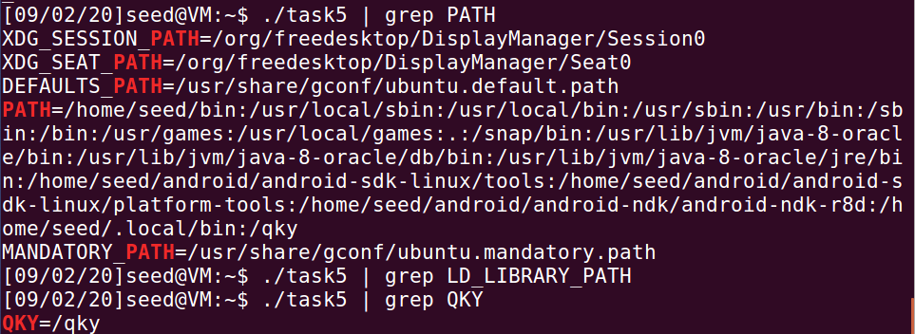

**可以看出子进程没有继承shell process（父进程）的LD_LIBRARY_PATH环境变量，但是可以继承PATH和自定义的环境变量。**

TASK6：The PATH Environment Variable and Set-UID Programs

**编译程序并将其改成root权限以及设置为Set-UID程序：**

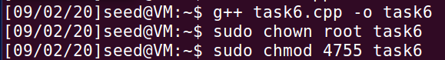

**由于system中传的是相对路径，所以会从PATH中查找绝对路径，只要把我自己编译的ls的路径添加到PATH之前就可以让自己的ls先被查找到并且执行：**

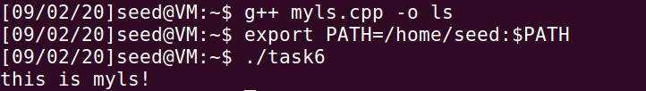

**由输出结果可以看出，运行task6的时候，并没有执行/bin/ls而是输出了自己编译的ls文件。**

TASK7：The LD_PRELOAD Environment Variable and Set-UID Programs

**新建好动态链接库libmylib并设置好环境变量，编译myprog程序。**

**普通用户运行myprog：**



**普通用户运行root权限的Set-UID程序myprog：**

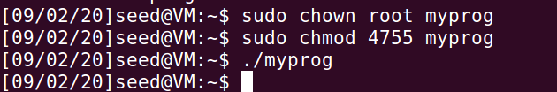

**在root权限下更改环境变量并运行root权限的Set-UID程序myprog：**

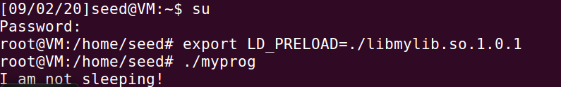

**将myprog变为seed2所有，在seed权限下更改环境变量并且运行seed1权限的Set-UID程序myprog：**

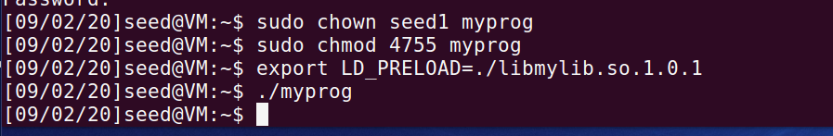

**补充：root权限下改变环境变量并且运行seed1权限的Set-UID程序myprog：**

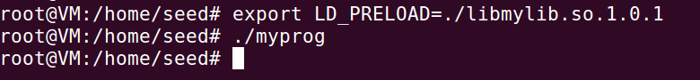

**可以发现只有权限所有者去更改环境变量并且运行程序才会使用LD_PRELOAD环境变量，重载sleep函数。**

**为了看出环境变量LD_PRELOAD的影响，在myprog.c的文件里做如下改动：**

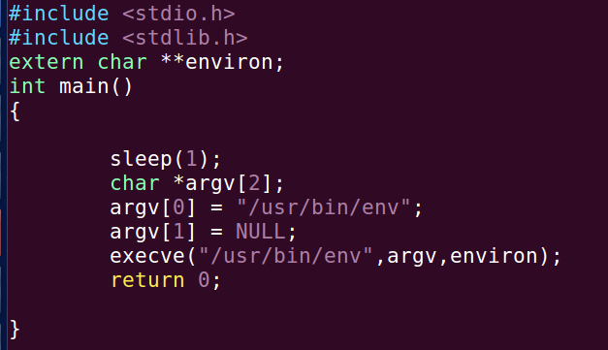

**分别运行四个情况：**



**无LD_PRELOAD**



**无LD_PRELOAD**

**得到以上四种情况，可以看出只有文件权限所有者去更改环境变量并且运行程序才会使用LD_PRELOAD环境变量，进而改变sleep函数的内容。**

TASK8：Invoking External Programs Using system() versus execve

**使用system()函数，可以通过使用“；”来执行另外的指令：**

**创建一个test.c文件并将其权限改为000即无任何权限**



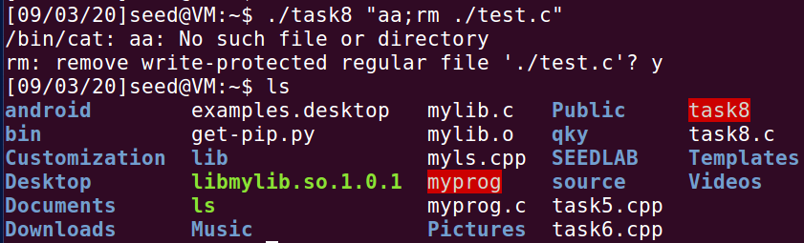

**可以发现test.c文件已经被删除。**

**改成execve()函数，重新编译以及修改权限：**



**则上述步骤无法达到删除文件的目的。**

**execve()函数可以避免通过参数设置泄露权限。**

TASK9：Capability Leaking

**新建etc/zzz文件，更改文件权限。将task9设置为root权限的Set-UID程序，运行task9后查看zzz文件：**

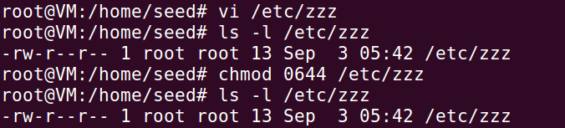

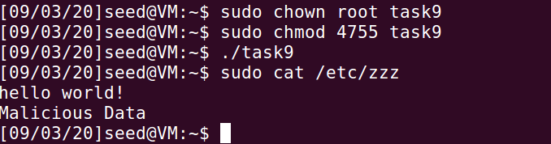

**文件已经被修改。**

**在setuid(getuid())之后，程序应该降为普通进程。根据程序代码，猜测是fork()函数导致的权限泄露，但是通过修改程序，发现不用fork()也能达到攻击效果（/etc/zzz也已经改回“hello world！”）：**

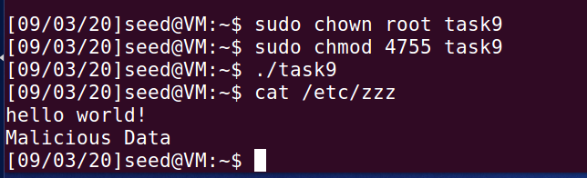

**因此只剩下句柄fd，由此可得由于句柄fd拥有特权没有被释放掉，所以在普通用户的操作下依旧可以更改/etc/zzz的内容。**

SUMMATION

**首先，我熟悉了环境变量相关的操作以及函数。得知了如何获得环境变量：子进程能够继承父进程的环境变量；调用execve()函数，通过参数传递来得到环境变量。system()可以自动传递环境变量，而execve()函数需要设置传入的参数。**

**接着了解了怎样通过环境变量达到攻击的目的。system()函数传入相对路径时，就会通过PATH环境变量来查找绝对路径，只要改变PATH的值就可以让其运行路径靠前的同名程序以达到攻击的效果。在动态链接库方面，只有程序的权限所有者去更改环境变量并且运行程序才会使用LD_PRELOAD环境变量，重载相关函数，在其他情况下会受到保护，不会被更改。system()通过调用shell来执行传入的命令，可以通过加“；”让其运行两个命令，由于运行Set-UID程序时，用户权限被提升到root权限，所以可以进行一些强制操作来进行攻击。在Set-UID程序撤销其特权的时候，如果没有将其相关操作的权限撤销，会导致权限的泄露，普通用户仍然可以通过未撤销特权的操作来达到一些恶意目的。**