Indah Water Collections Dashboard
A plain-language walkthrough of everything the demo contains — every screen, every number, and where the data behind it comes from.
Prepared for: Non-technical reviewers
Organisation: Indah Water Konsortium (IWK)
Status: Demonstration build

Contents
- 1. What this is
- 2. Where the data comes from
- 3. Signing in
- 4. How to move around
- 5. The customer record
- 6. The screens
- Dashboard
- Voice AI
- Call Alerts
- Call / Join
- Book Position
- Segments
- Treatment & Channels
- Performance
- Compliance
- DCA & Legal
- Areas
- Customers
- Settings
- 7. Glossary of measures
- 8. What is and isn't real

1. What this is
This is a working demonstration of a debt-collections dashboard for Indah Water Konsortium — Malaysia's national sewerage company. It brings two things that normally live apart into a single screen: the money side of collections (who owes what, how old it is, what recovering it costs) and the conversation side (the AI voice calls actually made to customers).
The purpose of the demo is to show what a collections team would see day to day: the size and shape of the arrears book, which customers are worth chasing and how, what each attempt to contact someone costs, whether the programme is behaving fairly, and what happened on individual phone calls — right down to listening to the recording.
It is a real, running piece of software rather than a set of slides. Every screenshot in this report was taken from the live application.

The thirteen screens at a glance
Screen | What it answers
Dashboard | How are we doing overall, right now?
Voice AI | What happened on each AI phone call, and what did it cost?
Call Alerts | Which calls have been flagged for a human to look at?
Call / Join | Placing live calls (not enabled in this demo)
Book Position | How much is owed, by whom, and how old is it?
Segments | Why isn't this customer paying, and how should we treat them?
Treatment & Channels | How are we contacting people, and what does it cost?
Performance | Is the programme actually recovering money efficiently?
Compliance | Are we treating customers fairly and within the rules?
DCA & Legal | How are debt agencies and legal action performing?
Areas | Where in Malaysia is the debt concentrated?
Customers | The underlying account records themselves
Settings | The assumptions and policies the numbers are built on

2. Where the data comes from
This is the single most important thing to understand before reading any number in the demo. There are two different kinds of data in the application, and they behave very differently.

[Live] Real data, pulled from real services
Three parts of the dashboard connect to genuinely live systems and show real information that changes on its own:
- Voice AI call logs — every call, cost, transcript and audio recording comes from Vapi, the service that runs the AI phone agent. These are real calls that really happened.
- Call Alerts — a live feed of calls that have been flagged, delivered from an automation service.
- Assistant details — the configuration of the AI agent itself.

[Demo] Realistic invented data
Everything else — the 900 customer accounts and all the collections analytics built on them — is invented for the demonstration. It is not real IWK customer data. No real person's details appear anywhere in this software.
The invented data was produced once by a generator that follows realistic rules (explained in section 5), so the numbers hang together sensibly: the ageing matches the ladder stages, the costs match the contact volumes, and the agency figures match the accounts actually placed with them.
Changes do not save
You can add, edit and delete customer records, and change settings. The screen updates immediately and every other page recalculates. But nothing is saved. Refresh the page and the original 900 records come back exactly as they were.
This is deliberate, so the demo can be handled freely without anyone breaking it for the next person.

3. Signing in
The dashboard sits behind a simple sign-in screen. The username and password are fixed for the demonstration.
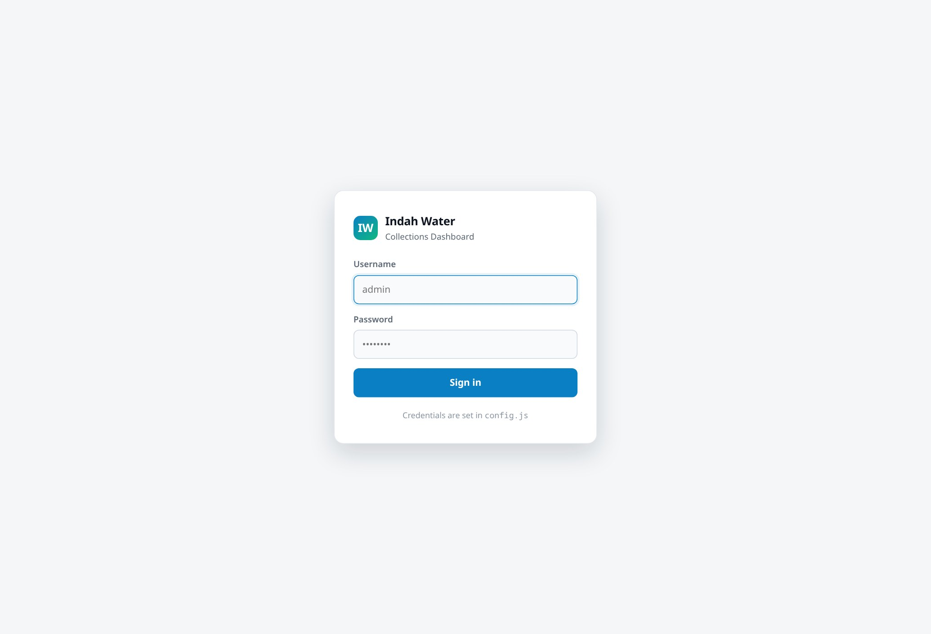
Sign-in. A single set of demo credentials gives access to every screen.
Note on security
This sign-in is a demonstration convenience, not real security. It keeps the dashboard tidy rather than protecting anything sensitive — which is acceptable here precisely because the customer data is invented.

4. How to move around
Every screen is reachable from the menu down the left-hand side, grouped by the kind of question it answers. The current screen is highlighted.
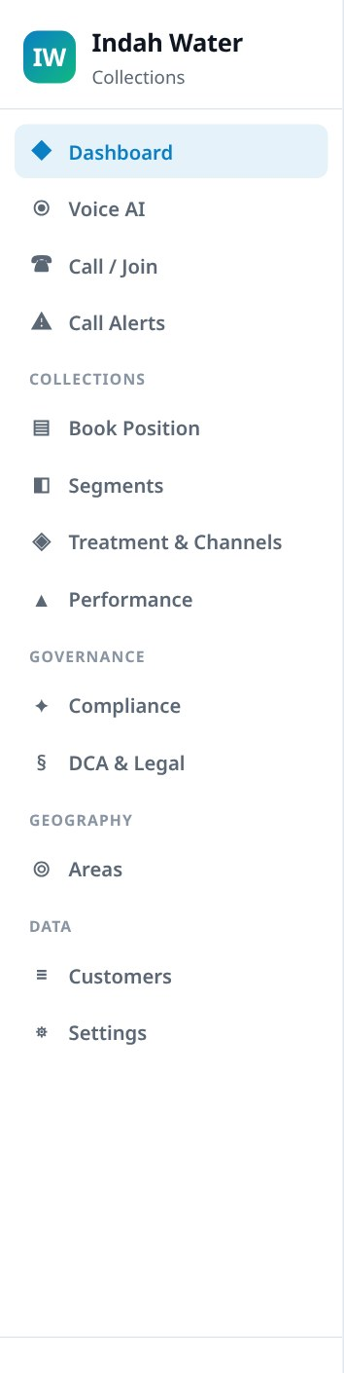
Navigation. Grouped into Collections, Governance, Geography and Data, with the Dashboard, Voice AI, Call / Join and Call Alerts screens at the top.
On a phone or tablet the menu folds away behind a button and the screens stack into a single column, so the dashboard remains usable on a small screen.

5. The customer record
Almost every figure in the demo is calculated from one list of 900 customer accounts. Understanding that record explains where nearly all the numbers come from.

How the 900 accounts were created
They were produced by a generator script, run once, that invents accounts following rules drawn from how a real sewerage-billing book behaves. The generator uses a fixed starting number, which means it produces exactly the same 900 accounts every time — the demo is identical for everyone who opens it.
The rules it follows:
- How overdue an account is decides its ladder stage. An account 5 days overdue is "Pre-Due"; one 400 days overdue is "Residual". The two can never disagree, because one is calculated from the other.
- The amount owed reflects the customer type. A household owes hundreds of ringgit; a factory owes tens of thousands. The amount also grows the longer the debt runs, because more monthly bills pile up.
- Behaviour follows the age of the debt. Fresh debt is mostly people who simply haven't got round to paying. Very old debt skews towards people who won't pay or can't.
- About one in eight accounts needs special handling — a deceased estate, an empty property, a registered hardship case, or an open dispute.
- Promises and payment plans only exist where they realistically could — the customer has to be contactable and actually overdue.
- Only seriously overdue accounts go to a collections agency, and never ones flagged for special handling.
- Names reflect Malaysia's actual population mix, with correct Malay, Chinese and Indian naming conventions.

What each account holds
Below is a real record from the demo, with every field explained in plain language.
Field | What it means | Example
Account ID | Internal reference used across the dashboard | ACC-100098
Account number | The billing account number the customer would recognise | 3579-9716-3154
Name | The account holder, or the organisation | Syafiqah binti Salleh
Category | Type of customer: Domestic, Commercial, Government or Industrial | Domestic
Address, area, state, postcode | Where the premise is. The area drives the whole Areas screen | 51, Lorong Maarof · Petaling Jaya, Selangor
Phone, email | How the customer would be contacted | +60142904562
Arrears amount | How much is owed, in ringgit. Added up, this is the total arrears figure | RM 1,194.44
Days overdue | How long the debt has been outstanding. Drives the stage and the ageing buckets | 680
Last bill date | When the customer was last billed | 2 Nov 2024
Last payment date | When they last paid anything. Blank if they never have | 3 Aug 2024
Stage | Position on the collections ladder, from Bill Presented through to Residual | Residual
Segment | Why they aren't paying: Friction Payer, Refuser, Constrained or Non-viable | Refusers
Special routing | A flag taking the account out of normal collections — deceased estate, vacant premise, hardship, or open dispute | None
Contactable | Whether we are able and permitted to contact them | Yes
Promise to pay | If they promised payment: the date, the amount, and whether they kept it | 25 Aug 2026 · RM 539.32 · kept
Instalment plan | If they're on a payment plan: the monthly amount and how well they're sticking to it | RM 238.89/month · 83% adherence
Agency placement | If handed to a debt collection agency: which one, and when | DCA-01 · 15 Aug 2026
Account opened | When the customer account was created | 7 Oct 2021

The two classifications that matter most
Two fields do most of the analytical work, and both appear on several screens.

Stage — how far along the process this debt has travelled
Stage | Roughly | Meaning
Bill Presented | Not yet due | The bill has been issued; nothing is late
Pre-Due | 1–14 days | Just past the due date; a gentle reminder is appropriate
Early Arrears | 15–60 days | Genuinely late, but still routine to recover
Committed Arrears | 61–120 days | Established debt; needs a firmer approach or a plan
Formal | 121–240 days | Formal notices; agency referral becomes an option
Residual | 241+ days | Long-standing debt; legal action or write-off territory

Segment — why this customer isn't paying
Segment | Meaning and how they should be handled
Friction Payers | They will pay — something is just getting in the way (forgot, lost the bill, unclear how to pay). Cheap digital reminders resolve most of them. The most profitable group to chase.
Refusers | They can pay but choose not to. Reminders don't work; this group needs escalation and formal action.
Constrained | They want to pay but genuinely cannot afford to in full. The right answer is an instalment plan or hardship support, not pressure.
Non-viable | There is no realistic prospect of recovery. Spending more money chasing them destroys value; these are write-off candidates.
Why this matters commercially
Treating all four groups the same is what makes collections expensive. A Friction Payer resolved by an 8-sen WhatsApp message and a Refuser needing a RM145 legal demand pack are completely different economics — and the dashboard is built to keep them visibly separate.

6. The screens

Dashboard [Demo] [+ Live]
The opening screen. It combines the collections position with live Voice AI activity so the whole operation can be judged in one glance.
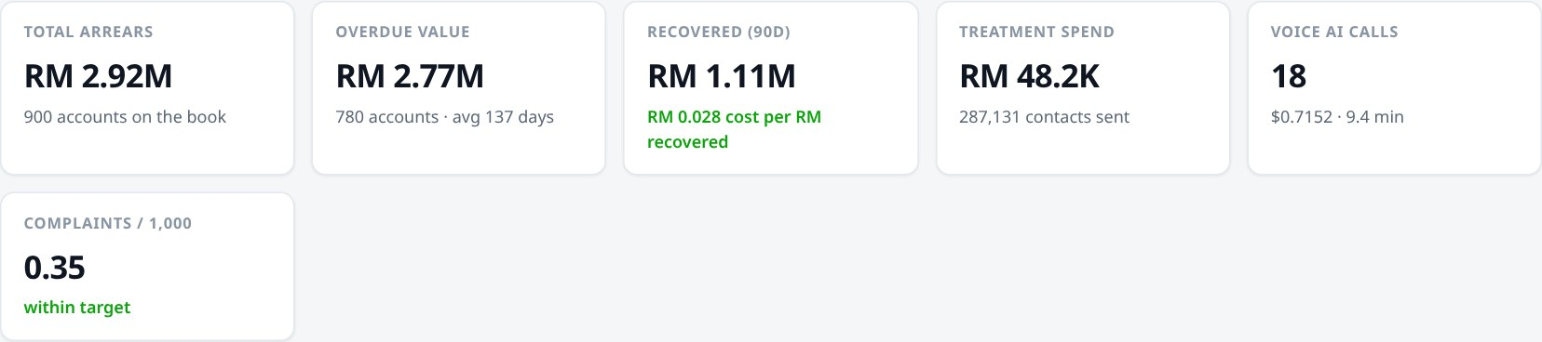
Headline figures. Total arrears and overdue value come from the customer records; amount recovered and treatment spend from the campaign history; Voice AI calls and cost are fetched live from the calling service. Complaints per 1,000 is colour-coded against its target.
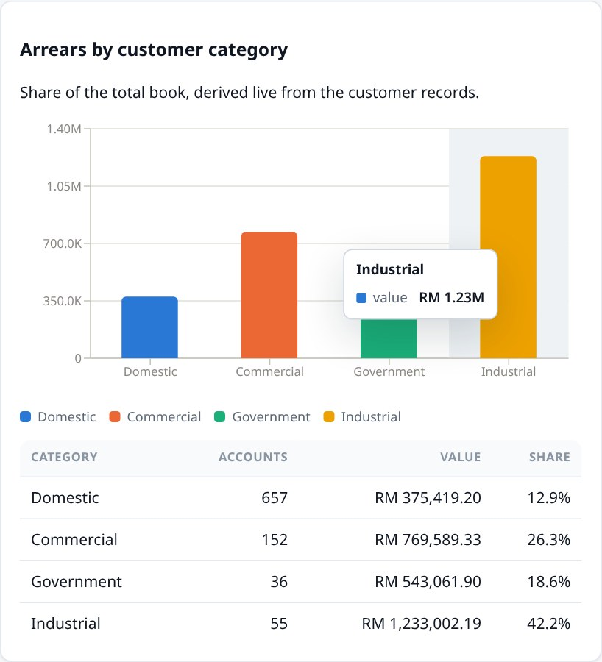
Arrears by customer category. Shows that although households are the most numerous, industrial and commercial accounts hold most of the money.
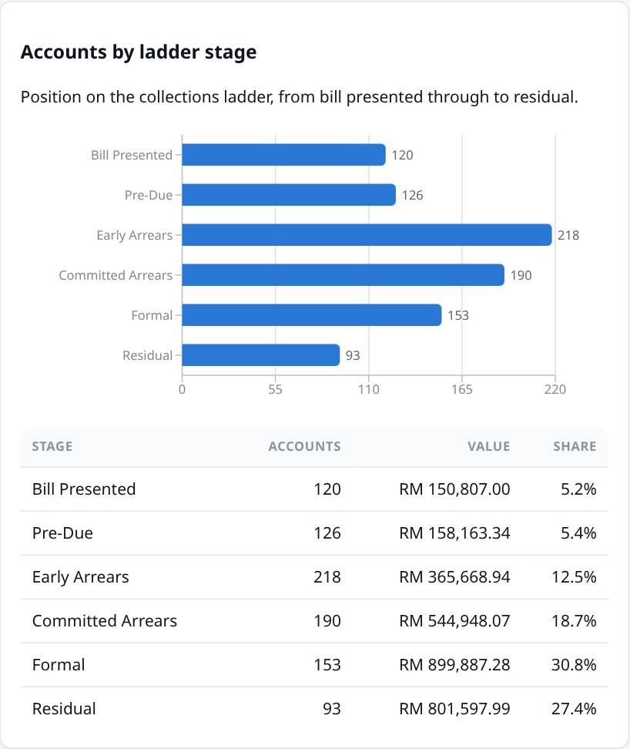
Accounts by ladder stage. How the book is distributed across the six stages, with value and share alongside.
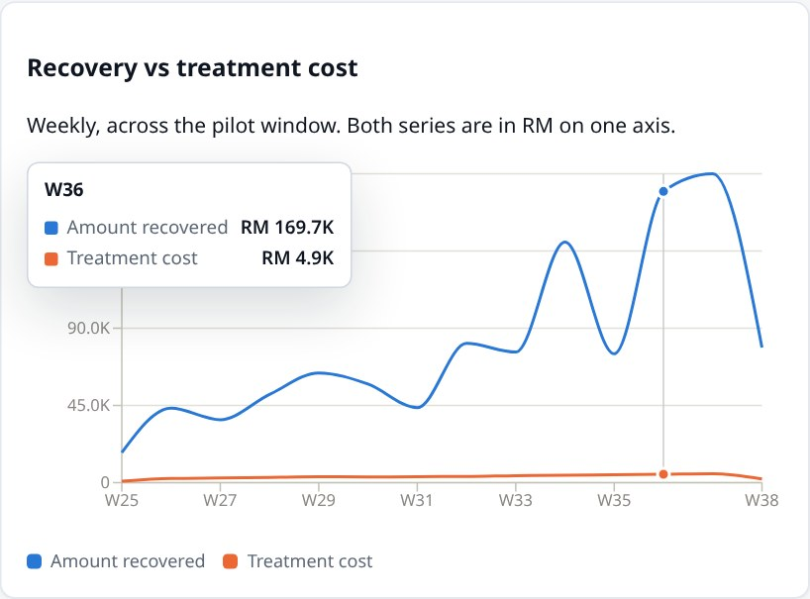
Recovery versus cost. Money collected each week plotted against what was spent collecting it — the gap between the lines is the value the programme creates.
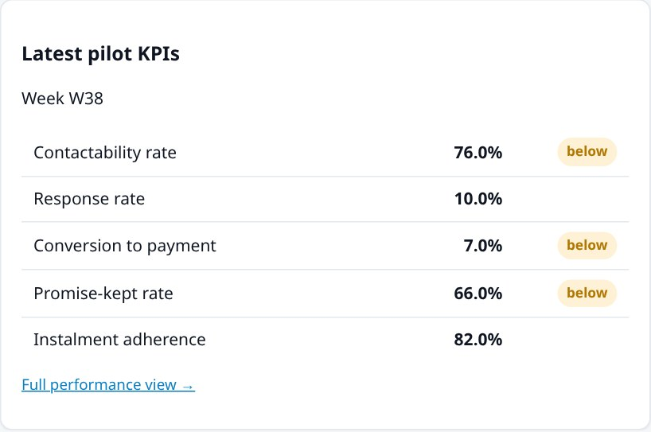
Latest KPIs. The five headline measures with a badge showing whether each is meeting its target.
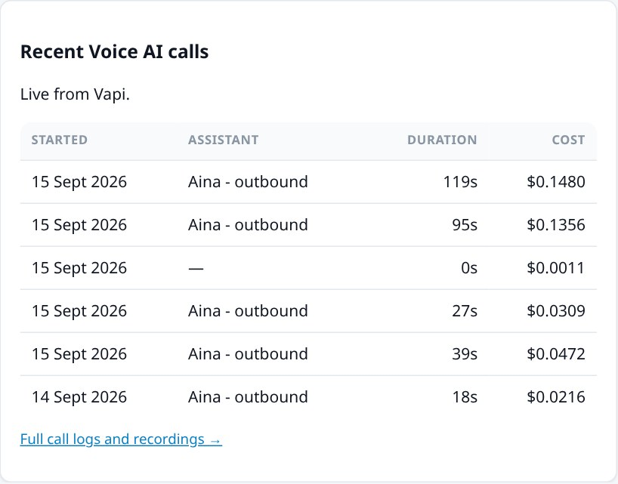
Recent Voice AI calls. A live preview of the most recent calls, linking through to the full call log.

Voice AI [Live]
This screen shows real phone calls made by the AI voice agent. Nothing here is invented. Every row is a call that actually took place, and the costs are the real amounts billed.
Call summary. How many calls, what they cost in total, how long the agent spent talking, and the resulting cost per minute. These recalculate as you filter the list.
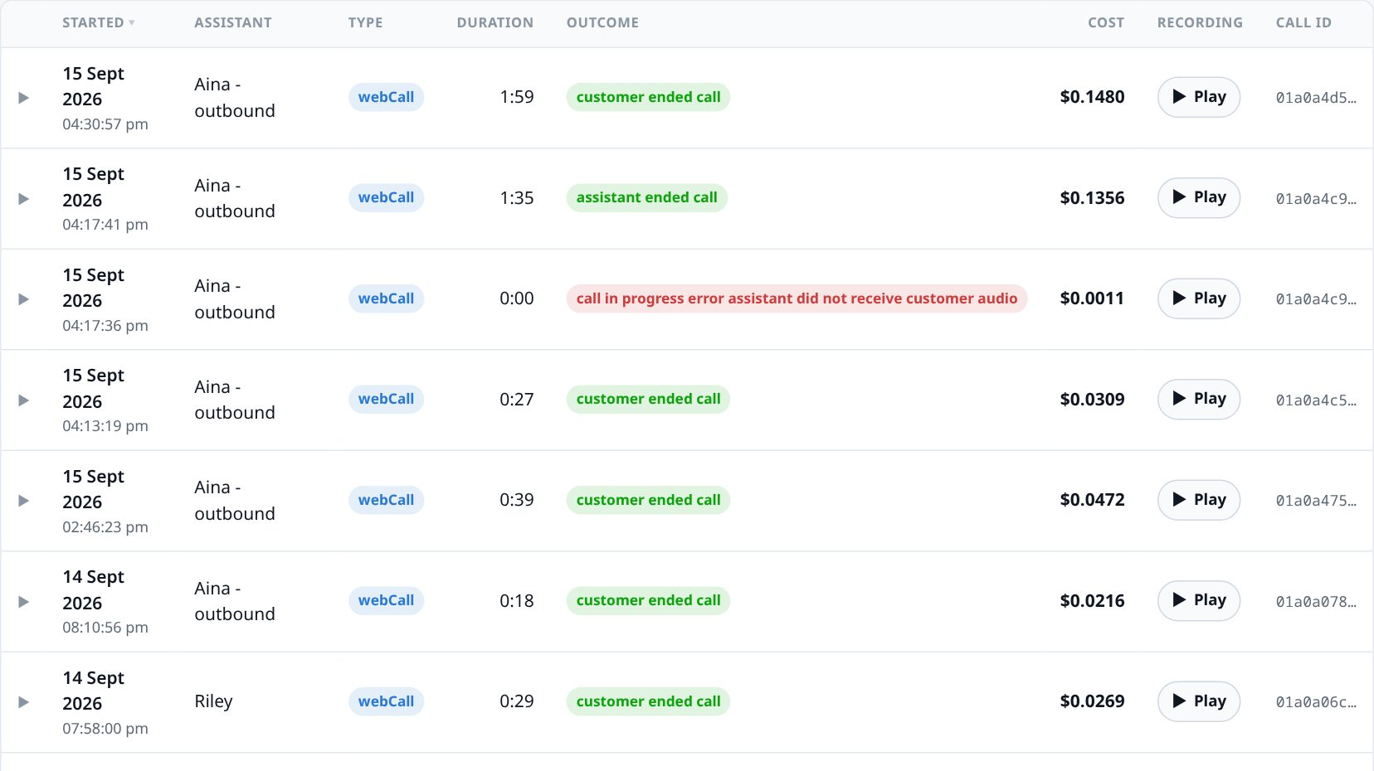
The call log. Each call shows when it started, which AI assistant handled it, how long it lasted, how it ended, and what it cost. Calls can be searched, filtered by date or outcome, sorted, and exported to a spreadsheet.
Clicking any row opens the full detail of that call — including the ability to listen to the recording directly in the browser.
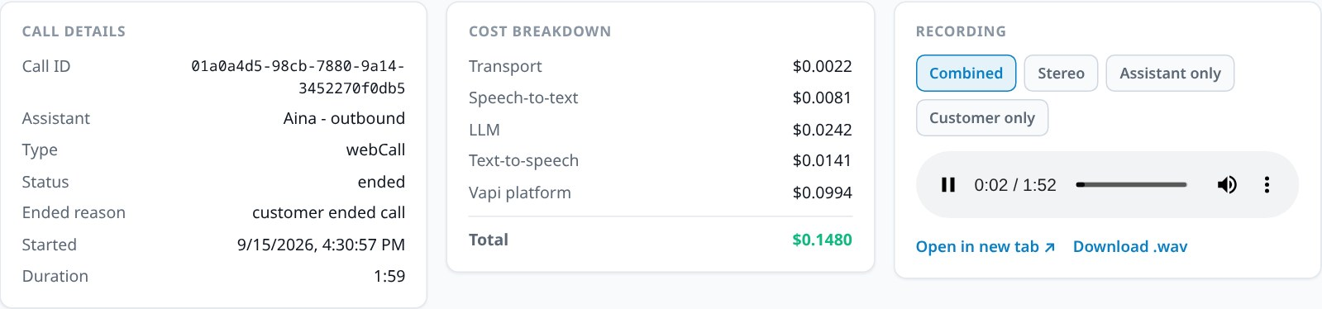
Call detail. Left: the facts of the call. Middle: a full cost breakdown — the telephone connection, converting speech to text, the AI's thinking, the synthesised voice, and the platform fee, adding to the total. Right: the audio player, offering the combined recording, a stereo version, or just the agent's or just the customer's side.
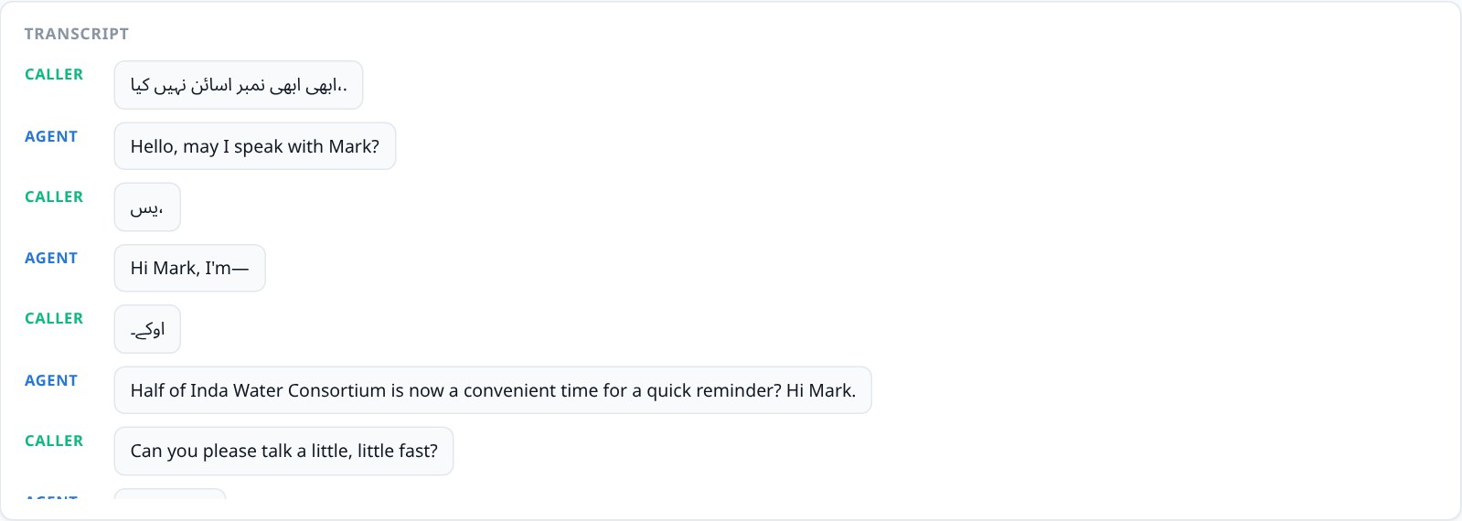
Transcript. The conversation written out and labelled by speaker, so a call can be reviewed without listening to it.
About the recordings
Call recordings are stored privately and cannot simply be opened with a link — they are protected. The dashboard retrieves each one securely on your behalf when you press play, which is why there is a brief pause the first time a recording loads.

Call Alerts [Live]
A live feed of calls that have been flagged as needing human attention — for example, a customer who said they were not interested, or who disputed the amount.
Alert summary. How many alerts are in the feed, how many distinct calls they relate to, how recently the last one arrived, and when the dashboard last checked.
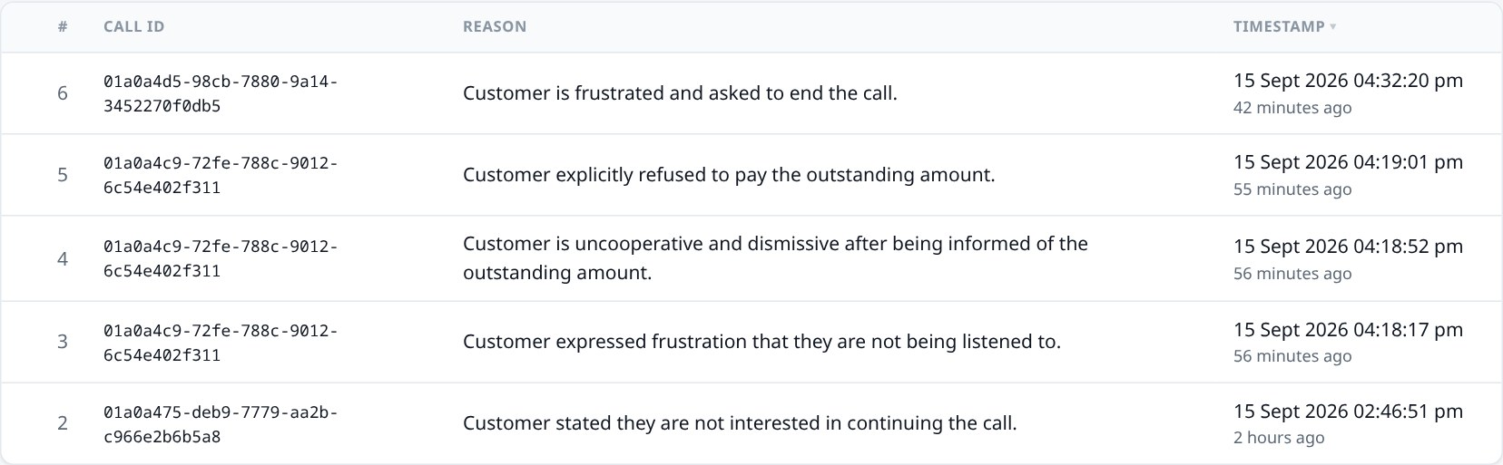
The alert list. Each alert shows which call it relates to, the reason it was flagged, and when — shown both as a date and as plain language such as "58 minutes ago". The list can be searched, sorted and exported.

Call / Join [Not enabled]
Placing a live outbound call, or joining one in progress, requires a paid telephony subscription that is not active for this demonstration. The screen states this plainly rather than presenting a button that would not work.
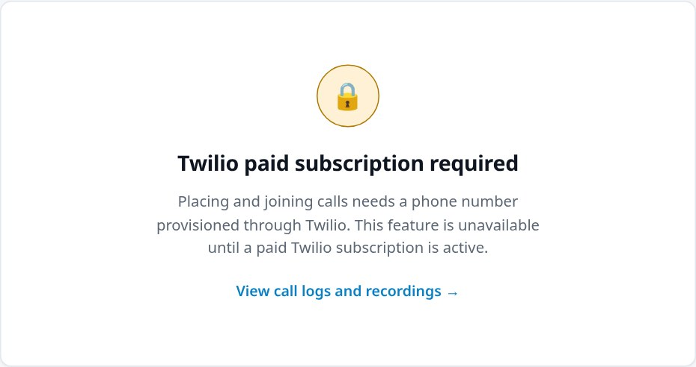
Call / Join. Reviewing past calls and listening to recordings is unaffected — only placing new live calls is gated.

Book Position & Movement [Demo]
The finance and management view: how much is owed, by which kind of customer, how old it is, and — critically — whether the situation is getting better or worse.
The book in four numbers. Total owed, how much of it is actually late, the average age of overdue debt, and the average balance per account.
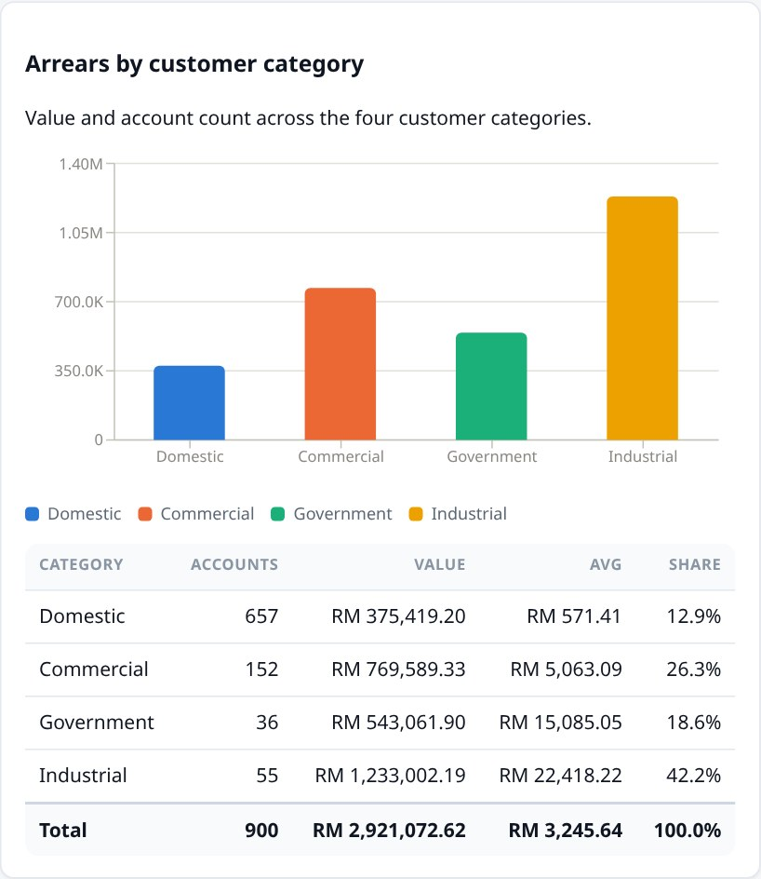
By customer category. Account numbers, total value, average balance and share of the book for each of the four categories.
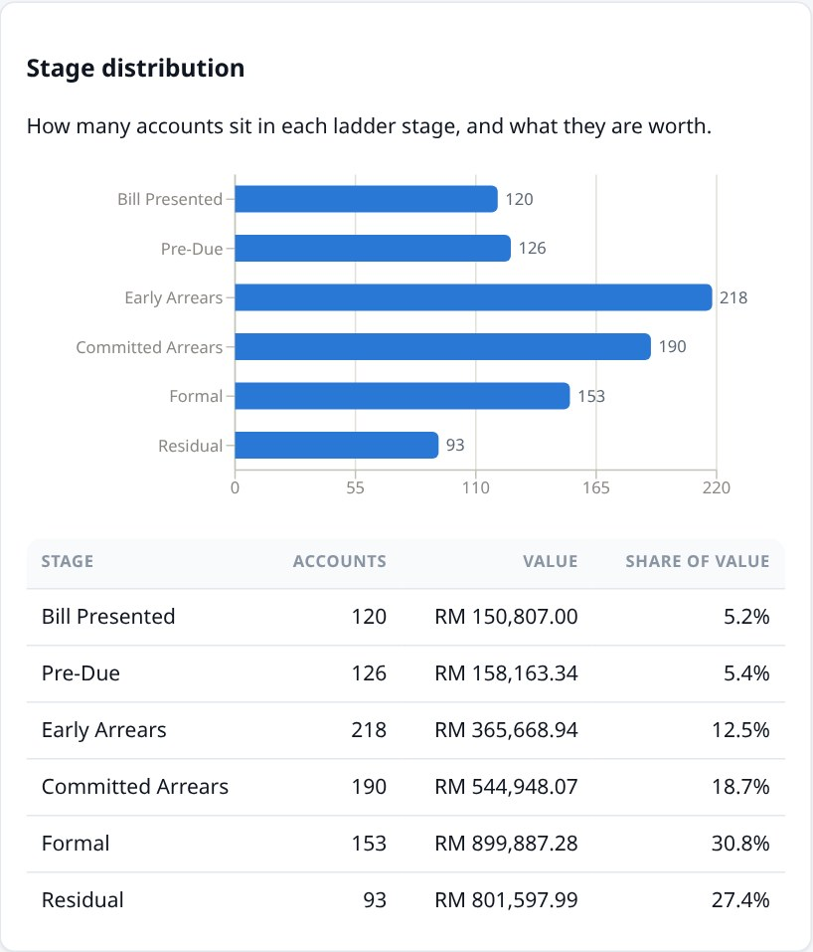
By ladder stage. Where accounts sit on the collections process, and how much value is parked at each step.
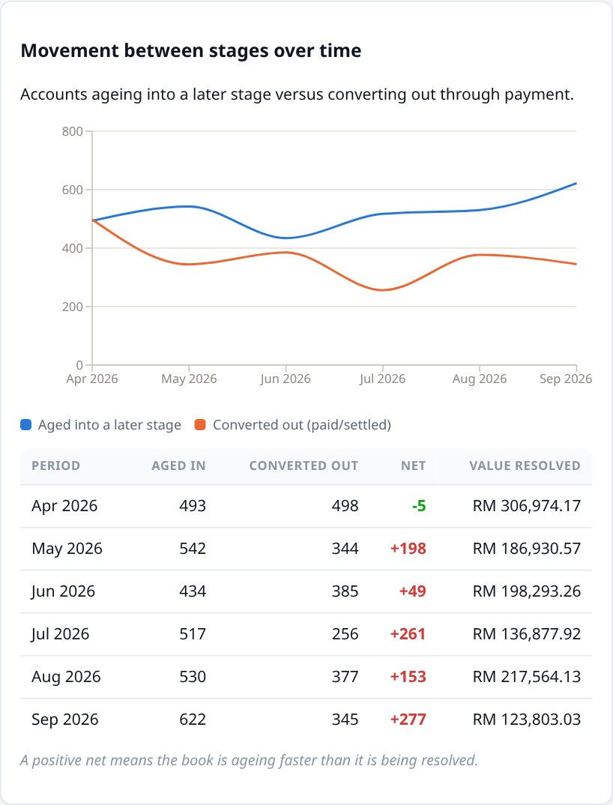
Movement over time. The most important chart for management. The rising line is accounts getting worse — ageing into a later stage. The other line is accounts being resolved. A positive net figure, shown in red, means the book is deteriorating faster than it is being cleared.
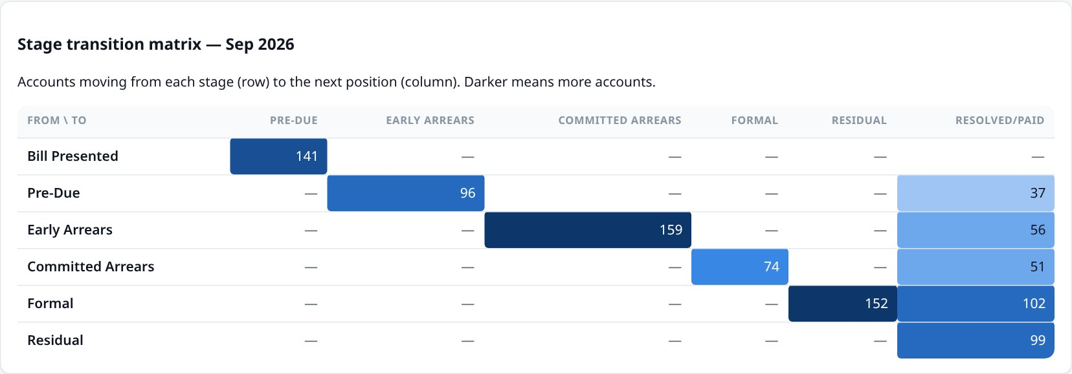
Transition grid. Reading across a row shows where accounts at that stage ended up. Darker shading means more accounts took that path, making the busiest routes through the process obvious at a glance.

Segment Breakdown [Demo]
Splits the book by why people aren't paying, rather than by how much they owe. This is what decides the treatment each account receives.
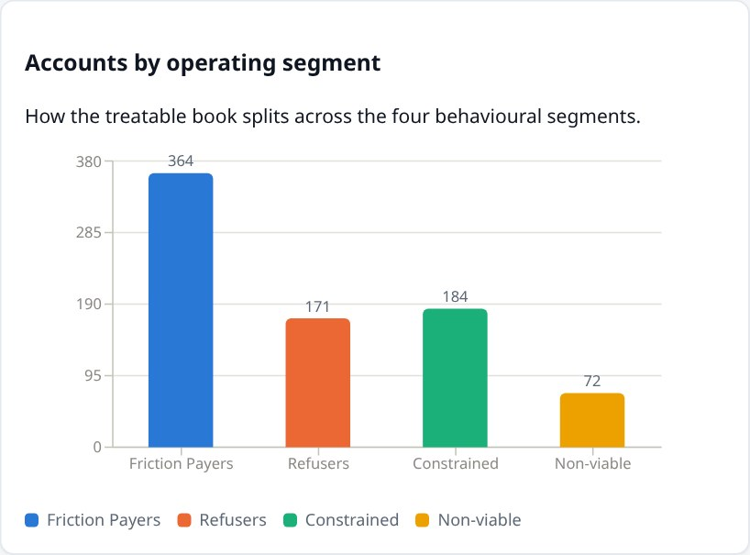
Accounts by segment. How the treatable book divides between Friction Payers, Refusers, Constrained and Non-viable customers.
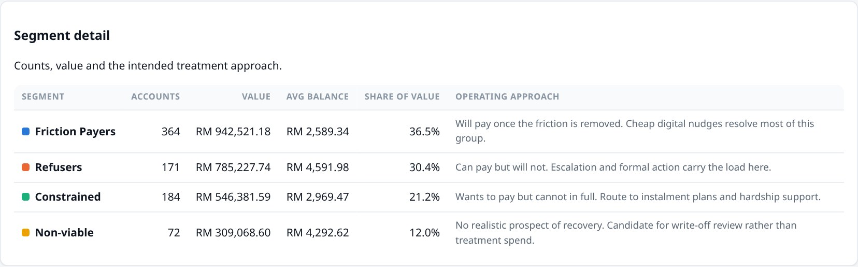
Segment detail. Each segment with its size, value and — in the final column — the intended handling. Note how the segment holding the most accounts is rarely the one holding the most money .
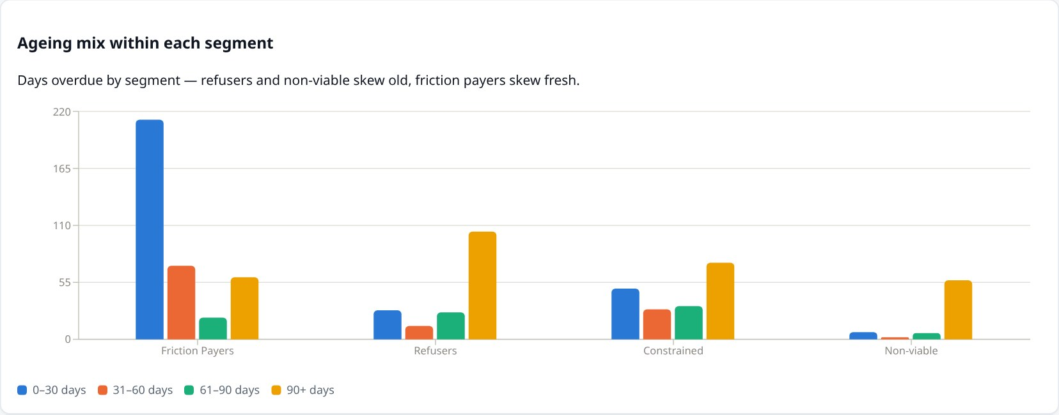
Ageing within each segment. Confirms the underlying pattern: Friction Payers are mostly fresh debt, while Refusers and Non-viable accounts skew heavily to 90+ days.
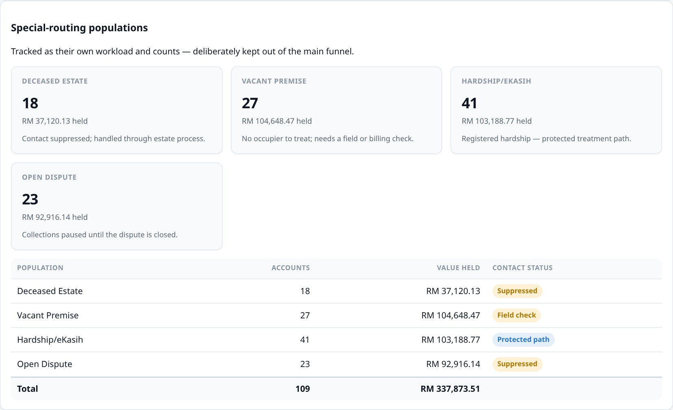
Special-routing populations. Deliberately kept outside the main figures. A deceased estate or a registered hardship case should never be swept into a routine chasing campaign, so they are counted and worked separately, with contact suppressed where appropriate.

Treatment & Channel Activity [Demo]
How customers are actually being contacted, whether those contacts arrive, and what each one costs. This is where the economics of collections become visible.
Contact summary. Volume sent, total spend, responses generated, and how many messages failed to arrive at all.
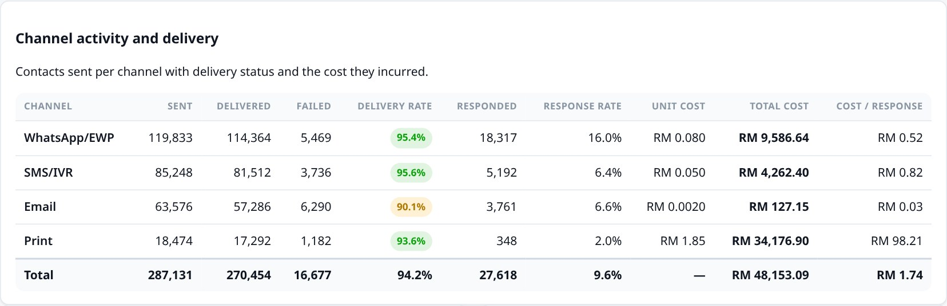
Channel performance. Every contact method side by side. WhatsApp achieves far higher response rates than print at a fraction of the cost per response — the single clearest argument in the dashboard for digital-first contact.
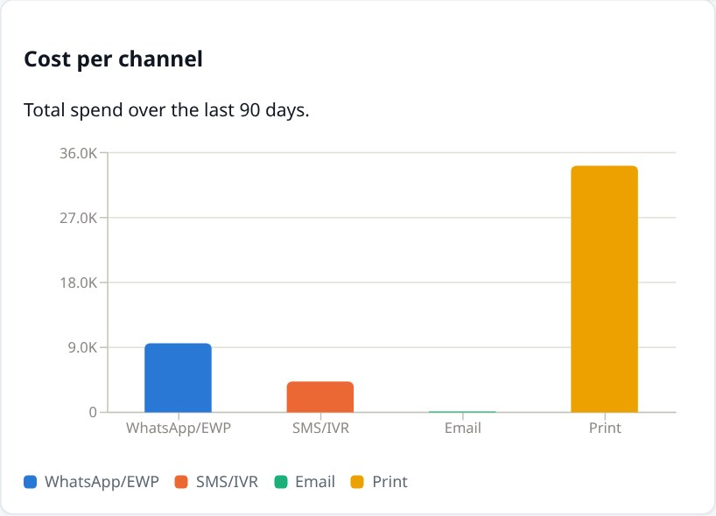
Spend by channel. Where the contact budget actually goes. Print consumes a large share of spend for a small share of contacts.
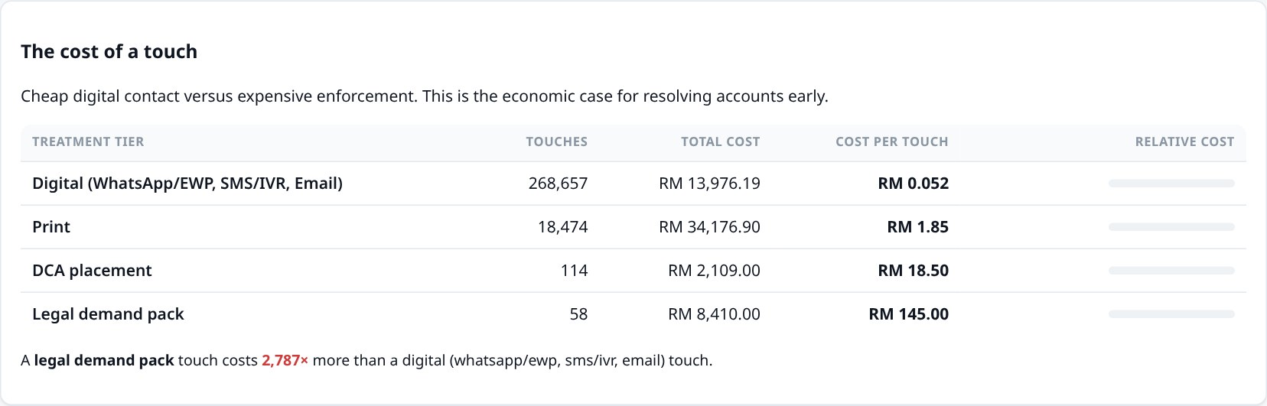
The cost of a touch. The commercial heart of the case. A digital message costs a few sen; a legal demand pack costs around RM145. Resolving someone early, cheaply, is worth enormous amounts compared with letting them reach enforcement.
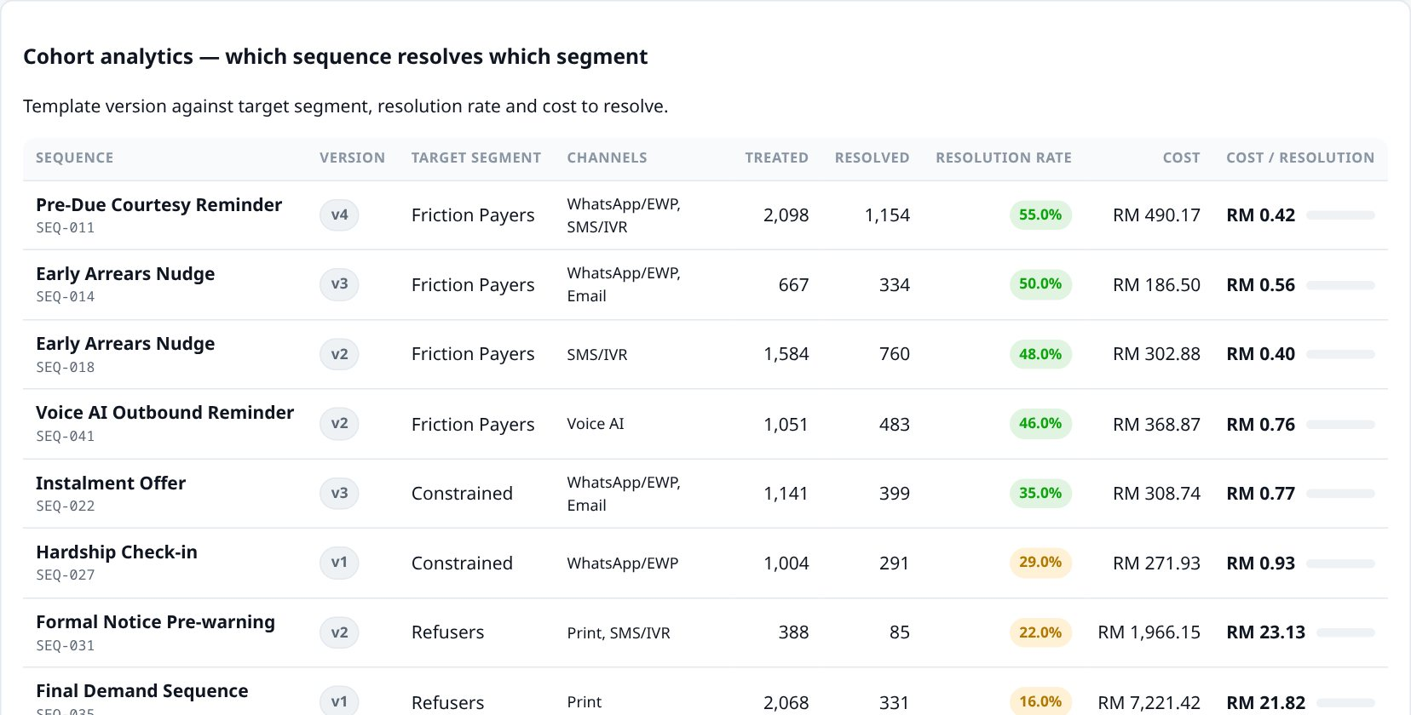
Campaign effectiveness. Which message sequence resolves which segment, at what cost. Because each sequence is tracked by version, improvements to the wording can be measured: later versions resolve more accounts for less money.

Conversion & Collections Performance [Demo]
Whether the programme works, measured against agreed targets. These are the formal pilot measures, carried into day-to-day reporting rather than written up once.
Headline performance. Money recovered, what it cost to recover each ringgit, and the two behavioural rates that matter most — with the change since week one.
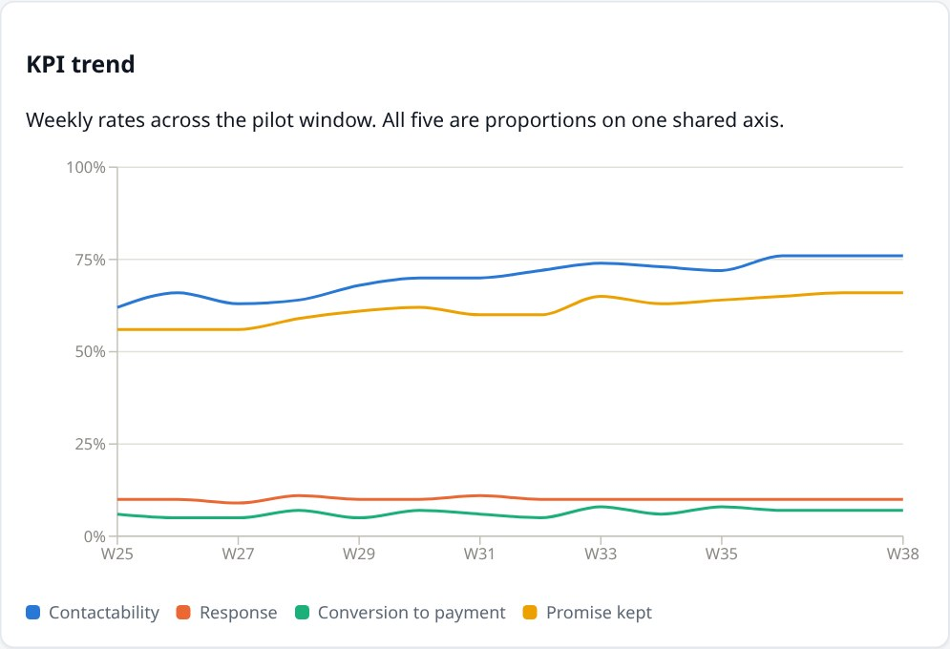
Trend. The four core rates week by week, showing whether performance is improving.
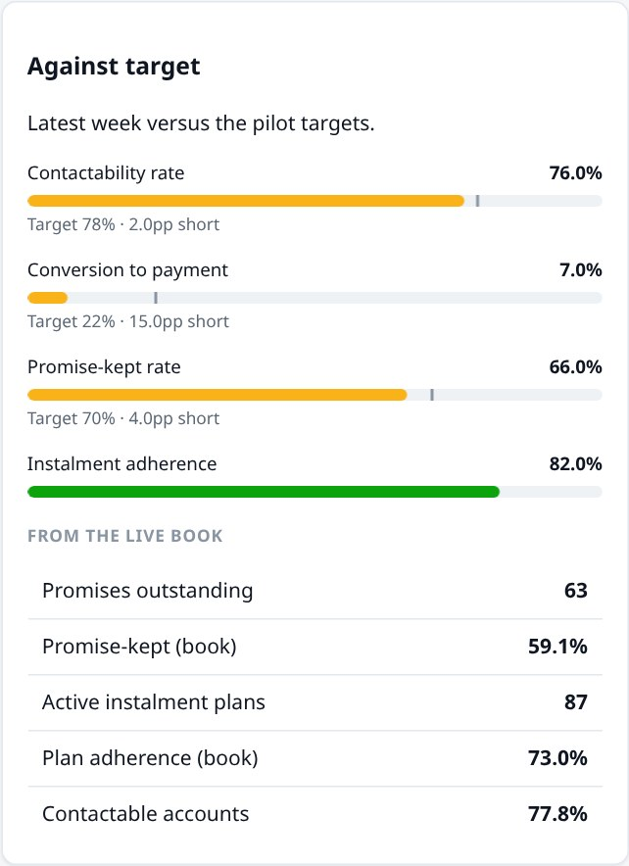
Against target. Each bar shows the current level, with a marker at the agreed target and a note on how far short it falls.
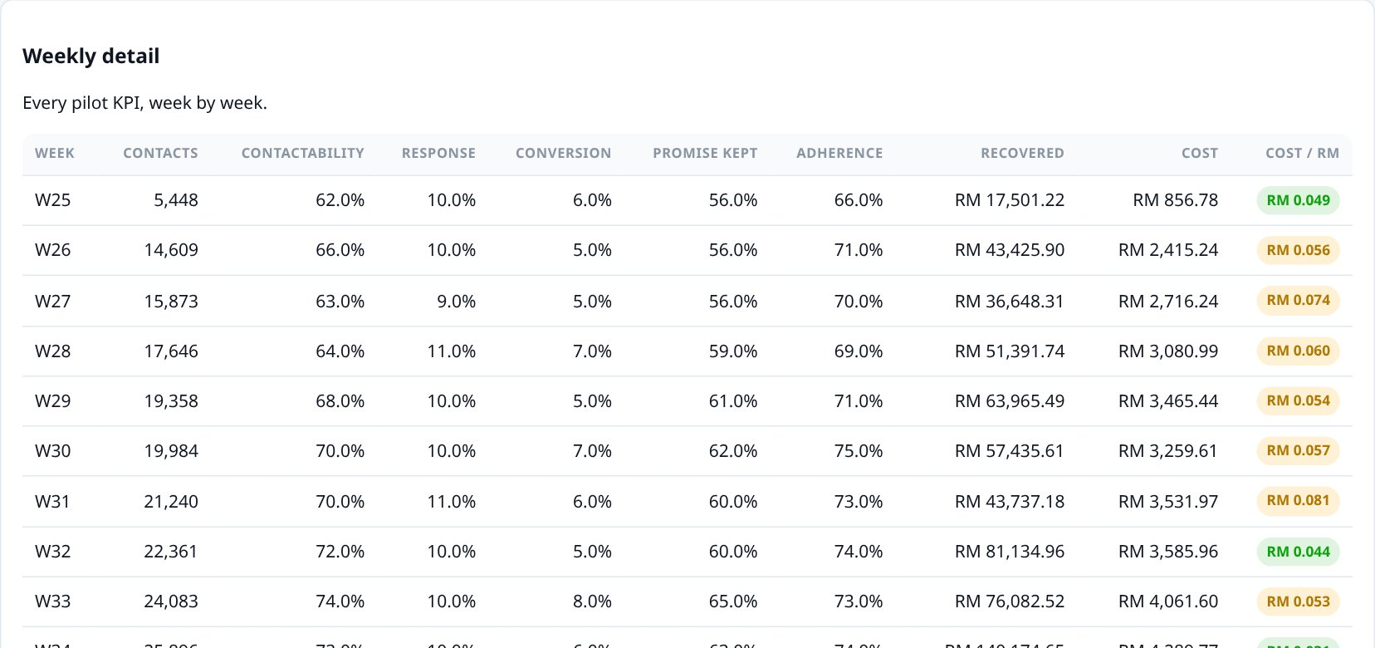
Week-by-week detail. Every measure for every week, for anyone who needs the underlying numbers rather than the chart.

Compliance & Conduct [Demo]
The governance view: proof that customers are being treated fairly. For a government-owned utility this is not optional reporting — it is the licence to operate the programme at all.
Conduct summary. Complaints measured per 1,000 contacts rather than as a raw count, so scaling up a campaign cannot flatter the figure.
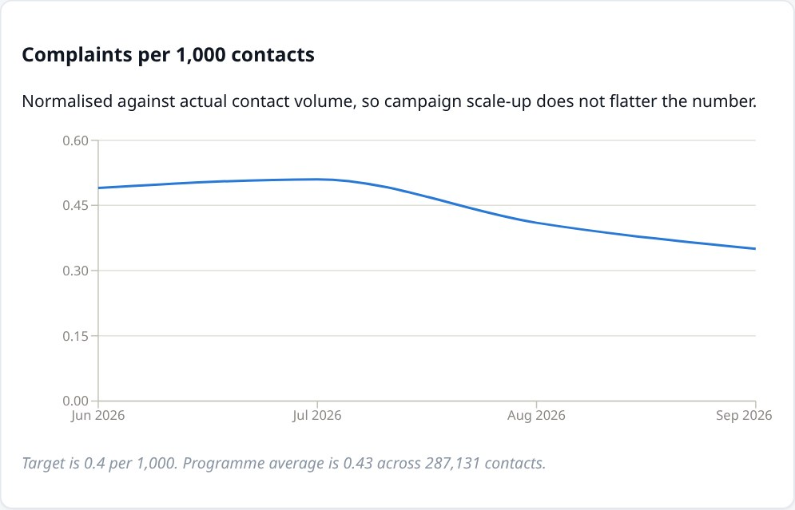
Complaint trend. Complaints per 1,000 contacts month by month, against the agreed target. A falling line while contact volume rises is the pattern to look for.
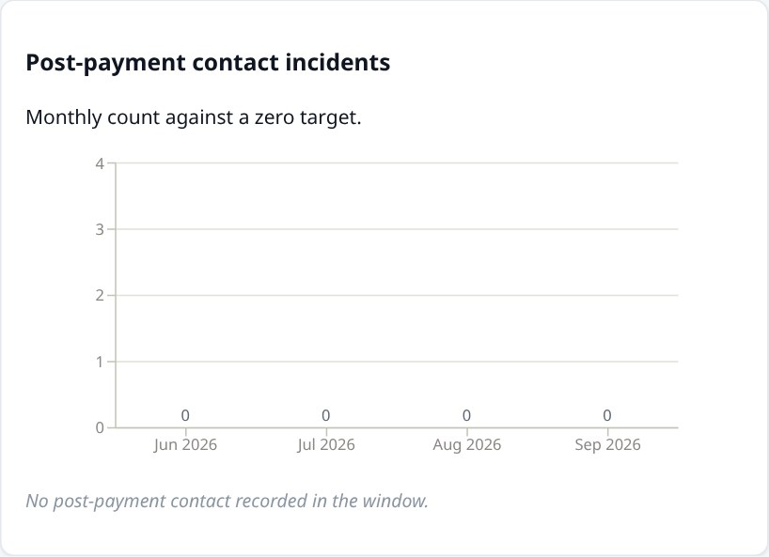
Post-payment contact. The critical trust measure, with a target of zero rather than a percentage. Chasing somebody who has already paid is the fastest way to destroy confidence in the entire programme, so each incident is investigated individually.
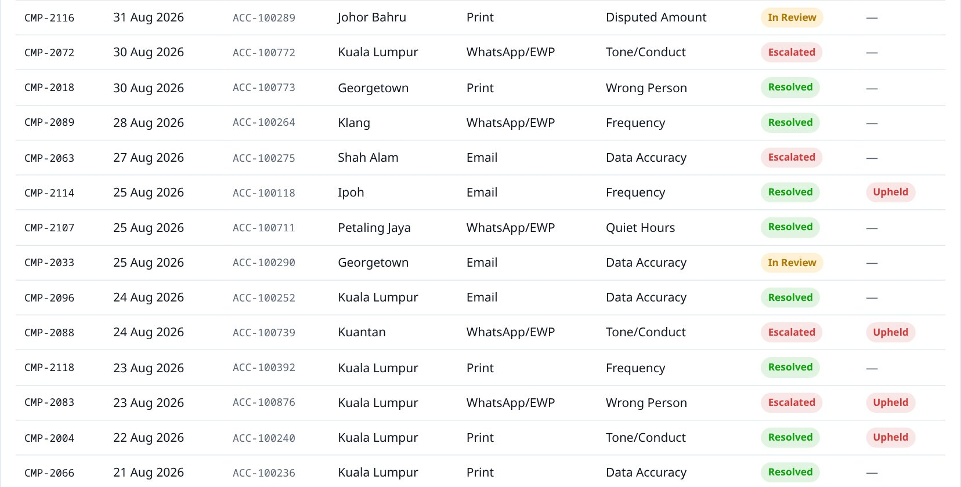
Complaint register. Every complaint individually logged and traceable — what it concerned, which channel caused it, whether it was upheld, and whether it has been resolved.

DCA & Legal Handover [Demo]
What happens to accounts passed to external debt collection agencies, and to those entering formal legal action.
Handover summary. How much debt sits with agencies, how much they have recovered, and what the handover has cost.
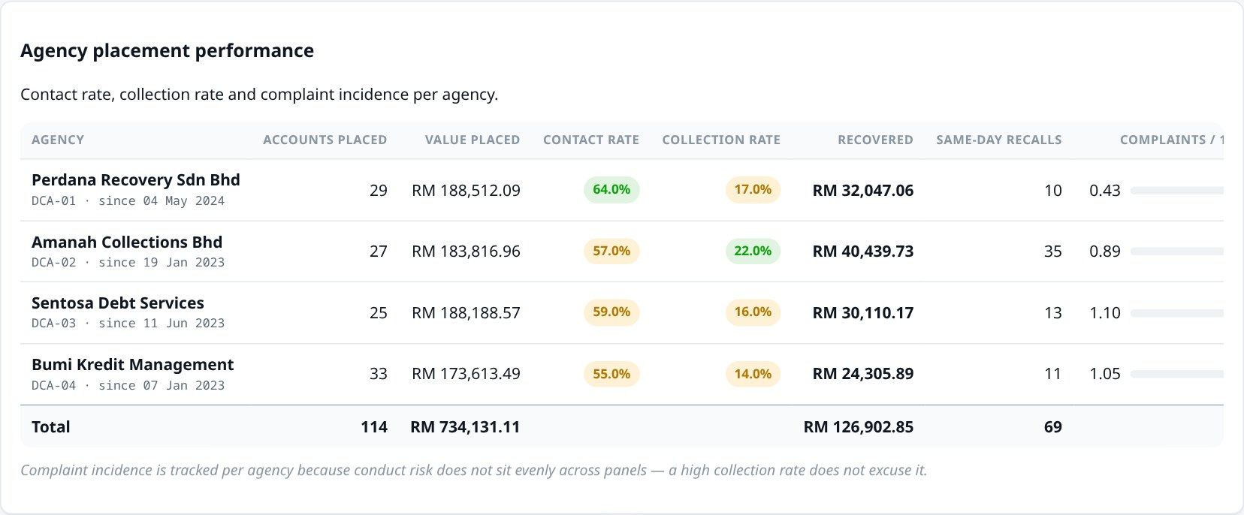
Agency scorecard. Agencies compared side by side. Complaint rates are tracked per agency alongside collection rates — deliberately, so that an agency collecting well through aggressive conduct cannot hide behind its recovery figures.
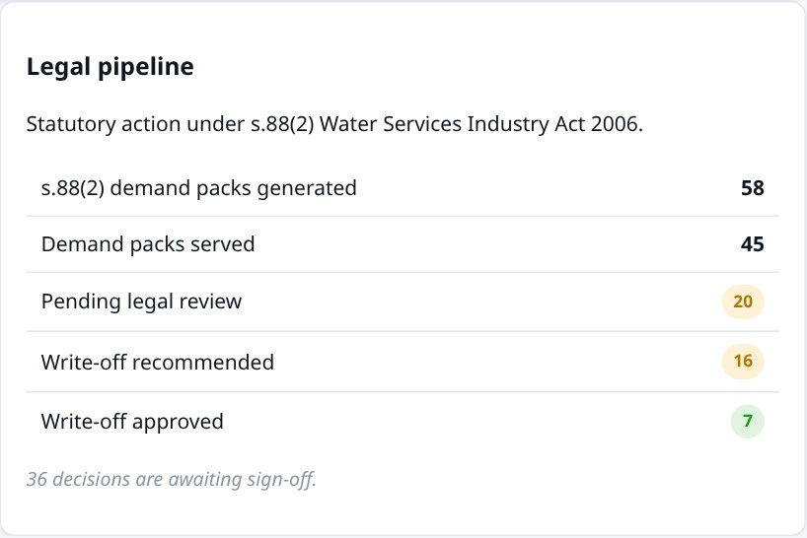
Legal pipeline. Statutory demand packs issued under section 88(2) of the Water Services Industry Act 2006, plus decisions awaiting sign-off.
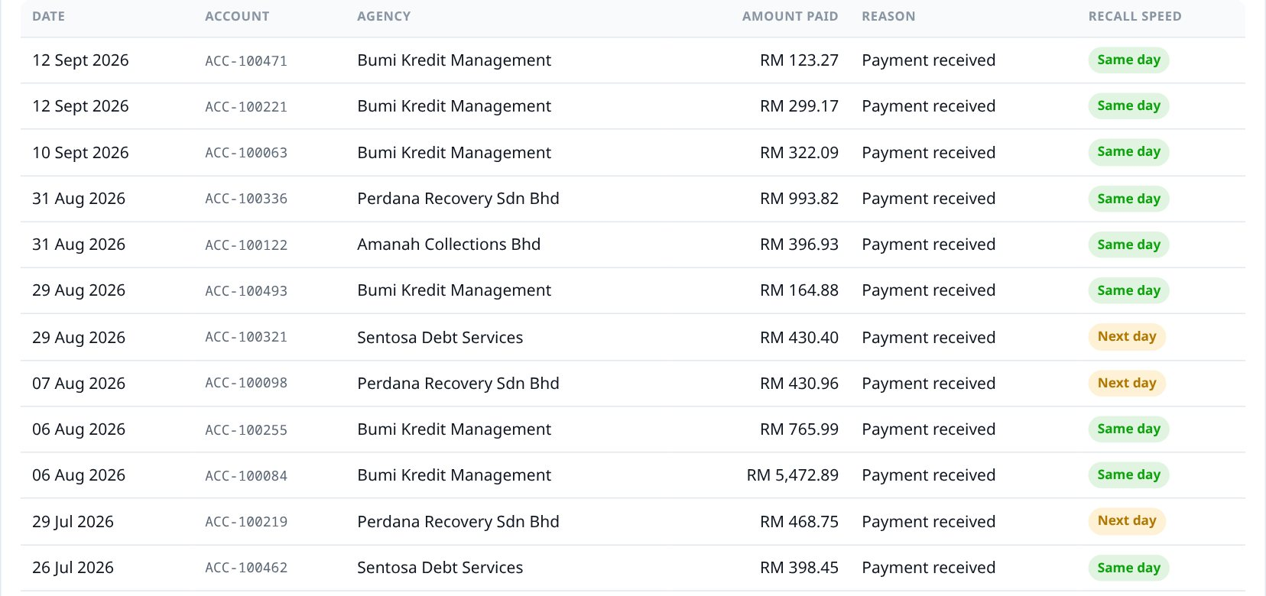
Payment-triggered recalls. When a customer pays, their account must be pulled back from the agency immediately. Same-day recall prevents the worst conduct failure of all.

Geographic Layer — Areas [Demo]
Where in Malaysia the arrears actually sit, so field resources and campaigns can be aimed at the right places.
Geographic summary. Which area carries the most debt, how many premises are flagged as empty, and how much of the network is covered.
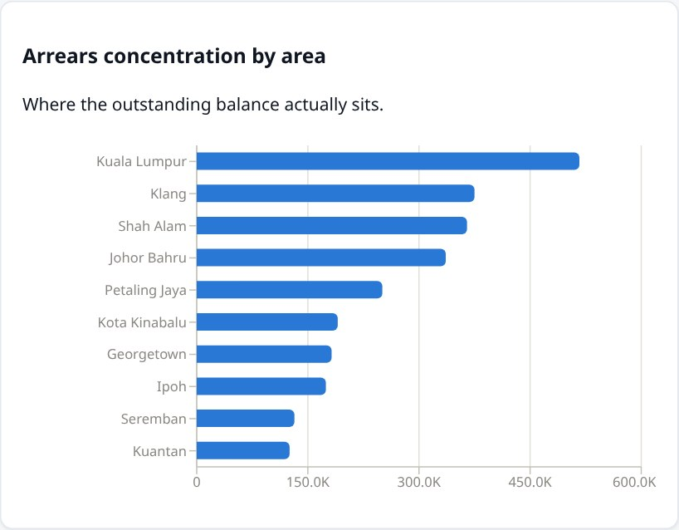
Concentration by area. Ranked by outstanding value across real IWK operating areas — Kuala Lumpur, Shah Alam, Klang, Johor Bahru and the rest.
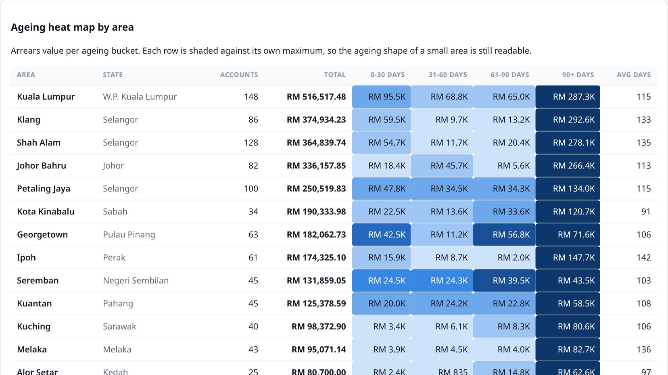
Ageing heat map. Each area against how overdue its debt is. Darker cells mean more money in that age band. Each row is shaded against its own maximum, so a small area's ageing pattern is still readable next to Kuala Lumpur's.
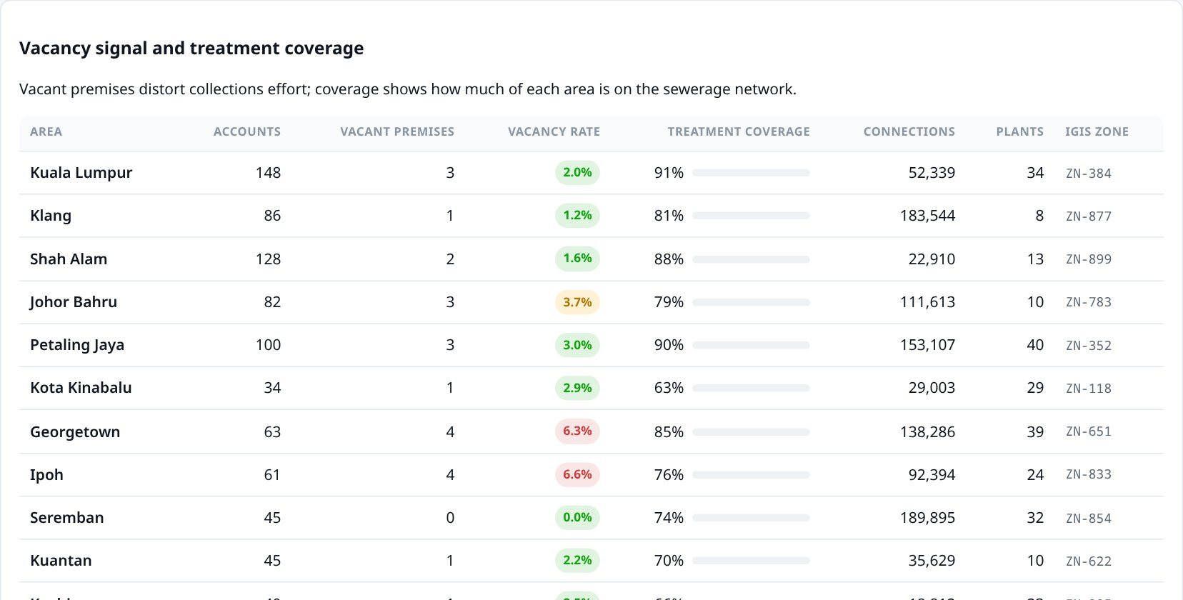
Vacancy and coverage. Empty premises distort collections effort — there is nobody there to chase — so they are flagged separately, alongside how much of each area is actually connected to the sewerage network.
Scope
This is the area-level summary. Detail down to individual premises, for authorised users, belongs in IWK's mapping system (IGIS) rather than in this dashboard.

Customers [Demo]
The underlying account records, and the one screen where they can be changed.
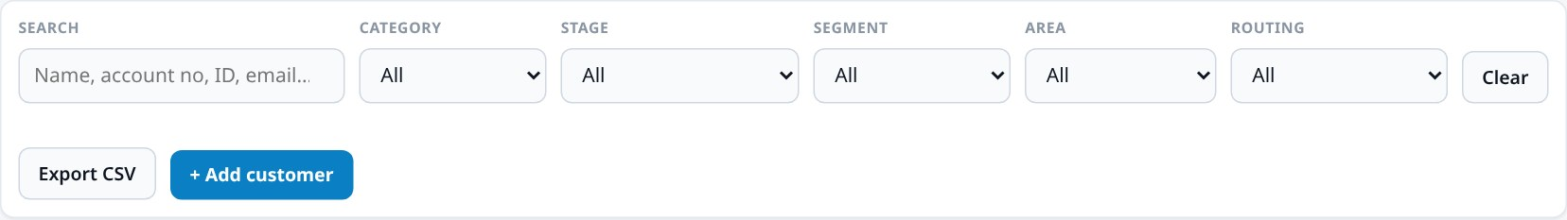
Finding accounts. Search by name, account number or email, and narrow by customer type, ladder stage, segment, area, or special-routing status.
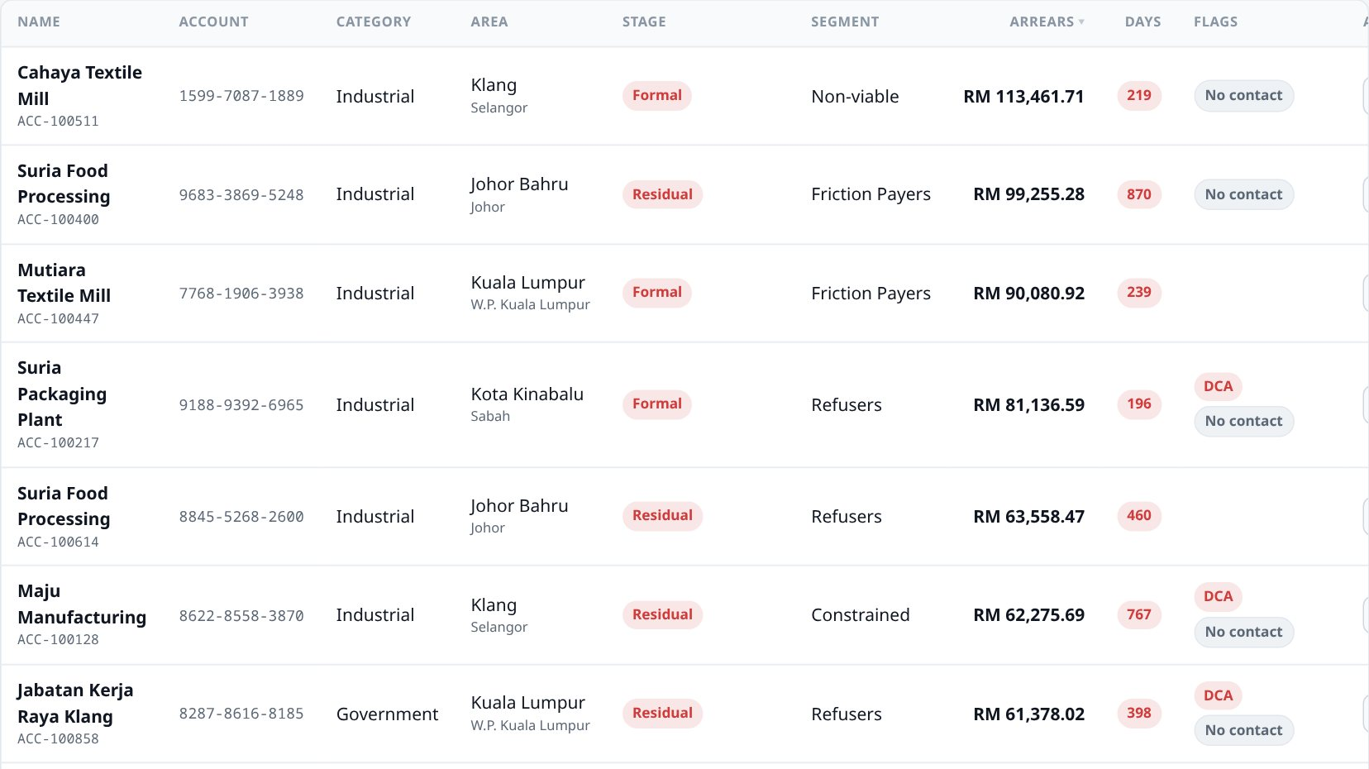
The account list. Coloured tags mark the stage, how overdue the account is, and any special status — whether it is with an agency, on a payment plan, or must not be contacted.
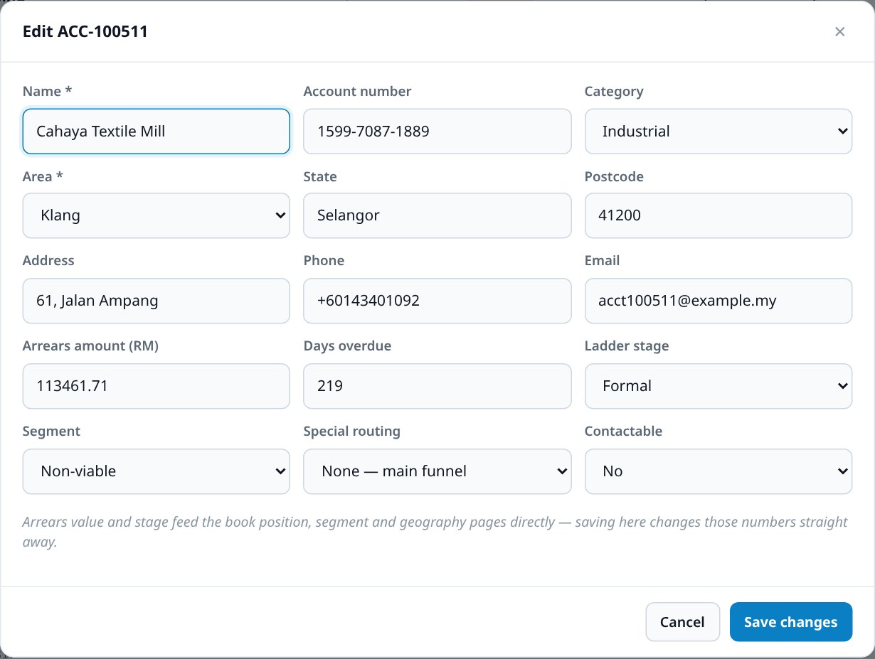
Adding or editing. Every field from section 5 can be set here. Selecting an area fills in the state automatically.
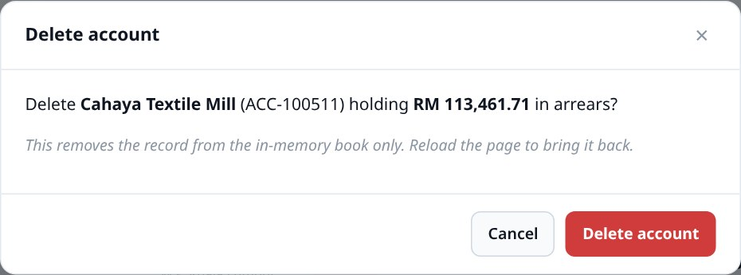
Deleting. Deletion asks for confirmation and states plainly that the record returns when the page is reloaded.
Everything is connected
Changes here ripple through the whole dashboard immediately. Delete a large industrial account and the total arrears figure drops, its ladder stage loses an account, its area falls down the geographic ranking, and — if it was with an agency — that agency's placement figures change too.
Nothing is saved. Refresh the page and all 900 original records return.

Settings [Demo]
The assumptions behind the numbers. This screen is worth understanding because changing a value here visibly changes figures elsewhere.
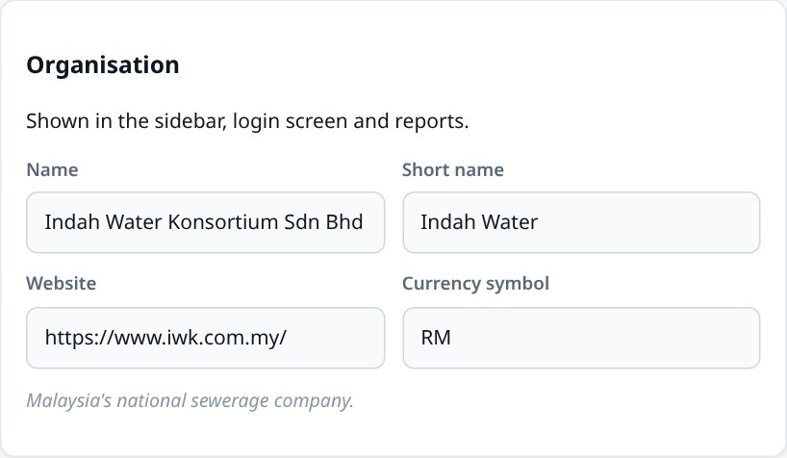
Organisation. The details shown throughout the dashboard.
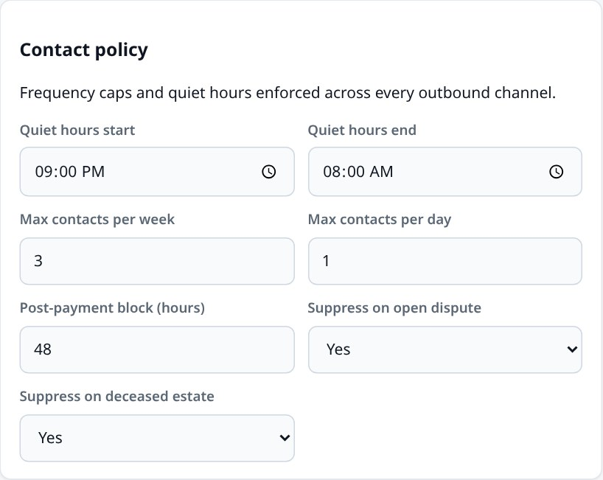
Contact policy. Quiet hours, how often a customer may be contacted, and the rules that automatically suppress contact — after payment, during a dispute, or for a deceased estate.
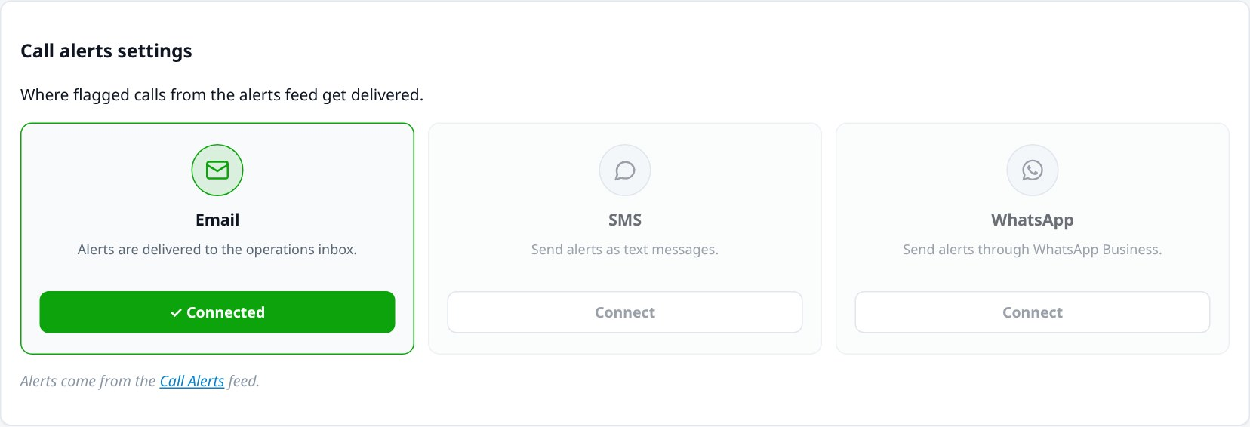
Call alerts settings. Where flagged calls are delivered. Email is connected and active; SMS and WhatsApp are shown faded because they require a paid subscription and further setup.
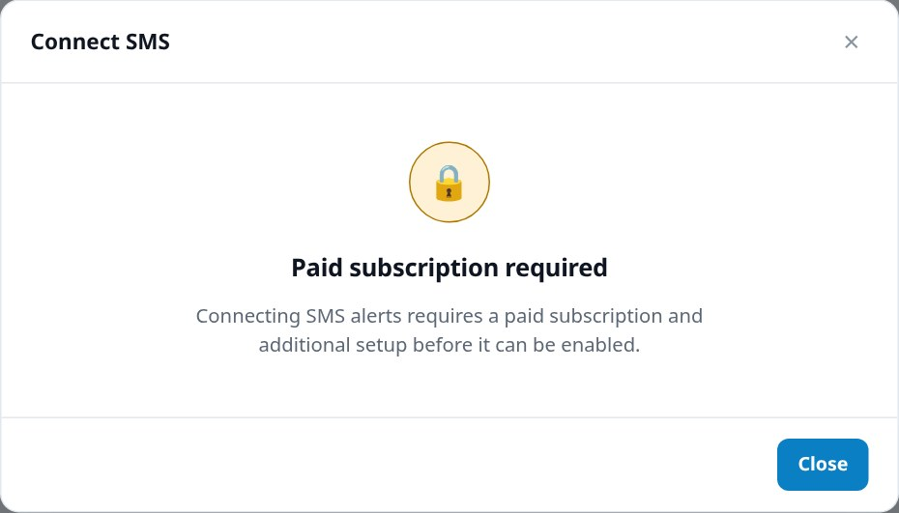
Connecting a channel. Selecting SMS or WhatsApp explains what would be required rather than failing silently.
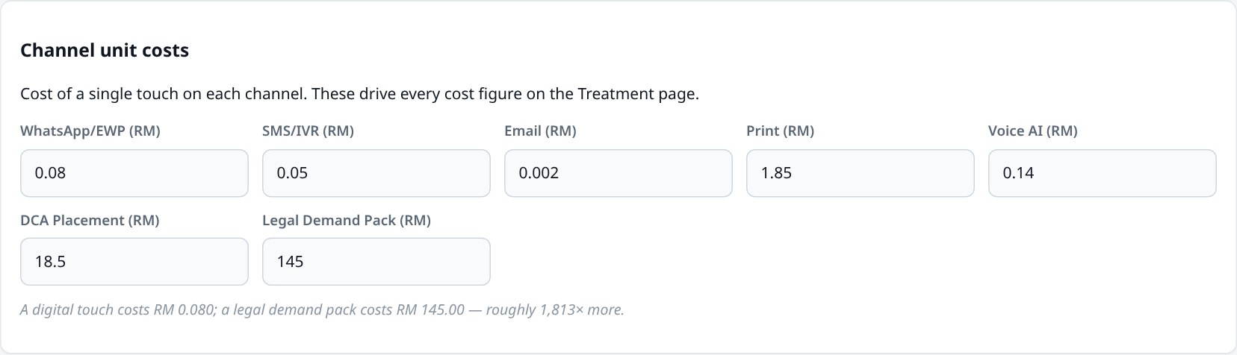
Channel unit costs. What a single contact costs on each channel. These values drive every cost figure on the Treatment screen — change one and those numbers move immediately, which makes the screen useful for testing "what if postage went up?" style questions.
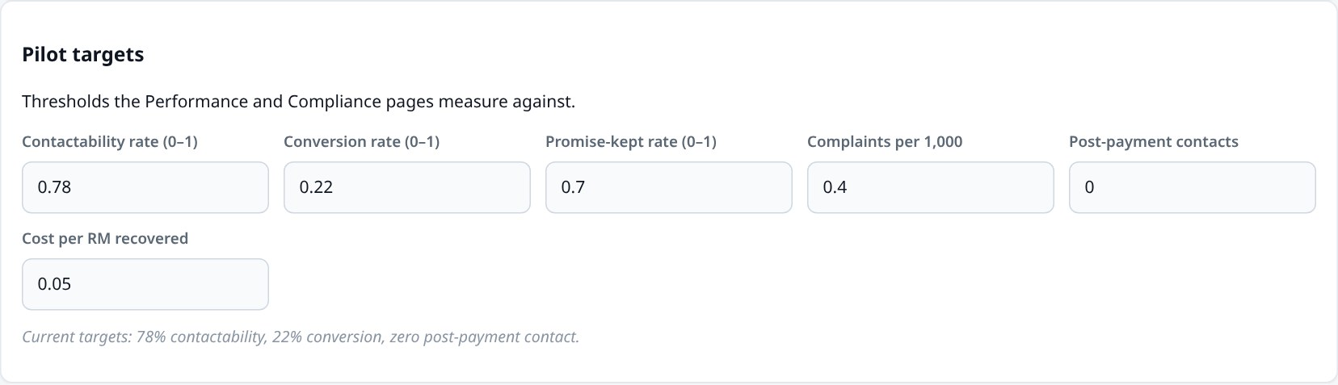
Targets. The thresholds the Performance and Compliance screens measure against, including the zero target for post-payment contact.

7. Glossary of measures
Every measure used anywhere in the dashboard, in plain language.

The arrears book
Measure | What it means
Total arrears | Every ringgit owed across all 900 accounts added together
Overdue value | The portion that is genuinely past its due date
Average days overdue | How long the typical late account has been outstanding
Share of book | What percentage of the total money a group represents
Ageing buckets | Debt grouped by age: 0–30, 31–60, 61–90 and 90+ days. Older debt is recovered less often
Aged in | Accounts that got worse and moved to a later stage
Converted out | Accounts resolved through payment or settlement
Net movement | Aged in minus converted out. Positive means the book is deteriorating

Contact and cost
Measure | What it means
Contacts sent | Messages or calls attempted, across all channels
Delivery rate | What share of messages actually arrived
Response rate | What share of delivered messages got a reply
Unit cost | The cost of one single contact on that channel
Cost per response | Total channel spend divided by replies received — the honest efficiency measure
Cost per touch | The cost of one contact attempt at a given level, from a digital message up to a legal demand pack
Treatment cost | Everything spent trying to recover the debt
Resolution rate | What share of accounts a particular message campaign actually resolved
Cost per resolution | What it cost that campaign to resolve one account

Performance
Measure | What it means
Contactability rate | What share of customers we can actually reach — wrong numbers and dead addresses reduce this
Conversion to payment | What share of contacts led to an actual payment. The measure that matters most
Promise-kept rate | Of customers who promised to pay, how many did. Low figures mean promises are being extracted rather than agreed
Instalment adherence | How reliably customers on payment plans keep up with them
Cost per ringgit recovered | What it costs to collect RM1. Lower is better; this is the programme's efficiency in one number

Conduct and compliance
Measure | What it means
Complaints per 1,000 contacts | Complaints measured against contact volume, so growing a campaign cannot disguise a rising complaint rate
Post-payment contacts | Times somebody was chased after already paying. Target: zero
Frequency cap adherence | How well the limit on how often a customer is contacted is being respected
Quiet-hours adherence | How well the ban on contacting people late at night or early morning is respected
Upheld complaint | A complaint found to be justified after review

Agencies and legal
Measure | What it means
Accounts placed | Debts handed to an external collection agency
Contact rate | What share of placed accounts the agency managed to reach
Collection rate | What share of the placed value the agency actually recovered
Same-day recall | An account pulled back from an agency the same day the customer paid
s.88(2) demand pack | A formal statutory demand under the Water Services Industry Act 2006
Write-off recommended | Debt judged unrecoverable, awaiting approval to be written off

Voice AI
Measure | What it means
Talk time | Total minutes the AI agent spent on calls
Cost per minute | What a minute of AI calling costs
Ended reason | How the call finished — the customer hung up, the call completed, or something failed
Cost breakdown | The five components of a call's cost: the telephone connection, converting speech to text, the AI's reasoning, generating the spoken voice, and the platform fee
Recording tracks | Four versions of the audio: combined, stereo, agent only, or customer only
A note on currency
Every collections figure is in Malaysian ringgit (RM). Voice AI costs are shown in US dollars, because that is how the calling service bills. The two are never added together anywhere in the dashboard.

8. What is and isn't real
Part of the demo | Status | Notes
Voice AI call logs and costs | [Real] | Genuine calls from the live calling account, with real billed costs
Call recordings and transcripts | [Real] | Retrieved securely and played in the browser
Call Alerts feed | [Real] | Live feed from an automation service; updates on its own
900 customer accounts | [Invented] | Generated to realistic rules. No real customer data is used
All collections analytics | [Invented] | Calculated from the invented accounts and campaign history
Adding, editing, deleting | [Temporary] | Works fully on screen, but resets on refresh
Placing live calls | [Not enabled] | Requires a paid telephony subscription
SMS and WhatsApp alerts | [Not enabled] | Require paid subscriptions and setup. Email alerts are connected

Known limitations of the demonstration
- Nothing is saved. There is no database behind the customer records; the demo deliberately resets so it is always in a known state.
- The sign-in is not real security. It keeps the demo tidy, nothing more.
- Only outbound calling is gated — reviewing past calls works fully.
- The dashboard reads; it does not act. It cannot send a message, place a call or refer an account to an agency. It shows what such a system would produce.

What a production version would add
- A connection to IWK's real billing and customer systems, replacing the invented accounts
- A proper database so changes persist, with a record of who changed what
- Real user accounts and permissions, so different teams see appropriate information
- Live telephony, so calls can be placed and joined from the dashboard
- Automatic delivery of alerts by SMS and WhatsApp alongside email
Indah Water Collections Dashboard — demonstration build. Every screenshot in this report was captured from the running application. Customer records shown are invented for demonstration purposes and do not represent real individuals or accounts.

