
SignServer
PDF Signing Guide
1.0
© PrimeKey Solutions AB, 2008

Table of Contents
Introduction 3
Who should read this document 3
Terms explained 3
Document Signatures 4
Introduction 4
Server signatures 4
Client signatures 4
Enabling PDF Signing 5
Prerequisites 5
Installing the PDF signer 5
Installing the SignServer node package 5
Installing the SignServer managment package 7
Configure a demo PDF signer 8
Signing documents 9
Verifying signed documents 10
Advanced configuration 13
Configure the PDF signer with a real certificate 14

Introduction
This document describes how to perform server side PDF signing using SignServer with the PDF signing plug-in.

Who should read this document
The system administrators in charge of setting up server side PDF signing.

Terms explained
Here are some of the common terms used in this document.

Term | Explanation
SignServer | An framework performing cryptographic operations for other applications. The framework is plug-in based and one such plug-in is the PDF signing plug-in.
EJBCA | “Enterprise Java Bean Certificate Authority”, Open Source Certificate Authority
CA | “Certificate Authority”.  A CA issues certificates to, and vouches for the authenticity of entities. The level of trust you can assign to a CA is individual, per CA, and depends on the CAs policy and practices statement.
PDF | The Portable Document Format is the open file format created by Adobe Systems for document exchange.

“Adobe” and “Adobe Reader” are registered trademarks of Adobe Systems Incorporated.

Document Signatures

Introduction
Generating signed document can be done for different reasons and in different ways. The most common reason is for integrity and authentication meaning that the recipient of the signed document can, through verification, be assured that the document has not been altered and that it originates from the expected source.
An organization that wishes to utilize these security features can choose between server generated signatures or client signatures.

Server signatures
Server generated signatures is used when a document is signed as originating from an organizational entity, or from a person but that person does not have the ability to create signatures on the local workplace. A recipient can verify that the document originates form the organization or person who created the document. This is many times a desired feature. Server signatures can be created by a signing server, such as SignServer and this is the method that will be described in this document.

Client signatures
Client signatures is created on the client where the document is authored. The client signature is initiated by the author of the document and the signature on the document identifies and authenticates the author. This method is out if the scope of this document, but is described in the SmartCard2.0 package.

Enabling PDF Signing
This guide will install and configure the PDF Signer on a single machine. For running in a clustered environment additional configuration is needed.

Prerequisites
Before installing the PDF Signer you need a computer with Linux or Windows with Sun JDK 6 installed. Also the Unlimited strength crypto policy files should be installed. See the JDK download site as java.sun.com for more information.
© PrimeKey Solutions AB, 2008

Installing the PDF signer
To install the PDF signer with everything on a single node you need to install both the signserver node and the signserver management packages.

Installing the SignServer node package
Run the signserver node installer:
On Linux:
# sudo ./signservernode-3.1-linux-installer.bin

On Windows run signservernode-3.1-linux-installer.exe.

You will be presented with a graphical installer to go through. Use default values for all options for the easiest setup.

First press Forward, accept the license and press Forward again.
Choose the installation directory and press Forward.

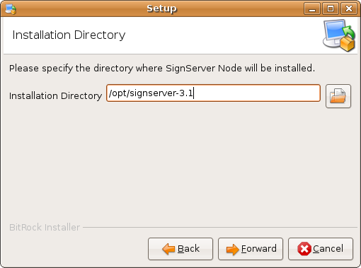

Choose if you want to send log events to syslog, leave as default No for easiest setup and press Forward.

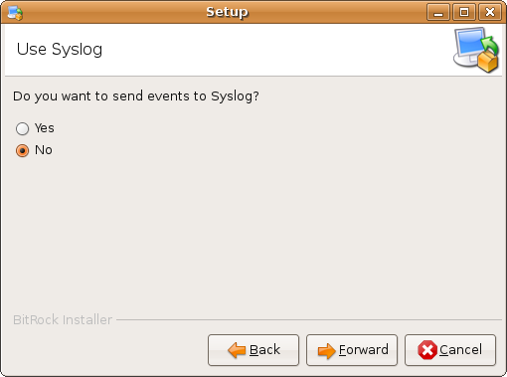

Finally press Forward to start the installation.

Press OK when you get an information event about generation of HTTPS keystores.

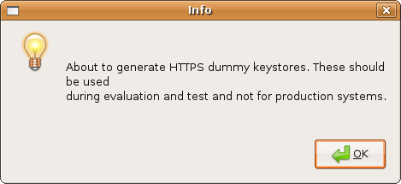

Press OK when you get an information event about starting Jboss.

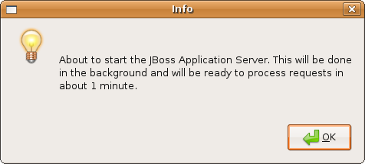

The installation of the signserver node is now completed, press Finish to terminate the installation program.

Installing the SignServer managment package
Run the signserver management installer:
On Linux:
# sudo ./signservermgmt-3.1-linux-installer.bin

On Windows run signservermgmt-3.1-linux-installer.exe.

You will be presented with a graphical installer to go through. Use default values for all options for the easiest setup.

First press Forward, accept the license and press Forward again.
Choose the installation directory and press Forward.

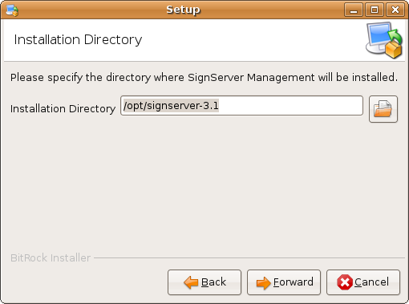

Finally press Forward to start the installation.

The installation of the signserver management is now completed, press Finish to terminate the installation program.

Configure a demo PDF signer
To enable the PDF signer we simply need to install the PDF module in SignServer and say that it is a demo signer. Execute the commands:

# cd /opt/signserver
# sudo signserver.sh module add modules/pdfsigner.mar demo

The output should look like the following:

===========================================
Executing Command on host : localhost
===========================================

WARNING: Module functionality is still experimental.

Loading module PDFSIGNER with version 3100 ....
Loading part server ....
Configuring properties included in the part : server, for the environment demo
Setting the property REASON to Officially issued document for worker 1
Setting the property LOCATION to Stockholm for worker 1
Setting the global property WORKER1.CLASSPATH to org.signserver.module.pdfsigner.PDFSigner with scope GLOB.
Setting the property KEYDATA to
rO0ABXNyABVqYXZhLnNlY3VyaXR5LktleVBhaXKXAww60s0SkwIAAkwACnByaXZh
dGVLZXl0ABpMamF2YS9zZWN1cml0eS9Qcml2YXRlS2V5O0wACXB1YmxpY0tleXQA
...
ZW50cQB+AAV4cHEAfgAMcQB+ACI= for worker 1
Setting the property NAME to PDFSigner for worker 1
Setting the property AUTHTYPE to NOAUTH for worker 1
Setting the global property WORKER1.SIGNERTOKEN.CLASSPATH to org.signserver.server.cryptotokens.SoftCryptoToken with scope GLOB.
Setting the property MODULENAME to PDFSIGNER for worker 1
Setting the property MODULEVERSION to 3100 for worker 1

Module loaded successfully.

Signing documents
To sign a PDF document go to the URL:
http://localhost:8080/signserver/pdfsign.html

There you can upload a PDF document, and the document will be returned, signed, instantly. The PDF document will be identical to the one uploaded but with a signature field added.

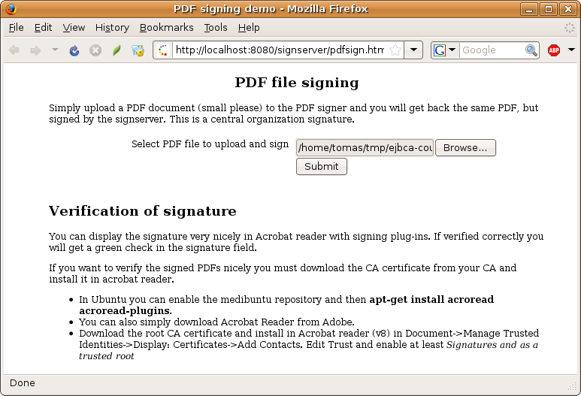
You can configure the size and location if the signature field to suit your documents, or
even choose not to display a signature field at all. You can also configure different signers with different types of signature fields.
This configuration is done by setting properties on the PDF Signer, see Signserver Manual for information about these properties.

Verifying signed documents
This chapter describes how you can verify signed PDF-documents using Adobe® Reader.

To be able to fully verify a signature the trusted Root certificate must be installed in Adobe.

Importing the certificate is done in the menu Document->Manage Trusted Identities.

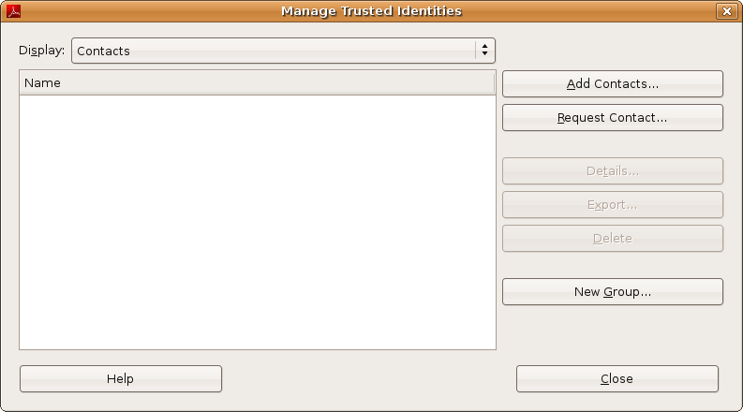

Click Add Contacts, browse to the Root CA certificate file and import it.

The Root CA certificate is located in the file:
/opt/signserver-3.1/sample-configs/ServerCA.crt

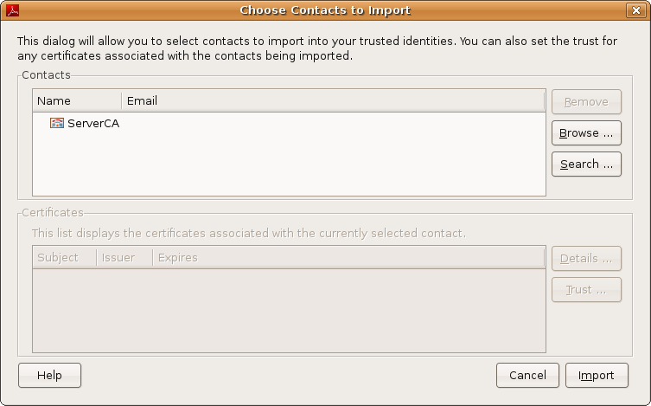

Press Import to import the certificate.

After this you also have to select the newly imported certificate in the Certificates list. First select Certificates in the drop-down list.

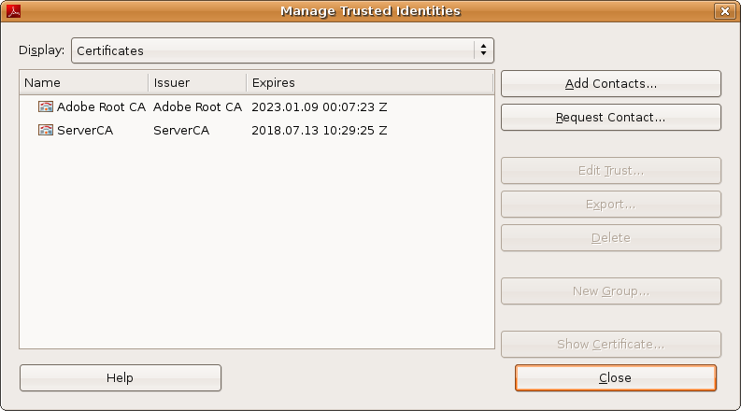

Select ServerCA and click Edit Trust. Select the check boxes Signatures and as a trusted root and Certified documents.

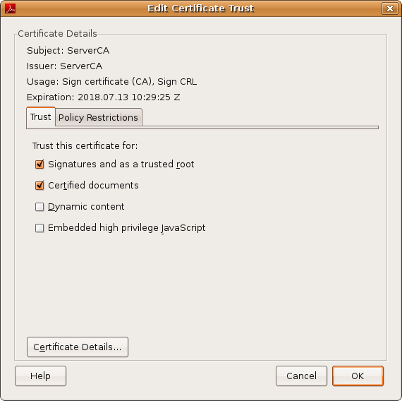

Click OK and the Close to finalize the installation of the certificate.

Verifying signed documents is done automatically when opening a signed PDF using Adobe® Acrobat or Adobe® Reader. When a document is signed a panel Signatures is shown on the left. By clicking in this panel you can get full information about the signer of the document, and the verification steps performed. You can also get information by clicking on the signature field in the document.

To verify a PDF document, simply open it in Adobe® Reader.

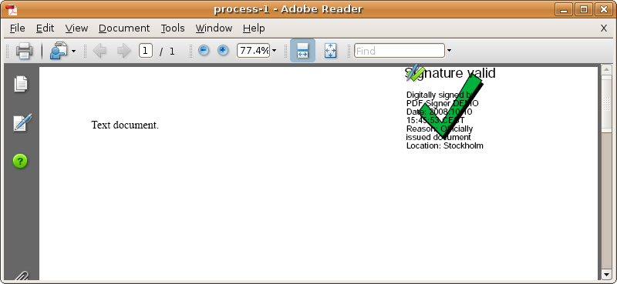

If you click the signed picture you get the picture below where you can get more information about the signature.

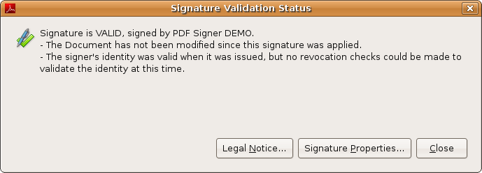

Advanced configuration
On the SignServer you can find out which signers you have with the command:
# bin/signserver.sh getstatus complete all

If you see that your PDF signer have the ID 1, you can verify the configuration of the PDF signer with the command:
# bin/signserver.sh getconfig 1

The server log file is located in:
/var/log/signserver/server.log

Configure the PDF signer with a real certificate
To configure the PDF signer with real keys and a real certificate, you use the SignServer CLI .to generate a new key pair and a certificate request:
# bin/signserver.sh generatecertreq 1 "C=SE,CN=PDF Signer" SHA1WithRSA pdfsigner.req

The certificate request will be created and stores in the file pdfsigner.req.
Now you should create a user in EJBCA and issue the PDF signer certificate to. When issuing PDF signing certificates you should at least use key usage digital signature and possibly also non-repudiation. You must also consider OCSP certificate validation and have an OCSP responder available and the correct OCSP Service Locator URI in the certificate. One other alternative is to use the OCSP No Check certificate extension to avoid OCSP validation.

When getting the certificate from EJBCA you can go to the public web and use Create Server Certificate. There you can enter the username and password for the user you created in EJBCA, and paste the contents of the request file pdfsigner.req. EJBCA will issue the certificate for you to save as cert.pem.
You must also download the CA certificate in pem format from the CA.

When you have:
- CA certificate, cacert.pem
- PDF Signer certificate, cert.pem

You can import the signer certificate and certificate chain in the signer with the following commands:
# cat cert.pem AdminCA1.cacert.pem> certchain.pem
# bin/signserver.sh uploadsignercertificate 1 glob cert.pem
# bin/signserver.sh uploadsignercertificatechain 1 GLOB certchain.pem
# bin/signserver.sh reload 1

After reload, which is the last command, you can use the PDF signer with your real signing certificate instead of the demo certificate.

