**Growing pattern for population of active users of e-commerce company**

Keyi Zhong, Peicheng Wang, Yile Tan

AMATH 383

Instructor: Jeremy Upsal

University of washington

Seattle, WA 98195, USA

Autumn 2018

# **Abstract**

The population of active users is a key measurement to evaluate the success of an e-commerce company. In this paper we create several models analyzing the population of active users of e-commerce companies like Amazon and Alibaba. Through studying the past growing pattern of active users of successful e-commerce companies, we develop a model of population of active users of an e-commerce company in different growing stages. Although there are many uncertainties in the growth of an e-commerce company, we hope that the model can be useful in predicting the future active users for other emerging e-commerce companies. In the following paper, we will call this model “Users Model”.

# **1. Introduction**

**1.1 Problem Description**

Electronic commerce has become a new way of buying and selling products for sellers and consumers with the development of the internet recently. The brand-new online retail company with rapid development breaks the structure of traditional retail market and is considered of huge potential which attracts many investors.

There are several approaches to evaluate the value of company stock based on the financial reports and the estimation of future. If the current stock price is higher than the value of stock, most of investors will sell the stock. Otherwise they will buy the stock. One of common evaluation approaches is Discounted cash flow (DCF) is

DCF = $\sum_{i = 1}^{n}{}\frac{{CF}_{i}}{(1 + r){}^{i}{}^{}}$

where is the estimated cash flow of future year i, r is discount rate(WACC) and DCF is the value of stock [1]. The discount rate(r) is from the calculation of a firm’s cost of capital which is not directly correlated with the revenues and cost of a company. The discount rate r is related to the categories of business sectors and financial leverage ratio like the ratio between liability and equity. Simply, we can view discount rate(r) as a positive constant like the interest rate and the future cash flow(CFi) as estimated future earnings.

Earnings generally can be represented by the multiplication of sale quantity and (price - cost) [2]

Earnings = Quantity $×$ (Price - Cost).

The future cash flow CFi is the estimated future earnings. If investors can predict the future sales quantity correctly, they can estimate the future cash flow under the assumption of constant (Price - Cost). According to the DCF evaluation method, given appropriate future cash flow(CF) and constant discount rate r , investors can estimate the value of stock. Finally, they can benefit from trading stock based on the DCF evaluation method. That is why investors are more concerned with the sales quantity.

As the main buyers of the e-commerce company, the population of active users will be positively correlated to sale quantity, making it an important signal of an e-commerce company measuring its popularity among consumers. More active users in e-commerce would create more orders implying making increasing revenue in total. Finally, the population of active users can be a significant reference for investors. Through the analysis of growth pattern of the population, the situation of the growth of an e-commerce company can be represented mathematically, which is an reliable resource for both companies and investors to determine what action they should take. In the following paper, we will call this model as “Users Model”.

**1.2 Relevant Factors**

There are several factors that may affect the growth rate of the population of active users. From the perspective of the market, the growth rate would be influenced by popularity of internet and cell phones and etc. For e-commerce companies, their level of advertisement expenses, population of active users in the previous periods, customers’ retention rate, and the amount of invitation reward would be the determinants of population of active users.

# **2. Continuous Models**

**2.1 Single company model**

First we consider the simplest case for a single e-commerce company in a market without any competitors. In this case, we only consider the nature of active users of e-commerce which spread by invitation and recommendation. The growth of population of active users consists of the difference between the number of new users invited by existing users (one existing user would invite a given number of new users on average) and the number of users who leave this e-commerce company. The mathematical representation of growing rate of active users is

$\frac{dP}{dt}$ = $αP$- $Q(t)$, (eq.1)

where P(t) is the number of active users for an e-commerce company, α is promotion rate and Q(t) is the churn population (the population of active users who discontinues their purchases of one e-commerce company within a given period). We assume that the churn population would be a function with respect to time t to simulate the phenomenon of quitting e-commerce in real world. For simplification we first consider Q(t) as a constant Q here as well as in later models.

Solving eq.1[Appendix 1] we obtain

$P(t)=\frac{1}{α}e^{αt}⋅(αP_{0}-Q)+\frac{Q}{α}$. (sol. 1)

In this case we assume that active users will invite their friends at a fixed rate $α$ for simplification. However, the growth would not continue endlessly as there are many limitations on the users and the e-commerce company. In the e-commerce market, the potential users are the population of laptop and mobile users who can get access to e-commerce. The number of actual active users cannot exceed the number of laptop and mobile users since other consumers are not accessible. Since the number of active users can be considered as the population, we can make an assumption that there is a maximum number of active user that one market can reach like the carrying capacity in an environment. For simplification, we assume that the number of laptop and mobile users (no matter whether they are already users of e-commerce or not) is a constant K. The differential equation of active users growth would become a simulation of population growth model [3]. We then obtain

$\frac{dP}{dt}$ = $αP×\left(1-\frac{P}{K}\right)$. (eq.2)

Solving eq.2 we have

$P(t)=$ $\frac{KP_{0}e^{αt}}{K+P_{0}(e^{αt}-1)}$. (sol. 2)

If we consider both factors, population of users who quit this e-commerce company and population of potential consumers, the part $αP$ in eq.2 becomes $αP$- Q in the updated model, we find

$\frac{dP}{dt}=$ $(αP-Q)×\left(1-\frac{P}{K}\right)$. (eq.3)

Solving eq.3 we obtain

$P(t)=\frac{Ke^{Qc}e^{at}+e^{aKc}e^{\frac{Qt}{K}}}{ae^{aKc}+e^{Qc}e^{at}}$ where $c=\frac{ln(\frac{K-P_{0}}{P_{0}a-1})}{aK-Q}$. (sol.3)

**2.2 Analysis**

We want to compare and evaluate these three models for practical use. We first consider the limit of all P(t) when t goes to infinity. For solution 1, P goes to infinity as the exponential part of the solution denominates. However, the active user of an e-commerce company cannot actually go to infinity as there are many limitation, so this case would only happen when we consider the most simple case and set it a basis for exploring more complex and ideal models. For solution 2, we solve the limit by dividing numerator and denominator by exp($at$). When t goes to infinity, P will converge to K, which correspond to our assumption that the number of laptop and mobile users is the upper bound of the number of active users of e-commerce. To evaluate the limits when t goes to infinity for solution 3, we first transform the representation of P and take the limit by parts. We have

$P(t)=\frac{Ke^{Qc+at}}{ae^{aKc}+e^{Qc+at}}+\frac{e^{aKc}e^{\frac{Q}{K}t}}{ae^{aKc}+e^{Qc+at}}$

The limit of the first term is K when we follow the same process solving for the limit of solution 2 but divide the numerator and denominator by exp(Qc+ $at$) instead. For the second term, the exponential part exp(Qt/K)goes to 0 when t goes infinity since Q/K represent the ratio of churn population verse mobile and computer users population which is always smaller than 1. The exponential part $exp(Qc+at)$ goes to infinity when t goes to infinity, so the limit of the second term is 0. Therefore, considering the addition of two limits, the limits of P in solution 3 would be K which also agrees with our assumption.

Then we plot the later two model in Desmos to evaluate the relationship between those parameters with x-coordinate stands for time t, $p$ stands for initial value of active users P0. We test these two models with different values for , P0 and most of the graphs agree to our assumption and look like figure 1. The graph is reasonable that when we consider the churn population, the e-commerce company needs more time to reach its equilibrium. With other parameters fixed, larger $a$ will bring a steeper slope, implying that a higher level of promotion rate enables the population grows faster. Also, a larger K will bring a higher upper bound for the number of active users.

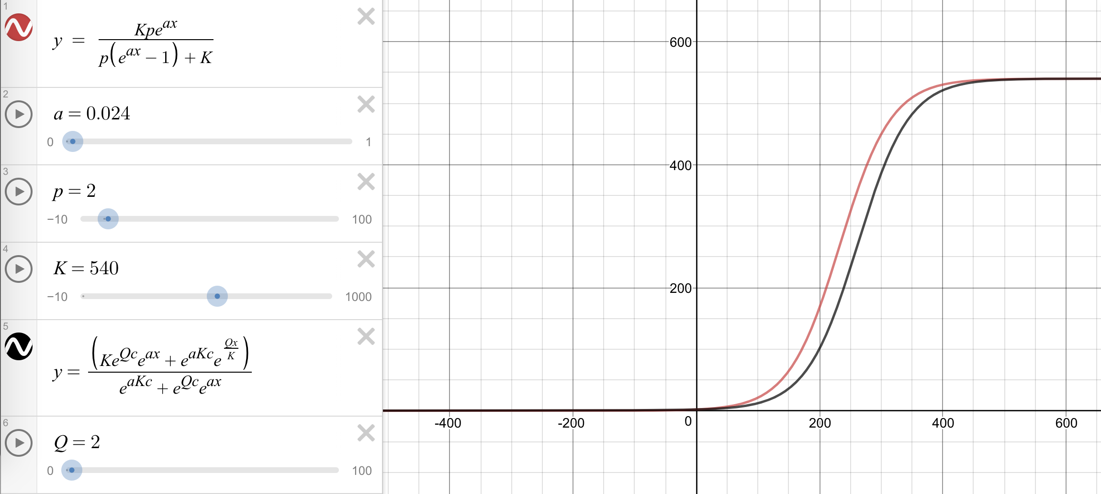

*Figure 1*

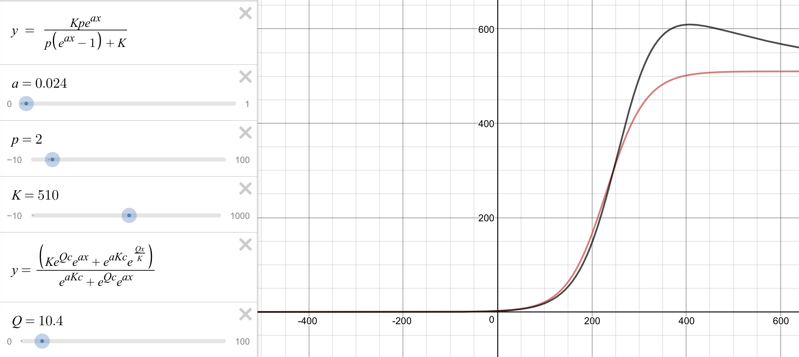

*Figure 2*

We notice that some graphs disagree with our assumptions like figure 2 shows. Comparing these two kinds of graphs, we find that the initial value of number of users P0 should be set greater than Q to be practically meaningful, which implies that the number of users who want to quit cannot exceed the initial population of active users at the beginning.

**2.3 single company model with changing number of churn population**

Models above assume the number of users who quitting the e-commerce company as a constant, now we update the model by setting it as a function with regards to time t. So the model becomes

$\frac{dP}{dt}=$ $(αP-Q(t))×\left(1-\frac{P}{K}\right)$. (eq.4)

The equilibrium of eq. 4 is given by setting dP/dt = 0. We obtain an equilibrium P*=K, which consists of the models above that the final stage of the population would goes to K. We cannot derive equilibrium solving the first term of the right hand sides as the Q(t) changes over time. At some point other than P*=K, dP/dt might be 0 but for some time around the point, Q(t) varies and the grow rate of the active users varies.

# **3. Discrete Models**

We now want to consider a discrete model for the number of active users because the number of active user is not continuous in reality. The data only reflects the change during a period of time. To build the discrete model, we first introduce a concept, customer retention rate (r). A customer retention rate reflects the portion of users who currently use the products and will still use the product in the next period. If $P_{0}$ is the initial number of active users, $P_{1}$ is the number of active users in next period. The customer retention rate is supposed to be a variable depending on period t because more time spending on the company’s products make the user more likely to be a loyal customer of the company.

We consider the group of users who use the products at one time without advertisement and promotion. On the other way, say, a group of users are attracted by the new ways of purchasing and start to use its products. After one period of time the remaining users is $P_{1}$ and is equal to $P_{0}×r_{1}$, where $P_{0}$ is the initial number of users and $r_{1}$ is the retention rate during the first period. Then, after some periods the number of user will become:

$P_{1}=P_{0}×r_{1}$

$P_{2}=P_{1}×r_{2}$

$P_{3}=P_{2}×r_{3}$

$P_{n+1}=P_{n}×r_{n+1}$

We make assumptions for the retention rate that $r(t)=1-5×e^{-t}$ and $r_{n}=1-5×e^{-n-1}$ because the retention rate for active users should start from a relative low ratio in this case which we assume to be approximately 0.5, and end at 1.

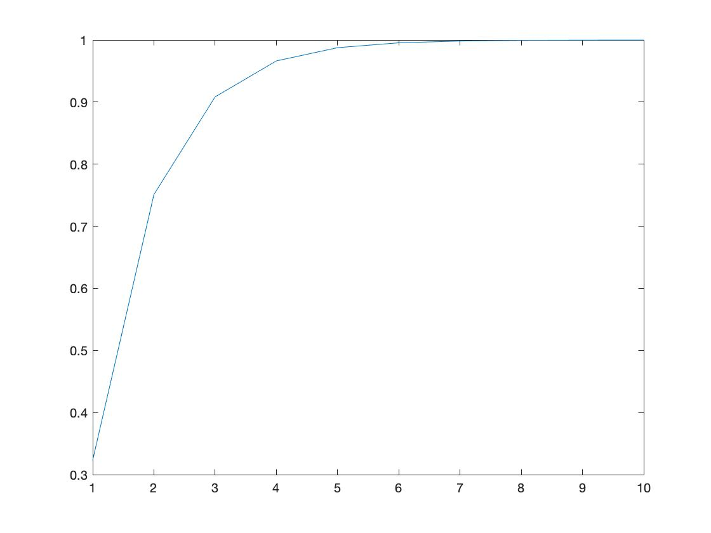

*Figure 3. Retention Rate*

Under this assumption we have

$P_{n+1}=P_{n}×(1-5×e^{-n-1})$

$P_{n+1}=P_{n-1}×(1-5×e^{-n-1})×(1-5×e^{-n})$

$P_{n+1}=P_{0}×\prod_{n=1}^{n+1}{}1-5×e^{-n-1}$ (eq.5)

Using Matlab, we observe that after n = 14, $P_{n+1}=0.209009*P_{0}$, so $\prod_{n=1}^{∞}{}1-5×e^{-n-1}$ converges to 0.209009. We can estimate that one fifth of new customers will become loyal users of the company.

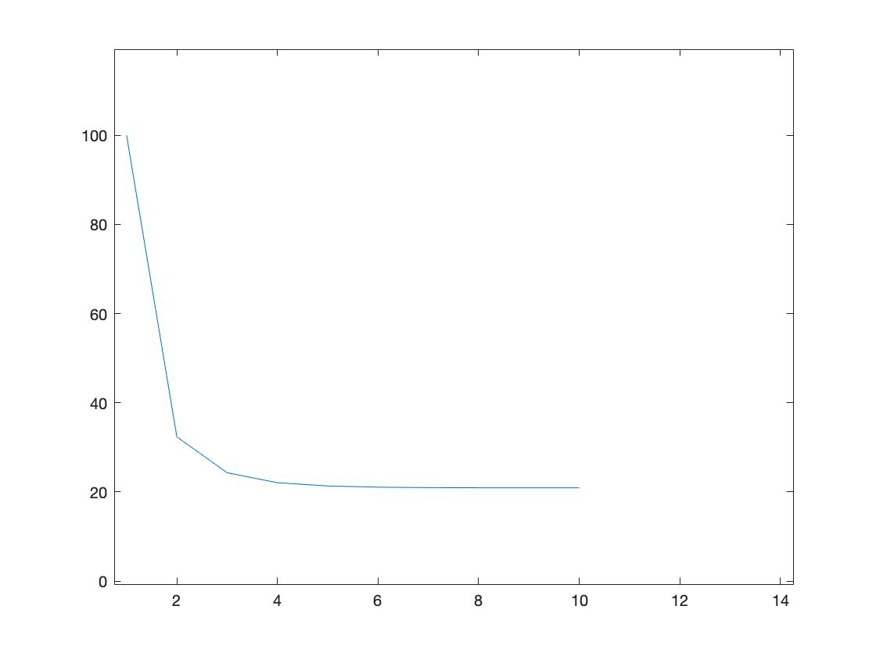

*Figure 4. Population with no advertisement*

The graph agrees to to the graph in “Retention Curves for Android Apps”[5].

Now consider the situation that the company continuously spend money on advertisement and encourage user to invite their friends. The discrete model for the e-commerce with advertisement is based on model of e-commerce without advertisement and is inspired by the growth model of user population introduced by Zhan and Tse which considers the market size [4]. Market size refers to the population of potential users of a product or a service, represented by the difference between the population and the number of existing users. We apply their definition and adjust its mathematical representation to fit the model which includes the promotion of advertisement. In the model, the number of new active users entering the e-commerce is a proportion of the market size, represented by $a(K-P_{0}$). Therefore, we can represent the number of active users of one stage by a function of the number of active users of its previous stage. We obtain

$P_{1}=P_{0}×r_{1}+a(K-P_{0})$

$P_{2}=P_{0}×r_{1}×r_{2}+a(K-P_{0})×r_{1}+a(K-P_{1})$

$P_{3}=P_{0}×r_{1}×r_{2}×r_{3}+a(K-P_{0})×r_{1}×r_{2}+a(K-P_{1})×r_{1}+a(K-P_{2})$

$P_{n+1}=P_{0}×r_{1}×r_{2}×...×r_{n+1}+a(K-P_{0})×r_{1}×r_{2}×...×r_{n}+...+a(K-P_{n})$

Following the iterations above, we have the final representation of number of active users for stage n+1 given the initial value of active users.

$P_{n+1}=P_{0}×\prod_{i=1}^{n+1}{}r_{i}+\sum_{j=0}^{n}{}(a(K-P_{j})×\prod_{i=1}^{n-j}{}r_{i})$ (eq.6)

Let $P_{0}=0, K=10000, a = 0.05$, we can get P after fifty period

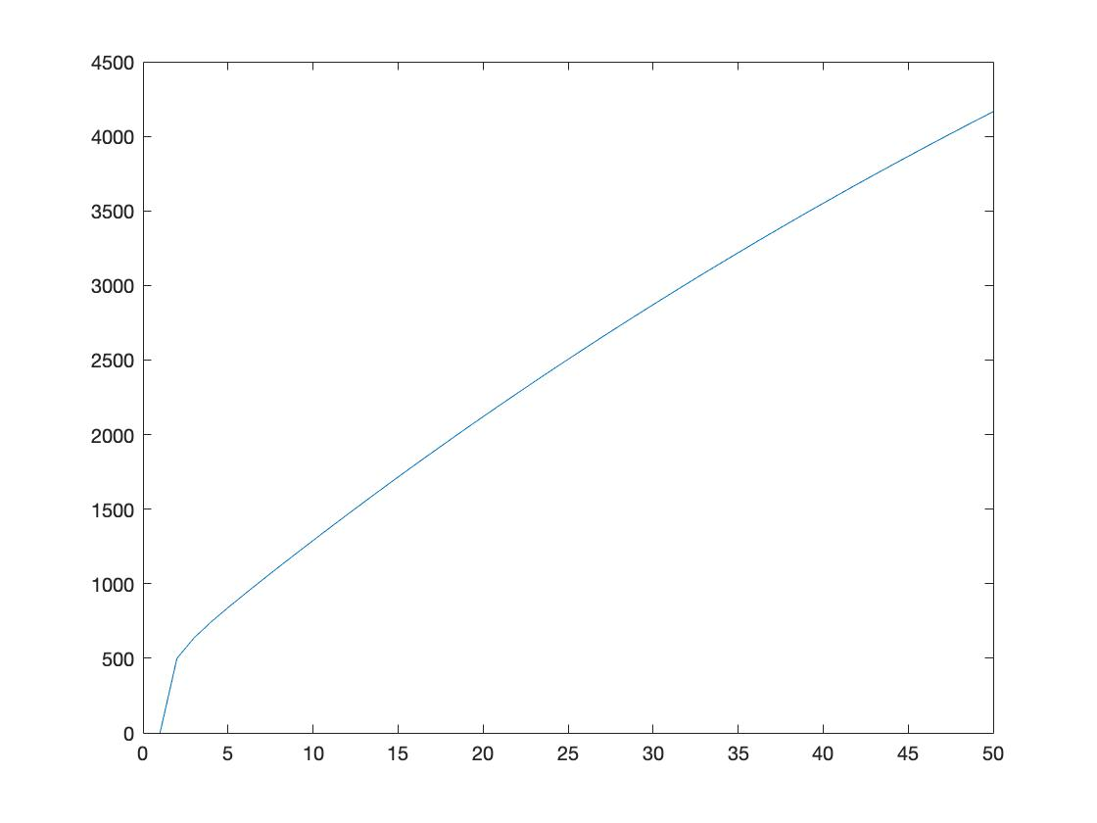

*Figure 5. Population when a = 0.05*

From the figure above we observe that when $a$ is small, which represents the level of attractiveness of the company and the level of advertisement expenses, the population is increasing in a steady pace except for the first period. We also try $a$ = 0.5 and $a$ = 0.9.

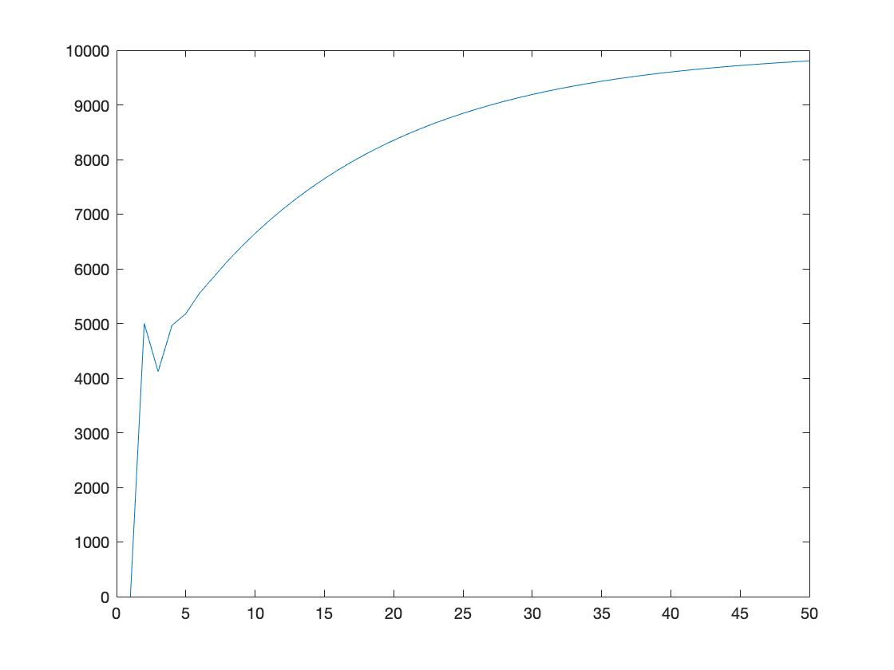

*Figure 6. Population when a = 0.5*

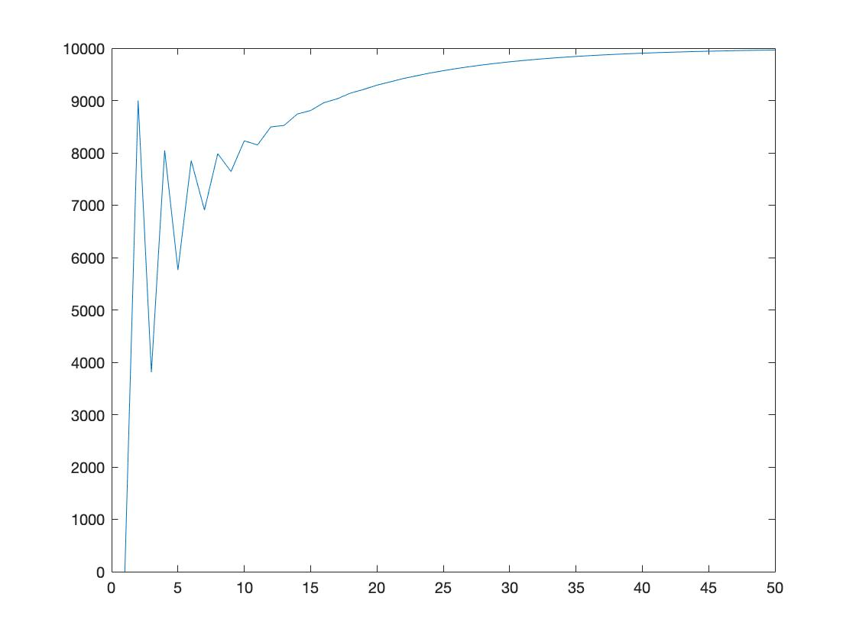

*Figure 7. Population when a = 0.9*

From figure 7 we observe that when $a$ is relatively large, there would be some fluctuations at the beginning, and the population approaches to K after some periods, which means the more attractive a company is the more unstable its active user grows at the beginning. At one stage with high level of advertisement, a large number of new active users would be attracted because the market size is relatively large. For the next stage, the number of new active users would decrease since the market size is small and given the fixed population who quit is relatively large, the number of active users would decrease for next stage. Also, though $a$ is almost doubled from 0.5 to 0.9, the population after fifty periods does not vary significantly. Therefore, we make an extra graph on advertisement rate versus population after 50 periods evaluate the relationship between them.

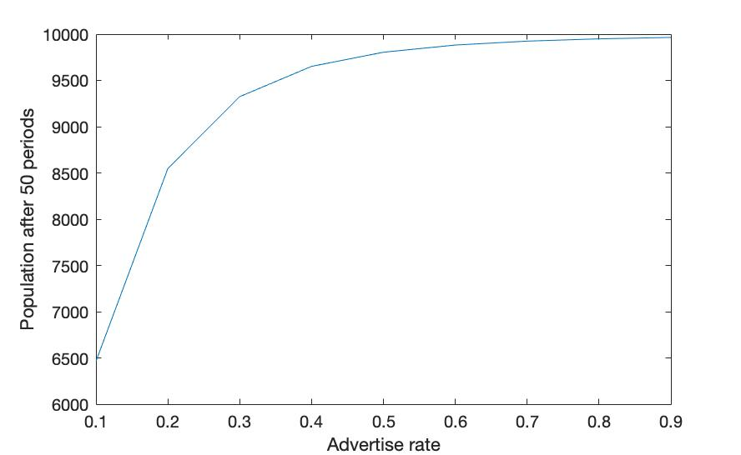

*Figure 8*

The graph shows that the effectiveness of spending money on advertisement is different. Marginal benefit of advertise rate decreases when the advertise rate is higher. Spending money on advertisement too much sometimes is not an efficient strategy.

# **4. Reflection**

The continuous model we have consider the case when there is one single company in the market. Improvement of the user model could be done by analysing the case when competitors enter the market and the number of active users of all e-commerce companies are correlated.

Figure 6 and figure 7 show uncommon fluctuations when advertisement rates are large because we assume that advertisement rate only affect those people who are not active users of the e-commerce company currently. However, the growth of active users is more complicated in reality. For instance, advertisement rate can affect retention rate that users are more likely to stay when the advertisement level of e-commerce company is high [3]. Also, the level of advertisement is related to the population of existing active users because the more users the company has, the more profit it can gain from users and it can spend more money on advertisement to attract other users.

**Reference**

[1]B. Graham. *The Intelligent Investor: a Book of Practical Counsel.* 2013.

[2]G. Mankiw. *Principles of Microeconomics*, 7e. USA: Cengage Learning. pp. 94–98, 106–107, 260–262, 283-288 & 304-308. [ISBN](https://en.wikipedia.org/wiki/International_Standard_Book_Number) [978-1-285-16590-5](https://en.wikipedia.org/wiki/Special:BookSources/978-1-285-16590-5), 2013.

[3]G. E. Belch and M. A. Belch. *Advertising and Promotion: An Integrated Marketing Communications Perspective*. 2014.

[4] R. [Pearl](https://en.wikipedia.org/wiki/Raymond_Pearl) and [L. Reed](https://en.wikipedia.org/wiki/Lowell_Reed). ["On the Rate of Growth of the Population of the United States"](http://math.bu.edu/people/mak/MA565/Pearl_Reed_PNAS_1920.pdf). [*Proceedings of the National Academy of Sciences of the United States of America*](https://en.wikipedia.org/wiki/Proceedings_of_the_National_Academy_of_Sciences_of_the_United_States_of_America). 6 (6). p. 275, 1920.

[5] C. Zhan and C. K. Tse. A universal model for growth of user population of products and services, *Network Science* 4 (4): 491–507. 2016.

[6] How to define good APP retention rate. Retrieved Dec 1, 2018, from Mixpanel website: https://mixpanel.com/