DESIGN PROCESS DOCUMENTATION
Spa Booking Platform

Architecture · User Flows · Database · Design System · Timeline

Version 1.0 · February 2026 · Confidential

Document | DESIGN-SPA-001 | Status | Draft
Project | Spa Booking Platform | Author | Design Team

1. Design Process Overview
This document captures the end-to-end design process for the Spa Booking Platform — a full-stack web application enabling customers to discover, book, and manage spa appointments. It covers system architecture decisions, user experience flows, data modeling, visual design language, and project phasing, with annotated visual diagrams for each domain.

This documentation accompanies the Software Requirements Specification (SRS-SPA-001). Together they form the complete technical and design foundation for the platform build.

1.1 Design Philosophy
Every design decision was guided by three core principles:

Simplicity First | At under 10,000 users, complexity is the enemy. The architecture deliberately avoids microservices, distributed caches, and over-engineered patterns. A monolithic Next.js application with Supabase provides everything needed.
Mobile-First UX | Over 70% of spa bookings occur on mobile devices. Every interface component — from the booking calendar to the service card — was designed at 320px viewport before scaling up.
Convention Over Config | Using Next.js with Vercel, Supabase with its built-in auth and RLS, and Tailwind with its utility-first approach means the team builds product, not infrastructure.
Seamless Handoff | Clear, layered documentation — SRS, design system, database schema, and sprint plan — ensures the platform can be maintained or extended by any competent developer after initial delivery.

1.2 Document Structure
This document is organized into five visual sections, each accompanied by a full-width annotated diagram:
- Section 2 — System Architecture: Technology stack, layer responsibilities, and integration map
- Section 3 — User Experience Flow: Customer booking journey from discovery to confirmation
- Section 4 — Database Schema: Entity-relationship model with table definitions and security rules
- Section 5 — Design System: Color palette, typography, UI components, and spacing scale
- Section 6 — Project Timeline: 14-week sprint roadmap with milestones and critical path

2. System Architecture

2.1 Overview
The platform is a conventional full-stack web application built on modern, managed services. The architecture optimizes for developer velocity, operational simplicity, and low infrastructure cost at the target scale of up to 10,000 registered users.
The core stack — Next.js on Vercel with Supabase as the backend-as-a-service — was chosen because it eliminates server provisioning, built-in authentication, database hosting, real-time subscriptions, and CI/CD in a single pair of products. This keeps the complexity surface minimal and the team focused on business logic.

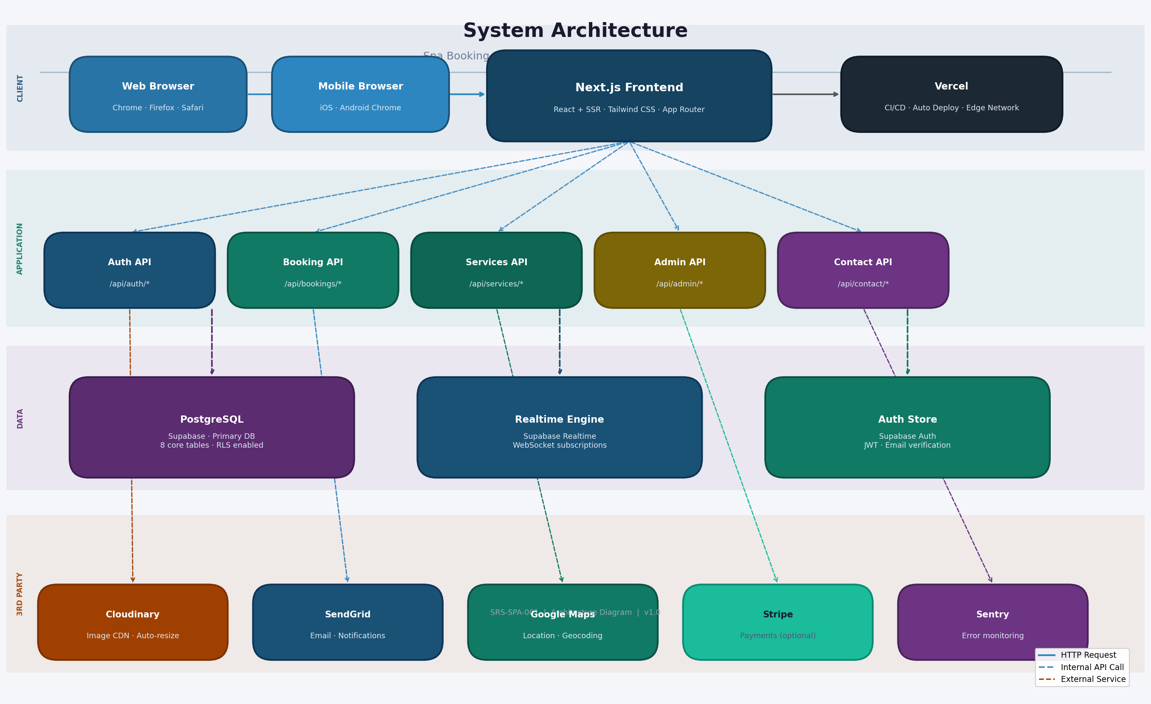
Figure 1 — System Architecture Diagram: Four-layer overview of the Spa Booking Platform infrastructure

2.2 Layer Breakdown

2.2.1 Client Layer
The client layer is any standards-compliant web browser — desktop or mobile. There is no native application in v1.0. The Next.js application serves pre-rendered HTML via SSR for public pages (homepage, services, about, contact) for SEO performance, and uses client-side React for interactive components like the booking calendar and admin dashboard.

2.2.2 Application Layer
Five dedicated API route groups handle the platform's business logic, each scoped to a single domain:

API Route | Responsibility
Auth API | Registration, login, logout, password reset, session validation. Delegates to Supabase Auth under the hood.
Booking API | Availability queries, slot locking, booking creation, confirmation, cancellation, and rescheduling.
Services API | CRUD operations for the service catalog, category filtering, and Cloudinary image management.
Admin API | Protected routes for admin operations: therapist management, schedule management, booking overrides, and message inbox.
Contact API | Contact form submission with rate limiting (5 req/IP/hour), database persistence, and email dispatch via SendGrid.

2.2.3 Data Layer
All persistent state lives in a PostgreSQL database hosted on Supabase. Three Supabase services are utilized: the core relational database for all application data, Supabase Realtime for WebSocket-based slot availability updates during the booking flow, and Supabase Auth for user identity and session management.

2.2.4 Third-Party Integrations

Service | Purpose
Cloudinary | Image upload, automatic format optimization (WebP), and responsive resizing for all service and gallery images.
SendGrid | Transactional email for booking confirmations, admin notifications, and contact form auto-replies.
Google Maps | Embedded interactive map on the homepage and contact page. Falls back to a static address card if unavailable.
Stripe | Optional payment processing for deposits. Not required for v1.0 launch — can be toggled via environment variable.
Sentry | Runtime error monitoring with real-time alerting. Captures frontend JS exceptions and backend API errors.

2.3 Key Architecture Decisions

Decision: Monolith over microservices. At the target scale, a monolith is simpler to build, deploy, and debug. Microservices would add network latency, operational overhead, and distributed tracing complexity with no meaningful benefit.

Decision: Supabase over custom backend. Supabase provides auth, database, storage, and real-time in one product with a generous free tier, reducing the team's operational surface to near zero.

Decision: Next.js over separate SPA + API. Colocating the frontend and API routes in one Next.js codebase simplifies deployment, eliminates CORS configuration, and keeps the project maintainable by a solo developer.

3. User Experience Flow

3.1 Booking Journey
The booking flow is the most critical user journey on the platform. It must be frictionless, fault-tolerant, and fast. The design goal is for any new user to complete a booking in under 5 minutes without guidance — a benchmark validated in UAT with 5+ test participants.
The flow is structured as a linear wizard with clear exit points and error recovery paths. No step requires knowledge of a previous step, meaning users can navigate back freely without losing their selections.

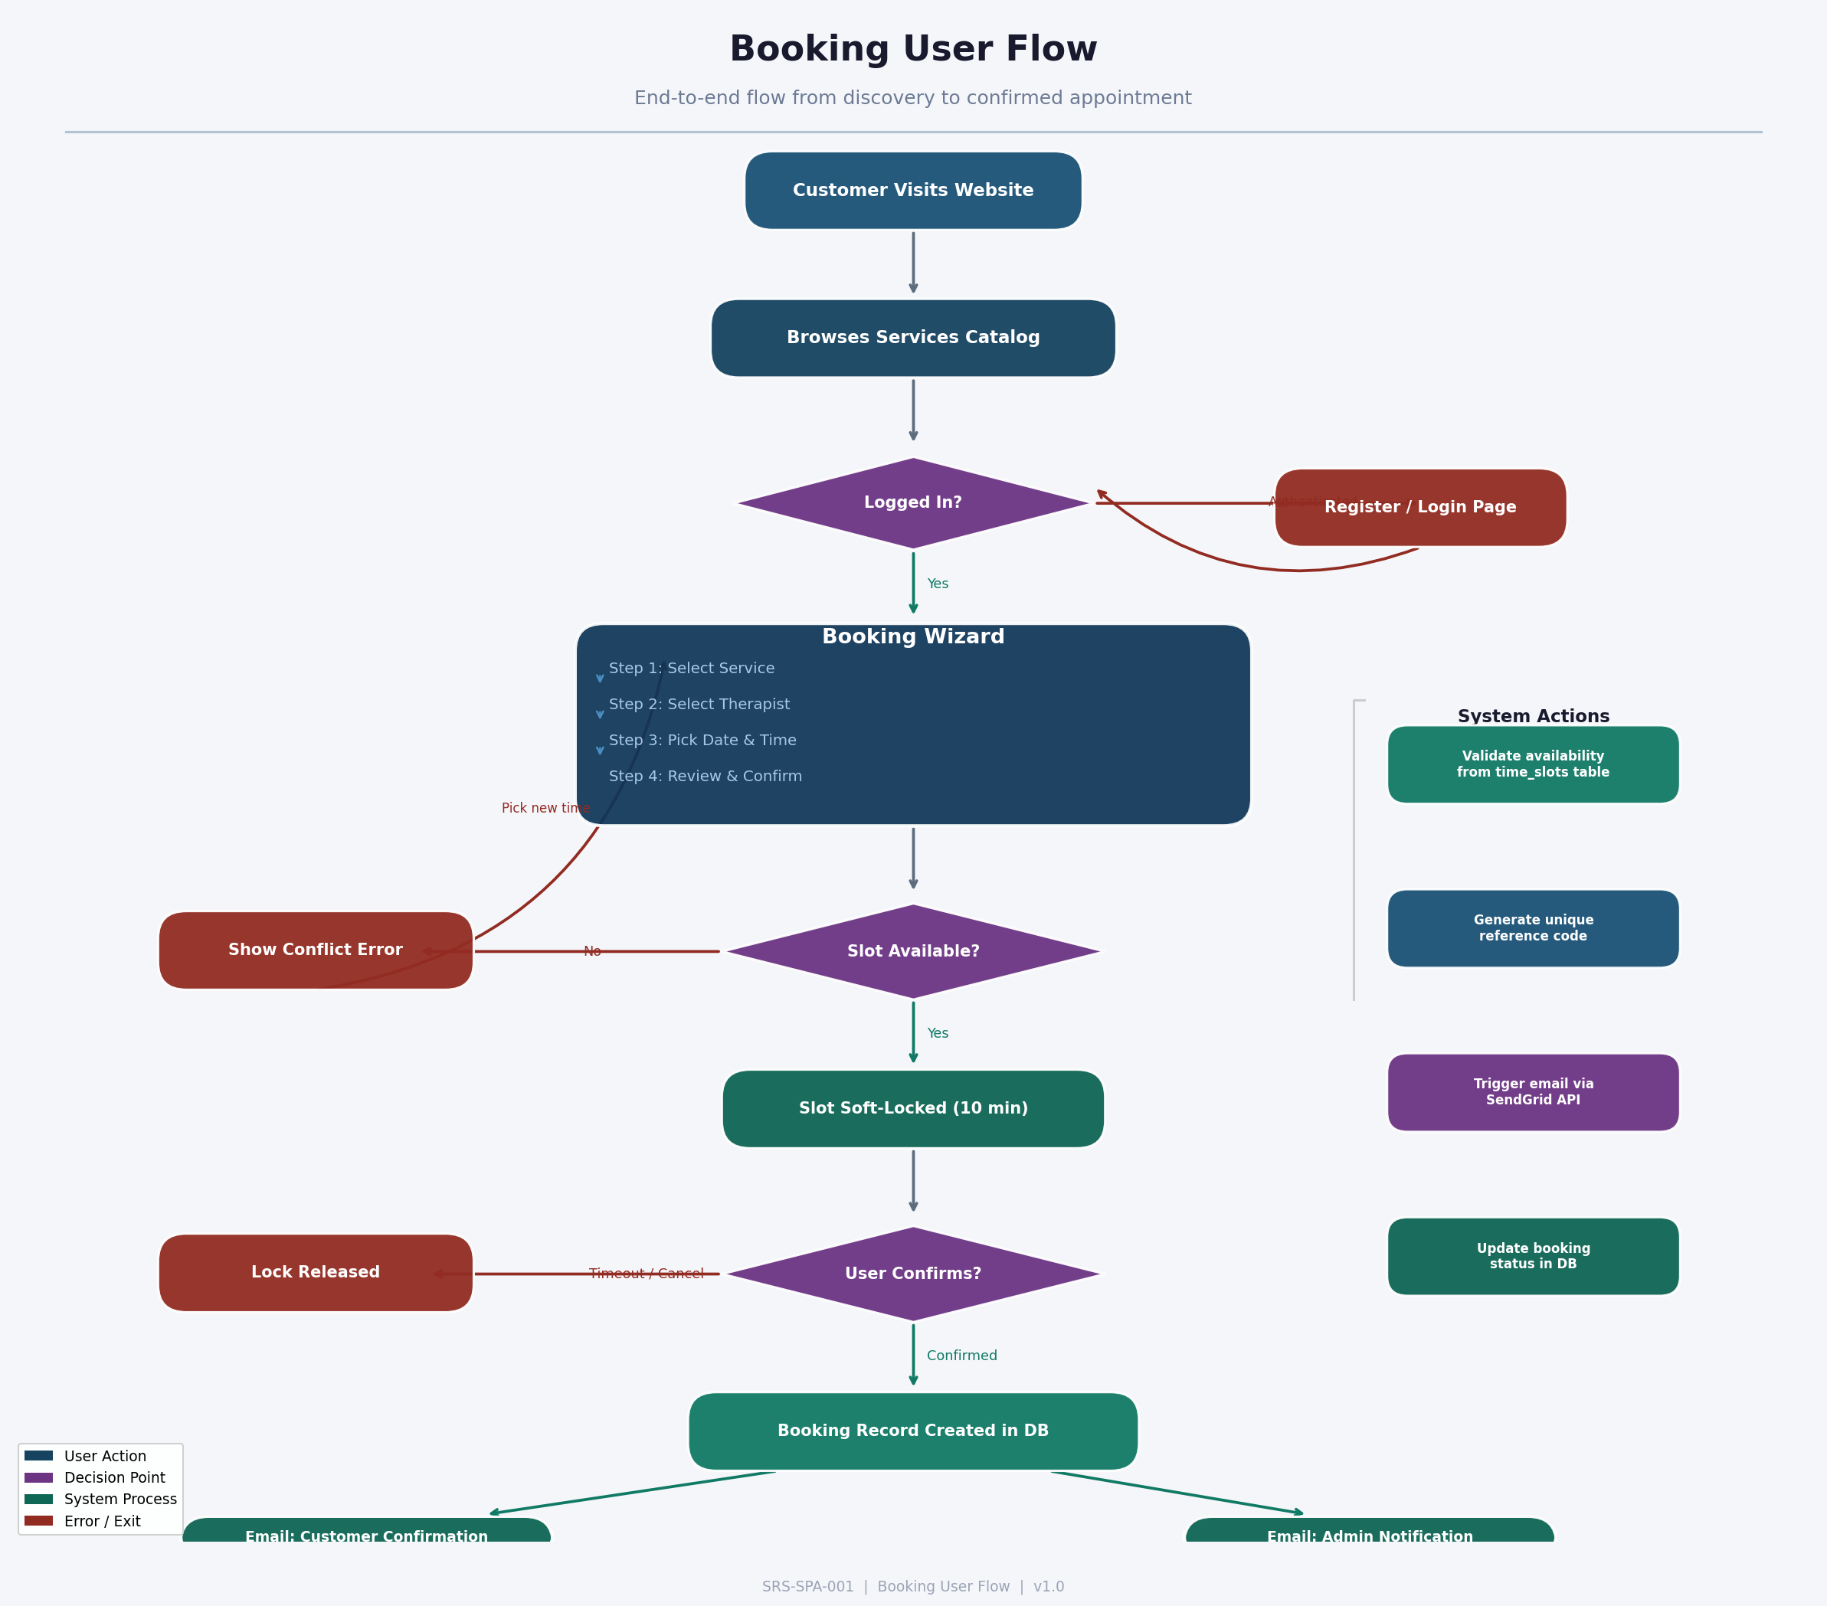
Figure 2 — Booking User Flow: From homepage visit through service selection, availability check, slot locking, and booking confirmation

3.2 Flow Analysis

3.2.1 Authentication Gate
Unauthenticated users are not blocked from browsing services — they can explore the full catalog and click 'Book Now'. The auth gate only activates when they initiate the actual booking flow. Their selected service and therapist are persisted in session storage, so after authentication they are returned directly to their booking context without starting over.

3.2.2 Multi-Step Wizard
The booking wizard is divided into four discrete steps. This reduces cognitive load versus presenting all selections simultaneously on a single form. Each step validates its own input before allowing the user to proceed. Step 3 (availability calendar) is the most technically complex, requiring a real-time query to the time_slots table and a 10-minute soft-lock on the selected slot.

Wizard Step | Design Notes
Step 1: Select Service | Customer chooses from the full service catalog. The selection persists across the wizard. Changing the service at any point resets therapist and time slot.
Step 2: Select Therapist | Shows only therapists qualified for the chosen service (via therapist_services junction table). Includes photo, title, and short bio.
Step 3: Pick Date & Time | Calendar shows available days. Selecting a day reveals time slots. A slot locked by another user is visually disabled with a countdown.
Step 4: Review & Confirm | Summary of all selections with total price. Customer enters any notes and clicks Confirm. System creates the booking record and dispatches confirmation emails.

3.2.3 Slot Locking Strategy
Double-booking prevention is implemented via a soft-lock mechanism. When a user selects a time slot, the locked_until field in the time_slots table is set to 10 minutes from now. The slot is visually locked for other concurrent users. If the original user abandons the booking (tab close, timeout, navigation away), the lock expires automatically. A database trigger resets is_available when locked_until passes. This is validated with concurrent load tests using k6.

3.2.4 Error Recovery Paths
The flow includes three graceful error paths: if a selected slot is taken before confirmation (race condition), the user is returned to the calendar with a clear message and their other selections preserved; if authentication fails, the user is shown a retry option without losing their booking context; if the email dispatch fails, the booking record is still committed and the email is queued for retry.

4. Database Schema

4.1 Entity-Relationship Overview
The database is a PostgreSQL instance hosted on Supabase. The schema consists of 8 core tables organized around the central bookings entity, which aggregates a customer, a service, a therapist, and a time slot into a single confirmed appointment record.

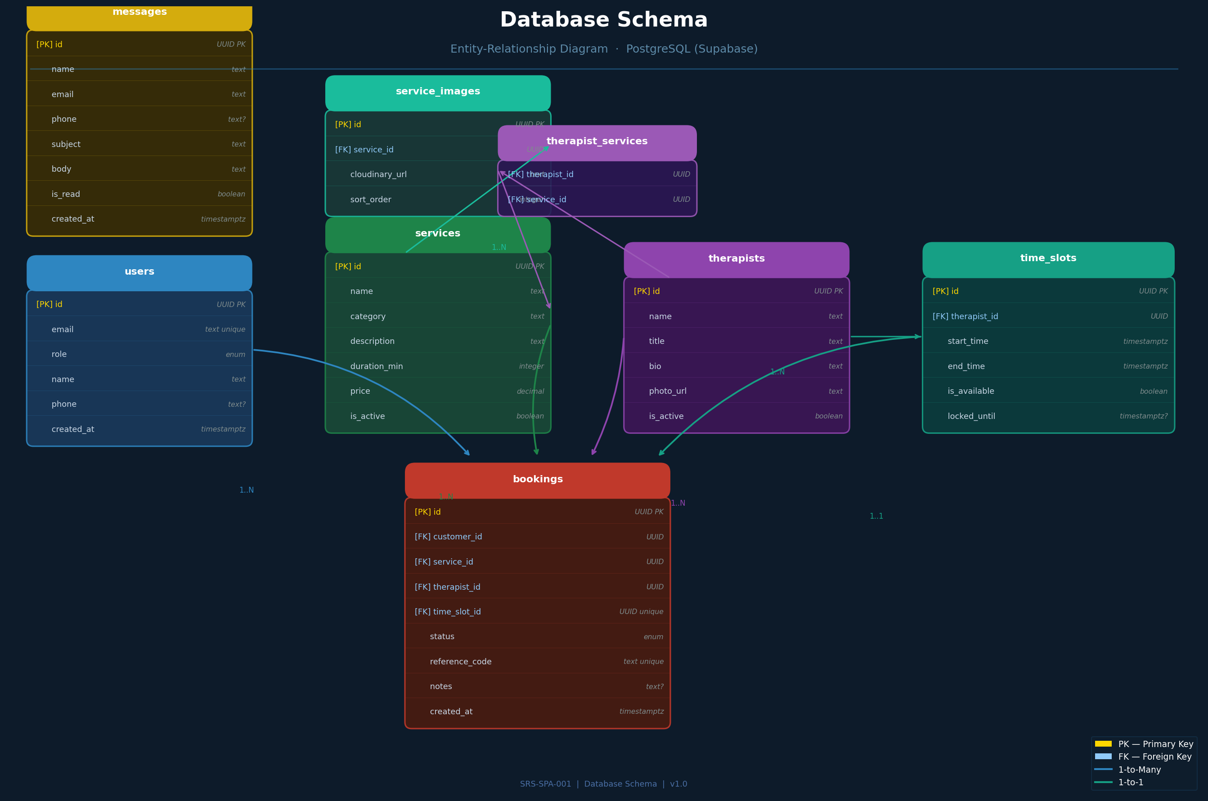
Figure 3 — Database Schema: Entity-Relationship Diagram showing all tables, key fields, and foreign key relationships

4.2 Core Design Decisions

4.2.1 Soft Delete for Services
Services are never hard-deleted. The is_active boolean flag controls visibility on the public catalog. This preserves historical booking data integrity — a booking record will always be able to reference its service, even if the service is retired. The same pattern applies to therapists.

4.2.2 Unique Time Slot Constraint
The time_slot_id foreign key in the bookings table carries a UNIQUE constraint, enforced at the database level. Even if the application-layer soft-lock fails (e.g., network race condition), the database will reject the second booking attempt with a constraint violation, preventing double-booking at the lowest possible layer.

4.2.3 Row Level Security
Supabase RLS policies enforce data isolation at the database query level, independent of the application code:

Table | RLS Policy
users / profiles | SELECT and UPDATE restricted to own row. Admin role bypasses RLS via service key on server-side API routes.
bookings | Customers can SELECT their own bookings only. INSERT allowed for authenticated users. UPDATE/DELETE restricted to server-side admin operations.
time_slots | Public SELECT for all authenticated users. INSERT/UPDATE restricted to server-side functions only (slot locking logic).
services & therapists | Public SELECT (no auth required). All mutations restricted to admin role.
messages | INSERT allowed without authentication (public contact form). SELECT restricted to admin. No UPDATE/DELETE permitted.

4.2.4 Junction Table: therapist_services
The many-to-many relationship between therapists and services is managed through a junction table. This allows the booking wizard to dynamically filter therapists based on the chosen service, and ensures that a therapist cannot be booked for a service they are not qualified to perform — enforced both at the application layer (query filter) and at the data layer (only valid therapist-service pairs exist in the table).

4.3 Key Relationships

Relationship | Cardinality & Notes
users → bookings | One-to-many. A customer may have many bookings across their history.
services → bookings | One-to-many. Each booking references a single service.
therapists → bookings | One-to-many. Each booking references a single therapist.
time_slots → bookings | One-to-one. A time slot can only appear in one confirmed booking (UNIQUE FK).
therapists → time_slots | One-to-many. A therapist has many scheduled time slots across their calendar.
services → service_images | One-to-many. A service can have up to 8 gallery images.
therapists + services ↔ th_services | Many-to-many junction. A therapist may be qualified for multiple services; a service may be performed by multiple therapists.

5. Design System

5.1 Overview
The design system establishes the visual language of the platform: a consistent palette of colors, a clear typographic scale, a library of reusable UI components, and a spacing rhythm. All implemented with Tailwind CSS utility classes, ensuring that any developer can produce consistent interfaces by following the patterns defined here.

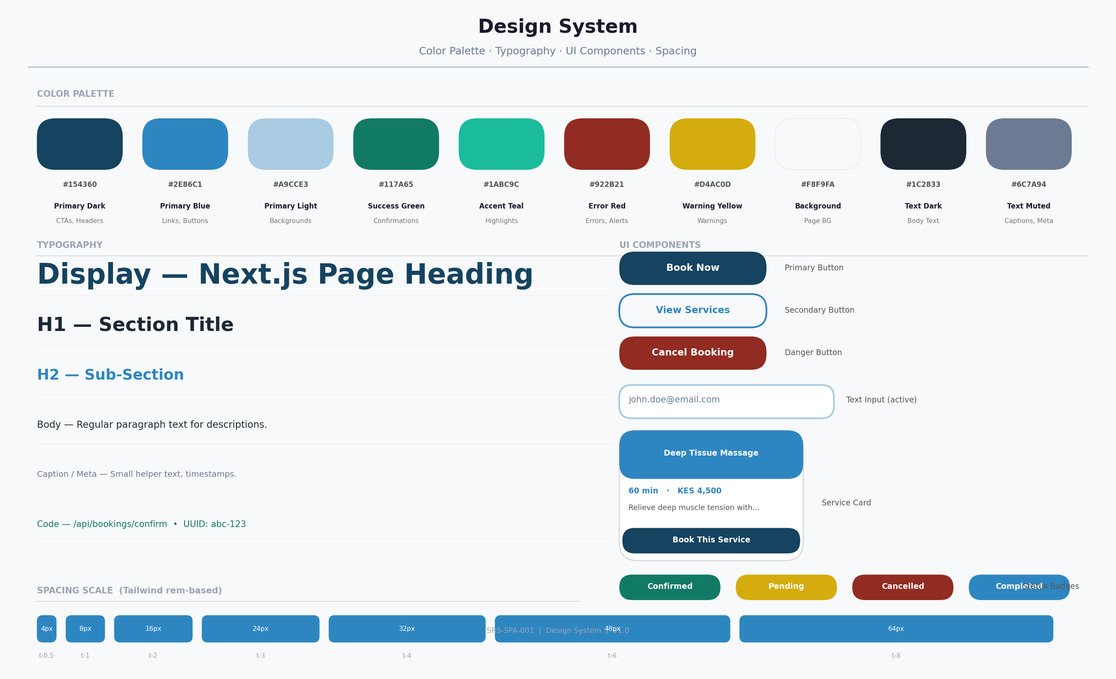
Figure 4 — Design System: Color palette, typography hierarchy, UI components (buttons, inputs, cards, badges), and spacing scale

5.2 Color Palette
The palette is built around a navy-blue primary anchored in trust and professionalism — appropriate for a health and wellness brand. The palette provides clear semantic meaning: blue for primary actions, green for success states, red for errors, and yellow for warnings.

Color / Token | Usage
Primary Dark (#154360) | Used for CTAs, section headers, and the navigation bar. Communicates authority and trust.
Primary Blue (#2E86C1) | Used for interactive links, secondary headings, and highlighted UI elements.
Primary Light (#A9CCE3) | Used for background washes, card borders, and informational callout boxes.
Success Green (#117A65) | Booking confirmations, success toasts, and status badges for confirmed appointments.
Error Red (#922B21) | Form validation errors, cancellation buttons, and failed state messaging.
Warning Yellow (#D4AC0D) | Pending booking status, rate limit warnings, and slot-expiry countdown timers.
Background (#F8F9FA) | Page background. Slightly off-white to reduce eye strain for admin users working long sessions.
Text Dark (#1C2833) | Primary body text. Near-black for maximum readability against light backgrounds.
Text Muted (#6C7A94) | Captions, metadata, placeholder text, and secondary labels throughout the UI.

5.3 Typography
The typographic system uses a clear hierarchical scale derived from a base font size of 16px (1rem). All sizes are defined in Tailwind's rem-based scale, ensuring they respect user browser font size preferences for accessibility.

Role | Size · Weight · Color · Usage
Display / Page Title | 32px · Bold · #154360 — Used exclusively for top-level page headings (H1 equivalent).
Section Heading (H1) | 24px · Bold · #1C2833 — Major section headings within a page.
Sub-heading (H2) | 20px · SemiBold · #2E86C1 — Sub-sections and card titles.
Body Regular | 16px · Regular · #1C2833 — All descriptive body copy and paragraph text.
Body Small / Caption | 14px · Regular · #6C7A94 — Timestamps, metadata, image captions.
Code / Mono | 14px · Mono · #117A65 — API routes, reference codes, and code snippets.
Label / Badge | 12px · Bold · White on color — Status badges, pill labels, button text.

5.4 Component Library
Four primary component types form the building blocks of the interface. Each is designed for accessibility (44px minimum tap target), keyboard navigation (focus ring visible), and Tailwind implementation.

5.4.1 Button Variants
- Primary — Dark navy fill, white bold text. Used for the single primary action per screen (e.g., 'Book Now', 'Confirm Booking').
- Secondary — Transparent with blue border and text. Used for secondary actions alongside a primary (e.g., 'View Details').
- Danger — Red fill, white text. Used exclusively for destructive actions (e.g., 'Cancel Booking').
- Ghost — No border, color text only. Used for tertiary actions and navigation links.

5.4.2 Form Inputs
- Text Input — White background, #A9CCE3 border at rest, #154360 border on focus. Clear validation error state with red border and inline error message below field.
- Date Picker — Built on react-datepicker. Dates with no available slots are greyed and non-selectable. Today's date is highlighted in Primary Blue.
- Select / Dropdown — Consistent with text input styling. Uses native select or Radix UI select for accessibility.

5.4.3 Service Card
The service card is the central discovery unit. It presents a thumbnail image (served from Cloudinary), the service name, category badge, duration and price, a truncated description, and a 'Book This Service' primary button. On mobile the card occupies the full viewport width; on tablet it becomes a 2-column grid; on desktop a 3-column grid.

5.4.4 Status Badges
Booking status is communicated via color-coded pill badges: Confirmed (green), Pending (yellow), Completed (blue), Cancelled (red). Each badge is sized at 12px bold white text on a solid color background with 4px border-radius.

5.5 Spacing Scale
The spacing system follows Tailwind's default rem-based scale. The eight most commonly used values are: 4px (spacing-1), 8px (spacing-2), 12px (spacing-3), 16px (spacing-4), 24px (spacing-6), 32px (spacing-8), 48px (spacing-12), and 64px (spacing-16). Section padding uses spacing-16. Card padding uses spacing-6. Button padding is spacing-3 vertical and spacing-6 horizontal.

5.6 Responsive Breakpoints

Breakpoint | Layout Behavior
sm · 640px | Single-column layout. Full-width cards, stacked navigation. The default — design starts here.
md · 768px | Two-column service grid. Horizontal booking wizard step indicator. Sidebar appears in admin panel.
lg · 1024px | Three-column service grid. Side-by-side layout for booking wizard review step.
xl · 1280px | Maximum content width of 1200px centered. All layouts finalized at this breakpoint.

6. Project Timeline

6.1 Sprint Roadmap
The platform is delivered across 7 sprints spanning 14 weeks. The critical path runs through Sprint 4 (Booking System, Weeks 7–9), which is the longest sprint, has the highest implementation complexity, and is a dependency for the admin panel in Sprint 5. Risk mitigation focuses on Sprint 4: all integration dependencies (Supabase Realtime, email delivery) are established in Sprints 1–2 to prevent blockers.

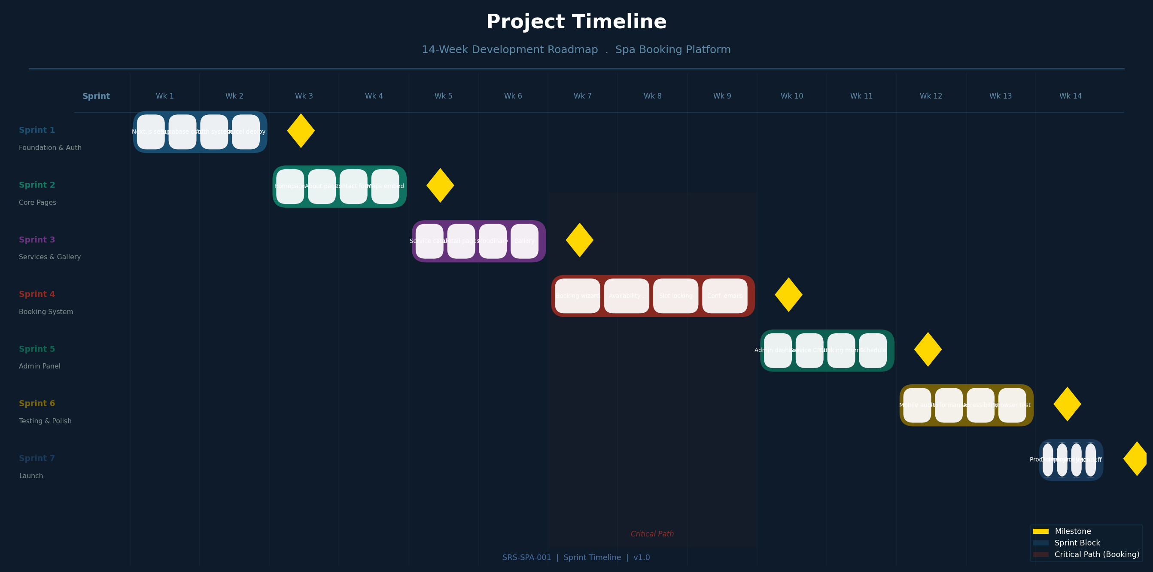
Figure 5 — Sprint Timeline: 14-week roadmap with task breakdown, critical path (Weeks 7–9), and milestone markers

6.2 Sprint Summaries

Sprint | Scope & Exit Criteria
Sprint 1 (Wks 1–2) | Foundation: Next.js project, Supabase database + auth, Tailwind CSS setup, Vercel deployment pipeline. Exit: authenticated skeleton live.
Sprint 2 (Wks 3–4) | Public pages: Homepage (hero, services, map), About page, Contact form with SendGrid. Exit: all public pages accessible.
Sprint 3 (Wks 5–6) | Services & gallery: Full catalog, service detail pages, Cloudinary image upload, category filtering. Exit: admin can upload images.
Sprint 4 (Wks 7–9) | Booking system: Multi-step wizard, availability calendar, slot locking, confirmation emails, customer dashboard. Exit: complete booking achievable end-to-end. [CRITICAL PATH]
Sprint 5 (Wks 10–11) | Admin panel: Dashboard metrics, service CRUD, therapist management, schedule management, booking management, message inbox. Exit: all admin operations functional.
Sprint 6 (Wks 12–13) | Quality: Mobile responsiveness audit, Lighthouse performance pass (target ≥90), WCAG 2.1 AA accessibility, cross-browser testing, UAT with 5 participants. Exit: 0 critical bugs.
Sprint 7 (Wk 14) | Launch: Production deployment, custom domain + SSL, Google Analytics, admin training, handoff documentation. Exit: platform live with monitoring.

6.3 Risk Register

Risk | Impact | Likelihood | Mitigation
Double-booking race condition | High — trust breach, customer dissatisfaction | Medium | DB unique constraint on time_slot_id + soft-lock logic + k6 concurrent load tests
Email delivery failure | Medium — user misses confirmation | Low | Booking record committed before email. SendGrid retry queue. Sentry alert on failure.
Sprint 4 scope overrun | High — delays all downstream sprints | High | 10-day buffer (3-week sprint). Calendly integration as fallback if custom calendar is too complex.
Supabase free tier limits | Medium — rate limits under load | Low at launch | Monitor via Supabase dashboard. Paid tier ($25/mo) if >500 MAU.
Google Maps API billing | Low — map becomes static | Low | Leaflet.js open-source map as pre-built fallback. API quota alerts configured.

7. Appendix

A. Diagram Index

Diagram | Location & Description
Figure 1 — System Architecture | Section 2 (p.2). Full-stack layer diagram: client, application, data, and third-party services.
Figure 2 — Booking User Flow | Section 3 (p.4). End-to-end flowchart from homepage visit to booking confirmation.
Figure 3 — Database Schema | Section 4 (p.6). Entity-Relationship Diagram: 8 tables, foreign keys, and RLS policy summary.
Figure 4 — Design System | Section 5 (p.8). Color palette, typography scale, UI components, and spacing system.
Figure 5 — Sprint Timeline | Section 6 (p.10). 14-week Gantt chart with tasks, milestones, and critical path.

B. Technology Stack Summary

Layer | Technology | Rationale
Frontend | Next.js 14 | SSR + App Router, React Server Components, file-based routing, TypeScript support
Styling | Tailwind CSS | Utility-first, JIT compilation, responsive-first design, zero-config with Next.js
Backend | Next.js API Routes | Colocated with frontend, no separate server, serverless deployment on Vercel
Database | PostgreSQL (Supabase) | Managed hosting, RLS, real-time subscriptions, REST + JS SDK out of the box
Auth | Supabase Auth | Email verification, JWT sessions, social auth ready, PKCE flow built-in
Images | Cloudinary | Auto-format, auto-resize, CDN delivery, generous free tier (25GB storage)
Email | SendGrid | High deliverability, free tier (100 emails/day), template support
Payments | Stripe (optional) | PCI-compliant, no raw card data handling, Stripe Elements for UI
Maps | Google Maps JS API | Satellite + street view, info windows, geocoding. Leaflet.js as free fallback
Hosting | Vercel | Auto CI/CD from GitHub, Edge Network, preview deployments, Next.js native
Monitoring | Sentry | Real-time error tracking, sourcemaps, 5000 errors/month free
Analytics | Google Analytics 4 | Funnel tracking, conversion goals, booking flow analytics

End of Document — DESIGN-SPA-001 v1.0
This document is subject to change. Amendments require version increment and project lead approval.

