**Comcast Telecom Consumer Complaints .**

**Task Analysis**

1. Provide the trend chart for the number of complaints at monthly and daily granularity levels.

Analysis :

**Monthly Complaints Trend Chart**

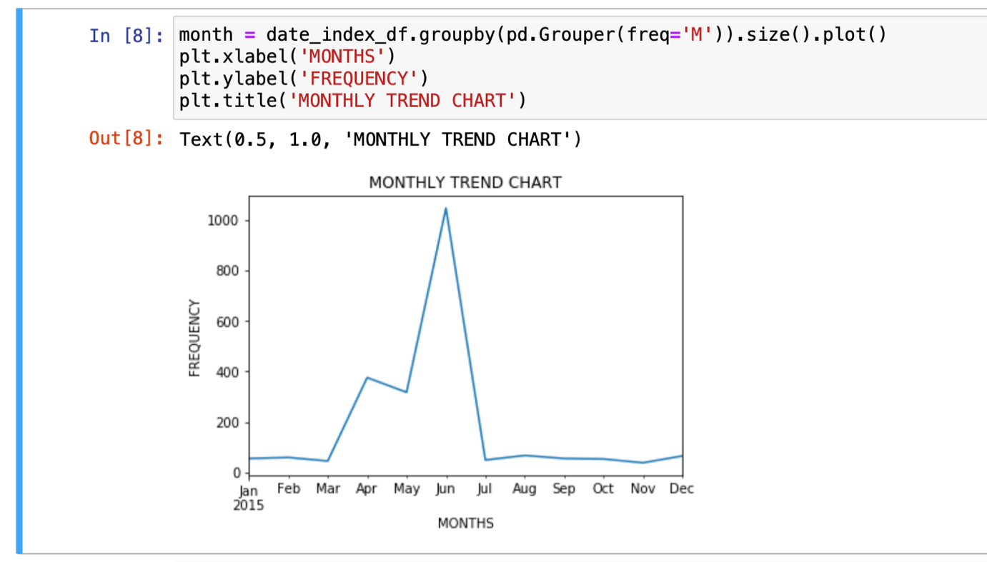

**Daily Complaints Trend Chart**

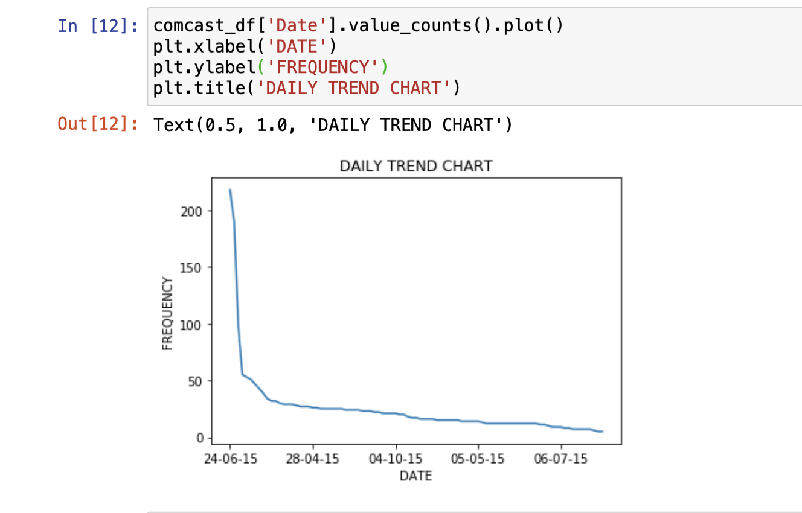

2. Provide a table with the frequency of complaint types.

* Which complaint types are maximum i.e., around internet, network issues, or across any other domains.

Analysis :

If we categories complaint as Internet, Network, Billings, Service and Other, then the maximum number of complaints are from Other category.

**{'internet': 408, 'network': 30, 'billing': 353, 'service': 360, 'other': 1073}**

3. Create a new categorical variable with value as **Open**and **Closed**. Open & Pending is to be categorized as Open and Closed & Solved is to be categorized as Closed.

Analysis :

Here I create a new column as “newStatus” and values for this column is assigned by below logic.

**comcast_df['newStatus'] = ['Open' if status=='Open' or status=='Pending' else 'Closed' for status in comcast_df['Status']]**

4. Provide state wise status of complaints in a stacked bar chart. Use the categorized variable from Q3. Provide insights on:

* Which state has the maximum complaints
* Which state has the highest percentage of unresolved complaints

Analysis :

State Wise status of complaints.

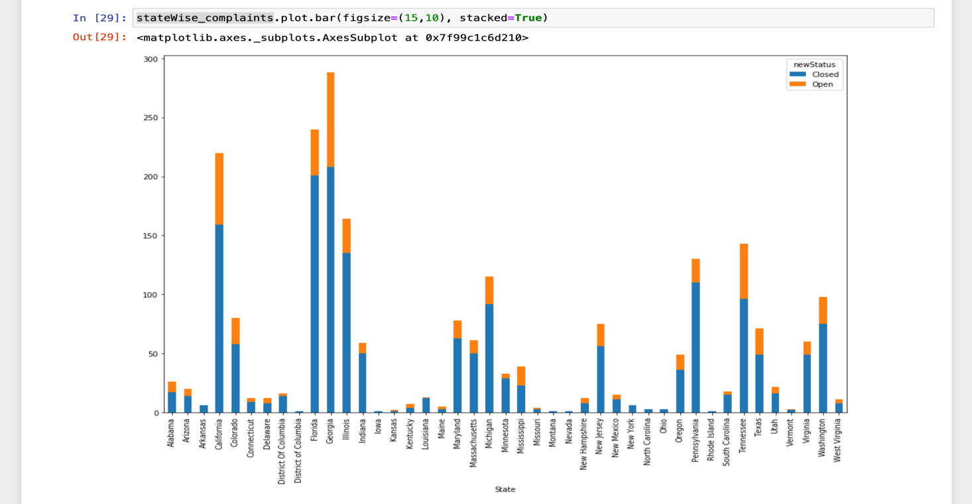

Insights from above charts

* Maximum number of complaints reported where from **Georgina**
* Highest percentage of unresolved complaints are from **Georgina**

5. Provide the percentage of complaints resolved till date, which were received through the Internet and customer care calls.

Analysis :

Below table provides the required information.

