KEYSIGHT
TECHNOLOGIES

CloudLens Ansible
Azure Customer Runbook

Automated sensor deployment for Linux and Windows VMs at scale

Version | v1.0.0
Date | June 2026

Keysight Technologies | Network Visibility Solutions

Table of Contents

1. Executive Summary
2. Solution Overview
3. Choosing Your Deployment Path
4. Prerequisites Checklist
5. Deployment, Step by Step
5.1 Tier 1: One-Click from the Azure Portal
5.2 Tier 2: Azure Cloud Shell
5.3 Tier 3: Docker (laptop or CI/CD)
6. Supported VM Scenarios
7. Verification Checklist
8. Scaling Guide
9. Troubleshooting Reference
Appendix A: customer_input.yaml Schema
Appendix B: Bulk Tag Script
Appendix C: Quick Links

1. Executive Summary
CloudLens Ansible for Azure is a fully automated kit that deploys Keysight CloudLens sensors to every tagged virtual machine in an Azure subscription. It works on Linux and Windows, from a single VM to 5,000+, without any manual per-host steps.
It is built for customer DevOps and network teams who need network visibility instrumented quickly and reliably, and for Keysight Sales Engineers who need a repeatable, demoable proof-of-value asset.

Why it matters
- Eliminates the per-VM SSH / RDP grind. Tag a VM with cloudlens=yes and the kit handles the rest.
- Three entry points (Azure Portal one-click, Cloud Shell curl, or Docker), so customers run it wherever they already work.
- Production-tested against real Azure. End-to-end deployment of 3 mixed-OS sensors verified in 8 minutes.

Proof points
Scenario | Result | Time
Ubuntu 22.04 (private IP via jumpbox) | Sensor running | 4 min
Ubuntu 22.04 (private IP via jumpbox) | Sensor running | 4 min
Windows Server 2022 (WinRM direct) | Sensor running | 6 min
CLMS 6.14.141 registration | All 3 sensors registered | <1 min
End-to-end | 3/3 success | 8 min

Date verified: 2026-06-02. Subscription: CloudLensPublic (eastus2).

2. Solution Overview
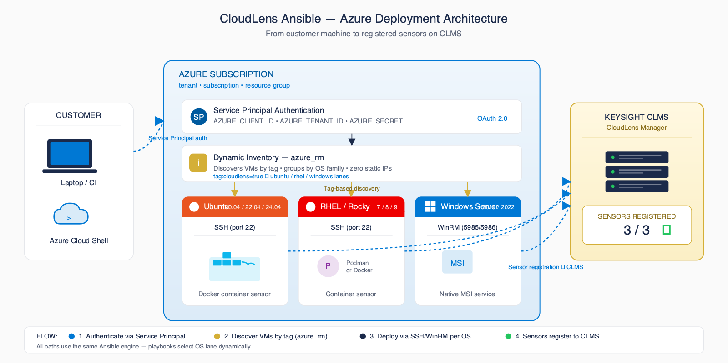
Figure 1: End-to-end architecture (control point → Azure inventory → OS lanes → CLMS)
A single Ansible control point authenticates to Azure (Service Principal, Managed Identity, or Cloud Shell session), queries the Azure Resource Manager API for every VM matching the customer's tag filter, and routes each host to the OS-specific playbook lane: Ubuntu, RHEL, or Windows.
Linux hosts run the CloudLens agent in a Docker container. Windows hosts run the CloudLens Windows sensor as a native service. Every sensor self-registers with CloudLens Manager (CLMS) on first start using the project key supplied in customer_input.yaml. No per-VM UI steps, no static inventory files to maintain.

3. Choosing Your Deployment Path
All three paths run the same Ansible engine. Same playbooks, same automation. Pick the entry point that matches how your team works.
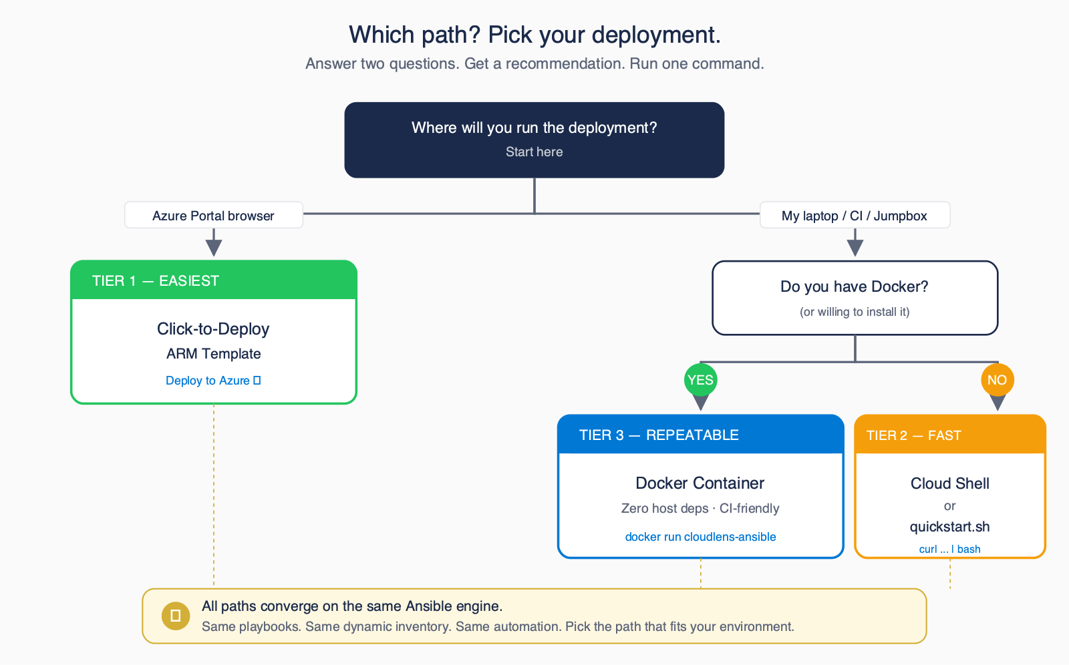
Figure 2: Decision tree (pick the entry point that matches your environment)
Tier | Best For | Tools Needed | Effort
Tier 1: One-Click Portal | Customers who live in the Azure Portal and want zero local setup | Web browser only | Lowest
Tier 2: Cloud Shell | Customers already authenticated to Azure in the browser | Azure Cloud Shell (pre-authenticated) | Low
Tier 3: Docker | Repeatable runs from a laptop or CI/CD pipeline | Docker, Service Principal, customer_input.yaml | Medium

4. Prerequisites Checklist (Printable)
Confirm every item below before kicking off a deployment. Tick each box as you go. The kit will not magically fix a missing prerequisite.
☐ Azure subscription with at least Reader + Virtual Machine Contributor roles
☐ Service Principal created (Tier 3 only: see scripts/setup_azure_sp.sh)
☐ CLMS Manager deployed and reachable from the target VM subnets
☐ Project Key obtained from the CLMS UI (Projects → API Keys)
☐ Target VMs tagged with cloudlens=yes, os=ubuntu|rhel|windows, env=prod|dev|qa
☐ SSH key (Linux) and Windows admin password ready in your control environment
Tip
Tags are how the dynamic inventory discovers hosts. If a VM is not tagged, the kit cannot see it. That is the single most common support ticket. Use the bulk-tag script in Appendix B to tag an entire resource group in one shot.

5. Deployment, Step by Step

5.1 Tier 1: One-Click from the Azure Portal
Best when you want zero local tools. The Portal provisions a short-lived Ubuntu runner VM in your subscription, the runner uses Managed Identity to authenticate, deploys sensors to every tagged VM, then self-destructs.
- Open the README in GitHub and click the 'Deploy to Azure' button.
- Sign in to the Azure Portal when prompted; the ARM template opens in a 'Custom deployment' blade.
- Fill in the four parameters: CLMS IP/FQDN, Project Key, Tag Filter (default cloudlens=yes), and Resource Group for the runner.
- Review + Create. Azure provisions the runner VM (~2 minutes).
- Watch the runner's boot diagnostics log. Every tagged VM is sensored in parallel.
- Runner self-destructs after 1 hour. Confirm sensors in CLMS → Sensors page.
[Screenshot placeholder: Azure Portal Deploy blade]
Expected outcome
Tagged VMs appear in CLMS → Sensors within 8 minutes. Runner VM is destroyed automatically. No artefacts left on the customer's laptop.

5.2 Tier 2: Azure Cloud Shell
Best when the customer is already logged into Azure in a browser tab. Cloud Shell is pre-authenticated, so there is no Service Principal to create and no local install.
- Open Azure Cloud Shell (shell.azure.com) and choose Bash.
- Run the quickstart bootstrap:
- Answer the wizard prompts: CLMS IP, Project Key, tag filter, connection mode.
- Confirm sensors in CLMS → Sensors page (~8 min for a small environment).
curl -sSL https://raw.githubusercontent.com/Keysight-Tech/cloudlens-ansible-azure/main/quickstart.sh | bash
Expected outcome
Wizard discovers tagged VMs, auto-tunes Ansible forks, deploys sensors, and prints a 3/3 success summary. All state lives in your Cloud Shell home directory, with nothing installed locally.

5.3 Tier 3: Docker (laptop or CI/CD)
Best for repeatable runs from a developer laptop, a CI pipeline, or any container host. Every build is tagged main-<sha>; pin one in CI and every run uses exactly the same image on macOS, Windows, Linux, GitHub Actions, GitLab CI and Jenkins.
- Create a Service Principal with `bash scripts/setup_azure_sp.sh` (one-time).
- Copy customer_input.yaml.example to customer_input.yaml and fill in your vController address, project key, and tag filter.
- For Windows VMs, put the installer from vController in files/ next to customer_input.yaml.
- Export AZURE_SUBSCRIPTION_ID, AZURE_TENANT, AZURE_CLIENT_ID, AZURE_SECRET, ANSIBLE_WINRM_PASSWORD as env vars.
- Run the container from that folder (in CI, drop -it and pin a main-<sha> tag):
docker run --rm -it --platform linux/amd64 \
-v "$(pwd)/customer_input.yaml:/work/customer_input.yaml:ro" \
-v "$(pwd)/files:/work/files:ro" \
-v "$HOME/.ssh/id_rsa:/root/.ssh/id_rsa:ro" \
-e AZURE_SUBSCRIPTION_ID -e AZURE_TENANT \
-e AZURE_CLIENT_ID -e AZURE_SECRET \
-e ANSIBLE_WINRM_PASSWORD \
ghcr.io/keysight-tech/cloudlens-ansible-azure:latest
Expected outcome
Ansible prints a PLAY RECAP line per VM and the container exits 0. It exits non-zero when the Azure login fails, when no VM matches the tags, or when any host fails, so a CI job cannot pass having deployed nothing.

6. Supported VM Scenarios
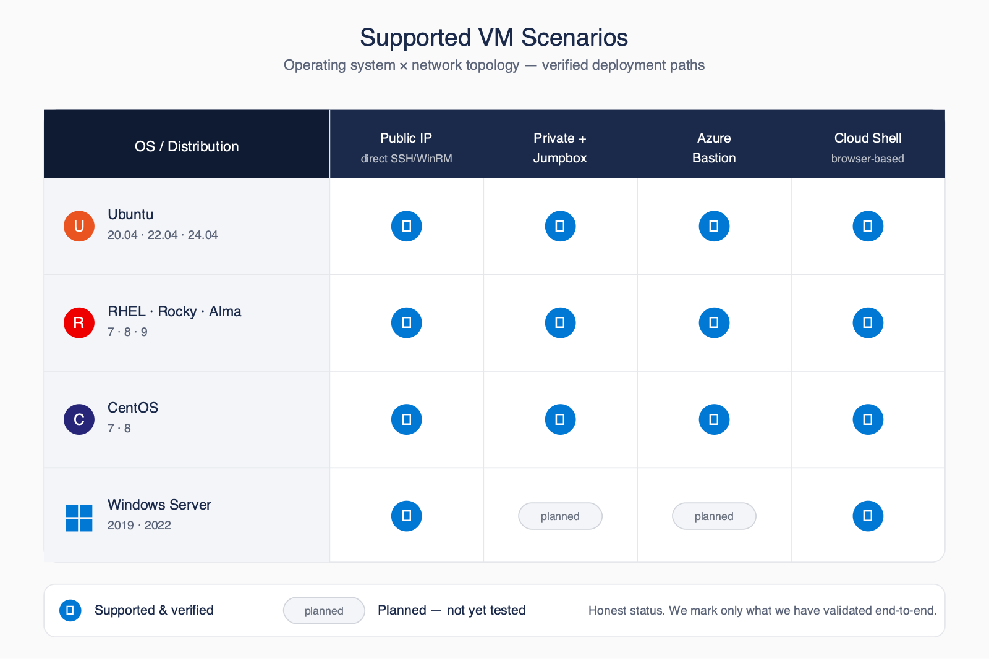
Figure 3: VM compatibility matrix (OS × topology × auth method)
OS / Topology | Public IP direct | Private + Jumpbox | Azure Bastion | Cloud Shell
Ubuntu 20.04 / 22.04 / 24.04 | Supported | Supported | Supported | Supported
RHEL 7 / 8 / 9 | Supported | Supported | Supported | Supported
CentOS / Rocky / AlmaLinux | Supported | Supported | Supported | Supported
Windows Server 2019 / 2022 | Supported | Planned | Planned | Supported

7. Verification Checklist (Printable)
After every deployment, walk this list. If any item fails, jump to section 9 (Troubleshooting Reference).
☐ All sensors visible in CLMS → Sensors page
☐ Filter by custom_tags (e.g. Customer=Acme) returns the expected VMs
☐ Test traffic from a sensored VM shows up in the destination tool/probe
☐ Container logs show no errors (Linux): `docker logs cloudlens-agent`
☐ CloudLens service running (Windows): `Get-Service CloudLensAgent`

8. Scaling Guide
VM Count | Auto Forks | Sharded? | Approx Time
1–50 | 20 | No | 5–10 min
50–500 | 50 | No | 15–30 min
500–2,000 | 200 | No | 30–60 min
2,000–10,000 | 500 / shard | Yes (auto) | 30–60 min
10,000+ | 1000 / shard | AWX | 1–2 hr

The kit auto-tunes the Ansible fork count based on the number of VMs the dynamic inventory discovers. Above 2,000 VMs it also auto-shards: the inventory is split into batches of `deploy.shard_size` VMs and the playbook runs them sequentially. This keeps memory and Azure API throttling under control while still finishing in under an hour for tens of thousands of hosts. See docs/SCALING.md in the repository for AWX/Tower integration details.

9. Troubleshooting Reference
Organised by symptom area. The full reference lives at docs/TROUBLESHOOTING.md in the repository.

Inventory
Symptom | Likely Cause | Fix
Inventory finds 0 VMs | Tags missing on VMs | az vm update --set tags.cloudlens=yes tags.os=<os> tags.env=prod
Subset of VMs missing | Tag value mismatch (case-sensitive) | Use exact lowercase values: ubuntu, rhel, windows, prod

SSH (Linux)
Symptom | Likely Cause | Fix
Permission denied (publickey) | Public key not present on target VM | Bootstrap via az vm run-command invoke or use jumpbox mode
Connection timeout | NSG blocks port 22 from control point | Switch connection.mode to jumpbox or bastion

WinRM (Windows)
Symptom | Likely Cause | Fix
WinRM timeout on 5985 | WinRM disabled on Windows VM | Run playbooks/bootstrap_windows_winrm.yaml against the host
401 Unauthorized | ANSIBLE_WINRM_PASSWORD env var not exported | export ANSIBLE_WINRM_PASSWORD='...' before running the kit

Container (Linux sensor)
Symptom | Likely Cause | Fix
apt_pkg.Error: Signed-By conflict | Stale Docker apt source list | The playbook auto-cleans on the next run; rerun the kit
Container restarts in a loop | Wrong CLMS IP or project key | docker logs cloudlens-agent; fix manager_ip_or_fqdn / project_key

Registration with CLMS
Symptom | Likely Cause | Fix
Sensor not in CLMS UI | Wrong project key | Check CLMS → Projects → API Keys; update customer_input.yaml
Sensor offline after restart | CLMS IP unreachable from VM subnet | Open egress from VM subnet to CLMS on TCP/443

Appendix A: customer_input.yaml Schema
Full annotated example. Copy customer_input.yaml.example from the repository to customer_input.yaml and fill in values. Never commit customer_input.yaml to git. Credentials belong in env vars.
# === Azure Environment ===
azure:
subscription_id: "00000000-0000-0000-0000-000000000000"
tenant_id: "00000000-0000-0000-0000-000000000000"
# Tag selector: VMs are matched by these tags
tag_filters:
cloudlens: "yes"
env: "prod"
resource_groups: [] # empty = all RGs in the subscription
locations: [] # empty = all regions
# === CloudLens Configuration ===
cloudlens:
manager_ip_or_fqdn: "clms.customer.example.com"
project_key: "REPLACE_WITH_PROJECT_KEY"
custom_tags: "Env=Azure Region=eastus2 Customer=Acme"
registry_type: "insecure" # or "secure"
ssl_verify: "no"
auto_update: "yes"
local_ca_path: "files/cloudlenscerts.crt"
ca_cert_dir: "/etc/ssl/certs"
agent_container_name: "cloudlens-agent"
log_max_size: "50m"
log_max_file: "5"
# === Connection Mode ===
# direct_public | jumpbox | bastion | cloud_shell
connection:
mode: "jumpbox"
jumpbox_host: "1.2.3.4"
jumpbox_user: "azureuser"
jumpbox_ssh_key: "~/.ssh/id_rsa"
bastion_resource_id: ""
# === Linux SSH ===
linux:
ansible_user: "azureuser"
ssh_key_file: "~/.ssh/id_rsa"
# === Windows WinRM ===
# Password MUST be set via env var: export ANSIBLE_WINRM_PASSWORD='...'
windows:
ansible_user: "azureuser"
ansible_connection: "winrm"
ansible_winrm_transport: "basic"
ansible_winrm_server_cert_validation: "ignore"
ansible_port: 5985
installer_path: "files/cloudlens-win-sensor-6.13.0.359.exe"
installer_filename: "cloudlens-win-sensor-6.13.0.359.exe"
# === Deployment Behavior ===
deploy:
forks: 0 # 0 = auto-tune
timeout_seconds: 60
reinstall_if_unhealthy: true
shard_size: 500 # for >2000 VMs

Appendix B: Bulk Tag Script
Apply the three required tags to every VM in a resource group, filtered by OS. Run these from Azure Cloud Shell or any shell with the Azure CLI logged in.

Ubuntu VMs
for vm in $(az vm list -g <RG> --query \
"[?storageProfile.imageReference.offer=='0001-com-ubuntu-server-jammy'].name" \
-o tsv); do
az vm update -g <RG> -n $vm \
--set tags.cloudlens=yes tags.os=ubuntu tags.env=prod
done

RHEL VMs
for vm in $(az vm list -g <RG> --query \
"[?storageProfile.imageReference.publisher=='RedHat'].name" \
-o tsv); do
az vm update -g <RG> -n $vm \
--set tags.cloudlens=yes tags.os=rhel tags.env=prod
done

Windows VMs
for vm in $(az vm list -g <RG> --query \
"[?storageProfile.osDisk.osType=='Windows'].name" \
-o tsv); do
az vm update -g <RG> -n $vm \
--set tags.cloudlens=yes tags.os=windows tags.env=prod
done

Appendix C: Quick Links
Resource | Location
GitHub repository | https://github.com/Keysight-Tech/cloudlens-ansible-azure
README (technical entry point) | https://github.com/Keysight-Tech/cloudlens-ansible-azure/blob/main/README.md
Deployment guide | docs/DEPLOYMENT_GUIDE.md (in the repo)
Scaling guide | docs/SCALING.md (in the repo)
Troubleshooting guide | docs/TROUBLESHOOTING.md (in the repo)
Customer email template | docs/CUSTOMER_EMAIL.md (in the repo)
GitHub Issues (bug reports / feature requests) | https://github.com/Keysight-Tech/cloudlens-ansible-azure/issues
Related: vPB + Azure GWLB | https://github.com/Keysight-Tech/cloudlens-vpb-azure-gwlb

Support email subject (for the Keysight account team): 'CloudLens Ansible Azure: <customer name>, <brief issue>'.

