CloudLens AutoPilot
Deployment Runbook

Keysight Technologies
CloudLens Visibility Platform

Version 2.0 | March 2026
Confidential — Internal Use Only

1. Overview
CloudLens AutoPilot automates the deployment and configuration of the Keysight CloudLens visibility stack in AWS. This runbook covers the complete deployment process from infrastructure provisioning to sensor deployment at scale.

Choose Your Deployment Path
CloudLens AutoPilot offers two deployment paths. Both create identical infrastructure — choose the one that fits your environment:

 | Terraform (Section 3) | CloudFormation (Section 3b)
Best for | SEs and DevOps teams | Customers and self-service
Install needed | Terraform CLI | None — AWS Console only
Auto-mirror | Separate module | Included in template
Multi-cloud | Yes (Azure, GCP ready) | AWS only

Online Resources
No GitHub access required. Everything is hosted and publicly accessible:

Resource | URL
Deployment Form (Terraform) | https://cloudlens-autopilot-artifacts.s3.amazonaws.com/deployment-form.html
CloudFormation Template | https://cloudlens-autopilot-artifacts.s3.amazonaws.com/cloudlens-autopilot.yaml

The Deployment Form generates Terraform .tfvars files interactively. The CloudFormation Template can be uploaded directly to the AWS Console for one-click deployment.

Architecture
AutoPilot uses a 3-phase approach:

Phase | Tool | What It Does
Phase 1 | Terraform | Deploys VPC, KVO, CLMS, vPB, IAM, Security Groups, SSM Documents (~35 AWS resources)
Phase 2 | Manual (Web UI) | Accept EULA, verify licenses, get project key, adopt devices, configure CloudConfig (~10 minutes)
Phase 3 | AWS SSM | Deploy CloudLens sensors to all tagged VMs (Docker, Podman, or Windows) at scale

Products Deployed
Product | Role | Instance Type | Source
KVO | Master orchestrator, analytics, CloudConfig | c5.2xlarge | AWS Marketplace
CLMS | Sensor management and registration | t3.xlarge | AWS Marketplace
vPB | Traffic filtering, dedup, load balancing | t3.xlarge | AWS Marketplace

2. Prerequisites

- AWS account with EC2, VPC, IAM, and SSM permissions
- AWS CLI v2 installed and configured (SSO or access keys)
- Terraform v1.5 or higher installed
- EC2 key pair created in the target region
- AWS Marketplace subscriptions accepted for all 3 Keysight products:

- Keysight Vision One (KVO)
- Keysight CloudLens Manager (CLMS)
- Keysight CloudLens vPB-KVO

Important: AWS Marketplace EULAs must be accepted once per product per AWS account via the AWS Marketplace console. This is a one-time step and cannot be automated.

AWS Marketplace Subscription
For each product, visit the AWS Marketplace listing, click Subscribe, then Accept Terms. Wait for the subscription to become Active before proceeding.

Instance Type Restrictions
Keysight Marketplace AMIs have publisher-defined instance type restrictions:

Product | Required Instance Type | Notes
KVO | c5.2xlarge | Only c5.2xlarge works
CLMS | t3.xlarge | Standard instance type
vPB | t3.xlarge | Only t3.xlarge works
Important: These restrictions are enforced by the AMI publisher and are not documented in the AMI metadata. Using unsupported instance types will result in an UnsupportedOperation error.

3. Phase 1: Infrastructure Deployment (Terraform)
Terraform creates the complete AWS infrastructure: VPC with 3 subnets, KVO/CLMS/vPB EC2 instances, security groups, IAM user for CloudConfig, and SSM Command Documents for sensor deployment.

Step 1: Clone and Configure

git clone https://github.com/Keysight-Tech/cloudlens-autopilot.git
cd cloudlens-autopilot/terraform/environments/demo
cp demo.tfvars.example demo.tfvars

Edit demo.tfvars with your settings:

aws_region = "us-east-1"
aws_profile = "your-aws-profile"
prefix = "demo"
owner = "your-name"
key_pair_name = "your-key-pair"
allowed_ssh_cidrs = ["your.ip.address/32"]
allowed_web_cidrs = ["your.ip.address/32"]

Step 2: Deploy

terraform init
terraform apply -var-file=demo.tfvars

Terraform will show a plan of ~35 resources. Type yes to confirm.
Deployment takes approximately 3-5 minutes.

Step 3: Note the Outputs
After deployment, Terraform displays the product URLs:

terraform output urls

# Output:
# {
# "clms" = "https://54.x.x.x"
# "kvo" = "https://52.x.x.x"
# "vpb" = "https://100.x.x.x"
# }

Important: Save these URLs. You will need KVO and CLMS URLs for Phase 2.

3b. Alternative: CloudFormation Deployment
If you prefer AWS-native deployment without installing Terraform, use the CloudFormation template instead. This deploys the identical infrastructure with a single command or via the AWS Console.

Download the Template
Download the CloudFormation template from:

https://cloudlens-autopilot-artifacts.s3.amazonaws.com/cloudlens-autopilot.yaml

Or from the GitHub repository: cloudformation/cloudlens-autopilot.yaml

Option A: AWS Console (One-Click)
- Open the AWS CloudFormation Console (https://console.aws.amazon.com/cloudformation)
- Click Create Stack > With new resources (standard)
- Under Prepare template, select Choose an existing template
- Under Template source, select Amazon S3 URL
- Paste this URL into the Amazon S3 URL field:

https://cloudlens-autopilot-artifacts.s3.amazonaws.com/cloudlens-autopilot.yaml

- Click Next
- Enter a Stack name (e.g., cloudlens-demo)
- Fill in the parameters — the form is auto-generated from the template with grouped sections:

- Deployment Information: name, owner
- Network Configuration: VPC CIDR, subnets, your IP for SSH/Web access
- Keysight Products: KVO, CLMS, vPB toggles and instance types
- Auto-Mirror: enable/disable automatic VPC Traffic Mirroring

- Click Next on Configure stack options (defaults are fine)
- On the Review page, scroll to the bottom
- Check the box: I acknowledge that AWS CloudFormation might create IAM resources with custom names
- Click Submit
- Wait 5-10 minutes for the stack status to show CREATE_COMPLETE
- Click the Outputs tab to find all product URLs, private IPs, and credentials

Important: You do not need to download the template file. CloudFormation pulls it directly from the S3 URL. Alternatively, you can select Upload a template file if you prefer to download and upload manually.

Option B: AWS CLI

aws cloudformation create-stack \
--stack-name cloudlens-demo \
--template-body file://cloudformation/cloudlens-autopilot.yaml \
--parameters \
ParameterKey=DeploymentName,ParameterValue=demo \
ParameterKey=KeyPairName,ParameterValue=<YOUR_KEY_PAIR> \
ParameterKey=AllowedSshCidrs,ParameterValue=<YOUR_IP>/32 \
ParameterKey=AllowedWebCidrs,ParameterValue=<YOUR_IP>/32 \
ParameterKey=LambdaS3Bucket,ParameterValue=cloudlens-autopilot-artifacts \
ParameterKey=LambdaS3Key,ParameterValue=auto-mirror-lambda.zip \
--capabilities CAPABILITY_NAMED_IAM \
--region us-east-1

# Wait for completion
aws cloudformation wait stack-create-complete --stack-name cloudlens-demo

# View outputs (URLs, credentials, commands)
aws cloudformation describe-stacks --stack-name cloudlens-demo \
--query "Stacks[0].Outputs" --output table

CloudFormation vs Terraform
Feature | Terraform | CloudFormation
Install required | Terraform CLI | None (AWS Console/CLI)
Deployment method | terraform apply | AWS Console or CLI
Auto-mirror Lambda | Separate module (planned) | Included in template
Multi-cloud | Yes (Azure, GCP) | AWS only
State management | Local or S3 backend | AWS-managed
Best for | SEs, DevOps teams | Customers, self-service

CloudFormation Teardown
aws cloudformation delete-stack --stack-name cloudlens-demo --region us-east-1

Important: Both deployment paths create identical infrastructure and are fully interchangeable. Choose Terraform for multi-cloud flexibility or CloudFormation for AWS-native simplicity. Phase 2 (product configuration) and Phase 3 (sensor deployment) are the same regardless of which path you choose.

4. Phase 2: Product Configuration (Manual)
This phase configures the Keysight products via their web UIs. All steps are performed once per deployment and take approximately 15 minutes total.

Step 1: Accept KVO EULA
KVO requires End User License Agreement acceptance before any functionality is available.

- Open the KVO URL in your browser (https://<kvo-ip>)
- You will be redirected to the EULA page
- Read the Keysight Software End User License Agreement
- Click the "Agree" button
- You will be redirected to the KVO login page

Important: KVO blocks ALL access (including APIs) until the EULA is accepted. This must be done via the web browser.

Step 2: Activate KVO License
KVO requires license activation to enable full functionality including vPB management and CloudConfig.

- Log into KVO with default credentials: admin / admin
- Navigate to Settings (gear icon) > Product Licensing
- Click Load data to load available activation codes
- Set the quantity to activate for each license (typically 1 each)
- Click Activate to apply the licenses

You should see three license types available:
- CloudLens Private Virtual Packet Processing - Advanced (for vPB)
- CloudLens Enterprise Edition - 150 credits (for sensors)
- Vision Orchestrator (KVO) perpetual license - 10 devices

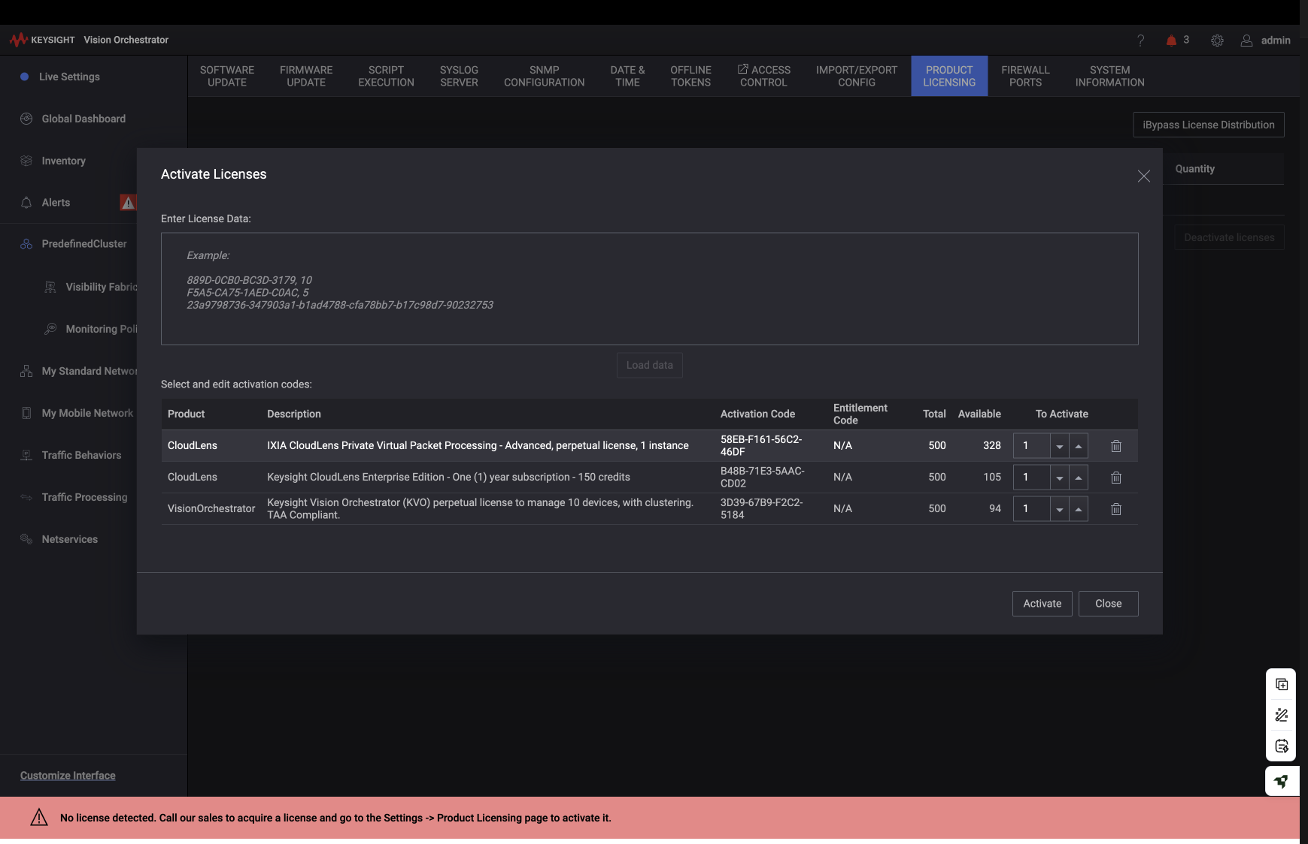
Figure 1: KVO Product Licensing - Activate all three license types

Step 3: Configure CLMS
Before adopting CLMS into KVO, you must first log into CLMS, change the default password, and create a KVO user account.

3a. Log into CLMS:
- Open the CLMS URL in your browser (https://<clms-ip>)
- Log in with default credentials: admin / Cl0udLens@dm!n

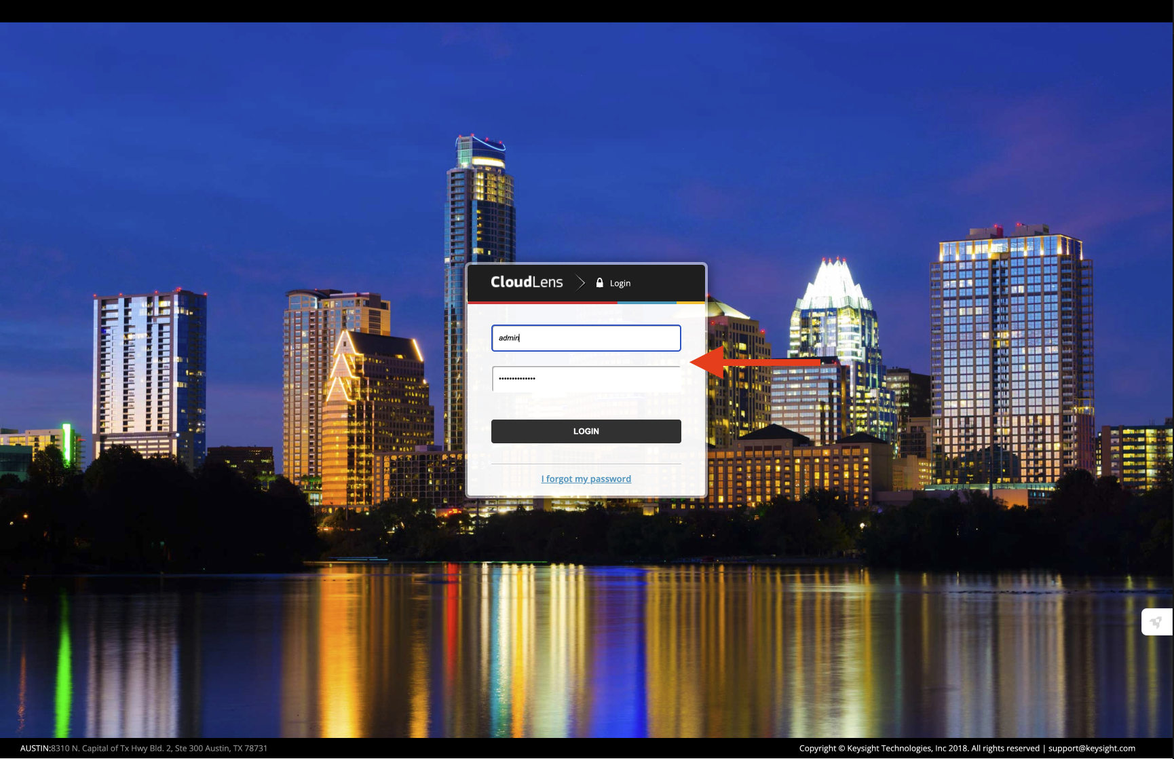
Figure 2: CLMS Login Page

3b. Change the default password:
- On first login, CLMS will prompt you to change the password
- Enter the old password (Cl0udLens@dm!n)
- Enter and confirm your new password
- Click Change Password

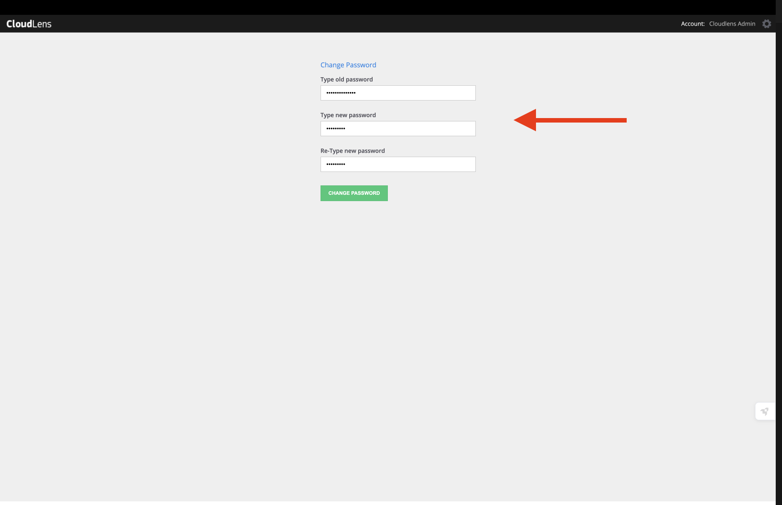
Figure 3: CLMS Change Password

3c. Create a KVO User in CLMS:
KVO needs credentials to connect to CLMS. Create a dedicated user with the KVO User role.

- In CLMS, navigate to User Management (left sidebar)
- Click Create User
- Enter an email address (e.g., kvo@keysight.com)
- Set a password
- Set the role to KVO User
- Click Save

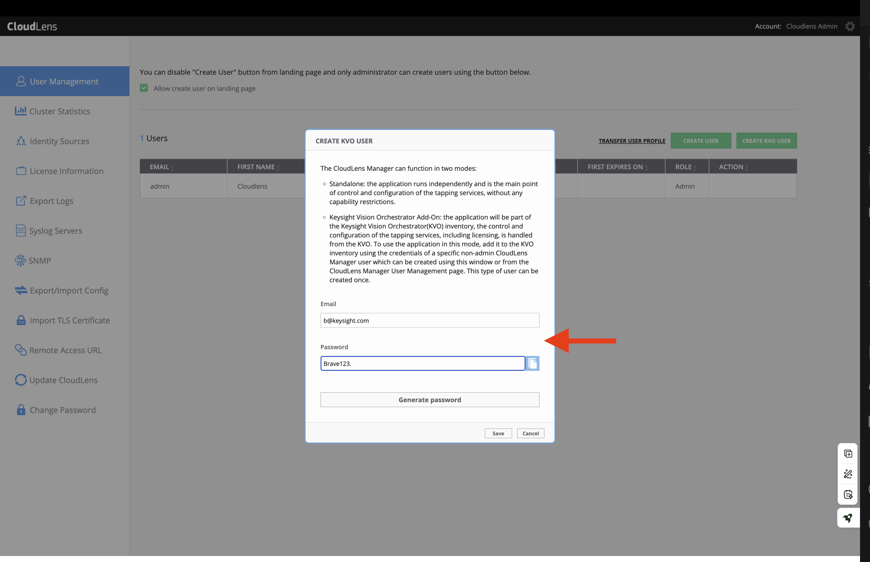
Figure 4: CLMS - Create KVO User Account

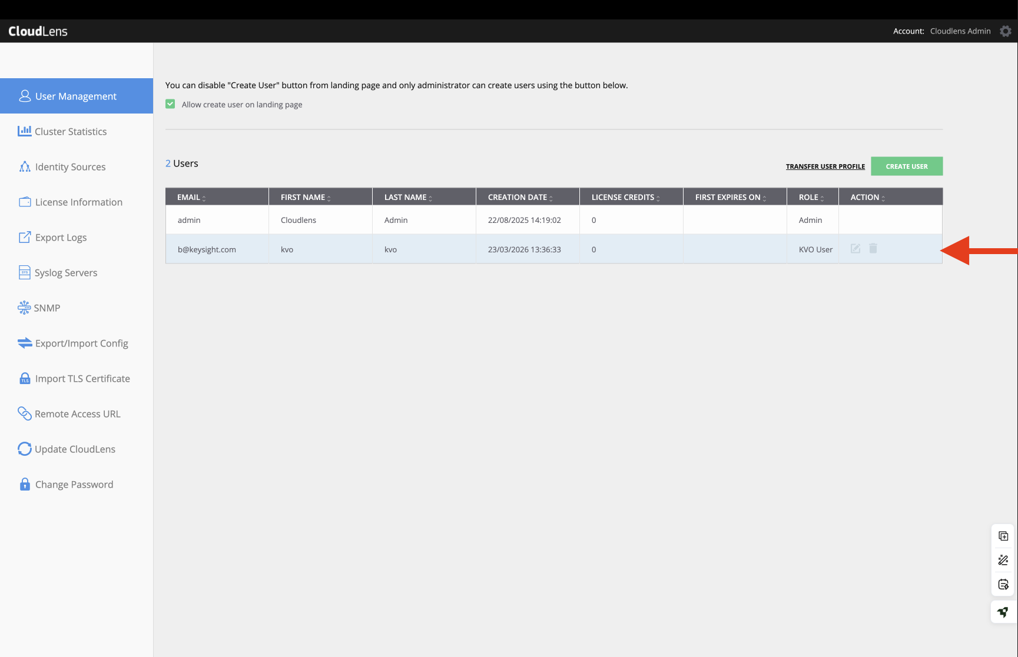
Figure 5: CLMS - User list showing admin and KVO user

Important: The KVO User role is specifically designed for KVO-to-CLMS integration. It provides the minimum permissions KVO needs to manage sensors and projects through CLMS.

Step 4: Adopt CLMS into KVO
Now connect KVO to the CLMS instance using the KVO user credentials you just created.

- In KVO, navigate to Inventory > Cloudlens Manager tab
- Click Discover Cloudlens Manager
- Fill in the form:

Field | Value
Name | CLMS_AWS (or any descriptive name)
Hostname / IP | CLMS private IP (e.g., 10.0.1.19) - use private IP, not public
Username | The KVO user email you created in Step 3c
Password | The KVO user password you set in Step 3c

- Click Ok to initiate discovery
- Wait for the status to show CONNECTED

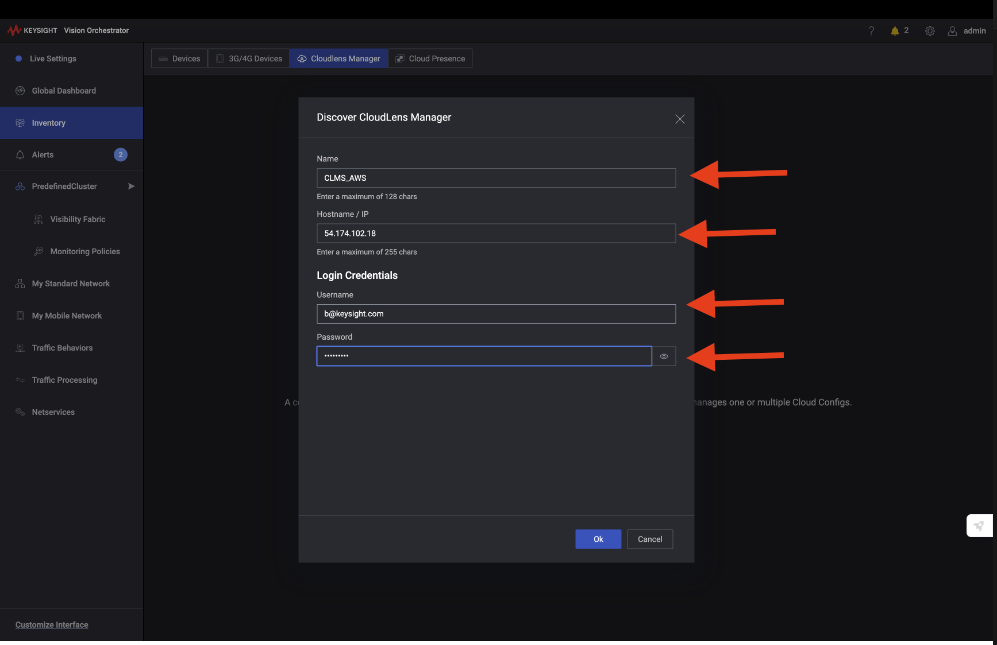
Figure 6: KVO - Discover CloudLens Manager with credentials

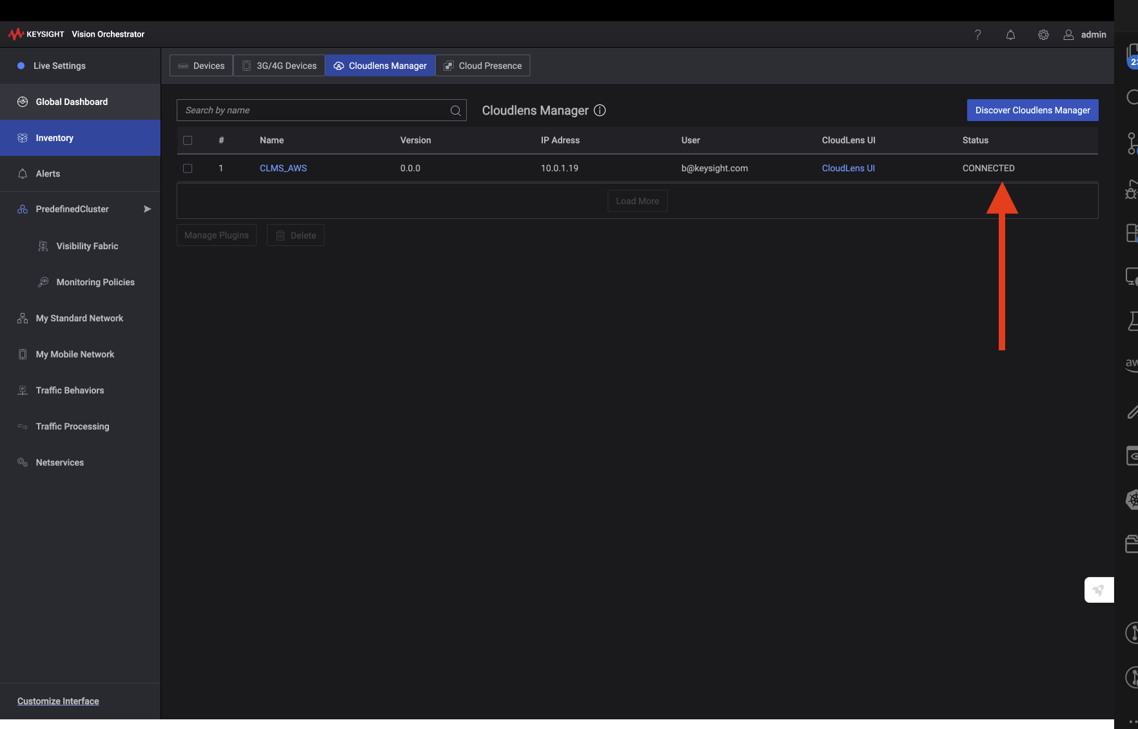
Figure 7: CLMS successfully adopted - Status: CONNECTED

Important: Use the CLMS private IP address, not the public IP. Both KVO and CLMS are on the same VPC subnet (10.0.1.0/24) and communicate directly via private networking.

Step 5: Create Cloud Config and Get Sensor Access Key
Create a Cloud Config in KVO to link to the adopted CLMS. This generates the Sensor Access Key (project key) needed for sensor deployment in Phase 3.

- In KVO, navigate to Visibility Fabric > Cloud Configs tab
- Click New Cloud Config
- Select Custom Cloud from the dropdown

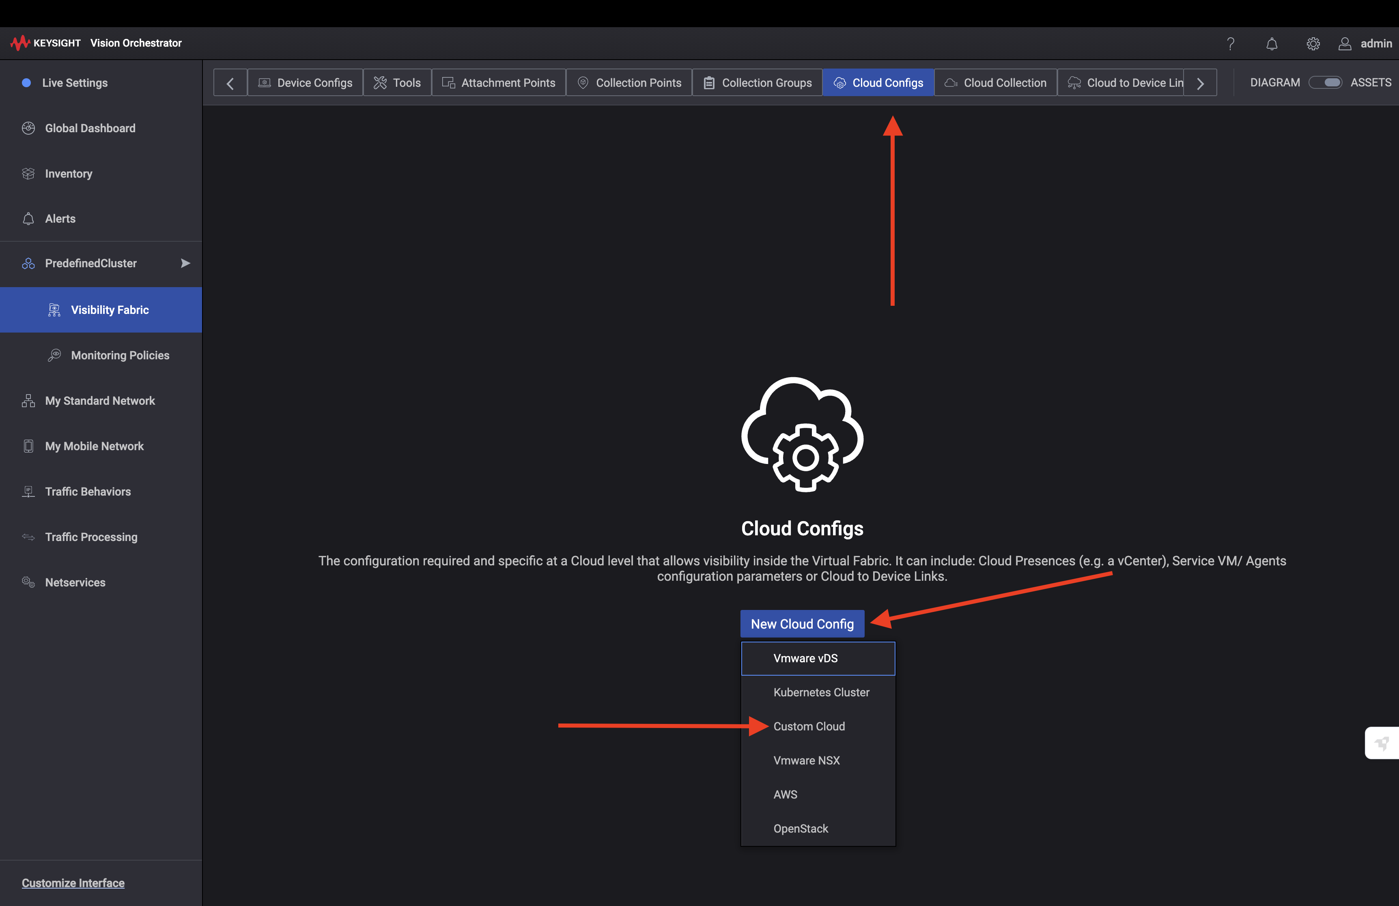
Figure 8: KVO - New Cloud Config dropdown (select Custom Cloud)

- Fill in the Cloud Config form:

Field | Value
Name | CLMS_CC (or any descriptive name)
CloudLens Manager | Select CLMS_AWS (the CLMS you adopted in Step 4)

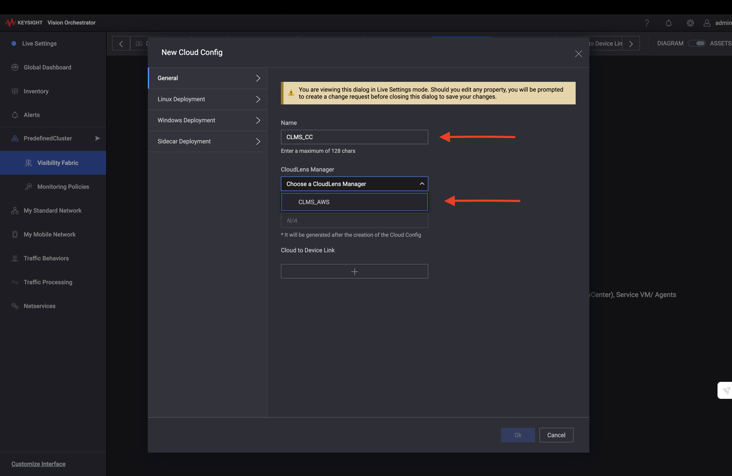
Figure 9: New Cloud Config - Select the adopted CLMS

- Click Ok to create the Cloud Config
- You will see the Cloud Config listed with CLMS Status: CONNECTED
- Click Commit (top right) to save the changes

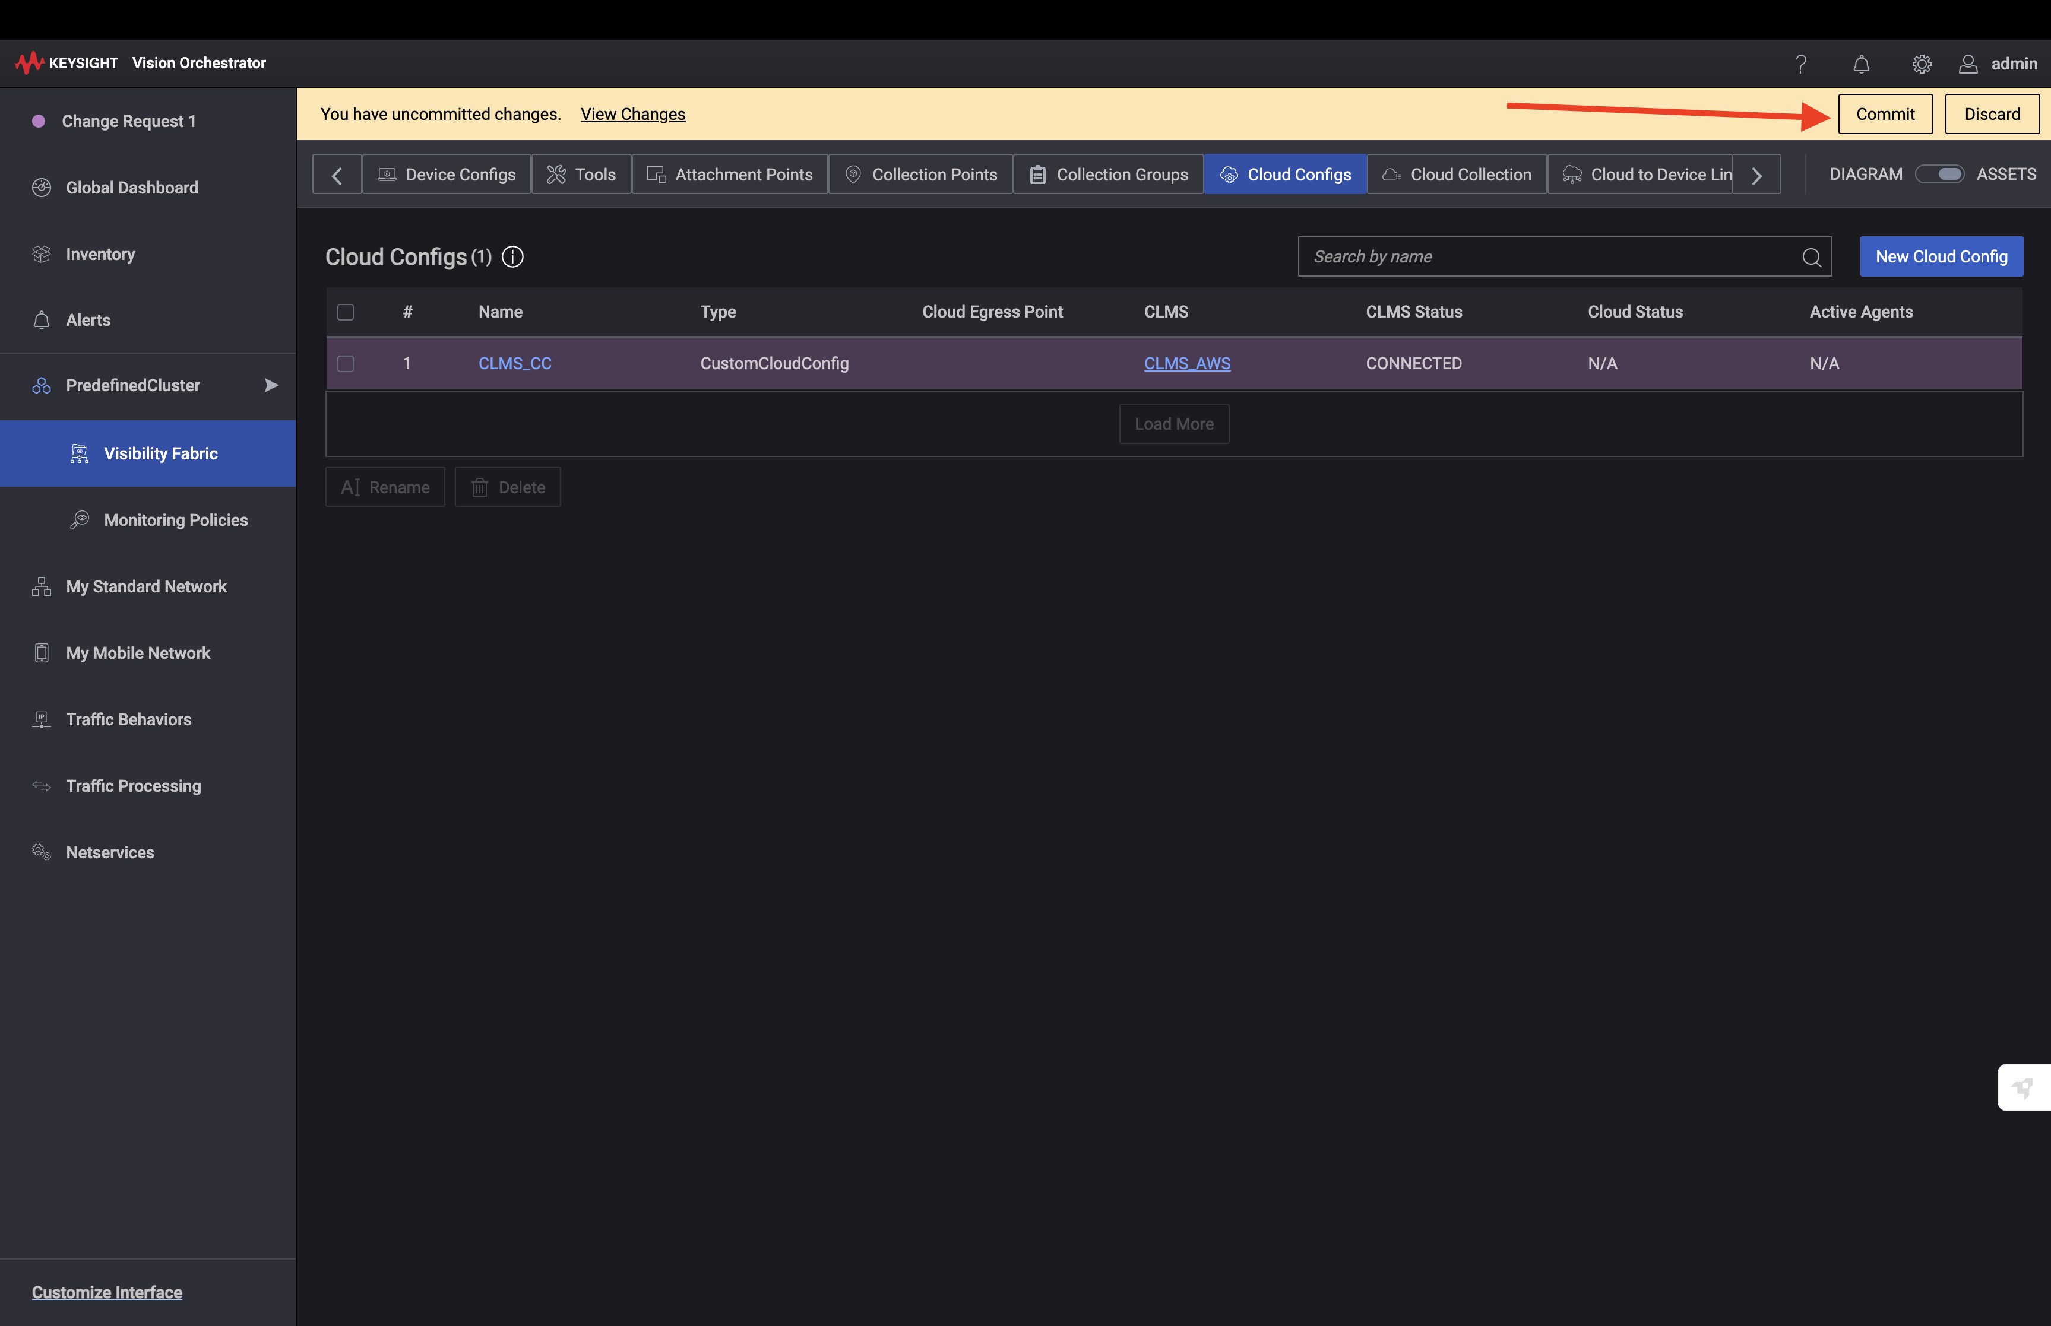
Figure 10: Cloud Config created - Click Commit to save

- Click on the Cloud Config to edit it
- Copy the Sensor Access Key value
- Save this key - this is the project key for Phase 3 sensor deployment

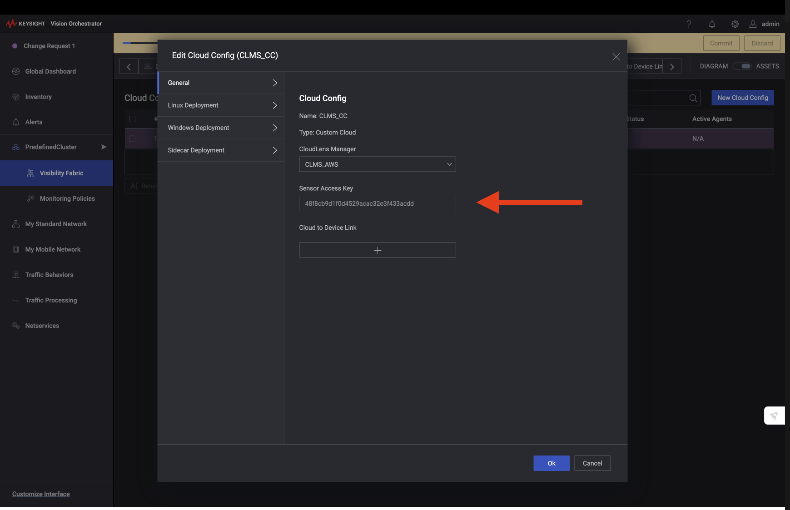
Figure 11: Cloud Config - Copy the Sensor Access Key

Important: The Sensor Access Key is generated after the Cloud Config is created and committed. This is the project key you will pass to the deploy-sensors.sh script in Phase 3.

Step 6: Adopt vPB into KVO
The vPB (Virtual Packet Broker) is adopted differently from CLMS. For the KVO-managed vPB Marketplace AMI, adoption is initiated from the vPB side via its CLI.

Important: The KVO-managed vPB Marketplace AMI (cloudlens-vpb-kvo) uses SSH on port 9022, NOT the standard port 22. Ensure your security group allows inbound TCP 9022 from your IP. Connect with: ssh -i ~/Downloads/your-key.pem admin@<vPB-PUBLIC-IP> -p 9022 (default password: admin). Once inside, configure KVO’s PRIVATE IP: configure terminal → kvo → ip <KVO-PRIVATE-IP> → port 443 → enable → monitored → end → write memory. Then check KVO → Inventory → Devices → Adopt Devices → Auto Discovery — the vPB should appear within 1-2 minutes.

6a. Connect to vPB via SSM Session Manager:

# Find the vPB instance ID
aws ec2 describe-instances --filters "Name=tag:Name,Values=demo-vpb" \
--query "Reservations[0].Instances[0].InstanceId" --output text

# Connect via SSM Session Manager
aws ssm start-session --target <vpb-instance-id> --region us-east-1

Alternatively, use the AWS Console: Systems Manager > Session Manager > Start session > select the vPB instance.

6b. Run KVO adoption commands:
Once connected to the vPB CLI, run these commands to point the vPB at KVO:

CloudLensVPB# kvo
CloudLensVPB-kvo# ip <KVO_PRIVATE_IP> (e.g., 10.0.1.192)
CloudLensVPB-kvo# port 443
CloudLensVPB-kvo# enable
CloudLensVPB-kvo# exit

# Verify the configuration
CloudLensVPB# show running-config

Default vPB CLI credentials: admin / ixia

6c. Verify in KVO:
- In KVO, navigate to Inventory > Devices tab
- The vPB should appear automatically after running the kvo enable command
- Wait for the status to show Online/Connected

vPB Interface | Subnet | Purpose | IP
eth0 (mgmt) | 10.0.1.0/24 | Management, KVO comm | 10.0.1.99
eth1 (ingress) | 10.0.2.0/24 | Sensor traffic IN | 10.0.2.175
eth2 (egress) | 10.0.3.0/24 | Processed traffic OUT | 10.0.3.129

To retrieve IPs from Terraform:

cd terraform/environments/demo
terraform output -json bootstrap_config

5. Preparing Existing Customer VMs
If you are deploying sensors to existing EC2 instances (not created by AutoPilot), those VMs need to be prepared first. New VMs created by AutoPilot's demo-targets Terraform are already configured and can skip this section.

What Existing VMs Need
Prerequisite | Can Auto-Fix? | Details
IAM Role | Yes | AmazonSSMManagedInstanceCore policy. Script creates and attaches automatically.
SSM Agent | Mostly | Pre-installed on Amazon Linux, Ubuntu 16.04+, Windows Server 2016+. Must be installed manually on RHEL/CentOS.
Tags | Yes | cloudlens=true + Platform tag (linux-docker, linux-podman, or windows). Script auto-detects OS and applies correct tags.

Step 1: Scan Your Environment
Run the prep script in scan-only mode to see what needs fixing:

./scripts/prep-targets.sh --region us-east-1 --profile customer --scan-only

Example output:

============================================================
TARGET VM READINESS REPORT
============================================================

Ready for sensor deployment: 12 instances
Missing tags (cloudlens+Platform): 20 instances
Missing SSM Agent: 8 instances
Missing IAM role: 7 instances
Total running instances: 47

Step 2: Auto-Fix All Issues
Run with --auto-fix to automatically prepare all VMs:

./scripts/prep-targets.sh --region us-east-1 --profile customer --auto-fix

This will:
- Create an IAM role (CloudLens-SSM-Role) with SSM + S3 permissions
- Attach the IAM role to instances that don't have one
- Add SSM policy to instances that already have a different IAM role
- Install SSM Agent on Linux instances via EC2 Instance Connect (no standing SSH needed)
- Auto-detect each VM's OS and apply the correct Platform tag
- Tag all instances with cloudlens=true for sensor targeting

Or run without --auto-fix for interactive mode (asks before each change).

Step 3: Manual SSM Agent Install (if needed)
If EC2 Instance Connect is not available (no public IP, security group blocks SSH), install SSM Agent manually:

Ubuntu / Debian:
sudo snap install amazon-ssm-agent --classic
sudo systemctl enable snap.amazon-ssm-agent.amazon-ssm-agent.service
sudo systemctl start snap.amazon-ssm-agent.amazon-ssm-agent.service

RHEL / CentOS:
sudo dnf install -y https://s3.amazonaws.com/ec2-downloads-windows/SSMAgent/latest/linux_amd64/amazon-ssm-agent.rpm
sudo systemctl enable amazon-ssm-agent
sudo systemctl start amazon-ssm-agent

Windows (PowerShell as Administrator):
# SSM Agent is pre-installed on Windows Server 2016+
# If not responding, restart it:
Restart-Service AmazonSSMAgent

Important: After installing SSM Agent, wait 30-60 seconds for it to register with AWS Systems Manager. Verify with: aws ssm describe-instance-information --region us-east-1

SSM Agent Removal (Optional)
Once CloudLens sensors are installed and running, they communicate directly with CLMS over HTTPS 443. SSM Agent is no longer needed for sensor operation. However, keeping SSM Agent is recommended for future sensor updates, troubleshooting, and removal at scale.

To remove SSM Agent after sensor deployment:

# Ubuntu/Debian:
sudo snap remove amazon-ssm-agent

# RHEL/CentOS:
sudo dnf remove -y amazon-ssm-agent

# Windows (PowerShell as Administrator):
msiexec /x {SSM_AGENT_GUID} /quiet

6. Phase 3: Sensor Deployment (SSM)
Deploy CloudLens sensors to your target VMs at scale using AWS Systems Manager. No SSH or WinRM access is required - the SSM Agent on each VM communicates outbound to AWS.

Prerequisites for Target VMs
- SSM Agent installed (pre-installed on Amazon Linux, Ubuntu 16.04+, Windows Server 2016+)
- IAM instance role with AmazonSSMManagedInstanceCore policy attached
- VMs tagged with: cloudlens = true
- VMs tagged with the correct Platform tag (see table below)

Tagging Target VMs
Tag your target EC2 instances to identify them for sensor deployment:

OS | cloudlens Tag | Platform Tag | Sensor Type
Ubuntu / Debian | true | linux-docker | Docker container
RHEL / CentOS | true | linux-podman | Podman container
Windows Server | true | windows | .EXE installer

You can tag instances via the AWS Console, CLI, or Terraform:

# Tag a single instance
aws ec2 create-tags --resources i-0abc123def456 \
--tags Key=cloudlens,Value=true Key=Platform,Value=linux-docker

# Tag multiple instances
aws ec2 create-tags --resources i-0abc123 i-0def456 i-0ghi789 \
--tags Key=cloudlens,Value=true Key=Platform,Value=linux-docker

Windows Prerequisite: Upload Sensor Installer to S3
Windows sensors require the CloudLens .EXE installer to be hosted on S3. Linux sensors (Docker/Podman) pull their image directly from CLMS, so this step is only needed if deploying to Windows VMs.

# 1. Create an S3 bucket for artifacts
aws s3 mb s3://cloudlens-autopilot-artifacts --region us-east-1

# 2. Upload the Windows sensor installer
aws s3 cp cloudlens-win-sensor-6.12.0.316.exe \
s3://cloudlens-autopilot-artifacts/

# 3. Grant target VMs S3 read access (if not already done)
aws iam put-role-policy \
--role-name demo-target-vm-ssm-role \
--policy-name s3-sensor-download \
--policy-document '{"Version":"2012-10-17","Statement":[{"Effect":"Allow","Action":["s3:GetObject"],"Resource":"arn:aws:s3:::cloudlens-autopilot-artifacts/*"}]}'

Important: The Windows sensor .EXE can be downloaded from the Keysight support portal or found in the Ansible deployment files. The installer URL will be: https://cloudlens-autopilot-artifacts.s3.amazonaws.com/cloudlens-win-sensor-6.12.0.316.exe

Deploy Sensors
Run the deployment script from the project root. Use --profile if you use AWS SSO or named profiles.

Deploy to ALL platforms at once (Linux + Windows):

./scripts/deploy-sensors.sh \
--clms-ip <CLMS_PRIVATE_IP> \
--project-key <SENSOR_ACCESS_KEY> \
--installer-url https://<bucket>.s3.amazonaws.com/cloudlens-win-sensor-6.12.0.316.exe \
--prefix demo --region us-east-1 --profile autopilot

Deploy by Target OS
You can target specific operating systems individually. This is useful when you want to roll out sensors incrementally or troubleshoot platform-specific issues.

Ubuntu / Debian (Docker sensor):
Deploys the CloudLens sensor as a Docker container. No installer URL needed - pulls the image directly from CLMS.

./scripts/deploy-sensors.sh \
--clms-ip <CLMS_PRIVATE_IP> \
--project-key <SENSOR_ACCESS_KEY> \
--platform docker \
--prefix demo --region us-east-1 --profile autopilot

RHEL / CentOS (Podman sensor):
Deploys the CloudLens sensor as a Podman container. No installer URL needed - pulls the image directly from CLMS.

./scripts/deploy-sensors.sh \
--clms-ip <CLMS_PRIVATE_IP> \
--project-key <SENSOR_ACCESS_KEY> \
--platform podman \
--prefix demo --region us-east-1 --profile autopilot

Windows Server (.EXE sensor):
Deploys the CloudLens sensor using the Windows .EXE installer. Requires the --installer-url flag pointing to the S3-hosted installer.

./scripts/deploy-sensors.sh \
--clms-ip <CLMS_PRIVATE_IP> \
--project-key <SENSOR_ACCESS_KEY> \
--platform windows \
--installer-url https://<bucket>.s3.amazonaws.com/cloudlens-win-sensor-6.12.0.316.exe \
--prefix demo --region us-east-1 --profile autopilot

Deploy to Specific Instances
To target individual instances instead of all tagged VMs, use AWS SSM Run Command directly:

# Deploy Docker sensor to a specific Ubuntu instance
aws ssm send-command \
--document-name demo-Deploy-CloudLens-Docker \
--instance-ids i-0abc123def456789 \
--parameters "ClmsIp=<CLMS_IP>,ProjectKey=<KEY>" \
--region us-east-1 --profile autopilot

# Deploy Podman sensor to a specific RHEL instance
aws ssm send-command \
--document-name demo-Deploy-CloudLens-Podman \
--instance-ids i-0abc123def456789 \
--parameters "ClmsIp=<CLMS_IP>,ProjectKey=<KEY>" \
--region us-east-1 --profile autopilot

# Deploy Windows sensor to a specific Windows instance
aws ssm send-command \
--document-name demo-Deploy-CloudLens-Windows \
--instance-ids i-0abc123def456789 \
--parameters "ClmsIp=<CLMS_IP>,ProjectKey=<KEY>,InstallerUrl=https://<bucket>.s3.amazonaws.com/cloudlens-win-sensor.exe" \
--region us-east-1 --profile autopilot

Script Options Reference
Flag | Description
--clms-ip | CLMS private IP address (from terraform output)
--project-key | Sensor Access Key from KVO Cloud Config (Step 5)
--platform | Target OS: all (default), docker (Ubuntu/Debian), podman (RHEL/CentOS), windows
--installer-url | S3 URL for Windows .EXE installer (required for Windows deployments)
--profile | AWS CLI profile name (e.g., autopilot for SSO users)
--prefix | Resource name prefix matching your Terraform deployment (default: demo)
--region | AWS region (default: from AWS config)
--from-terraform | Load CLMS IP automatically from Terraform state directory
--tags | Custom tags for sensor identification (default: deployed-by=autopilot)
--dry-run | Preview what would be deployed without executing

Important: The deploy script uses AWS SSM Run Command which supports up to 50 concurrent executions by default. For deployments of 1000+ VMs, SSM handles queuing and rate limiting automatically. A real-time progress bar shows deployment status for each platform.

Verify Sensor Registration
- Open CLMS in your browser (https://<clms-ip>)
- Navigate to the Cloud Config project
- Verify sensors appear in the Agents list
- Each sensor should show status as Online within 2-3 minutes

You can also verify from KVO:
- In KVO, navigate to Visibility Fabric > Cloud Configs
- Click on your Cloud Config (CLMS_CC)
- Check the Active Agents count — should match your deployed sensor count

7. Phase 4: AWS Traffic Mirroring (KVO Native)
KVO natively manages AWS VPC Traffic Mirroring through the Cloud Config pipeline. When you create a Monitoring Policy, KVO automatically deploys collector instances (Service VMs), creates Traffic Mirror filters, targets, and sessions, and auto-scales collectors based on the number of tapped interfaces. No custom Lambda or EventBridge rules are required for traffic mirroring.

7.1 Step 1: IAM User (Already Done)
The Terraform/CloudFormation deployment created an IAM user with the full CloudLens IAM policy (matching the official Keysight v6.13.0 documentation). The Access Key ID and Secret Access Key are available in the deployment outputs. This policy grants permissions for EC2 instance management, Traffic Mirror operations, Auto Scaling, and Launch Templates — all scoped with cloudlens:monitored:vpcid condition tags for security.

7.2 Step 2: Adopt CLMS into KVO (Already Done)
The CLMS was adopted into KVO during Section 4. The status must show “CONNECTED” before proceeding. If not connected, revisit Section 4.3.

7.3 Step 3: Create AWS Cloud Config
Navigate to Cloud Fabric → Cloud Configs → New Cloud Config → AWS. Fill in:
Name: Descriptive name (e.g., “AWS-Production”)
Access Key ID: From Terraform/CloudFormation output (CloudConfigAccessKey)
Secret Access Key: From Terraform/CloudFormation output (CloudConfigSecretKey)
CloudLens Manager: Select the adopted CLMS from the dropdown
→ Click the blue “Connect” button to validate credentials against the AWS API. KVO will verify your IAM keys can access the specified region. → Once connected, the Region dropdown populates — select your deployment region (e.g., us-east-1). → The VPC ID dropdown then populates — select the VPC where your target VMs reside. → Click “Ok” at the bottom. Note: After clicking Ok, you will see a “New Cloud Config” wizard with 4 tabs: Properties, Deployment, Zone Tapping, and Connect To Device. You must configure Deployment and Zone Tapping before committing.

7.4 Step 4: Deployment Panel (Collector Configuration)
The Deployment panel configures the Service VM (collector) that KVO will auto-deploy. One collector handles up to 10 tapped interfaces. Fill in:
AMI ID: CloudLens Collector SVM AMI (NOT the vPB AMI). For us-east-1: ami-0c22ade3667f8d35a (v6.13.0). Find it in AWS Marketplace under “cloudlens-vpb-svm”. This is the Service VM that KVO auto-deploys as a collector.
SSH Key Pair: Select your EC2 key pair from the dropdown
Management Security Groups: SG for CLMS communication (port 443)
Ingress Security Groups: SG for receiving mirrored traffic (VXLAN UDP 4789)
Egress Security Groups: SG for forwarding traffic to tool (VXLAN/GRE)
Important: Management, Ingress, and Egress security groups must each be in SEPARATE subnets.

7.5 Step 5: Zone Tapping
Configure collector deployment per availability zone. For each zone you want to tap:
• Enable tapping on the zone (e.g., us-east-1a)
→ Collector Type: Select an instance type from the dropdown (e.g., c5.2xlarge with 8 cores / 16 GB). This is the instance type for the auto-deployed collector SVM, not a Marketplace restriction.
• Min Collectors: 1 (always-on baseline)
• Max Collectors: 5 (scales automatically based on tapped interfaces)
• Select Management, Ingress, and Egress subnets for each zone (only subnets in that AZ are shown)

7.6 Step 6: Create Remote Tool
Navigate to Visibility Fabric → Tools → New Tool → Remote. Configure:
• Name: e.g., “Wireshark-Tool” or “SIEM-Ingestion”
• Uncheck “Strip Path Solver VLAN” (does not apply to cloud traffic)
• Traffic Source: select “Traffic source is a cloud”
• Remote IP: IP address of your packet analysis tool
• Encapsulation Protocol: VXLAN or L2GRE

7.7 Step 7: Create Cloud Collection
Navigate to Visibility Fabric → Cloud Collection → New Cloud Collection. Configure:
• Cloud Config: select the AWS config from Step 3
• Add Workload Selectors (regex supported): Instance Name, Instance ID, Interface ID, or Subnet ID
• Example: Instance Name = “.*” (all instances) or “web-.*” (web servers only)

7.8 Step 8: Create Monitoring Policy
Navigate to Monitoring Policies → New Policy. This connects your traffic source to destination:
• Traffic Source: select the Cloud Collection from Step 7
• Traffic Destination: select the Remote Tool from Step 6
• Commit the change request. This triggers KVO to automatically deploy everything.

7.9 Step 9: Verify Deployment
After committing the Monitoring Policy, KVO automatically:
• Deploys collector EC2 instances (named “cloudlens.collector.<vpc-id>”)
• Creates AWS Traffic Mirror filters, targets, and sessions
• Auto-scales collectors (1 per 10 tapped interfaces)
Verify in KVO: Cloud Fabric → Cloud Configs → check Cloud Status shows “Online”. Verify in AWS Console: VPC → Traffic Mirroring → Sessions to see active mirror sessions. License credits are consumed per tapped interface (check Settings → Licensing → License Statistics).

7.10 Network Requirements
Interface | Port | Protocol | Purpose
Management | 443 | TCP | CLMS ↔ Collector communication
Management | 22 / 9022 | TCP | SSH troubleshooting (optional)
Ingress | 4789 | UDP | VXLAN from AWS Traffic Mirror
Egress | 4789 | UDP | VXLAN to remote tool
Egress | 47 | GRE | GRE to remote tool (if using L2GRE)

7.11 Collector Auto-Scaling
KVO automatically manages collector scaling:
• 1 collector handles up to 10 tapped interfaces (not instances — interfaces)
• 5 instances with 2 interfaces each = 1 collector
• 45 instances with 1 interface each = 5 collectors
• Collectors scale up and down automatically based on monitoring policy
• Scale Cooldown controls how long idle collectors persist before removal

7.12 Auto-Tag Lambda (Optional)
If deployed via CloudFormation with Auto-Mirror enabled, an optional Lambda function auto-tags new EC2 instances with the cloudlens-mirror tag. This makes new instances automatically appear in KVO Cloud Collections workload selectors. This is a convenience feature — not required. You can manually select instances in Cloud Collections instead.

8. Teardown

Step 1: Remove Sensors from Target VMs
Before destroying infrastructure, remove CloudLens sensors from all target VMs:

Remove from ALL platforms:
./scripts/remove-sensors.sh --region us-east-1 --profile autopilot

Remove from specific OS:
# Ubuntu/Debian only
./scripts/remove-sensors.sh --platform docker --region us-east-1 --profile autopilot

# RHEL/CentOS only
./scripts/remove-sensors.sh --platform podman --region us-east-1 --profile autopilot

# Windows only
./scripts/remove-sensors.sh --platform windows --region us-east-1 --profile autopilot

Also remove Docker/Podman runtime (full cleanup):
./scripts/remove-sensors.sh --remove-runtime --region us-east-1 --profile autopilot

Step 2: Destroy Target VMs (if created by AutoPilot)
cd terraform/environments/demo-targets
terraform destroy -var-file=targets.tfvars

Step 3: Destroy Keysight Infrastructure
cd terraform/environments/demo
terraform destroy -var-file=demo.tfvars

Type yes when prompted. This removes KVO, CLMS, vPB, VPC, IAM, and SSM documents.

Important: Always remove sensors (Step 1) before destroying infrastructure (Step 3). If you destroy CLMS first, the remove script cannot unregister sensors cleanly.

9. Troubleshooting

Issue | Cause | Solution
UnsupportedOperation on terraform apply | Wrong instance type for Marketplace AMI | KVO must use c5.2xlarge, vPB must use t3.xlarge
KVO shows EULA page on every request | EULA not accepted | Open KVO URL in browser, click Agree
SSM command fails with AccessDenied | Target VM missing IAM role | Attach AmazonSSMManagedInstanceCore policy to instance role
Sensor container not starting | CLMS IP not reachable | Ensure target VM can reach CLMS on port 443. Check security groups.
SSM shows 0 target instances | Missing tags or SSM Agent not running | Verify cloudlens=true and Platform=<type> tags. Check SSM Agent status.
Terraform state lock error | Previous run interrupted | Run: terraform force-unlock <lock-id>

10. Appendix

Default Credentials
Product | Username | Password
KVO | admin | admin
CLMS | admin | Cl0udLens@dm!n

Network Topology
Subnet | CIDR | Purpose | Resources
Management | 10.0.1.0/24 | SSH, HTTPS, REST API | KVO, CLMS, vPB eth0
Data | 10.0.2.0/24 | Sensor traffic (GRE/VXLAN) | vPB eth1 (ingress)
Tool | 10.0.3.0/24 | Processed traffic to tools | vPB eth2 (egress)

SSM Command Documents
These documents are registered automatically by Terraform:

Document Name | Target Platform
<prefix>-Deploy-CloudLens-Docker | Ubuntu, Debian (Docker)
<prefix>-Deploy-CloudLens-Podman | RHEL, CentOS (Podman)
<prefix>-Deploy-CloudLens-Windows | Windows Server (.EXE)

Future: AWS Service Catalog Self-Service
This deployment can be packaged as an AWS Service Catalog product for customer self-service:

- Customer opens AWS Console > Service Catalog
- Selects "Keysight CloudLens Visibility Stack"
- Fills in parameters (region, instance sizes, key pair)
- Clicks "Launch" - infrastructure deploys automatically
- Follows Phase 2 runbook for product configuration
- Tags target VMs and runs sensor deployment

This path requires no Terraform installation and gives customers a fully governed, point-and-click deployment experience within their own AWS account.

