# **PART 4 - MongoDB** **Text search (refer to chapter 9).**

## **Q1** Specify and word matches instead of or word matches.

Find documents with “2006” and “Drama”

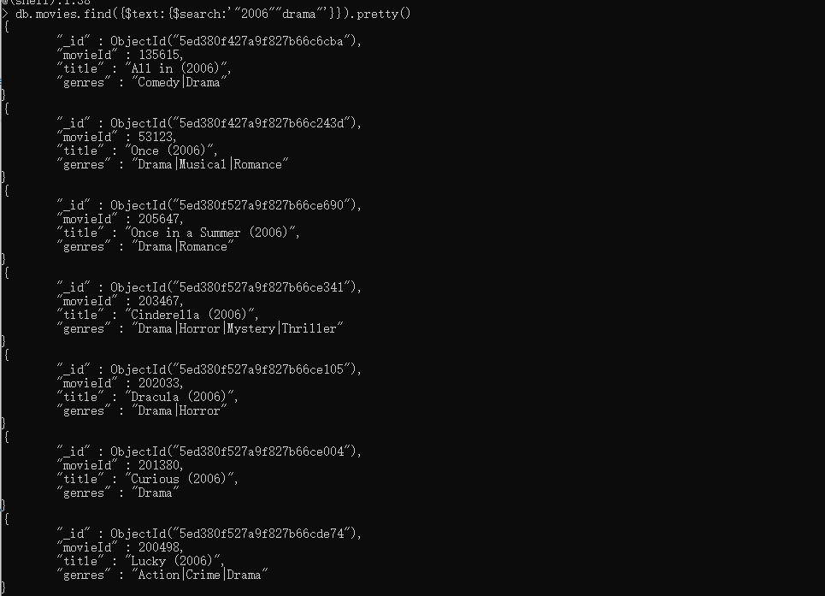

## Q2 Perform exact phrase matches.

Find documents with phrase “Drama”

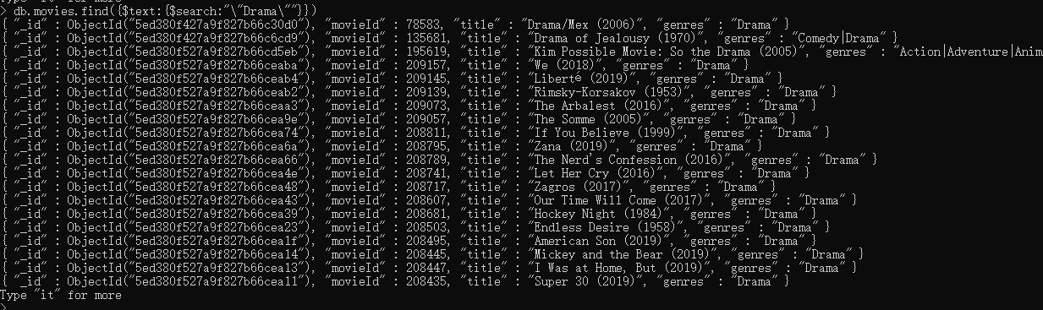

## Q3 Exclude documents with certain words.

Find documents with “2006” but without “Drama”

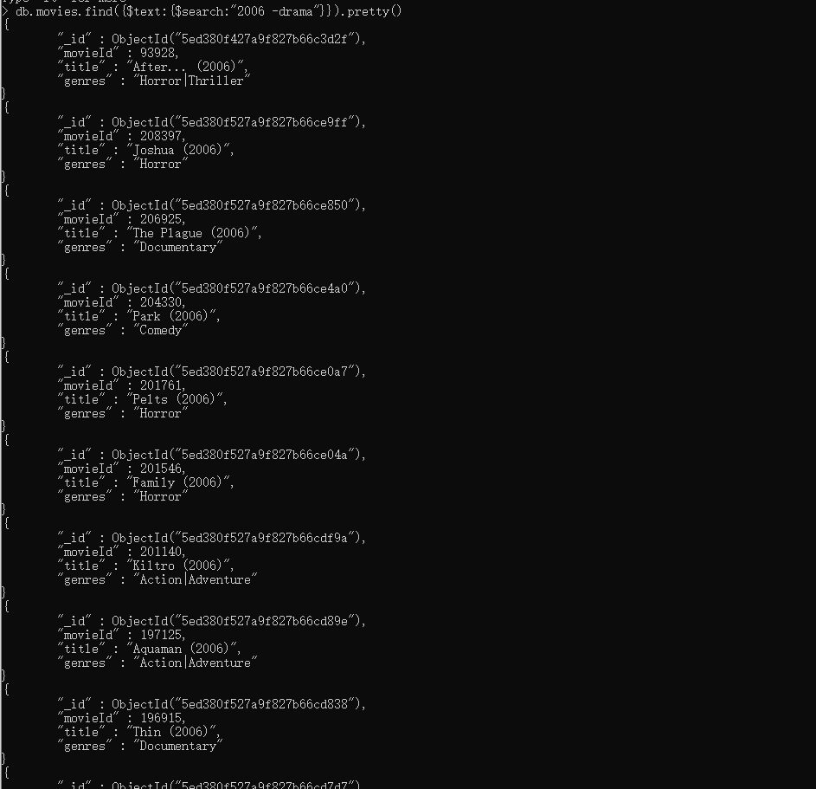

## Q4 Exclude documents with certain phrases.

Find documents with phrases “Drama” but without phrases “Drama 2016”

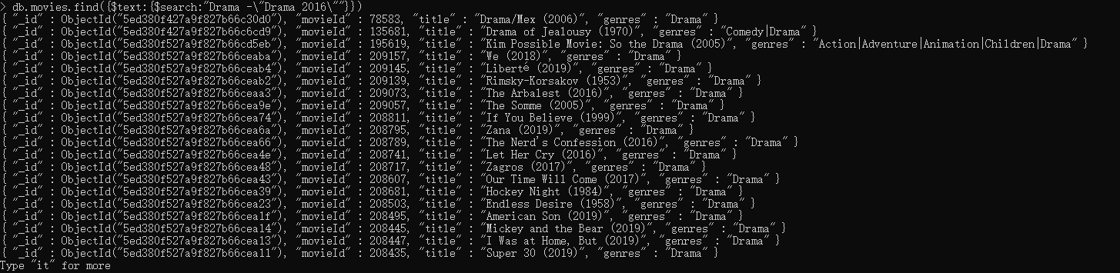

# **PART 5 - PROGRAMMING ASSIGNMENT**

## Q1 Number of Movies released per year (Movies Collection)

MAP: 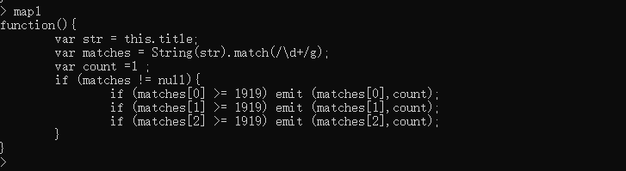

Reducer:

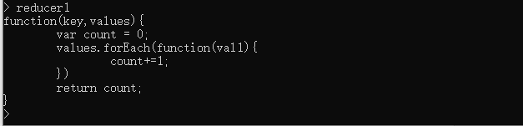

MapReduce:

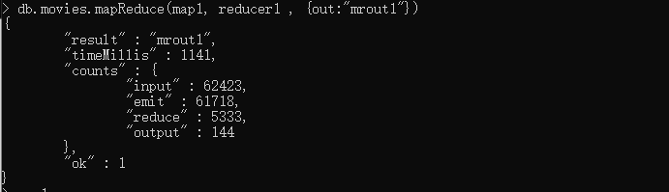

MRout:

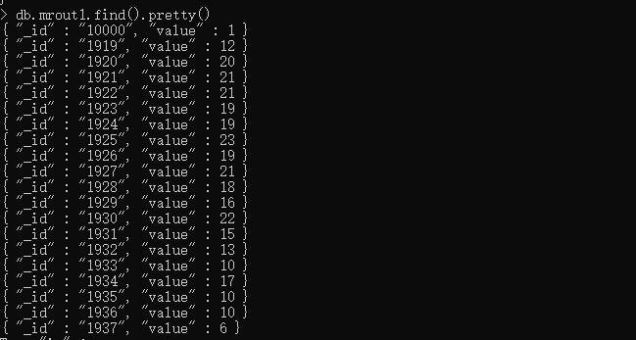

## Q2 Number of Movies per genre (Movies Collection)

MAP:

## Q3 Number of Movies per rating (Ratings Collection)

MAP:

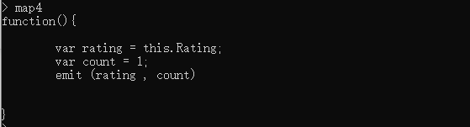

Reduce:



MapReduce:

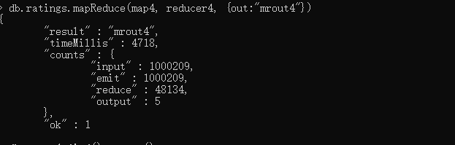

MRout4：

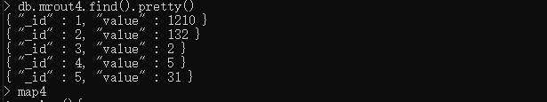

## Q4 Number of times each movie was tagged (Tags Collection)

MAP:

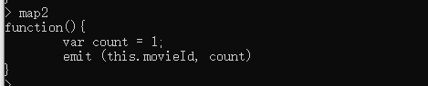

Reducer:



MapReduce:

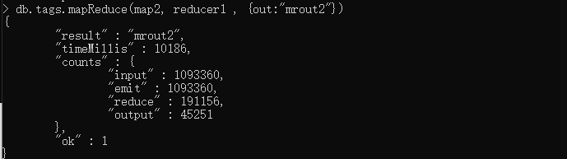

MRout:

