Lab 02 Current and Voltage law (submit before 12:00pm)

Task 1: Wire the circuit on the breadboard ( using LED with the same color).

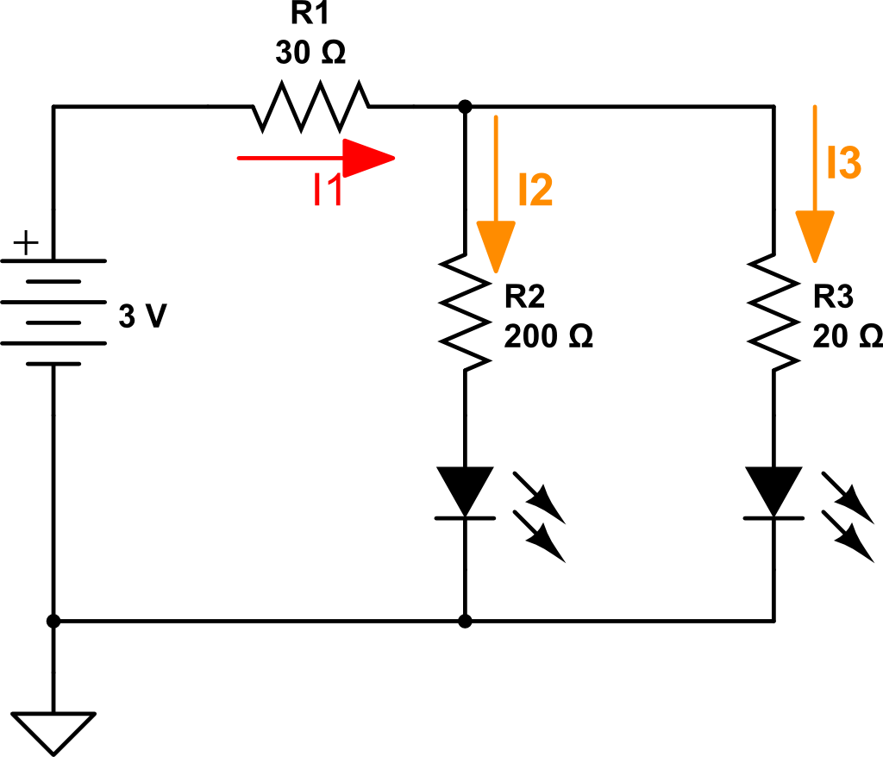

- Paste your circuit here:

- Which LED is brighter?

- Measure I1, I2 and I3 using multimeters, record the readings below:

I1 = _____ mA, I2 = ____ mA, I3 = ______mA.

- What is the relationship among I1, I2 and I3?
Do they satisfy Kirchhoff’s Current Law (KCL)? (Small discrepancy is acceptable!)

- Based on the data you collected, explain why one LED is brighter than the other.

Task 2: Wire the circuit on the breadboard, and build it in CircuitLab!
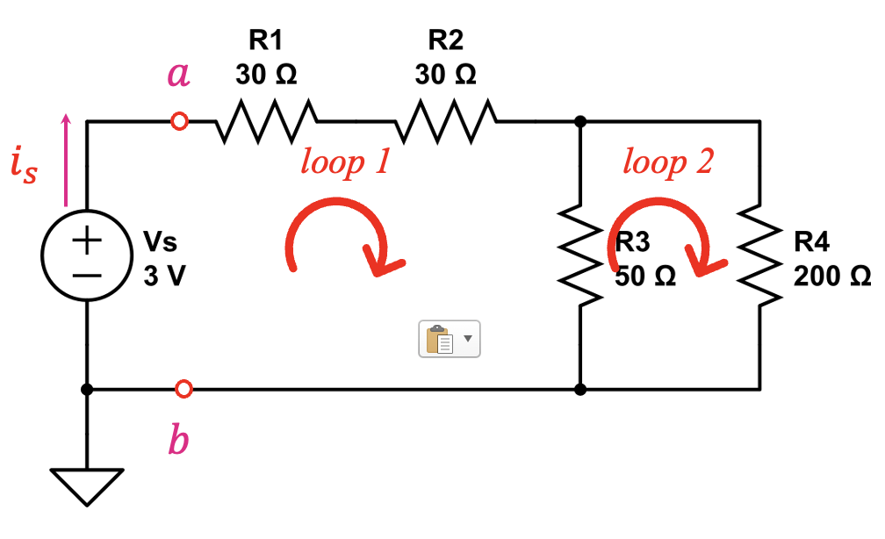

- Paste pictures of your two circuits here. (one on the breadboard and one in CircuitLab). And record the data in the following table:
Table 1
 | $$i_{s}$$ | $$v_{ab}$$ | $$v_{R1}$$ | $$v_{R2}$$ | $$v_{R3}$$ | $$v_{R4}$$
Breadboard
CircuitLab

- Analytically determine the voltages across the resistors (KCL, KVL, Ohm’s law), Show all steps clearly.

- Using the data you recorded, write the KVL equations for Loop 1 and Loop 2. Are the KVL equations satisfied? (Small discrepancy is acceptable!)

- Calculate the equivalent resistance $R_{eq}$between terminals a and b, as seen from left to right. Show detailed steps.
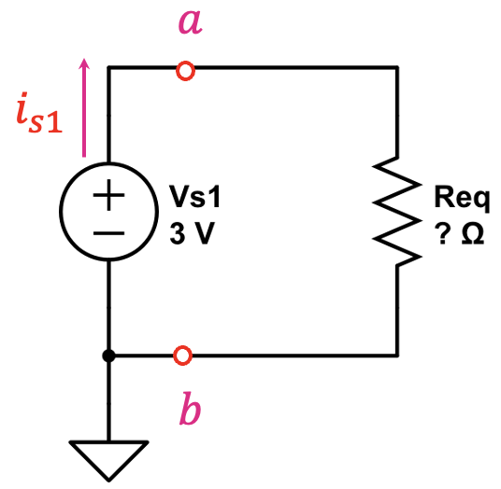

- In CircuitLab, replace the resistor network with its equivalent resistor. Record the values of $i_{s1}$ and $v_{ab}$, and compare them with the results from the original circuit (in Table one). Are the values equivalent? What conclusion can you draw?

