Lab 03 Nodal and Mesh Analysis (submit before 12:00pm)

You need：
Items | 1 k$Ω$ | 100 $Ω$ | 200 $Ω$ | 20 $Ω$ | LED | 3V | 5V
Total | 1 | 2 | 1 | 2 | 1 | 1 | 1

Task 1:
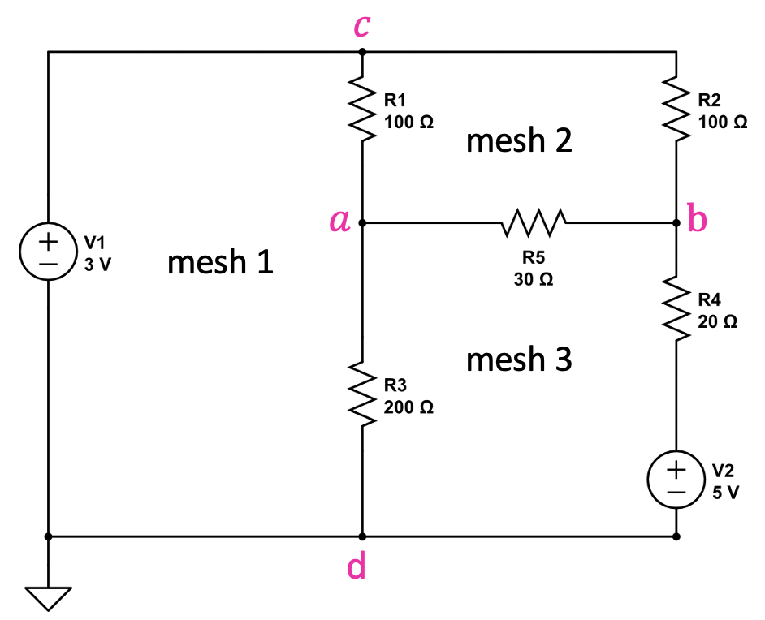

(1a) Find the voltage across and the current through each resistor using nodal or mesh analysis. (You may first formulate the equations and then use ChatGPT or other computational tools to solve them.)

(1b) Wire the circuit on a breadboard and measure the voltage at each node using a multimeter. Then, build the circuit in CircuitLab and record all data—including the calculated values from part (a)—in the table below. (Attach the two pictures below)
Table 1 votages
 | $$v_{a}$$ | $$v_{b}$$ | $$v_{c}$$
Breadboard
CircuitLab
Calculated

Table 2 Mesh currents
 | $$Mesh current 1$$ | $$Mesh current 2$$ | $$Mesh current 3$$
Breadboard
CircuitLab
Calculated

Paste the two pictures there:

Task 2: Design your circuits

Background
A demolition team has rigged an LED-based ignition system to destroy an abandoned building. The LED serves as the arming indicator—while it glows, the bomb is live and dangerous.

Safety Regulation: To protect the demolition crew working nearby, the current flowing through the bomb (LED) must be strictly limited to 5 mA or less.

The system is given below,
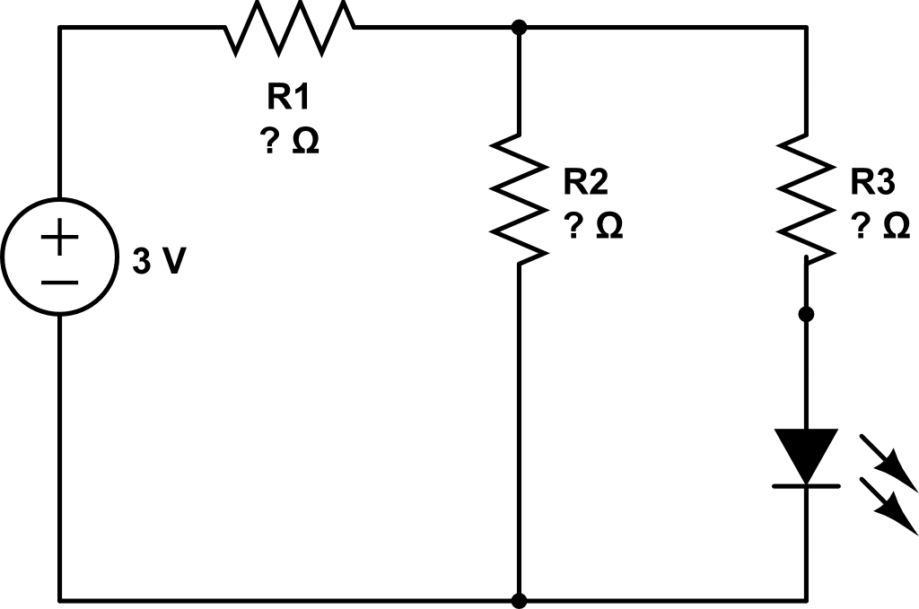

Your task (2a): You have one 20 Ω, one 100 Ω, and one 200 Ω resistor available. Determine how to place these resistors in the circuit to ensure that the LED (bomb) operates safely. Justify your design mathematically.
The LED turn-on voltage is approximately 1.8 V.
You may use breadboard or CircuitLab to help you design the circuit.

Your task (2b):
After the device has been armed, the team discovers that one one person is still inside the building. The demolition must be aborted immediately. However, the device cannot be disassembled or disconnected.
You are allowed to add exactly ONE resistor in the circuit. But,
- No components may be removed
- No wires may be disconnected
- The power supply remains connected
As a result, the LED turns OFF (the voltage across it is less than 1.8 V) and then bomb is safely disabled
Now, you have one 20 $Ω$ and one 1$kΩ$ resistor, and you have only one attempt to defuse the explosive device; failure results in detonation. State which resistor you would select and provide a detailed justification for your choice

