* **Instructions for run the script**

**Note:**  Ensure that you will never forget the password which you set for the login. Because without it you can’t decrypt your files in the future.

* First set the command line location as per your python project and then type the following command:

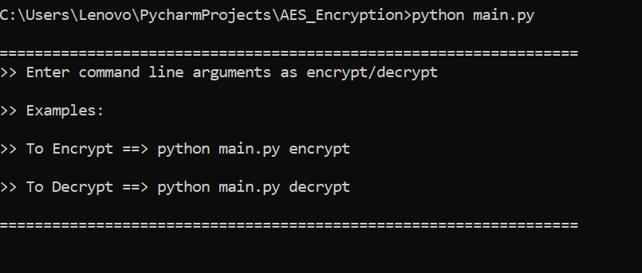

* **For Encryption process:**
* As mentioned above you have to type the following command:

***“python main.py encrypt”***

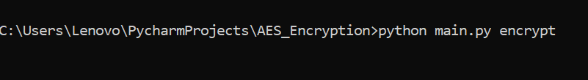

* Then you have to provide your login credentials for encrypting your text or image. The sample image of the login screen is below:

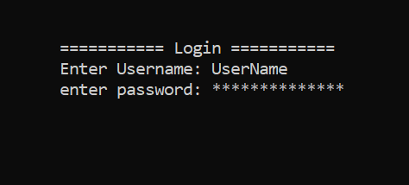

* Then you are able to see the main menu screen. Select your choice from the menu.

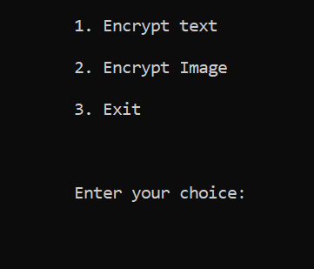

* If you choose the first option(Encrypt text) and once the string is encrypted you have to provide the filename to store your encryption string.

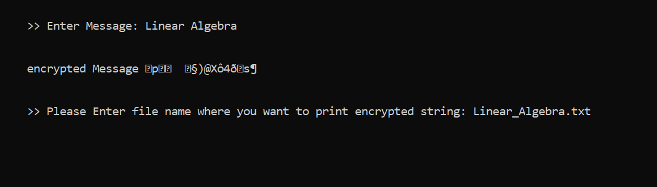

* If you choose the second option(Encrypt image) and once the image is encrypted you don’t have to provide the filename to store your encrypted image the code will automatically generate an encrypted image file as Filename_enc.
* **For Decryption process:**
* As mentioned in the menu you have to type the following command:

***“python main.py decrypt”***

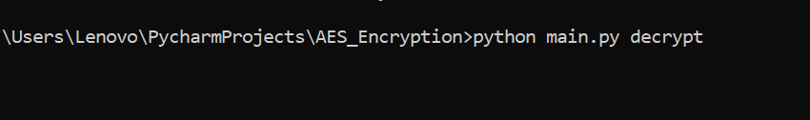

* then you must the same login credentials as encryption. Otherwise, you are not able to decrypt the image.
* Then you are able to see the main menu screen. Select your choice from the menu.

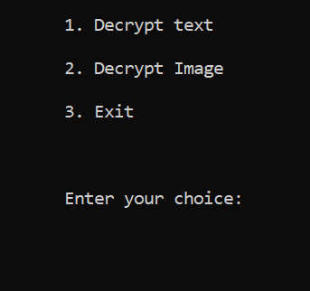

* If you choose the first option(Decrypt text) and then you have to provide the Filename which you want to decrypt as below.

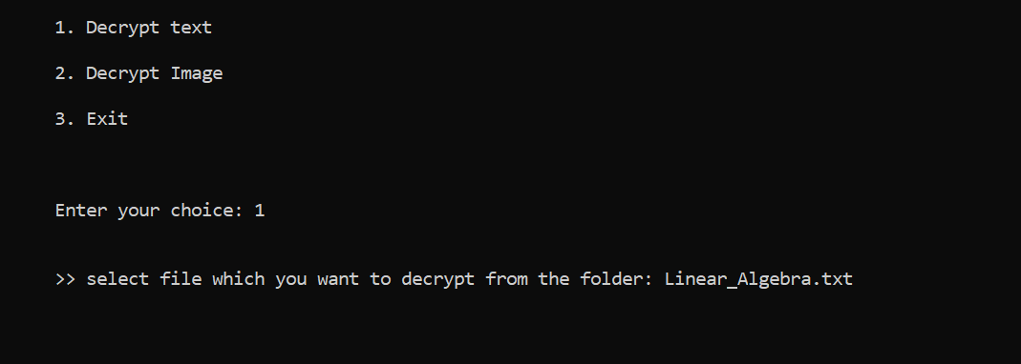

* If you choose the second option(Decrypt image) and then you have to provide encrypted Filename (Filename_enc)

