**Android Fundamentals**

1. **What is R.java File**

Being an auto-generated file that is generated by AAPT (Android Asset Packaging Tool), Android R.java contains resource IDs for all the resources of res/ directory. The id for the created component is automatically generated in the R.java whenever a component is created in the android activity_main.xml file. The life cycle methods for an activity such as onCreate, onStop, OnResume, etc is provided by the Activity java class. The created ID can later be used in the Java Source file. To act on a component, the corresponding id can be used in the activity source file. The android creates the R.jar file automatically in case the R.jar file is deleted. The android R.java file contains many static nested classes such as menu, id, layout, attr, drawable, string, etc.

1. **What is activity and activity lifecycle**

In Android, an activity is referred to as one screen in an application. It is very similar to a single window of any desktop application. An Android app consists of one or more screens or activities.

Each activity goes through various stages or a lifecycle and is managed by activity stacks.

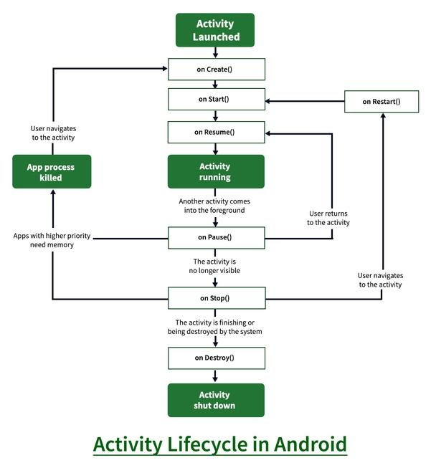

1. **What is fragment and fragment lifecycle**

In Android, the fragment is the part of Activity which represents a portion of User Interface(UI) on the screen. It is the modular section of the android activity that is very helpful in creating UI designs that are flexible in nature and auto-adjustable based on the device screen size. The UI flexibility on all devices improves the user experience and adaptability of the application. Fragments can exist only inside an activity as its lifecycle is dependent on the lifecycle of host activity. For example, if the host activity is paused, then all the methods and operations of the fragment related to that activity will stop functioning, thus fragment is also termed as sub-activity. Fragments can be added, removed, or replaced dynamically

To navigate transitions between stages of the activity lifecycle, the Activity class provides a core set of six callbacks: onCreate(), onStart(), onResume(), onPause(), onStop(), and onDestroy(). The system invokes each of these callbacks as the activity enters a new state.

Below Figure presents a visual representation of this paradigm.

