PRN: 21070521036

Name: Keyur Dhage

SUBJECT: GENAI CA2

**Q:3** Generate a model for an Insurance company to hold information on the insurer's vehicle,

and create a chart of monthly, yearly, and qtrly premiums based on no. of years of insurance

where in each year, the value of the vehicle depreciates by 7%.

Solution🡪

import pandas as pd

import numpy as np

class InsuranceModel:

def init(self, vehicle_id, initial_value, years_of_insurance, premium_rate):

self.vehicle_id = vehicle_id

self.initial_value = initial_value

self.years_of_insurance = years_of_insurance

self.premium_rate = premium_rate

self.depreciation_rate = 0.07 # Depreciation by 7% annually

self.vehicle_value_over_time = self.calculate_depreciation()

def calculate_depreciation(self):

values = []

current_value = self.initial_value

for year in range(self.years_of_insurance):

values.append(current_value)

current_value -= current_value * self.depreciation_rate

return values

def calculate_premiums(self):

premiums = []

for value in self.vehicle_value_over_time:

yearly_premium = value * self.premium_rate

quarterly_premium = yearly_premium / 4

monthly_premium = yearly_premium / 12

premiums.append({

'Yearly Premium': yearly_premium,

'Quarterly Premium': quarterly_premium,

'Monthly Premium': monthly_premium

})

return premiums

def generate_premium_chart(self):

premiums = self.calculate_premiums()

years = np.arange(1, self.years_of_insurance + 1)

df = pd.DataFrame(premiums, index=years)

df.index.name = "Year"

return df

vehicle_id = 'V123'

initial_value = 20000 # Vehicle value in dollars

years_of_insurance = 5 # Insured for 5 years

premium_rate = 0.05 # 5% of the vehicle's depreciated value is the premium

insurance_model = InsuranceModel(vehicle_id, initial_value, years_of_insurance, premium_rate)

premium_chart = insurance_model.generate_premium_chart()

premium_chart

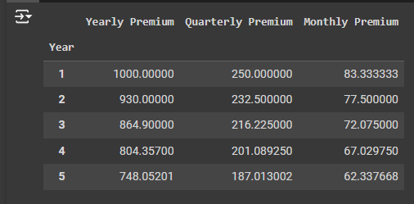

**EXPLAINATION:**

InsuranceModel Class:

This class holds information about the vehicle (vehicle_id, initial_value, years_of_insurance, premium_rate).

It calculates the depreciated value of the vehicle over the insured years using a 7% annual depreciation.

Premium Calculation:

The calculate_premiums() method calculates the yearly, quarterly, and monthly premiums based on the vehicle's depreciated value.

Chart Generation:

The generate_premium_chart() method returns a pandas DataFrame containing the premiums for each year, allowing us to easily visualize the data.

**Q:4** Generate a model to represent interest calculations of a Bank account where the process of

calculating interest for 6 months is a. Find minimum balance for each month b. Make a total of

all minimum balances c. Calculate interest based on interest rate d. Divide interest by 12 to

find one-month interest e. Multiply interest by 6 to show interest in the account. Generate a

model to represent transactions and interest calculations for 6 months.

**Solution🡪**

import pandas as pd

import numpy as np

class BankAccount:

def __init__(self, account_number, interest_rate):

self.account_number = account_number

self.interest_rate = interest_rate # annual interest rate (e.g., 5% as 0.05)

self.transactions = {month: [] for month in range(1, 7)} # dictionary to store transactions for each month

def add_transaction(self, month, amount):

if month in self.transactions:

self.transactions[month].append(amount)

else:

print(f"Invalid month {month}. Only 1-6 are valid.")

def find_minimum_balance(self):

min_balances = {}

balance = 0

for month in range(1, 7):

monthly_transactions = self.transactions[month]

monthly_balances = [balance + sum(monthly_transactions[:i + 1]) for i in range(len(monthly_transactions))]

if monthly_balances:

min_balances[month] = min(monthly_balances)

balance = monthly_balances[-1] # Carry forward the last balance to the next month

else:

min_balances[month] = balance # No transactions, so balance carries over

return min_balances

def calculate_interest(self):

min_balances = self.find_minimum_balance()

total_min_balance = sum(min_balances.values())

yearly_interest = total_min_balance * self.interest_rate

monthly_interest = yearly_interest / 12

# Step d & e: Calculate interest for 6 months

six_month_interest = monthly_interest * 6

return six_month_interest, min_balances

def generate_transaction_summary(self):

max_len = max(len(transactions) for transactions in self.transactions.values())

padded_transactions = {

month: transactions + [np.nan] * (max_len - len(transactions))

for month, transactions in self.transactions.items()

}

summary = pd.DataFrame(padded_transactions)

summary.index.name = 'Transaction_Index'

return summary.T # Transpose to make months the index

account = BankAccount(account_number="123456789", interest_rate=0.05) # 5% annual interest

account.add_transaction(1, 1000)

account.add_transaction(1, -200)

account.add_transaction(1, 300)

account.add_transaction(2, 1500)

account.add_transaction(2, -500)

account.add_transaction(3, 100)

account.add_transaction(3, -50)

account.add_transaction(4, 1200)

account.add_transaction(4, -300)

account.add_transaction(5, 400)

account.add_transaction(5, -100)

account.add_transaction(6, 700)

transaction_summary = account.generate_transaction_summary()

six_month_interest, min_balances = account.calculate_interest()

transaction_summary, six_month_interest, min_balances

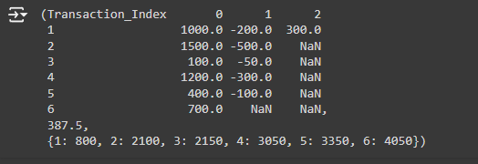

**Explaination:**

BankAccount Class:

The class contains methods for adding transactions (add_transaction), finding the minimum balance for each month (find_minimum_balance), and calculating the interest for 6 months (calculate_interest).

Transactions:

Transactions are stored month by month (1-6).

The minimum balance for each month is calculated based on the transactions.

Interest Calculation:

Once the minimum balance for each month is determined, the total minimum balance is calculated.

The yearly interest is computed by multiplying the total balance by the interest rate, then divided by 12 to get monthly interest.

The final interest for 6 months is obtained by multiplying the monthly interest by 6.

Result:

The output will show the transaction summary, the calculated interest for 6 months, and the minimum balances for each month.